INDOOR AIR QUALITY/WATER DAMAGE INVESTIGATION

Dr. Kevin M. Hurley Middle School
650 Newman Avenue
Seekonk, Massachusetts

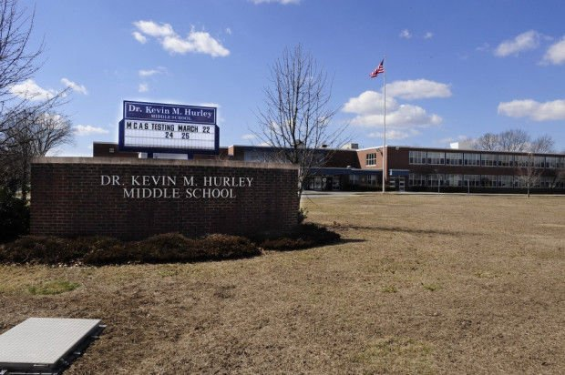

Prepared by:
Massachusetts Department of Public Health
Bureau of Environmental Health
Indoor Air Quality Program
December 2021

Background
Building: | Dr. Kevin M. Hurley Middle School (HMS)
Address: | 650 Newman Avenue, Seekonk, MA
Assessment Coordinated Through: | Jim Roy, Supervisor, Buildings and  Grounds, Seekonk Public Schools (SPS)
Reason for Request: | Water damage/mold concerns in Office Area
Date of Assessment: | November 18, 2021
Massachusetts Department of Public Health/Bureau of Environmental Health (MDPH/BEH) Staff Conducting Assessment: | Cory Holmes, Assistant Director, Indoor  Air Quality (IAQ) Program
Building Description: | The Director of Technology & Digital Learning office is a small room located on the ground floor of the HMS, which was built in 1956 and renovated in 1997. The room contains office furniture, wall to wall carpeting directly on concrete floor (no padding/backing), concrete block and brick walls with a suspended ceiling tile system. Above the suspended tiles is a concrete “honeycombed” ceiling.
Windows: | There are no windows in the space but there is a door to the outside.

METHODS
DPH staff conducted a series of visual assessments, temperature, and relative humidity measurements to identify likely areas that could be prone to condensation in hot, humid weather. Please refer to the IAQ Manual for methods, sampling procedures, and interpretation of results (MDPH, 2015).

RESULTS AND DISCUSSION
The following is a summary of indoor air testing results (Tables 1 and 2):
- Temperature was within the MDPH recommended range of 70°F to 78°F.
- Relative Humidity was within the MDPH recommended range of 40 to 60%.
- Moisture Measurement of porous materials (i.e., carpeting and ceiling tiles) prone to condensation/mold growth due to elevated relative humidity conditions were normal (i.e., dry) at the time of the assessment.
- Carbon Monoxide was not detected (ND) in the area tested.
- Particulate matter (PM2.5) concentrations measured were below the National Ambient Air Quality (NAAQS) level of 35 μg/m³ in the area tested.

Ventilation
A heating, ventilating and air conditioning (HVAC) system has several functions. First, it provides heating and, if equipped, cooling. Second, it is a source of fresh air. Finally, an HVAC system will dilute and remove normally occurring indoor environmental pollutants by not only introducing fresh air, but by filtering the airstream and ejecting stale air to the outdoors via exhaust ventilation. Even if an HVAC system is operating as designed, point sources of respiratory irritation may exist and cause symptoms in sensitive individuals.
Fresh air in the space is provided by a rooftop air handling unit (AHU). Fresh air is drawn into the AHU from outside, heated or cooled, and delivered to occupied space via supply diffusers. Return air is drawn into ceiling grates and ducted back to the AHU. To maximize air exchange, the IAQ program recommends that both supply and exhaust ventilation operate continuously during periods of occupancy. To have proper ventilation with a mechanical ventilation system, the systems must be balanced after installation to provide an adequate amount of fresh air to the interior of a room while removing stale air from the room. It is recommended that HVAC systems be re-balanced every five years to ensure adequate air systems function (SMACNA, 1994).

Microbial/Moisture Concerns
In order for building materials to support mold growth, a source of water exposure is necessary. The US Environmental Protection Agency (US EPA) and the American Conference of Governmental Industrial Hygienists (ACGIH) recommend that porous materials (e.g., wallboard, carpeting) be dried with fans and heating within 24 to 48 hours of becoming wet (US EPA, 2008; ACGIH, 1989). If porous materials are not dried within this time frame, mold growth may occur. Below are observations made in the area evaluated:
- The majority of building materials observed were non-porous surfaces [i.e., concrete ceiling (above suspended tiles), brick and cinder block walls], which are not conducive to mold growth as opposed to porous materials such as gypsum wallboard.
- No musty odors, current leaks, visible mold and/or related water damage were observed during the assessment.
- Moisture testing of carpeting was normal (i.e., dry).
- The plenum (above ceiling tiles) was clean and dry with no evidence of leaks or visible mold growth.

Building Materials Prone to Condensation
It is important to note that Massachusetts has experienced extended periods of relative humidity during the summer of 2021. This July was the wettest ever recorded in Massachusetts, and the three-month period from June through August, known as the meteorological summer, was the fourth wettest on record, according to the National Oceanic and Atmospheric Administration’s Centers for Environmental Information. The three-month period also was the third warmest ever in the state and was tied for the warmest on record across the United States (HG, 2021, NOAA, 2021).
The key to managing condensation in hot, humid weather indoors is understanding dew point. When warm, moist air passes over a cooler surface, condensation can form. Condensation is the collection of moisture on a surface at or below the dew point. The dew point is the temperature that air must reach for saturation to occur. If a building material/component has a temperature below the dew point, condensation will accumulate on that material. Over time, condensation can collect and form water droplets.
A method to locate areas in a building prone to condensation would be to measure air and building material temperatures using a laser thermometer (Table 2). If a wide temperature range exists between measurements, the building materials at the colder end of the range may be prone to becoming moistened with condensation if exposed to hot, humid weather (outdoor relative humidity >70%) for extended periods of time (at least 48 hours). According to the test results at the time of assessment (Table 1), the area did not appear to be prone to condensation.

Other Issues
As previously mentioned, the area was carpeted. Carpets should be cleaned annually (or semi-annually in soiled/high traffic areas) in accordance with Institute of Inspection, Cleaning and Restoration Certification (IICRC) recommendations, (IICRC, 2012). Regular cleaning with a high efficiency particulate air (HEPA) filtered vacuum in combination with an annual cleaning will help to reduce accumulation and potential aerosolization of materials from carpeting. It was reported by Mr. Roy that the SPS has a carpet cleaning program in place.
Exposure to low levels of total volatile organic compounds (TVOCs) may produce eye, nose, throat, and/or respiratory irritation in some sensitive individuals. To determine if VOCs were present, BEH/IAQ staff examined rooms for products containing VOCs. BEH/IAQ staff found dry erase materials and cleaners in use within the building. These products have the potential to be irritants to the eyes, nose, throat, and respiratory systems of sensitive individuals.
Ceiling-mounted vents were observed to have accumulated dust/debris (Pictures 1 and 2). Operation of HVAC equipment can re-aerosolize accumulated dust particles providing a source of eye and respiratory irritation.
Finally, to supplement mechanical ventilation and filtration, the room was provided with a HEPA-filtered air purifier. It is important to note that filters should be changed and these units be maintained in accordance with the manufacturers’ recommendations.

CONCLUSIONS AND RECOMMENDATIONS
In view of the findings at the time of the visit, the following recommendations are made:

Ventilation recommendations
- Operate the HVAC system to provide for continuous fresh air ventilation and filtration during occupied hours.
- Continue with regular filter changes for HVAC equipment using the best quality/highest Minimum Efficiency Reporting Value (MERV) rated filters that can be used with current equipment.
- Consider adopting a balancing schedule of every 5 years for all mechanical ventilation systems, as recommended by ventilation industrial standards (SMACNA, 1994).
- The U.S. Department of Education has released new guidance encouraging the use of American Rescue Plan (ARP) funds to improve ventilation systems and make other indoor air quality improvements in schools. More information can be found at this link https://www.ed.gov/coronavirus/improving-ventilation.

Water Damage Recommendations
- There are many factors that must be taken into consideration to operate the building’s HVAC system efficiently over summer months to provide comfort and prevent excess humidity and condensation; consult with an HVAC engineering firm regarding best practices for operation as needed. Some of the following activities may be considered to increase comfort and reduce potential water damage to materials:
  - Ensure that supply/exhaust/return vents are kept free of dust to avoid potential mold colonization.
  - Store porous items such as paper and cardboard away from the path of supply air and off floors.
  - Ensure that condensation from AC equipment is draining properly. Check collector pans, piping and any associated pumps for clogs and leaks and clean periodically to prevent stagnant water build-up and remove debris that may provide a medium for microbial growth.
  - Consider utilizing portable dehumidifiers as needed during excessive relative humidity periods (>70%) to supplement the HVAC system. Ensure dehumidifiers are cleaned/maintained as per the manufacturer’s instructions to prevent mold/bacterial growth.
- For more information about mold, consult the US EPA’s “Mold Remediation in Schools and Commercial Buildings” (US EPA, 2008). Available at: http://www.epa.gov/mold/mold-remediation-schools-and-commercial-buildings-guide.

Other Recommendations
- Change filters and maintain portable air purifying units as per manufacturers’ recommendations.
- Regularly clean/vacuum supply/exhaust/return vents to avoid aerosolizing accumulated particulate matter.
- Clean carpeting annually or semi-annually in soiled high traffic areas as per the recommendations of the Institute of Inspection, Cleaning and Restoration Certification (IICRC 2012).
- Reduce use of products and equipment that create irritating volatile organic compounds (VOCs) and only use in well-ventilated areas. Minimize the use of air fresheners (e.g., plug-ins), deodorizers and scented products.
- For buildings in New England, periods of low relative humidity during the winter are often unavoidable. Therefore, scrupulous cleaning practices should be adopted to minimize common indoor air contaminants whose irritant effects can be enhanced when the relative humidity is low. To control dusts, a high efficiency particulate arrestance (HEPA) filter equipped vacuum cleaner in conjunction with wet wiping of all surfaces is recommended. Avoid the use of feather dusters. Drinking water during the day can help ease some symptoms associated with a dry environment (throat and sinus irritations).
- Consider forming an IAQ committee in each school building district wide. Committees should have an IAQ liaison/teacher representative, a member of maintenance/facilities, and a member of administration that conduct regular walk-throughs to identify on-going and/or potential environmental issues.
- Consider adopting the US EPA (2000) document, “Tools for Schools”, as an instrument for maintaining a good IAQ environment in the building available at: https://www.epa.gov/iaq-schools/indoor-air-quality-tools-schools-action-kit
- Refer to resource manual and other related IAQ documents located on the MDPH’s website for further building-wide evaluations and advice on maintaining public buildings. These documents are available at: http://mass.gov/dph/iaq.

REFERENCES
ACGIH. 1989. Guidelines for the Assessment of Bioaerosols in the Indoor Environment. American Conference of Governmental Industrial Hygienists, Cincinnati, OH.
HG. 2021. Mold keeps South Hadley High School shuttered. Hampshire Gazette. https://www.gazettenet.com/South-Hadley-High-School-still-closed-amid-mold-remediation-42413519.
IICRC. 2012. Institute of Inspection, Cleaning and Restoration Certification. Carpet Cleaning: FAQ. Retrieved from https://www.iicrc.org/page/IICRCStandards.
MDPH. 2015. Massachusetts Department of Public Health. “Indoor Air Quality Manual: Chapters I-III”. Available at: https://www.mass.gov/lists/indoor-air-quality-manual-and-appendices#indoor-air-quality-manual-
NOAA. 2021. Summer 2021 neck and neck with Dust Bowl summer for hottest on record. National Oceanic and Atmospheric Administration, 1401 Constitution Avenue NW, Room 5128, Washington, DC 20230 https://www.noaa.gov/news/summer-2021-neck-and-neck-with-dust-bowl-summer-for-hottest-on-record
SMACNA. 1994. HVAC Systems Commissioning Manual. 1st ed. Sheet Metal and Air Conditioning Contractors’ National Association, Inc., Chantilly, VA. SMACNA. 1994. HVAC Systems Commissioning Manual. 1st ed. Sheet Metal and Air Conditioning Contractors’ National Association, Inc., Chantilly, VA.
US EPA. 2000. Tools for Schools. Office of Air and Radiation, Office of Radiation and Indoor Air, Indoor Environments Division (6609J). EPA 402-K-95-001, Second Edition. https://www.epa.gov/iaq-schools/indoor-air-quality-tools-schools-action-kit
US EPA. 2008. “Mold Remediation in Schools and Commercial Buildings”. Office of Air and Radiation, Indoor Environments Division, Washington, DC. EPA 402-K-01-001. September 2008. Available at: http://www.epa.gov/mold/mold-remediation-schools-and-commercial-buildings-guide.

Picture 1
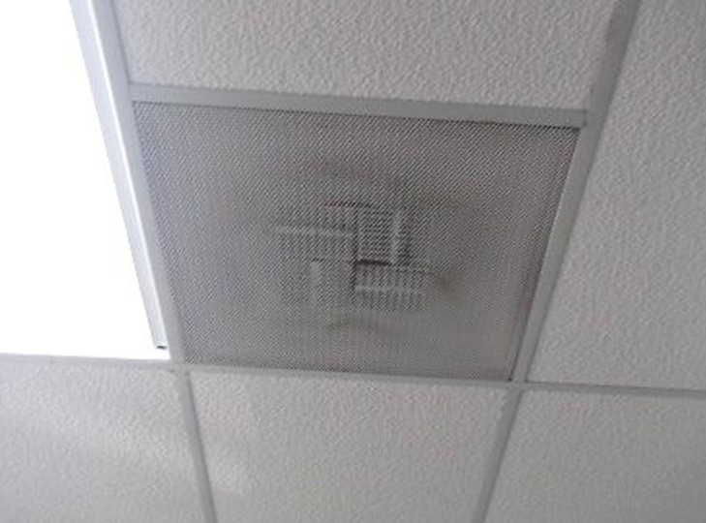
Dust/debris accumulated on supply vent

Picture 2
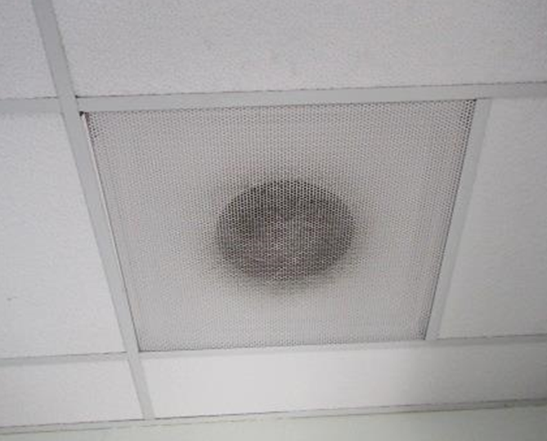
Dust/debris accumulated on return vent

Location | Air Temp  (ºF) | Relative Humidity  (%) | Dew Point  (%) | Floor Temp  (ºF) | Temp at Floor/ Exterior Wall Junction  (ºF) | Water-Damaged Ceiling Tiles-stained  (#) | Water- Damaged  Bowed Ceiling Tile  (#) | Ventilation |  |  | Floor to Air Temp  Difference  (ºF) | Comments
 |  |  |  |  |  |  |  | Windows openable | Supply | Exhaust
Background (outdoors) | 61 | 66 | 52 |  |  |  |  |  |  |  |  | Unseasonably warm, sunny, moderate traffic conditions
Director of Technology & Digital Learning | 71 | 51 | 52 | 69 | 69 |  |  | N | Y | Y | 2 | No visible water damage, musty odors or mold growth, moisture measurements of carpet and ceiling tiles normal (i.e., dry), ceiling plenum clean and dry

Location | Carbon Monoxide  (ppm) | Temp  (°F) | Relative  Humidity  (%) | PM2.5  (µg/m³) | Windows  Openable | Ventilation |  | Remarks
 |  |  |  |  |  | Supply | Exhaust
Background | ND | 61 | 66 | 22 |  |  |  | Unseasonably warm, sunny, moderate traffic conditions
Director of Technology & Digital Learning | ND | 71 | 51 | 9 | N | Y | Y | AP, carpeted, dust/debris on vents, DEM

