1


Massachusetts Partnership for Health
Promotion and Chronic Disease Prevention
Annual Summit:

Achieving Health Equity Through Community-
Clinical Linkages

Carolyn S. Langer, MD, JD, MPH Chief Medical Officer, MassHealth Director, Office of Clinical Affairs January 16, 2014
MassHealth’s Mission Statement

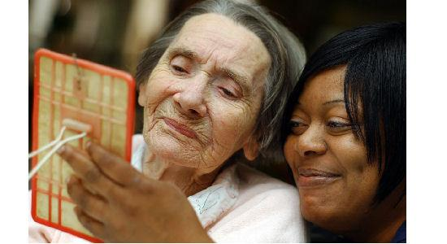




To improve the health outcomes of our diverse members, their families and their communities, by providing access to integrated health care services that sustainably promote health, well-being, independence, and quality of life.

The Status Quo

• Fragmented care

• Lack of coordination

• Poor management of chronic disease

• Lack of focus on population health

• Pay for volume, not for value

• Inadequate data

• Lack of transparency

• Slow dissemination of evidence-based practices

• Poor behavioral health (BH) integration

• Workforce shortages/workforce development issues
3

Medicaid Population*

• Lower income


• Less educated

• Racially and ethnically diverse

• Lower literacy levels; ESL

• Fewer social supports


• Less reliable transportation

• More frequent housing/utility issues




*Adapted in part from Paul Mendis, MD

MassHealth covers children, adults, and seniors, and often supplements other insurance

Percent of total MassHealth enrollment, FY 2012 Estimate

Seniors in Nursing
Facilities – 27,484

Seniors in
Community –
112,725
LT Unemployed
Adults – 128,541

2% 9%

8%
38%

Non-Disabled
Children –
523,268

Adults with
Disabilities –
230,267
17%

23% 2%

Non-Disabled
Adults – 308,096


Children with
Disabilities – 31,503

5

Examples of MassHealth Initiatives that Address Health
Disparities and Promote Community Linkages

• Intensive care management programs


• Waiver programs

• Acute hospital P4P program

• New payment reform and care delivery models


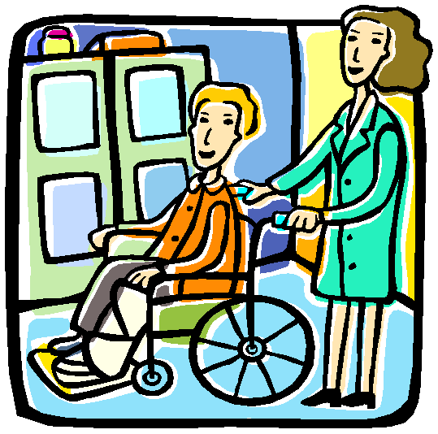

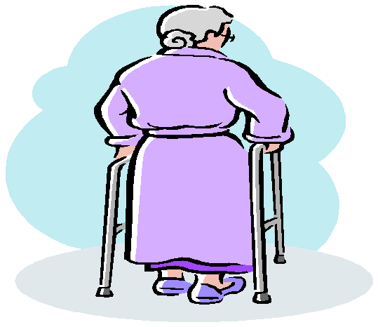

1915(c) Waivers

Massachusetts currently operates 10 Home and Community Based Services or 1915(c) Waivers, including:

▪ Frail Elder waiver

▪ DDS Intensive Supports waiver

▪ DDS Community Living waiver

▪ DDS Adult Supports waiver

▪ Traumatic Brain Injury waiver

▪ Acquired Brain Injury – Residential Habilitation waiver

▪ Acquired Brain Injury – Non-residential waiver

▪ Money Follows the Person – Residential Supports waiver

▪ Money Follows the Person– Community Living waiver

▪ Autism Spectrum Disorder Waiver (for children through age 8)

7
MassHealth has multiple programs to move towards
integrated, accountable care

Global
Payment
Payment Methodology
Payment Innovation
True Accountable Care

Duals


PCPR

PCMHI

Health
home

“Business as Usual”

Current
Market


Delivery System
Transformation

MBHP Care Mgmt

DSTI

FFS

Limited
Integration
Full Care
Integration

Degree of Integration

OneCare Program
Duals Demonstration Project

■ Began coverage on October 1, 2013

■ Blends Medicare and Medicaid funding to pay participating plans a per-member-per-month capitation

■ Includes 111,000 individuals aged 21-64 who are dually eligible for MassHealth and Medicare

■ Over 2/3 have a behavioral health diagnosis

■ ~50% have a chronic medical diagnosis

■ Majority of these members currently reside in the community

OneCare Performance Measures

■ HEDIS, Health Outcomes Survey (HOS), and CAHPS measures consistent with Medicare requirements

■ All existing Part D metrics

■ Additional MassHealth-proposed metrics pertinent to target population, in such areas as:
– Care management, appropriate care, follow-up for behavioral health
– Person-centered care planning, management, transitions
– Access to care, including LTSS services and ADA compliance

■ Examples:

– Tracking of demographic information: Race, Ethnicity, Primary language, Homelessness, Disability type

– Screening for preferred language

– Wait time for interpreter
Primary Care Payment Reform Initiative
Goals

Enhance:

■ Access to care

■ Panel enrollee experience

■ Quality of care

■ Efficiency

■ Wellness

■ Innovation

11


Implements a New Care Delivery
Model Emphasizing:

▪ Patient centered medical home

▪ Primary care and behavioral health integration

▪ Change in payment mechanisms

• Comprehensive Primary Care Payment (CPCP)

• Quality Incentive Payments

• Shared savings/risk


Proposed payment structure

A

Comprehensive
Primary Care
Payment (CPCP)
• Risk-adjusted capitated payment
for primary care services
• Options for including outpatient
behavioral health services

B Quality Incentive
Payment
• Annual incentive for quality performance, based on primary care performance

C Shared savings
payment
• Primary care providers share in savings on non primary care spend, including hospital and specialist services

The payment structure will not change billing for non-primary care services (specialists, hospital); PCP’s will not be responsible for paying claims for these services. However, we are evaluating complementary alternative payment methodologies to hospitals and specialists for acute services. 3

1


Components of the Comprehensive Primary
Care Payment (CPCP)

• Fee-for-service billable primary care services

• Example: evaluation and management of acute illness

• Non-billable medical home activities

• Examples: medication reconciliation, care coordination

• Behavioral health services:

• Tier 1: Only non billable BH services

• Examples: case management, care coordination

• Tier 2: Fee-for-service billable outpatient BH services provided by master’s
level and/or bachelor’s level professionals

• Examples: alcohol/drug assessment, mental health assessment by non-physician, crisis intervention, BH prevention education

• Tier 3: Fee-for-service billable outpatient BH services provided by prescribing clinicians and psychotherapists (masters/doctoral level)

• Examples: psychiatric assessment, medication management, cognitive-behavioral therapy
14

A Proposed Payment Structure:
Comprehensive Primary Care Payment (CPCP)

What is the purpose of this payment?

•Does not limit practices to revenue streams that are dependent on
appointment volume or RVU’s

•Gives practices the flexibility to provide care as the patient needs it, without depending on fee for service billing codes. This arrangement may support an expanded care team, community health workers, peer supports, phone and email consultations, group appointments, targeting appointment length to patient complexity, etc.

•Allows a range of primary care practice types and sizes to participate

•Provides financial support for behavioral health integration by including some outpatient behavioral health services in the CPCP

•Ensures support and access for high-risk members through risk adjustment based on age, sex, diagnoses, social status, comorbid conditions

15

Proposed payment structure

A

Comprehensive
Primary Care
Payment (CPCP)
• Risk-adjusted capitated payment
for primary care services
• Options for including outpatient
behavioral health services

B Quality Incentive
Payment
• Annual incentive for quality performance, based on primary care performance

C Shared savings
payment
• Primary care providers share in savings on non primary care spend, including hospital and specialist services

The payment structure will not change billing for non-primary care services (specialists, hospital); PCP’s will not be responsible for paying claims for these services. However, we are evaluating complementary alternative payment methodologies to hospitals and specialists for acute services. 6

1

B Proposed Payment Structure: Quality Incentive Payment

•Similar to pay-for-performance programs, participants will win some percentage bonus to the base payment based on quality performance

•Uses a set of metrics that are common across other programs, including programs deployed by other payers or used for other quality measurement purposes

•Measurement Areas
• Pediatric Health
• Adult Chronic Conditions
• Access

• Care Coordination

17


Role of Quality Metrics

■ Financial incentives

– Determines amount of quality incentive
payment

– Determines eligibility for shared savings payment

– Determines percentage payout for shared savings payment

■ Quality improvement

■ Program monitoring & evaluation
Critical Domains of Quality

• Enhanced access:

– Improved access to primary care services through extended hours, partnerships with urgent care, or other ways means
• Patient-centeredness:

– Patient involvement in decision making, increased focus on the patient experience
• Behavioral health integration:

– Appropriate screening and testing for behavioral health conditions in primary care settings; enhanced coordination between behavioral health and primary care providers
• Care coordination:

– Better management of care transitions, alignment on care plans with other providers
• Improved health and wellness:
– Improvements in patient health and wellness outcomes,
child and adult, chronic and acute
Measure Prioritization Criteria

• Broadly accepted and validated (e.g., NQF measures)

• Aligned with MassHealth’s goals and quality domains

• Able to be influenced by primary care physicians

• Not currently at uniformly high level of performance across providers

• Feasible to track and report

• Aligned with other EOHHS initiatives and other payers’


programs (e.g. BCBSMA AQC)
Claims-Based Measures

# NQF # Measure Name Measure Steward
3  4  5  7  8  15  16  9  10  21 | 33 Chlamydia screening NCQA (HEDIS)
3  4  5  7  8  15  16  9  10  21 | 32 Cervical cancer screening NCQA (HEDIS)
3  4  5  7  8  15  16  9  10  21 | 31 Mammography screening NCQA (HEDIS)
3  4  5  7  8  15  16  9  10  21 | 4 Initiation and engagement of alcohol/drug dependence NCQA (HEDIS)  treatment
3  4  5  7  8  15  16  9  10  21 | 576 Follow up after hospitalization for mental illness (includes NCQA (HEDIS)  children and adults)
3  4  5  7  8  15  16  9  10  21 | 1516 Well child visits 3 – 6 years NCQA (HEDIS)
3  4  5  7  8  15  16  9  10  21 | Adolescent well visits NCQA (HEDIS)
3  4  5  7  8  15  16  9  10  21 | 108 ADHD medication management for children NCQA (HEDIS)
3  4  5  7  8  15  16  9  10  21 | 36 Asthma medication NCQA (HEDIS)
3  4  5  7  8  15  16  9  10  21 | Ambulatory Sensitive ED Visits Mercer

Record-Based Measures

# NQF # Measure Name Measure
Steward
1  2  6  11  12  13  14  17  18  19  23 | 421 Adult weight screening and follow up CMS
1  2  6  11  12  13  14  17  18  19  23 | 28 Tobacco use assessment and tobacco cessation CMS  intervention
1  2  6  11  12  13  14  17  18  19  23 | 418 Depression screening CMS
1  2  6  11  12  13  14  17  18  19  23 | 24 BMI assessment and counseling NCQA (HEDIS)
1  2  6  11  12  13  14  17  18  19  23 | 1506 Adolescent immunization NCQA (HEDIS)
1  2  6  11  12  13  14  17  18  19  23 | 1448 Developmental screening in first three years CAMHI
1  2  6  11  12  13  14  17  18  19  23 | 1392 Well child visits: <15 months, NCQA (HEDIS)
1  2  6  11  12  13  14  17  18  19  23 | 38 Childhood immunizations NCQA (HEDIS)
1  2  6  11  12  13  14  17  18  19  23 | 731 Diabetes composite NCQA (HEDIS)
1  2  6  11  12  13  14  17  18  19  23 | 18 Hypertension: Controlling high blood pressure NCQA (HEDIS)
1  2  6  11  12  13  14  17  18  19  23 | 97 Medication reconciliation (all patients, regardless of age) NCQA (HEDIS)

Survey Based Measures

# NQF # Measure Name Measure
Steward
20 6 Getting timely appointments, care and information AHRQ
6 How well providers communicate with patients AHRQ
6 Helpful, courteous, and respectful office staff AHRQ
6 Patients’ rating of provider AHRQ
6 Child growth and development AHRQ
6 Advice to parents on keeping a child safe and health AHRQ
22 6 Follow-up of test results AHRQ
6 Providers pay attention to mental or emotional health AHRQ
6 Providers support you in taking care of your own health AHRQ
6 Providers discuss medication decisions AHRQ

Coordination with Other Payer Initiatives
CPCR # | Measure Name | EOHHS  Medical  Home | BCBS  AQC | Meaningful  Use | CMS  Adult  Core | CMS  CHIPRA | SQAC
Adult Prevention and Screening
1  2  3  4  5 | Adult weight screening and follow-up  
1  2  3  4  5 | Tobacco use assessment and tobacco cessation intervention   
1  2  3  4  5 | Chlamydia screening in women     
1  2  3  4  5 | Cervical cancer screening    
1  2  3  4  5 | Mammography screening (breast cancer)    
Behavioral Health
6  7  8 | Screening for clinical depression and follow-up plan   
6  7  8 | Initiation and engagement of alcohol and other drug dependence treatment   
6  7  8 | Follow-up after hospitalization for mental illness   
Pediatric Health
9  10  11  12  13  14  15  16  17 | Follow-up care for children prescribed attention-deficit/hyperactivity disorder mediation    
9  10  11  12  13  14  15  16  17 | Use of appropriate medications for people with asthma  
9  10  11  12  13  14  15  16  17 | Weight assessment for children and adolescent   
9  10  11  12  13  14  15  16  17 | Adolescent immunization  
9  10  11  12  13  14  15  16  17 | Screening using standardized screening tools for potential delays in social and emotional   
9  10  11  12  13  14  15  16  17 | Well child visits in the first 15 months of life  
9  10  11  12  13  14  15  16  17 | Well child visits in the third, fourth , fifth and sixth years of life  
9  10  11  12  13  14  15  16  17 | Adolescent well-care visit   
9  10  11  12  13  14  15  16  17 | Childhood immunization status    
Adult Chronic Conditions
18  19 | Comprehensive diabetes care    
18  19 | HTN: Controlling high blood pressure (hypertension)     
Access
20  21 | CAHPS: Getting timely care, appointments and information 
20  21 | Ambulatory sensitive ED visits 
Care Coordination
22  23 | CAHPS: Follow-up of test results
22  23 | Reconciled Medication List

Questions

