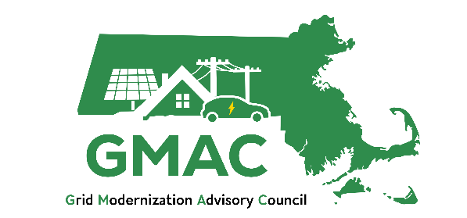

2026 Workplan for the Grid Modernization Advisory Council

2026 Workplan
GMAC’s workplan for 2026 is organized by ongoing administration and four objectives, described in greater detail below and illustrated in Figure 1. The GMAC will meet on a monthly basis, the Executive Committee will meet on a quarterly basis, and the Equity Working Group will meet on a quarterly basis. The GMAC will host additional subcommittees as needed, such as for the Long-Term System Planning Process (LTSPP). Any subgroup activities and member composition will be determined by the GMAC. The GMAC will host an end-of-year public event to provide interested stakeholders an overview of ESMP implementation progress, as well as a readout of work products ready for public engagement from the GMAC’s 2026 workplan.
The EDCs appreciate the opportunity to comment on the GMAC's proposed 2026 Workplan. As the Department noted in their ESMP Order, Section 92C, does not explicitly identify specific activities for or expectations of the GMAC during the intervening time between draft plan filings but the Department encourages continued collaboration between the GMAC, GMAC consultants, and the Companies during the intervening time. The EDCs echo these sentiments and look forward to providing educational presentations (as suggested by DOER and the Department) to allow for additional collaboration to ultimately expedite and improve the GMAC’s review of subsequent draft plans.
All GMAC members can agree that electric infrastructure serves as the foundation to enable the state’s climate goals and Administration's policy agenda. It is incumbent upon all of us to find ways to address any and all hurdles to reaching those goals while also keeping affordability of the transition front and center. Below is a graphic and EDC recommendations for how the GMAC can play a leading role in doing all it can to cut the red tape as we collectively work to achieve the Commonwealth’s clean energy goals, while the EDCs simultaneously work to maintain and plan for a safe and reliable grid.

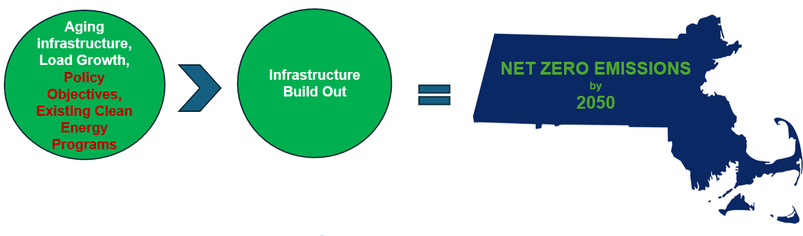
The Department found that proposed ESMP investments are not attributed to the Companies’ system needs in the provisioning of their core public service obligations to provide safe and reliable electric service; rather, the proposed investments are geared towards enabling the Commonwealth to achieve its clean energy goals as a result of a statutory directive. Therefore the Department also found there is very limited value for, and it would not be feasible to require, more comprehensive alternatives proposals or analyses of EDC forecasts as part of ESMP strategic planning.

Objective 1: ESMP Enablement and Execution
Based on the 9/18 GMAC meeting there appeared to be general consensus (DOER, MA CEC, AGO, MAPC, Acadia) that the GMAC’s focus relative to forecasting should not be how the forecast is completed, but overall awareness and understanding of what the EDCs are proposing to build, when, and why.
Objective: ESMP Enablement and Execution | Focusing on how the GMAC can help align policy objectives, existing programs to ensure the grid is ready for infrastructure build out to enable the state’s goals, including an overall awareness and understanding of what the EDCs are proposing to build, when, and why.
Goals | - EDC educational presentation for the GMAC to further develop the GMAC’s knowledge of each company’s forecasting methodologies, including the differences in forecasting assumptions and methodologies (as recommended by the DPU and DOER).  - Identify and address bottlenecks to enable implementation of infrastructure to enable policy objectives.  - Focus on what happens after planning/forecasting and what bottlenecks exist today that prevent the streamlined and cost effective build out of the Grid in order to accomplish our climate goals? Subsequent to that effort, establish workstreams to address those specific identified bottlenecks.  - GMAC’s review of EDCs’ biannual reports to see how ESMP is being implemented, in reality
Connection to GMAC Role | - Aligns with DPU recommendation that the EDCs present to develop the GMAC’s knowledge of the EDC forecast methodologies.  - Supports GMAC understanding of the EDC forecasts, review of the 2029 draft ESMPs, and review of utility reprioritization of investments in biannual reports.
Workplan | Introduction and Overview: Forecast methodology (January)  The EDCs are happy to provide an educational presentation for the GMAC to further develop the GMAC’s knowledge of each company’s forecasting methodologies, including the differences in forecasting assumptions and methodologies (as recommended by the DPU and DOER).  As the ESMP is a strategic document, the EDCs propose a single dedicated GMAC meeting for educational discussions on forecasting.  Presentation to include how the EDC forecasts:  - Electric vehicle adoption and charging impacts to the Grid as vehicles move throughout the state. How do EDCs see charging patterns evolving?  - Solar Adoption, including considerations for CIP investments, and how weather adjusted impacts to the grid are calculated  - Heating electrification, weather assumptions and real world data on efficiency of electric heating systems and their impact to the electric system  - How the Companies track their step loads, challenges with such loads, and what mechanisms are in place to provide more visibility
Workplan | ESMP Enablement Deep Dives (February-October):  How the ESMPs are playing out in the real world should be reflected in the EDCs’ biannual reports, and the GMAC’s review of those realities is pivotal to success. The first step is identifying those barriers and then as an Advisory Committee, the GMAC offers a platform to talk about solutions and solve any on the ground bottlenecks – including municipal customers’ experiences.  Some key questions:  - How do EDCs plan proactively for step loads?  - How does the current EDC process work with municipal customers interfacing with the EDCs on their electrification plans?  - Who bears the costs of distribution upgrades?  - Does the CIAC model need to change?  Specific real-world examples include but are not limited to: CIAC model, engineering, construction, siting, different permitting agencies involved with approval of construction, costs, community engagement.
Workplan | GMAC Resolution on Forecasting (November-December)  - Summary of EDC forecasting practices and methods and other bottom-up demand drivers by forecast area.  - Documentation of challenges and barriers to implementing ESMP.  - GMAC observations and recommendations.  - GMAC presentation on this work at the end-of-year stakeholder event
Timeline

Duties | GMAC Members  - Attend GMAC meetings having reviewed meeting materials in advance  - Engage in productive and collaborative discussion with members and speakers  - Lead and facilitate discussions during meetings as needed  - Deliver presentations if bottleneck area is related to member representation  - Discuss, review, and vote on a resolution that memorializes GMAC observations and recommendations on ESMP implementation.
Duties | Consultants  - Support DOER with agenda development and materials coordination with speakers  - Identify discussion questions for meetings and prepare GMAC member facilitators  - Take minutes at GMAC meetings per Open Meeting Law requirements  - Draft summary of EDC forecast elements after educational session  - Document and synthesize implementation bottlenecks and recommendations discussed during meetings  - Prepare initial draft of GMAC resolution based on synthesized observations and recommendations
Duties | EDCs  - Present on forecast; present on ESMP implementation hurdles and challenges.  - Respond to GMAC member questions and collaborate during discussions
Duties | DOER  - Develop agendas for each meeting  - Chair GMAC meetings and facilitate GMAC discussion
Duties | External Presenters  - Provide presentations on relevant activities that might impact Massachusetts sector-specific forecasting (ex. EVICC, Mass Economics, EEAC, Municipal Customers)  - Provide case studies of implementation challenges and/or technological innovations.
Final Products | GMAC resolution containing summary and recommendations
Next Steps for 2027 | Collaborate with EDCs on policy or other solutions to the bottlenecks hampering ESMP implementation.

Objective 2: Affordability
Objective | Discuss the ongoing balance of affordability and the pace at which this transition occurs, with increased transparency around costs and stakeholder engagement in the grid- planning process.
Goals | - Seek to encourage least-cost investments in electric distribution systems;  - Seek alternatives to investments or;  - Seek alternatives to approaches to financing investments that will facilitate achievement of the Commonwealth’s climate goals.  - Document and make transparent the projected bill impacts of each EDC’s planned direct ESMP and ESMP-related core investments  - Improve EWG and GMAC members’ knowledge of investment alternatives and initiate discussions on how to minimize costs and ratepayer impacts  - Document EWG and GMAC discussions on promoting least-cost distribution planning and mitigating impacts on ratepayers  - Collaborate with EDCs on cost-effective alternative investment options for next ESMP
Connection to GMAC Role | - Encourages least-cost investments in the distribution system, alternatives to investments, or alternative approaches to financing investments  - Supports minimizing or mitigating impacts on ratepayers  - Increases transparency of the grid planning process
Workplan | Quarter 1: Deep dive into costs: what is included in investments?  - Project development and Engineering  - Stakeholder/community engagement  - Siting and Permitting  - Construction  - Transformers: pole top vs padmount  - Behind the Meter work  - Labor  - Non-EDC costs: Public Policy, Supply Procurement among others  - Forecasts of these costs over a ten year period
Workplan | Quarter 2: How can we strategically align existing customer-facing programs which helps to lower system demands and forecasted peak loads, thus mitigating or minimizing ratepayer impacts by delaying the need for new investments? Based on Q1 discussion, EDCs present bill impact analysis to GMAC  - Are SMART incentives aligned with where the need is? Or where hosting capacity is?  - Have we exhausted flexible interconnection?  - Are EE incentives aligned with where system need is for Demand Response?  - Are electrification incentives aligned with where hosting capacity exists or where the EDCs are making reliability and resiliency investments?  - How are these incentives aligned and tied into Integrated Energy Planning?
Workplan | Quarter 3: Discuss Cost-Effective Investments/Alternatives and Priorities  - Engage in level-setting discussion on the factors considered when evaluating investments beyond the cost of investments  - Discuss least-cost vs. cost-effective investments  - Discuss options for reducing costs and bills, including but not limited to NWAs, DERs, alternative financing, benefit-cost analysis methods and assumptions  - Discuss state-led incentives to encourage cost-effect investments, such as innovative technologies and incentive program structures.  - Discuss EDC processes to determine and evaluate least cost and alternative investments
Workplan | Quarter 4: Next Steps  - Present completed and proposed future work at the end-of-year event to publicize GMAC’s efforts to identify cost-effective alternatives to traditional capital investments and mitigate impacts on ratepayers.  - Continue discussing cost impact and options for reducing costs and bills, including NWAs, DERs, alternative financing, etc.  - Discuss potential next steps
Timeline

Duties
Duties | GMAC Members  - Oversee and provide feedback on EWG activities and progress through updates at GMAC meetings
Duties | Consultant  - Work with DOER, the EWG, and the EDCs to determine the data necessary to perform bill impacts analysis  - Create summary factsheet on bill impacts for stakeholders  - Support discussions on options for reducing costs and mitigating impacts on ratepayers.  - Support planning and administration of the stakeholder event
Duties | EDCs  - Provide presentations on current efforts and processes to reduce costs and mitigate impacts on ratepayers
Duties | DOER  - Oversee and manage consultant activities  - Support developing meeting agendas and materials
Duties | External Presenters  - Others, as identified
Final Products | - Slide deck illustrating increased transparency around costs and stakeholder engagement in the grid- planning process
Next Steps for 2027 | - Continue to collaborate with EDCs on the practices for identifying and selecting least-cost investments

Objective #3: ESMP biannual report and cost recovery filings: Understanding Challenges of ESMP Implementation
Objective | The GMAC will monitor and discuss challenges to ESMP implementation through review of the EDC biannual reports and cost recovery filings and develop summary documents to educate GMAC members and other stakeholders engaged in ESMP activities. The GMAC will discuss if any additional information would help its review and understanding of ESMP implementation progress and challenges.
Goals | - Keep GMAC members up-to date on ESMP implementation  - Increase transparency of ESMP implementation and planning  - Improve transparency of future biannual reports  - Understand challenges of ESMP implementation
Connection to GMAC Role | - Supports GMAC review of next draft ESMPs.  - Provides input for EDCs to consider in developing the draft 2029 ESMPs.  - Increases transparency of the grid planning process
Workplan | Memo and Discussion of March 31, 2026 biannual report  - EDCs present on biannual report and implementation challenges.  - GMAC and EWG discuss biannual report in meetings identifying if there are ways to improve transparency of reports and implementation successes and challenges. GMAC discusses observations it may want to document.  - Consultant drafts a summary memo of the biannual report and includes synthesis of GMAC and EWG meeting discussion.
Workplan | Memo and Discussion of May 1, 2026 annual cost recovery filing  - EDCs present on cost recovery filing and associated challenges.  - Consultant summary memo on annual cost recovery filing, reporting on investment implementation progress, alignment with biannual reports.  - GMAC discusses cost recovery filing and any observations.
Workplan | Memo and Discussion of September 30, 2026 biannual report  - EDCs present on biannual report and implementation challenges.  - GMAC and EWG discuss biannual report in meetings identifying if there are ways to improve transparency of reports and implementation successes and challenges. GMAC discusses observations it may want to document.  - Consultant drafts a summary memo of the biannual report and includes synthesis of GMAC and EWG meeting discussion.
Workplan | Public Presentation of ESMP Implementation Progress  - At end-of-year GMAC stakeholder event, EDC and GMAC members co-lead presentation and discussion of ESMP implementation progress and challenges over the past year. Provide opportunity for public feedback and questions.
Timeline
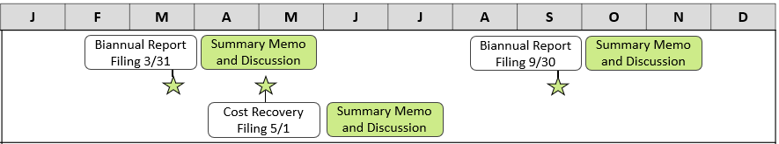
Duties | GMAC Members  - Review biannual reports and cost recovery filings in advance of relevant GMAC meetings  - Discuss observations on the reports and filings during meetings, collaborate on implementation challenges  - Equity Working Group (EWG) members discuss observations on equity and stakeholder engagement reporting/implementation  - Provide feedback on consultant drafts of cumulative GMAC member observations and meeting discussion  - Co-present on the GMAC process and discussions of ESMP progress over 2026 at end-of-year event, as needed
Duties | Consultant  - Draft memos on biannual report and cost recovery filings following EDC presentation of reports and cost recovery filing, including information not covered by EDC presentation, if applicable.  - Document and synthesize GMAC and EWG member observations on reports and filings to include in each summary memo  - Support planning and administration of end-of-year public event
Duties | EDCs  - Provide presentations on biannual reports and cost recovery filing, highlighting implementation challenges.  - Discuss information provided in biannual reports and cost recovery filing  - Present on elements of ESMP implementation progress at end-of-year event
Duties | DOER  - Chair GMAC meetings and facilitate discussion  - Oversee development of consultant summary memos with GMAC observations  - Develop agenda for end-of-year public event for GMAC feedback
Final Products | - March 2026 Biannual Report Summary Memo + GMAC Observations  - May 2026 ESMP Cost Recovery Filing Summary Memo + GMAC Observations  - September 2026 Biannual Report Summary Memo + GMAC Observations  - Public presentation on ESMP implementation progress
Next Steps for 2027 | - Evaluate and adjust GMAC review process as needed  - Continue biannual report and cost recovery filing review

Objective 4: Grid Modernization Efforts
Objective | Develop and maintain GMAC knowledge of and alignment around concurrent activities related to grid modernization, including but not limited to related DPU dockets and other relevant working groups, Councils, and ongoing processes.
Goals | - Develop and maintain GMAC knowledge of ongoing activities related to grid modernization that may be otherwise disparate and siloed.  - Improve transparency of grid modernization activities in Massachusetts
Connection to GMAC Role | - Supports GMAC knowledge of activities related to ESMPs and grid modernization.  - Develops materials for improving stakeholder understanding of ESMP-related issues. Supports GMAC review of next draft ESMPs.
Workplan | Element 1: Grid modernization tracker  - Develop tracker of concurrent grid modernization activities to post on the GMAC website.  - Every other month, the GMAC reviews the tracker and GMAC members provide updates on grid modernization activities.
Workplan | Element 2: Review of DOER-developed stakeholder guide to grid modernization activities  - DOER will develop a general stakeholder guide to grid modernization activities. This may include an overview of grid mod elements, a summary of relevant activities, how stakeholders can engage, and a list of activities.  - DOER to request GMAC input and feedback on content.
Timeline 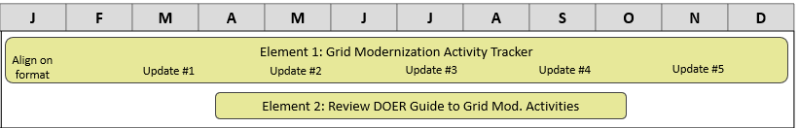
Duties | GMAC Members  - Provide updates on ongoing activities related to grid planning at meetings.  - Provide feedback on stakeholder guide as needed.  - Share materials with and bring back feedback from GMAC member representation networks as appropriate.
Duties | Consultant  - Develop and manage tracker of concurrent grid modernization activities  - Provide feedback on stakeholder guide as needed.  - Support facilitation and collection of GMAC member representation network feedback as needed.
Duties | EDCs  - Provide updates on ongoing activities related to grid planning at meetings  - Provide feedback on stakeholder guide as needed.
Duties | DOER  - Send updates on relevant activities to GMAC and GMAC list-serve  - Lead vision and content development for stakeholder guide activities
Final Products | - Regularly updated tracker of grid modernization activities.  - High-level stakeholder guide on grid modernization activities.

Potential Ideas for the 2027 GMAC Workplan
The following objectives were inspired by GMAC feedback and may be further explored in 2027. As part of ongoing administration, the GMAC will largely discuss strategic planning for 2027 in the end of Q2 – beginning of Q3.

Collaborate on EDC Demand Assessments
- Continuation of load forecast workstream
- Includes GMAC collaboration on demand assessments and sensitivity analyses.
- EDC presentations on demand assessment scope, process, inputs, and uses
- Presentations and discussions on EDC sensitivity analyses for 2050 long-term demand assessment
- GMAC discussion leading to Council resolution & observations memo on Company process and general recommendations for next draft ESMP

Assess EDC Climate Vulnerability Assessments and Climate Vulnerability & Resilience Plans
- Review EDC CVAs and how EDCs are using them to implement resiliency investments.
- Review statutory CVRP requirements and collaborate with EDCs on any progress or planning for them underway.
- Coordinate with resiliency stakeholders and develop GMAC resolution with recommendations on CVRPs for the EDCs to incorporate into their next draft ESMPs.

Assess EDC planning processes and applications of cost-effective and least-cost investments
- Continuation of affordability and cost-effectiveness workstream
- Include a review of non-wires alternatives, bridge-to-wires solutions, load management and load flexibility practices and programs, updates on the implementation and use of the Grid Services Compensation Fund.
- Evaluate how these elements impact grid capacity and system costs today.

Analyze locational impacts of distribution system infrastructure and approved ESMP investments to understand distributional equity impacts.
- Provide GMAC, EWG, and interested stakeholders with information on the distribution of benefits of ESMP investments. Potential activities:
    - Public Mapping Tool: A map showing locations of distribution system investments including the Grid Services Compensation Fund projects, distribution system infrastructure, resilience investments, substations, and DER deployment.
    - Distributional Equity Report: Analyze locational impacts of EDC planning and investments to assess how well EJCs are being served. Could include focus on EDC resilience performance in EJCs (e.g., SAIDI, SAIFI).
    - Community Benefit Agreements (CBAs) Analysis: After siting and permitting reform regulations are available in early 2026, discuss and translate the results into implications for CBAs resulting from the ESMPs.

See a similar project conducted by DPU: Angela Yang, Grid Modernization & Environmental Justice Technical Summary (2024), https://storymaps.arcgis.com/stories/849bf45ec7dd4012875bc0f4e323c52e

