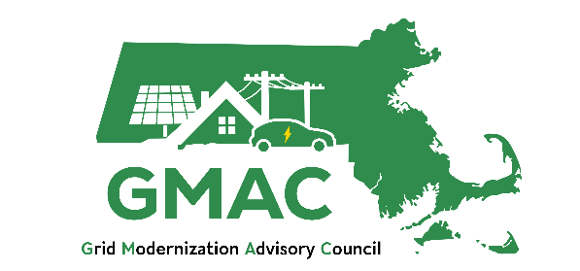

2026 Workplan for the Grid Modernization Advisory Council

Background
In August 2022, An Act Driving Clean Energy and Offshore Wind (Act) was signed into law. Recognizing the importance of the electric grid in facilitating emissions reductions in the Commonwealth, and the need for a comprehensive and transparent grid planning process, the Act established the Grid Modernization Advisory Council (GMAC) to encourage least-cost investments in the electric grid, alternatives to investments or to financing investments that facilitate meeting emissions reductions limits, increase transparency and stakeholder engagement in grid planning processes. GMAC is required to review and provide recommendations to the electric distribution companies (EDCs) regarding their electric-sector modernization plans (ESMPs). The ESMPs are strategic plans that must contain the following:
- Plans to upgrade the distribution system to:
  - improve reliability and resiliency,
  - enable adoption of renewable energy and distributed energy resources,
  - promote energy storage and electrification technologies,
  - prepare for climate-driven grid impacts,
  - accommodate increased transportation and building electrification,
  - minimize or mitigate impacts on ratepayers.
- Plans shall describe: distribution grid improvements to meet the strategic plan elements noted above; the availability and suitability of new technologies that can help meet forecasted reliability and resiliency needs; facilitate achievement of statewide emissions limits; and, alternatives to investment proposals, including alternative approaches to financing the investments.

- 5- and 10-year forecasts and a demand assessment through 2050.
On November 20, 2023, the GMAC reviewed and provided 88 recommendations on the EDCs’ inaugural draft ESMPs. On August 29, 2024, the Department of Public Utilities (DPU) issued a Phase I Order approving the filed ESMPs as strategic plans. On June 13, 2025, the DPU issued a Phase II Order approving a subset of the proposed investments and an interim cost-recovery mechanism.
The GMAC is authorized to submit a budget for approval to the DPU to support its activities on an annual basis. The DPU found that the GMAC and EDCs should engage in ongoing collaboration in between ESMP filings.

Plan Purpose
The purpose of this document is to provide a clear and transparent plan for how GMAC will conduct its work in 2026 and fulfill its mandate to support least-cost and transparent grid planning. The years leading up to the next draft ESMPs in 2029 allow the GMAC additional time to investigate, assess, and collaborate on discrete elements of GMAC’s responsibilities and the ESMPs as described by the Act. The coming planning year, 2026, is also the first full year of implementation of the 2025-2029 ESMPs. During this year, as GMAC monitors implementation via DPU filings and updates from the EDCs, the Council can also serve as a forum for triaging and navigating solutions to implementation barriers and issues. While this plan looks at 2026 comprehensively, revisions and refinements may be made to the plan throughout the year in response to GMAC members’ feedback and recommendations.
This plan has been informed by input from all GMAC members, particularly from a written survey and several small group discussions. Some of the themes of this input include general agreement from GMAC members that:
- The scope of the GMAC covers grid modernization, which includes review of distribution system planning.
- The GMAC’s role is to be an advisor on issues related to ESMPs, providing guidance to the EDCs, the DPU, and other stakeholders engaged in ESMP activities (e.g., municipalities, stakeholders in related work groups).
- Individual GMAC members, as representatives of their individual sectors and interest groups, could take more active roles in being a touchpoint and resource for stakeholders in their represented industry. This may be a function for which GMAC administrators/consultants help to provide guidance and support to GMAC members.
- It is useful for the GMAC to compile and present educational materials on ESMP topics, with the goal of informing GMAC members and other “201-level” stakeholders that are engaged in ESMP-related activities (e.g., municipalities, stakeholders in related work groups).
- The GMAC should monitor DPU ESMP dockets on biannual reports and cost recovery. GMAC may have through its members the expertise and ability to help triage and navigate solutions to implementation barriers and issues identified via monitoring.
- It is not the role of the GMAC to intervene as a body or otherwise engage in DPU ESMP dockets. However, the GMAC may discuss the contents of reports during meetings with the EDCs, when relevant.

- The GMAC should monitor ESMP-related activities, such as related DPU dockets or working groups, but not spend much time engaging in those activities.
- The GMAC should work towards better informing itself in preparation for reviewing and providing recommendations on the draft 2029 ESMPs.

Role of the GMAC
The landscape of grid modernization and distribution system planning is rapidly evolving in Massachusetts. The DPU ESMP Phase I and Phase II Orders added clarity around implementation expectations and scope of the ESMPs, the 2024 Climate Law created new Climate Vulnerability and Resilience Plan (CVRP) requirements for the ESMPs, and Governor Healey has proposed legislation that would further evolve the ESMP and distribution system planning space.
To ground planning and scoping efforts for the next calendar year, the GMAC adopts the following definitions and intention for its role in 2026.
Grid Modernization is the process of enabling the electric grid to support the evolving needs of the economy and climate, including decarbonization, affordability, and other drivers of increasing demand for electric capacity, and heightened system resilience. Grid modernization includes enabling new technologies, functionality, programs, and other supporting systems that go beyond the technologies that have been used traditionally to ensure safe and reliable grid services.
Electric Distribution System Planning is a forecast, analysis, and solution planning cycle the electric utilities conduct for maintenance and development of the grid, including both traditional distribution solutions and grid modernization solutions. The goal is to maintain safe, reliable, and affordable service while also efficiently operating the existing electrical facilities that make up the grid.
GMAC Role: In 2026, the GMAC will collaborate as a Council to advance grid modernization in Massachusetts. It will investigate specific elements of distribution system planning that align with the GMAC statutory objectives of encouraging least-cost investments in the electric distribution system, alternatives to investments or to financing investments that facilitate meeting emissions reductions limits, and increasing transparency and stakeholder engagement in grid planning processes.
This role aligns with the DPU’s finding that the GMAC and EDCs should engage in ongoing collaboration in between ESMP filings. Some specific areas the DPU identified for potential GMAC work include: (1) exploring each EDC’s investment reprioritization process based on updated forecasts; (2) presentations and collaboration on forecasting methods and least-cost investments; (3) sensitivity analyses for 2050 long-term demand assessments, and (4) resiliency considerations to inform future CVRP and ESMP filings.

2026 Workplan
GMAC’s workplan for 2026 is organized by ongoing administration and four objectives, described in greater detail below and illustrated in Figure 1. The GMAC will meet on a monthly basis, the Executive Committee will meet on a quarterly basis, and the Equity Working Group will meet on a quarterly basis. The GMAC will host additional subcommittees as needed, such as for the Long-Term System Planning Process (LTSPP) or Integrated Energy Planning. Any subgroup activities and member composition will be determined by the GMAC. The GMAC will host an end-of-year public event to provide interested stakeholders an overview of ESMP implementation progress, as well as a readout of work products ready for public engagement from the GMAC’s 2026 workplan.
Figure 1. Overview of draft GMAC workplan for 2026.
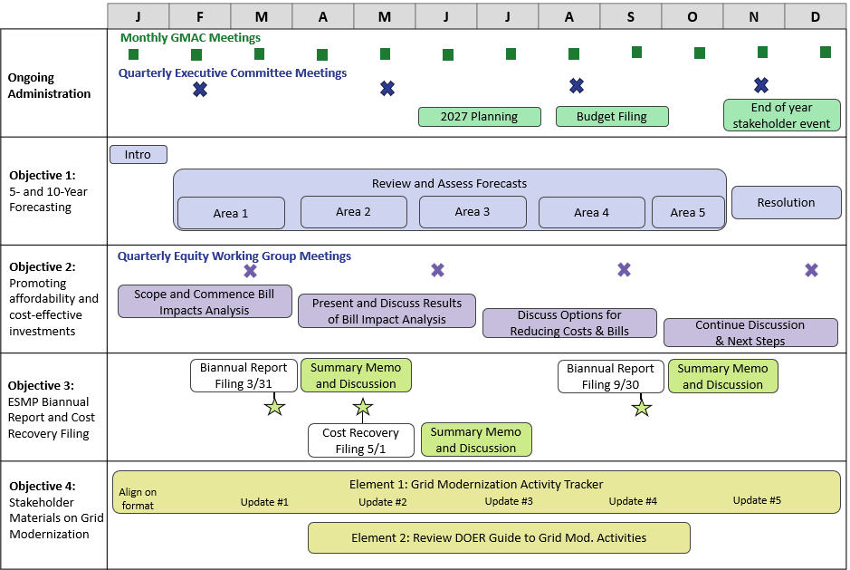

Collaborate on forecasting: Understanding process and challenges to meeting electric demand

Objective | The GMAC will learn about EDC forecasting practices, methods, and assumptions, including key inputs such as step loads (including data centers), electrification impacts, and DER impacts. The GMAC will discuss the top-down ESMP forecasts and how they relate to bottom-up demand drivers. The GMAC will prepare and vote on a resolution that summarizes the GMAC’s investigation, identifies GMAC observations, and describes GMAC priorities and initial recommendations for forecasts in the next draft ESMP review.
Goals | - Broaden GMAC member awareness of concurrent activities in Massachusetts that impact forecasts  - Identify and discuss barriers to serving electric demand and recommend potential solutions.  - Deepen GMAC understanding of EDC top-down forecasts, other bottom-up demand drivers, and identify interactions and alignment between the two.  - Leverage GMAC member time and expertise by identifying challenges and potential recommendations.  - Inform later regulatory process
Connection to GMAC Role | - Aligns with DPU recommendation that the EDCs present to develop the GMAC’s knowledge of the EDC forecast methodologies.  - Supports GMAC understanding of the EDC forecasts, review of the 2029 draft ESMPs, and review of utility reprioritization of investments in biannual reports.  - Provides input for EDCs to consider in developing the draft 2029 ESMPs.  - Develops public-facing materials for improving understanding of forecasts.
Workplan | Introduction and Overview (January)  - Overview of forecasts with information on the difference between forecasts and demand assessments, use cases for each, the role of forecasting in informing investment decisions, top-down forecasts versus bottom-up demand drivers, and an overview of key challenges to serving load.  - Finalize forecasting areas to be discussed throughout the year and discuss invitations to external speakers who may provide additional context on the areas under discussion.
Workplan | Forecast Area Deep Dives (February-October):  - Current plan is to spend two months on four of the forecast areas, and one month on one forecast area (see timeline below).  - Meeting 1: Presentations from the EDCs on current forecasting practices and challenges followed by GMAC questions, observations, and facilitated discussion.  - Meeting 2: Presentations from GMAC members and external experts, including industry leaders inside and outside of Massachusetts, on ongoing activity relevant to the forecast areas. GMAC discussion and observations or recommendations relating back to EDC forecasts.  - Information on each forecasting area will be compiled and summarized in a brief memo after each topic.  - Proposed Forecast Areas  - Area 1: Baseloads & large loads (step/spot/data center loads)  - Area 2: Transportation electrification (electric vehicles)  - Area 3: Buildings (heat pumps energy efficiency, codes)  - Area 4: DERs (solar and storage)  - Area 5: Demand response and other load reducers
Workplan | GMAC Resolution on Forecasting (November-December)  - Summary of EDC forecasting practices and methods and other bottom-up demand drivers by forecast area.  - Documentation of challenges and barriers by forecast area.  - Resolution with GMAC observations and recommendations.  - GMAC presentation on this work at the end-of-year stakeholder event
Timeline
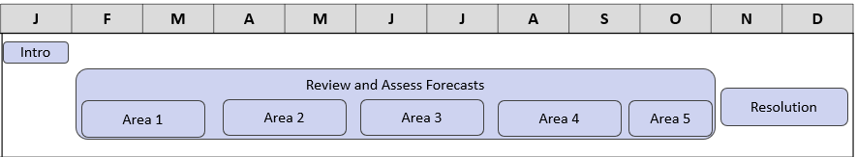
Duties | GMAC Members  - Attend GMAC meetings having reviewed meeting materials in advance  - Engage in productive and collaborative discussion with members and speakers  - Lead and facilitate discussions during meetings as needed  - Deliver presentations if forecast area is related to member representation  - Discuss, review, and vote on a resolution that memorializes GMAC observations and recommendations to the EDCs on forecasts
Duties | Consultants  - Support DOER with agenda development and materials coordination with speakers  - Identify discussion questions for meetings and prepare GMAC member facilitators  - Take minutes at GMAC meetings per Open Meeting Law requirements  - Draft summary of EDC forecast elements after each forecast area is discussed to include in final GMAC resolution  - Document and synthesize GMAC forecasting observations and recommendations discussed during meetings  - Prepare initial draft of GMAC resolution based on synthesized observations and recommendations
Duties | EDCs  - Present on forecast scope, inputs, uses, and challenges.  - Respond to GMAC member questions and collaborate during discussions
Duties | DOER  - Develop agendas for each forecasting topic  - Chair GMAC meetings and facilitate GMAC discussion
Duties | External Presenters  - Provide presentations on relevant activities that might impact Massachusetts sector-specific forecasting (ex. EVICC, Mass Economics, EEAC)  - Provide presentations offering observations on forecast areas and responding to EDC forecasts, if relevant.  - Provide case studies of implementation challenges and/or technological innovations.
Final Products | GMAC resolution containing summary of EDC forecasting elements and processes and observations and recommendations on EDC short-term forecasts
Next Steps for 2027 | Collaborate with EDCs on demand assessments, sensitivity analyses, and further learn how the short-term forecast and demand assessments inform investment decisions. Iterating on improvements, supporting/doing studies that inform better forecasts across Massachusetts.

Promoting affordable grid investments: Understanding least-cost and cost-effective grid modernization
Objective | The EWG and GMAC will (1) request that the EDCs prepare and present forecasts of bill impacts resulting from direct ESMP and ESMP-related core investments; and (2) discuss and collaborate with the EDCs on cost-effective investments and alternative approaches to financing investments.
Goals | - Document and make transparent the projected bill impacts of each EDC’s planned direct ESMP and ESMP-related core investments  - Improve EWG and GMAC members’ knowledge of investment alternatives and initiate discussions on how to minimize costs and ratepayer impacts  - Document EWG and GMAC discussions on promoting least-cost distribution planning and mitigating impacts on ratepayers  - Collaborate with EDCs on cost-effective alternative investment options for next ESMP
Connection to GMAC Role | - Encourages least-cost investments in the distribution system, alternatives to investments, or alternative approaches to financing investments  - Supports minimizing or mitigating impacts on ratepayers  - Increases transparency of the grid planning process
Workplan | Quarter 1: Scoping & Analysis  - Gain awareness and understanding of ongoing energy affordability work in Massachusetts, including the work of the Interagency Rates Task Force, DOER’s Load Management Report, Office of Energy Transformation, DPU 24-15 affordability investigation, and other state initiatives.  - Determine the scope and design of the 2026 bill impacts analysis, including which investments should be included.  - Define workstreams and roles associated with (1) affordability and (2) cost-effective investments  - Discuss the GMAC’s role in encouraging cost-effective investments in the distribution system.  - Collaborate with EDCs on how to conduct the 2026 bill impact analysis, and associated inputs and method.
Workplan | Quarter 2: Bill Impacts Presentation and Discussion  - Based on Q1 discussion, EDCs present bill impact analysis to EWG  - Analysis updated as necessary based on the first ESMP cost recovery filing on May 1st  - EWG discusses the bill impact results and whether further analysis is warranted  - Consultant produces summary factsheet on bill impacts analysis  - Revisit scoping discussion and determine Q3 goals
Workplan | Quarter 3: Discuss Cost-Effective Investments/Alternatives and Priorities  - Engage in level-setting discussion on the factors considered when evaluating investments beyond the cost of investments  - Discuss least-cost vs. cost-effective investments  - Discuss options for reducing costs and bills, including but not limited to NWAs, DERs, alternative financing, benefit-cost analysis methods and assumptions  - Discuss state-led incentives to encourage cost-effect investments, such as innovative technologies and incentive program structures.  - Discuss EDC processes to determine and evaluate least cost and alternative investments
Workplan | Quarter 4: Next Steps  - Present completed and proposed future work at the end-of-year event to publicize GMAC’s efforts to identify cost-effective alternatives to traditional capital investments and mitigate impacts on ratepayers.  - Continue discussing options for reducing costs and bills, including NWAs, DERs, alternative financing, etc.  - Discuss potential next steps
Timeline
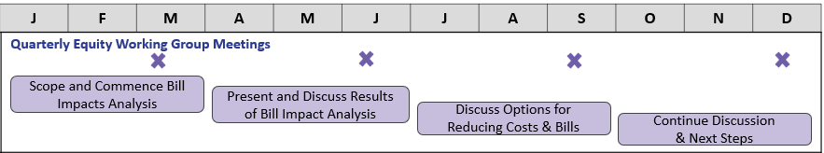
Duties | EWG Members  - Manage and oversee the work performed on this objective  - Prepare for and attend quarterly EWG meetings  - Discuss bill impacts analysis and cost-effective investment priorities  - Provide regular updates to the GMAC on objective progress
Duties | GMAC Members  - Oversee and provide feedback on EWG activities and progress through updates at GMAC meetings  - Manage and oversee work performed in Quarter 3 and 4.
Duties | Consultant  - Work with DOER, the EWG, and the EDCs to determine the data necessary to perform bill impacts analysis  - Create summary factsheet on bill impacts for stakeholders  - Support discussions on options for reducing costs and mitigating impacts on ratepayers.  - Support planning and administration of the stakeholder event
Duties | EDCs  - Conduct rate and bill impact analysis in collaboration with consultants and EWG members  - Provide presentations on current efforts and processes to reduce costs and mitigate impacts on ratepayers
Duties | DOER  - Lead drafting of bill impacts and objective scoping  - Present straw proposal for objective scope for EWG and EDC review  - Oversee and manage consultant activities  - Support EWG in developing meeting agendas and materials
Duties | External Presenters  - Interagency Rates Working Group (IRWG) presentation regarding the findings of their recent studies, as they pertain to understanding electric rate cost drivers generally  - Others, as identified
Final Products | - Slide deck presentation summarizing the bill impact results.  - Summary factsheet on bill impacts results
Next Steps for 2027 | - Continue to collaborate with EDCs on the practices for identifying and selecting least-cost investments

ESMP biannual report and cost recovery filings: Understanding Challenges of ESMP Implementation
Objective | The GMAC will monitor and discuss challenges to ESMP implementation through review of the EDC biannual reports and cost recovery filings and develop summary documents to educate GMAC members and other stakeholders engaged in ESMP activities. The GMAC will discuss if any additional information would help its review and understanding of ESMP implementation progress and challenges.
Goals | - Keep GMAC members up-to date on ESMP implementation  - Increase transparency of ESMP implementation and planning  - Improve transparency of future biannual reports  - Understand challenges of ESMP implementation
Connection to GMAC Role | - Supports GMAC review of next draft ESMPs.  - Provides input for EDCs to consider in developing the draft 2029 ESMPs.  - Increases transparency of the grid planning process
Workplan | Memo and Discussion of March 31, 2026 biannual report  - EDCs present on biannual report and implementation challenges.  - GMAC and EWG discuss biannual report in meetings identifying if there are ways to improve transparency of reports and implementation successes and challenges. GMAC discusses observations it may want to document.  - Consultant drafts a summary memo of the biannual report and includes synthesis of GMAC and EWG meeting discussion.
Workplan | Memo and Discussion of May 1, 2026 annual cost recovery filing  - EDCs present on cost recovery filing and associated challenges.  - Consultant summary memo on annual cost recovery filing, reporting on investment implementation progress, alignment with biannual reports.  - GMAC discusses cost recovery filing and any observations.
Workplan | Memo and Discussion of September 30, 2026 biannual report  - EDCs present on biannual report and implementation challenges.  - GMAC and EWG discuss biannual report in meetings identifying if there are ways to improve transparency of reports and implementation successes and challenges. GMAC discusses observations it may want to document.  - Consultant drafts a summary memo of the biannual report and includes synthesis of GMAC and EWG meeting discussion.
Workplan | Public Presentation of ESMP Implementation Progress  - At end-of-year GMAC stakeholder event, EDC and GMAC members co-lead presentation and discussion of ESMP implementation progress and challenges over the past year. Provide opportunity for public feedback and questions.
Timeline
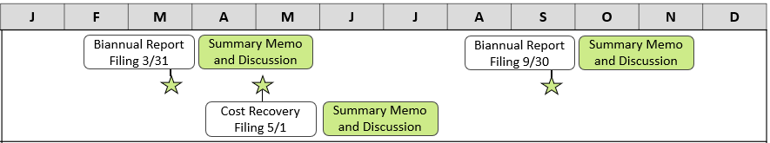
Duties | GMAC Members  - Review biannual reports and cost recovery filings in advance of relevant GMAC meetings  - Discuss observations on the reports and filings during meetings, collaborate on implementation challenges  - Equity Working Group (EWG) members discuss observations on equity and stakeholder engagement reporting/implementation  - Provide feedback on consultant drafts of cumulative GMAC member observations and meeting discussion  - Co-present on the GMAC process and discussions of ESMP progress over 2026 at end-of-year event, as needed
Duties | Consultant  - Draft memos on biannual report and cost recovery filings following EDC presentation of reports and cost recovery filing, including information not covered by EDC presentation, if applicable.  - Document and synthesize GMAC and EWG member observations on reports and filings to include in each summary memo  - Support planning and administration of end-of-year public event
Duties | EDCs  - Provide presentations on biannual reports and cost recovery filing  - Highlight “real world” ESMP implementation challenges  - Discuss information provided in biannual reports and cost recovery filing  - Present on elements of ESMP implementation progress at end-of-year event
Duties | DOER  - Chair GMAC meetings and facilitate discussion  - Oversee development of consultant summary memos with GMAC observations  - Develop agenda for end-of-year public event for GMAC feedback
Final Products | - March 2026 Biannual Report Summary Memo + GMAC Observations  - May 2026 ESMP Cost Recovery Filing Summary Memo + GMAC Observations  - September 2026 Biannual Report Summary Memo + GMAC Observations  - Public presentation on ESMP implementation progress
Next Steps for 2027 | - Evaluate and adjust GMAC review process as needed  - Continue biannual report and cost recovery filing review

Tracking Grid Modernization in Massachusetts
Objective | Develop and maintain GMAC knowledge of and alignment around concurrent activities related to grid modernization, including but not limited to related DPU dockets and other relevant working groups, Councils, and ongoing processes.
Goals | - Develop and maintain GMAC knowledge of ongoing activities related to grid modernization that may be otherwise disparate and siloed.  - Improve transparency of grid modernization activities in Massachusetts
Connection to GMAC Role | - Supports GMAC knowledge of activities related to ESMPs and grid modernization.  - Develops materials for improving stakeholder understanding of ESMP-related issues. Supports GMAC review of next draft ESMPs.
Workplan | Element 1: Grid modernization tracker  - Develop tracker of concurrent grid modernization activities to post on the GMAC website.  - Every other month, the GMAC reviews the tracker and GMAC members provide updates on grid modernization activities.
Workplan | Element 2: Review of DOER-developed stakeholder guide to grid modernization activities  - DOER will develop a general stakeholder guide to grid modernization activities. This may include an overview of grid mod elements, a summary of relevant activities, how stakeholders can engage, and a list of activities.  - DOER to request GMAC input and feedback on content.
Timeline 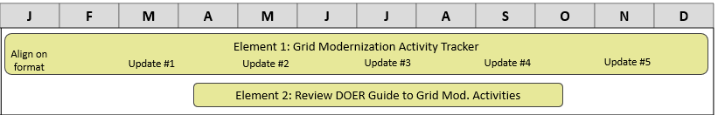
Duties | GMAC Members  - Provide updates on ongoing activities related to grid planning at meetings.  - Provide feedback on stakeholder guide as needed.  - Share materials with and bring back feedback from GMAC member representation networks as appropriate.
Duties | Consultant  - Develop and manage tracker of concurrent grid modernization activities  - Provide feedback on stakeholder guide as needed.  - Support facilitation and collection of GMAC member representation network feedback as needed.
Duties | EDCs  - Provide updates on ongoing activities related to grid planning at meetings  - Provide feedback on stakeholder guide as needed.
Duties | DOER  - Send updates on relevant activities to GMAC and GMAC list-serve  - Lead vision and content development for stakeholder guide activities
Final Products | - Regularly updated tracker of grid modernization activities.  - High-level stakeholder guide on grid modernization activities.

Potential Ideas for the 2027 GMAC Workplan
The following objectives were inspired by GMAC feedback and may be further explored in 2027. As part of ongoing administration, the GMAC will largely discuss strategic planning for 2027 in the end of Q2 – beginning of Q3.

Collaborate on EDC Demand Assessments
- Continuation of load forecast workstream
- Includes GMAC collaboration on demand assessments and sensitivity analyses.
- EDC presentations on demand assessment scope, process, inputs, and uses
- Presentations and discussions on EDC sensitivity analyses for 2050 long-term demand assessment
- GMAC discussion leading to Council resolution & observations memo on Company process and general recommendations for next draft ESMP

Assess EDC Climate Vulnerability Assessments and Climate Vulnerability & Resilience Plans
- Review EDC CVAs and how EDCs are using them to implement resiliency investments.
- Review statutory CVRP requirements and collaborate with EDCs on any progress or planning for them underway.
- Coordinate with resiliency stakeholders and develop GMAC resolution with recommendations on CVRPs for the EDCs to incorporate into their next draft ESMPs.

Assess EDC planning processes and applications of cost-effective and least-cost investments
- Continuation of affordability and cost-effectiveness workstream
- Include a review of non-wires alternatives, bridge-to-wires solutions, load management and load flexibility practices and programs, updates on the implementation and use of the Grid Services Compensation Fund.
- Evaluate how these elements impact grid capacity and system costs today.

Analyze locational impacts of distribution system infrastructure and approved ESMP investments to understand distributional equity impacts.
- Provide GMAC, EWG, and interested stakeholders with information on the distribution of benefits of ESMP investments. Potential activities:
    - Public Mapping Tool: A map showing locations of distribution system investments including the Grid Services Compensation Fund projects, distribution system infrastructure, resilience investments, substations, and DER deployment.
    - Distributional Equity Report: Analyze locational impacts of EDC planning and investments to assess how well EJCs are being served. Could include focus on EDC resilience performance in EJCs (e.g., SAIDI, SAIFI).
    - Community Benefit Agreements (CBAs) Analysis: After siting and permitting reform regulations are available in early 2026, discuss and translate the results into implications for CBAs resulting from the ESMPs.

G.L. c. 164, §§ 92C.
Electric Sector Modernization Plans, D.P.U. 24-10, D.P.U. 24-11, D.P.U. 24-12 (Aug. 29, 2024) (ESMP Phase I Order) at 81.
“The Department has determined it will review the ESMPs as strategic plans, including whether each plan complies with the requirements of Section 92B”, ESMP Phase I Order at 242.; Electric Sector Modernization Plans; “The Department reiterates that in the long term, cost recovery for grid modernization and resiliency will be accomplished through base distribution rates as part of the utilities’ standard business practices” [D.P.U. 24-10, D.P.U. 24-11, D.P.U. 24-12 (Jun. 13, 2025) (ESMP Phase II Order) at 1.]
G.L. c. 164, §§ 92B(iv).
“An Act relative to energy affordability, independence and innovation”, Bill H.4144, Section 30 at 74.
The GMAC will reevaluate these definitions and its role in grid modernization on an annual basis.
G.L. c. 164, §§ 92C and ESMP Phase I Order at 81.
ESMP Phase I Order at 150.
Id. at 82.
Id.at 139.
ESMP Phase II Order at 152.
See a similar project conducted by DPU: Angela Yang, Grid Modernization & Environmental Justice Technical Summary (2024), https://storymaps.arcgis.com/stories/849bf45ec7dd4012875bc0f4e323c52e

