Charles River Task Force
on Equitable River Access

  - Report of Recommendations

TABLE OF CONTENTS
- Executive Summary
- Introduction
- Charles River Taskforce Activities
- Summary of Key Findings
- Reflections from the Task Force
- Final CRTF Recommendations
- Closing Remarks from the Task Force’s Co-Chairs
APPENDICES
- Section 205
- Membership of the Charles River Task Force
- All engagement materials
  - Agenda for focus groups and public hearings
    - Fall 2025 Focus Group Agenda
    - Fall 2025 Public Hearing Agenda
    - Spring 2026 Focus Group Agenda
    - Spring 2026 Public Hearing Agenda
  - Flyers
    - Fall 2025 Public Hearing Flyer
    - Spring 2026 Focus Group Flyer
    - Spring 2026 Public Hearing Flyer
  - Survey Questionnaires
    - Fall 2025 Survey Questionnaire
    - Spring 2026 Survey Questionnaire
- Engagement outcomes
  - Survey responses for Fall 2025 Public Hearing
  - Survey responses for spring 2026 Public Hearings
  - Key themes from fall and spring engagement activities
- DCR’s Current Processes for Engagement and Outreach
- Fall 2025 Site Tour Notes

Executive Summary

Acknowledgement from the Task Force Co-Chairs
The Charles River Task Force on Equitable River Access (CRTF) was established to strengthen how the Department of Conservation and Recreation (DCR) engages with communities who live near, use, and are affected by decisions involving the Charles River area between the Longfellow Bridge and Eliot Bridge in Cambridge. Through this work, the Task Force sought to identify barriers to meaningful participation in DCR decision-making and develop recommendations that would improve communication, outreach, and public engagement, particularly for historically underrepresented and marginalized communities.
Over the course of this effort, Task Force members, residents, community organizations, agency representatives, and local partners contributed significant time, expertise, and lived experience to inform the findings and recommendations contained in this report. We are grateful to all who participated in meetings, focus groups, surveys, public hearings, interviews, and outreach activities. Their contributions helped shape a set of recommendations intended to improve engagement in the Charles River corridor and to inform broader improvements to DCR’s public engagement practices across the Commonwealth.

About the Charles River Task Force
The Massachusetts Legislature established the Charles River Task Force on Equitable River Access under Section 205 of the FY2025 Enacted Budget. The Task Force was charged with studying and making recommendations to DCR regarding equitable access to the Charles River in the area between the Longfellow Bridge and Eliot Bridge on the Cambridge side of the river.
The legislation directed the Task Force’s recommendations to include, but not be limited to, how DCR can better incorporate environmental justice principles into decision-making, improve notification and communication with neighborhoods and stakeholders, and ensure meaningful public participation when decisions are being considered.
The Task Force was co-led by the Executive Office of Energy and Environmental Affairs (EEA) Office of Environmental Justice and Equity (OEJE) and DCR, with facilitation and technical support provided by the Metropolitan Area Planning Council (MAPC). Membership included representatives from state agencies, community organizations, advocacy groups, and residents.

Engagement and Outreach Activities
To inform its recommendations, the Task Force conducted an extensive public engagement process between August 2025 and June 2026. Engagement activities included:
- Eleven Task Force meetings;
- Four focus groups;
- Four public hearings;
- One-on-one conversations with community organizations;
- Door-knocking and neighborhood outreach efforts; and
- Two public surveys.
Collectively, these efforts engaged hundreds of community members and stakeholders and created opportunities to hear from residents with a broad range of experiences, perspectives, and levels of prior engagement with DCR.
A central objective of the engagement process was to hear directly from residents and communities who have historically been underrepresented in DCR’s public decision-making processes and outreach. The Task Force sought to understand communication and outreach concerns related to access, infrastructure, and roadway closures, and also how DCR can build stronger relationships with communities through more effective collaboration, coordination, and opportunities for participation.

Key Findings
Across engagement activities, several themes emerged consistently, including:

Need for More Consistent Communication
Residents expressed uncertainty about how to contact DCR, where to find information about projects and closures, and how concerns or questions are addressed. Community members consistently requested clearer points of contact, more proactive communication, and regular project updates.

Need for Earlier and More Meaningful Engagement
Many participants reported that they often learn about projects at the implementation phase rather than during the development phase, or decisions after they have already been made. Residents expressed a desire for earlier notifications and outreach, more opportunities to provide input in planning processes and to be engaged throughout a project by receiving ongoing updates throughout project implementation.

Importance of Equitable and Accessible Outreach
Participants emphasized that information should be available through multiple communication channels and in formats that are accessible to diverse communities. Suggestions included multilingual outreach, printed materials, community-based outreach, mailings and physical notices, and partnerships with trusted organizations and institutions.

Need for Stronger Coordination
Community members frequently identified confusion regarding the roles and responsibilities of DCR, the City of Cambridge, and other public agencies. Participants expressed a desire for stronger coordination among agencies and the City, and more consistent messaging to the public.

Infrastructure and Access Concerns
Community members also identified a range of infrastructure-related concerns, including pedestrian and bicycle safety along pathways and at crossings, accessibility, maintenance needs including vegetation and pathway maintenance, roadway closures including lack of clear advance detour information, and overall neighborhood impacts. While these issues were beyond the primary scope of the Task Force’s charge, they informed discussions regarding communication, outreach, and public involvement practices.

Recommendations
Based on the findings of the engagement process, the Task Force developed four recommendations for DCR.

Recommendation 1: Project Planning Improvement
DCR should develop a consistent approach for communicating information about projects and initiatives. This includes providing clear project information, regular updates, using multiple communication channels, and providing opportunities for public input throughout project development and implementation.

Recommendation 2: Process and Communication Improvement
DCR should establish clear processes and responsive communication tools that help community members understand how to engage with the agency, obtain information, provide feedback, and receive timely responses. This recommendation focuses on improving effectiveness, accountability, and accessibility in day-to-day communications. When collaborating on initiatives with other agencies, DCR should utilize its enhanced approach and methods and share them with the partner agencies.

Recommendation 3: Centering Equity and Environmental Justice
DCR should establish processes that ensure historically marginalized and underrepresented communities have meaningful opportunities to participate in agency decision-making. This includes integrating environmental justice principles, language access considerations, and public involvement best practices into project planning and implementation.

Recommendation 4: Pilot Implementation Along the Charles River
DCR should apply the communication and engagement strategies identified in this report to projects, programs, and activities within the Charles River corridor between the Longfellow and Eliot Bridges. Lessons learned through this pilot effort can help inform broader improvements to public engagement practices across the Commonwealth.

Looking Ahead
The Task Force recognizes the implementation of some of these recommendations may be implementable in the near term with existing staff and resources. However, other recommendations will require increased resources for DCR, including staff and funding, before they can be implemented. The recommendations in this report provide DCR with a practical roadmap for action, identifying both the improvements that can be made with existing resources and the additional investments that will be required to achieve meaningful and sustained engagement as envisioned by the Task Force. In doing so, they offer the public a clear understanding of what progress is achievable in the near term and what will require capacity building and funding to achieve in the long term.

INTRODUCTION

Historical context of the issues related to access and the use of the area along the Charles River
The Department of Conservation and Recreation (“DCR”) oversees nearly half a million acres of land, making up one of the largest and most diverse state park systems in the country. The agency’s work focuses on nurturing the vital connection between people and the environment by protecting, promoting, and enhancing our commonwealth of natural, cultural, and recreational resources for the well-being of all.
DCR infrastructure connects people to and through the landscapes and accessible recreational facilities under its care. DCR staff strive to build healthier, more resilient Massachusetts where all residents and visitors can relax, reflect and feel a sense of belonging in the state’s open spaces and public lands. DCR has historically struggled to effectively engage marginalized communities across the state, missing opportunities to inform residents about projects and programming, and to incorporate community input at earlier stages of decision-making. These challenges have been acutely present in DCR’s engagement with communities who live and access the area along the Charles River in Cambridge.

About the Charles River Task Force (CRTF)

Legislative statute: Section 205 of the FY2025 Enacted Budget
The Massachusetts Legislature established the Charles River Task Force (“CRTF” or “Task Force”) on Equitable River Access under Section 205 of the FY2025 Enacted Budget (“Section 205”). Section 205 was enacted to study and make recommendations to DCR to address equitable access to the Charles River in the area between the Longfellow Bridge and the Eliot Bridge on the Cambridge side of the river. The CRTF was charged to make recommendations that include: (i) ensuring that DCR considers environmental justice principles when making decisions involving the area of the Charles river between the Longfellow Bridge and the Eliot Bridge; (ii) ensuring that all stakeholders are engaged when substantive decisions are made regarding closing or limiting access to Memorial Drive; (iii) ensuring that the residents of the abutting neighborhood receive proper notification when DCR makes changes to access to Memorial Drive; and (iv) improving programming along the Charles River that may be enjoyed by a wide variety of stakeholders.
Details of Section 205 are included as Appendix A.

Membership of the Task Force
Section 205 dictated that CRTF membership include the EEA Undersecretary of Environmental Justice, the DCR Commissioner, representatives from specific community organizations, and not less than 6 individuals whose primary residence is within 1/2 mile of the Charles River and who are members of an environmental justice population or live in subsidized housing and where at least 2 of the individuals reside in the Riverside neighborhood.
Task force co-chairs and members are listed in Appendix B.
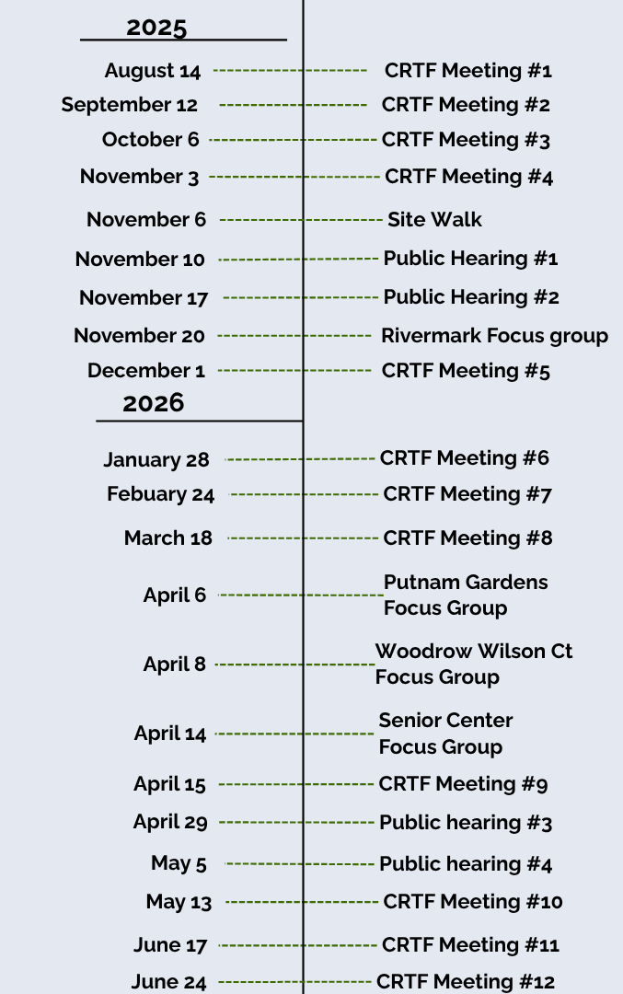
Figure 1. Timeline of Task Force Meetings

Project Team and Timeline
The CRTF project team was co-led by the Massachusetts Executive Office of Energy and Environmental Affairs (EEA) and DCR and was supported by the Metropolitan Area Planning Council (MAPC) as the consultant for the project. EEA and DCR staff members served as resources for the Task Force, helping to inform and implement the Task Force’s work (Figure 1) and communicate its progress to the public. MAPC provided meeting facilitation, gathered public comments, and supported the Task Force with generating the final report of Task Force findings and recommendations.

CHARLES RIVER TASK FORCE ACTIVITIES

Task Force Meetings

Area of focus and discussion at CRTF meetings
Eleven Task Force meetings occurred between August 2025 and June 2026. Task Force meetings were conducted as a space for EEA, DCR, Task Force members, and MAPC to discuss, collaborate, and make decisions on all project work, including stakeholder identification, engagement and outreach processes, materials and strategy, report recommendations, and more (Figure 2). Task Force meeting materials including agendas and meeting minutes are publicly available on the Charles River Task Force’s webpage (https://www.mass.gov/info-details/charles-river-task-force-on-equitable-river-access#task-force-meetings).
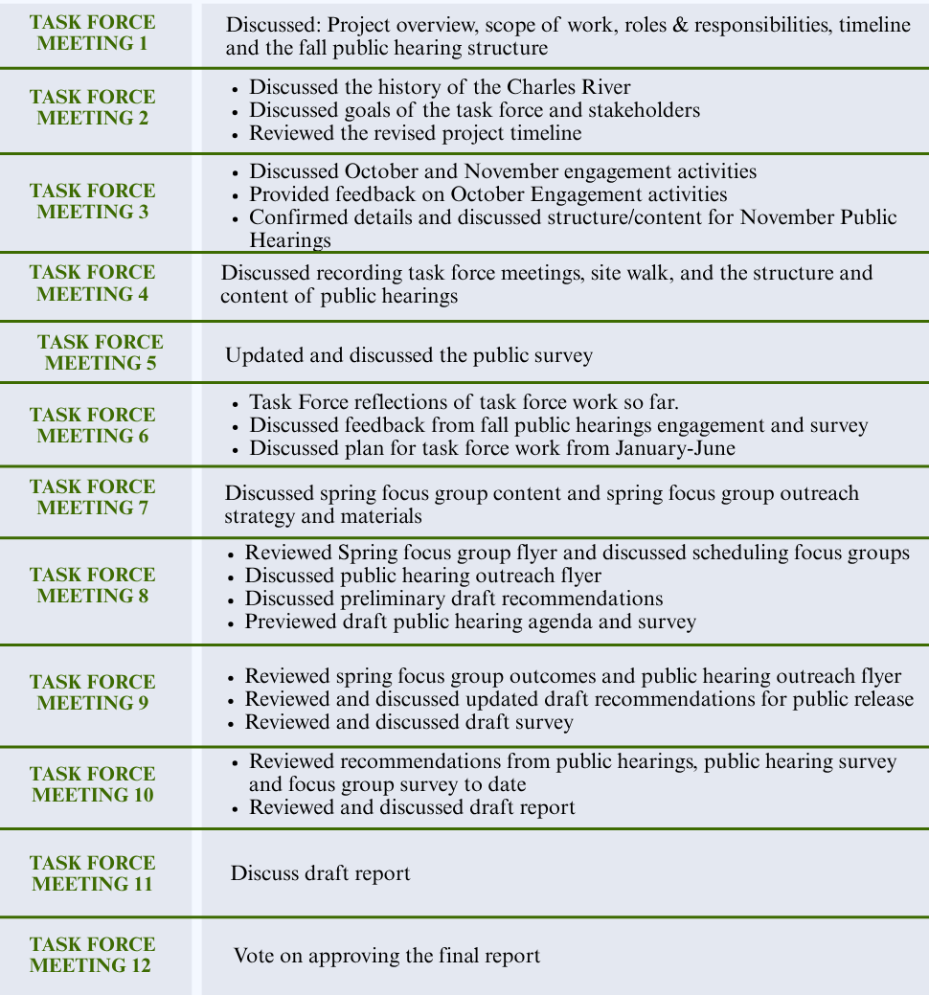
Figure 2. Summary of Task Force meetings.

Engagement and outreach activities
The CRTF engagement process included focus groups, one-on-one conversations, door-knocking, public hearings, and public surveys. Engagement activities were developed to help inform the recommendations to EEA and DCR on improving the process for reaching and connecting with a broader range of community stakeholders. Enhancing community engagement will have a positive impact on DCR activities, planning, and decisions that have the potential to impact access to and use of the area along the Charles River in Cambridge, between the Longfellow and Eliot Bridges, or have the potential to impact adjacent neighborhoods and communities. Key themes from these engagement activities from the fall and spring can be found in Appendix D.

Focus groups
Four focus groups were held at locations suggested and agreed upon by the Task Force. The purpose of the focus groups was to hear directly from community members. Themes from the focus groups included challenges in connecting with and understanding DCR, what means of outreach and engagement best meet their needs and preferences, and generally what changes they would like to see DCR make in communication and outreach efforts related to the park amenities, access, and management of the shared parkland. A focus group was held in the Fall at Rivermark (808-812 Memorial Drive), followed by additional sessions in the spring at Cambridge Housing Authority buildings (Putnam Gardens and Woodrow Wilson Court) and the Cambridge Senior Center.

One-on-One Conversations
One-on-one conversations were held in the early Fall with staff of four local organizations who support communities utilizing the area along the Charles River to gain a deeper understanding of the community context. Participating organizations in the one-on-one conversations were recommended by the Task Force and included:
- Cambridge Community Center: Zach Goldhammer, Director of Engagement and Partnership
- Cambridgeport Neighborhood Association: Rebecca Bowie, Coordinator
- City of Cambridge: Jackson Price, Community Engagement Director; Jeremy Warnick, Communications Director.
- Homeowners Rehab Inc.: Joe Deignan, Director of Community Engagement

Door-knocking
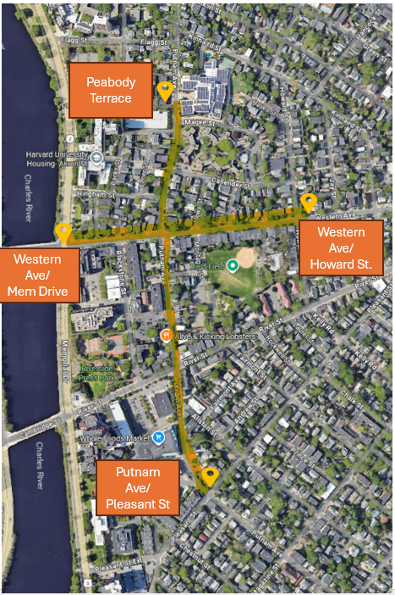
Two door knocking efforts occurred in the Fall to inform and promote the first two public hearings in November 2025, as well as to have conversations with community members about their use of the area along the Charles River. Door knocking (Figure 3) focused on the Cambridgeport and Riverside neighborhoods. Conversations were held with a total of 35 people, and 129 flyers were distributed.
Figure 3. Map of door-knocking activities.
Door knocking occurred at:
- Putnam Avenue: From Putnam Avenue and Peabody Terrace down to Putnam Avenue and Pleasant Street
- Western Avenue: From Western Avenue and Memorial Drive down to Western Avenue and Howard Street
- River Street: From River Street & Memorial Drive down to River and Pleasant Street

Public Hearings
Four public hearings were held to inform the Task Force's work. Two hearings were held in November 2025 to gather community input on the impacts of DCR decisions—one virtual hearing on November 10th (55 attendees) and one in-person hearing at the Cambridge Community Center on November 17th (77 attendees). Two public hearings were held in spring 2026—one in-person hearing at Morse Elementary School on April 29th (21 attendees) and one virtual hearing on May 5th (24 attendees). The spring public hearings had the goal of overviewing the Task Force’s draft recommendations and gathered feedback on the recommendations and proposed action items associated with each. For feedback related to requests for physical changes to the park, paths, and roadways, DCR recorded these separately and will incorporate that feedback into future capital and maintenance budget planning.

Public Surveys
Two online public surveys were conducted; one in the Fall and one in the Spring. The Fall public survey was administered from October 14th through December 31st, 2025. This survey received a total of 475 responses. Figure 4 below shows the breakdown of survey respondents.

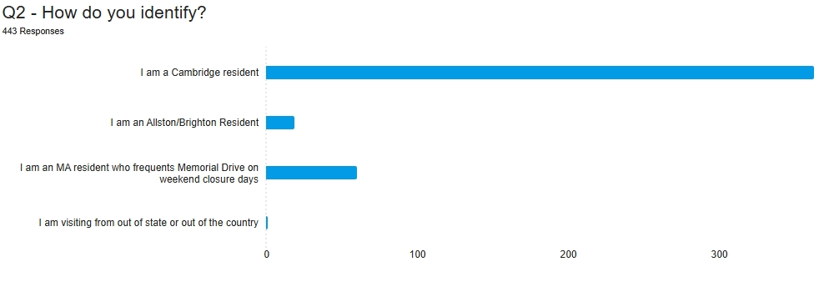
Figure 4. Breakdown of survey respondents in the Fall

The spring public survey, which focused on obtaining feedback on the draft set of recommendations for the final report, was open from April 29th through May 29th and had a total of 232 responses. Figure 5 shows the breakdown of survey respondents. See Appendix C for the submitted survey responses.
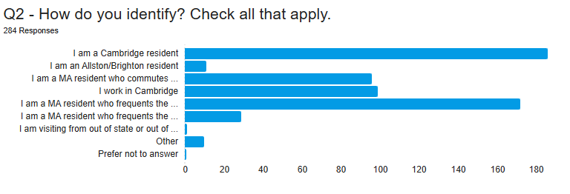
Figure 5. Breakdown of survey respondents in the Spring

SUMMARY OF KEY FINDINGS

Key themes emerged from engagement materials in the Fall and in the Spring
The Fall engagement, which focused on general feedback, ideas, and concerns revealed:
- The need for more infrastructure improvements to the park and roadway, including safer crosswalks, improved pedestrian and bicycle accessibility and infrastructure, increased maintenance.
- Roadway closure continues affect communities differently, with some community members recognizing their benefits and others expressing concerns about their impacts; particularly where certain communities experience a disproportionate share of the burdens associated with roadway closures.
- The need for more, consistent, and ongoing communications and outreach from DCR for projects, maintenance, programming and road closures.
The following Figures 6-7 summarize key themes captured across different engagement platforms
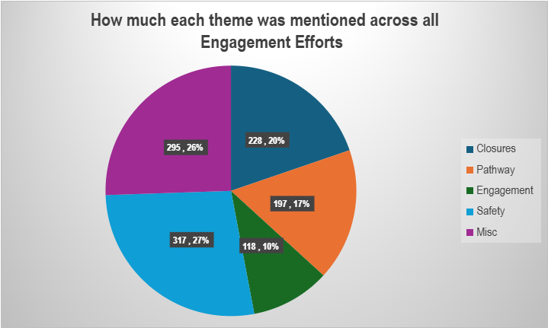
Figure 6. Themes captured across different engagement efforts in Fall 2025

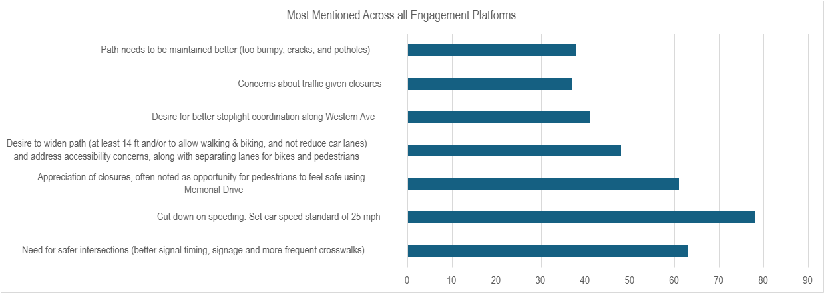
Figure 7: Top comment themes captured across engagement platforms in Fall 2025

The spring engagement, which focused on feedback and input on the draft proposed recommendations by the Task Force revealed:
- The need for more, consistent, and ongoing communications and outreach from DCR with local communities, especially those who reside in DCR project areas.
- The need to explore and diversify the methods and mechanisms to communicate and share information with community members.
- The majority of public input and feedback received (both in focus groups and survey responses) indicated agreement with the proposed Task Force recommendations, however, further explanations and language clarity (e.g., definitions, specific metrics, goals, timelines, etc.) are required.
The following Figures 8-11 summarize general sentiments on the draft recommendations (received via public survey responses):

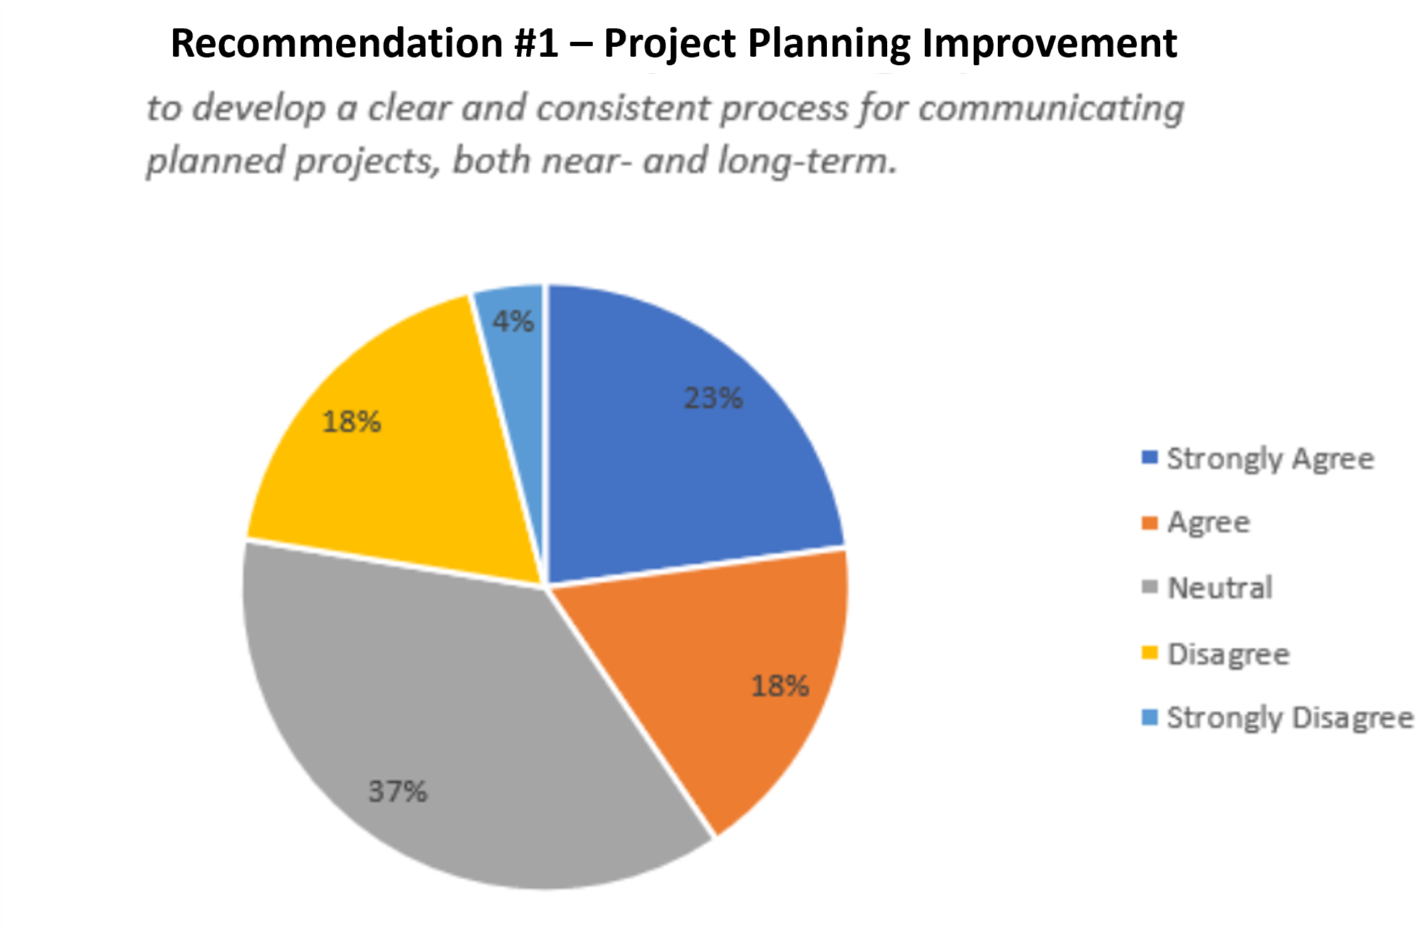
Figure 8. Survey responses for Recommendation 1

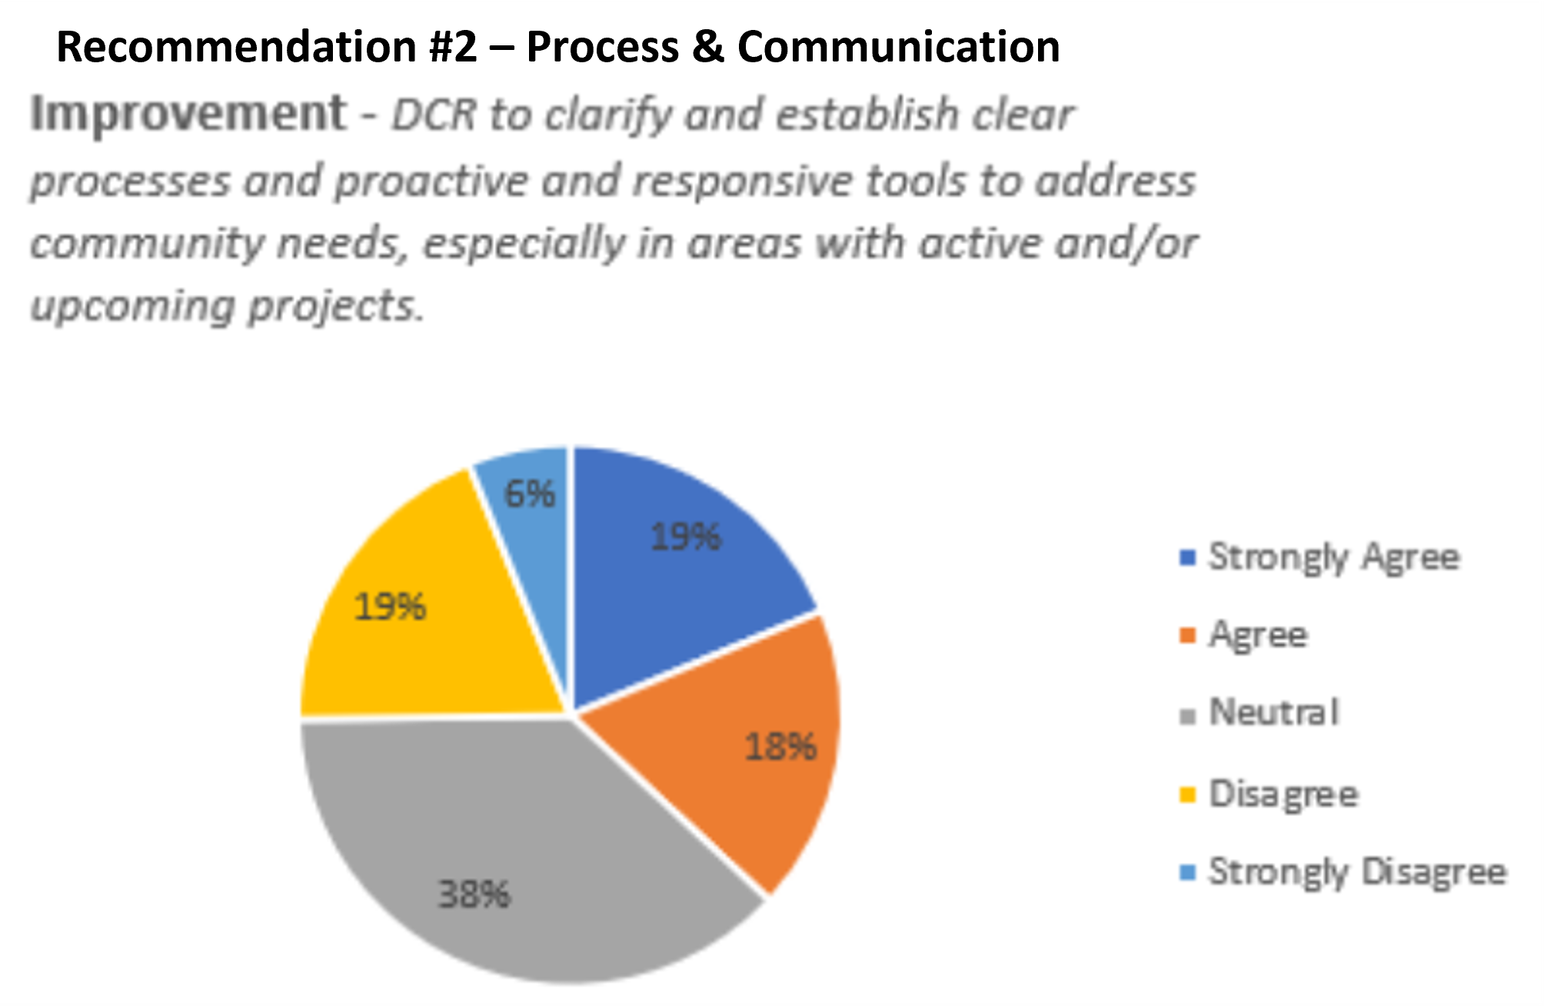
Figure 9. Survey responses for Recommendation 2
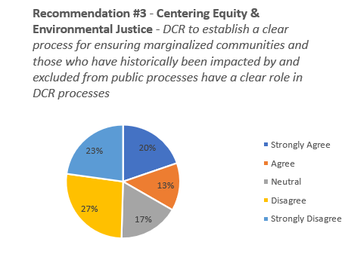
Figure 10. Survey responses for Recommendation 3
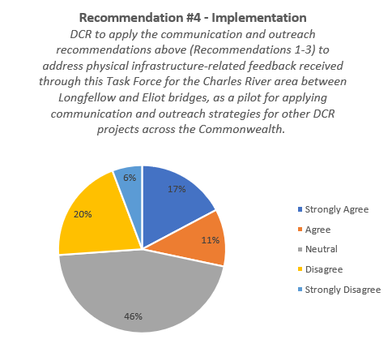
Figure 11. Survey responses for Recommendation 4

Acknowledging the two phases of engagement
The CRTF was originally enacted to complete its work between July 2024 and June 2025 as a 6-month project. The project was not able to launch until July 2025 due to staff capacity constraints experienced by DCR and a lack of funding to support the work of the Task Force. Once launched, it was evident that more than 6 months was needed for relationship building between the project team and Task Force members; in addition to executing the robust engagement objectives of the Task Force to gain the perspectives from residents in the area. As a result, the project was extended to be completed by June 30th, 2026.
To help resolve communication and relationship building challenges from early meetings of the Task Force, Task Force Meeting #6, held on January 28, 2026, was designed as a longer in-person workshop to determine the best ways to move forward with Task Force work and engagement throughout the Spring, as well as to determine the elements that were needed to complete the final report. During this period, the Commissioner of DCR and the Energy and Environmental Affairs Undersecretary for Environmental Justice became more actively engaged in the CRTF meetings and activities, reflecting the Task Force’s interest in leadership participation and involvement.

Additional financial resources and staff capacity needed to support DCR to implement Task Force’s recommendations
DCR recognizes through the feedback received during this process the need to strengthen engagement efforts with communities and to improve communication and outreach methods. Several improvements have been implemented in recent years, such as the establishment of a Community Relations team to respond to inquiries and concerns from residents and the creation of a Legislative and Partnerships team to coordinate with municipalities, elected officials and local community groups interested in DCR-managed properties and resources. DCR also has a Director of Public Engagement and has recently hired a Senior Director of Environmental Justice. Capacity limitations still impact DCR’s ability to meet engagement goals in the way DCR or the Task Force envisions for this particular area and more broadly across the state. The implementation strategies and timeline components of the recommendations outlined below reflect what would be needed to advance them.

REFLECTIONS FROM CRTF
Throughout its work, the Task Force identified several lessons that may help inform future community engagement efforts, advisory bodies, and public participation processes undertaken by DCR and other agencies.

Project Design and Shared Understanding
The Task Force found that establishing a shared understanding of a project's purpose, scope, legislative intent, and expected outcomes at the outset is critical to success. Early uncertainty regarding the Task Force's charge and objectives contributed to differing expectations among participants and affected project momentum. Future efforts would benefit from:
- A comprehensive project kickoff that clearly communicates goals, roles, responsibilities, decision-making authority, and expected outcomes;
- A shared project plan outlining key milestones, deliverables, decision points, and opportunities for participant input;
- Early orientation to the legislative and historical context that led to the formation of the effort; and
- Site visits and place-based learning opportunities to build a common understanding of community conditions and local perspectives.

Community Engagement and Representation
A central challenge throughout the process was balancing the wide range of perspectives brought forward by Task Force members and community participants while remaining focused on the legislative charge and the needs of communities who have historically been underrepresented in public decision-making. The Task Force found that:
- Building relationships with communities who have not historically engaged with DCR requires significant time and intentional outreach;
- Existing distrust stemming from prior projects and decisions can influence participation and community perceptions;
- DCR often relies on organizations and stakeholders with established relationships to the agency, creating barriers to reaching new voices; and
- Additional effort is needed to ensure engagement processes meaningfully include historically underrepresented communities while also providing opportunities for broad public participation.

Capacity, Resources, and Long-Term Commitment
The Task Force recognized that meaningful engagement requires substantial investments of time, staffing, funding, and organizational capacity. Resource limitations affected the scope of outreach activities, including door knocking, distribution of flyers, and relationship-building efforts. The Task Force also found that:
- Sustaining engagement and consensus-building among a large group representing diverse experiences and interests can be challenging, particularly over an extended project timeline;
- Project teams benefit from training, support, and flexibility to facilitate collaborative engagement processes and navigate complex stakeholder dynamics; and
- Strong community engagement cannot be achieved through a single initiative alone and instead requires sustained institutional commitment and investment over time.

Key Observations
In addition to the recommendations contained in this report, the Task Force documented community concerns related to infrastructure, accessibility, maintenance, and safety along the Charles River corridor. While these issues were beyond the primary scope of the Task Force's charge, they underscore the importance of continued communication, engagement, and partnership between DCR and the communities it serves.

FINAL CRTF RECOMMENDATIONS
DCR recognizes through the feedback received while working with the Task Force there is a real need to strengthen engagement efforts with communities who surround the parklands that are under DCR's stewardship. In addition, DCR and other state and municipal agencies need to work in earnest to improve communication, planning and outreach methods.
Each of the following four (4) recommendations presented outline steps to improve DCR’s communication and outreach processes. For each of these recommendations, the Task Force also suggest specific implementation strategies or actions, proposed timeline based on guidance from DCR and EEA, and potential resources needed to ensure DCR have adequate resources and support to implement them. Additional financial resources and staff capacity are required to support DCR for implementation of some of these recommendations.

Recommendation 1 – Project Planning Improvement: DCR to develop a clear and consistent process for communicating planned projects, both near- and long-term.
Background context: This recommendation is built on the need for more regular and consistent approaches to communicating project work to community members in the impacted project area. A consistent theme the Task Force heard from the community is the desire for more regular updates from DCR on project progress and next steps. Currently, the available mechanisms for which community members can provide comments or share concerns with DCR in any particular issue is limited. This recommendation is intended for DCR to ensure more consistent processes for project communication to community members.
Timeline definitions: Near-term = 3 months-2 years; Mid-term = 3-5 years; Long-term = >5 years.
Other definitions: CRM = Customer Relationship Management
Suggested Implementation Strategies or Actions | Implementation Timeline | Resources Needed to Support Implementation | Already in Place or in Progress
- Implement stakeholder management technology and processes to communicate more effectively with potentially impacted communities about projects and programming (planning, different phases, and updates). Communication recipients could include community leaders/groups, local churches, cultural centers, senior centers, senior housing, public and affordable housing, in addition to local municipalities and partner state agencies. | Near-term | Staff: Existing staff  IT: CRM tool in the process of being implemented  Other Resources: None | DCR’s Public Affairs team currently uses a case management tool, which is helpful in organizing notes but is lacking in many other aspects for the kind of community and partnerships outreach, coordination, and communication work that DCR would like to do.
- Establish external-facing project landing pages for each project that communicates project goals, alternatives considered, anticipated impacts, opportunities for community input, and project updates – for example, in a format with similar functionality as the City of Cambridge's Construction Projects webpage. | Near-term or Mid-term (funding dependent) | Staff: Additional support for Communications team to manage IT infrastructure and additional support for Public Affairs to provide more frequent project updates.  IT: Project Management system in development (internal); Existing external facing IT  Other Resources: None | DCR currently maintains project webpages for many large and multi-phase projects and uses these webpages to post project information and updates. DCR is considering improvements that could be made within the mass.gov webpage system.
- Establish a consistent communication approach using multiple communication modes, tailoring outreach strategies to communities potentially most impacted by project developments. For example, include posting flyers near the physical location of the updates in advance of the project and using traditional media outlets such as newspapers, radio or local TV channels, as well as social media outlets, targeting multilingual channels as well. | Mid-term (funding dependent) | Staff: Additional support for Public Affairs team to implement enhanced outreach and engagement activities.  IT: CRM tool in the process of being implemented  Other Resources: Language access services, funding for postage and media buys, etc. | DCR currently promotes public meetings through legislative, municipal, and known stakeholder briefings, and encourages them to spread awareness of public meetings through their respective networks. DCR also updates its Public Meetings webpage and sends outreach emails about these meetings.
- Ensure equitable access to information. Examples include:  - Using plain-language materials and summaries  - Using accessible formats and consistent design  - Translating materials | Near-term | Staff: Existing staff  IT: None  Other Resources: Language access services | DCR currently translates all public meeting notices into the top five most spoken languages in Massachusetts. DCR is also making significant progress regarding digital accessibility for online-based materials.

Recommendation 2 – Process and Communication Improvement: DCR to clarify and establish clear processes, and proactive and responsive tools to address community needs, especially in areas with active and/or upcoming projects.
Background context: Community members are often confused about how and/or who they can contact at DCR when they have feedback and/or concerns. In some instances, community members don’t receive consistent communication updates, prompt responses, or follow-up from DCR. The intent of this recommendation is for DCR to build in more communication and coordination process mechanisms.
Timeline definitions: Near-term = 3 months-2 years; Mid-term = 3-5 years; Long-term = >5 years.
Other definitions: CRM = Customer Relationship Management
Suggested Implementation Strategies or Actions | Implementation Timeline | Resources Needed to Support Implementation | Already in Place or in Progress
- Provide a point of contact for community members to reach out to for questions regarding projects, programs, or closures impacting the park and roadway. | Long-term (funding dependent), with further strategic planning needed to determine placement among DCR divisions | Staff: Additional support for Public Affairs to establish dedicated community liaisons for areas with significant DCR assets  IT: CRM tool in process of being implemented  Other Resources: None | For larger DCR projects, a point of contact is often listed on the project webpage.
- Launch an info campaign to communicate about DCR’s Community Relations team and other public input processes for how community members can reach DCR, what types of inquiries go where, and what response timelines they can expect. | Near-term | Staff: Existing staff  IT: Existing IT  Other Resources: Communication materials, language access services. | Currently, the public can reach out to DCR at (617) 626-1250 or mass.parks@mass.gov. The public can also access DCR’s Public Meeting page and Public Comments portal to view opportunities to submit input.
- Strengthen project-related communication feedback loops so residents receive follow-up on how their concerns were considered or resolved. | Mid-term | Staff: Additional support for Public Affairs to ensure feedback loops are consistent, responsive, and can occur in a timely manner.  IT: CRM tool in the process of being implemented  Other Resources: Language access services | Calls made to the DCR are often resolved in the moment or prompt follow up is conducted to the resident. Comments made during public meetings are attempted to be addressed in the moment or shortly afterwards.
- Provide advance notice and clear explanations for closures, disruptions, and project timelines. | Near-term | Staff: Existing staff  IT: CRM tool in the process of being implemented  Other Resources: language access services | DCR currently sends out alerts via email to anyone subscribed to DCR Updates, and these are also posted on DCR’s Park Alerts webpage.
- Improve and increase coordination with key departments and communications teams within municipalities and state agencies to coordinate and amplify outreach efforts to impacted communities. | Long-term (funding dependent) | Staff: Additional support for Public Affairs to enhance coordination with municipal and state agencies.  IT: None  Other Resources: Municipality and state agency cooperation and capacity to interact and coordinate with DCR | DCR currently has a team of 5 coordinators responsible for liaising state-wide with the hundreds of legislators, municipalities, sister agencies, and partners.

Recommendation 3 – Centering Equity & Environmental Justice: DCR to establish a clear process for ensuring marginalized communities and those who have historically been impacted and excluded have a clear role in DCR processes.
Background context: Community members expressed that, in many instances, decision making at DCR does not reflect or include the voice of the immediately impacted community. Community members don’t feel that they are included in the planning and decision-making milestones, and as a result, are often left experiencing the repercussions (e.g., traffic congestion, safety-related issues, etc.) without enjoying the benefits. The Task Force believes that this recommendation will ensure equity is centered in all DCR’s planning and decision-making processes.

Timeline definitions: Near-term = 3 months-2 years; Mid-term = 3-5 years; Long-term = >5 years.
Other definitions: CRM = Customer Relationship Management

Suggested Implementation Strategies or Actions | Implementation Timeline | Resources Needed to Support Implementation | Already in Place or in Progress
- As part of a project’s pre-planning phase, conduct a process at the start of any project to determine who will be potentially impacted by the construction or final project outcomes and determine what role they can or should play throughout this project lifetime. | Near-term (funding dependent) | Staff: Additional support for Public Affairs to assess impacted communities and establish and implement robust outreach plans  IT: CRM tool in the process of being implemented  Other Resources: Consultants to develop project impact studies at ideation phase | During pre-planning/design phases for most projects, DCR holds legislative, municipal, and known-stakeholder briefings in advance of broad public meetings.
- As part of a project’s pre-planning phase, coordinate with project partners or local authorities (i.e., other state agencies and/or City of Cambridge) to conduct outreach to the identified potentially impacted communities | Long-term (funding dependent) | Staff: Additional support for Public Affairs team to implement robust outreach plans including tabling, flyering, mailings, etc.  IT: None  Other Resources: Language access services | DCR currently has a team of 5 coordinators responsible for liaising state-wide with the hundreds of legislators, municipalities, sister agencies, and partners.
- Ensure that DCR’s Language Access Plan is integrated in these processes. | Near-term (funding dependent) | Staff: Existing staff  IT: None  Other Resources: Language access services. | DCR already has mechanisms in place to provide some language access services.
- Establish and implement a DCR Public Involvement Plan, which will be based on the framework for EEA’s Public Involvement Plan. | Mid-term (funding dependent) | Staff: Existing staff  IT: None  Other Resources: consultants to assist DCR in developing a robust plan | DCR has an internal working draft in progress.
5. After a project is complete, conduct a review of outreach and communication efforts that occurred throughout the project with municipalities, community stakeholders, partners, and organizations. | Near-term or Mid-term (funding dependent) | Staff: Additional support for PublicAffairs to conduct post-effort analysis, follow-up, and reporting.  IT: None  Other Resources: None | DCR currently creates Outreach and Engagement Plans for projects, relying on existing relationships with stakeholders.

Recommendation 4 - Implementation: DCR to apply the communication and outreach recommendations above (Recommendations 1-3) to address physical infrastructure-related feedback received through this Task Force for the Charles River area between Longfellow and Eliot bridges, as a pilot for applying communication and outreach strategies for other DCR projects across the Commonwealth.
Background context: DCR should implement strategies/actions listed in the above recommendations to the Charles River area between Longfellow and Eliot bridges. Best practices and lessons learned in this pilot implementation effort can be replicated to other areas across the state that are facing similar challenges.
Timeline definitions: Near-term = 3 months-2 years; Mid-term = 3-5 years; Long-term = >5 years.
Suggested Implementation Strategies or Actions | Implementation Timeline | Resources Needed to Support Implementation | Already in Place or in Progress
- Create a communication and engagement plan for different scenarios brought up during Task Force meetings, focus groups or public meetings related to infrastructure improvements in the area and how they could be addressed via the recommendations above for potentially impacted communities. These scenarios should include a:  - Large event that may require road closure (e.g., Head of the Charles, concerts, etc.)  - Small project that may require temporary closure of parks or roadway, or public space for maintenance (e.g., road races, festivals)  - Large new project that has multiple phases of engagement (e.g., Magazine Beach) | Mid-term (funding dependent) | Staff: Additional support for Public Affairs to implement robust outreach plans including establishing and maintaining relationships with new stakeholders, trusted community resources, and identified impacted communities, and providing enhanced outreach including tabling, flyering, mailings, etc.  IT: None  Other Resources:  For examples that involve capital investments, project funding would be required. | Through the Task Force’s work, DCR has collected a lot of feedback on communication and public engagement needs for specific events and infrastructure related projects in the Cambridge area to inform the development of best practice scenarios.
- Develop a clear evaluation framework to track what communication strategies are effective, where gaps remain and how community members experience the new process. | Mid-term (funding dependent) | Staff: Existing resources  IT: None  Other Resources: Consultants to assist DCR in developing a robust evaluation framework | No current evaluation framework exists.

CLOSING REMARKS FROM THE CO-CHAIRS
The work of the Charles River Task Force reaffirmed the importance of meaningful, transparent, and sustained community engagement in public decision-making. Throughout the engagement process, community members consistently emphasized the need for clearer communication, earlier opportunities for input, stronger coordination among state and municipal agencies, and outreach practices that reach communities who have historically been underrepresented in public processes.
While the Task Force undertook a significant engagement effort through public hearings, focus groups, public surveys, one-on-one conversations, door knocking, and direct conversations with community partners, we recognize that this work was only a starting point. Building trust, strengthening relationships, and creating more inclusive engagement practices cannot be accomplished through a single task force or one year of outreach. Meaningful engagement requires sustained investment, dedicated staff capacity, adequate funding, and a long-term commitment to listening, learning, and adapting.
The recommendations in this report provide a roadmap for how DCR can begin to strengthen its communication, outreach, and public engagement practices. Some improvements can be advanced with existing resources, while others will require additional investment and organizational capacity. Together, these recommendations establish a realistic path forward, one that acknowledges both the opportunities that exist today and the longer-term commitments necessary to build lasting trust and more equitable public participation across the Commonwealth.

