Meeting the Massachusetts Stream Crossing Standards to the Maximum Extent Practicable
Massachusetts Department of Environmental Protection
Bureau of Water Resources
Wetlands Program
February 12, 2025
Scott Jackson
Department of Environmental Conservation, University of Massachusetts Amherst
Scott Civjan
Department of Civil and Environmental Engineering, University of Massachusetts Amherst
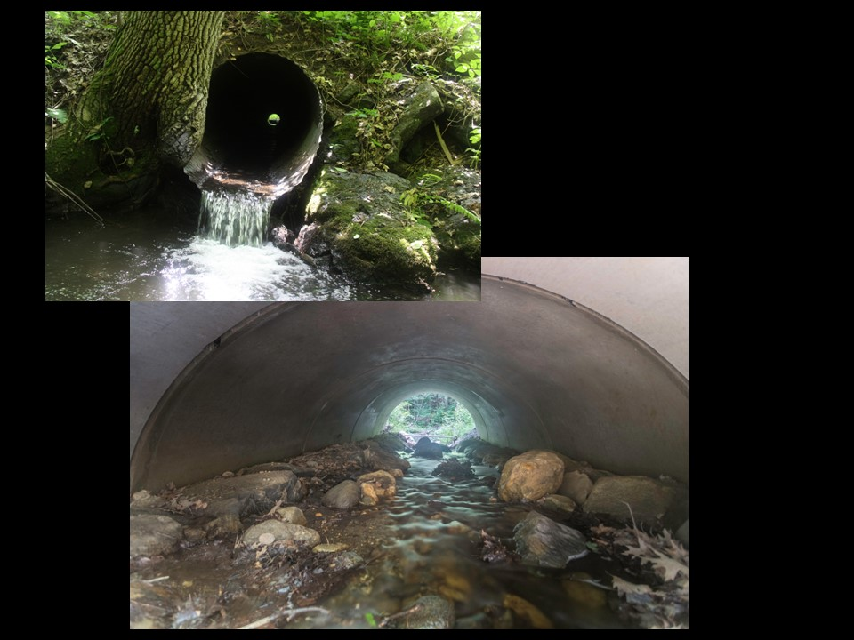

Preface to the

Meeting the Massachusetts Stream Crossing Standards to the Maximum Extent Practicable

Guidance Document

In September 2020, the Massachusetts Culverts and Small Bridges Working Group issued a report as directed by Section 102 of the 2019 General Appropriations Act for Senator Adam G. Hinds and Massachusetts Legislature titled Recommendations for Improving the Efficiency of Culvert and Small Bridge Replacement Projects. In response to recommendations of the report, MassDEP is working with the United States Geological Survey and UMass Amherst to develop an easy-to-use web-based tool, including a statewide hydraulic model, and a guidance document to streamline the regulatory process and maximize improvement in resiliency, aquatic organism passage, and habitat connectivity without exacerbating downstream flooding, property damage or other impacts. MassDEP’s goal in creating such a tool and guidance is to develop a companion regulatory presumption if certain criteria are met to make permitting of river and stream crossing projects easier.
Under the Wetlands Protection Act regulations at 310 CMR 10.53 (8), projects that propose to replace culverts and/or bridges must meet the Stream Crossing Standards (SCS) to the Maximum Extent Practicable provided they consider 12 criteria such as the potential for downstream flooding, the potential for erosion and head-cutting, engineering constraints, and cost.
This provision of the regulations is referred to as a “limited project,” which provides the Issuing Authority (conservation commission or MassDEP) discretion in applying the SCS. This will not change. However, since many stream crossing replacement projects determine their design based on “cost of replacement,” a presumption has been developed to further facilitate permitting of these projects. With certain exceptions, the design alternative is presumed to meet the SCS to the Maximum Extent Practicable when the projected cost of the project complies with the Guidance document herein and the cost exceedance above the baseline alternative goes towards improving aquatic organism passage.

Massachusetts Department of Environmental Protection
February 2025

Table of Contents
1.0 Summary 1
2.0 Introduction 3
2.1 The Massachusetts River and Stream Crossing Standards (General Standards) 4
2.2 Other benefits of meeting the crossing standards 6
2.3 Fully meeting the crossing standards is not always practicable 6
3.0 Physical Constraints 7
3.1 Utilities 7
3.2 Adjacent structures and right-of-way constraints 7
3.3 Grade and height to roadway 7
3.4 Stability of Underlying Soil 8
3.5 Downstream flooding 9
3.6 Head cutting and stream stability 9
3.7 Upstream wetlands and important habitat 10
3.8 Archaeological or Historical Significance 10
3.9 Effects of physical constraints 10
4.0 Cost 11
4.1 Ecological benefits 11
4.2 Establishing a baseline for assessing the additional cost of meeting the crossing standards 12
4.3 Balancing costs and ecological benefits 14
4.4 Chapter 85 review requirements 15
5.0 Scenarios 15
5.1 Cost comparisons using four scenarios 15
5.2 Important considerations relating to culvert replacement costs 18
5.2.1 Replace in kind (not often practicable due to Hydraulic and Hydrologic considerations) 18
5.2.2 Low volume vs. high volume road 18
5.2.3 Staged construction 19
5.2.4 Western MA vs. Eastern MA 19
5.2.5 Chapter 85 Review 19
6.0 Maximizing ecological benefits when full compliance with Crossing Standards is not practicable 19
6.1 Erosion and scour 20
6.2 Upsizing substrate material 23
6.3 Protecting upstream wetlands 23
6.4 Reducing velocity and ensuring adequate water depths 24
6.5 Best practices for instream mitigation 28
6.5.1 Low flow channel maintaining appropriate water depths and velocities 28
6.5.2 Stabilizing the streambed and grade control structures 29
6.5.3 Log versus rock weirs and cross vanes 29
6.5.4 Ensuring a proper foundation 29
6.5.5 Additional resources for design and construction of grade control structures 30
7.0 Reviewing proposals for crossing replacement that do not comply with the Crossing Standards 30
7.1 Demonstrating maximum extent practicable 30
7.2 Emergency replacements 32
8.0 Conclusion 33
Appendix A: Details of the four hypothetical scenarios for purposes of cost comparison 34
Appendix B: Checklist for Demonstrating Maximum Extent Practicable (MEP) for Stream Crossing Replacement Projects Limited by Cost 36

Summary
In 2006, The River and Stream Continuity Partnership consisting of UMass Amherst, the Massachusetts Division of Ecological Restoration, American Rivers, and The Nature Conservancy developed the Massachusetts River and Stream Crossing Standards (Crossing Standards) to provide guidance on bridge and culvert designs that would facilitate the movement of fish and wildlife beneath roads and railroads. Recognizing that the Crossing Standards were relevant to several of the “Interests” protected by the Massachusetts Wetlands Protection Act (WPA), in 2014 the Massachusetts Department of Environmental Protection (MassDEP) incorporated the standards into the WPA regulations (Regulations). The Crossing Standards are now required for all new, permanent crossings of rivers and streams. It was recognized that, in some cases, it might be impossible or infeasible to fully meet those standards when replacing an existing crossing. As a result, MassDEP included language in the Regulations stating that replacement crossings must meet the Crossing Standards “to the maximum extent practicable”. Bridge replacement projects that are exempt from review under the WPA must still meet Massachusetts Water Quality Standards administered by MassDEP; these standards also require replacement crossings to meet Stream Crossing Standards to the maximum extent practicable.
This document provides guidance for conservation commissions, conservation agents, MassDEP staff, potential applicants, and environmental consultants, on to how to apply the concept of maximum extent practicable during the design and permitting of replacement stream crossings. It provides information on evaluating site conditions and considering cost as a factor in determining if meeting the Crossing Standards is practicable and provides conceptual design options for maximizing aquatic organism passage in circumstances where it is not practicable to fully meet the Crossing Standards. Wetlands Protection Act regulations that require replacement crossings to meet the Crossing Standards to the maximum extent practicable help protect the fisheries and wildlife habitat “Interests” of the WPA. In addition, this guidance identifies Minimum Hydraulic Design Criteria (see Section 4.2) for road-stream crossings to enhance the resiliency of transportation infrastructure and ensure that culverts and bridges are designed and constructed in ways that further the flood and storm damage prevention “Interests” of the WPA. Those Minimum Hydraulic Design Criteria are used to define baseline requirements against which the costs of full compliance with Crossing Standards are compared to determine whether meeting those standards is practicable. Meeting the flood and storm damage interests – and thus increased storm resiliency – will increase the likelihood that the crossing will withstand future storms and avoid having to employ limited resources for repeat reconstruction projects and mitigation of consequential flooding that could be avoided.
Sometimes it is just not practicable to replace a crossing with one that fully meets the Crossing Standards. Often this is not simply a matter of what is possible, but how much it will cost. Section 3.0 discusses various physical, legal and regulatory constraints, such as property ownership, associated utilities, adjacent buildings, other roads and driveways, upstream wetlands, potential for downstream flooding, and potential for stream instability and head cutting. Section 4.0 discusses financial considerations, and how the concept of maximum extent practicable accounts for the need to balance costs with ecological benefits.
Recognizing that the cost of meeting the Crossing Standards is a major obstacle for implementing culvert replacement projects, one of the most important considerations for evaluating maximum extent practicable is the balance between cost and ecological benefits. We begin with the assumption that if significant ecological benefits are likely to be achieved by meeting the Crossing Standards, then a substantial increase in replacement costs, beyond what is needed to meet the baseline requirements can be justified. The question then becomes how much increased cost is justified before that cost is no longer considered “practicable?” In this guidance, we propose that cost thresholds above baseline for exceeding maximum extent practicable should be based on 1) habitat quality and 2) the increase in aquatic connectivity likely to be achieved by meeting the Crossing Standards (connectivity restoration potential). How crossings and stream segments are classified by habitat quality and connectivity restoration potential is discussed in Section 4.1. Cost thresholds can be found in Section 4.3, Table 2.
Section 5.0 discusses culvert replacement scenarios to illustrate some generic design options and their relative costs, with details provided in Appendix A. Section 6.0 discusses design elements that can be used to maximize aquatic organism passage during crossing replacement when full compliance with the Crossing Standards is not practicable. These include:
- Reducing velocity and ensuring adequate water depths
- Construction of low-flow channels
- Stabilizing the streambed and grade control structures
- Use of log and rock weirs and cross vanes
- Preventing erosion and scour
- Upsizing substrate material
- Protecting upstream wetlands
Section 7.0 provides guidance on Notice of Intent submittals and the review of proposed crossing replacements. When reviewing proposed crossing replacement projects that seek to use the Maximum Extent Practical standard to avoid fully meeting the Crossing Standards it is important to keep in mind that proposing to replace a crossing with an ‘in-kind’ structure is not sufficient to demonstrate maximum extent practicable. To demonstrate maximum extent practicable, a written alternatives analysis must accompany the Notice of Intent. At a minimum, cost and descriptive information about each of the following three alternatives should be included in the Alternative Analysis.
- A baseline alternative, which must be a design that can pass the appropriate MassDOT design flood for the road class on which the crossing is located (see Section 4.0, Table 1) and provide the appropriate freeboard.
- A full compliance alternative designed to fully comply with the Crossing Standards and WPA performance standards.
- At least one Maximum Extent Practicable (MEP) Alternative with mitigation elements to maximize aquatic organism passage with crossing replacement costs at least as much as the relevant cost factor listed in Section 5.0 (Table 2).
All alternatives should be based on a thorough site assessment, including a long profile of the stream, documentation of the channel bed adjustment potential, stream bed analyses, and measurements of bankfull width in reference sections of the stream. NOI submittals should also include:
- Engineered plans and calculations stamped by a registered professional engineer (PE) of the proposed activity, along with at least conceptual level plans and calculations of the alternatives considered, and
- Documentation prepared by a PE to substantiate the cost estimates of the proposed activity and each alternative considered (see Section 4.0).
There are an estimated 25,000-30,000 road stream crossings in Massachusetts. Along with legacy dams scattered across the state, stream crossings are fragmenting our river and stream networks in ways that undermine their ecological integrity and ability to support healthy populations of fish, salamanders, turtles, crayfish and other aquatic or semi-aquatic organisms. The climate change that is threatening populations of cold-water and other aquatic species, also threatens to undermine our transportation infrastructure. Legacy culverts will need to be replaced with structures that can better accommodate the extreme storm and flood events that are projected to occur with increasing frequency due to climate change. At a minimum, all crossing replacements should be able to pass MassDOT design floods for the road classes where they occur. Where there are opportunities to restore aquatic connectivity, especially for high-quality habitat, we need to design and construct new and replacement crossings to meet the Massachusetts River and Stream Crossing Standards to the maximum extent practicable.

Introduction
In 2004, the River and Stream Continuity Partnership released its first edition of the Massachusetts River and Stream Crossing Standards (Crossing Standards). The Partnership – University of Massachusetts Amherst, the MA Division of Ecological Restoration, American Rivers, and The Nature Conservancy – developed the Crossing Standards to provide guidance on bridge and culvert designs that would facilitate the movement of fish and wildlife beneath roads and railroads. The Crossing Standards were revised in March 2011 and a minor error was corrected in 2012.
Recognizing that the Crossing Standards were relevant to several of the “Interests” protected by the Massachusetts Wetlands Protection Act (WPA), the Massachusetts Department of Environmental Protection (MassDEP) in 2014 incorporated the standards into the WPA regulations. The Crossing Standards are now required for all new, permanent crossings of rivers and streams. It was recognized that, in some cases, it might be impossible or infeasible to fully meet those standards when replacing an existing crossing. As a result, MassDEP included language in the Regulations stating that replacement crossings must meet the Crossing Standards “to the maximum extent practicable” (310 CMR 10.53(8)(a). The Regulations included a list of stream features and site conditions that should be evaluated when considering whether a crossing replacement must fully comply with the Crossing Standards or only comply to the maximum extent practicable. However, it has become clear that additional guidance is needed for both potential applicants and Issuing Authorities (conservation commissions and MassDEP), as to how to apply the concept of maximum extent practicable during project review and permitting.
This guidance document is based on conclusions from the Culvert and Small Bridge Work Group and provides information on evaluating site conditions and considering cost as a factor in determining if meeting the Crossing Standards is practicable, and provides conceptual design options for maximizing aquatic organism passage in circumstances where it is not practicable to fully meet the Crossing Standards. It is primarily intended for conservation commissions, conservation agents, MassDEP staff, potential applicants for Orders of Conditions under the WPA, and environmental consultants that advise applicants and/or conservation commissions.
Wetlands Protection Act regulations that require replacement crossings to meet the Crossing Standards to the maximum extent practicable help protect the fisheries and wildlife habitat “Interests” of the WPA. In addition, this guidance identifies Minimum Hydraulic Design Criteria (see Section 4.2) for road-stream crossings to enhance the resiliency of transportation infrastructure and ensure that culverts and bridges are designed and constructed in ways that further the flood and storm damage prevention “Interests” of the WPA. Where cost is the primary factor in considering whether meeting the Crossing Standards is practicable, it is worthwhile to consider that local intense storms have in recent years caused numerous crossing failures in towns across Massachusetts. Given that climate change is expected to produce increasing numbers of intense storms, as well as storms of higher intensity in the future, it is recommended that culvert replacement projects meet the Crossing Standards whenever possible, to avoid adverse impacts to public safety, transportation infrastructure, and the ecological integrity of river and stream ecosystems.

The Massachusetts River and Stream Crossing Standards (General Standards)
The Crossing Standards were developed “specifically for freshwater, non-tidal rivers and streams and may not be appropriate for coastal waterways.” They were intended as conceptual performance standards to facilitate fish and wildlife movement and maintain river and stream continuity. In addition to tidally influenced crossings, the standards are also not intended for ditches (unless they are modified streams), storm water management systems, and wetland crossings (where there is no defined stream channel). They are not meant to be a substitute for proper design and engineering to address hydraulic capacity (ability to pass specific storm flows), safety, and stability of structures and embankment.
The Crossing Standards are summarized below.
General Standards
- Spans (bridges, 3-sided box culverts, open-bottom culverts or arches) that preserve the natural stream channel are strongly preferred.
- Culverts should have open bottoms or be embedded below the stream bed:
  - a minimum of 2 feet for all culverts
  - a minimum of 2 feet and at least 25 percent of the diameter for round pipe culverts
  - When substrate material used to embed a culvert includes components >15 inches in diameter, embedment depths should be at least twice the D84 (particle width larger than 84% of particles) of the substrate material
- Crossings should span the channel width (a minimum of 1.2 times the bankfull width). Bankfull width is the width of the channel at bankfull elevation, the elevation at which water fills the channel just before it spills out into the floodplain.
- Substrate within embedded or open bottom structures should have characteristics (size, shape) comparable to the substrate within the natural channel. Comparable in this case means within the range of variability of characteristics found in the natural channel.
- Crossing structures should be designed with appropriate bed forms and streambed characteristics so that water depths and velocities within the crossing are comparable to those found in the natural channel at a variety of flows.
- Crossing structures should have an Openness greater than or equal to 0.82 feet (0.25 meters). Openness is the cross-sectional area of the structure opening (excluding those portions of the structure occupied by substrate or persistent water) divided by structure length (measured as a straight line from midpoint of the inlet to the midpoint of the outlet).
- Banks should be present on each side of the stream matching the horizontal cross-sectional profile of the existing stream and banks
The MA River and Stream Crossing Standards were developed by the River and Stream Continuity Partnership “…to prevent barrier effects of road-stream crossings on populations of fish and wildlife…” Thus, they are important for protecting two of the eight “Interests” of the WPA: protection of fisheries and protection of wildlife habitat. These standards are not intended for streams that are found not to be significant to these “Interests.” However, all stream crossings should meet Minimum Hydraulic Design Criteria to address flood prevention and storm damage prevention interests of the Act (see Section 4.2).
Perennial streams and rivers are important as habitat and/or movement corridors for fish and wildlife. Many intermittent streams serve as seasonal habitat for fish (especially brook trout) and stream salamanders (two-lined, dusky and spring salamanders). Therefore, it is not appropriate to dismiss intermittent streams as unimportant for fish and wildlife movement. However, these standards are not intended for channels that lack habitat for fish or wildlife and do not serve as movement corridors needed to access appropriate habitat. That said, it can be difficult to determine whether any particular intermittent stream is important for fish and wildlife passage. Unless compelling evidence indicates otherwise, intermittent streams should be assumed to have value for fish and wildlife passage.
Individuals involved in crossing design and construction, and the permitting of road-stream crossings, are strongly encouraged to read the Crossing Standards document. It contains detailed explanations for each of the crossing standards listed above, as well as a list of important considerations when applying the standards.

Other benefits of meeting the crossing standards
The Crossing Standards were specifically developed to enhance aquatic connectivity and facilitate the movement of woody debris and substrate, which maintain downstream habitats and stream stability. However, the fact that crossings constructed to meet these standards are generally larger than the ones they replace means that they provide more than just ecological benefits. Their larger openings are more efficient at passing woody debris (the branches and trunks of trees) and less likely to clog from accumulated debris. Accumulated debris at the inlet can result in water overtopping the road and is a common cause of culvert failure. Overtopping can also occur when culverts are not blocked but are undersized and unable to pass enough water to prevent it from backing up and eventually either flowing over the road surface or piping through the road fill.
Undersized crossings concentrate water during high flows, increasing water velocities and erosive power that can lead to scour. Scour, particularly at the crossing outlet, can undermine footings, aprons, adjacent banks, and other structures. Both scour and overtopping can cause washouts. Washouts and overtopping typically result in road closures and can also cause property damage both upstream and downstream of the crossing. In some rare instances, culvert failures have cost lives. Crossing structures built to Crossing Standards generally are more durable than standard culverts and have longer lifetimes. The shorter lifespan of traditional culverts, increased maintenance, the necessity of replacing failed crossings, and the property damage caused by crossing failures often negate the initial cost savings achieved by constructing undersized crossing structures. In other words, the near-term investment to meet Crossing Standards will decrease long term costs associated with storm damage.
Climate change has already caused rain events to be more severe, and severe storm events more frequent. Forecasts suggest that this will only get worse in the foreseeable future. It is difficult to determine how large structures will need to be to handle future flood events. However, replacing undersized culverts and bridges with crossings that meet the Crossing Standards will improve resiliency and better protect both infrastructure and the environment.

Fully meeting the crossing standards is not always practicable
Sometimes it is just not practicable to replace a crossing with one that fully meets the Crossing Standards. Often this is not simply a matter of what is possible, but how much it will cost. Sections 3.0 and 4.0 will discuss some of the constraints that can make it impracticable to fully meet the Crossing Standards during culvert or bridge replacement. Section 3.0 discusses various physical, legal and regulatory constraints, such as property ownership, associated utilities, adjacent buildings, other roads and driveways, upstream wetlands, potential for downstream flooding, and potential for stream instability and head cutting. Section 4.0 discusses financial considerations, and how the concept of Maximum extent practicable can take into account the need to balance costs with ecological benefits. Section 5.0 discusses culvert replacement scenarios to illustrate some generic design options and their relative costs, with details provided in Appendix A. Section 6.0 discusses design elements that can be used to maximize aquatic organism passage during crossing replacement when full compliance with the Crossing Standards is not practicable.

Physical Constraints
Site conditions can make it difficult or impossible to meet the Crossing Standards. Some of these conditions will be apparent when evaluating a replacement project and others may surface during the design or construction phases. In general, it is best to evaluate site conditions as early as possible during project scoping before progressing with design development. Constraints may result in yes/no scenarios (for example, can land rights be obtained or an adjacent structure demolished to meet Crossing Standards?). More often they result in cost increases that, even when significant, should be evaluated against the ecological benefits of meeting the standards (see Section 4.0). Below are some common examples of physical constraints that may be encountered.

Utilities
Existing and proposed general utilities, oriented through the culvert or along the existing roadway, could possibly be re-routed, but typically this requires coordination with utility companies, temporary or permanent relocations, temporary support, and/or temporary connections. However, utilities that are buried or part of a gravity system, can introduce significant constraints. Gravity systems, such as sewer or drainage structures require a specific gradient to work properly. Pump stations, siphon systems, or force mains can be included if gradients are affected, but require additional infrastructure, a larger footprint, and equipment. Buried utilities can be difficult to locate and re-route, especially if they have a concrete encasement. The extent of the constraint will vary depending on the project.

Adjacent structures and right-of-way constraints
Adjacent structures can include buildings, roadways, and miscellaneous foundations. In more urban areas, these may include a building on one side of the culvert and roadway that cannot be shifted on the other side of the stream. A site may be constrained by limited right-of way such as private property on either side of the culvert that would require eminent domain land costs and time for negotiations. Relocation of smaller structures is sometimes possible, though with related expenses, approvals, and permitting.

Grade and height to roadway
A change in elevation of the existing roadway may be required to meet the Crossing Standards. This could be due to the general increase in size required for the replacement culvert to meet hydraulic and hydrologic (H&H) design, maintain a reasonable culvert cross section to avoid blockages, or to meet the openness requirements in the Crossing Standards. In many cases, this can be accommodated in the design, but in some situations a significant roadway elevation change can impose a series of cascading effects.
Given that the stream elevation will be constant, meeting the Crossing Standards may require a change in roadway elevation above the culvert. For instance, realistic grading to change elevation for a 35-mph paved roadway is approximately 1 foot per 20 feet of roadway. Therefore, a roadway elevation change of 5 feet would require roadway re-construction for 100 feet along the roadway on each side of the existing culvert, as well as re-grading transverse to the roadway. This can be accommodated but may significantly increase the project scope and cost. The length of roadway affected by raising the road elevation depends on the speed limit, with impact areas that are much longer for higher speed limits.
Depending on the site, adjacent FEMA defined flood areas, wetlands, or rights of way may be impacted when roadway elevations are raised. This can impose requirements for impacts studies and the need to provide additional compensatory storage mitigation, all of which can increase project scope, cost, and schedule. Driveways, intersections, utilities, or traffic signals may need to be relocated or regraded to align with the new roadway elevations, which may be difficult to accommodate at certain sites and/or require site work on private land. Some structural systems may be able to accommodate openness with less impact to roadway elevation (less cover to the roadway or topping slab requirements), and the Engineer of Record should evaluate a range of possible options, including any possible trade-off in structure durability and maintenance requirements.
Culverts crossing wide roadways, such as multi-lane highways, may not be able to meet the openness requirements of the Crossing Standards. This is acknowledged in the Crossing Standards, where it is stated, “However, for some very long structures it may be impractical or impossible to meet this standard.” The Crossing Standards document also acknowledges the lack of a strong scientific basis for the openness requirement in the Standards. Therefore, although the openness standard should be met whenever possible, it is the criterion in the Crossing Standards where not meeting the standard can be most easily justified so long as the general intent of maximizing aquatic organism passage is accommodated.

Stability of Underlying Soil
Underlying soils determine the foundation requirements for a new culvert. For a given culvert, this could impact whether footings are a viable option for support, or whether a 4-sided culvert or embedded pipe bearing on the soil would be more feasible. Poor soil may require deep foundations (such as piles). Longer spanning culverts transfer higher loads to foundations and underlying soil. Soils that may have been suitable for shorter spanning culverts may require more costly and intrusive foundations when replaced by longer spans.

Downstream flooding
Undersized culverts should be replaced in ways that satisfy baseline requirements (see Section 4.0) and thereby reduce the risk of roadway overtopping or washout. For existing undersized crossings that provide detention storage (i.e., impound water) at their specified design storm, special consideration is required to ensure that the crossing replacement will not result in increased downstream flooding. Stream crossings that are significantly affected by detention storage are uncommon, and few of these crossing, when enlarged, are likely to cause an increase in water surface elevation downstream during normal flows or major flood events. Analysis and discussion of potential downstream flooding should be a part of a Notice of Intent submission when the existing crossing provides detention storage combined with one or both of the following scenarios.
- An additional undersized culvert of the same of size or smaller occurs a short distance downstream (i.e., inadequate capacity to absorb a potential increase in flow from the loss of storage associated with the culvert replacement)
- Structures or other infrastructure located between the project site and the next downstream crossing are below the road deck elevation of the downstream crossing
The responsibility to avoid flood impacts lies with the applicant and Professional Engineer. Demonstration of downstream flooding avoidance should be submitted when the Issuing Authority requires it but should not be requested as a rule of thumb for all projects. When required, acceptable demonstration of downstream flood impact avoidance includes a HEC-RAS or similar FEMA-approved model. When the applicant proposes a smaller crossing than baseline, conceptual designs or handwritten calculations should not be accepted.
As stated above, increased downstream flow does not always cause an increase in downstream water surface elevation. In most cases where there is concern about downstream flooding, the potential for flooding can be accommodated or mitigated through other means of controlling stream flow (see Section 6.0), although the project area may need to include work in the stream upstream or downstream of the immediate culvert site. In some situations, the effects of downstream flooding may require a holistic approach of replacing multiple culverts throughout a system in an order that mitigates flood conditions.

Head cutting and stream stability
An incised or unstable channel downstream from the crossing can result in the propagation of head cutting (erosion of the stream bed) upstream. An existing culvert can impede the head cutting process but may create an outlet drop and some scour at the culvert location, restrict fish passage, and increase the risk of foundation failures. However, meeting the Crossing Standards and providing natural substrate in the new culvert could remove the obstruction and allow head cutting to propagate through the culvert and upstream. In the case of a low-gradient stream with soft bed material, head cutting of half a mile or more is possible, resulting in serious degradation of stream habitat up-gradient of the crossing. This can be accommodated in a design through mitigation measures that stabilize the stream, but it requires additional design work and remediation of the stream beyond the immediate culvert site (see Section 6.0).

Upstream wetlands and important habitat
The restriction of flow at a culvert can result in an increase in water elevation upstream by the backing up of water due to the culvert. In these backwatered areas small amounts of bordering vegetated wetland (BVW) may develop. The loss of a small amount of BVW can be justified by meeting the Crossing Standards and achieving a significant improvement in aquatic connectivity, and such losses can be allowed by Issuing Authorities when conducted as a Limited Project. However, in some rare cases, the wetland upstream may be too valuable to lose, such as when it is particularly large, provides an unusual habitat type, or supports a state-listed rare or endangered species. In the case of state-listed species, consultation with the Natural Heritage and Endangered Species Program is always required.
When it is necessary to protect a valuable wetland that formed due to an undersized culvert, it may be possible to maintain the wetland and fully comply with the Crossing Standards. This can sometimes be accommodated through mitigation measures (e.g., rock vanes and weirs) that restrict stream flow and promote backwatering up-gradient of the crossing (see Section 6.0), but this approach often requires work in the stream beyond the immediate culvert site. However, it is highly preferred over maintaining an undersized culvert, as the latter will present a more significant barrier to aquatic organisms than a series of low weirs, and the crossing will be at risk of roadway overtopping and washout.

Archaeological or Historical Significance
A site, or the structure itself, may have archaeological or historical significance that results in limitations or prohibitions on the areas that can be affected or work that can be done at the site. These constraints may take precedent over the Crossing Standards and result in design and construction that focuses on alternative measures (see Section 6.0) that can mitigate restrictive culvert design considerations. Waivers from archaeological or historical constraints may be possible in some cases but may require time and effort to procure.

Effects of physical constraints
Physical site constraints such as existing buildings and utilities may make it difficult to meet Crossing Standards without substantial construction impacts, scheduling delays, and costs. The net effect of physical constraints may be that: it is necessary to adjust the crossing design to address the constraint while meeting the Crossing Standards, there is a cost increase required to meet Crossing Standards, or it is not possible to fully meet the Crossing Standards.
For most crossing replacement projects, meeting Crossing Standards will not be significantly affected by physical constraints. In some cases, however, physical constraints may make it impossible to meet the Crossing Standards or will significantly increase the project cost in order to meet the Standards. In almost all cases, these constraints can be quantified as additional costs to the project and addressed via the analysis of costs and benefits discussed later (see Section 4.0). The financial cost of meeting the Crossing Standards is fully justified in many cases. However, there are some constraints that can increase the project cost so significantly that the project would no longer be feasible. The Regulations allow for these situations through the maximum extent practicable language.

Cost
Recognizing that the cost of meeting the Crossing Standards is a major obstacle for implementing culvert replacement projects, one of the most important considerations for evaluating maximum extent practicable is the balance between cost and ecological benefits. We begin with the assumption that if significant ecological benefits are likely to be achieved by meeting the Crossing Standards, then a substantial increase in replacement costs, beyond what is needed to meet the baseline requirements can be justified. The question then becomes how much increased cost is justified before that cost is no longer considered “practicable?” In this guidance, we propose that cost thresholds above baseline for exceeding maximum extent practicable should be based on 1) habitat quality and 2) the increase in aquatic connectivity likely to be achieved by meeting the Crossing Standards (connectivity restoration potential).

Ecological benefits
For habitat quality, we classify stream segments, and the crossings on those segments, into three classes (highest quality, high quality, general quality) based on whether they fall into one or more of the following categories.
- BioMap Aquatic Core (a component layer of BioMap, the State’s prioritization of lands and waters that are most important for conserving biological diversity in Massachusetts)
- Coldwater fisheries resource (streams, rivers, or tributaries identified by the MA Division of Fisheries and Wildlife that support reproducing cold-water fish)
- Diadromous fish run (streams and rivers identified by the MA Division of Marine Fisheries to be important as spawning or migratory habitat for fish that migrate between freshwater and the ocean)
- Area of Critical Environmental Concern (ACEC; places designated by the Massachusetts Secretary of Energy and Environmental Affairs that receive special recognition because of the quality, uniqueness and significance of their natural and cultural resources)
- Wild and Scenic River (rivers in Massachusetts that have been federally designated as Wild and Scenic Rivers)
Classes are assigned to stream segments and associated crossings according to the following.
Highest Quality: two or more of the above categories apply
High Quality: one of the above categories apply
General Quality: All other stream and river segments
This classification is presumed to accurately indicate the habitat quality of stream segments. That presumption may be overcome, to either lower or raise the classification level of a given stream segment, by the presentation of credible evidence from a competent source. Evidence can include local knowledge of biota supported by that stream segment, documentation of environmental degradation sufficient to impair the stream’s ability to provide habitat for fish and wildlife (assuming that the degradation was not caused by an existing crossing), high CAPS Index of Ecological Integrity (IEI) scores, or results of habitat suitability models suggesting that the stream segment supports cold-water fish.
To assess connectivity restoration potential, we use the most current Critical Linkages and Coldwater Critical Linkages analyses from the Landscape Ecology Lab at the University of Massachusetts Amherst.
Highest Restoration Potential: Top 5% of statewide Critical Linkages or top 10% of Coldwater Critical Linkages Effect scores for crossings on streams with a projected mean summer temperature ≤ 16 ⁰C (61 ⁰F)
Very High Restoration Potential: 5-10% of statewide Critical Linkages or top 10-20% of Coldwater Critical Linkages Effect scores for crossings on streams with a projected mean summer temperature ≤ 16 ⁰C (61 ⁰F)
High Restoration Potential: 10--20% of statewide Critical Linkages or top 20-30% of Coldwater Critical Linkages Effect scores for crossings on streams with a projected mean summer temperature ≤ 16 ⁰C (61 ⁰F)
Medium Restoration Potential: 20-25% of statewide Critical Linkages or top 30-40% of Coldwater Critical Linkages Effect scores for crossings on streams with a projected mean summer temperature ≤ 16 ⁰C (61 ⁰F)
Other: All other crossings (below top 25% for Critical Linkages; below top 40% for Coldwater Critical Linkages)
Critical Linkages scores are derived from models and field assessments of how passable road-stream crossings are for aquatic organisms. Field assessments have not been done for all crossings in Massachusetts and Critical Linkages scores are not available for all crossings. These classifications are presumed accurate, but the presumption may be overcome, and the classification adjusted to either raise or lower the classification level of a given crossing, by the presentation of credible evidence from a competent source. For example, a road-stream crossing that is classified as having Very High Restoration Potential, but which occurs just above or below an impassable waterfall, may warrant being reclassified as Other. The presence of mapped dams and other stream crossings are already factored into Critical Linkages scores. The potential that a dam may be removed, or another stream crossing upgraded, might warrant increasing the restoration potential classification. Discovery of an unmapped dam or other crossing in the vicinity might warrant decreasing the classification.

Establishing a baseline for assessing the additional cost of meeting the crossing standards
Maximum extent practicable based on cost should be determined by comparing the cost to fully meet the Crossing Standards against the baseline cost. Baseline cost should not be determined by replacement-in-kind but by the cost of a crossing design that accommodates the Massachusetts Department of Transportation (MassDOT) Hydraulic Design Flood for that road classification (Table 1) and meets other conditions listed below. Although MassDOT intended their Hydraulic Design Flood criteria to apply to crossings with spans greater than 10 feet, this guidance extends those criteria to crossing structures with lesser spans.
Table 1. MassDOT Design Floods for Various Road and Highway Functional Classifications. Adapted from the MassDOT LRFD Bridge Manual, 2013 (revised in 2020), Table 1.3.4-1
Road or Highway Functional Classification | Hydraulic Design Flood
Interstate or Limited Access Highway | 100-year flood
Rural Principal Arterial | 50-year flood
Rural Minor Arterial | 50-year flood
Rural Collector, Major | 25-year flood
Rural Collector, Minor | 10-year flood
Rural Local Road | 10-year flood
Urban Principal Arterial | 50-year flood
Urban Minor Arterial Street | 25-year flood
Urban Collector Street | 10-year flood
Urban Local Street | 10-year flood
Driveways with stream watersheds less than or equal to 0.5 square miles | 5-year flood
Driveways with stream watersheds greater than 0.5 square miles | 10-year flood
Rail Trails and Pedestrian Crossings | 10-year flood
Railroad Crossings | Functional equivalent of the MassDOT road classification. At a minimum the 10-year flood.
In addition to accommodating the MassDOT hydraulic design flood, the baseline design must provide at least one foot of freeboard for crossings with spans < 20 feet, or at least two feet of freeboard for crossings on streams with spans of 20 feet or wider. In some cases water levels downstream of a crossing will control water levels during flood events once the proposed crossing opening reaches a certain size. In these situations, a crossing with less freeboard may be sufficient if documentation is provided showing larger openings will not increase freeboard. Natural substrate should be included within the stream crossing and the substrate must be included in the hydraulic analysis. Below are minimum span requirements for replacement crossing baseline design.
- 80% of the bankfull channel width for a 10-year baseline design flood
- 90% of the bankfull channel width for a 25-year baseline design flood
- 100% of the bankfull channel width for 50-year and 100-year baseline design floods
Meeting these Minimum Hydraulic Design Criteria is necessary for addressing two “Interests” of the WPA: Flood Control and Storm Damage Prevention. It is recommended that designers incorporate climate change predictions based on current state guidance when evaluating hydraulic and hydrologic conditions for crossing replacement.

Balancing costs and ecological benefits
The proportional cost increases (full compliance cost relative to baseline cost) for determining what is practicable based on habitat quality and connectivity restoration potential, are presented in Table 2. Cost estimates should cover all the costs of the replacement crossing, even costs that would be the same for each option (e.g., site assessment costs). Costs in the estimate should include stream survey, geotechnical analysis, design, permitting, materials, and construction. There are several permitting implications for not fully meeting the Stream Crossing Standards. For example, crossing replacements that meet baseline requirements but do not fully comply with the Crossing Standards are not eligible for the U.S. Army Corps of Engineers’ Self-Verification process under the Clean Water Act; a Pre-Construction Notification (PCN) would be required instead. The additional cost of the PCN process should be included in the baseline cost estimate. Cost increases up to and including the percentage shown in Table 2, for the appropriate habitat quality and connectivity restoration potential, are considered practicable.
Table 2. Maximum Extent Practicable Cost Factors. Fully meeting the Crossing Standards is considered practicable if the cost to do so is equal to or less than the values presented, based on habitat quality and connectivity restoration potential.
 | Highest Quality | High Quality | General Quality
Highest restoration potential | 150%  of baseline cost | 130%  of baseline cost | 125%  of baseline cost
Very high restoration potential | 140%  of baseline cost | 125%  of baseline cost | 120%  of baseline cost
High restoration potential | 130%  of baseline cost | 120%  of baseline cost | 115%  of baseline cost
Medium restoration potential | 120%  of baseline cost | 115%  of baseline cost | 110%  of baseline cost
Other | 110%  of baseline cost | 110%  of baseline cost | 100%  of baseline cost
When, based on this table, the total cost of meeting the Crossing Standards (design, permitting, and construction) would make the replacement project impracticable, the Issuing Authority should consider other design options to maximize aquatic organism passage with resulting crossing replacement costs up to, but not exceeding the cost factors listed above. Section 6.0 of this document describes various design elements that could be used to mitigate the barrier effects of road-stream crossings, even when full compliance with the Crossing Standards is not practicable.

Chapter 85 review requirements
The Federal Highway Administration defines a vehicular bridge as a structure spanning more than 20 feet. A bridge structure is part of the National Bridge Inventory (NBI) database and is subject to National Bridge Inspection Standards (NBIS) for regular inspection and appraisal. State departments of transportation are responsible for implementing bridge inspections and load ratings for municipally owned structures in addition to state-owned bridges.
In Massachusetts, smaller structures spanning over 10 feet but less than or equal to 20 feet have a separate designation as small bridges (Massachusetts code: “BRI”). This contrasts with most other states, where the structures would be classified as culverts. These structures are subject to many of the same regulations and requirements as the longer span structures. The “small bridge” designation is significant, because it invokes several provisions that would otherwise only apply to spans of more than 20 feet. Massachusetts General Law Chapter 85, Section 35 (specifically, Chapter 85: Regulations and By-laws Relative to Ways and Bridges) requires that municipal small bridge projects be reviewed and approved by MassDOT. Bridge design standards are described by the MassDOT LRFD Bridge Design Manual.
Chapter 85 requirements may result in longer review periods, require additional engineering design and reporting requirements, and higher project materials costs to meet MassDOT highway and bridge design standards. The MassDOT review can extend a project timeline, the degree to which will vary depending on the project. If initial project estimates do not account for Chapter 85 review, additional engineering costs may be incurred to account for the design requirements and reporting submittals.
MassDOT bridge standards have been developed over many years and represent the best practice for design and construction of highway/vehicular bridges in the Commonwealth. In some cases, it can be argued that some standards are not all or partially needed for small municipal, lightly travelled roadways. For some crossings on low-volume or low-speed roadways, there may be justification for waivers on some items such as crash-tested highway guardrail.
MassDOT has published guidance on Chapter 85 design considerations specific to bridge superstructure replacement which applies to both small bridge or federal vehicular bridge structures (span of 10 feet up to 20 feet and greater than 20 feet, respectively). Chapter 85 review only applies to public roads and highways and is not applicable for structures with spans of 10 feet or less.

Scenarios

Cost comparisons using four scenarios
The cost factors of Section 4.0 focus on ecological benefits and resulting costs above baseline that can be justified when meeting Crossing Standards to the maximum extent practicable. In this section, culvert replacement scenarios are provided to help illustrate relative costs for culvert replacements. For these scenarios we assume there are none of the physical constraints described in Section 3.0. The scenarios are based on replacement of typical legacy culverts (culverts installed prior to modern design standards) traversing a rural paved local road. Representatives from three Massachusetts-based bridge design consulting firms with broad expertise in the design of culvert replacement projects evaluated these scenarios, determined appropriate structural systems based on conceptual designs, provided cost estimates, and discussed best practices for maintaining stream continuity when Crossing Standards are not fully met.
Relative costs based on consultant conceptual designs are provided in Table 3 for the scenarios discussed below. Note that absolute costs have varied greatly in the past few years due to Covid-19 restrictions, supply chain issues, and international conflicts. However, relative costs remain a useful approach for this discussion.
Scenarios 1 and 2 involved crossings on a small stream (bankfull width = 7 feet) with an existing 36-inch diameter corrugated metal pipe while Scenarios 3 and 4 dealt with crossings on a larger stream (bankfull width = 13 feet) with existing twin 48-inch diameter corrugated metal pipes. The first of each set (Scenarios 1 and 3) assumed a low gradient stream with substrate of silt, sand, and gravel while the other scenarios (Scenarios 2 and 4) assumed a high-gradient stream with a substrate of boulders and cobble. Additional details for these scenarios and results are provided in Appendix A.
The consultants provided design and cost estimates for fully meeting the SCS requirements, and designs based on meeting the baseline requirements under a 25-year flood event and a 10-year flood event estimated for actual sample sites. The 10-year flood event, which would typically be required for a rural local road, was considered the baseline design. Cost estimates for the other two designs are provided in Table 3 and serve as the basis for the cost factors in Table 2. Resulting design schematics to show relative scale are provided in Figure 1 for Scenario 1 and Figure 2 for Scenario 3.
Table 3. Scenario results show the preferred structure type and size (WxH) and estimated cost increase over baseline (10-year design flood) for crossings designed to comply with Crossing Standards and to pass a 25-year flood.
Scenario | Meet Crossing Standards |  | 25-year Flood Event |  | 10-year Flood Event
 | Recommended Structure | Cost increase over baseline | Recommended Structure | Cost increase over baseline | Recommended Structure
1 | 3-Sided 9X10 | 23% | 3-Sided 6X7 | 6% | 3-Sided 6X5 | baseline
2 | 3-Sided 9X11 | 25% | 3-Sided 6X10 | 7.5% | 3-Sided 6X8 | baseline
3 | 3-Sided 16X10 | 26% | 3-Sided 8X8 | 0% | 3-Sided 8X8 | baseline
4 | 3-Sided 16X12 | 2% | 3-Sided 16X12 | 2% | 3-Sided 16X7 | baseline

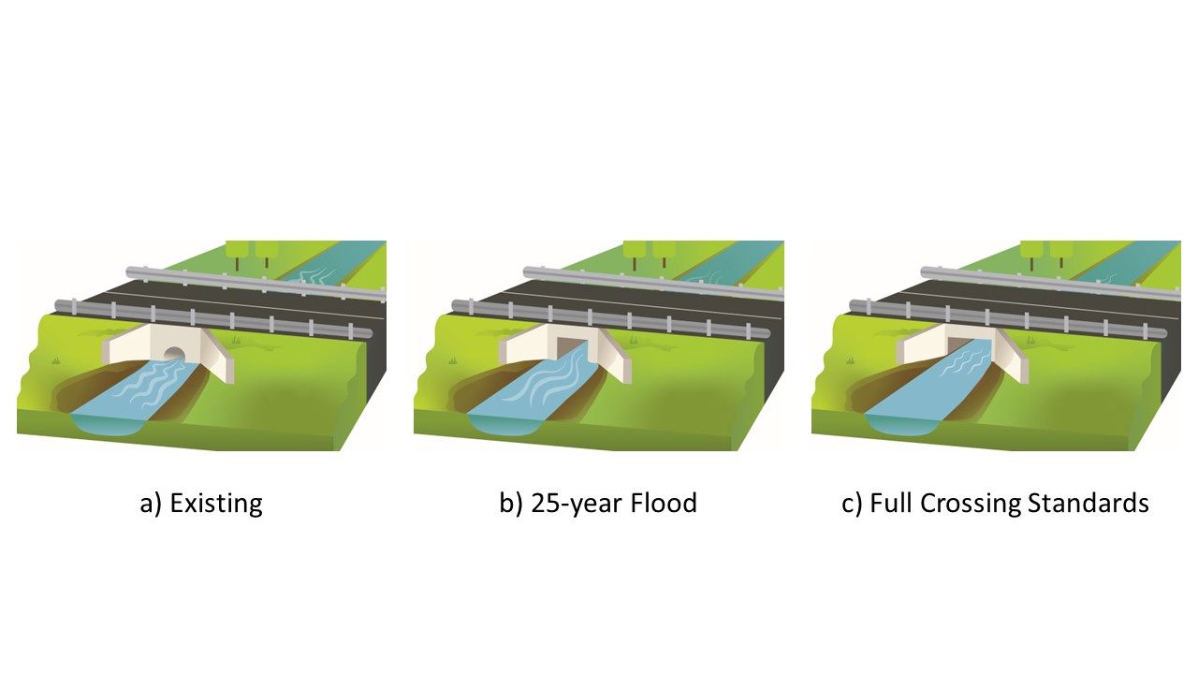
Figure 1. Crossing design comparison for Scenario 1
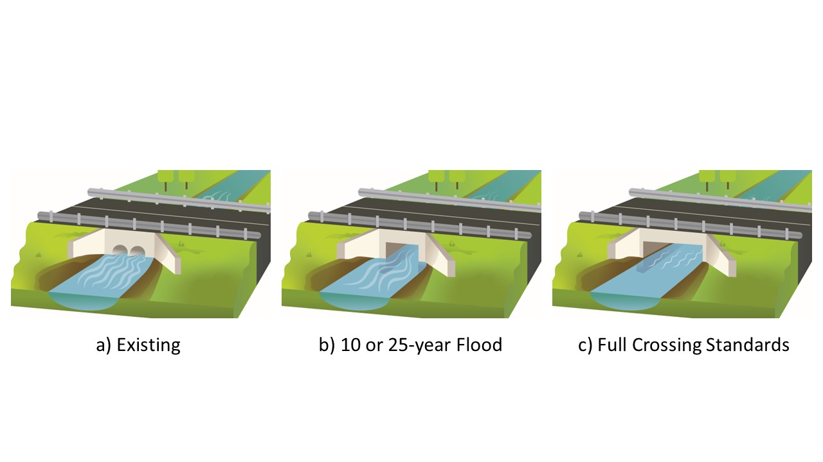
Figure 2. Crossing design comparison for Scenario 3
For the 36-inch culvert replacement (Scenarios 1 and 2), cost increases above baseline for both the low and high gradient streams were moderate, approximately 23-25% to meet Crossing Standards, and 6-7.5% to meet the design conditions for a 25-year flood. For an approximately 17% increase in cost over the 25-year flood design, or 23-25% over the 10-year flood (baseline) design, a structure could be provided that fully meets the Crossing Standards. Based on the MEP cost factors in Section 4.0, the cost factors for these scenarios (ranging from 1.17 to 1.25) would be justified for many crossing replacements (Table 2).
For the twin 48-inch culvert replacement with a low gradient stream (Scenario 3), the same size structure was required to meet both 10-year and 25-year flood design requirements, and the cost of fully meeting the Crossing Standards would be an additional 26%. For the high gradient stream (Scenario 4) a structure designed to meet the 25-year flood design requirements would also fully meet the Crossing Standards, with negligible cost savings (2%) if designed to only meet requirements of the 10-year flood. For Scenario 4 the Crossing Standards had minimal effect on the culvert sizing and cost. Comparing Scenarios 3 and 4, the cost of meeting the 10-year and 25-year flood requirements were up to 30% higher for the high-gradient stream (Scenario 4) than for the low-gradient stream (Scenario 3). The costs of fully meeting the Crossing Standards were only 3.5% higher for Scenario 4 compared to Scenario 3. The cost benefit comparison of Section 4.0 (Table 2) could be used to determine whether meeting the Crossing Standards was justified in Scenario 3 but would almost always be justified for Scenario 4.
Flood requirements for 10-year and 25-year events should generally be available for crossings on most streams in Massachusetts. Cost comparisons between a structure that meets Crossing Standards and one that only meets baseline requirements should be made when considering maximum extent practicable relative to the Crossing Standards. In the scenarios presented, the cost increase to fully meet the Crossing Standards would often be justified based on the MEP cost factors in Section 5.0 (Table 2).

Important considerations relating to culvert replacement costs

Replace in kind (not often practicable due to Hydraulic and Hydrologic considerations)
In most cases, it would not be acceptable to replace legacy culverts, such as the corrugated metal pipe ones used in the scenarios above, with identical replacements (replace in-kind). The original culverts in all the scenarios were clearly unacceptable by current standards because they did not meet basic hydraulic capacity requirements for MassDOT design floods. This would result in potentially hazardous conditions that can lead to severe scour and/or washout. In addition, the existing structures fell far short of meeting the Crossing Standards.
The “replace in kind" scenario is often discussed in the context of lower up-front costs, overlooking the major differences in life-cycle costs between an undersized culvert and one built to baseline standards or the Crossing Standards. Undersized culverts will likely require much more maintenance and repair and have a shorter design life than an appropriately sized structure. Proper assessment of life-cycle costs will include upfront costs, as well as comparative maintenance, repair, and replacement costs relative to the expected design life of the culvert.
Existing structures are often at significant risk of failure during a storm, and a “replace in kind” project would not decrease that risk. In addition, a “replace in kind” structure retains the likelihood of scour, debris accumulation at the inlet, reduced durability of materials, and restricted aquatic organism passage. Meeting baseline requirements can usually mitigate these risks for a small fraction of the total project cost. There is sometimes a misconception that the entire difference between replace-in-kind material and construction costs and the cost of structures that fully meet the Crossing Standards are solely due to the Crossing Standards. “Replace in kind” for the structures in these Scenarios would not be acceptable due to the high risk of hydraulic failure (scour or overtopping), irrespective of the Crossing Standards.

Low volume vs. high volume road
The scenarios that were evaluated assumed a low volume road. When the culvert replacement carries a high-volume road, the costs will often increase substantially to avoid road lane restrictions or closures during construction. This can require limiting work to times outside of high traffic periods, such as nights and weekends. The impact can result in a longer project schedule or require use of innovative accelerated bridge construction methods and materials. These can significantly shorten the construction schedule but may increase cost and require additional design efforts.

Staged construction
When road or lane closures are not an option, either due to the road being a critical transportation link or in cases such as a high-volume roadway with limited detour possibilities, staged construction is required. The degree of staging will vary depending on the project site. In some projects, this will require construction of one side of the structure at a time, to maintain traffic on the bridge section not being worked on. Another option is to construct the new structure adjacent to the existing one and change the road alignment to meet the new structure after construction is complete. This option requires significant use of adjacent land, and the costs associated with acquiring or accessing the adjacent property. Another option is to provide a temporary bridge during construction and return the traffic to the replacement structure at the end of construction. All these options are much more expensive and take longer to build than providing detours and closing a road during the construction process. The need for staged construction is more prevalent on major routes, in urban areas, and in rural areas where long detours would be a significant burden on the community.

Western MA vs. Eastern MA
Construction in Eastern MA (east of Worcester) is typically more expensive than in Western MA (west of Worcester). Several factors lead to this cost differential, including higher wage rates, higher volume roads, right-of-way constraints, utility relocation issues, and less available area for construction staging than in Western MA. It is not uncommon for costs to increase by a factor of 1.5 in Eastern MA compared to the scenarios discussed in this section.

Chapter 85 Review
Additional costs due to Chapter 85 review (discussed in Section 4.4) can be significant. Since this review is not applicable to structures with a span of less than 10 feet, there can be an incentive to find an acceptable structure with a span of just under 10 feet. For the scenarios considered, the consultants estimated that between $55,000 and $95,000 of additional costs would be added to a project subject to Chapter 85 review. This would be due to additional submittals, site surveying, design requirements, geotechnical investigation requirements, H&H requirements, the overall review process, and potential delays to project schedule during the design phase. During the construction phase, there will be additional review. Other added costs may be associated with use of approach slabs, precast transition elements, and standard crash tested barriers. For small bridges that have a span just over 10 feet, it may be possible to obtain waivers on some elements. There is no guarantee that a waiver will be granted, and reliance on a waiver can be a risky design assumption.

Maximizing ecological benefits when full compliance with Crossing Standards is not practicable
One goal of the WPA regulations is that culvert replacements meet the Crossing Standards to maintain the capacity of streams to provide flood prevention, storm damage prevention, fisheries, and wildlife habitat (“Interests” of the WPA). This is not always possible due to constraints noted in Sections 3.0 and 4.0, and for these cases designing to the maximum extent practicable may be justified. The recommended approach for evaluating the tradeoffs between aquatic connectivity and financial cost when a proposed replacement crossing will not meet the Crossing Standards are discussed in Section 4.0.
Whenever a decision is made to invoke the maximum extent practicable provisions in the Regulations, designers must propose measures to minimize negative effects on aquatic organism passage. Properly designed and constructed mitigation strategies can result in stream properties at the crossing location that effectively mitigate the crossing’s impacts on aquatic life in the stream. Discussions with engineering consultants that evaluated the culvert replacement scenarios indicated that most mitigation strategies can be implemented with minimal impact to total project cost, though oversight of construction methods and ensuring adequate performance is critical to a successful project. Anyone implementing these strategies should be well versed in successful construction methods as improper implementation can lead to washout of mitigation measures during storms, necessitate ongoing maintenance, or end up providing minimal benefit. Mitigation may require work in the stream outside of the road right-of-way and the need for access to perform such work can be a significant constraint.
The intent of the Crossing Standards is to ensure stream continuity by placing all culvert structural elements outside of the bankfull width (preferably, outside the 1.2 x bankfull width span). When not fully meeting the Crossing Standards requirement, extra mitigation may need to be taken to maintain conditions that are similar to the natural stream. It is almost always preferable to use an open bottom structure, so that the substrate is continuous and naturally meets the stream at the inlet and outlet. However, an improperly designed or constructed open-bottom culvert can lead to scour at the foundations, and deeper foundations may be warranted to ensure they are below the calculated scour depths.
When using a closed-bottom structure it is essential that it be properly embedded. With closed-bottom culverts there is the risk of substrate washout during a flood event. This can then lead to scour and undercutting of the culvert at the inlet and outlet, which can lead to failures. There are products on the market where the culvert itself is formed to mimic characteristics of stream roughness or surface shape. These are generally less effective than using natural substrate materials, which can be constructed to meet specific site requirements and create a channel that has similar characteristics to the natural streambed.

Erosion and scour
Erosion and head cutting can be mitigated by hardening the streambed to reduce the risk of failure if they should occur. Structural mitigation includes proper depth and stability of foundations and appropriate use and design of wingwalls, headwalls, and other protective elements. Traditional riprap may succeed in protecting crossing structures, but it does little to facilitate aquatic organism passage and does not meet the natural substrate requirements of the Crossing Standards. In some cases, it may be possible to provide rip rap scour protection below the substrate with two feet or more of natural streambed material over it. If buried riprap is used for scour protection, it is important that fine soil components (silt and clay) be washed into the voids among the rocks. Otherwise, there is a danger that at low flow, what little water is in the stream might go sub-surface leaving too little water for aquatic organism passage. The strategic placement of appropriately sized stone to form rock cross vanes (see Figure 3, Figure 4, and Figure 5), can provide grade control above, below or within crossing structures that mimic natural conditions in streams where step pools naturally occur, or quasi-natural conditions in other streams as an acceptable option to avoid erosional head cuts.
Where there is a risk of an outlet drop forming over time due to scour from high velocity water exiting the crossing structure, rock or log weirs placed downstream of the outlet may be able to prevent an outlet drop even if the culvert invert is perched above the streambed due to scour. Weirs designed to function like natural stream features can create a tailwater pool with a water elevation high enough to cover the culvert bottom sufficient to allow fish and other aquatic organisms to swim into the structure without needing to leap. Sometimes the height of a weir needed to backwater the culvert would, itself, pose a significant barrier to aquatic organism passage. In these cases, consider the use of a series of weirs to incrementally increase water elevations until the desired elevation at the culvert is reached.
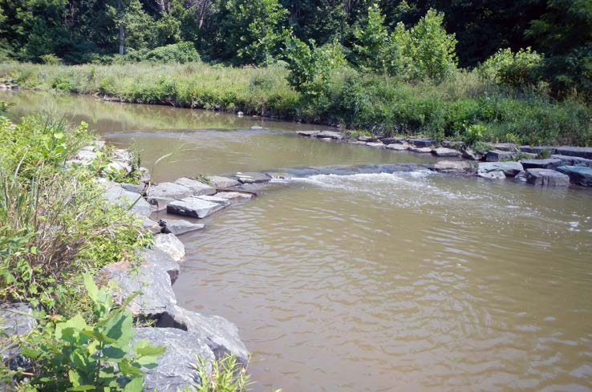
Figure 3. Cross vane (A-vane, from Virginia Tech Stream Restoration Series Fact Sheet Number 1)
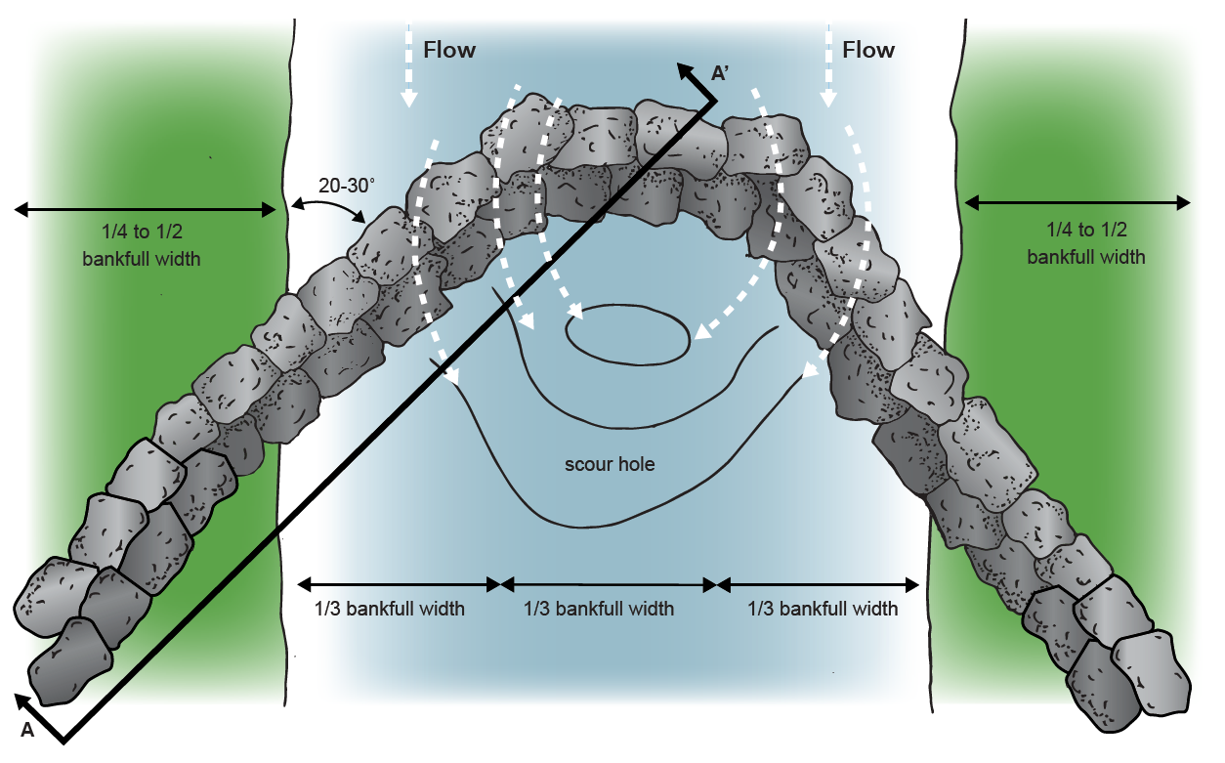
Figure 4. Cross vane plan view (illustration by Sarah Cisneros, from Virginia Tech Stream Restoration Series Fact Sheet Number 1)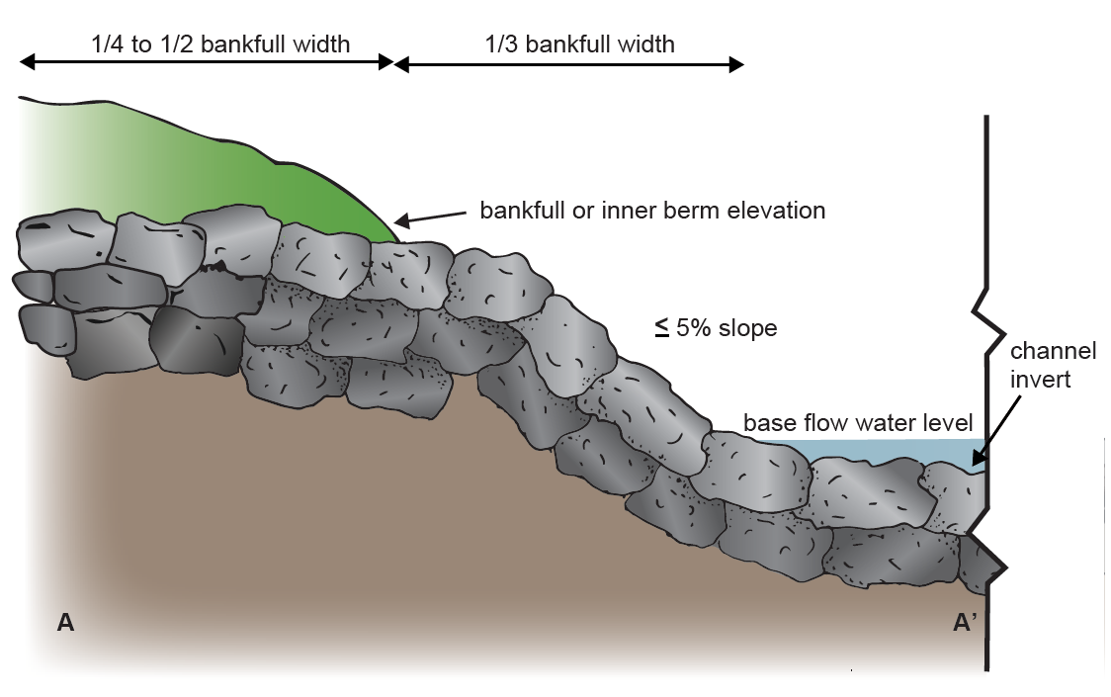
Figure 5. Cross vane profile view (illustration by Sarah Cisneros, from Virginia Tech Stream Restoration Series Fact Sheet Number 1)

Upsizing substrate material
If it is impracticable to construct a crossing that meets the Crossing Standards for width (1.2 x bankfull width), then it will be important to choose substrate materials and a channel design that will resist being washed out of the crossing structure during significant storm events. This will require a shear analysis to adequately size the substrate material and a channel design that retains substrate by controlling driving forces and providing adequate resistance. Crossings that constrict bankfull flows are likely to cause scour; the key is to avoid scour at the inlet, within the structure, or at the outlet. Depending on how much of a constriction is proposed (and the shear forces anticipated), it may be necessary to size material and design the crossing to achieve a static bed within the structure, and potentially for some distance upstream and downstream. Where rocks and boulders are used to construct streambeds associated with crossing, it is important to fill voids with fine sediments by washing them in to ensure that streamflow doesn’t go sub-surface. Washing in the fines will also "lock" in the larger substrates making the streambed more stable and less vulnerable to the erosive forces.
Although it is desirable to equip the crossing structure with substrate that matches what is found in the natural stream channel, it may be necessary to upsize the substrate material to ensure streambed and channel stability. It may be possible to use substrate on the surface (on top of a static bed) that falls within the range of natural variability for the natural channel, even if it is not possible to match average or predominant substrate conditions found in the stream. For crossings on high-gradient streams, it might be feasible to use retention sills to prevent substrate from washing out of a culvert. Care should be taken, however, when using retention sills, because if they prove ineffective at preventing substrate washout, they can themselves act as barriers to aquatic organism passage.

Protecting upstream wetlands
Replacement of under sized culverts with larger, more resilient structures can result in drainage of upstream areas, which can be harmful to wetlands, important habitat, or cyclical benefits of natural floodplains. Where these valuable habitats occur, mitigation strategies can be used to prevent or reduce the loss of wetlands while also improving aquatic organism passage. A series of low weirs or rock vanes can be used to incrementally raise water elevations upstream of a crossing (see Figure 6) to prevent the dewatering of wetlands that would otherwise be drained if the crossing was built in compliance with Crossing Standards. The weirs and rock vanes may, themselves, reduce aquatic organism passage to some degree, but they may be useful as a compromise measure to protect wetlands and other valuable upstream habitats while providing some increased aquatic connectivity. These strategies can be implemented upstream, downstream, and/or within the crossing structure. Best practices should be consulted when designing and constructing these features (see Section 6.5).
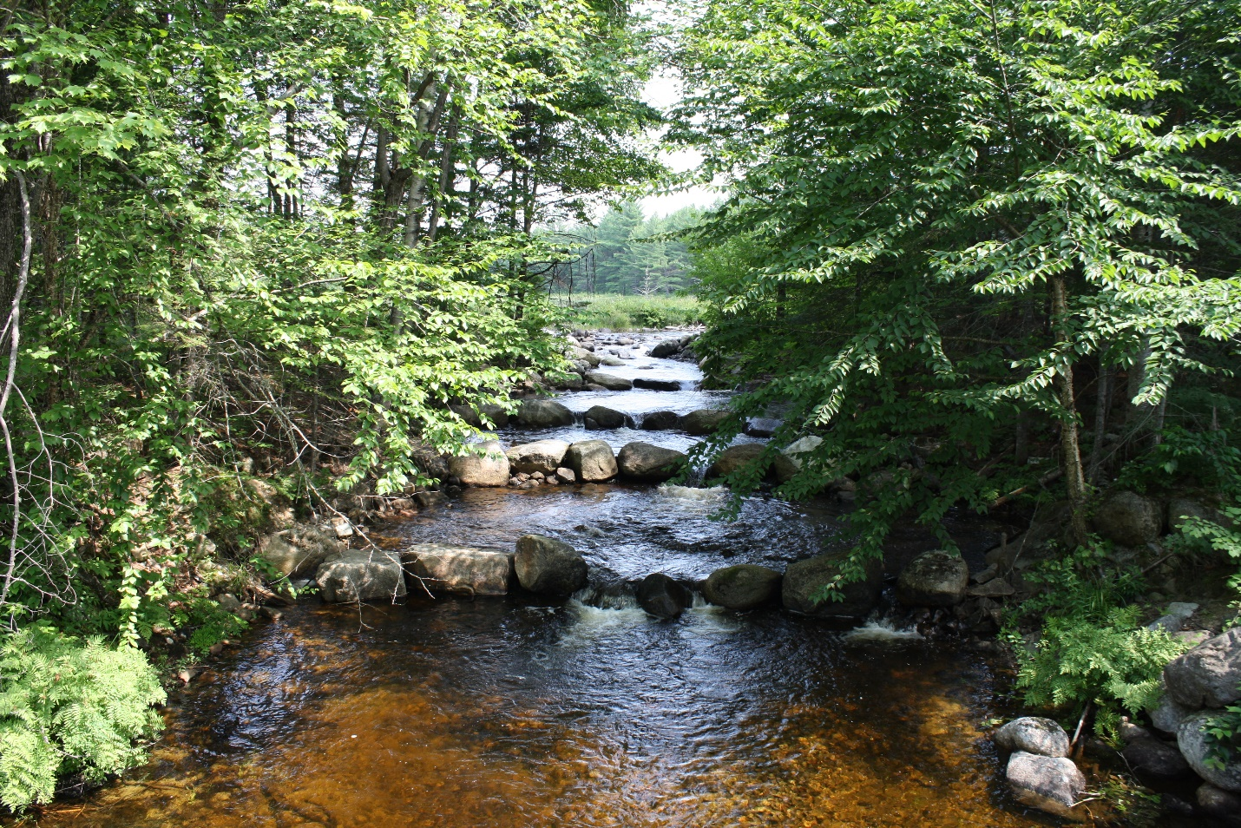
Figure 6. Rock weirs to enhance fish passage in Northeastern Maine (photo credit: USFWS)

Reducing velocity and ensuring adequate water depths
To ensure aquatic organism passage, culverts and bridges need to have similar characteristics to the natural channel upstream and downstream during the full range of flow conditions likely to be experienced in a typical year. Low flow channels, necessary for many aquatic organisms, are especially important for migratory (diadromous) fish.
When not fully meeting the Crossing Standards requirement, extra mitigation may need to be taken to maintain flow during dry conditions and slow the flow during flood events. When crossings are constructed with smaller spans than that required by the Crossing Standards, efforts should be made to reduce water velocities using methods that mimic natural features and processes in streams. These can include backwatering above and below the crossing as well as the creation of a roughened channel within the structure itself. A roughened channel incorporates features that provide drag and resistance to water flow.
The following approaches can be used within a structure or in the stream channel upstream or downstream of the crossing to regulate water depths and velocities. These are examples and typical designs would be expected to have some, but not all, of these features.
- Installation of large rocks and boulders to roughen the channel (Figure 7 and Figure 8)
- A sinuous low-flow channel within the structure with habitat boulder placement under the direction of a fluvial geomorphologist
- Banks on both sides of the stream within the structure to provide bank-edge where water velocities are typically lower than in the main part of the channel (Figure 9)
- Rock and log deflectors that are anchored on one bank and extend out into the channel
- Rock cross vanes that extend from bank to bank across the stream channel. V-shaped cross vanes or weirs can also be used to concentrate low flows (Figure 3, Figure 4, and Figure 5)
- Constructed step pools in higher gradient streams (Figure 10)
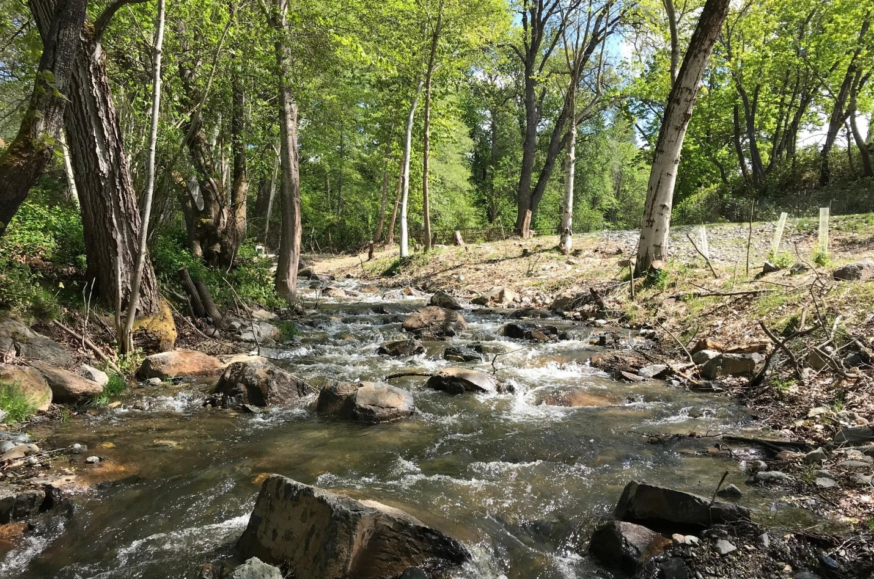
Figure 7. Roughened channel after dam removal on Wagner Creek, Oregon (Rogue River Watershed Council website)
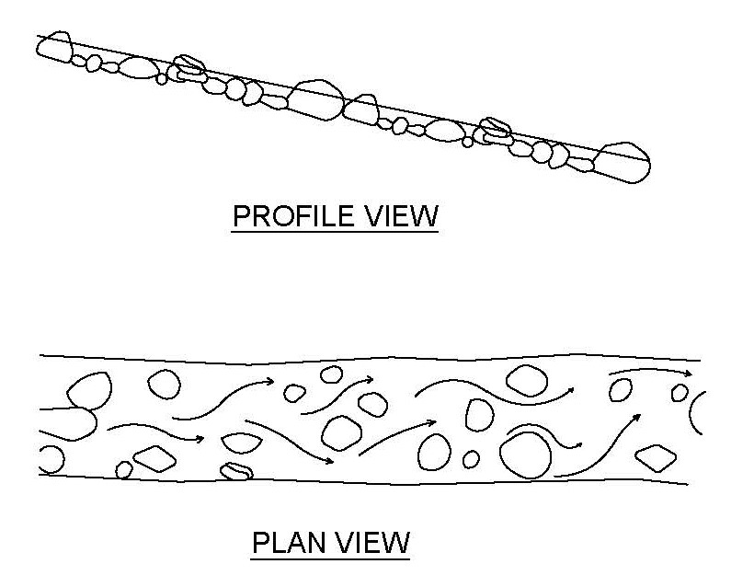
Figure 8. Use of large rock embedded in the substrate to create a roughened channel. It is important to use rocks large enough and embed them deep enough to prevent them from being dislodged by seasonal high velocity and storm flows.
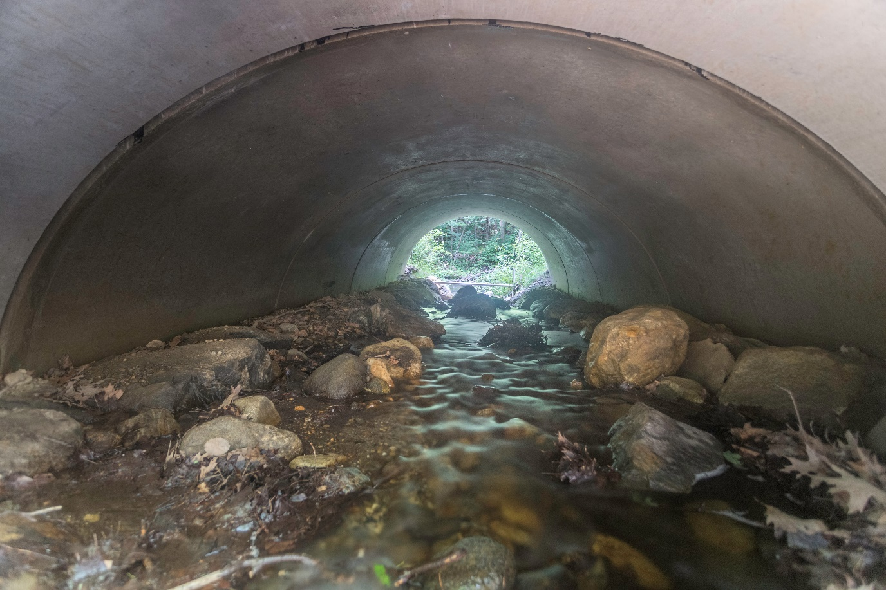
Figure 9. Banks within the structure provide bank-edge habitat where water velocities are typically lower than in the main part of the channel. In this photo, banks also contribute to the formation of a low-flow channel that provides sufficient water depth for aquatic organism passage at low flows.

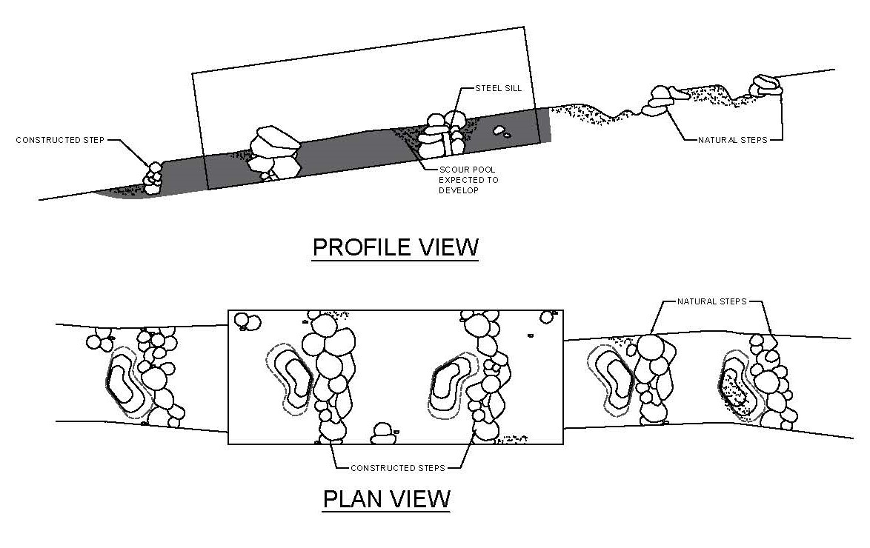
Figure 10. Created step pools can be used within or outside the structure to create instream habitat, reduce stream velocity, and backwater the outlet to prevent the formation of an outlet drop.

Best practices for instream mitigation
Mitigation measures to enhance aquatic organism passage when crossings cannot be built to achieve Crossing Standards requires expertise and experience so that those measures are adequately designed and properly constructed. The approach is to mimic natural features and flows in the more constructed width and environment of a crossing. Traditional riprap dumped into a stream or on its banks may achieve some of the objectives discussed in this section, but it is likely to be much less effective, perhaps even harmful, than efforts to mimic natural stream processes with the strategic placement of wood and rock.
Previous sections have provided context for the importance of controlling stream velocity and associated scour, both to allow for aquatic organism passage and to maintain streambed stability. The following are some general best management practices (BMPs) for implementing strategies described in this section, but designers should keep abreast of available training opportunities and literature for other BMPs. These are general design recommendations and caveats. They are no substitute for proper site assessment and analysis, and site-specific design and construction oversight by people with the appropriate training and experience.

Low flow channel maintaining appropriate water depths and velocities
Maintaining appropriate water depths and velocities at a variety of flows generally requires the construction of a low-flow channel to concentrate water during periods of low flow, and with adequate width to avoid velocities at moderate to high flows that exceed those found in the natural stream channel. The bed should be graded to the thalweg (deepest part) of the channel, so it continually concentrates flow as stage drops. The culvert invert slope should be continuous with the streambed (avoid formation of inlet or outlet drops) and the substrate designed and constructed correctly to form a low-flow channel within the crossing structure. The subsurface of the streambed should be sealed and impervious (see next section). The proposed low-flow channel should ideally be based on a stream reference reach located outside the influence of the replacement crossing. Cross section profile should mimic the reference reach, including low-flow channel, channel widths and features and banks when possible.

Stabilizing the streambed and grade control structures
When designing or constructing a streambed for a crossing, much attention is paid to the size, shape and placement of structural components (boulders, rocks, riprap). That is important. Designers should perform shear analyses to determine how large those elements should be and how deeply they would be buried. However, it is equally important to focus on the finer elements of the substrate (silt and clay). These elements are needed to seal the bed and prevent water at low flow from disappearing into the substrate. The substrate recipe should be thoroughly mixed before it is added to the constructed streambed and, after it is in place, the fines should be washed into the voids below using a water hose or other methods. When properly implemented, the subsurface layer should be impervious.
For rock weirs and cross vanes, place seal material with fines on the upstream side of the structures to limit permeability.

Log versus rock weirs and cross vanes
Weirs and cross vanes can be constructed of rock/boulders or logs. Rocks and boulders are generally preferred over grade control structures made of logs. Log grade control structures are less durable (shorter life expectancy) and more easily undercut than rock/boulder structures. If used, logs should be at least 8 inches in diameter and keyed into the bank. Log cross vanes should not create a bed elevation change greater than 0.5 foot. For rock weirs and cross vanes, boulders should be somewhat angular so that they can be keyed together. Boulder sizes should be determined based on a shear analysis and calculated scour depth, with a built-in safety margin. The size of boulders needed for weirs and vanes are generally larger than for riprap because boulders within grade control structures are more exposed to flow than riprap. Rock cross vanes should not change the bed elevation by more than 2 feet. Multiple cross vanes may be needed to achieve the desired drop in stream elevation.

Ensuring a proper foundation
Both boulder and log weirs must be buried into the streambed and banks to ensure a proper foundation that can resist displacement during high flow events. Single log weirs are not recommended; in some cases, two logs can be stacked to get sufficient depth of burial to be stable. For rock structures, one layer of rock should be buried as a “footer” for a second layer that sticks up above the water surface during most flows. Structures should slope down toward the center of the channel (the “sill” of a cross vane). Weirs and cross vanes must be buried into stream banks to prevent bank erosion around the ends. U-shaped or V-shaped cross vanes can focus the flow and erosive forces toward the center of the channel and help prevent erosion and “outflanking” at the banks (see Figure 4 and Figure 5). The ability to carefully place and interlock rocks and boulders to create stable grade control structures comes with experience. A good design can be ruined if implemented by an inexperienced construction crew.

Additional resources for design and construction of grade control structures
- Virginia Tech’s Stream Restoration Series Fact Sheet Number 1 on Cross Vanes
- US Forest Service Stream Simulation Working Group. 2008. Stream Simulation: An Ecological Approach to Providing Passage for Aquatic Organisms at Road-Stream Crossings. 2008. San Dimas: US Forest Service Technology and Development Program (specifically Appendix F, but the entire manual is an excellent resource for designing road-stream crossings for aquatic organism passage)
- Grade stabilization techniques. 2007. USDA-NRCS Part 654, Stream Restoration Design, National Engineering Handbook Technical supplement 14G
- Rosgen Geomorphic Channel Design. 2007. USDA-NRCS Part 654, Stream Restoration Design, National Engineering Handbook, Chapter 11.
- Guidance for Stream Restoration by Steven E. Yochum. 2018. USDA Forest Service, National Stream & Aquatic Ecology Center Technical Note TN-102.4
- Assessment, Planning, Design, and Maintenance of Large Wood in Fluvial Ecosystems: Restoring Process, Function, and Structure. 2016. National Large Wood Manual. U.S. Bureau of Reclamation and U.S. Army Corps of Engineers.

Reviewing proposals for crossing replacement that do not comply with the Crossing Standards

Demonstrating maximum extent practicable
When reviewing proposed crossing replacement projects that seek to use the Maximum Extent Practical standard to avoid fully meeting the Crossing Standards, it is important to keep in mind that proposing to replace a crossing with an ‘in-kind’ structure is not sufficient to demonstrate maximum extent practicable. To demonstrate maximum extent practicable, a written alternatives analysis must accompany the Notice of Intent. At a minimum, cost and descriptive information about each of the following three alternatives should be included in the Alternative Analysis. All alternatives should be based on a thorough site assessment, including a long profile of the stream, documentation of the channel bed adjustment potential, stream bed analyses, and measurements of bankfull width in reference sections of the stream.
- A baseline alternative, which must be a design that can pass the appropriate MassDOT design flood for the road class on which the crossing is located (see Section 4.0, Table 1) and provide the appropriate freeboard.
- A Full compliance alternative designed to fully comply with the Crossing Standards and WPA performance standards.
- At least one MEP Alternative with mitigation elements to maximize aquatic organism passage with crossing replacement costs at least as much as the relevant cost factor listed in Section 5.0 (Table 2).
NOI submittals should also include:
- Engineered plans and calculations stamped by a registered professional engineer (PE) of the proposed activity, along with at least conceptual level plans and calculations of the alternatives considered.
- Documentation prepared by a PE to substantiate the cost estimates of the proposed activity and each alternative considered (see Section 4.0).
Project proponents replacing stream crossings are expected to fully meet the Massachusetts Stream Crossing Standards unless it is demonstrated to be impracticable, and then the standards must be met to the maximum extent practicable. Cost is an important consideration when deciding if a proposed crossing replacement project has met the Crossing Standards to the maximum extent practicable. However, those costs must be balanced against the ecological benefits that could be achieved if the Crossing Standards were fully applied (see Section 4.0). WPA Regulations (310 CMR 10.24(10) and 10.53(8) list 12 elements that should be evaluated when considering whether it would be practicable for a proposed replacement project to fully meet the MA Stream Crossing Standards. Appendix B is a detailed checklist that can be used by applicants and Issuing Authorities to determine whether a proposed crossing replacement meets the Crossing Standards to the maximum extent practicable.
- The potential for downstream flooding
- Upstream and downstream habitat (in-stream habitat, wetlands)
- Potential for erosion and head-cutting
- Stream stability
- Habitat fragmentation caused by the crossing
- The amount of stream mileage made accessible by the improvements
- Storm flow conveyance
- Engineering design constraints specific to the crossing
- Hydrologic constraints specific to the crossing
- Impacts to wetlands that would occur by improving the crossing
- Potential to affect property and infrastructure
- Cost of replacement
Some of these elements are related to physical constraints that might make it impossible or prohibitively expensive to meet the MA Stream Crossing Standards (see Section 3.0). Other elements pertain to the need to balance financial costs with potential ecological benefits (see Section 4.3).
This guidance uses two factors to determine whether a replacement crossing meets regulatory requirements to the maximum extent practicable: minimum hydraulic design criteria (baseline alternative, see Section 4.2) and cost. A design alternative is presumed to meet the MA Stream Crossing Standards to the maximum extent practicable when the projected cost equals or is greater than the relevant cost factor percentage listed in Section 4.0, Table 2, AND the cost exceedance above the baseline alternative goes towards improving aquatic organism passage (see Section 6.0).
Consistent with other Limited Projects, in rare cases when the project cannot meet the maximum extent practicable cost factor or the minimum hydraulic design criteria, the Issuing Authority may issue an Order of Conditions and impose such conditions as will contribute to Interests identified in the WPA. In determining whether to exercise its discretion to approve the Limited Project, the Issuing Authority shall consider the elements listed above and whether the applicant has adequately addressed them.
Whether a proposed crossing replacement fully meets the MA Stream Crossing Standards or meets those standards to the maximum extent practicable, appropriate site assessment and engineering is required to ensure that structures are sized and designed to avoid downstream flooding, achieve desired bed elevations, avoid scour, and provide adequate stability for stream channels, bedforms, footings and abutments. This is especially important for limited projects that cannot meet the maximum extent practicable cost factor and the minimum hydraulic design criteria. Many of the elements from the list above are important factors that should be considered in the design of a replacement crossing.
Some “bridge replacement projects” may be exempt from review under the WPA. These projects are still covered by Massachusetts Water Quality Standards administered by MassDEP. The MA Water Quality Standards also require replacement crossings to meet Stream Crossing Standards “…to the maximum extent practicable.”

Emergency replacements
Occasionally, severe localized storms result in crossing failures (i.e. washouts). When this occurs on public roads, it can cause disruptions that require quick action to reopen the road. These types of replacement projects are often implemented after a request for Emergency Certification is granted by the appropriate conservation commission. This often leaves little time for site assessment, design, and the acquisition of materials necessary to construct a replacement crossing that meets the Crossing Standards. The result is often pressure on the conservation commission to permit a replacement crossing that does not meet the Crossing Standards to the maximum extent practicable.
One way to avoid approving a sub-standard crossing replacement is for the conservation commission to work with the municipal highway or public works department to assess stream crossings and identify those that are vulnerable to failure, either because they are structurally deficient or undersized, or due to some other vulnerability. Once these vulnerable crossings are identified, action can be taken to replace those crossings before they fail. Communities can seek funding for these replacements from grants including:
- Hazard Mitigation Grants, for projects that will reduce or eliminate risk of damage to people and property caused by natural hazards ( MA Emergency Management Agency, MEMA),
- Municipal Vulnerability Preparedness (MVP) Action Grants, for crossings identified as vulnerable due to climate change in the municipality’s Municipal Vulnerability Preparedness Plan (MA Executive Office of Energy and Environmental Affairs, EOEEA),
- Culvert Replacement Municipal Assistance Grants, for culverts located in areas of high ecological value (MA Division of Ecological Restoration, MA DER), and
- Municipal Small Bridge Program, for replacements at existing crossings designated as small bridges or bridges; see Section 4.4 for more details on MassDOT bridge categories (MA Department of Transportation, MassDOT).
Each of these funding programs has specific objectives that would have to be met for a successful grant application, and it is important to select the grant opportunity that provides the best possibility of being funded. By cooperating in the assessment of vulnerable crossings, conservation commissions and municipal highway officials can also discuss possible replacement options should an emergency replacement be necessary. If such an emergency materializes, both parties will be in a better position to take quick action to permit and implement a crossing replacement project.
Another option for dealing with emergency washouts is for the conservation commission to approve under Emergency Certification the installation of a temporary crossing with a condition that within a specified amount of time a Notice of Intent shall be filed to replace the temporary crossing with a permanent crossing that meets regulatory performance standards.

Conclusion
There are an estimated 25,000-30,000 road stream crossings in Massachusetts. Along with legacy dams scattered across the state, stream crossings are fragmenting our river and stream networks in ways that undermine their ecological integrity and ability to support healthy populations of fish, salamanders, turtles, crayfish and other aquatic or semi-aquatic organisms. Over time, and especially given the projected impacts of climate change on our rivers and streams, we can expect small, isolated populations of fish and wildlife will disappear. Without adequate aquatic connectivity, some of those vacant habitats will not be colonized by dispersing animals from other populations. With warming air and water temperatures, the discontinuity of future cold-water habitats, and the disruption of aquatic connectivity caused by stream crossings and dams, the risk is especially high for cold-water species.
The climate change that is threatening populations of cold-water and other aquatic species, also threatens to undermine our transportation infrastructure. Legacy culverts will need to be replaced with structures that can better resist the extreme storm and flood events that are projected to occur with increasing frequency due to climate change. At a minimum, all crossing replacements should be able to pass MassDOT design floods for the road classes where they occur. Where there are opportunities to restore aquatic connectivity, especially for high-quality habitat, we need to design and construct new and replacement crossings to meet the Massachusetts River and Stream Crossing Standards. The upfront cost of designing and constructing crossings to meet the Crossing Standards are likely to result in long-term savings due to their longer life spans compared to legacy culverts, and by reducing maintenance costs and avoiding crossing failures.

Appendix A: Details of the four hypothetical scenarios for purposes of cost comparison
Scenario 1. The first scenario involved the replacement of an existing 36-inch diameter corrugated metal pipe extending 40 feet in length along a stream with a bankfull width of 7 feet. The waterway is a relatively low gradient stream with substrate of silt, sand, and gravel. To fully meet the Crossing Standards, a three-sided 9’x10’x30’ or an embedded four-sided 9.5’x8’x52’ reinforced concrete culvert would be acceptable, with the three-sided option preferred because it provides an open bottom with natural stream bed. There are other options that could be used, including a bridge, open-bottom arch, or large, embedded round pipe but these were not considered optimal for typical conditions. The baseline design was based on H&H for a 10-year flood that would typically be required for a rural local road. Based on estimated cost for the various designs it was estimated that a 25-year flood can be accommodated for costs that are similar (about 6% higher) to the costs for a crossing designed to pass a 10-year flood. For an approximately 23% increase in cost over the 10-year flood (baseline) design, a structure could be provided that fully meets the Crossing Standards.
Scenario 2. The second scenario was similar to scenario 1, except that the waterway was a high-gradient stream with a 7-foot bankfull width with a substrate of boulders and cobble. The preferred structure for full compliance with the Crossing Standards is very similar to that for scenario 1, as were the estimated cost increases over baseline for the 25-year flood design (7.5%) and full compliance with Crossing Standards (25%).
Scenario 3. For the next scenario we considered replacement of a crossing consisting of twin 48-inch diameter corrugated metal pipes extending 50 feet in length along a stream with bankfull width of 13 feet. Like the waterway in scenario one, it was a low gradient stream with substrate of silt, sand, and gravel. To fully meet Crossing Standards a three sided 16’X10’X30’ reinforced concrete, or 16-foot span aluminum arch bridge were considered acceptable, with the three-sided option preferred due to its greater durability compared to an aluminum structure. The baseline design was based on H&H for a 10-year flood event. For this scenario, the same structure size necessary to pass a 10-year flood would also pass the 25-year flood. To fully meet the Crossing Standards would require an approximately 26% increase in cost over a crossing designed to pass a 10-year flood.
Scenario 4. For the fourth scenario a twin 48” diameter culvert crossing is being replaced on a higher gradient and higher velocity stream with a boulder/cobble substrate. As with Scenario 3, bankfull width was 13 feet. Culvert sizes to accommodate baseline H&H for a 10-year flood were significantly larger than for Scenario 3. However, Crossing Standards were met with only slightly larger culverts than required for the low gradient stream conditions (scenario 3). The consultants agreed that different designs for the substrate were required to accommodate significant differences in the hydraulic shear and to allow for natural aggregation and degradation of the substrate. However, substrate design was not expected to significantly change the total project cost or schedule. Meeting the 25-year flood design requirements in this high gradient stream resulted in a structure that also fully meets the Crossing Standards. Both the 25-year flood design and the Crossing Standards compliant design had costs that were only 2% above baseline (10-year flood design), a cost that would be justified for nearly all cases.
Based on the maximum extent practicable cost factors in Section 4.0, the cost factors above baseline needed to fully meet the Crossing Standard (ranging from 1.02 – 1.26%) would be justified in many cases, particularly when accounting for increases in resiliency (Table 2, Section 4.0).
Table 4.Scenario results show the preferred structure and estimated cost increase over baseline (10-year design flood) for crossings designed to comply with Crossing Standards and to pass a 25-year flood (same as Table 3 in Section 5.0).
Scenario | Meet Crossing Standards |  | Meet 25-year Flood |  | 10-Year Flood Event
 | Recommended Structure | Cost increase over baseline | Recommended Structure | Cost increase over baseline | Recommended Structure
1 | 3-Sided 9X10 | 23% | 3-Sided 6X7 | 6% | 3-Sided 6X5 | baseline
2 | 3-Sided 9X11 | 25% | 3-Sided 6X10 | 7.5% | 3-Sided 6X8 | baseline
3 | 3-Sided 16X10 | 26% | 3-Sided 8X8 | 0% | 3-Sided 8X8 | baseline
4 | 3-Sided 16X12 | 2% | 3-Sided 16X12 | 2% | 3-Sided 16X7 | baseline

Appendix B: Checklist for Demonstrating Maximum Extent Practicable (MEP) for Stream Crossing Replacement Projects Limited by Cost
In accordance with 310 CMR 10.53(8), applicants must demonstrate that a replacement crossing complies with the Massachusetts Stream Crossing Standards to the Maximum Extent Practicable (MEP). This checklist assists the Conservation Commission in determining if a project has met the burden of complying to the MEP if the replacement stream crossing does not fully meet the Stream Crossing Standards due to cost limitations. It is important to note that this checklist does not evaluate the project design, hydraulic capacity, safety, or stability of the proposed structure.

A.1 Notice of Intent (NOI) - Submittal Requirements
To demonstrate compliance to the MEP, the following information must be submitted:
- Written Alternatives Analysis including the Crossing Design and the Estimated Cost (A.2)
- Documentation of Physical Constraints (A.3)
- Estimated Ecological Benefit based on Habitat Quality and Restoration Connectivity Potential (A.4)
- Determination of Practicable Cost using the Relative Cost Factor Ratio (A.5)

A.2 Alternatives Analysis – Crossing Design and Cost Estimates
(See Section 3.0 in the Guidance for more details)
The alternatives analysis should document the iterative process of conceptually designing the crossing and balancing the cost as follows:
A.2.1 Crossing Designs Alternatives
- Full Compliance Design Alternative - design that fully complies with the Stream Crossing Standards
- Baseline Design Alternative - minimally acceptable design that may meet the MEP criteria
- MEP Design Alternative - design after planning a Full Compliance replacement crossing and reconciling the design with any site constraints and the estimated cost
Note: All Design Alternatives must consider aquatic and wildlife passage, flooding (for existing undersized that provide detention storage), head cutting and stream stability, impacts to upstream wetlands, and MassDOT review, if required.
A.2.2 Estimated Cost
- Written cost estimate (including stream survey, geotechnical analysis, design elements (including all those indicated in Section A.3.1), applicable permitting, materials, and construction costs for each of the three design alternatives

A.3 Assessment of Physical Constraints or Site Considerations
(See Section 4.0 in the Guidance for more details)
The NOI should document the presence of site constraints that may limit the crossing design, including:
- Engineering design constraints specific to the crossing such as existing utilities (sewer pipes, drainage structures, right-of-way limitations, bedrock, etc.)
- Potential to affect property and infrastructure (buildings, roadways, foundations, historic structures, etc.)
- Significant/prohibitive roadway elevation requirements
- Presence of impounded water or wetlands upstream
- Presence of incised or unstable stream channel

A.4 Assessment of Ecological Benefit
(see Section 5.0 in the Guidance for more details)
The NOI should determine the ecological benefit by assessing habitat quality and connectivity restoration potential:
- Identify if the stream segment falls within a BioMap Aquatic Core, Coldwater Fishery, ACEC, Wild and Scenic River, or has Physical Site Constraints
- Assign a habitat quality class according to the number of categories above
- Determine the Connectivity Restoration Potential using the Critical Linkages

A.5 Balancing Crossing Design, Estimated Cost, and Ecological Benefit
(See Section 5.0 in the Guidance for more details)
The NOI should compare the cost of the Full Compliance Design Alternative with the cost of the baseline Design Alternative cost and then consider the ecological benefit:
- Document the relevant Cost Factor Percentage
- Compare the estimated cost included with the Alternatives Analysis (A.3.2) and the Cost Factor Percentage in Table A-1
- Determine if the design alternative is Practicable
Note: A design alternative is presumed to meet the Stream Crossing Standards to the MEP when the estimated cost is at least equal to the relevant Cost Factor Percentage AND all costs greater than the baseline cost contribute toward improving aquatic organism passage.

A.6 Confirm Compliance with MEP
To determine if the proposed replacement stream crossing has been designed to meet the Stream Crossing Standards to the MEP, the Conservation Commission should confirm that the proposed stream crossing has the following:
- Baseline design criteria (at a minimum) or MEP design
- Elements to facilitate aquatic organism and wildlife passage
- Estimated cost that is considered practicable

https://www.mass.gov/doc/massachusetts-culverts-and-small-bridges-working-group-report/download
https://www.mass.gov/doc/massachusetts-river-and-stream-crossing-standards/download
https://www.mass.gov/doc/massachusetts-river-and-stream-crossing-standards/download
The eight interests of the WPA are: 1) protection of public and private water supply, 2) protection of ground water supply, 3) flood control, 4) storm damage prevention, 5) prevention of pollution, 6) protection of land containing shellfish, 7) protection of fisheries, and 8) protection of wildlife habitat.
Massachusetts River and Stream Crossing Standards. 2011 (corrected in 2012). River and Stream Continuity Partnership, 27 pp.
The Crossing Standards include General Standards, intended to facilitate the passage of fish and other aquatic organisms, and Optimal Standards addressing the needs of both aquatic organisms and terrestrial wildlife. References to the Crossing Standards in WPA regulations relate only to the General Standards.
References to meeting the Crossing Standards “to the maximum extent practicable” are also included in 310 CMR 10.24(10), 10.35(6)(a), 10.54(4)(6), and 10.56(4)(a).
Massachusetts Culverts and Small Bridges Working Group issued a report as directed by Section 102 of the 2019 General Appropriations Act for Senator Adam G. Hinds and Massachusetts Legislature titled Recommendations for Improving the Efficiency of Culvert and Small Bridge Replacement Projects.
In some cases, the presence of a wetland and absence of a defined channel upstream of a crossing may be the result of water being impounded by the crossing itself. In these cases, use of the Crossing Standards would be appropriate.
A copy of the Massachusetts River and Stream Crossing Standards document can be downloaded from https://www.mass.gov/doc/massachusetts-river-and-stream-crossing-standards/download?_ga=2.267917646.1936442256.1664714409-1969708928.1657060224.
Language in this paragraph was adapted from the Massachusetts River and Stream Crossing Standards, River and Stream Continuity Partnership, 2011.
A copy of the Massachusetts River and Stream Crossing Standards document can be downloaded from https://www.mass.gov/doc/massachusetts-river-and-stream-crossing-standards/download?_ga=2.267917646.1936442256.1664714409-1969708928.1657060224.
Page 12 of Massachusetts River and Stream Crossing Standards.
Pages 25-26 of Massachusetts River and Stream Crossing Standards.
Upstream flooding is often an important consideration when enlarging crossings on tidal streams and rivers. This guidance document is not intended for tidal stream crossings.
310 CMR 10.53(3)
Information about Critical Linkages is available at the UMassCAP.org website: https://umasscaps.org/applications/critical-linkages.html
Critical Linkages scores are generally unavailable for crossings on small headwater streams (watershed size < 74 acres) or due to unmapped streams or unmapped roads.
Driveways, railroad crossings, rail trails, and pedestrian crossings are not listed in the MassDOT LRFD Bridge Manual. They are added here to clarify the baseline sizing for these other types of crossings. All crossings, regardless of type are also subject to no-rise Floodway criteria adopted by municipalities to participate in the National Flood Insurance Program. See 44 CFR 60.3(d)(3) and (4).
Freeboard is the height between the hydraulic design flood water surface elevation and the proposed crown of a culvert or low chord of a bridge to allow for the passage of debris and ice.
Municipal Bridge Projects MGL Chapter 85 Section 35 Review Process: Design Requirements and Submittals for New Bridge and Full Bridge Replacement Projects.
Estimated in 2020 dollars; these costs are likely to vary over time.
Note: Table 1 is a modified version of the MassDOT Table; additional crossing types not regulated by MassDOT (e.g., railroads, driveways, rail trails) have been added. The baseline requirements also apply to these other crossing types.
Dimensions are given as width x height x length (inlet to outlet).

