# Phillips Manor Nursing Home

28 Linwood Road Lynn, MA 01905-1638

Tel: (781) 592-8000

Fax: (781) 598-1556

E-Mail: [Raugeri@phillipsmanor.com](mailto:Raugeri@phillipsmanor.com) [www.phillipsmanor.com](http://www.phillipsmanor.com/)

##### PLAN FOR ORDERLY CLOSURE

INTRODUCTION OF INTENT TO CLOSE:

This closure plan is developed and submitted to the Department of Public Health for approval by the licensee, following a decision to close a long-term care facility licensed under Massachusetts General Law 105CMR153 .023.

Facility Name: Phillips Manor Nursing Home Facility License#: 0332

Facility Address: 28 Linwood Road, Lynn, MA 01905-1638 Planned Closing Date: 02/20/2025

Census as of 10/18/2024

0 (zero)

1 (one)

9 (nine)

1 (one)

Medicare Resident Private Paying Resident

Medicaid/Medicaid Pending Residents Medicaid in hospital

Phillips Manor Nursing Home

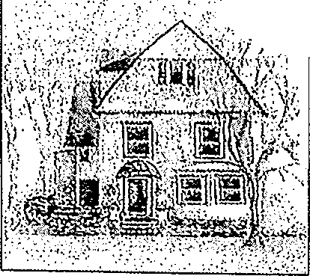

*:·-.?f./,<;'.i-*

··"" ,·,.·:,,

;

l,

'

28 Linwood Road Lynn, MA 01905-1638

Tel: (781) 592-8000

#### Fax: (781) 598-1556

E-Mail: [Raugeri@phillipsmanor.com](mailto:Raugeri@phillipsmanor.com) [www.phillipsmanor.com](http://www.phillipsmanor.com/)

**CLOSURE AND RELOCATION PLAN FOR PHILLIPS MANOR NURSING HOME**

INTRODUCTION **EFFECTIVE** October 21, 2024

This closure plan is developed and submitted pursuant to the determination of the owner to voluntarily close the Phillips Manor Nursing Home due to financial feasibility. The closure will be initiated on November 1, 2024. No patient will be discharged prior to the plan's approval unless it becomes their desire. Phillips Manor Nursing Home is a Level III facility which is Medicare certified and located at 28 Linwood Road, Lynn, MA 01905-1638. The owner and licensee is Phillips Manor Nursing Home L.L.C., d/b/a Phillips Manor Nursing Home. The licensed bed capacity is twenty-two (22) and currently the census is eleven (11), ten (10) of whom are Medicaid residents, and one (1) Private Pay.

This plan is developed in accord with the Department of Public Health (DPH) and Division of Medical Assistance (DMA) regulations, the DMA Relocation Guidelines for Health Care Facilities and the DPH Emergency Patient Relocation Plan.

This plan is organized into the following six areas of activity:

1. Admission Freeze
2. Notification Requirement
3. Resident Assessments
4. Family Meetings
5. Bed Search and Match with Residents
6. Resident Relocation

The Nursing Home is responsible for accomplishing the safe and orderly closure of the facility and for assuring that residents receive appropriate care pending the closure. This responsibility shall be coordinated by Richard Augeri, Administrator, Evelyn Foleke, Social Worker and Tammy Dalton, DNS on behalf of the Nursing Home.

The Department of Public Health and Division of Medical Assistance shall be notified and their expertise in these matters utilized as needed.

The underlying objective of this plan is to ensure a safe, orderly and clinically appropriate transfer of each and every resident and to ensure the successful adjustment of each resident with a minimum stress for residents, family and facility staff. This objective shall be accomplished in as expeditious a manner as possible under the circumstances. All time frames contained within this plan are reasonable approximations.

Medicaid Coverage Determination

Nursing Home shall complete appropriate assessments of all

residents and shall document such assessments on the appropriate forms. These

, forms will be made available to Nursing Home by DMA during the

initial site visit. These long-term care assessment forms will be reviewed by DMA staff for the purpose of detennining the medical eligibility of residents for continued Medicaid coverage.

Medical and Social Assessment

Each resident shall be assessed by nurses and social workers from

Nursing Home, with assistance from DPH and DMA as appropriate, to identify specific needs, including the need for guardianship, that must be considered in

finding an appropriate new bed or alternative service. This assessment shall

consider the resident's medical needs, family and social ties and other significant factors.

Psychological Preparation of Residents for Transfer

As necessary, appropriate psychological preparation and counseliri.g for each resident shall be provided by the Nursing Home to minimize the

impact of the closure on residents and facilitate the residents' adjustment to their new environment.

FAMILY MEETINGS

Day 2-10 On-site conferences shall be held with the residents, family members, guardians, facility staff and, as appropriate, DPH and/or DMA staff to discuss the relocation and specific plans to be formulated for each resident.· At these meetings, resident needs, the possibility of alternative placements and resident and family preferences shall be discussed. The options and responsibilities shall be determined. The involvement of family and guardians is essential.Jo assuring successful placements for residents and to assure residents' rights are protected.

BED SEARCH AND MATCH WITH RESIDENTS

Day 2-45 The Nursing Home staff, with the assistance of DPH and DMA

staff, as necessary, shall contact long-term care facilities in the area and notify them of the impending closure and need for beds. The DMA and DPH criteria specify that an appropriate bed be found within a 25-mile radius of the

facility and/or resident's family and friends. To the extent that a resident has a special need to be met or there are other family considerations or beds within the 25-mile radius have been exhausted, a bed search in other areas will be authorized and initiated. '

Upon finding beds, Nursing Home staff, with assistance

from DPH and DMA staff, shall match available beds with residents to arrange for the best accommodation in terms of location, services and psycho-social needs. To the extent possible, residents and/or their families shall be given an opportunity to participate in this process and to visit a suggested facility to determine whether it is acceptable. Nursing Home will make all

arrangements for the pre-admission visit.

Once a placement is determined the resident and family shall be notified in

track resident funds.

Social Security Information: The Nursing Home shall

complete and mail, on behalf of each resident transferred, aSocial Security

change of address form. In addition, a SC-1 form shall be completed for each

transferred resident and mailed to the Medicaid Long Term Care Unit.

PLAN IMPLEMENTATION

Implementation of this plan shall be the responsibility of Nursing Home with assistance from DPH and DMA, as needed and appropriate. Nursing Home shall keep DPH informed of the progress of the closure on a weekly basis by phone followed up by written reports. DPH shall apprise DMA of such progress, as appropriate. Nursing Home shall notify DPH, in writing, of proposed changes in the plan and obtain DPH approval of such changes prior to effectuating them. After the closure of Nursing Home, DPH conducts a closure visit. Nursing Home shall

prepare for this visit a list of all the residents transferred and the facilities to which they were transferred and the medications which accompanied them, medication disposal records, a list of all nurse aides trained by the facility in a state-approved nurse aide training program after July 1, 1989, the location where records will be stored and the name, address and telephone number of the individual responsible for the safekeeping of such records. The licensee is responsible for returning the original license to DPH after the closure visit.

Date: October 18, 2024



cc: EOEA, LTC Ombudsman

NOTICE OF PUBLIC HEARING CONCERNING

Phillips Manor,Nursing Home

On October 21, 2024, the owner and operator of Phillips Manor Nursing Home, filed a Notice of Intent to Close with the Department of Public Health, Division of Health Care Facility Licensure and Certification (the "Department"). Per the Notice oflntent to Close, Phillips Manor Nursing Home, an twenty-two (22) bed facility located at 28 Linwood-Road, Lynn, MA 01905-1638, will close on February 20, 2025. A public hearing regarding the closure of Phillips Manor Nursing Home will be held on Wednesday, November 20, 2024, at 5:00 PM at Lynn Public Library, 5 N. Common Street, Lynn, MA 01902,

|  |  |  |
| --- | --- | --- |
|  |  | **Phillips Manor Nursing Home** |
| . / ,:•')1> -if@ //, | | 28 Linwood Road Lynn, MA 01905-1638 |
| l ,  C | ,'(' | Tel: (781) 592-8000  Fax: (781) 598-1556  E-Mail: [Raugeri@phillipsmanor.com](mailto:Raugeri@phillipsmanor.com) |
|  |  | [www.phillipsmanor.com](http://www.phillipsmanor.com/) |

October 18, 2024 Stephen Davis, Director

Department of Public Health

Division of Health Care Facility Licensure & Certification 67 Forest Street

Marlborough, MA 01752 Dear Mr. Davis

Enclosed please find a voluntary closure plan for Phillips Manor Nursing Home, located at 28 Linwood Road, Lynn, MA 01905-1638 and sample notification letters.

It has been determined by the owner that Phillips Manor Nursing Home should close due to financial feasibility.

We plan to adhere to the closure plan as outlined in 105 CMR 153.023 in accommodating every resident in the relocation process, once this plan is approved.

We would additionally request a one-year temporary deactivation of our license as we are in the architectural phase of evaluating the building.

Should you need further information please contact me at (781) 592-8000 or (781) 420-9245. I await your further instructions.·

Sin

. Ric Auge Owner/Operator

## Phillips Manor Nursing Home

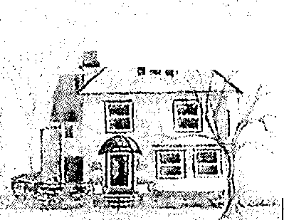

'

'

*' 'M'r·* ·-,- •-:-' / *,,:*

,, '

- r

28 Linwood Road Lynn, MA 01905-1638

#### Tel: (781) 592-8000

##### Fax: (781) 598-1556

E-Mail: [Raugeri@phillipsmanor.com](mailto:Raugeri@phillipsmanor.com) [www.phillipsmanor.com](http://www.phillipsmanor.com/)

October 18, 2024

Commissioner of Medical Services

Executive Office of Health & Human Services Division of Medical Assistance

600 Washington Street, 5th Floor Boston, MA 02111

Dear Commissioner,

Enclosed please find a voluntary closure plan for Phillips Manor Nursing Home, located at 28 Linwood Road, Lynn, Massachusetts 01905 and sample notification letters.

It has been determined by the owners that Phillips Manor Nursing Home should close.

We plan to adhere to the closure plan in accommodating every resident in the relocation process, once this plan is approved.

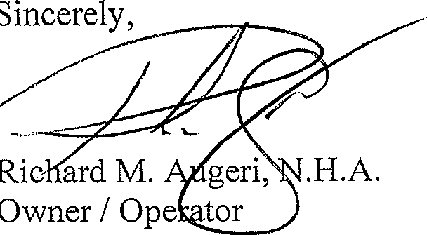Should you need further information please contact me at (781) 592-8000 or (781) 420-9245. I await your further instructions.

## Phillips Manor Nursing Home

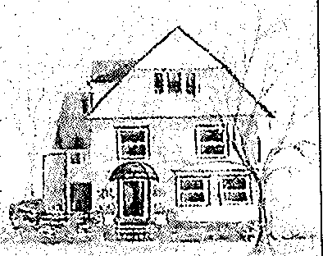

#### 28 Linwood Road Lynn, MA 01905-1638

Tel: (781) 592-8000

Fax: (781) 598-1556

E-Mail: [Raugeri@phillipsmanor.com](mailto:Raugeri@phillipsmanor.com) [www.phillipsmanor.com](http://www.phillipsmanor.com/)

October 18, 2024

Massachusetts L.T.C. Ombudsman Program 1 Ashburton Place

Room 517

Boston, MA 02108 Dear Carolyn Fenn,

Enclosed please find a voluntary closure plan for Phillips Manor Nursing Home, located at 28 Linwood Road, Lynn, Massachusetts 01905 and sample notification letters.

It has been determined by the owners that Phillips Manor Nursing Home should close.

We plan to adhere to the closure plan in accommodating every resident in the relocation process, once this plan is approved.

Should you need further information please contact me at (781) 592-8000 or (781) 420-9245.

I await your further instructions.

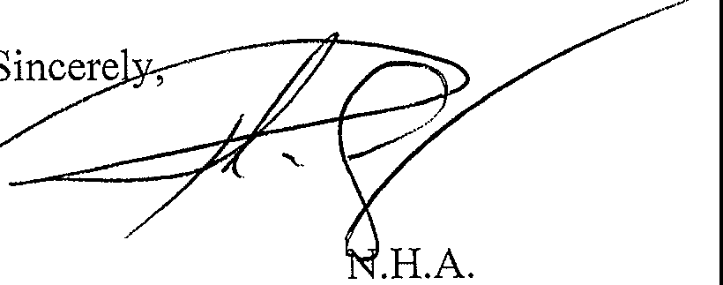

Richard M. Augeri,

Owner / Operator

### Phillips Manor Nursing Home

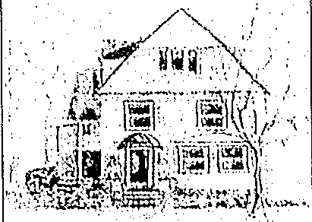

#### 28 Linwood Road Lynn, MA 01905-1638

Tel: (781) 592-8000

Fax: (781) 598-1556

E-Mail: [Raugeri@phillipsmanor.com](mailto:Raugeri@phillipsmanor.com) [www.phillipsmanor.com](http://www.phillipsmanor.com/)

October 18, 2024

Greater Lynn Senior Services 8 Silsbee Street

Lynn, MA 01901

Dear Jillian,

Enclosed please find a voluntary closure plan for Phillips Manor Nursing Home, located at 28 Linwood Road, Lynn, Massachusetts 01905 and sample notification le ers.

It has been determined by the owners that Phillips Manor Nursing Home should close.

We plan to adhere to the closure plan in accommodating every resident in the relocation process, once this plan is approved.

Should you need further information please contact me at (781) 592-8000 or (781) 420-9245. I await your further instructions.

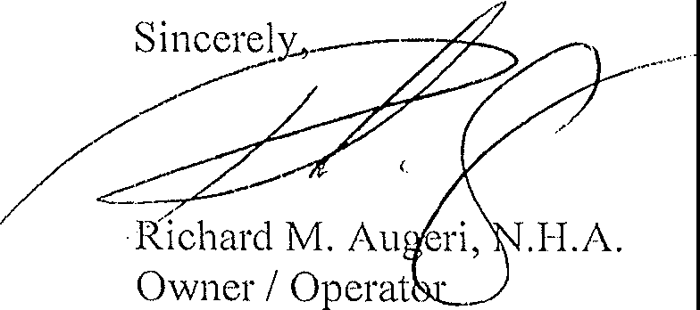

### Phillips Manor Nursing Home , ,

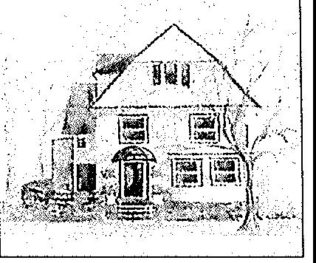

28 Linwood Road Lynn, MA 01905-1638,, · '1• .j '

Tel: (781) 592-8000 .. IS A i;J: B

3

Fax: (781) 598-1556 • 2024 OC \

E-Mail: [Raugeri@phillipsmanor.com](mailto:Raugeri@phillipsmanor.com) [www.phillipsmanor.com](http://www.phillipsmanor.com/)

October 18, 2024

Mayor Jared Nicholson 3 City Hall Square Lynn, MA 01901

Dear Mayor,

Enclosed please find a voluntary closure plan for Phillips Manor Nursing Home, located at 28 Linwood Road, Lynn, Massachusetts 01905 and sample notification letters

It has been determined by the owners that Phillips Manor Nursing Home should close.

We plan to adhere to the closure plan in accommodating every resident in the relocation process, once this plan is approved.

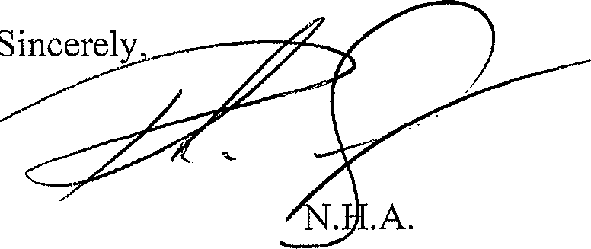Should you need further information please contact me at (781) 592-8000 or (781) 420-9245. I await your further instructions.

Richard M. Auger·, Owner *I* Operator

### Phillips Manor Nursing Home

##### 28 Linwood Road Lynn, MA 01905-1638

Tel: (781) 592-8000

Fax: (781) 598-1556

E-Mail: [Raugeri@phillipsmanor.com](mailto:Raugeri@phillipsmanor.com) [www.phillipsmanor.com](http://www.phillipsmanor.com/)

October 18, 2024

Dear Mr. Wong,

Enclosed please find a voluntary closure plan for Phillips Manor Nursing Home, located at 28 Linwood Road, Lynn, Massachusetts O1905 and sample notification letters

It has been determined by the owners that Phillips Manor Nursing Home should close.

We plan to adhere to the closure plan in accommodating every resident in the relocation process, once this plan is approved.

Should you need further information please contact me at (781) 592-8000 or (781) 420-9245. I await your further instructions.

*�/*



Sincere].Y.,-·

Richard M. Augeri Owner *I* Operator

/

/

**cc:**

EOEA

State Long Term Care Ombudsman

# Phillips Manor Nursing Home

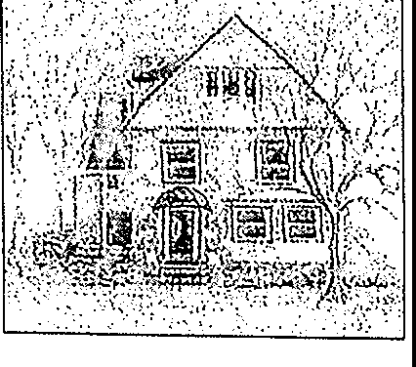

28 Linwood Road Lynn, MA 01905-1638

Tel: (781) 592-8000

Fax: (781) 598-1556

E-Mail: [Raugeri@phillipsmanor.com](mailto:Raugeri@phillipsmanor.com) [www.phillipsmanor.com](http://www.phillipsmanor.com/)

Dear ,

It is the purpose of this letter to inform you of the owner's decision to close the Nursing Home. As required under Massachusetts law, we have submitted a voluntary closure notice and plan to the Massachusetts Department of Public Health (DPH). This plan once approved will be available for your review. Please contact the Administrator should you wish to obtain a copy of the plan.

The closure process entails 1) notification to you, your family or legal representative, your physician and other care givers, 2) reassessment of your needs, 3) finding an appropriate placement and

4) arranging for your relocation along with all your belongings and appropriate clinical records. The closing of the facility will be done with a minimum of disruption and inconvenience to you and our other residents. A family and resident meeting will be held at the Nursing Home on Monday, November 4, 2024, from 4 p.m. to 6 p.m. and again on Friday, November 8, 2024, from 10 a.m. to noon to review the closure process and to answer any questions you may have.

The management of the Nursing Home will be responsible for ainnging your transfer to an appropriate healthcare facility. In accordance with state law, we will endeavor to find the most appropriate placement within a twenty-five-mile radius of this home or your family. Every effort will be made to obtain your input in finding an acceptable healthcare facility.

There are federal and state laws which relate to the transfer or discharge of nursing home residents. Under Massachusetts law, we are required to inform you of a voluntary closure at least 60 days in advance of your transfer or discharge. Therefore, you will not be transferred before Monday, December 16, 2024.

Of course, if an opening is found in a nursing home or other appropriate setting and you wish to take advantage of that opportunity, we will facilitate your discharge or transfer as early as you wish.

Under federal law, you are entitled to a 30-day advance notice which contains specific information about the date and place to which you will be transferred or discharged. Also, under the federal law, you have the right to appeal the transfer or discharge if you are not satisfied with the arrangements that are made. When a specific relocation decision has been made, you will receive a separate letter with more specific information on the relocation and your rights.

If you have any questions about the closure process, you may call the Aqministrator or the Social Worker at (781) 592-8000.

Richard M. Augeri, Owner / Operator

## Phillips Manor Nursing Home

28 Linwood Road Lynn, MA 01905-1638

Tel: (781) 592-8000

Fax: (781) 598-1556

E-Mail: [Raugeri@phillipsmanor.com](mailto:Raugeri@phillipsmanor.com) [www.phillipsmanor.com](http://www.phillipsmanor.com/)

**30-DAY APPEAL**

Date:

Dear

The purpose of this letter is to notify you that the Nursing Home will be transferring you on . We are transferring you because Phillips Manor Nursing Home is closing.

Arrangements have been made for you to be admitted to _

You have the right to appeal this decision. If you wish to appeal, you must put your request in writing and mail to: Division of Medical Assistance

Board of Hearings 100 Hancock Street

Quincy, MA 02171

1-(800) 655-0338, Fax 617-847-1204

If you file an appeal within thirty (30) days after receiving this notice, you will not be

trat1. fyrryd.-9.r disctarge,d u.ntil after a decision.l?,a. 11 made,:i:egarct{ng ½O\lf;&P1wab ,;,*:.,,i.�* • .·:'.·,.. .< •.·,_,•

For additional information or assistance, you may also contact the State Long Term Care Ombudsman at 1 Ashburton Place, 5th Floor, Boston, MA 02108, 1-(800)-243-4636.

Disability Law Center, 11 Beacon Street, Suite 925, Boston, MA 02108, (617) 723-8455 or 1-

(800) 872-9992.

OR

Center for Public Representation, 22 Green Street, Northampton, MA 01060, (413) 586-6024

or (617) 965-0776.

If you have any other questions about this notice, please contact the Administrator, the Director of Nursing or the Social Worker at (781) 592-8000.



# Phillips Manor Nursing Home

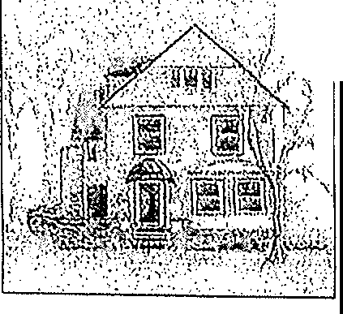

*�•;_(�i�*

*': .*.,··-.

*,·_;{·.·*

·/,

;.

**>:j**

·\:

28 Linwood Road Lynn, MA 01905-1638

Tel: (781) 592-8000

Fax: (781) 598-1556

E-Mail: [Raugeri@phillipsmanor.com](mailto:Raugeri@phillipsmanor.com) [www.phillipsmanor.com](http://www.phillipsmanor.com/)

October 18, 2024 Dear Doctor Anand,

It has been determined by the owners that the Phillips Manor Nursing Home will be closed.

The management of the Nursing Home will need to coordinate with you to arrange for the relocation of your patient(s).

Name of Patient(s):

* Reade, Virginia
* Byrne, Maryanne
* Harrison, Barbara
* Tanzella, Rita
* Kelley, Christina
* Walkey, Sharon
* Wiggin, Dorothy
* Taylor, Maryellen
* Assimakopoulos, June
* King, Barbara
* Davis, Esther

At this time, the management of the Phillips Manor Nursing Home is notifying all the residents and their families of the impending closure. Our staff will be evah:tating each resident's medical and social needs and the availability of long-term care beds in the area to find an appropriate match. We will be contacting you very soon to solicit your input into this relocation effort.

The Massachusetts Department of Public Health and Public Welfare have been notified of the impending closure and will be providing assistance if needed, in the resident relocation effort.

For information or assistance, you may contact the Administrator of Phillips Manor Nursing Home at (781) 592-8000 or (781) 420-9245.

Sincerel ----- _,. •--•

*-.L--*

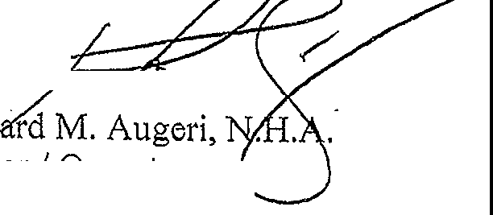

0--· Operator