

Submitted by:

Executive Office of Elder Affairs
One Ashburton Place
5th Floor
Boston, MA 02108
Massachusetts
Senior Community Services
Employment Program
State Plan
2012-2015

DRAFT
November 25, 2014

Table of Contents
Introduction 3
Section I. Overview of Massachusetts’ Economy and Labor Market Information 4
Overall Trends in Massachusetts Economy 4
Section II. Overview of Massachusetts’ older workers and MA-SCSEP 9
Older Workers in Massachusetts 9
MA-SCSEP participants characteristics 10
Most needed areas 12
Section III. Long-term job projections and MA-SCSEP 13
Unsubsidized job placements 13
MA-SCSEP Participants’ Employment Histories and Skills 13
Possible SCSEP occupations and skill training 14
Section IV. MA-SCSEP Coordination Plan with WIA and job training initiatives 15
Coordination with 16 Regional WIBs 15
Coordination with the Massachusetts Workforce Investment Board MWIB: 16
Coordination with the One Stop Career Centers (OSCCs) 16
Coordination with other labor market and job training initiatives (20 CFR 641.302(j)) 18
Section V. MA-SCSEP Coordination with other programs 19
AAAs and ASAPs 19
The State Health Insurance Assistance Program (SHIP) Program 19
Family Caregiver Support Program 19
COAs 19
Options Counseling 20
National SCSEP Grantees 20
Section VI. Coordination of MA-SCSEP with other private and public entities and programs 21
Integration of the Chronic Disease Self-Management Education (CDSME) Programs with MA-SCSEP and One Stop Career Centers 21
Section VII. Employer engagement 22
Section VIII. Equitable Distribution Strategy 23
The relative distribution of SCSEP eligible individuals 23
PY12 Equitable distribution 24
Section IX. Service to minority and most-in-need older individuals (20 CFR 641.302 (c)) 26
Section X. Community Service Assignments 27
Section XI. Program Improvement and Monitoring 29
Program policy and communications 29
Quality assurance and program monitoring 29
Section XII. The state’s long-term strategy to improve SCSEP services 31
Increase use of On-the Job-Experience (OJE) 31
Provide Job Club training 31
Implement Skill Training 32
Increase effectiveness of the Community Service Assignments 32
Conduct re-procurement for program sub grantees 32

MA-SCSEP State Plan

PYs 2012-2015

Introduction
The Executive Office of Elder Affairs (EOEA) operates the SCSEP program (MA-SCSEP) in all counties of the Commonwealth of Massachusetts except for Nantucket, Barnstable, and Franklin and Dukes counties. The three state regional MA-SCSEP subcontractors are:

- Citizens for Citizens, Fall River, MA, (CFC) serving Bristol, Hampden, Hampshire, Middlesex, Norfolk, and Plymouth Counties.
- Elder Services of Berkshire County, Pittsfield, MA (ESBC) serving Berkshire County.
- Operation Able of Greater Boston, Boston, MA, (ABLE) serving Essex, Middlesex, Suffolk and Worcester counties.

Massachusetts recognizes the goal of the Senior Community Services Employment Program to be of a dual nature. As conveyed in the Older Americans’ Act:

- Enable older low income job seekers to develop the skills and self-confidence to obtain unsubsidized jobs and become financially self-sufficient; and

- Provide valuable community service at on-the-job training sites, as a means to improve a participant’s self-sufficiency, perform meaningful civic service, and to strengthen communities.

While developing the MA-SCSEP 2012-2015 State Plan, EOEA has taken the opportunity to take a longer term strategic view of the SCSEP in the state, including the SCSEP’s role in workforce development and the role our service network for older adults can take to advance the interests of older workers in their local economies. Under the designation of Governor Duval Patrick, the Executive Office of Elder Affairs is responsible for the development and submission of the MA- SCSEP 2012-2015 State Plan. The State Plan presents an opportunity for the Commonwealth to build new partnerships as well as strengthen existing ones, create more employment opportunities and establish more employer-outreach partners and training locations in the state.

Section I. Overview of Massachusetts’ Economy and Labor Market Information

This section describes the long-term projections for jobs in industries and occupations in the state that are likely to offer employment opportunities for older workers. (20 CFR 641.302(d))

Overall Trends in Massachusetts Economy
The 21st Century economy represents a major transformation in the industrial structure of the US and Massachusetts economy. The new information technologies and globalization represent a major transformational force in the Massachusetts economy.
Massachusetts’ economy is driven by the widespread proliferation of IT and natural sciences, “in contrast, industries that have traditionally offered more blue-collar paths to middle-class prosperity, such as traditional manufacturing and construction, continue to struggle and, despite some signs of life in recent months, remain well below their prerecession employment levels.”
Massachusetts economy shows decline of production and manufacturing. Additionally, the housing bubble had significant impact on the construction industry that also shows decline and high unemployment rate.
While Massachusetts unemployment rate is below the national average, the jobs growth is primarily in highly skilled and technical jobs. The fastest growing occupations tend to be those with education-intensive fields such as computers, life sciences and management. See charts 1 and 2.

Chart 1. Labor Force and Unemployment Data. Area: Massachusetts Unemployment rate. Seasonally Adjusted Data.

2014 LMI data, http://www.mass.gov/lwd/economic-data/
Chart 2. Labor Demand
Job Growth in Massachusetts
Based on the MassBenchmarks’ - the journal of the UMass Donahue Institute's Economic and Public Policy Research published in cooperation with the Federal Reserve Bank of Boston - analysis “Massachusetts economy is slightly different from the National trends. For the past 17 years from 1990 to 2007, the Massachusetts employed labor force expanded at a constant annual growth rate of .2%, this compares with the much higher national rate of 1.2%over the same period.

Job growth was much faster during the 1990s than since 2000, even after accounting for the shorter time period. Given a considerably lower rate of overall employment growth, it is not surprising that Massachusetts lagged national growth rates in nearly all occupational classes. The exceptions where Massachusetts growth rates exceeded the nation were life, physical, and social science occupations. These positions are in scientific research and development industry.

Although the state was nearly on a par with US growth in personal care and services, and education, training and library occupation, the largest gaps between Massachusetts and the US were in extraction, production, and protective services-related occupations.” (Extraction jobs are a part of the construction occupation, production is a part of manufacturing, and protective services-related occupation is Homeland Security, Law Enforcement, Firefighting etc)

Over the same period of time “the fastest job growth occurred among computer and mathematical occupations for both Massachusetts and the nation. Most of the jobs created within this occupation class were among computer software engineers, computer support specialists, and computer scientists and systems analysts. Combined, these occupations added more than 50,000 net jobs to the Massachusetts economy between 1990 and 2007.”

Based on the Labor Market Information (LMI) data (see Appendix A.) the following are top ten main industries that have projected job growth by 2018:
- Health Care and Social Assistance
- Professional, Scientific and Technical Services*
- Ambulatory Health Care Services
- Educational Services*
- Hospitals
- Computer Systems Design*
- Management, Scientific, and Technical Consulting Services*
- Scientific Research and Development Services*
- Administrative and Waste Management *
- Social Assistance
- Nursing and Residential Care Facilities

*Six out of ten industries are high value-added sectors, meaning that they add investment and profits to the local economy and add high value per employee (high earnings), these are not however especially effective in terms of adding new jobs.

Retail, Construction, Accommodation and Food Services, Transportation and Warehousing have the largest percentage of employees without Bachelor’s Degree or higher. See Chart 3.

Chart 3. Educational Attainment of Employees by Major Industry in Massachusetts (2008-2010)

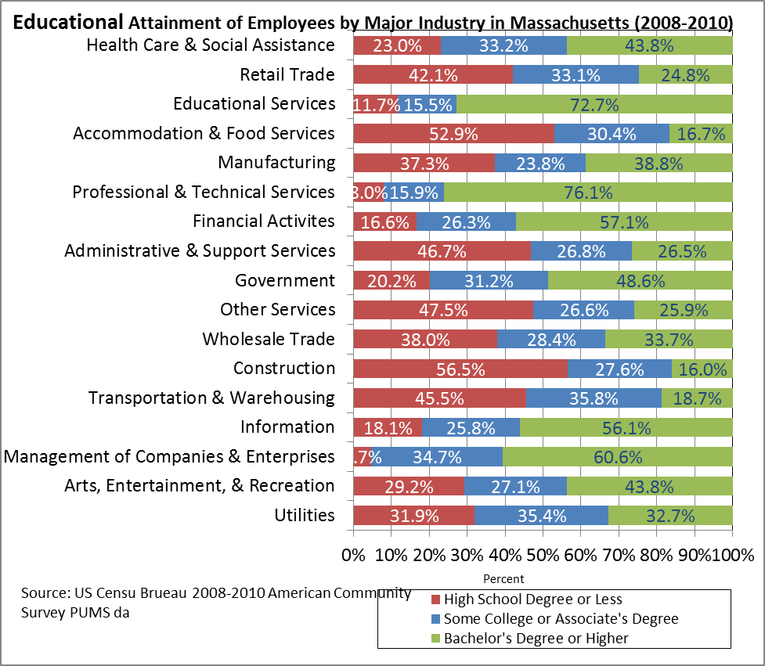
© 2012 Commonwealth Corporation

Chart 4 presents data on the following major occupations require mostly High School Degree and some College or Associate Degree. Some of these might provide a good match for SCSEP participants.
- Food Preparation & Serving
- Production
- Construction & Extraction
- Building and Grounds Cleaning
- Personal Care
- Installation, Maintenance and repair
- Healthcare support (see Chart 4 for more details)

Chart 4. Educational Attainment of Employees by Major Occupation in Massachusetts (2008-2010)

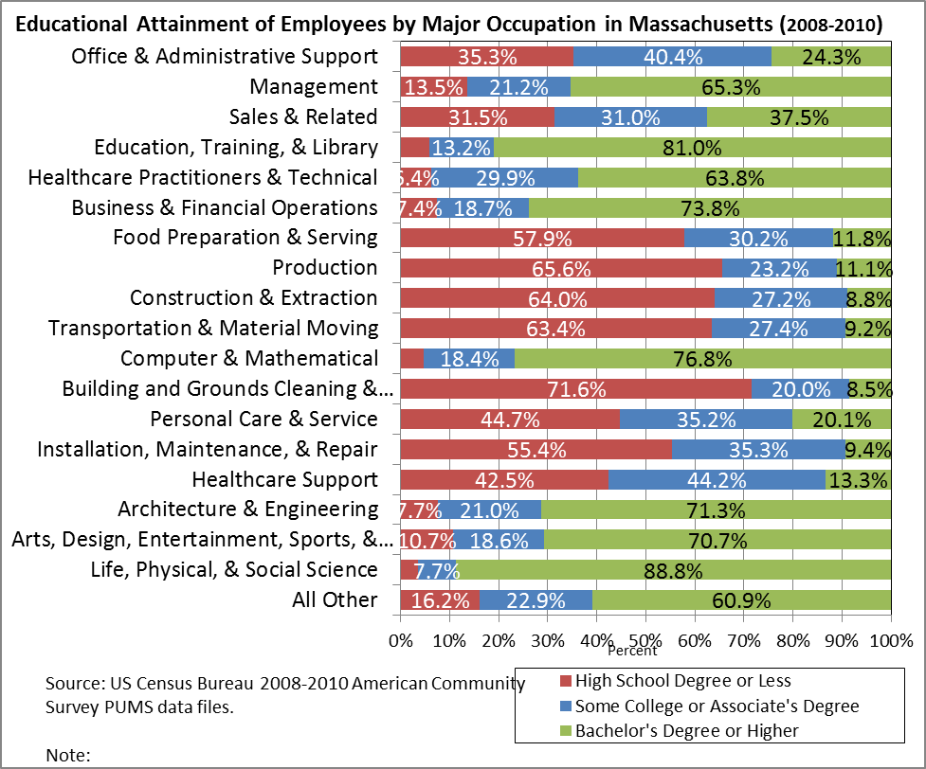
© 2012 Commonwealth Corporation

Section II. Overview of Massachusetts’ older workers and
MA-SCSEP
This section discusses the needs of mature workers, MA-SCSEP participants and the localities with the most need for SCSEP services.

Older Workers in Massachusetts

Based on the recent study by the Commonwealth Corporation and the Center for Labor Markets and Policy at Drexel University, “Massachusetts has a somewhat larger and more rapidly growing share of the older population than the nation. The older population is projected to be the source of all the population growth in the state between 2000 and 2030. Between 2008 and 2020, the share of older workers in the labor force is projected to increase from 19 percent to nearly 27 percent (24.6 percent in the nation).”
According to the same study, “the largest increase in the older worker share in the state occurred in the construction industry, rising by two-thirds, from 10.3 percent in 2003 and 10.7 percent in 2007 to 17.3 percent in 2010.

Chart 5. The Share of the Total Resident Population in the U.S and Massachusetts that is 55 Years or Older, 1950-2030

©Paul Harrington Center for Labor Markets and Policy Drexel University, “The Increased Presence of Older Workers in the Massachusetts Labor Market: Implications for Workforce Development Policies, Workplace Accommodation, and Universal Design.”
In 2010, nearly 21% of all workers were 55 and older, up from 16% in 2003; an increase of 30% over just 7 years.
This trend is expected to accelerate in the future since all of the labor force growth is projected to occur among those 55+ (44% increase) while the under 55 labor force growth is projected to decline (-7% decline).
The professional and business services sector also saw a sharp increase (45 percent) in the share of older workers; from 13 percent in 2003 to 16.8 percent in 2007 and nearly 19 percent in 2010.
Older worker shares increased between 2007 and 2010 by 40% in repair and maintenance services and personal services sector, by 35% in the education and healthcare sector, 30% in the retail and wholesale trade sector, and over one-quarter in the manufacturing sector of the state.
In 2010 the share of older workers across industry sectors varied from over 28 percent in the repair, maintenance, and personal services sector, nearly one-quarter in the educational services and healthcare and manufacturing sectors, and one-fifth in retail and wholesale trade establishments to 13 percent in the leisure and hospitality sector.
Sharp increases in the concentration of older workers in the shrinking goods-producing sectors of construction and manufacturing places them at increased risk of displacement, especially for those with fewer years of schooling.”

MA-SCSEP participants characteristics

Currently demographic data for MA-SCSEP participants suggests that participants are primarily female, between 55-64 years of age, with High School diploma or 1-3 years of college. However, in 2012-2015 the numbers of male participants are likely to increase due to the shrinking construction and manufacturing industry. Charts 6, 7 and 8 show demographic data for MA-SCSEP participants.

PY12 MA-SCSEP Demographic Data:
Chart 6. Gender

Chart 7. Education Level of MA-SCSEP Participants

Chart 8. Enrollment Age of MA-SCSEP Participants

Most needed areas
The following data on Chart 9 is based on the current unemployment rates for Massachusetts, identifies those localities for which projects of the type authorized by Title V are most needed (20 CFR 641.325 (d).) These areas are with the unemployment rate above the state average.

Chart 9. Unemployment Rate for Massachusetts and Labor Areas (Data not seasonally adjusted)
September 2014.

Section III. Long-term job projections and MA-SCSEP
This section describes current and projected employment opportunities in the state, the types of skills possessed by eligible SCSEP individuals, and how the long-term job projections relate to the types of unsubsidized jobs for which SCSEP participants will be trained and the types of skill training to be provided. (20 CFR 641.302(d)(20 CFR 641.325(c).)

Unsubsidized job placements
The long-term job projections in Massachusetts present a significant challenge to MA-SCSEP. Most participants are working to overcome multiple barriers to employment while seeking jobs in a highly competitive labor market. Majority of MA-SCSEP participants seek and enter entry-level jobs.

In 2010-2011 EOEA conducted a participant self-assessment survey. The survey was distributed by mail to the participants and Host Agencies in all counties EOEA serves except for Berkshire County. The participants’ survey helped identify the job interests of the participants, self-assessment of skills and other needs, such as transportation needs and desired commute time. Host Agency supervisors were asked to provide assessment of their participants’ skills and job readiness. The results showed that majority of participants prefer Office and Administrative Support Jobs, while lacking basic Microsoft Office skills. Also, it indicated that majority of participants are interested in part-time jobs with commute time not to exceed 30 minutes. Majority of participants indicated their own transportation as the main means of commuting to work. (See Appendix B. Summary of MA-SCSEP Survey, 2010-2011)

EOEA will continue to asses and evaluate MA-SCSEP participants’ skills and job interests, while focusing on specific occupations and skill training pathways.

MA-SCSEP Participants’ Employment Histories and Skills

MA-SCSEP participants often have gaps in their work histories for the two-three years prior to their enrollment; many have outdated job skills. Other participants have some job skills and have been unable to find employment due to barriers such as assumed age discrimination, physical limitations, and transportation. Computer illiteracy and level of education continue to be the greatest barriers to employment. Based on MA-SCSEP sub grantees feedback the following outlines typical skill profiles for SCSEP participants:

- MA-SCSEP participants have low computer literacy rates and require basic computer literacy training from learning to use the mouse and Microsoft;

- Participants previously employed in labor, construction, and production industries often have physical or health limitations and are no longer able to perform physically demanding duties, such as required for these types of jobs.

- Typically, MA-SCSEP participants focus on such entry level job goals as receptionist, file clerk, cashier, maintenance and janitorial worker, customer service representative, sales clerk, and food preparer and server.

- To compete for existing jobs, most participants need basic skills training to acquire new skills or update existing skills.

- Participants with mental health needs have especially poor employment prospects and often only achieve unsubsidized employment at their Host Agencies.

- The unsubsidized placement can be particularly difficult in rural areas.

As discussed above there is a mismatch of current and projected employment opportunities and the skills MA-SCSEP participants possess. However, there are certain areas where participants can utilize their soft skills, or the occupation is not requiring more than HS or Associate Degree, for example, in healthcare industry there are growing occupations that do not require a bachelor’s degree, such as Home Health Aides (HHA), or community health workers.

Possible SCSEP occupations and skill training

EOEA will continue to work with MA-SCSEP sub grantees to:

- Identify most likely jobs and training or certificate needed.
- Identify low-cost training providers.
- Identify interested participants and place them into the relevant training.

Given the educational and work experience of MA-SCSEP participants, and the projected occupational growth, the most likely unsubsidized jobs will be entry-level positions. The following table identifies key occupations areas that hold promise for employing MA-SCSEP participants and the types of skills training that could prepare them for unsubsidized employment.

Occupation | Example Skills training
Food Preparation and Serving | ServSafe Food Handler Program
Building and Grounds Cleaning and Maintenance | Green Building Maintenance
Healthcare support | PCA, HHA

Section IV. MA-SCSEP Coordination Plan with WIA and job training initiatives
This section describes the coordination plan for MA-SCSEP with WIA, One Stop Career Centers (OSCCs) and other labor market and job training initiatives. (20 CFR 641.302(g), 641.325(e))
The planned actions to coordinate activities of SCSEP grantees with WIA title I programs, including plans for using the WIA One-Stop delivery system and its partners to serve individuals aged 55 and older are outlined. (20 CFR 641.302(g), 641.325(e))
The actions to ensure that SCSEP is an active partner in the One-Stop delivery system and the steps the state will take to encourage and improve coordination with the One-Stop delivery system are described. (20 CFR 641.335)

Coordination with 16 Regional WIBs
EOEA has been working with the Massachusetts Workforce Board Association to raise awareness of mature workers job needs and the capacity of the MA-SCSEP to train and place qualified workers. EOEA will continue to work closely with the Massachusetts Workforce Board Association to address the needs of mature workers in the state. MA-SCSEP sub grantees have MOUs and are active members of local WIBs in our service areas. EOEA and MA-SCSEP sub grantees will continue to work with the local WIBs to ensure the most effective strategies to help MA-SCSEP participants obtain unsubsidized employment.

Year One
1. EOEA will work with local WIBs to develop better strategies for linking the older worker population with businesses that are searching for skilled workers by arranging for increased outreach efforts by aging services organizations in their service network. A key step will be to work with Councils on Aging to outreach to older workers and connect them with the One Stop Care Centers, with the use of and support by One Stop Career Center materials and staff.

2. In 2011 the Massachusetts Association of Councils on Aging (MCOA) piloted a new Job Search Skills Training Program for unemployed older adults age 55+, titled Job Search Skills Training Program. The program was first developed at the Marblehead COA, Essex County in 2009. The Job Search Skills Training Program workshop is offered at local COAs over a 4-6 week period, 3 hours per week and is taught by HR volunteers. EOEA will continue to work with MCOA to further connect their efforts with the WIA system. In particular, EOEA plans on coordinating with Councils on Aging so they can:
- Connect Job Search Skills Training Program with MA-SCSEP sub grantees to use the Job Search Skills Training Program workshop as a tool to help improve MA-SCEP participants’ job placement rates.
- Post COAs’ job openings at the One Stop Career Centers and with SCSEP.
- Promote the employment of older workers to local businesses, both public and private, and promote their use of the One Stop Career Centers to post jobs and recruit workers.
- Write and speak about the benefits of hiring older workers in their newsletters and public events.
- Include older workers’ issues in their brochures and outreach efforts.
- Make sure the information and referral staff at Councils on Aging and regional Area Agencies on Aging are aware of training programs and employee assistance services and can make appropriate referrals to employment and training programs.

Year Two
- Work with the WIBs on how to develop and implement a campaign to encourage businesses to:
- Recruit mature workers from the One Stop Career Centers.
- Consider adopting alternative work arrangements and phased retirement programs to attract and retain mature workers.
- Provide feedback to the public workforce investment system about the quality of referrals and services received at the local One Stop Career Centers.

- Work with the WIBs and One Stop Career Centers to monitor the performance of local One Stop Career Centers on the percentage of mature older workers placed in jobs.
- As needed, develop new strategies in response to low performance findings and incorporate these plans into the local WIB work plans.

Coordination with the Massachusetts Workforce Investment Board MWIB:

The mission of the Massachusetts Workforce Investment Board (MWIB) advises the Governor on continuously improving the Massachusetts Workforce Development system. EOEA will explore the possible re- appointment of the MA-SCSEP Director to the Statewide Massachusetts WIB.
EOEA will work with the MA WIB to enhance the services of the One Stop Career Centers provided to mature workers 55 and older by developing an older worker program. EOEA will assist the MWIB, the Executive Office of Labor and Workforce Development and the One-Stop Career Centers to develop funding to support services created as part of a targeted program. Such a program would mean the following changes to the current workforce development system:
- Make Career Centers more user-friendly for people 55 and older
- Offer more skill training classes geared to people 55 and over
- Establish more effective employer pipelines to hire older workers

Coordination with the One Stop Career Centers (OSCCs)

EOEA and MA-SCSEP sub grantees have been active partners with OSCCs. In the past EOEA offered training of OSCCs’ staff on MA-SCSEP program capacity and the benefits of hiring mature workers.

In 2012-2012 EOEA will continue working with One Stop Career Centers to conduct educational sessions for OSCCs staff about the unique aspects of serving SCSEP participants that are hardest to serve due to barriers, including:
- need for more pre-employment skills development and training
- disability
- lack of or limited transportation
- language/cultural barriers
- CORI

In collaboration with MA-SCSEP sub-grantees, EOEA will explore strategies to expand the availability of new and relevant job placements for MA-SCSEP participants.

Year One:
- Conduct state-wide assessment of employers and job openings in Food Preparation and Serving, Building and Grounds Cleaning and Maintenance, and Healthcare support occupations.
- Engage local employers from these industries to identify their workforce needs and pathways for MA-SCSEP participants to obtain unsubsidized placements with these employers.
- Analyze currently enrolled MA-SCSEP participants’ job interests and skills needed to obtain jobs in these areas.
- Evaluate Host Agency assignments to increase the effectiveness of Host Agencies in providing skills training that meets the needs of MA-SCSEP participants.
- Identify existing low-cost basic skills training vendors in these occupations.
- Pilot job readiness training through local One Stop Career Centers.

Year Two:
- Evaluate success of the pilot skills training, and
- Assess benefits of disseminating the training in other parts of the state.

Year Three-Four:

- Continue to analyze the skill training and job placement rates for MA-SCSEP participants.
- Develop additional types of occupational training.

In partnership with the Executive Office of Labor and Workforce Development, EOEA will develop and fund SCSEP-specific training curriculum at local OSCCs.

Year One

- Pilot job readiness training through the One Stop Career Centers in Springfield to serve 27 authorized positions in Hampden County and Franklin/Hampshire Career Center to serve 2 authorized positions in Hampshire County.

Year Two

- Evaluate training curriculum and delivery model. Assess benefits of and begin disseminating this training through other areas of the state.

Year Three- Four
- In conjunction with the 34 OSCCs continue to improve and provide job readiness training for all SCSEP participants.

Coordination with other labor market and job training initiatives (20 CFR 641.302(j))

MA-SCSEP will identify appropriate job training initiatives across the state in the above mentioned occupations and develop SCSEP specific training to obtain certificates.
MA-SCSEP will also continue to provide cross-training for MA-SCSEP sub grantees’ staff with other workforce development agencies.
For example, EOEA recently established a relationship with Commonwealth Workforce Coalition (CWC). This mission of CWC is to strengthen the capacity of Massachusetts’ community-based education, training, and employment system to produce better employment and earnings outcomes for low income residents and low wage workers. CWC focuses on building the skills and knowledge of direct service and program management staff; supporting increased communication networks and connection among practitioners and other system stakeholders; and developing and strengthening leaders within the workforce development field. CWC also provides staff development training and workshops on working with population with multiple barriers to employment.
EOEA will continue to work with CWC to organize training for MA-SCSEP sub grantees’ staff on how to work with ex-offenders, clients with difficult personalities and/or mental health needs and other staff development training.

Section V. MA-SCSEP Coordination with other programs
This section will describe the actions to coordinate MA-SCSEP with grantees with the activities being carried out in the state under the other titles of the Older Americans Act (OAA). (20 CFR 641.302(h))

AAAs and ASAPs
EOEA will continue to work with the AAAs, ASAPs and other service providers to coordinate access to the full array of social services. MA-SCSEP sub-grantees refer participants to the local AAA and ASAP I&R specialist and/or caregiver specialist, SHIP Program, and other services in order to make sure they are aware of all the ways they can stretch their limited pre-employment income and also use other supports as needed to remove barriers to employment.

EOEA will continue to collaborate with the Money Management Program offered by local AAAs to assist seniors with financial literacy and planning.

The State Health Insurance Assistance Program (SHIP) Program
SHIP (SHINE) volunteers are available to assist MA-SCSEP participants in understanding the basics of the Medicare health insurance program, Prescription Advantage Program, coverage gaps, supplemental insurance and prescription drug coverage options. This is important for the MA-SCSEP participants for their financial and healthcare planning.

MA-SCSEP will continue to refer SCSEP participants to SHINE for counseling.

Family Caregiver Support Program
According to a 2008 AARP survey of older workers, “about one-quarter (26%) of 45-74 year old workers currently care for one or more children, and nearly one in five (18%) provide care for a spouse. One in every seven (14%) older workers has responsibility for caring for both a child and an adult.”

The Family Caregiver support program provides one-on-one counseling, support groups, workshops, and respite, and can help to support family caregivers in SCSEP.

MA-SCSEP will continue to refer SCSEP participants to the Family Caregiver support program.

COAs
EOEA will continue to provide COAs with SCSEP program materials they can use as a part of the Job Search Skills Training Program workshop.

Options Counseling
Options Counseling is a gateway for many Massachusetts elders and people with disabilities to receive community supports and services. Launched throughout the Commonwealth in 2010, Options Counseling provides residents with objective information about long-term services and supports that can make the difference between people remaining in their homes -- or other preferred residential setting -- or placement in a nursing facility.
The program ensures that elders and people with disabilities have the opportunity to consider long-term support options at a variety of points in the planning process, not just prior to nursing facility admission. The timing and the number of counseling sessions provided depend on a consumer’s individual need for information and decision-making support.
Options Counseling service is accessible through the Commonwealth’s eleven Aging and Disability Resources Consortia (ADRCs). The counselors are located at ASAPs and Independent Living Center (ILCs.)
ADRCs are a local collaboration between Aging Service Access Points (ASAPs), Area Agencies on Aging (AAAs) and Independent Living Centers (ILCs) throughout the state.
EOEA will establish closer working relationships with the local ADRCs and ILCs to provide information about the SCSEP to their network, while ensuring that program participants are aware of the long-term services available in their community.

National SCSEP Grantees
EOEA shall continue to work with the National Grantees partners that include National ABLE, Senior Service America Inc. and the National Urban League. As the state SCSEP administrator, the Executive Office of Elder Affairs continues to:

- Negotiate the slot exchanges in selected counties;
- Develop of the annual Equitable Distribution and the State Coordination Plan;
- Promote collaboration with the One-Stop Delivery System and the recognition and promotion of mature workers state-wide;
- Coordinate the management of the respective SCSEP resources to the maximum benefit of participants, including participant transfer when approved by the Department of Labor;
- Work together to increase efficiency and efficacy of the mutual sub-recipients;
- Refer SCSEP applicants for aging and employment services to local providers;
- Continues partnering on special projects such as job fairs, training, workshops and conferences benefiting older workers especially where sub-recipients are shared;
- Host quarterly SCSEP meetings for all SCSEP providers to share “best practices” and enhance a coordinated approach to serving all SCSEP participants in the Commonwealth; and

Section VI. Coordination of MA-SCSEP with other private and public entities and programs
This section will outline the work that EOEA does with a variety of private and public entities and programs that provide services to older Americans and programs for those with special needs or disabilities. (20 CFR 641.302(i))

Integration of the Chronic Disease Self-Management Education (CDSME) Programs with MA-SCSEP and One Stop Career Centers
EOEA plans to explore ways to provide CDSME training to interested individuals through the One Stop Career Center system.

Background information on CDSME

CDSME programs include the following evidence-based programs: Chronic Disease Self-Management Program (CDSMP), Tomando Control de su Salud (Tomando- Spanish CDSMP) and Diabetes Self-Management Program (DSMP), both in English and Spanish, the Chronic Pain Self-Management Program. Also, an on-line version of CDSMP will be available.

Developed by Stanford University, CDSME programs are taught by lay leaders and provide a wide array of tools that can help people living with chronic health conditions:
- learn how to better manage their conditions
- develop action planning and problem solving skills
- gain confidence and self-esteem.

Recently EOEA developed a model integrating Chronic Disease Self-Management Program (CDSMP) workshops and the SCSEP. EOEA’s vision is to use CDSMP as a tool to:
- maximize employability of SCSEP participants with chronic conditions,
- help prepare job seekers to thrive in a workplace, and
- selected SCSEP participants may also be trained to become CDSMP workshop leaders.

CDSME provides a wide array of tools that can help those living with chronic health conditions and their caregivers learn how to better manage their conditions, develop personal goals, gain confidence and feel more positive about their lives, start and sustain healthier behaviors, communicate more effectively with healthcare providers, and make daily tasks easier (among others). The workshops are designed to help participants better manage their chronic conditions and to provide them with the tools to develop a realistic and attainable action plan for job search.

CDSME training is currently underway and is offered in English and Spanish in collaboration with local community based organizations serving people with disabilities in different regions. In the past two years MA-SCSEP completed CDSME workshops for 8 participants in Middlesex and Suffolk counties and 10 participants in Bristol County. MA-SCSEP sub grantees received very positive feedback from the participants.

Background information on disability and One Stop Career Centers services to people with disabilities:

Based on the U.S. Census Bureau report, Americans with Disabilities: 2010 about 56.7 million people ─ 19 percent of the population ─ had a disability in 2010, according to a broad definition of disability, with more than half of them reporting the disability was severe.
The report shows that 41 percent of those age 21 to 64 with any disability were employed, compared with 79 percent of those with no disability. Along with the lower likelihood of having a job came the higher likelihood of experiencing persistent poverty; that is, continuous poverty over a 24-month period. Among people age 15 to 64 with severe disabilities, 10.8 percent experienced persistent poverty; the same was true for 4.9 percent of those with a non-severe disability and 3.8 percent of those with no disability.
In FY2010 there were a total of 13,121 people with disabilities served by the Massachusetts OSCCs.

Section VII. Employer engagement
This section will outline the state’s long-term strategy for engaging employers to develop and promote opportunities for the placement of SCSEP participants in unsubsidized employment. (20 CFR 641.302(e))
EOEA has been working with the Business Service Representatives (BSRs) at OSCCs. Business Service Representatives work with employers find qualified new hires through OSCCs system. In collaboration with the Executive Office of Labor and Workforce Development EOEA will continue to work closely with the Business Service Representatives to:
- Raise their awareness about the needs of mature workers
- Educate them on goals and capacity of MA-SCSEP
- Coordinate employer outreach and recruitment
- Develop a marketing plan to better promote and market people with barriers to employment to the local employers

Section VIII. Equitable Distribution Strategy
This section will describe the state’s long-term strategy for achieving an equitable distribution of SCSEP positions within the state.

The relative distribution of SCSEP eligible individuals
Table 10 shows a profile of Massachusetts General Population the distribution of eligible individuals who are afforded priority service as provided under the Older Americans’ Act, section 518(b): the relative distribution of—‘‘(i) eligible individuals who are individuals with greatest economic need;‘‘(ii) eligible individuals who are minority individuals; and‘‘(iii) eligible individuals who are individuals with greatest social need;
Chart 10. Massachusetts: Profile of General Population 2010. (Based on the U.S. Census Bureau)

Urban and Rural Populations (Based on the U.S. Census Bureau) distribution of individuals residing in rural and urban areas of Massachusetts is presented in the Chart 11 below.

Chart 11.
Year | Rural | Urban | Total
1980 | 14,029 | 5,723,064 | 5,737,093
1990 | 17,651 | 59,981,774 | 6,016,425
2000 | 24,507 | 6,324,590 | 6,349,097
2007 | 26,016 | 6,423,739 | 6,449,755
http://www.census.gov/

Provided below is the current PY14 Equitable Distribution

PY14 Equitable distribution
Provided below is the proposed PY14 Equitable distribution. See Chart 12.
 |  |  | PY 14 ED
County | Total Population | SCSEP eligible number of people | All Grantees | State Grantee | National Grantees
Barnstable | 215,769 | 7,220 | 33 | 0 | 33
Berkshire | 129,288 | 5,380 | 24 | 24 | 0
Bristol | 548,922 | 17,960 | 90 | 0 | 90
Dukes | 16,766 | 655 | 3 | 0 | 3
Essex | 748,930 | 23,360 | 110 | 26 | 84
Franklin | 71,599 | 2,445 | 12 | 0 | 12
Hampden | 463,783 | 17,995 | 85 | 29 | 56
Hampshire | 157,822 | 3,860 | 18 | 0 | 18
Middlesex | 1,518,171 | 35,120 | 169 | 49 | 120
Nantucket | 10,142 | 405 | 1 | 0 | 1
Norfolk | 675,436 | 14,360 | 67 | 17 | 50
Plymouth | 497,579 | 11,315 | 52 | 13 | 39
Suffolk | 730,932 | 32,225 | 142 | 14 | 128
Worcester | 801,227 | 21,935 | 101 | 22 | 79
Statewide Total | 6,586,366 | 194,235 | 907 | 194 | 713

Source U.S. Census Bureau: State and County QuickFacts. Data derived from Population Estimates, American Community Survey, Census of Population and Housing, State and County Housing Unit Estimates, County Business Patterns, Nonemployer Statistics, Economic Census, Survey of Business Owners, Building Permits, Consolidated Federal Funds Report
Last Revised: Thursday, 07-Jun-2012 13:34:52 EDT

EOEA will continue to work with the new National Grantees, that include the National ABLE, Senior Service America Inc. and the National Urban League, to analyze the LMI data, SCSEP population needs, underserved locations in the state, rural and urban areas populations and their specific challenges to obtain and retain the unsubsidized employment.

Section IX. Service to minority and most-in-need older individuals (20 CFR 641.302 (c))

This section describes the strategies to ensure most effective service to minorities and most-in-need older individuals.

The Executive Office of Elder Affairs, through its elder network and partner agencies, serves all residents of the Commonwealth, reaching out to minority communities through local community service agencies, minority newspapers, and churches. The new immigrant populations in the Commonwealth are mainly Hispanic, Portuguese, Somali, Haitian and Vietnamese.

Key Strategies that MA-SCSEP will use to continue to increase culturally competent service to minorities is a combination of:

  - Ensuring culturally competent and linguistically diverse staff that can provide outreach and recruitment within the new immigrant communities,

  - Identifying and recruiting Host Agencies that serve minority populations;

  - Intensified efforts in reaching out to minority-owned businesses that would provide unsubsidized placements for the participants.

Section X. Community Service Assignments
This section describes community service assignments that are needed and the places where these services are most needed.

The most effective way to ensure best service to MA-SCSEP participants is finding an appropriate Community Service Assignment. A good match between the individual participant and a Host Agency strengthens the ability of the individual to become self-sufficient, provides much needed support to organizations which benefit significantly from increased civic engagement, and strengthens the communities that are served by such organizations.
Community service needs are met in a variety of ways which include providing services to the general community and the senior community. Appendix C. Provides regional data and the list of the current MA-SCSEP Host Agencies.
MA-SCSEP sub grantees give priority to those non-profit agencies providing the most needed community services. Those agencies provide excellent training but, due to limited funding, often cannot provide the opportunity for unsubsidized employment. Among these agencies, top priority is given to sites that provide needed community services, and offer training in areas where the skills are transferable to available jobs, and have the potential to hire the participant. The Commonwealth of Massachusetts and its sub grantees are continually searching for new training sites. Assignments to training sites are made based on the needs of the participant and the training site.

The current PY11 Quarterly Progress Report , Chart 13, demonstrates the number of participants assigned to the general community service agencies vs. those agencies that serve the elderly community.
Chart 13. Community Service Assignments
Data from Final of PY13 | No of Participants
Services to the  General Community | 249
Services to the  Elderly Community | 98
Total | 344

Although SCSEP participants provide a valued service to communities throughout Massachusetts, unmet community service needs still exist and have yet to be specifically identified.

To address the issue of unmet community service needs, MA-SCSEP will work with the National Grantees to convene a workgroup to develop a strategy to identify unmet needs, recruit host agencies to meet those needs, and place participants at non-profit organizations. This type of effort will result in a win-win situation for all parties involved.

MA-SCSEP sub grantees and the representatives or sub grantees of the National Grantees will work collaboratively to complete the following activities:

Year One

Gather information from assessment reports which identify unmet needs for community service in different areas of the Commonwealth, specifically addressing designated populations in particular locations. These reports may come from such sources as AAAs, County assessment reports and National Grantees research.

Year Two

Compile and analyze results from research and develop a plan of action which will be disseminated to all SCSEPs.

Year three-four

Initiate and execute the plan of action to recruit host agencies and place participants at host agencies to meet community service needs.

Section XI. Program Improvement and Monitoring
This section describes the state’s strategy for continuous improvement in the level of performance for SCSEP participants’ entry into unsubsidized employment, and to achieve, at a minimum, the levels specified in OAA Section 513(a)(2)(E)(ii). (20 CFR 641.302(f))

The Executive Office of Elder Affairs, acting on behalf of the Commonwealth of Massachusetts and in concert with the national SCSEP sponsors, is continuously working to improve relationships with the partners in the community, the aging network and employers across the Commonwealth.

MA-SCSEP sub grantees’ staff members attend DOL sponsored conferences and trainings as well as participate in any DOL recommended web-based trainings
With the current trends of many older adults needing to continue to work past their retirement age, and the SCSEP being the only employment and training program geared towards people 55 and over, there is a need to strengthen the ties in the community and with local employers. Additionally there is a need to:
- develop new and/or expand current training options to reflect a changing economy
- work closely with National Grantees to provide as many chances as possible for people 55 and over and residents of the Commonwealth.
- improve and expand relationship/role at One Stop Career Centers
- continue to promote the value of hiring an older worker.
To ensure that all negotiated levels of performance are achieved EOEA provides day-to-day policy guidance and quality assurance of the MA-SCSEP program.

Program policy and communications
During PY11, EOEA conducted a series of Town Hall Meetings with Host Agencies, and a written participants and supervisors’ survey. As a result of this work we learned that improved communication is needed by all stakeholders. Based on the feedback received, EOEA revised and released improved SCSEP Operations Manuals for sub grantees, host agencies and program participants. New manuals reflect the new policy and updated program procedures.
Additionally, EOEA has been designing a new on-line communication tool for all program users. This web portal will become the primary resource for all SCSEP stakeholders. It will contain all program handbooks, forms, relevant links and updated newsletter. It will also contain training webinars and participants’ benefits links. All SCSEP forms were converted into an electronic format and are available to all staff on line.

Quality assurance and program monitoring
The following are the steps in the quality assurance process.

Annual review of program goals and measurable objective

Every year, during the month of June EOEA releases program performance goals and measurable objectives for all Sub grantees. These are based on the DOL’s performance measures. They also reflect changes in the Labor Market Information, regional job trends and past year successes. Based on these objectives, each sub grantee is required to submit a detailed workplan at the beginning of fiscal year. This workplan is a part of the sub grantees’ contract with EOEA. The workplan outlines specific steps to increase job placement, and meet the program performance goals. Sub-grantee’s workplan is to be detailed; it has to be specific, measurable, attainable, realistic and timely. For each of six program performance goals, action steps and specific initiatives must be detailed by Sub-grantee, with assigned staff, a timeline and budget.

Quarterly reviews of the program goals and measurable objective

A workplan is a living document; it is updated and revised quarterly by MA-SCSEP sub grantees and the State Director. Quarterly revisions are to be submitted electronically to the State Director thirty calendar days after the quarter end. Changes and updates are reviewed through regular check-ins with sub grantees.

Bi-weekly reviews of program goals and measurable objective

To ensure the best program performance and management, the MA-SCSEP State Director monitors sub grantees’ program enrollment, exits and budget on a bi-weekly basis. State Director has bi-weekly teleconferences with the three sub grantees via phone. Additionally, State Director communicates weekly and daily via emails, or phone calls as the need arises. There are weekly SPARQ QPR reviews, and reviews of bi-weekly spending reports.

Finally, overview of the program compliance is achieved through the Data Validation process and comprehensive audit of the sub grantees, which is conducted by the State Director.

Section XII. The state’s long-term strategy to improve SCSEP services
This section outlines planned longer-term changes to the design of the program within the state, and planned changes in the use of SCSEP grantees and program operators to better achieve the goals of the program. This may include recommendations to the Department as appropriate. (20 CFR 641.302(k))

To improve SCSEP services, EOEA plans to focus on creating the industry-specific pipelines with the local employers to identify their workforce needs. EOEA will work with the local employers to identify their possible open positions and the types of skills that are needed to fulfill them. This is the most effective way to train MA-SCSEP participants. With the employers’ input EOEA will then provide classroom based training and on the job training to the MA-SCSEP participants.

Increase use of On-the Job-Experience (OJE)

The main strategy to engage employers will be outreach and recruitment to local employers with the On-the Job-Experience (OJE) program.

In the past two years MA-SCSEP developed more focused employer outreach. State Director collaborated with Workforce Investment Association partners to meet and present about the SCSEP program and explain the OJE component to the One Stop Career Centers’ Business Service Representatives

EOEA’s main strategy in the next four years is to continue to engage employers through outreach and recruitment. To that goal, EOEA plans to continue more focused employer outreach, on three specific occupations: Food Preparation and Serving, Building and Grounds Cleaning and Maintenance and the Healthcare support.
EOEA will also continue to collaborate with Workforce Investment Association and the Business Service Representatives at the local One Stop Career Centers.

Provide Job Club training

In the past year, EOEA implemented an intensive job search training program, Job Club. The concept and delivery model was adapted from a curriculum developed by AARP and it was re-designed to help MA- SCSEP participants find unsubsidized employment. The training is divided into four 6 hour-days over the course of four weeks, and includes extensive homework assignments. The training was developed and taught by the team of the state SCSEP director, the SCSEP outreach coordinator, and MA-SCSEP sub grantees. The training helped MA-SCSEP participants in developing a comprehensive job search strategy, while building their confidence and self-esteem.
In the next four years EOEA will continue to provide Job Club workshops in all service areas.

Implement Skill Training

EOEA will continue to asses and evaluate MA-SCSEP participants’ skills and job interests, while focusing on specific occupations and skill training pathways through WIA vendors, community colleges and other low-cost training providers.

Increase effectiveness of the Community Service Assignments
EOEA will continue to monitor and evaluate “best practices” and identify most effective Host Agencies that either provide best training opportunities or hire MA-SCSEP participants as staff.

Conduct re-procurement for program sub grantees

In 2015 EOEA will conduct re-procurement for MA-SCSEP.

Michael Goodman, Robert Nakosteen, “Diverging Destinies: The Commonwealth’s Relatively Robust but Imbalanced Economic Recovery,” MassBenchmarks, The Journal of the Massachusetts Economy, 2011
Henry Renski and Ryan Wallace “Workforce Skills and the Changing Knowledge Economy in Massachusetts,” 2012 Volume 14 Issue 1
Neeta P. Fogg, Paul E. Harrington, The Increased Presence of Older Workers in the Massachusetts Labor Market, July 2011
Matthew W. Brault, Americans With Disabilities: 2010

