INDOOR AIR QUALITY ASSESSMENT

Drewicz Elementary School
34 Hood Street
Lynn, Massachusetts

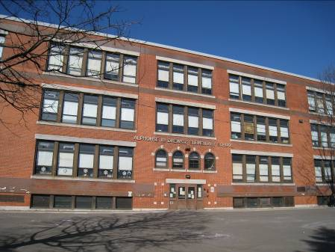

Prepared by:
Massachusetts Department of Public Health
Bureau of Environmental Health
Indoor Air Quality Program
March 2012

Background/Introduction
At the request of concerned parents, the Massachusetts Department of Public Health (MDPH), Bureau of Environmental Health (BEH) conducted an indoor air quality (IAQ) assessment at the Drewicz Elementary School (DES), 34 Hood Street, Lynn, Massachusetts. The request was prompted by concerns related to water damage, mold and general IAQ. The DES has reportedly had a number of water penetration issues during this school year. On February 10, 2012, a visit to conduct a general IAQ assessment was made to the DES by Sharon Lee, Environmental Analyst/Inspector, and Ruth Alfasso Environmental Engineer/Inspector, in BEH’s IAQ Program. MaryAnne O’Conner, Director, Lynn Health Department, Richard Connick, Supervisor of Custodians and Maintenance for the City of Lynn, Bernadette Stamm, Principal, DES, and Emmanuella LaGal, PTO President accompanied Ms. Lee and Ms. Alfasso during the visit.
The DES is a three-story brick building originally constructed in 1914. It has a flat multi-level roof which was reportedly replaced about ten years ago. Windows were openable in most areas of the building.

Methods
Air tests for carbon monoxide, carbon dioxide, temperature and relative humidity were conducted with the TSI, Q-Trak, IAQ Monitor, Model 7565. Air tests for airborne particle matter with a diameter less than 2.5 micrometers were taken with the TSI, DUSTTRAK™ Aerosol Monitor Model 8520. BEH staff also performed a visual inspection of building materials for water damage and/or microbial growth.

Results
The school houses approximately 430 students in grades pre-K through 5 and has a staff of approximately 35. The tests were taken during normal operations at the school and appear in Table 1.

Discussion

Ventilation
It can be seen from Table 1 that carbon dioxide levels were above 800 parts per million of air (ppm) in 9 of 35 areas surveyed indicating poor air exchange in some areas surveyed on the day of assessment. It is also important to note that windows were open in many classrooms and some areas/classrooms were empty/sparsely populated, which can greatly reduce carbon dioxide levels. Carbon dioxide levels would be expected to increase with windows closed and higher room occupancy.
A fresh air source is necessary for the dilution of indoor air pollutants. The DES does not have a modern mechanical ventilation system. It was designed with a natural/gravity ventilation system to provide airflow to most classrooms in combination with openable windows. Originally, ventilation was provided by a series of louvered vents. Each classroom has an approximately 3' x 3' grated air vent in an interior wall near the ceiling (Picture 1), which is connected by a ventilation shaft to a vault-like “air-mixing” room in the basement (Picture 2). A corresponding 3' x 3' vent located near the floor in each room (Picture 3) is connected to an exhaust ventilation shaft that runs from the basement to the roof (Pictures 4 and 5). Exhaust vents penetrating through the roof are enclosed with bird screens to prevent birds from nesting. Classrooms are constructed around these shafts to provide exhaust ventilation. The draw of air into these exhaust vents is typically controlled by a draw chain pulley system, which is designed to set the flue in the ventilation shaft at a desired angle to adjust airflow. In this type of system, air movement is provided by the stack effect. Heating elements located in the base of the ventilation shaft warm the air, which rises up the ventilation shaft. As the heated air rises, negative pressure is created, which draws cold air from the enclosed air-mixing room in the basement into the heating elements/ventilation shaft. This system was designed to draw in outside air from windows in the air-mixing room (Pictures 2 and 6). Due to age, condition of the terra cotta structures that form the system, and general disrepair, this system appears to have been abandoned for some time. Plywood has been used to seal vents located in each of the classrooms.
A second exhaust vent located in the coat closet of each classroom (Picture 7) is also ducted to an air vent that exhaust to the roof. Please note, in some cases, vents were blocked by materials stacked in the closet. This closet exhaust functions in a manner similar to the original system, relying on heated air generated by radiators to remove air from classrooms through shafts in the rooftop via the stack effect. These vents were not sealed at the time of assessment. The stack effect likely results in some air movement up these ducts, allowing air to exit via the bird-screened vent. However, when indoor temperatures are cooler than outdoor temperatures backdrafting can occur, allowing accumulated debris within the ductwork to become aerosolized in the indoor environment. Exposure to irritants/debris from the closet exhaust is limited since most closet doors are generally closed. Installation of an exhaust fan at the roof terminus of these vents would create active exhaust capabilities to remove waste heat/normally occurring indoor air pollutants from the classroom and prevent any backdrafting from occurring.
Without an operable ventilation system, open windows are the only source of fresh air to classrooms at the DES. Principal Stamm indicated that staff are instructed to open windows for this purpose. Consideration should also be given to opening classroom doors to create cross-ventilation. The DES is configured in a manner to use cross-ventilation to provide comfort for building occupants. The building is equipped with windows on opposing exterior walls. Most classrooms have two doors that open to the hallway. When doors and windows are open in opposing classrooms, airflow is created. For example, airflow enters an open window on the windward side, passes through a classroom and out the classroom door, enters the hallway, passes through the opposing open classroom door, into the opposing classroom and exits the building on the leeward side (Figure 1). With all windows and doors open, airflow can be maintained in a building regardless of the direction of the wind. The system fails if the windows or doors are closed (Figure 2).
The Massachusetts Building Code requires that each room have a minimum ventilation rate of 15 cubic feet per minute (cfm) per occupant of fresh outside air or have openable windows (SBBRS, 1997; BOCA, 1993). The ventilation must be on at all times that the room is occupied. Providing adequate fresh air ventilation with open windows and maintaining the temperature in the comfort range during the cold weather season is impractical. Mechanical ventilation is usually required to provide adequate fresh air ventilation.
Carbon dioxide is not a problem in and of itself. It is used as an indicator of the adequacy of the fresh air ventilation. As carbon dioxide levels rise, it indicates that the ventilating system is malfunctioning or the design occupancy of the room is being exceeded. When this happens, a buildup of common indoor air pollutants can occur, leading to discomfort or health complaints. The Occupational Safety and Health Administration (OSHA) standard for carbon dioxide is 5,000 parts per million parts of air (ppm). Workers may be exposed to this level for 40 hours/week, based on a time-weighted average (OSHA, 1997).
The MDPH uses a guideline of 800 ppm for publicly occupied buildings. A guideline of 600 ppm or less is preferred in schools due to the fact that the majority of occupants are young and considered to be a more sensitive population in the evaluation of environmental health status. Inadequate ventilation and/or elevated temperatures are major causes of complaints such as respiratory, eye, nose and throat irritation, lethargy and headaches. For more information concerning carbon dioxide, see Appendix A.
Temperature measurements ranged from 64º F to 76º F on the day of the visit, which were within or close to the MDPH recommended comfort range in the majority of areas. The MDPH recommends that indoor air temperatures be maintained in a range of 70º F to 78º F in order to provide for the comfort of building occupants. In many cases concerning indoor air quality, fluctuations of temperature in occupied spaces are typically experienced, even in a building with an adequate fresh air supply. Although all measured temperatures were below the upper limit of the MDPH comfort range, heating from solar gain, especially in classrooms on the south side of the building hallway, was notable and occupants reported complaints about heating throughout the school year in some locations. Shades were drawn down in some of these locations to reduce overheating.
The relative humidity measured in the building ranged from 12 to 32 percent at the time of visit, which was below the MDPH recommended comfort range (Table 1). The MDPH recommends a comfort range of 40 to 60 percent for indoor air relative humidity. Relative humidity levels in the building would be expected to drop during the winter months due to heating. The sensation of dryness and irritation is common in a low relative humidity environment. Low relative humidity is a very common problem during the heating season in the northeast part of the United States.

Microbial/Moisture Concerns
As mentioned, the DES has experienced several water-related events that have resulted in damage in the school. Most recently, a leaking pipe under a stairwell on the lower level resulted in mold growth. This leak reportedly occurred in late January 2012. Once the leak was reported, DES staff reportedly contacted the City Maintenance Department for assistance regarding removal/abatement and disinfection of this area. At the time damage occurred, the gypsum wallboard that formed walls, including the wall enclosing the space was damaged. When the space was examined, the floor was reportedly only partially cement finished, with a portion still consisting of dirt/soil. DES staff indicated a noticeable odor was observed in the area at the time the leak occurred and during remediation of this space. At the time of the MDPH assessment, City and School Department staff reported that the leak had been repaired; gypsum wallboard had been removed, cleaned and repainted; and cement was poured to form a solid floor in the area below the staircase (Picture 8). No staining or musty odors were noted at the time of the MPDH visit. It was reported that the plan was to limit access to this space by enclosing it with screen or lattice to allow airflow and for the detection of any subsequent leaks.
Another concern includes sewage backup issues, which reportedly have occurred previously in the lower level of the building. The majority of damage was sustained in the cafeteria. This and other affected areas have reportedly been remediated. At the time of assessment, no signs of damage or odors were observed in the cafeteria. Room B-15 had also been subject to an earlier flooding incident; the wallboard had reportedly been removed to at least two feet above the floor and replaced. This area also had a new univent and exhaust system.
In addition, a radiator leak experienced in the Conference Room/Nurse’s Office reportedly resulted in water damage to walls and floors of the area. This area has also reportedly experienced window leaks, due to their age and condition. At the time of assessment, this room was unoccupied. Carpeting for the area had been removed, exposing water-damaged wood flooring. Asbestos containing material is reportedly installed below the wood flooring. At the time of assessment, work for this room had stopped due to the need for remediation. Intact asbestos-containing materials (ACM) do not pose a health hazard. If damaged, however, ACM can be rendered friable and become aerosolized. Friable asbestos is a chronic (long-term) health hazard, but will not produce acute (short-term) health effects (e.g., headaches) typically associated with buildings believed to have indoor air quality problems. Where ACM are damaged, materials should be removed or remediated in a manner consistent with Massachusetts asbestos remediation laws (MDLI, 1993). Measures should also be taken to ensure that appropriate containment is used when remediating while the building is occupied. These include but are not limited to installing plastic barriers to prevent movement of materials, sealing of ventilation to prevent contamination, and using air pressurization to prevent movement of materials outside of the room. Discussion of these and other techniques can be found in MDPH’s Methods Used to Reduce/Prevent Exposure to Construction/Renovation Generated Pollutants in Occupied Buildings (Appendix B).
MDPH staff also examined the roof area accessible to the Conference Room/Nurse’s Office. This roof was reportedly replaced within the last 10 years. MDPH staff observed damage to the exterior wall of this room (Picture 9), especially along where the metal roof flashing is inserted into the exterior wall. Damaged window ledges were also observed (Picture 10). The condition of these ledges indicates that water is likely penetrating into the wall space behind brickwork and exiting via metal roof flashing. The movement of water out of the building likely resulted in damage to brickwork. Moisture remaining in the wall space may also contribute to prolonged moisture exposure of walls and flooring materials in this room.
Water-damaged ceiling tiles were observed in many classrooms (Picture 11, Table 1). These were noted mostly along the area near the windows, suggesting that wind-driven rain or rainwater flowing down the building may be infiltrating into the brickwork. Water-damaged ceiling tiles can provide a source for mold growth and should be replaced after a water leak is discovered and repaired.
Bubbling and peeling paint was also noted in some classrooms (Picture 6, Table 1), including inside closets. No signs of active/recent leaks were noted or reported in these areas. While these may represent historic damage, water penetration issues should be examined and repaired. Flakes of paint may be a skin or respiratory irritant; flaking paint should be removed and the area may be repainted.
The sinks present in some classrooms were examined for water tightness between the backsplashes and countertops, and there were spaces observed in some of them (Table 1). If these seams are not watertight, water can penetrate through the seam, causing water damage. Improper drainage or sink overflow can lead to water penetration into the countertop, cabinet interior and areas behind cabinets. Water penetration and chronic exposure of porous and wood-based materials can cause these materials to swell and show signs of water damage. Classroom sinks were also found to have porous materials (e.g., cardboard, paper, cloth; Picture 12) stored beneath them where they may be subject to moisture. Repeated moistening of porous materials can result in mold growth.
The US Environmental Protection Agency (US EPA) and the American Conference of Governmental Industrial Hygienists (ACGIH) recommends that porous materials be dried with fans and heating within 24 to 48 hours of becoming wet (US EPA, 2001; ACGIH, 1989). If porous materials are not dried within this time frame, mold growth may occur. Water-damaged porous materials cannot be adequately cleaned to remove mold growth. The application of a mildewcide to moldy porous materials is not recommended.
BEH staff examined the outside perimeter of the building to identify breaches in the building envelope and/or other conditions that could provide a source of water penetration. One of the doors along the side of the building had visible gaps beneath it (Picture 13), which can allow moisture to enter the building. In addition, these breaches can allow insects and rodents access to the building. A ¼-inch breach is enough space for rodents to enter a building.
Plants were observed in a few areas (Table 1). Plants can be a source of pollen and mold which can be respiratory irritants to some individuals. Plants should be properly maintained and equipped with drip pans and located away from univents to prevent the aerosolization of dirt, pollen and mold.

Other IAQ Evaluations
Indoor air quality can be negatively influenced by the presence of respiratory irritants, such as products of combustion. The process of combustion produces a number of pollutants. Common combustion emissions include carbon monoxide, carbon dioxide, water vapor, and smoke (fine airborne particle material). Of these materials, exposure to carbon monoxide and particulate matter with a diameter of 2.5 micrometers (μm) or less (PM2.5) can produce immediate, acute health effects upon exposure. To determine whether combustion products were present in the indoor environment, BEH staff obtained measurements for carbon monoxide and PM2.5.

Carbon Monoxide
Carbon monoxide is a by-product of incomplete combustion of organic matter (e.g., gasoline, wood and tobacco). Exposure to carbon monoxide can produce immediate and acute health affects. Several air quality standards have been established to address carbon monoxide and prevent symptoms from exposure to these substances. The MDPH established a corrective action level concerning carbon monoxide in ice skating rinks that use fossil-fueled ice resurfacing equipment. If an operator of an indoor ice rink measures a carbon monoxide level over 30 ppm, taken 20 minutes after resurfacing within a rink, that operator must take actions to reduce carbon monoxide levels (MDPH, 1997).
The American Society of Heating Refrigeration and Air-Conditioning Engineers (ASHRAE) has adopted the National Ambient Air Quality Standards (NAAQS) as one set of criteria for assessing indoor air quality and monitoring of fresh air introduced by HVAC systems (ASHRAE, 1989). The NAAQS are standards established by the US EPA to protect the public health from six criteria pollutants, including carbon monoxide and particulate matter (US EPA, 2006). As recommended by ASHRAE, pollutant levels of fresh air introduced to a building should not exceed the NAAQS levels (ASHRAE, 1989). The NAAQS were adopted by reference in the Building Officials & Code Administrators (BOCA) National Mechanical Code of 1993 (BOCA, 1993), which is now an HVAC standard included in the Massachusetts State Building Code (SBBRS, 1997). According to the NAAQS, carbon monoxide levels in outdoor air should not exceed 9 ppm in an eight-hour average (US EPA, 2006).
Carbon monoxide should not be present in a typical, indoor environment. If it is present, indoor carbon monoxide levels should be less than or equal to outdoor levels. Outdoor carbon monoxide levels were measured at 2.1 ppm on the morning of the assessment, most likely due to weather and traffic conditions. All indoor carbon monoxide measurements were non-detectable (ND) during the assessment (Table 1).

Particulate Matter (PM2.5)
The US EPA has established NAAQS limits for exposure to particulate matter. Particulate matter is airborne solids that can be irritating to the eyes, nose and throat. The NAAQS originally established exposure limits to particulate matter with a diameter of 10 μm or less (PM10). According to the NAAQS, PM10 levels should not exceed 150 micrograms per cubic meter (μg/m³) in a 24-hour average (US EPA, 2006). These standards were adopted by both ASHRAE and BOCA. Since the issuance of the ASHRAE standard and BOCA Code, US EPA established a more protective standard for fine airborne particles. This more stringent PM2.5 standard requires outdoor air particle levels be maintained below 35 μg/m³ over a 24-hour average (US EPA, 2006). Although both the ASHRAE standard and BOCA Code adopted the PM10 standard for evaluating air quality, MDPH uses the more protective PM2.5 standard for evaluating airborne particulate matter concentrations in the indoor environment.
Outdoor PM2.5 concentrations were measured at 34 μg/m³ on the day of the visit (Table 1), which is slightly below the NAAQS PM2.5 limit of 35 μg/m³. PM2.5 levels measured inside the school ranged from 12 to 19 μg/m³ (Table 1), which were below the NAAQS PM2.5 limit. Frequently, indoor air levels of particulates (including PM2.5) can be at higher levels than those measured outdoors. A number of mechanical devices and/or activities that occur indoors can generate particulate during normal operations. Sources of indoor airborne particulates may include but are not limited to particles generated during the operation of fan belts in the HVAC system, use of stoves and/or microwave ovens in kitchen areas; use of photocopiers, fax machines and computer printing devices; operation of an ordinary vacuum cleaner and heavy foot traffic indoors.

Volatile Organic Compounds
Indoor air concentrations can be greatly impacted by the use of products containing volatile organic compounds (VOCs). VOCs are carbon-containing substances that have the ability to evaporate at room temperature. Frequently, exposure to low levels of total VOCs (TVOCs) may produce eye, nose, throat and/or respiratory irritation in some sensitive individuals. For example, chemicals evaporating from a paint can stored at room temperature would most likely contain VOCs. In an effort to identify materials that can potentially increase VOC concentrations, BEH staff examined classrooms for products that may contain these respiratory irritants.
Household cleaning products, air fresheners and deodorizing materials were found in several areas (Picture 14, Table 1). Cleaning products and air deodorizers contain chemicals that can be irritating to the eyes, nose and throat of sensitive individuals. Many air fresheners contain 1,4-dichlorobenzene, a VOC which may cause reductions in lung function (NIH, 2006). Furthermore, deodorizing agents do not remove materials causing odors, but rather mask odors that may be present in the area. Additionally, a Material Safety Data Sheet (MSDS) should be available at a central location for all school chemicals in the event of an emergency such as an adverse chemical interaction between residues left from cleaners used by the facilities staff and those left by cleaners brought in by others.
Several classrooms contained dry erase boards and dry erase board markers (Table 1). Spray cans of paint, markers and other products were found in some classrooms. Materials such as permanent markers, dry erase markers and dry erase board cleaners and paints may contain VOCs, such as methyl isobutyl ketone, n-butyl acetate and butyl-cellusolve (Sanford, 1999), which can be irritating to the eyes, nose and throat.

Other Conditions
Other conditions that can affect indoor air quality were observed during the assessment. BEH staff observed chalk/dry erase board trays containing a build-up of chalk dust and whiteboard marker debris. These materials can be aerosolized by air movement from doors opening and closing, and/or foot traffic and may present a respiratory irritant.
A number of fans/blades and closet exhaust vents had accumulated dust/debris. Fans should be cleaned periodically in order to prevent them from serving as a source of aerosolized particulates. Exhaust vents should also be cleaned to prevent re-aerosolization of dust due to backdrafting.
In several classrooms, items were observed on the floors, windowsills, tabletops, counters, bookcases and desks (Picture 15). The large number of items stored in classrooms provides a source for dusts to accumulate. These items (e.g., papers, folders, boxes) make it difficult for custodial staff to clean. Items should be relocated and/or be cleaned periodically to avoid excessive dust build up. In addition, these materials can accumulate on flat surfaces (e.g., desktops, shelving and carpets) in occupied areas and subsequently be re-aerosolized causing further irritation. Similarly, dust/debris from items placed on top of radiators can become airborne through movement of the heated air. Plastic sealable totes may be used to store items that are not needed daily; these prevent dust from accumulating on the items and are cleanable on the outside.
Upholstered furniture, plush toys and area carpets were observed in several classrooms (Picture 16; Table 1). In addition, upholstered furniture is covered with fabrics that are exposed to human skin. This type of contact can leave oils, perspiration, hair and skin cells. Dust mites feed upon human skin cells and excrete waste products that contain allergens. In addition, if relative humidity levels increase above 60 percent, dust mites tend to proliferate (US EPA, 1992). In order to remove dust mites and other pollutants, frequent vacuuming of upholstered furniture is recommended (Berry, 1994). It is also recommended that upholstered furniture (if present in schools), be professionally cleaned on an annual basis. Where an excessively dusty environment exists due to outdoor conditions or indoor activities (e.g., renovations), cleaning frequency should be increased (every six months) (IICRC, 2000).
Open food items were seen in classrooms, including being used as art materials (Picture 17). Food is an attractant to pests and rodents. Proper food storage is an integral component in maintaining IAQ. Food should be properly stored and clearly labeled. Where food products are used in art, the artwork should be stored/displayed in a container or the food components should be treated in a manner that does not attract pests (i.e., non-toxic white glue sealant or other clear coat product). Reuse of food containers is not recommended, since food residue adhering to the surface may serve as an attractant to pests.

Conclusions/Recommendations
Based on observations at this time, it appears that water damage resulting from the sewerage backup as well as from a pipe leaking in the lower level areas have been addressed. At the time of the assessment, no odors or mold growth was observed. Work related to water damage in the Conference Room/Nurse’s Office remains to be completed and should be conducted in accordance with all asbestos regulations (MDLI, 1993). To remedy building problems, two sets of recommendations are made: short-term measures that may be implemented as soon as practicable and long-term measures that will require planning and resources to address overall IAQ concerns.

Short Term Recommendations
- To maximize air exchange operate existing ventilation equipment (in working order) continuously throughout the building (e.g., gym, auditorium, classrooms) during periods of school occupancy independent of thermostat control. Ensure all blockages to supply and exhaust vents are removed.
- Use openable windows in conjunction with existing operable equipment to facilitate air exchange. Care should be taken to ensure windows are properly closed at night and weekends to avoid the freezing of pipes and potential flooding.
- Use window shades to reduce solar glare and solar heating.
- Ensure any roof/exterior/plumbing leaks are repaired and replace water-damaged ceiling tiles and building materials. Examine the area above and around these areas for mold growth including the flashing. Disinfect areas of water leaks with an appropriate antimicrobial.
- Scrape and clean loose/bubbling paint from ceilings and walls. Refinish as needed.
- Seal breaches between sink countertops and backsplashes to prevent water damage. Avoid storage of porous materials under sinks.
- For buildings in New England, periods of low relative humidity during the winter are often unavoidable. Therefore, scrupulous cleaning practices should be adopted to minimize common indoor air contaminants whose irritant effects can be enhanced when the relative humidity is low. To control for dusts, a high efficiency particulate arrestance (HEPA) filter equipped vacuum cleaner in conjunction with wet wiping of all surfaces is recommended. Avoid the use of feather dusters. Drinking water during the day can help ease some symptoms associated with a dry environment (throat and sinus irritations).
- Ensure staff are provided with the school-sanctioned cleaning products with appropriate MSDSs and keep them out of reach of students. Remove/discard any household cleaners and air deodorizing materials.
- Ensure plants are equipped with drip pans. Examine drip pans periodically for mold growth and disinfect with an appropriate antimicrobial, as needed.
- Ensure doors are tight to prevent entry of moisture and pests.
- Where food products are used in art, the artwork should be stored/displayed in a container or the food components should be treated in a manner that does not attract pests (i.e., non-toxic white glue sealant or other clear coat product).
- Clean carpeting annually or semi-annually in soiled high traffic areas as per the recommendations of the Institute of Inspection, Cleaning and Restoration Certification (IICRC). Copies of the IICRC fact sheet can be downloaded at: http://www.certifiedcleaners.org/faq.shtml (IICRC, 2005).
- Relocate or consider reducing the amount of materials stored in classrooms to allow for more thorough cleaning of classrooms. Clean items regularly with a wet cloth or sponge to prevent excessive dust build-up. Use of plastic totes for storage of items not in use will allow for more thorough cleaning.
- Professionally clean upholstered furniture on an annual basis, if not feasible consider removing.
- Consider adopting the US EPA (2000) document, “Tools for Schools”, to maintain a good indoor air quality environment in the building. This document can be downloaded from the Internet at http://www.epa.gov/iaq/schools/index.html.
- Refer to resource manuals and other related indoor air quality documents for further building-wide evaluations and advice on maintaining public buildings. Copies of these materials are located on the MDPH’s website: http://mass.gov/dph/iaq.

Long Term Recommendations
- Consider installing rooftop motors on ductwork currently connected to the closet exhaust vents. If this cannot be achieved, consider temporarily sealing closet vents until such equipment can be installed. Sealing of these vents would prevent movement of materials when backdrafting occurs.
- Contact an HVAC engineering firm for a building-wide ventilation systems assessment. Based on issues with air exchange/IAQ complaints, age, physical deterioration and availability of parts for ventilation components, such an evaluation is necessary to determine the operability and feasibility of repairing/replacing HVAC equipment or adding additional mechanical ventilation equipment such as an air handling unit and exhaust fans.

References
ACGIH. 1989. Guidelines for the Assessment of Bioaerosols in the Indoor Environment. American Conference of Governmental Industrial Hygienists, Cincinnati, OH.
ASHRAE. 1989. ASHRAE Standard: Ventilation for Acceptable Indoor Air Quality. Sections 5.11, 5.12. American Society of Heating, Refrigerating and Air-Conditioning Engineers, Inc. Atlanta, GA.
Berry, M.A. 1994. Protecting the Built Environment: Cleaning for Health. Michael A. Berry, Chapel Hill, NC.
BOCA. 1993. The BOCA National Mechanical Code/1993. 8th ed. Building Officials and Code Administrators International, Inc., Country Club Hill, IL.
IICRC. 2000. IICRC S001 Reference Guideline for Professional On-Location Cleaning of Textile Floor Covering Materials Institute of Inspection, Cleaning and Restoration Certification. Institute of Inspection Cleaning and Restoration, Vancouver, WA.
IICRC. 2005. Carpet Cleaning FAQ 4 Institute of Inspection, Cleaning and Restoration Certification. Institute of Inspection Cleaning and Restoration, Vancouver, WA.
MDLI. 1993. Regulation of the Removal, Containment or Encapsulation of Asbestos, Appendix 2. 453 CMR 6,92(I)(i).
MDPH. 1997. Requirements to Maintain Air Quality in Indoor Skating Rinks (State Sanitary Code, Chapter XI). 105 CMR 675.000. Massachusetts Department of Public Health, Boston, MA.
NIH. 2006. Chemical in Many Air Fresheners May Reduce Lung Function. NIH News. National Institute of Health. July 27, 2006. http://www.nih.gov/news/pr/jul2006/niehs-27.htm
NIOSH. 1997. NIOSH Alert Preventing Allergic Reactions to Natural Rubber latex in the Workplace. National Institute for Occupational Safety and Health, Atlanta, GA.
OSHA. 1997. Limits for Air Contaminants. Occupational Safety and Health Administration. Code of Federal Regulations. 29 C.F.R 1910.1000 Table Z-1-A.
Sanford. 1999. Material Safety Data Sheet (MSDS No: 198-17). Expo® Dry Erase Markers Bullet, Chisel, and Ultra Fine Tip. Sanford Corporation. Bellwood, IL.
SBBRS. 1997. Mechanical Ventilation. State Board of Building Regulations and Standards. Code of Massachusetts Regulations. 780 CMR 1209.0.
US EPA. 1992. Indoor Biological Pollutants. US Environmental Protection Agency, Environmental Criteria and Assessment Office, Office of Health and Environmental Assessment, research Triangle Park, NC. EPA 600/8-91/202. January 1992.
US EPA. 2000. Tools for Schools. Office of Air and Radiation, Office of Radiation and Indoor Air, Indoor Environments Division (6609J). EPA 402-K-95-001, Second Edition. http://www.epa.gov/iaq/schools/tools4s2.html
US EPA. 2001. “Mold Remediation in Schools and Commercial Buildings”. Office of Air and Radiation, Indoor Environments Division, Washington, DC. EPA 402-K-01-001. March 2001. Available at: http://www.epa.gov/iaq/molds/mold_remediation.html
US EPA. 2006. National Ambient Air Quality Standards (NAAQS). US Environmental Protection Agency, Office of Air Quality Planning and Standards, Washington, DC. http://www.epa.gov/air/criteria.html
Picture 1

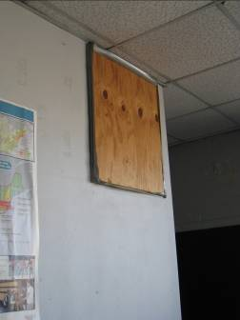

Sealed ventilation grate in classroom

Picture 2

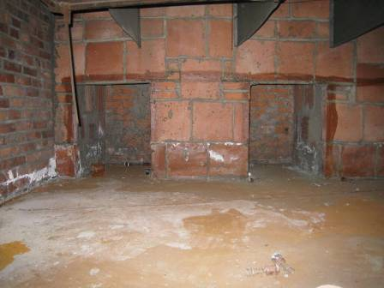

Air-mixing room in the basement

Picture 3

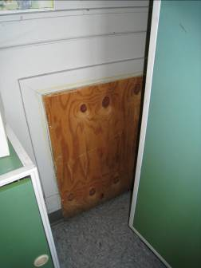

Sealed floor-level exhaust vent

Picture 4

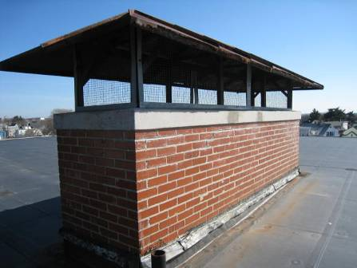

Exhaust ventilation shaft terminus on roof

Picture 5

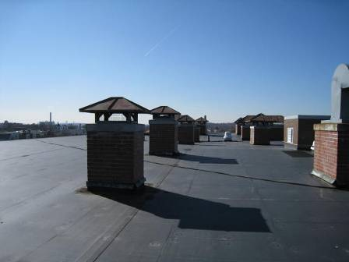

Exhaust ventilation shafts

Picture 6

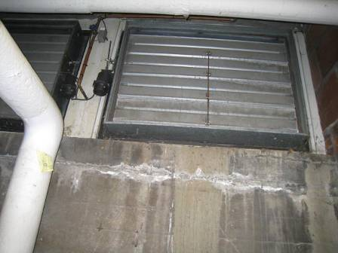

Windows to air mixing room (shut)

Picture 7

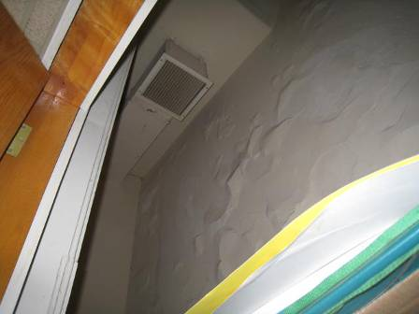

Exhaust vent in classroom closet (also note peeling paint on walls)

Picture 8

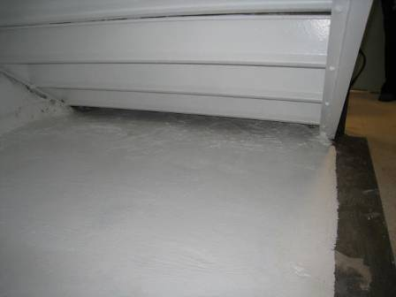

Under-stair area, site of recent leak, now repaired

Picture 9

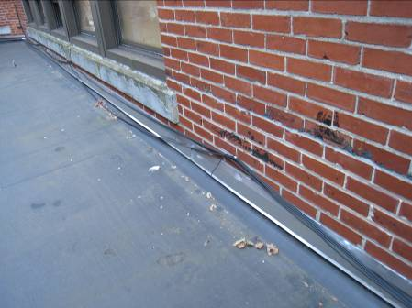

Nurse’s office exterior wall damage

Picture 10

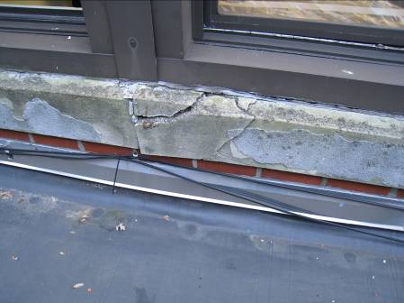

Damaged window ledge outside nurse’s office

Picture 11

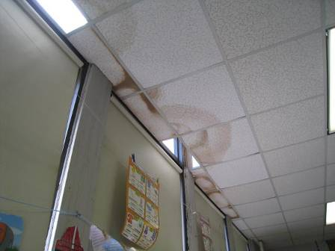

Water-damaged ceiling tiles near windows in classroom

Picture 12

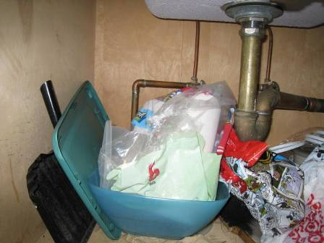

Items stored under sink in classroom

Picture 13

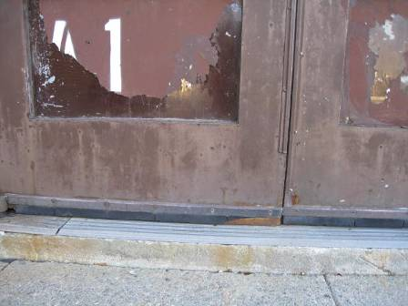

Damaged sweep/gaps under exterior door

Picture 14

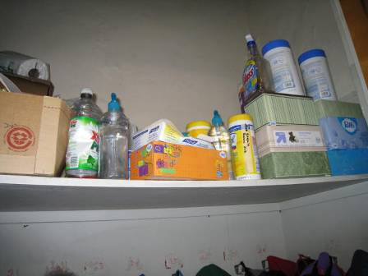

Cleaning products in classroom closet

Picture 15

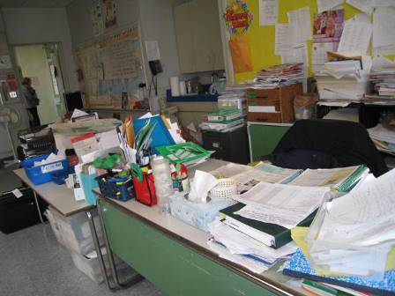

Items/clutter in classroom

Picture 16

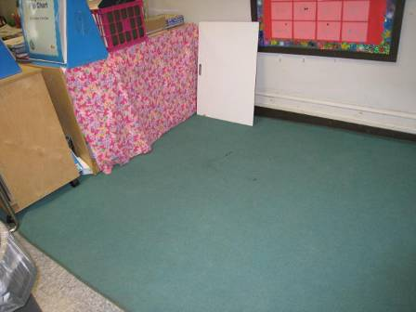

Area rug in classroom

Picture 17

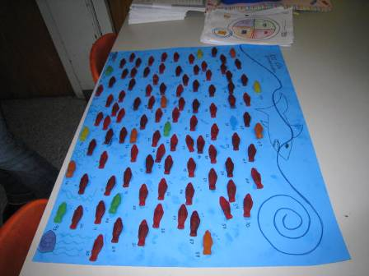

Food used as art material
Location | Carbon  Dioxide  (ppm) | Carbon Monoxide  (ppm) | Temp  (°F) | Relative  Humidity  (%) | PM2.5  (µg/m³) | Occupants  in Room | Windows  Openable | Ventilation |  | Remarks
 |  |  |  |  |  |  |  | Supply | Exhaust | Remarks
Background/ Outdoors | 345 | 2.1 | 59 | 14 | 34 |  |  |  |  | Sunny, clear sky, hazy, some traffic
Art | 586 | ND | 76 | 15 | 13 | 0 | Y  4/5 open | N | Y  Closet | DO, AD, CPs, food, items
B101 | 543 | ND | 66 | 19 | 12 | 1 | N | Y | Y | UV ajar but operating
B-15 | 347 | ND | 69 | 13 | 13 | 0 | Y | Y new | Y | Storage/meeting room, MT, this was area which had flooded and is now repaired., chalk, stored items in boxes on floor
B-17 | 770 | ND | 66 | 20 | 13 | 1 | Y |  |  | Radiators
Band room | 1275 | ND | 68 | 32 | 12 | 3 | N | N | N
Cafeteria | 844 | ND | 70 | 24 | 13 | 8 | N | Y  1/2 on | Y  Dusty, weak | CPs
Gym | 528 | ND | 67 | 22 | 15 | 1 | N | Y | Y | 5 WD-CT 1 AT
Janitor office | 354 | ND | 64 | 16 | 14 | 0 | N |  |  | Roof hatch, 1 MT
library | 547 | ND | 75 | 16 | 17 | 1 | Y | Y (off) |  | ~30 computers, radiators
Main office | 772 | ND | 73 | 17 | 13 | 4 | N | Y | Y
Principal’s office | 678 | ND | 69 | 22 | 13 | 1 | Y | Y | N | 2 WD-CT
Secondary nurse office | 767 | ND |  | 25 | 13 | 3 | N | N | N | Very small room
Teacher’s lounge | 605 | ND | 73 | 14 | 14 | 5 | Y  2/4 open | N | N | DO, fridge, toaster oven, bathroom exhaust-dusty
3rd floor women’s staff restroom |  |  |  |  |  |  |  |  | Y (on) | Deodorant odor
Stairwell room 3rd floor | 635 | ND | 73 | 18 | 17 | 0 | N | N | N | A repurposed staircase landing
3rd and 1st floor hallways |  |  |  |  |  |  |  |  |  | Copy machines located in hallways, no exhaust
101 | 1098 | ND | 74 | 22 | 15 | 12 (just left) | Y | N | Y closet (passive) | DEM, closet very full (blocking exhaust), area rug, 3 WD-CT, CD, solar gain
102 (loft) | 640 | ND | 75 | 15 | 17 | 0 | Y (open) | N | N
102 | 570 | ND | 76 | 14 | 16 | 23 | Y | N |  | 2 WD-CT, shades down, UV on, area rug, sink backsplash ok, items under sink
105 |  | ND | 76 | 18 | 16 | 24 | Y | N | In toilet room | Attached bathroom, 2 WD-CT, sink backsplash slightly open, items under sink, area rug, plush toys, solar gain
107 | 514 | ND | 75 | 13 | 19 | 21 | Y (open earlier) | Y | Y closet (passive) | 10 WD-CT by window, area rug, clutter on walls
108 | 1625 | ND | 73 | 20 | 15 | 23 | Y | Y |  | 4 WD-CT by windows, area rugs, computers, CD, items and books
118 | 1173 | ND | 72 | 23 | 17 | 21 | Y | N | Y  Closet | CPs, DEM, WD-CTs along window, exposed fiberglass around pipe
119 | 1287 | ND | 72 | 21 | 14 | 10 | Y | N | Y  Closet | AD, strong AD odor, CPs, WD-CTs along window
201 | 881 | ND | 74 | 16 | 14 | 22 | Y  1/5 open | N | Y  Closet | Items on floor, WD-plaster, stained papers, CPs
202 | 752 | ND | 74 | 15 | 13 | 27 | Y  1/5 open | N | Y  Closet | DO, DEM, items
206 | 324 | ND | 71 | 12 | 18 | 0 (at lunch) | Y (open) | N | Y closet (passive) | Sunny and hot (reportedly always hot)
207 | 456 | ND | 72 | 14 | 18 | 23 | Y (2 open) | Y | Y closet (passive) | DEM, dirty closet floor, bubbled paint on ceiling, CP in closet
208 | 527 | ND | 72 | 16 | 15 | 0 (at lunch) | Y | N | Y closet (passive)
209 | 700 | ND | 71 | 17 | 18 | 17 | Y | N | Y closet (passive) | CD, DEM, CP in closet, soiled floor in closet, items
213 | 764 | ND | 72 | 19 | 17 | 20 | Y | N | Y closet (passive) | CD, CP, peeling paint, food used as art displayed
214 | 1005 | ND | 73 | 20 | 16 | 21 | Y | N | Y Closet (passive) | Items, CD, items on vent, potting soil in closet (closed bag), peeling paint
301 | 702 | ND | 75 | 17 | 19 | 19 | Y (2 open) | N |  | Clutter, CD, solar gain from windows
302 (speech) | 491 | ND | 75 | 15 | 18 | 4 | N | N |  | DO
306 | 549 | ND | 74 | 15 | 18 | 0 (just left for lunch) | Y (open) | N |  | Room has skylight, AP, PF dusty, items, vent blocked by items
307 | 685 | ND | 75 | 16 | 13 | 0 | Y | N | Y  Closet | DO, PF, CPs
308 | 638 | ND | 75 | 15 | 13 | 0 | Y  3/5 open | N | Y  Closet | DO, breach between sink and backsplash
313 | 878 | ND | 76 | 20 | 15 | 12 | Y | N | Y  Closet | DO, items, WD-wall plaster

