**Massachusetts Workforce Development Board Meeting**  
Tuesday, June 20, 2017  
9:30 a.m. to 11:30 a.m.

**DRIVING AND PARKING DIRECTIONS**

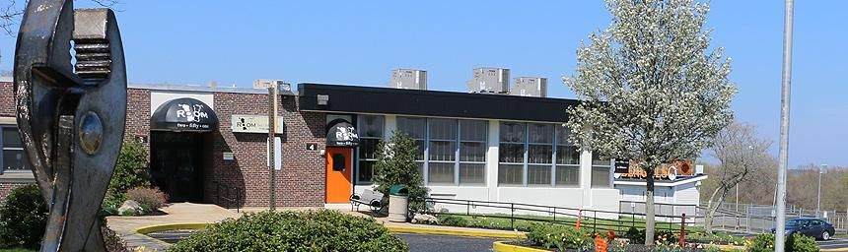

**Diman Regional Vocational Technical High School**

**Room 251**

[**251 Stonehaven Road, Fall River, MA**](https://goo.gl/maps/dmCyi4EUzfz)

**From Boston and Points North:**

* Take 93 South to Route 24 South*
* Follow Route 24 South to Exit 5 - "Route 6 President Ave / Eastern Ave”
* Follow exit ramp and enter rotary
* Take 2nd exit from the rotary to "6 East - Eastern Ave"
* At 3rd set of lights take a **left** onto Bedford St
* At end of Bedford take a left onto Stonehaven Rd
* Take 2nd right (main entrance road to Diman Regional Vocational Technical High School)
* FOLLOW “**CAMPUS DIRECTIONS**” BELOW

*For those coming from metro west, you can also take Route 495 South to Route 24 South

**From Western MA:**

* Follow Massachusetts Turnpike (Route 90 East) to Exit 10A toward US-20/MA-146/Worcester/Providence
* Turn right to merge onto MA-146 South toward Millbury/Providence Rl
* Follow Route 146 South all the way to Providence, RI
* Merge onto Route 95 South
* Keep left to stay on I-95 S
* Follow signs for Route 195 East (Exit 20 - Providence/Cape Cod)
* Follow Route 195 East through RI into MA to Exit 8B - Route 24 North - Boston (Exit Left)
* Follow Route 24 North to Exit 5 - "Route 6 President Ave / Eastern Ave”
* Follow exit ramp and enter rotary
* Take 2nd exit from the rotary to "6 East - Eastern Ave"
* At 3rd set of lights take a **left** onto Bedford St
* At end of Bedford take a left onto Stonehaven Rd
* Take 2nd right (main entrance road to Diman Regional Vocational Technical High School)
* FOLLOW “**CAMPUS DIRECTIONS**” BELOW

**From New Bedford, Cape Cod and Points East:**

* Follow Route 195 West toExit 8B – 24 North Taunton/Boston
* Follow Route 24 North to Exit 5 - "Route 6 President Ave / Eastern Ave”
* Follow exit ramp and enter rotary
* Take 2nd exit from the rotary to "6 East - Eastern Ave"
* At 3rd set of lights take a **left** onto Bedford St
* At end of Bedford take a left onto Stonehaven Rd
* Take 2nd right (main entrance road to Diman Regional Vocational Technical High School)
* FOLLOW “**CAMPUS DIRECTIONS**” BELOW

**CAMPUS DIRECTIONS AND PARKING**

* Follow entrance roadway past the gymnasium
* Take a LEFT at the Athletic Complex sign
* Designated parking for the meeting will be available in the parking lot to your LEFT
* The meeting will be in “**Room 251**”. Look for the brown/black awning across the courtyard (see picture at the top of this document)
* Note, you can access “Room 251” directly from the parking lot and courtyard. You do not need to go through the main entrance of the school.