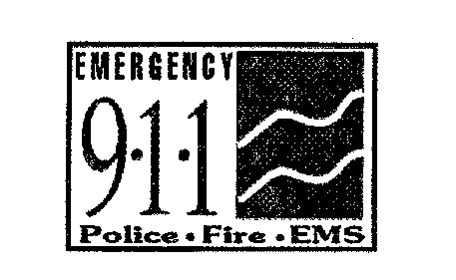The Commonwealth of Massachusetts
EXECUTIVE OFFICE OF PUBLIC SAFETY AND SECURITY
STATE 911 DEPARTMENT
151 Campanelli Drive, Suite A ~ Middleborough, MA 02346
Tel: 508-828-2911 ~ TTY: 508-828-4572 ~ Fax: 508-828-2585
www.mass.gov/e911

CHARLES D. BAKER Terrance M. Reidy
Governor Secretary

KARYN E. POLITO FRANK POZNIAK
Lieutenant Governor Executive Director

February 4, 2022

VIA ELECTRONIC MAIL

Shonda D. Green, Department Secretary
Massachusetts Department of Telecommunications and Cable
1000 Washington Street, Suite 820
Boston, Massachusetts 02118-6500

RE: Petition of the State 911 Department for Approval of Fiscal Year 2020 Expenditures, and Approval of Fiscal Year 2021 Development Grant Amount

Dear Ms. Green:

In connection with the above matter, and in accordance with the Department of Telecommunication and Cable’s Order 20-1, dated May 26, 2020, the State 911 Department hereby provides the Executive Office of Technology Services and Security COMIRS Fiscal Year 2022 Second Quarterly Report (Covering October 1, 2021 – December 31, 2021) regarding the use and the expenditure of Enhanced 911 Funds.

Finally, please find a Certificate of Service related to this submission.

Thank you for your attention to this matter.

Very truly yours,

Dennis J. Kirwan ____
Dennis J. Kirwan
General Counsel

Enclosures
COMMONWEALTH OF MASSACHUSETTS
DEPARTMENT OF TELECOMMUNICATIONS AND CABLE

_____________________________________________________
Petition of the State 911 Department for Approval of Fiscal Year )
2020 Expenditures and Approval of Fiscal Year 2021 )
Development Grant Amount )

CERTIFICATE OF SERVICE

I hereby certify that, on behalf of the State 911 Department in the above- captioned proceeding, I forwarded a copy of the attached Executive Office of Technology Services and Security COMIRS Fiscal Year 2022 Second Quarterly Report (Covering October 1, 2021 – December 31, 2021), regarding the use and the expenditure of Enhanced 911 Funds to those included on the Service List.

Respectfully submitted,

Dennis J. Kirwan ____
Dennis J. Kirwan
General Counsel
State 911 Department
151 Campanelli Drive, Suite A
Middleborough, Massachusetts 02346
Telephone: (508) 821-7223
Email: dennis.j.kirwan@state.ma.us
Facsimile: (508) 828-2585

Dated: February 4, 2022

