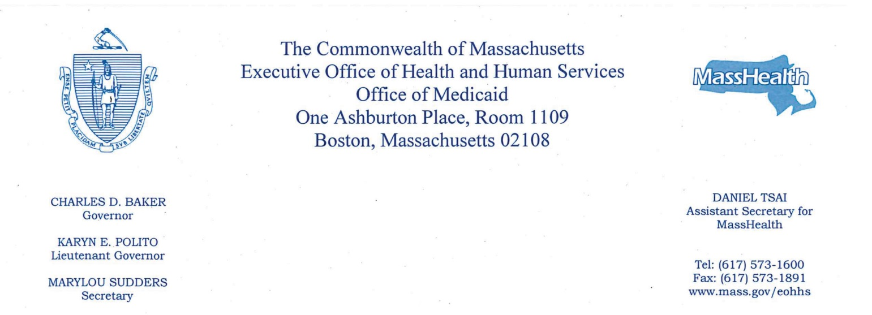

April 20, 2018
The Honorable Karen Spilka
Chair, Senate Committee on Ways and Means
State House, Room 212
Boston, MA 02133
The Honorable Jeffrey Sánchez
Chairman, House Committee on Ways and Means
State House, Room 243
Boston, MA 02133

Dear Chairwoman Spilka and Chairman Sánchez,

As you know, MassHealth is engaged with the federal government in an innovative program known as One Care in order to improve care for adults ages 21-64 who are enrolled in both Medicare and Medicaid (Dual Eligibles). One Care members are served through contracted managed care entities that provide comprehensive and coordinated services. The goal of One Care is to provide integrated, person-centered care, including a broader array of services in a more cost-effective way. One Care plans have achieved among the highest quality and member experience ratings among plans serving Dual Eligible individuals across the country.

The Fiscal Year (FY) 2018 budget, Chapter 47 of the Acts of 2017, requires in Section 2, line item 4000-0300 that the executive office of health and human services (EOHHS) shall report to the House and Senate Committees on Ways and Means on the number of members served in the dual eligible initiative, the average expenditure per member, the average expenditure per member prior to the demonstration project and the number of clients that receive care at skilled nursing facilities. I am pleased to provide you with the following information on One Care experience to date.

As of December 1, 2017, 18,502 individuals were enrolled in a One Care plan, including 88 individuals enrolled in the F1 (facility based care) rating category. Members in this rating category have been identified as having a long-term facility stay of more than 90 days. Applicable facilities include nursing facilities, chronic rehabilitation and psychiatric hospitals.

EOHHS and the Centers for Medicare and Medicaid Services (CMS) currently contract with two One Care plans to provide coordinated care covering all of the services of Medicare Parts A, B, and D, MassHealth, and additional dental, diversionary behavioral health, and community support services. As of December 1, 2017, MassHealth has paid an average monthly amount of $1,515 per enrollee in the form of a per member per month (PMPM) capitation payment to the One Care plans. This average PMPM reflects a higher enrollment concentration in higher-cost rating categories and a lower concentration of individuals in the lowest-cost rating category. As of December 1, 2017, approximately $1,727,460 has been withheld for performance on quality measures from plan capitation payments in FY 2018. The quality withhold amount will be distributed to the plans at a later date, provided they meet certain benchmarks for pre-defined quality measures.

The One Care program is now in its fifth year. Due to changes over that period in medical costs, administrative costs, and the benefit package for One Care, comparing the program’s current average expenditure per member to the average expenditure per member prior to the demonstration is not an accurate measure of program costs. One Care capitation rates are developed using a methodology that is structured using an actuarial estimate of the costs of serving these members in the absence of the demonstration. In other words, the rates are calculated using fee-for-service equivalents that are developed from actual base data for a population that is eligible but not enrolled in One Care.

Additional information about the One Care program may be found at: http://www.mass.gov/masshealth/onecare

Thank you for your continuing commitment to the MassHealth program. If you have any questions about this report, please contact me at (617) 573-1770 or Monica Sawhney at (617) 573-1649.

Sincerely,

Daniel Tsai
Assistant Secretary for MassHealth and Medicaid Director

cc: Marylou Sudders, Secretary, Executive Office of Health & Human Services

