**INDOOR AIR QUALITY ASSESSMENT**

**Dudley District Court**

**279 W Main Street**

**Dudley, MA**

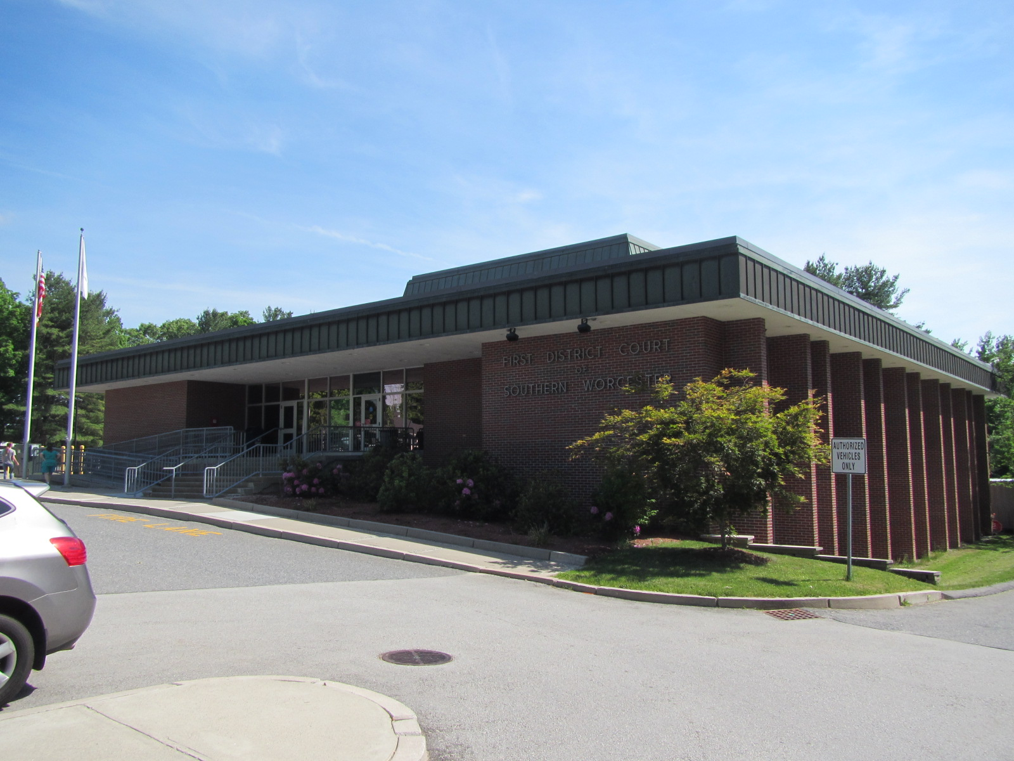

Prepared by:

Massachusetts Department of Public Health

Bureau of Environmental Health

Indoor Air Quality Program

August 2016

# Background

|  |  |
| --- | --- |
| Building: | Dudley District Court (DDC) |
| Address: | 279 West Main Street, Dudley, MA |
| Assessment Requested by: | Michael Lane, Environmental Coordinator, Office of Court Management/Facilities Management, Administrative Office of the Trial Court (AOTC) |
| Reason for Request: | Microbial growth and general indoor air quality (IAQ) concerns. |
| Date of Assessment: | June 2, 2016 |
| Massachusetts Department of Public Health/Bureau of Environmental Health (MDPH/BEH) Staff Conducting Assessment: | Mike Feeney, Director, IAQ Program |
| Building Description: | One story stone and brick courthouse. First floor and lower level/basement area consists of courtrooms, offices, waiting areas and a lockup. Building has a flat roof. |
| Building Population: | Approximately 80 employees at this location. The building is visited by several hundred members of the public daily. |
| Year of Construction: | 1971 |
| Windows: | Openable in most areas. |

# Methods

Please refer to the IAQ Manual for methods, sampling procedures, and interpretation of results (MDPH, 2015).

# IAQ Testing Results

The following is a summary of indoor air testing results (Table 1).

* ***Carbon dioxide levels*** were above 800 parts per million (ppm) in 11 out of 21 areas tested, indicating inadequate fresh air in half of the areas tested.
* ***Temperature*** was within the recommended range of 70°F to 78°F in all but one of the areas tested.
* ***Relative humidity*** was within of the recommended range of 40% to 60% in all areas tested.
* ***Carbon monoxide*** levels were non-detectable in all indoor areas tested.
* ***Fine particulate matter (PM2.5)*** concentrations measured were below the National Ambient Air Quality Standard (NAAQS) level of 35 μg/m3 in all areas tested.

This sampling indicates that the ventilation system is not providing adequate fresh air for the occupancy in the building.

## Ventilation

A heating, ventilating, and air conditioning (HVAC) system has several functions. First, it provides heating and, if equipped, cooling. Second, it is a source of fresh air. Finally, an HVAC system will dilute and remove normally occurring indoor environmental pollutants by not only introducing fresh air, but also filtering the airstream and ejecting stale air to the outdoors via exhaust ventilation. Even if an HVAC system is operating as designed, point sources of respiratory irritation may exist and cause symptoms in sensitive individuals. The following analysis examines and identifies components of the HVAC system and likely sources of respiratory irritant/allergen exposure due to water damage, aerosolized dust, and/or chemicals found in the indoor environment.

Fresh air for to DDC offices and courtrooms is provided by unit ventilators (univents) and air-handling units (AHUs), respectively. Air distributed by univents and AHUs is filtered, heated/cooled and delivered to rooms via ducted supply vents. Univents were blocked or obstructed by desks, boxes, and other items in some areas (Picture 1). Airflow to univents should be unrestricted in order for this equipment to function properly. Note also that these units were likely installed when the building was constructed (1971) which would make them over 40 years old. Function of equipment of this age is difficult to maintain, since compatible replacement parts are often unavailable. According to the American Society of Heating, Refrigeration, and Air-Conditioning Engineers (ASHRAE), the service life for a unit heater, hot water or steam, is 20 years, assuming routine maintenance of the equipment (ASHRAE, 1991). Despite maintenance staffs attempts to maintain the univents, the operational lifespan of the equipment has been exceeded.

Filters were examined from a univent (Picture 2) and were found to be a metal mesh type that provides minimal filtration. Filters that have been determined by ASHRAE to meet its standard for a dust spot efficiency of a minimum of 40 percent would be sufficient to reduce many airborne particulates (Thornburg, 2000; MEHRC, 1997; ASHRAE, 1992). Because of the age of the univents, use of a higher-efficiency filter may reduce flow or cause mechanical stress, so univents should be evaluated to ensure higher-efficiency filters can be used. Additionally, filters should be changed two to four times a year. Having univents unblocked, turned on, and equipped with good filtration should help reduce levels of particulate matter in the building.

In some areas, exhaust ventilation is provided by restroom vents, which were off in some cases. Operating exhaust vents in restrooms and other areas that are a source of water vapor and odors is necessary to prevent these from migrating into occupied areas. It is preferable to have these vents operating at all times the building is occupied, rather than demand-control of the bathroom light switch.

It is recommended that HVAC systems be re-balanced every five years to ensure adequate air systems function (SMACNA, 1994). It was unknown when the last time these systems had been balanced.

## Microbial/Moisture Concerns

BEH staff examined the DDC due to concerns related to possible sources of *Legionella* bacteria. According the Centers for Disease Control and Prevention (CDC, 2016a):

“*Legionella* is a type of bacterium found naturally in freshwater environments, like lakes and streams. It can become a health concern when it grows and spreads in human-made water systems like (1) hot tubs that aren’t drained after each use, (2) hot water tanks and heaters, (3) large plumbing systems, (4) cooling towers (air-conditioning units for large buildings), and (5) decorative fountains. This bacterium grows best in warm water.”

Home and car air-conditioning units do not use water to cool the air, so they are not a risk for *Legionella* growth. Based on this information, BEH staff ruled out the HVAC system as a possible source of the bacteria.

To determine whether *Legionella* is a concern, BEH staff recommended that the water system tested in the building. Lab results indicated that a swab sample found measureable amounts of *Legionella* from the faucet aerator in sink in Room 108. Water samples on the water heater water bubbler in Room 110 were negative. AOTC maintenance staff removed the sink’s aerator, which was thoroughly cleaned and soaked in a bleach/water solution for a minimum of 30 minutes (AOTC, 2016).

As part of this assessment, BEH staff examined the interior of several univents and found that condensation pans appear to lack means to drain water. No plumbing was present inside the univent cabinet. In addition, no drains or means for water drainage were evident through the univent fresh air intakes or on the building exterior (Picture 3). It appears that evaporation is the primary means for condensation removal. Without proper drainage, moistened accumulated debris and standing water in drip pans can lead to odors and microbial growth. To control odors, it appears that antimicrobial pads were inserted into condensation pans. This type of treatment contains ammonium salts, which, if mixed with water, produce an irritant to the eyes, nose, and respiratory system.

Plants were observed in a few areas (Table 1). Plants can be a source of pollen and mold, which can be respiratory irritants to some individuals. Plants should be properly maintained and equipped with drip pans to prevent water damage to porous materials. Plants should also be located away from air diffusers to prevent the aerosolization of dirt, pollen, and mold. Water coolers, fountains, and small refrigerators were found located on carpet, where they can moisten the carpet and lead to microbial growth.

## Other IAQ Evaluations

Other factors that may contribute to respiratory irritation include the presence of numerous stored items, including paper, boxes, and other items. Accumulation of these items makes it harder for custodial staff to clean. Personal fans, supply vents, and univents also had dust and debris on them, which can be reaerosolized and cause irritation.

# Conclusions/Recommendations

Based on observations at the time of assessment, a two-phase approach is required for remediation. The first consists of short-term measures to improve air quality, and the second consists of long-term measures that will require planning and resources to adequately address overall concerns.

## Short-term Recommendations

1. Maintain the water system at a temperature that is sufficient to prevent Legionella growth that is consistent with guidelines found in the Centers for Disease Control and Prevention (CDCP) document, “Developing a Water Management Program to Reduce Legionella Growth & Spread in Buildings, A PRACTICAL GUIDE TO IMPLEMENTING INDUSTRY STANDARDS” (CDC, 2016b). This document is included as [Appendix A](http://www.cdc.gov/legionella/maintenance/wmp-toolkit.html).
2. Remove blockages and obstructions from the front/top of univents to allow these units to operate.
3. Replace metal mesh filters with disposable filter with an appropriate MERV rating. Change filters two to four times a year, and vacuum univents to remove debris during each filter change.
4. Have the HVAC system balanced every 5 years in accordance with SMACNA recommendations (SMACNA, 1994).
5. Discontinue the use of ammonium salt pads in univents.
6. Keep plants in good condition, avoid overwatering, and avoid placing them on porous items such as carpets or paper.
7. Reduce stored materials and store in an organized manner to allow for thorough cleaning.
8. Clean supply and exhaust vents and personal fans regularly to prevent aerosolization of dust and debris.
9. Refer to resource manual and other related IAQ documents located on the MDPH’s website for further building-wide evaluations and advice on maintaining public buildings. These documents are available at: <http://mass.gov/dph/iaq>.

## Long-term recommendations:

1. Determine if univent condensation pans have drains. If not retrofit drains to remove condensation to the outside of the building.
2. Univents have exceeded their expected service life. Replacement of HVAC components should be a part of long-term planning for this building.
3. Consider hiring an HVAC consultant to assess if the HVAC system as it is built can supply the needs of this building and determine what modifications would be needed to improve overall air circulation in the building.

# References

ASHRAE. 1991. ASHRAE Applications Handbook, Chapter 33 “Owning and Operating Costs”. American Society of Heating, Refrigeration and Air Conditioning Engineers, Atlanta, GA.

ASHRAE. 1992. Gravimetric and Dust-Spot Procedures for Testing Air-Cleaning Devices Used in General Ventilation for Removing Particulate Matter. American Society of Heating, Refrigeration and Air Conditioning Engineers. ANSI/ASHRAE 52.1-1992.

CDC. 2016a. *Legionella* (Legionnaires' Disease and Pontiac Fever): Causes, How it Spreads, and People at Increased Risk. Center for Disease Control and Prevention. Atlanta, GA. Accessed at: <http://www.cdc.gov/legionella/about/causes-transmission.html>.

CDC. 2016b. *Developing a Water Management Program to Reduce Legionella Growth & Spread in Buildings, A PRACTICAL GUIDE TO IMPLEMENTING INDUSTRY STANDARDS*. Center for Disease Control and Prevention. Atlanta, GA. Accessed at: <http://www.cdc.gov/legionella/downloads/toolkit.pdf>.

MDPH. 2015. Massachusetts Department of Public Health. Indoor Air Quality Manual: Chapters I-III. Available at: <http://www.mass.gov/eohhs/gov/departments/dph/programs/environmental-health/exposure-topics/iaq/iaq-manual/>.

MEHRC. 1997. Indoor Air Quality for HVAC Operators & Contractors Workbook. MidAtlantic Environmental Hygiene Resource Center, Philadelphia, PA.

SMACNA. 1994. HVAC Systems Commissioning Manual. 1st ed. Sheet Metal and Air Conditioning Contractors’ National Association, Inc., Chantilly, VA.

Thornburg, D. 2000. Filter Selection: a Standard Solution. *Engineering Systems* 17:6 pp. 74-80.

**Picture 1**

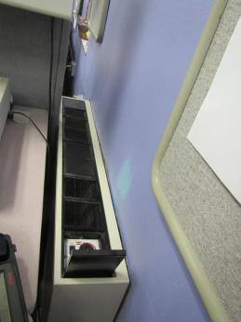

**Univent blocked by furniture**

**Picture 2**

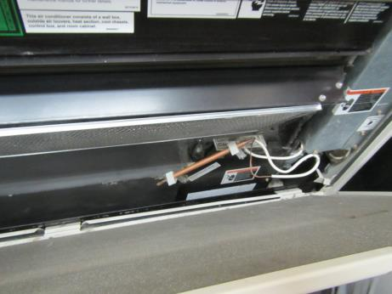

**Metal mesh filter inside univent**

**Picture 3**

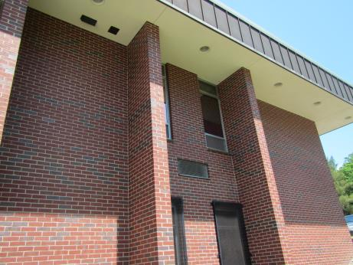

**Univent fresh air intake, note no drain or water stain that would indicate condensation drainage**

| **Location** | **Carbon**  **Dioxide**  **(ppm)** | **Carbon Monoxide**  **(ppm)** | **Temp**  **(°F)** | **Relative**  **Humidity**  **(%)** | **PM2.5**  **(µg/m3)** | **Occupants**  **in Room** | **Windows**  **Openable** | **Ventilation** | | **Remarks** |
| --- | --- | --- | --- | --- | --- | --- | --- | --- | --- | --- |
| **Supply** | **Exhaust** |
| Background (outdoors) | 444 | ND | 67 | 64 | 21 |  |  |  |  |  |
| Lobby | 731 | ND | 79 | 58 | 19 | 20+ | N | Y | Y | Outdoor door open |
| Cash office | 1064 | ND | 71 | 50 | 15 | 2 | N | Y | Y | Door open |
| Cafeteria | 846 | ND | 72 | 57 | 21 | 2 | Y | Y | N | Door open |
| Judge’s lobby | 1076 | ND | 74 | 52 | 16 | 1 | Y | Y | Y |  |
| Back foyer | 671 | ND | 73 | 56 | 25 | 0 | N | Y | N |  |
| Lock-up control | 791 | ND | 73 | 54 | 21 | 0 | Y | Y | Y | Restroom exhaust vent off |
| G10 | 550 | ND | 72 | 55 | 16 | 1 | Y | Y | N |  |
| G10 | 560 | ND | 72 | 55 | 16 | 1 | Y | Y | N |  |
| G10 | 610 | ND | 73 | 55 | 19 | 6 | Y | Y | N |  |
| G8 | 841 | ND | 73 | 56 | 19 | 1 | Y | Y | N | Plants |
| G5 | 791 | ND | 73 | 53 | 18 | 3 | N | Y | Y |  |
| G2 | 1062 | ND | 73 | 54 | 18 | 1 | N | Y | N |  |
| Courtroom 1 | 863 | ND | 70 | 49 | 10 | 50+ | Y | Y | Y |  |
| Courtroom 2 | 665 | ND | 70 | 60 | 18 | 6 | Y | Y | Y |  |
| 102 | 972 | ND | 74 | 51 | 14 | 1 | Y | Y | Y | Restroom exhaust vent off |
| 108 | 841 | ND | 71 | 56 | 19 | 3 | Y | Y | Y | Exhaust dependent on operation of restroom vent |
| 109 | 1026 | ND | 70 | 48 | 14 | 10 | Y | Y | Y |  |
| 110 | 795 | ND | 72 | 54 | 12 | 0 | N | Y | Y | Wall installed air conditioner |
| 113 | 864 | ND | 72 | 55 | 16 | 2 | N | Y | Y | Wall installed air conditioner |
| 115 | 617 | ND | 71 | 55 | 10 | 0 | Y | Y | Y | Restroom exhaust vent off |
| 116 | 1043 | ND | 72 | 50 | 15 | 0 | Y | Y | Y |  |