Minutes  Drug Utilization Review Board Meeting  DATE: March 9, 2022 | 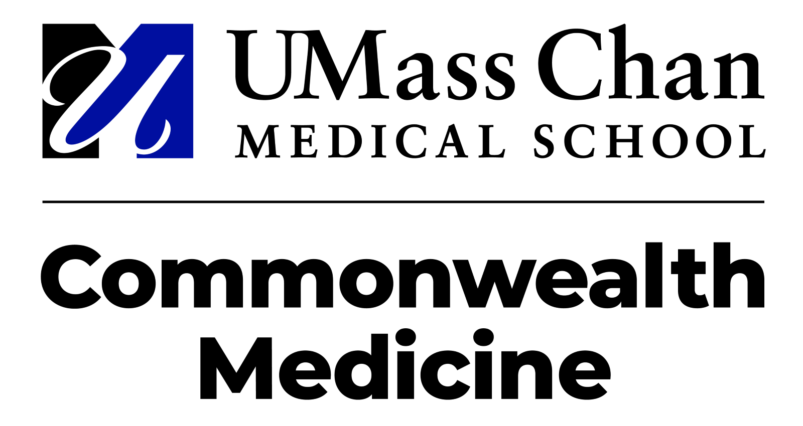

Meeting Purpose: Quarterly Drug Utilization Board Meeting
Meeting opened at 6:00 p.m. by Greg Low, RPh, PhD

The meeting was conducted under Massachusetts Public Meeting Law requirements.

Attendance: Melissa Coyle, PharmD; Timothy Fensky, RPh; James Gagnon, RPh, PharmD; Colleen Labelle, MSN, RN-BC, CARN; Greg Low, RPh, PhD; Lori Lewicki, RPh; Sarah M McGee, MD; Laura Spring, MD; Christy Stine, MD, PhD.; Michael Thompson, MD

Absent: Karen Ryle, MS, RPh

Agenda Items:

Welcome and Introductory Remarks

Minutes

Guest Speaker

Annual Pipeline Continuing Education Program

Hepatitis C Quality Assurance Analysis

MHDL Update

DUR Operational Update

Clinical Team Update

Open Forum

CAR-T Quality Assurance Analysis

Agenda Item | Discussion | Conclusions/Follow Up
Minutes | Motion to approve the minutes for December 2021 was made by Michael Thompson, MD and seconded by Timothy Fensky, RPh. | Follow Up  Minutes are approved.

Agenda Item | Discussion | Conclusions/Follow Up
Guest Speaker | Dr. Angela Fitch, Co-Director for MGH Weight Center spoke about obesity, diabetes, and weight loss. | Follow Up  Minutes are approved.
Action | Questions  Lenz commented that she appreciated that she spoke and provided comments on this topic. Lenz also stated that they were in the process of making some changes and updates on this subject. | Conclusion  The board reviewed the presentation.

Agenda Item | Discussion | Conclusions/Follow Up
Annual Pipeline Continuing Education Program | Annual Pipeline Continuing Education by Dr. Pavel Lavitas and Dr. Eliza Anderson  The Pipeline Update provided an overview of clinical and/or regulatory updates regarding select pharmaceutical pipeline agents in late-stage development. | Follow Up  Informational/Advisory
Action | Discussion  - Trends in historical approvals of new drugs  - FDA-approved new molecular entities  - First-cycle approvals granted for 86% (43/50) NMEs  - Does not include gene therapies or immunotherapies (reported by CBER)  - First-in-class approvals: 54% (27/50)  - Approvals for orphan diseases: 52% (26/50)  - Meeting PDUFA goal: 98%  - Pipeline Trends: Looking ahead  - Orphan Diseases Pipeline  - 5,608 drugs are being developed for orphan drug conditions.  - Almost one-third of drugs in development are for 648 orphan diseases.  - Mean costs in 2018, for the top 100 orphan drugs was $100,854/patient/year as compared to non-orphan drugs at $33,654/patient/year.  - Oncology  - Generic Pipeline: First Generation CAR-T Therapies  - High cost to manufacturer and administer treatment  - High rates of CRS/NT that is also costly to manage  - Up to four weeks to manufacturer plus payer approval  - Breyanzi (lisocabtagene maraleucel)  - Carvykti (ciltacabtagene autoleucel)  - EBV+ Post Transplant Lymphoproliferative Disease  - Tabelecleucel  - Infectious Diseases  - Limited activity in antibiotic pipeline  - HIV pipeline  - Less frequent dosing  - Options for multi-drug resistant disease and pre-exposure prophylaxis  - RSV Prophylaxis  - Nirsevimab  - Non-alcoholic Fatty Liver Diseases  - Prevalence ~15 million adults  - Largely asymptomatic  - Diagnosed by liver biopsy  - May progress to cirrhosis and require liver transplant  - No FDA-approved treatments  - Immunology  - Psoriasis  - Deucravacitinib  - Generalized pustular psoriasis (GPP)  - Spesolimab  - Ulcerative Colitis (moderate-to-severe)  - Mirikizumab  - Hematology  - Anemia in Chronic Kidney Disease  - Vadadustat  - Central Nervous System  - Seizures associated with CDD  - Ganaxolone  - Amyotrophic Lateral Sclerosis  - AMX-0035  - Multiple Sclerosis  - Ublituximab  - Behavioral Health  - Major Depressive Disorder  - AXS-05 (bupropion/dextromethorphan)  - Agitation with Schizophrenia and Bipolar Disorder  - BXCL501 (dexmedetomidine hydrochloride)  - Endocrine and Metabolic  - Type Two Diabetes  - Tirzepatide  - Amyloidosis  - Vutrisiran  - Inherited Disorders  - Niemann-Pick Disease Type A and Type B  - Olipudase alfa  - Gene Therapy  - Beta-Thalassemia  - Zynteglo (betibeglogene autotemcel)  - Adrenoleukodystrophy  - Elivaldogene autotemcel (eli-cel)  - Epidermolysis Bullosa  - Beremagene geperpavec (B-VEC)  - Conclusions  - Immuno-oncology and drugs for rare diseases continue to lead the pack for pipeline drug development.  - Cell and gene therapy approvals may accelerate.  - 10 to 20 approvals per year by 2025  - Biosimilar adoption was slow initially due to numerous factors but may start to increase over time.  Questions  - Thompson asked if the savings for biosimilars were significant as that might drive adoption. He also asked if formularies may influence biosimilar use as the provider choice is dictated by what is covered by a patient’s formulary.  - Anderson agreed that decisions can be driven by formularies. She also stated the cost savings is dependent on the agent.  - Thompson asked about the new drugs not being affected by the pandemic but rather a lag in FDA review because of difficultly with completing clinical trials.  - Lavitas agreed and responded that he did notice that when preparing for the meeting he saw several delays in some trials. | Conclusion  The board reviewed and accepted the presentation.

Agenda Item | Discussion | Conclusions/Follow Up
Hepatitis C Quality Assurance Analysis | Hepatitis C Quality Assurance Analysis by Dr. Collin Jerard  This overview was an evaluation of current medical literature and will provide a brief overview of new guideline recommendations in this disease state. | Follow Up  Informational/Advisory
Action | Discussion  - Estimated U.S. prevalence of HCV infection: 3.5 million  - MA prevalence: 200,000+  - MA incidence: 7,000 to 9,000 per year  - Liver fibrosis accumulates over decades (F0 F4)  - Treatment goal is HCV eradication, preventing complications and liver related deaths  - AASLD/IDSA recommend treating HCV infection with oral DAA combinations  - Mavyret (glecaprevir/pibrentasvir) or sofosbuvir/velpatasvir are recommended for most patients  - How has HCV management changed?  - Novel DAA treatment has been available for nearly ten years.  - States have been lifting restrictions on HCV management:  - Treating patients with early liver fibrosis stage  - Opening coverage to patients with active SUD  - Preferred product selection  - Removing PA entirely  - AASLD/IDSA Guideline Recommendations (Updated September 2021)  - HCV in Children  - Updated information based on FDA approval for DAA therapy in patients ≥ three years of age  - DAA treatment with an approved regimen is recommended for all children and adolescents with HCV infection aged ≥ three years  - Pediatric Expanded Indication  - Mavyret (glecaprevir/pibrentasvir)  - Clinical Trial Support  - DORA Part two: investigated G/P in pediatric subjects three years to < 12 years without cirrhosis who received G/P for eight, 12, or 16 weeks  - Key efficacy data demonstrated overall SVR12 rate was 98.4% (n=61/62) with no virologic failures  - Epclusa (sofosbuvir/velpatasvir)  - Clinical Trial Support  - Study 1143: investigated Epclusa in pediatric subjects three years to < six years of age to be treated for 12 weeks  - Key efficacy data demonstrated a SVR12 of 83% (34/41) among all patients  - Point-of-Sale Rules  - Provide for online adjudication of pharmacy claims through coding algorithms  - Claims pay at the pharmacy without PA if criteria are met.  - Minimize the need for a PA while promoting appropriate and cost-effective clinical care.  - Effective February 7, 2022, point-of-sale rules were implemented for sofosbuvir/velpatasvir and Mavyret (glecaprevir/pibrentasvir).  - Implemented Point-of-Sale Rules  - Claims will usually pay at the pharmacy without PA unless one or more of the following exceptions apply:  - Quantity exceeds one unit/day (sofosbuvir/velpatasvir) or three units/day (Mavyret)  - Member is < three years old  - History of paid pharmacy claims for a hepatitis C drug  - History of paid pharmacy claims for drugs suggestive of decompensated cirrhosis  - Recent history of pharmacy claims (in the last 90 days) for a drug that may lower DAA efficacy  - PA will generally still be required if HCV regimen selection is more nuanced e.g.,  - Decompensated cirrhosis  - Prior treatment for HCV infection  - HCV regimen impacted by drug-drug interactions  - Conclusions  - Preferred HCV DAA account for nearly all the pharmacy utilization  - PA criteria were updated to reflect the expanded indications for Mavyret and sofosbuvir/velpatasvir in children  - Due to appropriate utilization, high cure rates, and to promote access to treatment, point-of-sale rules were implemented  - Point-of-sale rules allow most claims for select DAA to pay at the pharmacy without PA  - A future QA analysis will evaluate the impact of point-of-sale rule implementation on DAA utilization, cost, and PA volume  Questions  - Low inquired about the numbers of prescribers that are primary care versus specialists.  - Jerard responded that he does not have the current numbers.  - Lavitas stated that when he looked at the numbers two years previously, 80% were specialists and 20% were primary care. Lavitas stated he thought that the shift in numbers may demonstrate increased primary care involvement and less specialist involvement if we take a look again at the numbers. | Conclusion  The board reviewed and accepted the presentation.

Agenda Item | Discussion | Conclusions/Follow Up
MHDL Update | MHDL Update by Dr. Phuong Luc  MHDL Overview included new additions, changes in Prior Authorization (PA) status, and related attachment updates to be implemented with a recent publication rollout. | Follow Up  Informational/Advisory
Action | Discussion  - There were 10 additions to the MHDL Drug list effective as of March 21, 2022.  - Of the 10 additions, eight will require PA and two will not.  - Changes in PA status  - One cerebral stimulant agent will require prior authorization.  - Two benign prostatic hyperplasia agents will no longer require prior authorization.  - One intranasal corticosteroid agent will no longer require prior authorization within quantity limits while one agent will require prior authorization for all quantities.  - Two topical antifungal agents will no longer require prior authorization while one agent will require prior authorization.  - Two cardiovascular agents will no longer require prior authorization while two agents will require prior authorization.  - Changes to the MassHealth Brand Name Preferred Over Generic Drug List  - 12 agents were added to the MassHealth Brand Name Preferred Over Generic Drug List.  - New FDA “A”-rated Generics  - Betaine is the generic equivalent of Cystadane.  - Changes to Miscellaneous Documents  - The MassHealth COVID-19 Pharmacy Program Emergency Response document has been updated to reflect recent changes.  - The MassHealth Quick Reference Guide has been updated to reflect recent changes to the MassHealth Drug List.  - The Chimeric Antigen Receptor (CAR)-T Immunotherapies Monitoring Program has been updated.  - Two products have been added to the MassHealth Non-Drug Product List.  - The MassHealth ACPP/MCO Unified Pharmacy Product List has been updated to reflect recent changes to the MassHealth Drug List. | Conclusion  The board reviewed and accepted the presentation.

Agenda Item | Discussion | Conclusions/Follow Up
DUR Operational Update | DUR Operational Update by Dr. Patricia Leto  DUR Operational Overview included statistics associated with Prior Authorization (PA) review and PA response, and Call Center metrics. | Follow Up  Informational/Advisory
Action | Discussion  - MassHealth PA requests from 2019 to 2022 (calendar year to date) showing with COVID leniencies initiated in March 2020 and then removed in August 2020.  - MassHealth call center volume from 2019 to 2021 (calendar year to date) showing with COVID leniencies initiated in March 2020 and then removed in August 2020.  - The monthly average for PAs from 2017 to 2022 (to date) were reviewed. Peak average of 10,547 per month in 2018 while currently 2022 (to date) average per month is 9,139.  - Call abandonment rate generally in the 2% range.  - Average wait time of answered call generally in the 30-second range.  - Average treatment time consistently around four minutes.  - MassHealth Appeals: Current monthly average is four.  - Provider Outreach Volume: Current monthly average is 668 calls.  - Top Ten Medications Requested for Prior Authorization – January 1, 2021, to December 31, 2021.  - Clindamycin - Methylphenidate  - FreeStyle Test Strips - Testosterone  - Tretinoin - Pregabalin  - Dexcom - Clonazepam  - Clonidine - Botulinum  - Prior Authorization Compliance Response Time – January 2021 to December 2021  - Total requests:107,904 requests  - 73% of all PAs decisions with in six hours.  - 99.5% of all PAs decisions in less than 24 hours.  - Prior Authorization Compliance Response Time during Call Center hours – January 2021 to December 2021  - Total requests: 107,904 requests  - 93% of all PAs decisions within six hours.  - 99 % of all PAs decisions in less than nine hours. | Conclusion  The board reviewed and accepted the presentation.

Agenda Item | Discussion | Conclusions/Follow Up
MassHealth Update | MassHealth Update by Dr. Kimberly Lenz  MassHealth Update is a summary of recent developments in MassHealth in the context of pharmacy, managed care, or public health. This edition will include historical milestones from the past two decades. | Follow Up  Informational/Advisory
Action | Discussion  - Report to Legislature November 2021  - Seventeen agreements with manufactures  - 50 medications  - ~$172 million (annualized) in new supplemental rebates  - Seven value-based contracts with manufacturers  - Claims Processing  - Covid-19 Antigen Testing Kits  - As of March 8, 2022, paid for over 26,000 individual tests  - Currently seeing weekly numbers decrease due to reduced positivity rates and availability of tests through other avenues  - Specialized Pediatric Formulas through the Pharmacy Benefit  - Started due to the shortages nationally  - Updated as of December 2021 to provide another channel for access.  - Digital Therapeutics  - First Medicaid Program in the country to cover digital therapeutics  - Continue to monitor outcomes of members utilizing these products  - Eight value-based contract  - Fully Unified Formulary  - Launch to be planned for calendar year 2023.  - 250 Unified drugs currently | Conclusion  The board reviewed and accepted the presentation.

Agenda Item | Discussion | Conclusions/Follow Up
Open Forum | Open Forum | Follow Up  Informational/Advisory
Action | Discussion  - This presentation was tabled until the next DUR Board meeting. | Conclusion  N/A

Agenda Item | Discussion | Conclusions/Follow Up
CAR-T Quality Assurance Analysis | CAR-T Quality Assurance Analysis by Dr. Karen Stevens  This overview was an evaluation of current medical literature and had provided a brief overview of new guideline recommendations in this disease state. | Follow Up  Informational/Advisory
Action | Discussion  - This presentation was tabled until the next DUR Board meeting. | Conclusion  N/A

Meeting adjourned at 8:00 p.m.

Respectfully submitted by Mylissa Price

Date: _________________

