Charles D Baker Marylou Sudders
1
Governor Secretary
Karen Polito Peter J. Forbes
Lieutenant Governor Commissioner

Massachusetts
Department of Youth Services 2016 Annual Report
December 2017

Massachusetts Department Of Youth Services Calendar Year 2016

EXECUTIVE HIGHLIGHTS

Youth Demographics
Commitment: DYS served 991 youth on commitment.

- 662 on commitment until age 18
- 75 on commitment until age 19
- 3 on commitment until age 20
- 251 on commitment until age 21, as youthful offenders
- 40% were committed for serious felonies, e.g. manslaughter, armed robbery and carjacking
- 17.2 years was the average age of the committed population
- 85% were male and 15% were female
- Race and Ethnicity:
  - 1% Asian
  - 37% Black
  - 37% Hispanic
  - 21% White
  - 4% Other

Detention: There were 1,859 detention admissions of youth pending future court dates

- 316 youth were in detention and later on commitment
- 16.3 years was the average age of the detained population
- 80% were male and 20% were female
- 29 days was the average length of stay in detention
- Race and Ethnicity:
  - 1% Asian
  - 28% Black
  - 39% Hispanic
  - 29% White
  - 3% Other

Arrest: There were 1660 overnight arrest admissions, 1,368 youth held.

Voluntary Services: 175 youth (49% of those discharged) signed up for YES (Youth Engaged in Services) to continue to receive DYS services after discharge.

Youth Academic Performance

10th Grade MCAS Pass Rate
 | General Education Students | Students with Disabilities | All DYS Students
English Language Arts | 100% | 90.5% | 94.9%
Math | 92.6% | 58.2% | 79.2%
Science | 56.0% | 29.0% | 36.1%

High School Equivalency Assessment Test (Hi-SET/GED)
DYS Youth | All Massachusetts Youth (including DYS)
76% Passed | 71% Passed

Youth Workforce Development and Career Readiness Training
70% completed orientation training | 64% completed subsidized employment

Massachusetts Department of Youth Services
The Department of Youth Services (DYS), under the Executive Office of Health and Human Services, is charged with providing a comprehensive and coordinated program of delinquency prevention and services to youth detained by or committed to the Department by the courts.

The Department is the first juvenile correctional system established in the nation, founded in 1846 with the opening of the Massachusetts State Reform School in Westborough.

MISSION
As the juvenile justice agency for the Commonwealth of Massachusetts, the Department promotes positive change in the youth in our care and custody. Our mission is to make communities safer by improving the life outcomes for youth in our care. We achieve our mission through investing in highly qualified staff and a service continuum that engages youth, families and communities in strategies that support positive youth development.

VISION
Every young person served by the Department will become a valued, productive member of their community and lead a fulfilling life.

VALUES
- We unwaveringly and persistently pursue the positive development of youth in our care.
- We promote safer communities by providing prevention, intervention and rehabilitation services.
- We actively engage and support youth, families and communities as our partners.
- We actively support a safe and healthy environment for our workforce.
- We work collaboratively with our public and private partners.
- We adhere to the highest ethical and professional standards in all our work.
- We respect and embrace diversity.

CHARLES D. BAKER

Governor

KARYN E. POLITO
Lieutenant Governor

MARYLOU SUDDERS
Secretary

PETER J. FORBES
Commissioner

The Commonwealth of Massachusetts
Executive Office of Health and Human Services
Department of Youth Services
600 Washington Street, 4th floor Boston, MA 02111

617-727-7575
FAX#: 617-727-0696
www.mass.gov

Dear Colleagues:

The Department of Youth Services is built on the energy and commitment of the direct care staff, managers, clinicians, and professionals working in collaboration with our not-for-profit provider community. Their dedication as mentors and caring adults has had a profound positive impact on the many young people committed to our care. This year’s Annual Report provides an update on the Department’s operations and highlights accomplishments and positive youth outcomes achieved. Successes during 2016 included:
- 74 youth attained a high school diploma
- 86 youth (76% ) passed the GED (General Equivalency Diploma) or Hi-Set (High School Equivalency Diploma)
- Youth enrolled in general and special education
  - 94.9% passed the 10th grade MCAS English Language Arts competency exam
  - 79.2% passed the 10th grade MCAS Mathematics competency exam
- 42 youth enrolled in post-secondary courses
- 175 youth (49% of those discharged) signed an agreement with DYS for voluntary services post discharge
- Opening of the Northeast Youth Service Center, a state-of-the-art facility in Middleton
- DYS PREA Working Group awarded the Manual Carballo Governor’s Award for Excellence in Public Service
These accomplishments are possible because of the many stakeholders who believe in our agency’s mission and values. Families and advocates continue to be important partners through their support and collaboration in helping to change the life trajectories of our young people. And the Department has benefitted immensely from the policy and fiscal support of Governor Baker, Lieutenant Governor Polito, Health and Human Services Secretary Sudders and members of our State Legislature.

All the support given to the Department of Youth Services is greatly appreciated. I am committed to maintaining this support by continuing to improve outcomes for our young people, and by demonstrating integrity in Department operations.

Sincerely,
Peter J. Forbes DYS Commissioner

Table of Contents
DYS Youth Demographic Trends 7
Committed Youth 7
Detained Youth 11
Raise-the-Age: Impact on DYS Commitment and Detention 14
DYS Alternative Lock-up (Overnight Arrest) Programs 16
DYS Revocation 19
Youth Engaged in Services 19
Recidivism 21
The DYS Service Continuum 23
DYS Placement Services 23
DYS Community Services 23
Education 24
MCAS Performance Outcomes (2015-2016) 25
Career Readiness 26
CY 2016 DYS HIGHLIGHTS 27
4th Annual Youth Art Showcase — Voicing What Matters! 27
JDAI 28
PREA 28
OJJDP Second Chance Grant 29
DYS Staff, Infrastructure & Finance 30
The DYS Workforce at a Glance 30
Training and Staff Development 30
DYS Capital Projects 31
DYS Fiscal Year 2016 Budget at a Glance 32

DYS Youth Demographic Trends

Committed Youth
The graphs below present data on the age, race, gender, and grid level of the youth who were committed to the Department of Youth Services (DYS) from 2012 through 2016. The majority of these youth were between the ages of 16 and 17, male, and fell in DYS Offense Grid Levels 2 and 3.
In CY 2016, there were 992 committed youth served by DYS, 316 of whom had been in detention earlier in the year.
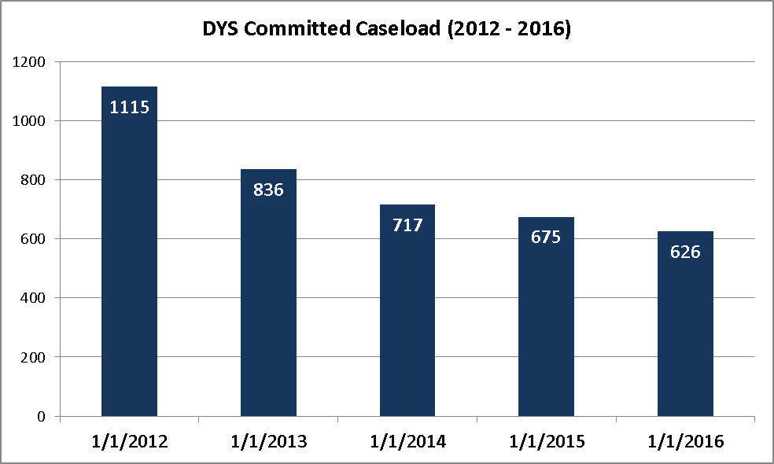
The DYS commitment caseload continued to trend downward in CY 2016.

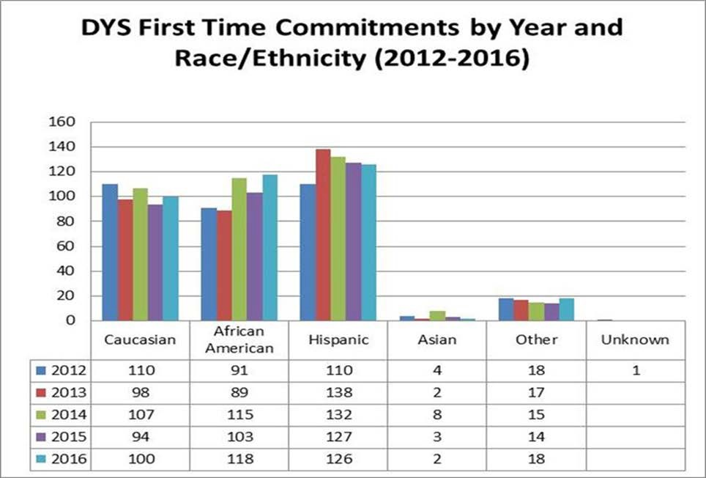
In the DYS committed population, the proportion of youth of color — relative to Caucasian youth — has continued to increase since 2012.

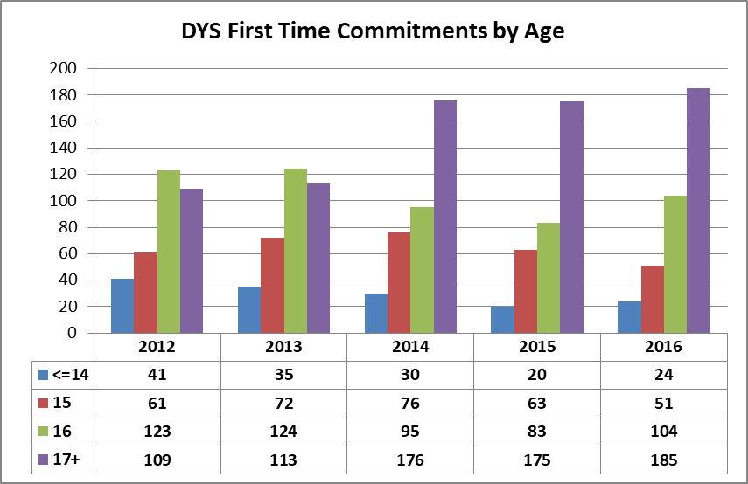
The average age of youth at first-time commitment in CY 2016 was 16.9. First-time commitments of 17-year-olds continue to increase, representing 32% in 2012, 51% in 2016.

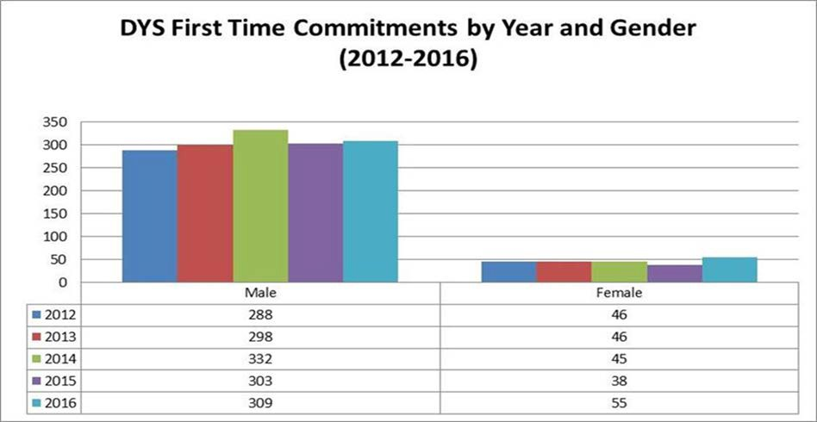
The percentage of committed females served by DYS was 15% in CY 2016, an increase from the 11 to 13% in the previous 4 years.

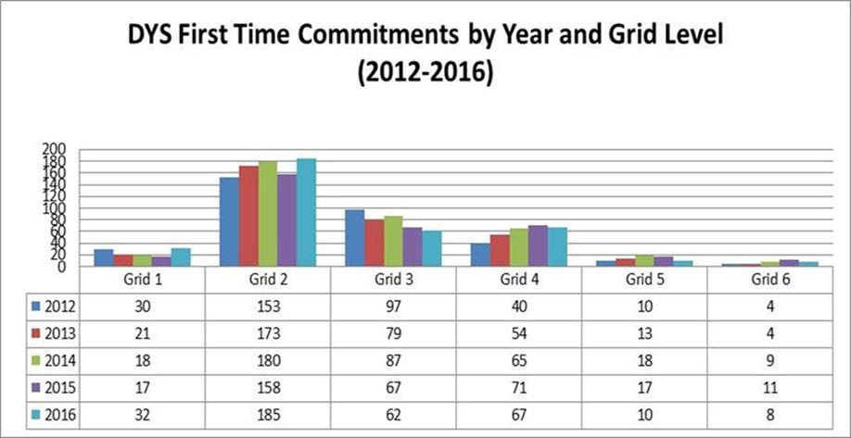
DYS assigns each committed youth a Grid Level reflecting the severity of the most serious offense for which they’ve been committed. The Grid Level is then used in the classification process to determine both the recommendation for time in the initial residential setting as well as whether the youth will be placed in a community-based or secure setting. Grid Levels range from one (least severe) to six (most severe); typical offenses corresponding to the Grid Levels are listed below:

- Grid 1: Operating a MV with a suspended license, marijuana possession (over 1 ounce), shoplifting, disorderly conduct, trespass
- Grid 2: OUI liquor or drugs, possession of heroin, assault, assault & battery, tagging, breaking & entering
- Grid 3: Robbery, stalking, burning buildings (arson)
- Grid 4: Indecent A&B on a child, assault to murder or maim, assault & battery with dangerous weapon (ABDW) with significant injury, armed robbery, carjacking, kidnapping
- Grid 5: Involuntary manslaughter, A&B on a child with substantial injury, attempted murder, armed robbery with firearm, assault to murder (armed), armed carjacking
- Grid 6: Manslaughter, home invasion, rape of child under 16 with force, trafficking firearms (20+ weapons)

In CY 2016, 77% of the most serious offenses related to first-time commitments were below Grid 4; 68% were Grid Levels 2 and 3.

Detained Youth
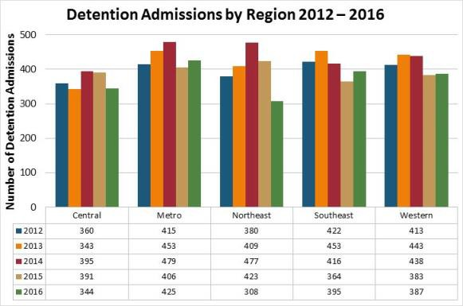
In CY 2016, there were 1,859 detention admissions.
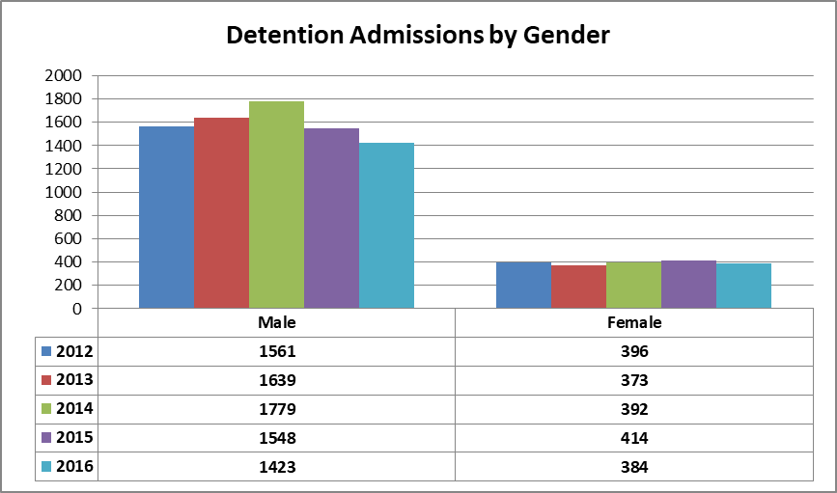
Twenty one percent (21%) of the youth detained in CY 2016 were females.

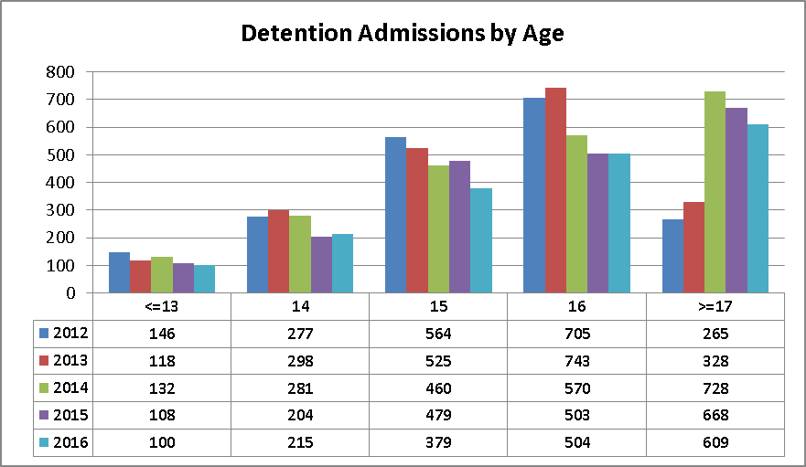
The average age of youth at the time of detention admission rose to 16.3 in CY 2016.
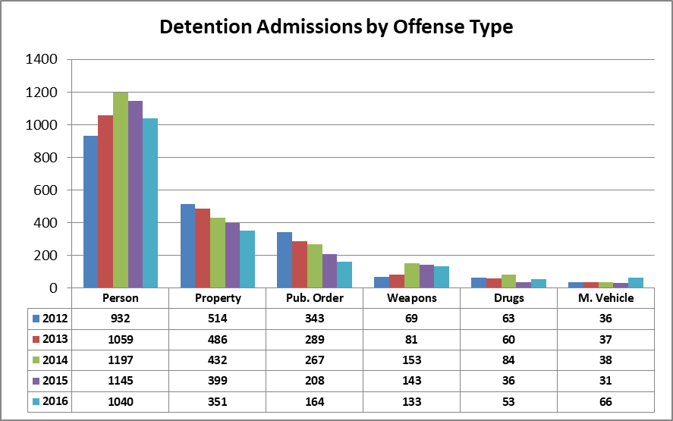
Most of detained youth were held for crimes against a person or property.

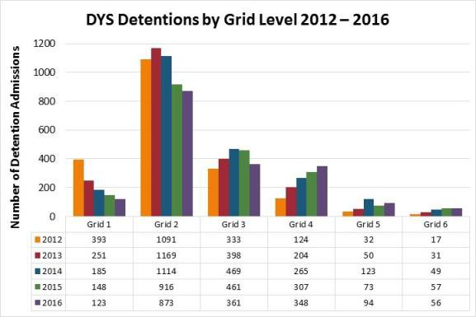
In CY 2016, most of the youth in detention were assigned Grid Level 2 for such offenses as OUI liquor or drugs, possession of heroin, assault, assault & battery, tagging, breaking & entering.
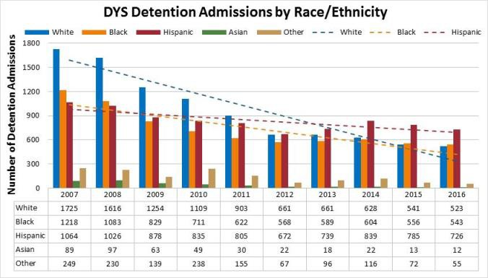
Since 2012, Hispanic youth have accounted for a larger proportion of the youth in detention as the number of Caucasian and African American youth in detention dropped at a greater rate.
In CY 2016, there were 726 detention admissions of Hispanic youth compared to 523 admissions of Caucasian youth.

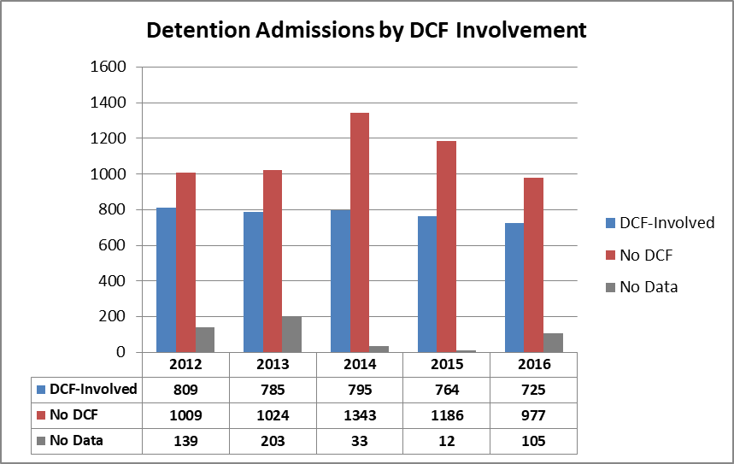
In CY 2016, the percentage of detention admissions of youth with DCF involvement was 42.5%. Over the 5 years from CY 2012 to CY 2016, the percentage of detention admissions of youth with DCF involvement has ranged from 37.2% to 44.5%.

Raise-the-Age: Impact on DYS Commitment and Detention
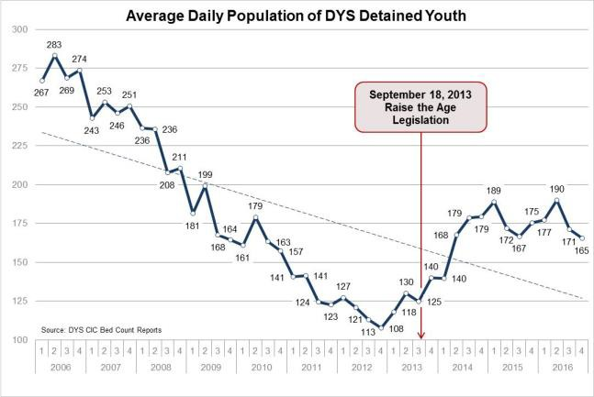In 2013, the Raise-the-Age legislation was passed in Massachusetts which increased the age of juvenile court jurisdiction from 17 to 18 for delinquency cases and youthful offender matters.
In CY 2016, DYS saw the statewide average daily detention population rate start to level off after trending upward following the passage of the Raise the Age legislation. In the last quarter of CY 2016, the statewide average daily detained population was 165 youth.

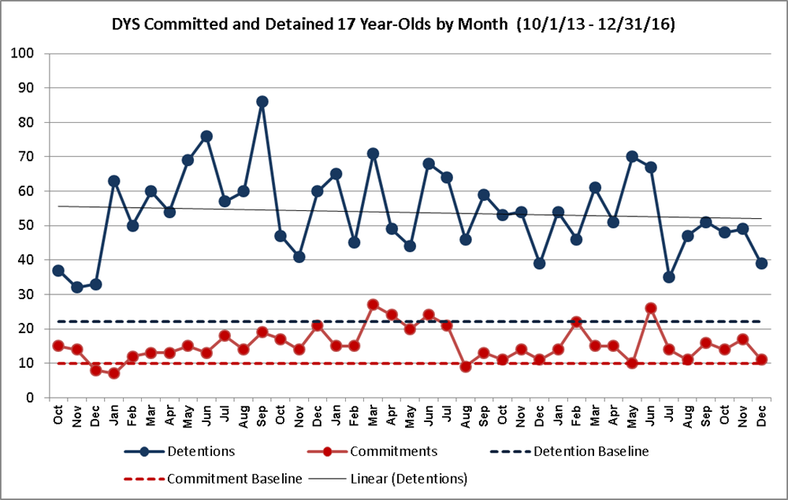
The number of youth age 17 detained since Raise the Age is starting to trend downward and the number of 17 year old youth committed since Raise the Age has been relatively constant.

DYS Alternative Lock-up (Overnight Arrest) Programs
The Department of Youth Services administers the Alternative Lockup Programs which provide secure placements for youth arrested when courts are not in session. The program is designed to provide a safe, non-police environment for youth who are awaiting a court appearance.

The alternative placement of youth awaiting arraignment follows both state and federal requirements that include:

- Youth who commit a status offense (an offense that is only prohibited for minors) may not be securely detained for any length of time
- Juveniles charged with a non-status offense may be securely detained for no longer than 6 hours in a local police station
- Youth must be sight and sound separated from adults
- No juvenile under the age of 14 may be held in a police lockup

DYS had 1663 overnight arrest admissions (placement for youth arrested overnight or during the weekend until arraignment or court date) in CY 2016.

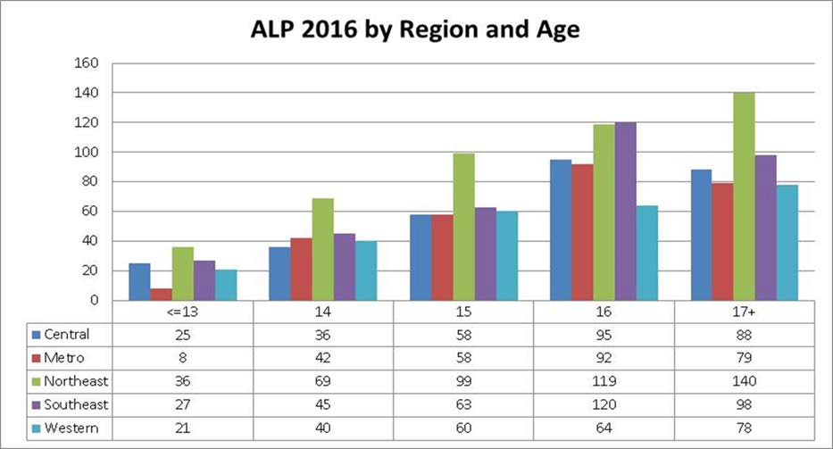
In CY 2016, the trend continued with the number of youth placed in a DYS Alternative Lock- Up programs increasing with the age of the youth.

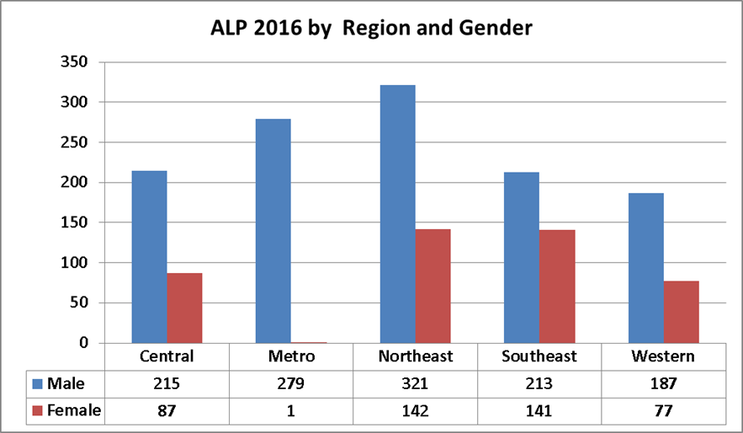
Young male represented 73% and young female represented 27% of the youth placed in a DYS Alternative Lock-Up Program in CY 2016.

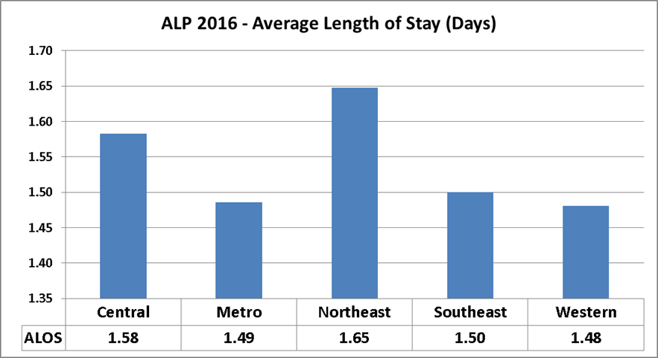
The average length of stay in a DYS Alternative Lock-Up Program was 1.55 days in CY 2016.

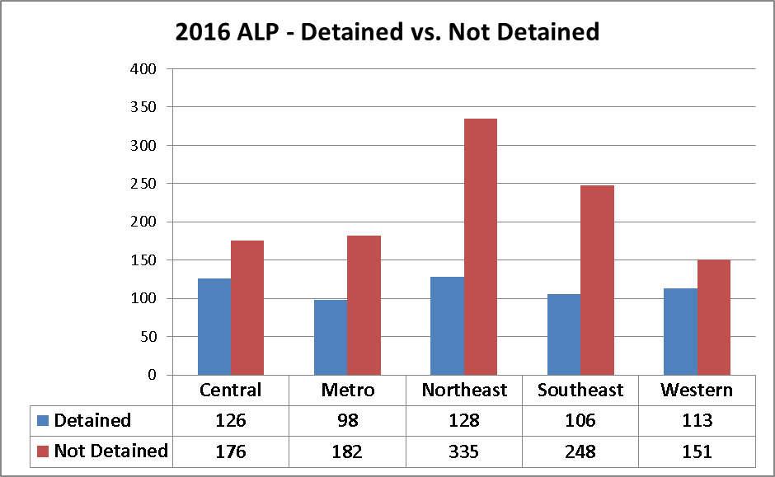
In CY 2016, 34% of youth placed in DYS Alternative Lock-Up programs were subsequently placed in detention as compared to 35% in CY 2015.

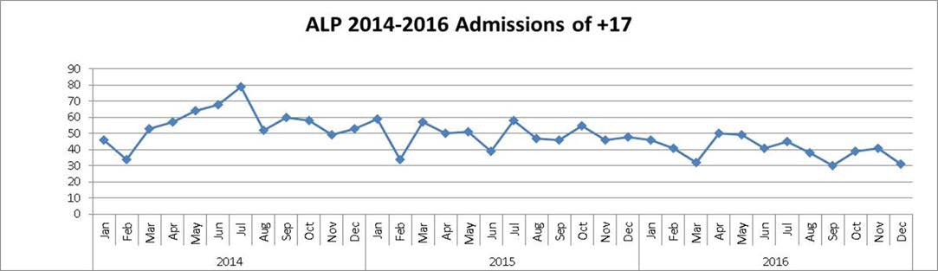
The average number of 17-year-olds referred each month to DYS for overnight arrest program has decreased from 56 in CY 2014 to 40 in CY 2016.

DYS Revocation
After youth are committed by the court to DYS and complete their residential or secure treatment requirement, they are then released into the community under an agreement similar to a parole agreement which is called the Grant of Conditional Liberty, or GCL.

The GCL is a document signed by youth and their DYS caseworkers that lists the conditions that the youth must follow, such as attending school regularly and staying in contact with the DYS caseworker. When DYS caseworkers believe that a youth is not following the conditions of their GCL, they may decide to return the youth to custody to face a revocation hearing.

Revocations by Calendar Year
In CY 2016, 353 youth were revocated. Thirty seven percent (37%) were black youth, 33% were Hispanic youth, 23% were white youth and 6% were in the other category; 47% of the youth were 17 years old at the time of revocation.

Youth Engaged in Services
In 2013, DYS began offering voluntary community support services to every youth discharging from DYS custody These voluntary services are intended to provide a safety net to youth released from care and prevent youth from engaging in behaviors that lead to adult criminal justice involvement. Through the voluntary agreement entered into with DYS, a youth agrees to abide by the conditions of the agreement following discharge in exchange for continuing case management and other transitional supports such as housing, continued education, treatment and/or job training.

In 2016, the statute, M.G.L. c.120, §15, was amended and authorized DYS to offer and provide the services to youth offenders after they are discharged at age 21 and also established a window of 90 days for a discharged youth to change his/her mind after initially rejecting the voluntary services. Prior to the amendment, DYS could not offer these voluntary services to youthful offender discharging at 21 or to a youth after discharge from the Department. Formerly known as the Assent of Ward program, the Youth Engaged in Services (“YES”) program is a DYS service strategy that is directed to reduce recidivism through increasing skill attainment and supporting other positive youth outcomes.

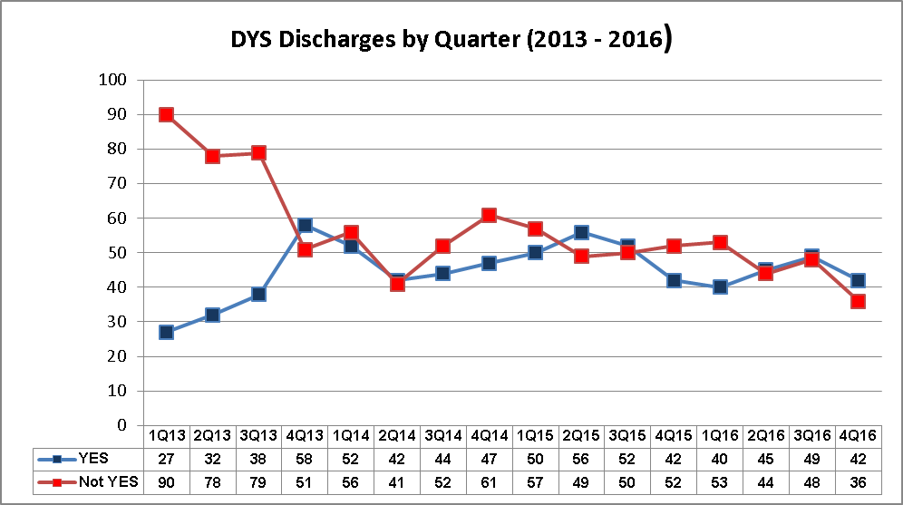
The Youth Engaged in Services voluntary agreements have increased almost four-fold since the inception of the program in CY 2013 from 23% to 49% in CY 2016. This trend reflects another positive step taken by youth in planning for their future post discharge.

Recidivism
In CY 2016, DYS tracked and evaluated the criminal history of 401 former DYS youth who were discharged in 2012 in order to find the rate of recidivism for the entire cohort. Of the 401 individuals in the study, 22% were convicted of an offense committed within 1 year of discharge from DYS which compares favorably with the rates in prior years. For the 2011 cohort, the rate was 22%; 25% for the 2010 cohort; 28% for the 2009 cohort; and a 37% rate for the 2008 cohort. Youth at high risk for conviction post discharge tended to be males who had been committed to DYS on property or person offenses.

One-Year Reconviction
Rate
Gender
Males | 24.8%
Females | 4.3%
Ethnicity
Afr. American | 30.5%
Hispanic | 23.3%
Caucasian | 17.6%
Other | 14.7%
DYS Committing Offense Type
Person | 25.0%
Property | 23.0%
Drug | 21.7%
Motor Vehicle | 7.1%
Weapons | 20.7%
Public Order | 17.9%
Grid Level
<= Grid 2 | 19.9%
Grid 3 | 22.7%
Grid 4 | 25.0%
>= Grid 5 | 29.0%

- In the current study, the one-year reconviction rate was the same for the 2012 cohort as it was for the 2011 cohort (22%).
- Of the youth who were reconvicted for offenses committed within one year of discharge 61% were reconvicted within the first six months.
- The recidivism rate for males was 25% while the rate for females was only 4%.
- Recidivism rates were significantly higher for youth who had been committed on a felony as a juvenile (27%) than those who had been committed on a misdemeanor (17%).
- Recidivism rates were highest for youth whose juvenile offenses involved a person (25%), or property (23%). The lowest rates were for those committed for motor vehicle offenses (7%).
- High recidivism rates were associated with youth committed to DYS for assault (36%) and larceny (32%). Low recidivism rates were associated with youth committed to DYS for carrying a dangerous weapon (15%) and assault and battery (17%).
- Of the five DYS Regions, the Northeast Region had the lowest recidivism rate (18%).
- Among the major Massachusetts cities, Worcester youth had the highest reconviction rate (46%), while Fall River youth had the lowest (8%).

Recidivism Rates for Former DYS Youth with Selected DYS Offenses Sample
DYS Offense Sample | # Adjudicated | Total in Sample | Recidivism
Assault | 5 | 14 | 35.7%
Larceny | 10 | 31 | 32.3%
Unarmed Robbery | 5 | 17 | 29.4%
Armed Robbery | 10 | 36 | 27.8%
ABDW | 5 | 19 | 26.3%
Drug Possession | 4 | 16 | 25.0%
Breaking and Entering | 4 | 22 | 18.2%
Assault and Battery | 13 | 78 | 16.7%
Carrying a Dangerous Weapon | 2 | 13 | 15.4%

Recidivism Rates for Former DYS Youth - Misdemeanors vs. Felonies

DYS Offense | # Adjudicated | Total in Sample | Recidivism Rate
Misdemeanor | 30 | 179 | 16.8%
Felony | 60 | 222 | 27.0%

The DYS Service Continuum
The Department of Youth Services employs a “continuum model” of services and supervision. This continuum includes residential programs, reception centers/foster care, and community- based sites. DYS divides its services into five geographic regions. While each region has its own continuum of services and supervision in order to serve youth as close to their home communities and families, all DYS residential and community programs provide positive youth development opportunities for DYS youth.

DYS Placement Services
In CY 2016, DYS operated 61 residential programs for youth, ranging from staff-secure programs to hardware-secure programs. Bed placement is determined by the youth’s status on the DYS continuum, which includes detention, assessment, commitment, and revocation. There are separate programs for girls and boys. Each residential program has a capacity of 10 to 20 beds. Residential programming services include clinical intervention, education, structured recreation and, health services.

Gender | Security Level | Provider | State | Total
Boys | Hardware Secure | 8 | 17 | 25
 | Staff Secure | 28 |  | 28
Girls | Hardware Secure | 2 | 2 | 4
 | Staff Secure | 4 |  | 4
Total |  | 42 | 19 | 61
As of December 31, 2016

DYS Community Services
The Community Services Network is part of the DYS service continuum that recognizes and complements work completed by youth in the residential phase through the support of families, and the collaboration with communities and locally based provider agencies to access and develop resources. Through 22 district offices that are strategically located across Massachusetts, DYS has caseworkers who provide supervision and support to committed youth living in their home communities. The caseworkers work with youth by connecting them with education and vocational services, job readiness training, employment, behavioral health, medical services, mentoring, and arts related services.
The Community Re-entry Initiative provides supports for the successful transition and re- entry of youth through mentoring, arts and cultural programming, GED/Hi-Set and adult basic education services, and workforce development opportunities that foster career readiness and employment.

Education
The DYS educational model provides students with multiple pathways to academic and vocational growth, including opportunities for youth to pursue and obtain a high school equivalency diploma (formerly the GED, now Hi-SET), earn credits towards a high-school diploma, achieve success in MCAS, and gain 21st century skills and knowledge. Youth in residential programs attend 5.5 hours of classes, 5 days a week. Classes are offered all but 2 weeks in a calendar year.
HIGH SCHOOL DIPLOMAS and GED/HI-SET DATA: Below are the High School Diploma and Hi-SET/GED attainment data from the past four (4) years. While the overall population of youth in DYS has declined over the past several years, our youth continue to attain success in this indicator at rates higher than the rest of the state. Contributing to this positive result is DYS’ collaboration with the Department of Elementary and Secondary Education in setting up three Hi-SET testing sites for youth in secure residential treatment who are unable to test at a community based Hi-SET testing site.

DYS Hi-Set and High School Diploma Attainment Data Years 2012-2016

School Year: | High School Diplomas: | Hi-Set/GED:
2015-2016 | 74 | 86
2014-2015 | 73 | 72
2013-2014 | 69 | 73
2012-2013 | 63 | 80

Hi Set Pass Rate 2015 - 2016

 | Test Completed | Pass | Pass Rate
DYS | 175 | 134 | 76%
Massachusetts | 5,058 | 3.580 | 71%
All Hi-Set States | 47.775 | 35.684 | 75%

Hi-Set Average Scores by Subject 2015-2016

 | Math | Social Studies | Science | ELA Reading | ELA Writing
DYS | 10.9 | 11.5 | 11.1 | 11.35 | 11.04
Massachusetts | 8.6 | 10.9 | 11 | 11.2 | 11.7
All Hi-Set States | 8.9 | 11.3 | 12.4 | 11.6 | 12

MCAS Performance Outcomes (2015-2016)

Student Academic Performance 2016 Results (General and Special Education)

2016 Student Academic Performance Overview – Mathematics
Results: General Education | 27 general education students took the 10th grade MCAS in Mathematics in the spring of 2016. 92.6% of these youth passed, including those who scored in the Needs Improvement, Proficient, and Advanced categories. This reflects an 18.4 percentage point increase over the 2015 results for 31 students.
Results: Students with  Disabilities | 55 students with disabilities took the 10th grade MCAS in Mathematics in the spring of 2016. 58.2% of these youth passed, including those who scored in the Needs Improvement, Proficient, and Advanced categories. This reflects a 6.3 percentage point increase over the 2015 results for 54 students.

2016 Student Academic Performance Overview – English Language Arts
Results: General Education | 36 general education students took the 10th grade MCAS in English Language Arts in the spring of 2016. 100% of these youth passed, including those who scored in the Needs Improvement, Proficient, and Advanced categories. This reflects a 3.6 percentage point increase over the 2015 results for 31 students.
Results: Students with Disabilities | 42 students with disabilities took the 10th grade MCAS in English Language Arts in the spring of 2016. 90.5% of these youth passed, including those who scored in the Needs Improvement, Proficient, and Advanced categories. This is a non-significant change relative to the 2015 results for 54 students.

2016 Student Academic Performance Overview -Science
Results: General Education | 25 general education students took a High School End of Course MCAS exam in Science (Biology, Chemistry, or Physics) in the spring of 2016. 56% of these youth passed, including those who scored in the Needs Improvement, Proficient, and Advanced categories. This reflects a 5.8 percentage point decrease from the 2015 results for 34 students.
Results: Students with  Disabilities | 69 students with disabilities took a High School End of Course MCAS exam in Science (Biology, Chemistry, or Physics) in the spring of 2016. 29% of these youth passed, including those who scored in the Needs Improvement, Proficient, and Advanced categories. This reflects a 3.9 percentage point decrease from the 2015 results for 70 students.

Post-Secondary Enrollment
During the 2015-2016 academic year, forty-two (42) students enrolled in post-secondary courses. This figure is a reflection of DYS’ efforts to partner with institutions throughout the Commonwealth that are dedicated to providing access to higher education and certifications for youth who are involved in the juvenile justice system and are interested in advancing their academic and/or vocational qualifications.

Career Readiness

The Bridging the Opportunity Gap (BOG) Initiative
BOG is a combination employability and re-entry program that provides career readiness, work-based learning opportunities and connections to employment. The BOG initiative is based on a positive youth development model that is asset- based, culturally responsive, and delivered by personnel with experience in operating youth employability programs. Programming is interactive and engaging to youth, and is delivered in a way that addresses a variety of learning styles. Human services agencies, community and faith-based organizations, workforce investment boards, career centers, and vocational technical high schools across the state participate in the BOG initiative. These organizations work with Commonwealth Corporation staff to build and expand program services and resources that result in access to a variety of employment and educational opportunities for DYS youth.
During fiscal year 2016, a total of 370 youth were enrolled in BOG programming. Summer enrollment totaled 134 youth and 236 youth were enrolled during the year round programming. A breakdown of the enrollments is below:

Year-Round BOG
Below is a breakdown of enrollments by program option for summer and year-round programming.

BOG Year Round FY 2016
BOG Program Option | Youth Enrollments | Percentage
Arts & Cultural | 31 | 13%
Hi-Set | 31 | 13%
Vocational | 21 | 09%
Work-Based Learning | 153 | 65%

Overall 53% of goals set in FY16 year-round programing were successfully completed. Orientation training has the highest completion rate at 70%. The subsidized employment goal was successfully completed by 64% of youth.

BOG Summer FY 2016
BOG Program Option | Youth Enrollments | Percentage
Arts & Cultural | 25 | 19%
Hi-Set | 20 | 15%
Vocational | 18 | 13%
Work-Based Learning | 71 | 53%

Overall 65% of goals set in FY16 summer programing were successfully completed. We also found that youth were most successful at completing arts and cultural activities (92%), orientation training (88%), career readiness training (66%) and subsidized employment (51%).

CY 2016 DYS HIGHLIGHTS

4th Annual Youth Art Showcase — Voicing What Matters!
On June 16th, the Department held its 4th Annual “Share Your Art, Share Your Voice!” Statewide Youth Showcase at Emerson College’s Paramount Center in the Boston theatre district. The showcase featured an art sale entirely composed of art by youth artists who received the proceeds of the sale of their art. The arts provide a channel for the emotions and expression of the youths, but it was also a source of pride for those that care for them.
The DYS Showcase was the culmination of months of preparation and rehearsal by youth; their art teachers; artists in residence; participating program staff, clinicians, teachers, and management;
community programs, and DYS community staff and caseworkers. The Department’s executive staff shared the stage with many youth performers and a guest speaker from the Lewis Brown Peace Institute.

Highlights from the 4th Annual Statewide DYS Showcase include:
- 130 youth visual artists participated
- 17 youth performed on the main stage at Emerson’s Paramount Theater
- 266 pieces displayed, including 2D paintings, drawings, and prints; 3D sculptures, and wearable arts
- 3 DYS residential programs created table displays with their youth participants
- 5 Bridging the Opportunity Gap (BOG) programs participated in field trips or developed table displays, some including items for sale
- DYS residential programs and BOG programs collectively sold 154 items connected to their programming, including youth-grown plants, youth-decorated planters, and a youth- operated pop-up book store
- Over 200 statewide attendees, including youth supporters, case workers, teachers, legislators, clinicians, program directors, provider partners, community organizations, families, and direct care staff attendees from the DYS
- Over 100 youth attendees from residential programs and the community including:
  - 13 residential programs in attendance with youth
  - 10 District Offices in attendance with youth

JDAI
The Juvenile Detention Alternatives Initiative is a national systems-reform initiative working to improve the detention component of the juvenile justice system. A public safety partnership led by DYS, it focuses on reducing the unnecessary and potentially harmful use of secure detention for low-risk juveniles. JDAI ensures that “the right youth, is in the right place, for the right reasons” through strategies that engage public, private, community and family partners.

The 8th Annual JDAI conference held in October focused on Building Bridges Towards Equity in Juvenile Justice. Attendees were engaged in learning about new strategies, hearing from youth impacted by the juvenile justice system, and discovering new ways to increase equity and collaborate with colleagues. Bethany Johnson-Javois, appointed by Missouri Governor Nixon to serve as the Managing Director of the Ferguson Commission, was the keynote speaker. The conference also premiered the JDAI Massachusetts produced training video, Seeing RED, filmed and directed by JDAI partners. Seeing RED was created to educate audience members about the inequities that exist in our system and the solutions we can work on together.

In the summer of 2016, JDAI Massachusetts, through the Department of Youth Services, received $894,960 from the Boston-based Lookout Foundation Inc. to increase staffing and expand the initiative's work in the Commonwealth. The Lookout Foundation provides grants designed to "improve the lives of underserved and struggling teenagers of all backgrounds by supporting holistic systems of progressive education, social justice, wellness, and self-reliance to ensure a safe and healthy passage into adulthood." JDAI Massachusetts will be using the funding to support county level implementation of JDAI and improve outcomes for JDAI sites. Over the next 3 years, the funding will also provide for the expansion of JDAI to more counties in the Commonwealth.

PREA
PREA AUDIT: For the third consecutive year, the Department of Youth Services achieved the top rating of compliance in the 2016 PREA (Prison Rape Elimination Act) audit. The 2016 audit concluded the last round of the three-year cycle of PREA audits of the DYS state- and provider-operated residential programs.

The PREA auditor noted in his report letter that:
Department of Youth Services' commitment to the implementation of the PREA standards and PREA compliance across the full spectrum of service providers (state operated programs and contract vendor providers) is second to none. Massachusetts has created a seamless and coordinated implementation of the PREA standards across its ENTIRE juvenile justice system [continuum].
“I do not believe there is any other state that can claim the entire juvenile justice system (intake, detention, residential treatment, aftercare and privately operated programs) in their state is in full compliance with PREA. In my professional opinion,

youth involved in the Massachusetts juvenile justice system are some of the safest youth in the country in terms of protection from sexual violence.

Passed in 2012, PREA requires states to come into compliance with a comprehensive set of standards focused on ensuring protection from sexual assault for all individuals confined in correctional settings. This legislation applies to youth confined in both staff secure and hardware secure residential programs.

The DYS PREA Working Group received the 2016 Governor’s Carballo Award for Excellence in Public Service for achieving the highest level of PREA compliance and the resulting enhancement of youth and program safety. The award was presented by Governor Baker at a State House ceremony held on October 21, 2016. Key accomplishments of the PREA Working Group include:
- Creation of a grievance process for all youth and staff.
- Development and revision of DYS policies to align with the PREA standards.
- Creation of a statewide standard for youth education related to PREA information and the intake process for all residential programs.
- Completion of 62 PREA audits, with 100% compliance for all, two months before the Department of Justice deadline.

OJJDP Second Chance Grant

Second Chance Act Smart on Juvenile Justice: Community Supervision Implementation Grant
DYS was awarded $413,598 over two years by the U.S. Department of Justice’s Office of Juvenile Justice and Delinquency Prevention (OJJDP). This award supports implementation of DYS’ Community Supervision Reform Strategic Plan, which is explicitly focused on reducing recidivism by employing adaptable, evidence-based practices to reduce unnecessary incarceration and revocation; address racial and ethnic disparities; improve family engagement and inclusion; and increase educational and employment opportunities for DYS- committed youth.
As part of its implementation efforts, DYS is partnering with Probation to develop a structured system of graduated incentives and sanctions designed to reduce bias. The grant also funds a Parent-Partner Advocate position that serves as the voice for families, and as an active participant in family-focused work groups and activities designed to support DYS- involved families.

DYS Staff, Infrastructure & Finance

The DYS Workforce at a Glance
As of December 31, 2016, DYS had 831 employees: 27.5% were female, 46.5% were persons of color; and 4.0% were veterans. Below is the breakdown of DYS staff by job categories used in the Commonwealth’s affirmative action reporting.

Officials/Administrators | 50
Professional | 255
Technician | 12
Protective Service - Sworn | 48
Protective Services - Non-sworn | 377
Office/Clerical | 47
Skilled Craft | 33
Service Maintenance | 9
Total Number of Employees | 831

Training and Staff Development

Training Academy
In 2016, the F. Robert Brown Training Center provided Basic Training to over 650 state and provider staff. Basic training is a 3-week course essential to the on-boarding of new employees. Basic training consists of 23 classroom modules, 6 e-Learnings, and an on-the-job training component. In addition, the Training Academy facilitated and supported more than 100 Annual Review trainings, where over 2,000 state and provider staff were trained. The Annual Review consisted of two full day’s training for veteran staff that covered the DYS Strategic Plan, De-escalation, Adolescent Brain Development, PYD, PREA, Safety & Searches, Suicide Prevention, Use of Force, Programming, Situational Awareness, Report Writing, DYS Restraint Technique, and Defensive & Disengagement Techniques.

Casework Conference in 2016
The 8th Annual Community Services Professional Development day was attended by close to 200 community staff. The day’s sessions focused on family engagement, with parents sharing their perspectives and experiences regarding DYS staff support while their children were in DYS care. The day's presentations included information on uncovering housing resources for DYS youth, youth performances, youth speakers, and DYS parents. The keynote presentation on “Unmasking Trauma Strategies for Working with Troubled Youth” was given by Dr. Kenneth Harding, Professor of Family Therapy at Drexel University.

DYS Capital Projects
In 2016, the DYS facilities housing hardware secure programs were the Judge John Connelly Youth Service Center in Roslindale, the Metro Youth Service Center in Dorchester, the Northeast Youth Service Center in Middleton, the Goss Building in Taunton, the Zara Cisco Brough, Sharp and Allen Hall buildings in Westborough, the Leahy Center in Worcester, the Western Youth Service Center in Springfield and the Westfield Youth Service Center in Westfield. Capital projects totaling $1.7 million completed in CY 2016 included upgrade and replacement of surveillance camera systems, replacement of water boilers at Zara Cisco Brough, second floor renovation at the Springfield facility and installation of new lighting, air conditioning, and ventilation system at the Metro Youth Service Center.

The Northeast Youth Service Center
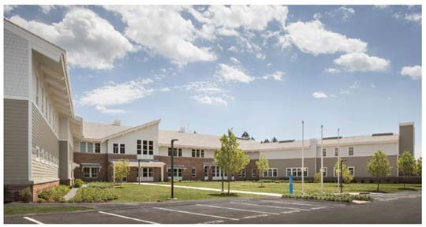
In 2016, the Department opened a newly constructed, 70,000-square-foot facility in Middleton. The Northeast Youth Service Center, a two-story residential facility on 39 acres, houses three programs—detention, treatment, and revocation—each with the capacity to serve 15 youth at a time. Each wing has 15 bedrooms, a dayroom, and dedicated teaching and clinical spaces. The facility also
includes a gym, an exercise yard, visitation rooms, library services, food services, health services, and classrooms—including specialized classrooms for art, music, and vocational education—as well as regional administrative offices, and staff and building support. Visitors enter through the courtyard and have access to a waiting area and secure visitation room. The building is sited to maximize solar exposure and utilizes high-performance shading through roof and window overhangs. The interior rooms receive sun approximately 80% of the day, and the kitchen facilities are designed to minimize water usage and use special ventilation controls for fan energy efficiency and conditioned air savings.

DYS Fiscal Year 2016 Budget at a Glance
The DYS Fiscal Year 2016 appropriation of $177.2 million that funded the six categories listed below enabled DYS to continue evidence-based programming, comprehensive staff training, and the reallocation/reconfiguration of programs to better serve the changing demographics and profiles of the youth coming to DYS.

ACCOUNTS | TOTAL
Administration | $4,434,660
Community Services | $23,286,86
Pre-Trial Detention | $27,187,833
Residential Services | $117,000,000
Teachers’ Salaries | $3,154,187
Alternative Lock-Up | $2,102,363
TOTAL | $177,165,639

