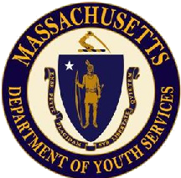
Commonwealth of Massachusetts Department of Youth Services
ANNUAL REPORT
Fiscal Year 2020

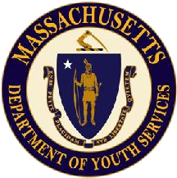

Introduction from the DYS Commissioner

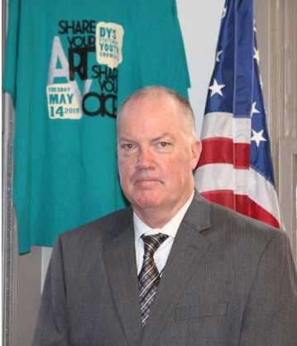
This report reflects the hard work, innovation and accomplishments by the Department of Youth Services (DYS) and provider staff in Fiscal Year 2020 (FY20). Our caseload for committed youth has trended down and we are now serving an older group of young people.

This shift has forced us to review and shift our strategic focus in the areas of life skills through our Empower Your Future curriculum and through innovation in our education efforts. Increasing positive outcomes for youth through skill development and increasing community safety remain our two primary high-level goals.

We generate lower recidivism through
a series of activities that engage youth, increase their insight into their behavior and result in better choices. Education, clinical services, effective staff- youth engagement strategies and employment preparation/placement all contribute to our rehabilitative strategy.

In FY20 we continued to support youth who are discharging from DYS. An increasing number of youths are taking us up on this offer and early data indicators are showing that youth who opt into voluntary services post-discharge are doing better than youth who opt out. We engaged an external evaluator to assess our performance in this area.

DYS involved youth continue to make academic progress. In FY20 DYS involved youth experienced significant success in post-secondary work.

Throughout FY20 DYS sustained its commitment to racial equity. We are holding ourselves accountable to ensure that our decision making
related to youth is fair, to diversity throughout the agency workforce and to delivering a work environment where staff are treated fairly and have the opportunity to raise concerns that they may have related to disparity or racism.

We continue to work collaboratively with our partners at Department of Children and Families (DCF), Department of Public Health (DPH), Massachusetts Probation Service, the Juvenile Court, Committee for Public Counsel Services (CPCS), law enforcement agencies, non-profit service providers, families and young people. These partnerships were critical as the Commonwealth confronted the challenges associated with the COVID-19 public health emergency. In the second half of FY20, DYS had to make significant adjustments in our approach to serving youth to ensure the safest possible environment for youth and staff. We employed innovative strategies with our delivery of education, staff training, youth hearings in juvenile court, family contact and re-entry support. Our workforce responded to this challenge in a remarkable and effective way.

Throughout FY20, DYS has navigated the many challenges associated with COVID-19 and Racial Equity with the consistent and high level support from the Baker-Polito administration and the legislature.

Thank you for your interest and continued support of the important work with the young people that we serve at DYS.

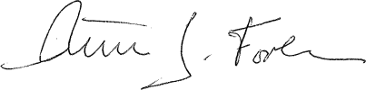
Peter J. Forbes DYS Commissioner

Who We Serve:

Committed Youth
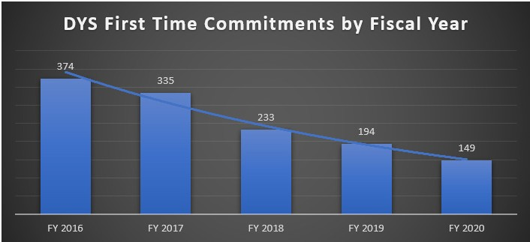
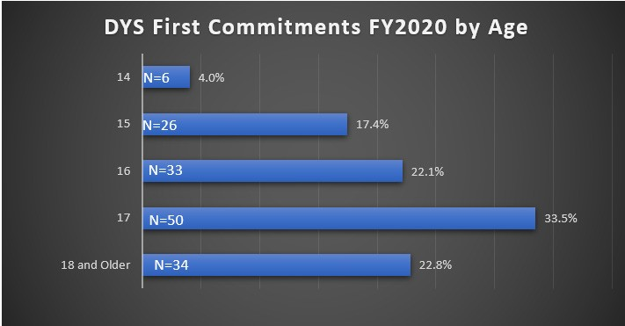
Youth who are adjudicated delinquent are committed to the custody of the Department of Youth Services (DYS) until the age of 18 for committing a felony, misdemeanor, or violating city ordinance or town bylaw. A youth may be committed to DYS custody each time the youth is adjudicated a delinquent.
In FY20, 15% were females and 85% were males. The average age of the committed population was
16.6 years, and the median age was 17.0 years.
DYS uses a grid system to categorize offenses based on their
severity which consists of:
Grid 1: Operating a motor vehicle with a suspended license, marijuana possession (over 1 ounce), shoplifting, disorderly conduct, trespass.
Grid 2: OUI liquor or drugs, possession of heroin, assault, assault & battery, tagging, breaking & entering.
Grid 3: Robbery, stalking, burning buildings (arson).
Grid 4: Indecent assault & battery on a child, assault to murder or maim, assault & battery with a dangerous weapon with significant injury, armed robbery, carjacking, kidnapping.
Grid 5: Involuntary manslaughter, assault & battery on a child with substantial injury, attempted murder, armed robbery with firearm, assault to murder (armed), armed carjacking.
Grid 6: Voluntary manslaughter, home invasion, rape of a child under 16 with force, trafficking firearms (20+ weapons). 3
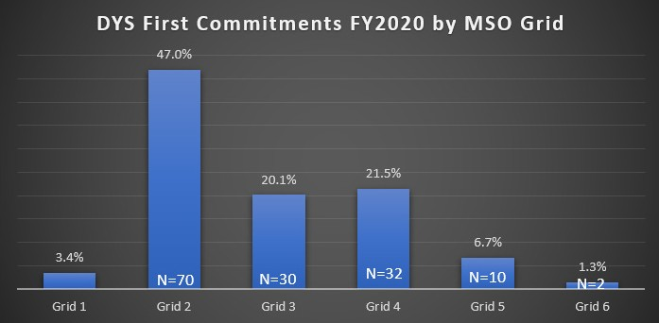
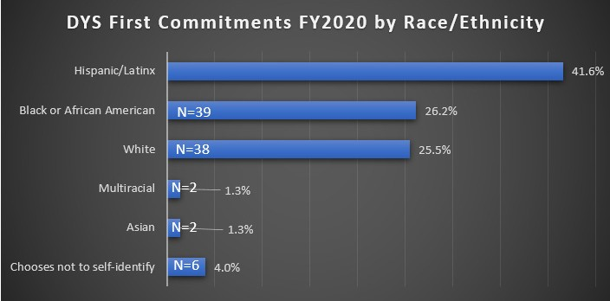
While approximately 33% of youth under the age of 18 in MA are youth of color, they represent 70% of the DYS committed population.

Who We Serve

Detained Youth

Youth may be held on a detention status and committed to the care of the Department of Youth Services during the pendency of their juvenile court cases.

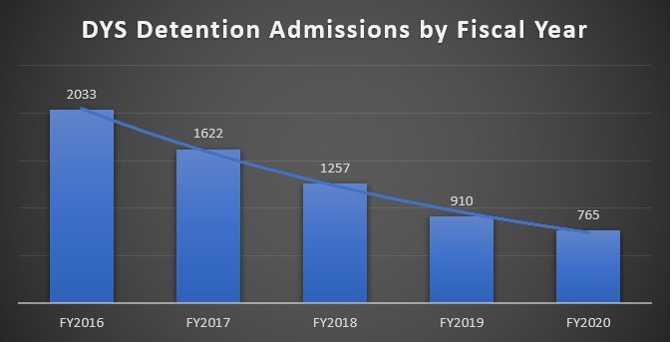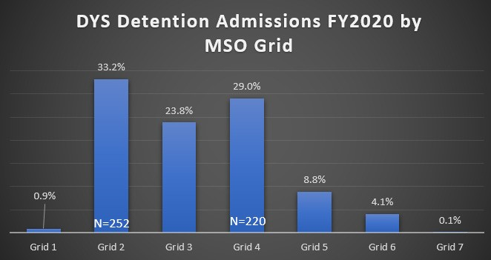

In FY20, 18.3% of the detention admissions were female and 81.7% were males. The average age of detained youth was 15.9 years and the median age was 16 years.
The majority of youth held in detention by DYS in FY 2020 was for high grid level offenses.

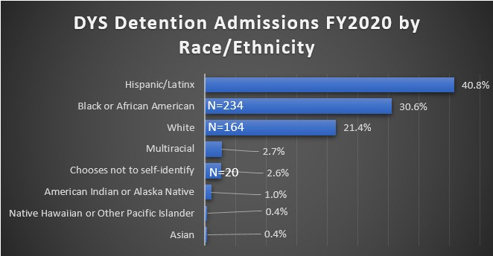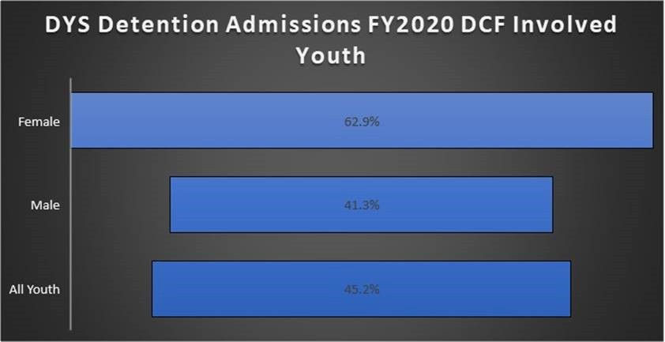

Seventy-six percent (76%) of the detention admissions in FY20 were youth of color.
DCF-involved youth represented 45.2% of all detention admissions in FY20.

Overnight Arrests
DYS operates a network of juvenile overnight arrest programs (ONAs) as a resource to local police departments by providing both a safe placement for youth and the means to be compliant with the Juvenile Justice Delinquency Protection Act, which prohibits youth from being held in adult jail or police lockup for 6 or more hours after arrest.

In July 2017, the ONA service model was changed from ONA beds in stand-alone site to ONA beds in both stand-alone and in detention programs. This change allowed DYS to right size the ONA network to align with the decline in the number of youths coming to the overnight arrest system.

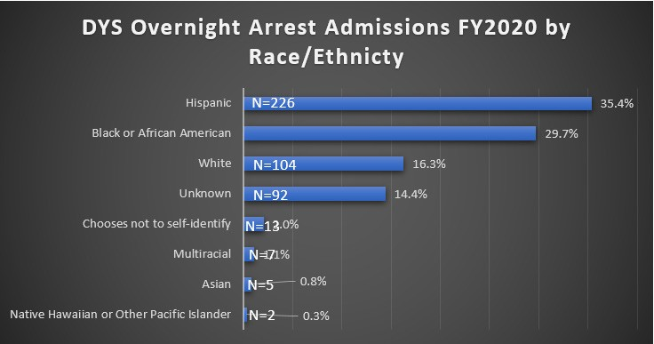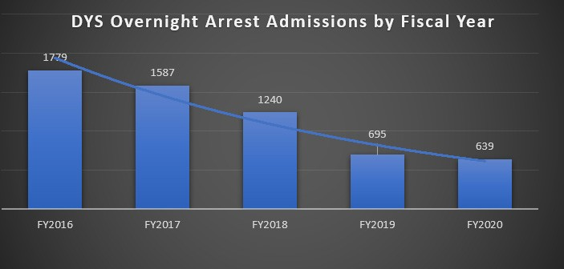

At least 67% of overnight arrests were youth of color.
In FY 2020, there were 639 overnight arrests; 18.6% were female and 81.4% were males. Over- night arrests in FY 2020 dropped by 64% from the number of overnight arrests in FY 2016.

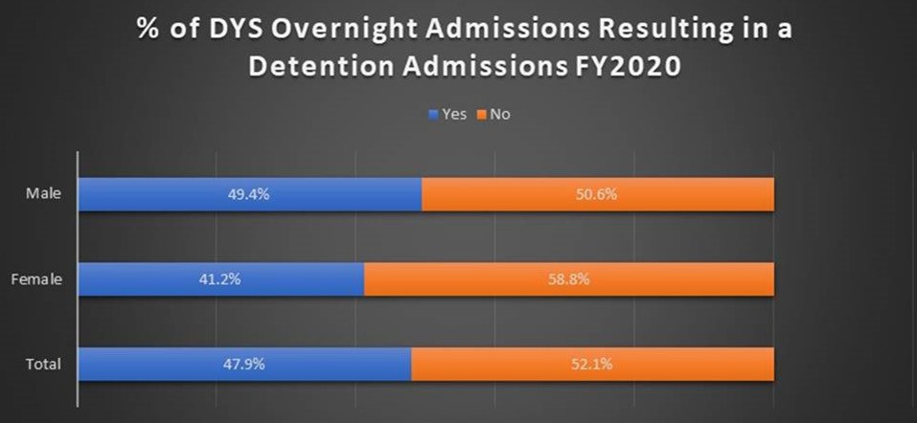
Overall, there are 639 total youth in overnight arrest. 306 (47.9%) of the 639 admissions resulted in a detention. Of the 119 females in overnight arrest, 49 (41.2%) resulted in detention and of the 520 males in overnight arrest, 257 (49.4%) resulted in detention.

Youthful Offenders

A youth between the ages of 14 and 17 who commits an offense may be indicted as a youthful offender when the youth 1) has previously been committed to DYS and is accused of committing a felony under Massachusetts law 2) is accused of committing an offense which involves the infliction or threat of serious bodily harm in violation of law,
3) is accused of certain violations of MA gun laws. A youth indicted as a youthful offender can be sentenced to the same maximum penalty as an adult facing the same charges.
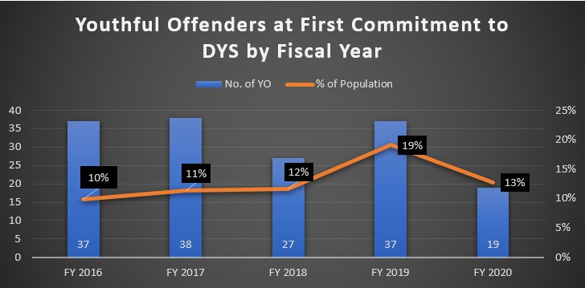
In FY 2020, DYS served 221 youthful offenders.

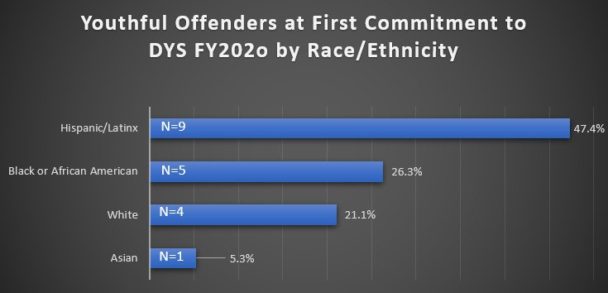
Seventy-nine percent (79%) of the youthful offenders were youth of color in FY 2020.

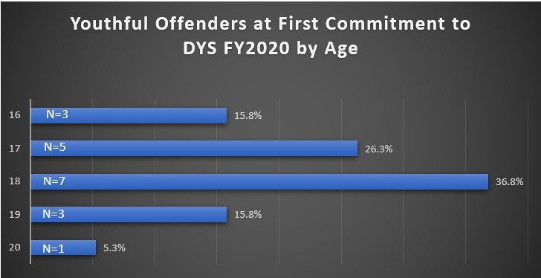
In FY20 the average age of youthful offenders was
17.7 years and the median age was 18.0 years.

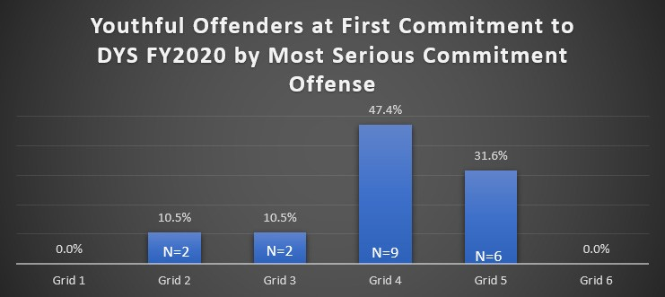
Over 47% of the youthful offenders were committed to DYS for Grid 4 Level offenses which include: Indecent assault & battery on a child, assault to murder or maim, assault & battery with a dangerous weapon with significant injury,armedrobbery,carjacking,kidnapping.

Youth Engaged in Services
DYS offers voluntary, post-discharge services to all youth committed as delinquents and as youthful offenders until the age of 22. The program, known as Youth Engaged in Services (YES), provides transitional supports and services to youth when they are at the highest risk of recidivism. Research has found that the time of highest risk of recidivism to be the first 6 months post discharge.

Through YES, youth work with their caseworker and enters into a voluntary agreement for transitional services to meet agreed upon goals, such as High School or Hi-Set attainment, taking college courses, or getting a paying job.

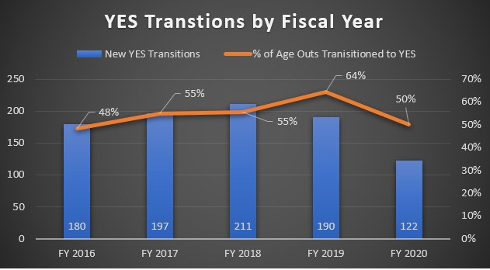
A youth’s progress in meeting their YES goals is reviewed every three (3) months. The youth or DYS may terminate the agreement at any time. All youth approaching the age of mandatory discharge from DYS are offered YES as part of the discharge planning process. Youth who do not enroll in YES at discharge are eligible to enroll within 90 days of discharge.
Since YES was offered to eligible DYS youth in FY16, approx. 50% elected to enroll in the voluntary program.
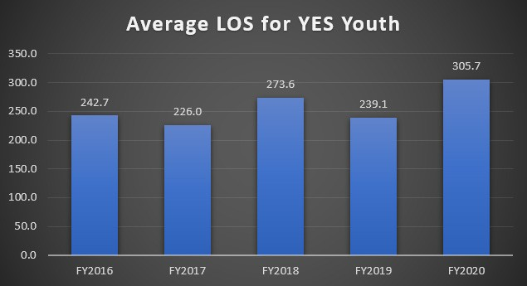
Youth participation in YES in FY20 has averaged 10 months post discharge from DYS.

Recidivism Study

Every year, the Department of Youth Services conducts a juvenile recidivism study which examines different metrics on the impact that policies, strategies, and practices have on interrupting the criminal trajectory of DYS youth. DYS defines recidivism as conviction in the adult system for an offense committed within one year of discharge from DYS.

Recidivism is generally the most common measure used to determine the effectiveness of interventions with justice involved youth. The 2019 study tracked the criminal histories of 349 youth, formerly committed to the Department of Youth Services’ custody and discharged from the agency during 2016. The information of their arrests, convictions and incarcerations post discharge was evaluated to find the rate of recidivism for the entire cohort, as well as the recidivism rates for selected segments of that cohort as displayed in the chart below.

 | One-Year
Gender | Recidivism
Males | 29%
Females | 2%
Ethnicity
Caucasian | 25%
African American | 31%
Hispanic | 21%
Other | 23%
DYS Committing
Offense Type
Weapons | 46%
Drugs | 31%
Motor | 31%
Person | 23%
Property | 22%
Public Order | 13%
Grid
<= Grid 2 | 20%
Grid 3 | 30%
Grid 4 | 33%
>= Grid 5 | 36%

FY20 Budget and Staff

FY20 Budget Allocation

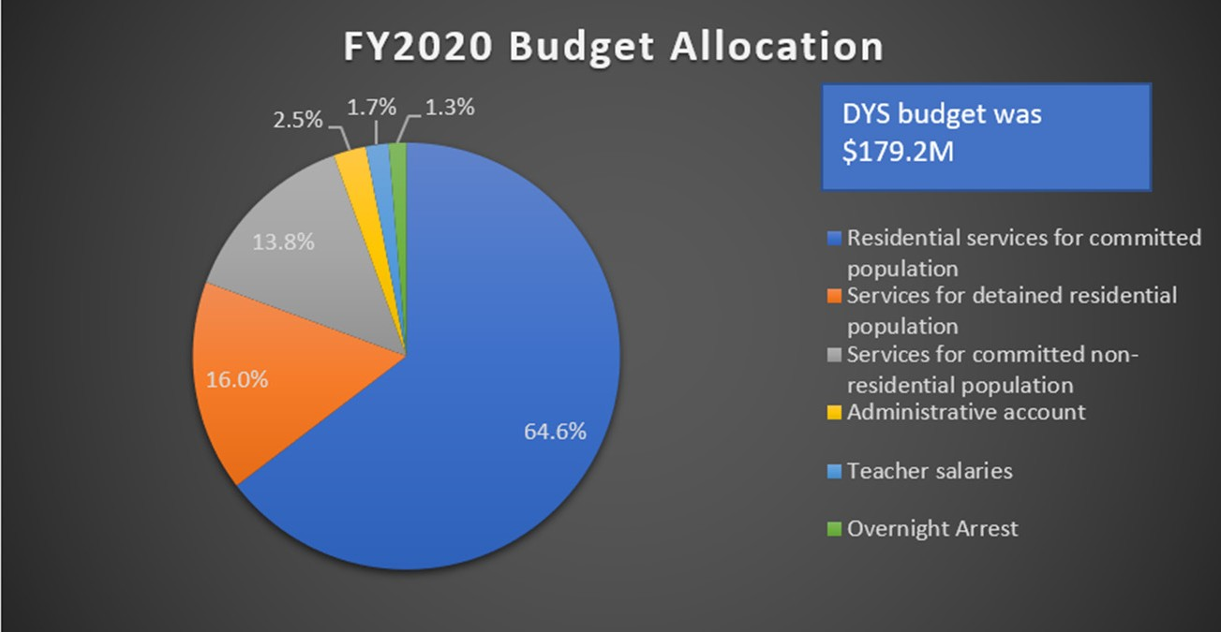

In Fiscal year 2020 the Department of Youth Services Budget was
$179,221,364 This was broken down into:
- 64.6% for Residential Services for Committed Youth ($115,777,001)
- 16% for Residential Services for Detained Youth ($28,675,418)
- 13.8% for Community-based Services for Committed Youth ($24,732,548)
- 2.5% for Administration and Operations ($4,480,534)
- 1.7% for Teacher Salaries ($3,046,763)
- 1.3% for Alternative Lockup ($2,329,877)

DYS Workforce

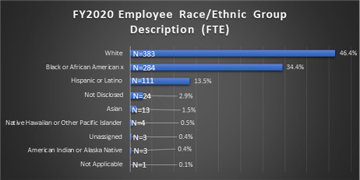
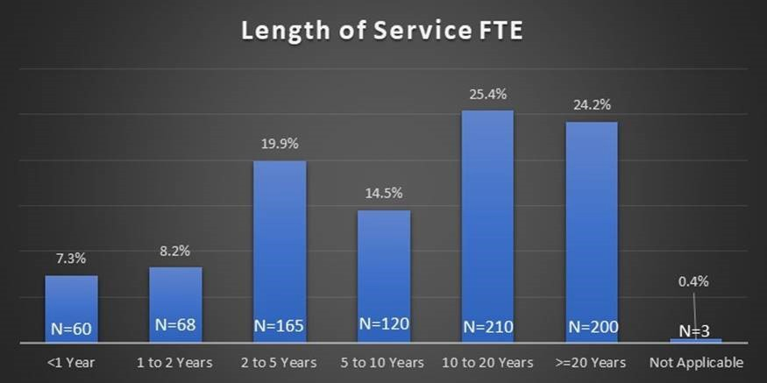

Job Title Change to Juvenile Justice Youth
Development Specialist Staff
In the Fall of 2019, the DYS Branding Committee was charged with creating a more appropriate and descriptive job title for the Group Youth Workers who work directly with our youth in the 24/7 secure residential programs. Through a series of discussions informed by a survey of group youth workers and other field operations staff, the Branding
Committee recommended the title be changed to “Juvenile Justice Youth Development Specialist.” “Juvenile Justice” was important to distinguish from those who work in other human services systems, such as child welfare. “Youth Development Specialist” was important as the phrase more accurately conveys the work that staff is being asked to perform.
The job title, Juvenile Justice Youth Development Specialist (JJYDS) reflects the evolution of a role that had been primarily focused on safety and security to one that now also:
- Emphasizes positive youth development by staff serving as a role model in helping youth develop coping, social and life skills,
and providing guidance and support through daily interactions,
- Provides encouragement, guidance, mentoring, supervision and participation with youth in various daily living activities; and
- Actively engages with youth in the classroom by helping them complete their school assignments and working with them on employment and vocational readiness.
With the change in title and job specifications, there was also a salary upgrade that accompanied the change for the more than 370 employees working in the job series.

Racial Trauma Professional Development
Over the past few years, DYS and its provider partners have been doing significant work
in the area of Racial and Ethnic Disparities, Culturally Responsive Practice, Positive Youth Development and Implicit Bias. This year, the DYS Education Team collaborated with the DYS Clinical Team to convene a
conference that addressed Racial Trauma. The conference’s goal was to help educators and clinicians develop a shared understanding of the DYS approach to racial trauma, build their knowledge on how racism triggers trauma, examine strategies for helping youth cope with it and clarify the next steps for DYS educators and clinicians to work together and be part
of the solution. The workshops offered at the conference included:
- An Exploration of Race, Racism and Racial Trauma: Looking Back to Move Forward
- Unmasking Racial Trauma: Healing the Mental, Emotional and Relational Lives of Youth of Color
- Making Space for Truth and Trauma with the Everett Company Stage and School
- Deeper than Rap “Hip-Hop Culture’s Potential Impact in the Classroom”
- Teaching and Learning for Healing and Freedom: Exploring Unconscious Bias, Culturally Sustaining Pedagogy, and Social Justice Education
- Using Latinx Cultural Wealth Frameworks to Advance Racial Equity

COVID-19 & Equity and Fairness
Since March, the Department of Youth Services and the entire nation faced historical challenges related to the COVID-19 public health emergency and racial injustice. We have seen the disproportionate impact that the COVID-19 pandemic is having on communities of color. DYS and our provider staff have been confronted with balancing their personal safety/ family responsibilities with their commitment
to our daily work. Each day, they have shown up to ensure that essential services continue without compromising safety. They deserve special recognition. Our agency is in good stead as a direct result of all their efforts.

COVID-19
This March 10, 2020, Governor Charlie Baker declared a state of emergency related to the public health challenge presented by the COVID-19 pandemic. Between March and June of 2020, we saw a reduction in the number of arrests and cases heard by the Juvenile Court. For the Department of Youth Services, this resulted in fewer youth being committed to DYS care and custody than the number of youth being discharged from DYS.

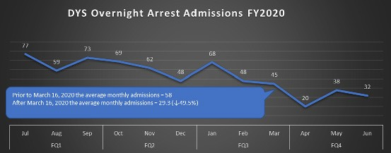

DYS, supported by our deeply committed workforce, pivoted to address the COVID-19 pandemic by instituting practices to minimize the risk of exposure and protect the safety and well- being of our staff and youth and standing ready to adjust those practices to respond rapidly
to the changing landscape presented by the pandemic.

Residential Programs: New protocols put in place included screening all individuals entering DYS facilities for potential COVID-19 exposure, allowing staff (who can) telework, quarantining new youth intakes for 14 days upon their arrival, requiring staff, and youth when appropriate,
to wear PPE, practice social distancing, hand hygiene, cleaning and disinfecting. With the limitation on outside visitors, DYS established other means for youth to stay
connected and for services to continue through the use of technology, such as virtual family visits, telehealth, and Google classroom and Chromebooks for education.

Education: DYS has expanded opportunities for virtual and online educational services that were initially all remote and have since transitioned
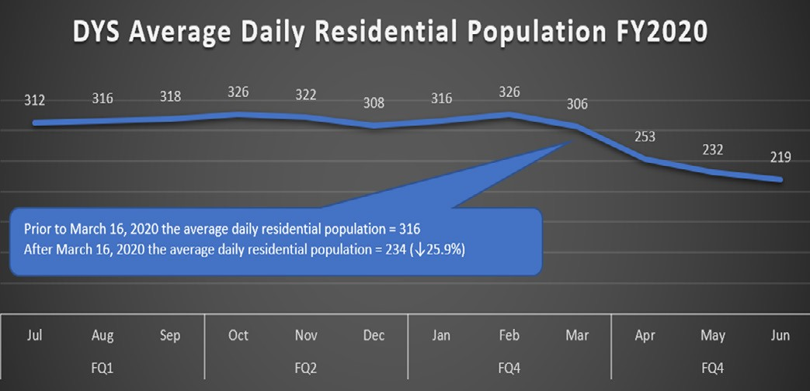
to mostly in-person and some remote instruction. DYS classrooms offered enrichment materials both on site and through remote participation, keeping in mind the health, safety and wellness of students, families, educators and staff. Most of the treatment programs were quickly able to use Google Classroom. DYS distributed one Chromebook for every student which allowed youth to access content course material as well as thematic topics and electives, such as, Art and Physical Education.

Clinical Services: Clinical services continued to be provided to youth in residential programs,
but the approach varied to include remote clinical sessions based on the conditions of the youth and the staff in the programs.

Individual, group and family therapies were of- fered but the format varied depending on pro- gram conditions.

For programs where social distancing could be maintained, group therapy was provided. In
other programs, smaller clinical groups were run twice to allow for social distancing.

Adjustments to how individual therapy was delivered were also made. In-person
sessions were held when youth were not in quarantine and via telehealth when youth were in quarantine. Due to restrictions on in- person visitation, traditional in-person family therapy was not possible, but family therapy via telehealth was offered instead. For youth in the community, DYS worked with MassHealth to allow community mental health providers to
provide 30 days of telehealth services prior to a youth’s release to the community.

Visitation and Passes: In-person visits by parents and guardians were suspended for a while but resumed in June with the establishment of new protocols consistent
with CDC and DPH guidelines. Community passes were also suspended for a while
but resumed for eligible youth with the issuance of new protocols for protecting the health and safety of youth, families and the DYS community staff. Passes were granted for activities that supported a youth’s safe and effective transition back to the community. Passes were used to facilitate family re-integration, re-orientation
to school/work, and as opportunities to obtain a state ID, apply for community- based
programming and to initiate medical, counseling, and clinical services in the community, as appropriate.

Virtual visits using iPads continued to occur for all youth and families. Virtual visits and
phone calls were at no cost to our youth or their families
Health Services: The Department’s Health Services Team was instrumental in developing the DYS response to COVID-19. They
worked with our Medical Consultant and the Department of Public Health, while following CDC guidelines, to create procedures and policies to model best practices and to protect the health of our young people and staff. Their work was detailed and written in language that program staff could understand. The medical staff did a superb job caring for our young people and staff by spending countless hours ensuring that they provided the most current information on the pandemic.

Food service: Staff became creative when faced with the challenges presented by COVID-19, such as, serving meals while youth are required to social distance, preparing meals while sanitizing frequently, and planning meals when working with a supply shortage.
During early stages of the pandemic, certain cuts of meat were in short supply or out of stock. Some cooks chose to use a less popular cut, such as chicken thighs to replace chicken breasts, for the same dish.

Since the beginning of the pandemic, our food services staff stepped up to the challenge and never missed a beat. And our facility-based staff not only provided quality support and supervision to the youth, they took the lead on manning the screening tents, initiated regular cleaning of the program spaces and supported the virtual court hearings and education offered remotely by the teachers.

COVID-19 Related Modified Recreational and
Leisure Activities:
Recreational and leisure time activities had to change with COVID-19 by taking into account the need for social distancing, cleaning, disinfecting to keep our staff and youth safe. Each region saw this challenge and came up with innovative activities that would keep our residential and community youth entertained, and safely. All games that required physical contact or sharing of equipment were strictly prohibited. In lieu of basketball, football, frisbee, volleyball and other contact activities, programs put forth new offerings that included:
- Solitaire with each youth using their own deck of cards for individual use or join in a program wide solitaire tournament to see who completed the game first.
- Trivia-based games
- Memory games where youth get 40 seconds to see all items displayed on a tray before they are removed, and the youth are asked to write down all the items they remember.
- Games such as charades where staff and youth can play while social distancing

The goal of these modified recreational and leisure activities was to use items and themes that appeal to the youth by keeping the activities relevant and fun.

Family Engagement: The Training Team hosted a statewide virtual “Family Feud” competition.
Sixteen residential programs participated in the WebEx competition. This innovative activity allowed staff, families and youth, including those in quarantine, to join in the fun. Since these games required fewer staff to participate, other staff on shift were able to clean and disinfect high touch areas.

Our agency’s ability to meet the challenges brought by the pandemic is a testament to the willingness and commitment of every single DYS and provider staff to support our youth and each other.
Training Staff During the COVID-19 Pandemic With staff out due to illness, COVID, or family needs, it was clear that DYS needed new employees more than ever and those new employees needed to be trained safely. The training team implemented a hybrid training model to meet that need. Under this model,
the training curricula is broadcasted on a large screen while one trainer is present on site
to help engage the groups in activities and discussions. The trainers worked as a team and took turns leading the onsite training while the other trainers and trainees followed on the screen.

As the hybrid model was about to launch, the nation found itself in another crisis after the killing of George Floyd, Breonna Taylor and Ahmaud Arbery. With the support of the
DYS Executive Team, the DYS Training Team incorporated discussion points on race, equity, and inclusion in every DYS Basic Training module. This created a space where racism and efforts to support black lives could be addressed and staff could speak and discuss and acknowledge that there are really two pandemics.

Equity and Fairness
The May killing of George Floyd, a black man by Minneapolis police ignited outrage, intense public discussion, and reflection about the state of racial justice and action in the United States and in DYS. The Department has remained committed to our Fairness and Equity work plan and the steady progress made in several key areas:
- Fairness related to decision making and treatment for youth
- Diversity throughout the ranks of the DYS workforce
- Ensuring organizational well-being where staff and youth are treated regardless of their race, ethnicity, or gender.

The Department has continued to support activities that allow staff and youth to engage in a dialogue about the challenges associated with racism and its impact on persons of color. Over the past year, these efforts included:
- Monthly meeting of the DYS Equity and Fairness Workgroup to engage in targeted discussions that examined the impact
of racial disparity in the juvenile justice system.
- Opportunities for interested staff to be trained as facilitators and trainers on diversity, equity and inclusion. DYS now has 32 facilitators/ trainers.
- Recruitment and retention strategies developed by DYS Human Resources team and the DYS Workforce Planning and Development Workgroup for attracting more diverse and qualified candidates
and more diverse interviewing panels, as well as modifying policies and practices that may be creating barriers to job opportunities across all job titles. These strategies have contributed to encouraging results in hiring, promotions and retention that are aligned with the Department’s Affirmative Action & Diversity Plan.
- Recommendations for changes in DYS policies and practices related to sexual orientation and gender identify resulting from the collaboration with the MA Commission on LGBTQ Youth and a Rappaport fellow that included:
  - Specific guidance for DYS staff in how to work with LGBTQI youth
  - Training for staff in how to provide nondiscriminatory and respectful care for LGBTQI youth in custody.
  - Practice changes in re-entry and reintegration programs that address the unique experiences and needs of LGBTQI youth to ensure against recidivism.
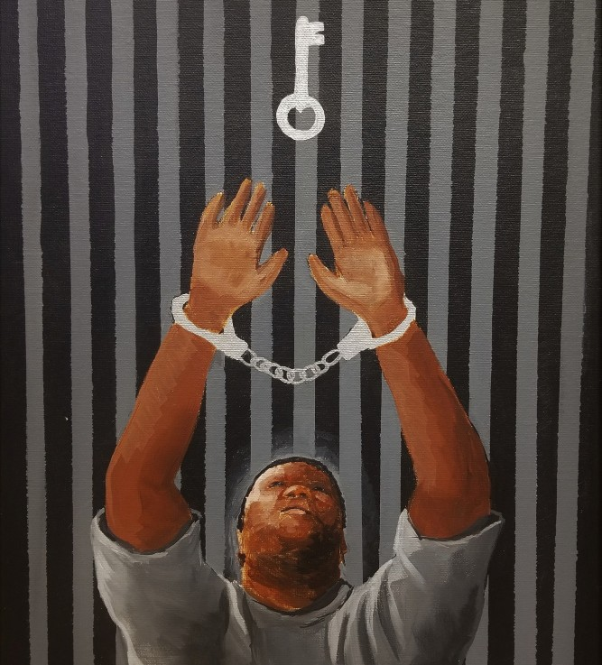
The Department of Youth Services’ encourages our youth to express themselves through creativity. Above and below are examples of our youth’s art.

JDAI Grants Sponsored by DYS
In July 2019, DYS announced a competitive grant opportunity for initiatives that can build and strengthen collaboration amongst JDAI partners and/or community-based organizations in the 7 local JDAI counties in
Massachusetts. DYS wanted to fund proposals that included positive youth outcomes showing a reduced reliance on confinement in secure detention for low risk
juvenile justice involved youth and meaningful participation by youth and families, including the use actionable strategies for promoting racial equity and inclusion.

DYS awarded two $50,000 grants. The award to Merrimack Valley Services was used for
an evidence-based mentoring and school attachment model for court-involved youth in two high schools. Adult mentors were recruited to work in the school environment and were matched with youth referred to the program by Juvenile Probation. The award to the Springfield Public Schools funded the
Peer Mediation & Family Support Program at a middle-school with a high proportion of at- risk youth. The project focused on improving student’s conflict resolution skills, increasing the positive supports in their lives and ultimately reducing court involvement. Later in the year, eight additional JDAI collaborative projects were also funded with the additional
$300,000 authorized in the supplemental budget.

JDAI 12th Annual Conference
Supported by the Annie E. Casey Foundation grant, JDAI Massachusetts held the 12th annual conference “Inclusion in Action
. . . The Power of Community Voice in Transforming the Juvenile Justice System,” was held on December 5th, 2019. Devone Boggan, Founder & Chief Executive Officer of Advancing Peace, gave the keynote address. Highlighted at the conference was the theme on how public and community- based stakeholders can achieve high impact outcomes for youth by implementing community-driven strategies.
JDAI stakeholders and partners walked away with new transformational interventions that will inform how they can engage with the community and rely less on law enforcement interventions.

OJJDP Second Chance Act Grant
In October 2019, the Department was awarded a three-year $775,000 Second Chance Act grant from the Office of Juvenile Justice and Delinquency Prevention (OJJDP). This grant
provided funding for Probation to add a Detention Reform Analyst to their team who would support the analysis of probation violation data at a higher level. It also funded DYS to continue its work addressing housing and homelessness faced by young people at discharge from DYS care and custody. A “Housing and Transition Specialist” was hired to lead the implementation of “From Surviving to Thriving” plan with strategies for preventing homelessness and housing instability.

Fresh Produce Project
The Fresh Produce Project started as a study to determine whether food loss and food cost can be reduced by ordering only the amount needed. At the time, most DYS food was ordered from national suppliers or distributors that would only accept bulk orders for each delivery. With that requirement, DYS found itself with unavoidable produce waste due to prolonged freezing or refrigeration. This prompted our Metro Food Service team to work with local distributors who agreed to accept small orders and to deliver
the produce several times each week. This local supply chain allowed Metro Food Service to shorten the time necessary for storage and refrigeration and realized savings because perishable produce was used before getting
damaged. It also allowed the youth to enjoy more locally grown, seasonal, fruits and vegetables.

This is a model that DYS seeks to replicate in other parts of the state and has begun the process of identifying local food distributors interested in working with DYS to supply our residential programs in each of our regions.

15 Grants & Initiatives

Innovating and Improving

Emerging Adults in Criminal Justice Task Force Report
The Emerging Adults in Criminal Justice Task Force, established by the Criminal Justice Reform Legislation, released their report in February. Commissioner Peter Forbes served as the designee of the Secretary of Health and Human Services, and Deputy Commissioner Margaret Chow-Menzer represented DYS. The Task Force, consisting of 19 representatives from other agencies that work with justice involved youth and emerging adults was chaired by State Senator Cynthia Creem and State Representative Paul Tucker. The work
of the Task Force resulted in the following recommendations:
- Expand the reach and scope of targeted programming for emerging adults by increasing the availability of community- based organizations working with justice- involved young people throughout the state and ensuring adequate resources for the Department of Probation to identify and oversee such programming.
- Expand gender-responsive programming to all facilities holding emerging adult women.
- Increase opportunities for diversion for emerging adults to the extent possible.
- Expand the specialized housing units to serve a larger portion of incarcerated
emerging adults in the adult criminal justice system and monitor the emerging adult court’s outcomes.
- Expand the use of the Positive Youth Development approach to all facilities serving emerging adults, including staff trainings.
- Expand continuing educational opportunities for emerging adults to the extent possible.
- Expand Department of Youth Services (DYS) programming and best practices to all facilities serving emerging adults, including staff trainings.

We are proud of the recognition given to the success achieved by DYS involved young adults and will continue

to develop programs with Positive Youth Development as a guiding construct.

DYS Fingerprint Background Check Legislation
On January 10, 2019, Governor Baker signed House Bill 5008, “An Act relative to background checks by the Department of Youth Services.” This legislation gives the Department of Youth Services the statutory authority to conduct fingerprint-based background checks on current and prospective state employees, candidates for promotion, interns, volunteers, and certain contractors. DYS sought state level authorization for fingerprint- based background checks to establish a uniform process for background checks on individuals working in the DYS service system.

New Detention Placement Instrument Since 2012, DYS Detention Coordinators and Communication Information Center (CIC) staff have used the Detention Placement
Instrument (DPI) to assist in placement decisions on the day of admission. Two key factors used by DYS to make placement decisions for detained youth were the risk of re-arrest and risk of flight.

In a 2017 study of 31 potential risk factors for predicted recidivism, the findings lead to the development of a new tool, the Detention Placement Recommendation (DPR) for making placement decisions based on risk. Since its implementation in FY 2020, the DPR is now completed for all detention admissions. At the same time, the Community-Based Options Placement Screening Instrument (CBO-PSI) was also introduced and implemented. The CBO- PSI further assesses youth for placement in a Reception Center, a less restrictive setting in the DYS service continuum. These new instruments were designed to reduce unintended bias in placement decisions. The tools however, do not replace structured professional decision-making regarding placement, but requires each youth to
be assessed for the same risks before making the final placement decision.
16

DEPARTMENT OF YOUTH SERVICES
www.mass.gov/dys

