Background/Introduction

INDOOR AIR QUALITY ASSESSMENT

E. Ethel Little School
7 Barberry Road
North Reading, Massachusetts

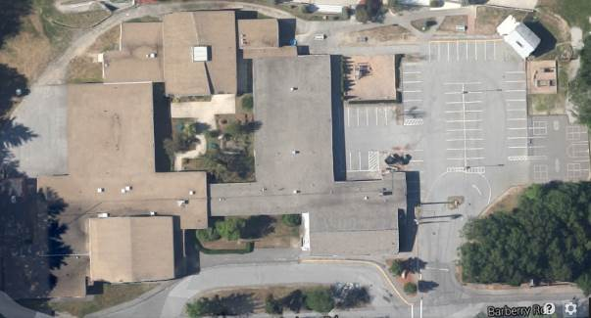

Prepared by:
Massachusetts Department of Public Health
Bureau of Environmental Health
Indoor Air Quality Program
January 2015
At the request of Wayne Hardacker, Supervisor of Buildings and Grounds, North Reading Public Schools (NRPS), the Massachusetts Department of Public Health (MDPH), Bureau of Environmental Health (BEH) provided assistance and consultation regarding indoor air quality (IAQ) at the E. Ethel Little School (ELS) located at 7 Barberry Road, North Reading, Massachusetts. On December 5, 2014 Ruth Alfasso, Environmental Engineer/Inspector, in BEH’s IAQ Program visited the school to conduct an assessment.
The BEH/IAQ program previously visited the school on November 13, 2014 to conduct a limited odor assessment. At that time, a report including remedial recommendations included: reinstall a missing fan in an exhaust vent on the rooftop; address rodent issues in the ceiling including the replacement of ceiling tiles and clean adjacent areas with an antimicrobial solution; and to seal any holes along the building perimeter. These actions were reportedly completed by NRPS staff (MDPH, 2014). The December 5, 2014 visit was conducted in order to assess indoor environmental conditions school wide.
The ELS is a one-story, cinderblock and brick building on slab. The original section was built in 1955, with additions in 1968 and 1997 and a section of modular classrooms added in 2003. The school consists of general classrooms, offices, a technology center, gymnasium, and cafeteria. Windows are openable throughout the building.

Methods
Air tests for carbon monoxide, carbon dioxide, temperature and relative humidity were conducted with the TSI, Q-Trak, IAQ Monitor, Model 7565. Air tests for airborne particle matter with a diameter less than 2.5 micrometers were taken with the TSI, DUSTTRAK™ Aerosol Monitor Model 8532. BEH/IAQ staff also performed visual inspection of building materials for water damage and/or microbial growth.

Results
The school houses approximately 330 students in grades pre-K through 5th grade and a staff of about 60. Tests were taken during normal operations at the school. Results appear in Table 1.

Discussion

Ventilation
It can be seen from Table 1 that carbon dioxide levels were above 800 parts per million (ppm) in 19 out of 36 areas, indicating a lack of air exchange in a little over half the areas examined. Fresh air in the 1955 and 1968 areas of the school is provided by unit ventilators (univents) (Pictures 1 and 2). A univent is designed to draw air from outdoors through a fresh air intake located on the exterior wall of the building (Picture 3). Return air is drawn through an air intake located at the base of each unit where fresh and return air are mixed, filtered, heated or cooled and provided to classrooms through an air diffuser located in the top of the unit (Figure 1). Univents were found deactivated or obstructed with classroom items/furniture on top/front of units in a number of areas (Picture 1; Table 1). In order for univents to provide fresh air as designed, intakes/returns must remain free of obstructions. Importantly, these units must remain on and be allowed to operate while rooms are occupied.
Note that the univents in this school are original equipment, more than 50 years old in the 1955 area and nearly 50 years old in the 1968 area. Function of equipment of this age is difficult to maintain, since compatible replacement parts are often unavailable. According to the American Society of Heating, Refrigeration and Air-Conditioning Engineers (ASHRAE), the service life for a unit heater, hot water or steam is 20 years, assuming routine maintenance of the equipment (ASHRAE, 1991). Despite attempts to maintain the univents, the operational lifespan of the equipment has been exceeded. Maintaining the balance of fresh air to exhaust air will become more difficult as the equipment ages and as replacement parts become increasingly difficult to obtain.
Exhaust ventilation in classrooms in the 1955 area is provided by exhaust vents located in coat closets (Pictures 4 and 5) ducted to fans on the roof. These vents were observed to be off or drawing weakly in some areas (Table 1). Some exhaust vents were also blocked by items inside the closet (Picture 4). Exhaust ventilation in the 1968 area is provided by unit exhausts, which look like univents, but do not have fresh air diffusers with only a return along the bottom. These units draw air out of the classroom and exhaust it directly outside through a vent in the outside wall. Many of the unit exhausts were obstructed and none were found to be on at the time of the visit.
The modular classrooms and areas in the 1997 area have ceiling-mounted supply and exhaust vents connected to air-handling units (AHUs) on the side of the building and inside ceilings.
A few occupied areas did not appear to have a means for natural ventilation (i.e., windows) or mechanical ventilation supply (Table 1). Under the building code, occupied areas are required to have a provision of fresh outside air either by windows or mechanical ventilation.
To maximize air exchange, the MDPH recommends that both supply and exhaust ventilation operate continuously during periods of occupancy. In order to have proper ventilation with a mechanical supply and exhaust system, the systems must be balanced to provide an adequate amount of fresh air to the interior of a room while removing stale air from the room. It is recommended that heating, ventilating and air conditioning (HVAC) systems be re-balanced every five years to ensure adequate air systems function (SMACNA, 1994). The date of the last balancing of these systems was not available at the time of the assessment.
Minimum design ventilation rates are mandated by the Massachusetts State Building Code (MSBC). Until 2011, the minimum ventilation rate in Massachusetts was higher for both occupied office spaces and general classrooms, with similar requirements for other occupied spaces (BOCA, 1993). The current version of the MSBC, promulgated in 2011 by the State Board of Building Regulations and Standards (SBBRS), adopted the 2009 International Mechanical Code (IMC) to set minimum ventilation rates. Please note that the MSBC is a minimum standard that is not health-based. At lower rates of cubic feet per minute (cfm) per occupant of fresh air, carbon dioxide levels would be expected to rise significantly. A ventilation rate of 20 cfm per occupant of fresh air provides optimal air exchange resulting in carbon dioxide levels at or below 800 ppm in the indoor environment in each area measured. MDPH recommends that carbon dioxide levels be maintained at 800 ppm or below. This is because most environmental and occupational health scientists involved with research on IAQ and health effects have documented significant increases in indoor air quality complaints and/or health effects when carbon dioxide levels rise above the MDPH guidelines of 800 ppm for schools, office buildings and other occupied spaces (Sundell et al., 2011). The ventilation must be on at all times that the room is occupied. Providing adequate fresh air ventilation with open windows and maintaining the temperature in the comfort range during the cold weather season is impractical. Mechanical ventilation is usually required to provide adequate fresh air ventilation.
Carbon dioxide is not a problem in and of itself. It is used as an indicator of the adequacy of the fresh air ventilation. As carbon dioxide levels rise, it indicates that the ventilating system is malfunctioning or the design occupancy of the room is being exceeded. When this happens, a buildup of common indoor air pollutants can occur, leading to discomfort or health complaints. The Occupational Safety and Health Administration (OSHA) standard for carbon dioxide is 5,000 parts per million parts of air (ppm). Workers may be exposed to this level for 40 hours/week, based on a time-weighted average (OSHA, 1997).
The MDPH uses a guideline of 800 ppm for publicly occupied buildings. A guideline of 600 ppm or less is preferred in schools due to the fact that the majority of occupants are young and considered to be a more sensitive population in the evaluation of environmental health status. Inadequate ventilation and/or elevated temperatures are major causes of complaints such as respiratory, eye, nose and throat irritation, lethargy and headaches. For more information concerning carbon dioxide, consult Appendix A.
Indoor temperature measurements the day of the assessment ranged from 68°F to 74°F (Table 1); the majority of areas were within the MDPH recommended comfort range. The MDPH recommends that indoor air temperatures be maintained in a range of 70°F to 78°F in order to provide for the comfort of building occupants. In many cases concerning indoor air quality, fluctuations of temperature in occupied spaces are typically experienced, even in a building with an adequate fresh air supply. In addition, it is difficult to control temperature and maintain comfort without operating the ventilation equipment as designed (e.g., univents/exhaust vents deactivated/obstructed).
Indoor relative humidity measurements on the day of the assessment ranged from 10 to 28 percent, all of which were below the MDPH recommended comfort range (Table 1). The MDPH recommends a comfort range of 40 to 60 percent for indoor air relative humidity. The sensation of dryness and irritation is common in a low relative humidity environment. Low relative humidity is a very common problem during the heating season in the northeast part of the United States.

Microbial/Moisture Concerns
Water-damaged ceiling tiles were observed in a few areas throughout the building (Picture 6; Table 1); these can indicate active/historic leaks from either the roof/building envelope or plumbing system. Most of the water-damaged ceiling tiles observed during the assessment appeared to be near areas where different portions of the building joined. Joining structures constructed at different times out of different materials can lead to leaks along the shared wall/roof joints because of differential settling/movement of the materials over time. Flashing or sealant on roofs/walls in these locations should be examined regularly and repaired to prevent leaks. If repeatedly moistened, ceiling tiles can be a medium on which mold can grow. Water-damaged tiles should be replaced after a water leak is discovered and repaired.
In a few areas, odors were noted coming from sinks (Table 1). The odors were reduced when water was poured down the drain. Odors from drains may be related to dry drain traps which can allow sewer gases and odors into occupied areas. In these cases it was reported that sinks are regularly used so it is more likely that drains are in need of cleaning/flushing to remove any substances that may be causing odors. Large quantities of porous items were also stored under these and other sinks (Table 1; Picture 7). The area under sinks is a moist environment that can lead to water damage and microbial growth on porous items. The large amount of items also makes any leaks difficult to detect. Items should be removed from under sinks and inspected for water damage. In addition, in many areas the backsplashes of sinks had open seams (Picture 8). If seams are not watertight, water can penetrate the seam, causing water damage. Water penetration and chronic exposure of porous and wood-based materials can cause them to swell, show signs of water damage and lead to potential mold growth.
In a storeroom off the library, there was evidence of water damage on the floor and on boxes stored on the floor (Picture 9). It was reported that this room is rarely used. It is likely that condensation occurred during the summer when hot, humid air came into contact with the floor, which would be colder due to being slab on grade. The water-damaged materials should be removed and discarded and the floor cleaned. Porous items in this and other storerooms should be kept off the floor through use of shelving or pallets, as evidenced in other areas of the school.
The US Environmental Protection Agency (US EPA) and the American Conference of Governmental Industrial Hygienists (ACGIH) recommend that porous materials (e.g., carpeting, gypsum wallboard) be dried with fans and heating within 24 to 48 hours of becoming wet (US EPA, 2001; ACGIH, 1989). If not dried within this time frame, mold growth may occur. Once mold has colonized porous materials, they are difficult to clean and should be removed/discarded.
Plants were noted in some classrooms and offices (Table 1). Plants can be a source of pollen and mold which can be respiratory irritants to some individuals. Plants should be properly maintained and equipped with drip pans and should be located away from univents to prevent the aerosolization of dirt, pollen and mold.
Small refrigerators were observed to be located in many classrooms and other areas including on carpeted areas. These appliances may cause spills or leaks which can moisten porous materials. In addition, refrigerators that aren’t kept clean can be a source of mold and odors. Consideration should be given to reducing the number of small refrigerators; thos that remain should be kept on non-porous surfaces and kept clean.
The exterior of the building was examined for conditions that might lead to indoor air quality concerns. Moss/plant growth was observed growing on exterior walls (Pictures 10 and 11), due to chronic moisture/lack of sunlight. Many areas of the school do not have gutter systems, and as a result water flows down over walls and splashes directly next to the building. In other areas, gutter downspouts terminate directly at the foot of the building, which may lead to infiltration back into the building. Existing gutters and downspouts should be maintained in good repair, and extended away from the building. Areas with “splash zones” directly at the base of the building should be evaluated to see if more effective drainage/gutters can be installed to direct water away from the side of the building.
Plants and mulch were seen up against the building in a few areas (Picture 12). Plants and mulch can hold moisture against the building exterior and prevent drying. The growth of roots against exterior walls can bring moisture in contact with the foundation. Plant roots can eventually penetrate the wall, leading to cracks and/or fissures in the sublevel foundation. Over time, these conditions can undermine the integrity of the building envelope and provide a means of water entry into the building via capillary action through exterior walls, foundation concrete, and masonry (Lstiburek & Brennan, 2001). The freezing and thawing action of water during the winter months can create cracks and fissures in the foundation that can result in additional penetration points for both water and pests. Trees and shrubs can also be a source of pollen, debris, and mold into univents and windows. Consideration should be given to removing landscaping in close proximity to the building so as to maintain a space of 5 feet between shrubbery and the building.
Doors to the exterior were seen to be missing weather stripping (Picture 13), which can allow unconditioned air, moisture and pests into the building.

Other IAQ Evaluations
Indoor air quality can be negatively influenced by the presence of respiratory irritants, such as products of combustion. The process of combustion produces a number of pollutants. Common combustion emissions include carbon monoxide, carbon dioxide, water vapor and smoke (fine airborne particle material). Of these materials, exposure to carbon monoxide and particulate matter with a diameter of 2.5 micrometers (μm) or less (PM2.5) can produce immediate, acute health effects upon exposure. To determine whether combustion products were present in the indoor environment, BEH/IAQ staff obtained measurements for carbon monoxide and PM2.5.

Carbon Monoxide
Carbon monoxide is a by-product of incomplete combustion of organic matter (e.g., gasoline, wood and tobacco). Exposure to carbon monoxide can produce immediate and acute health effects. Several air quality standards have been established to address carbon monoxide and prevent symptoms from exposure to these substances. The MDPH established a corrective action level concerning carbon monoxide in ice skating rinks that use fossil-fueled ice resurfacing equipment. If an operator of an indoor ice rink measures a carbon monoxide level over 30 ppm, taken 20 minutes after resurfacing within a rink, that operator must take actions to reduce carbon monoxide levels (MDPH, 1997).
The American Society of Heating Refrigeration and Air-Conditioning Engineers (ASHRAE) has adopted the National Ambient Air Quality Standards (NAAQS) as one set of criteria for assessing indoor air quality and monitoring of fresh air introduced by HVAC systems (ASHRAE, 1989). The NAAQS are standards established by the US EPA to protect the public health from six criteria pollutants, including carbon monoxide and particulate matter (US EPA, 2006). As recommended by ASHRAE, pollutant levels of fresh air introduced to a building should not exceed the NAAQS levels (ASHRAE, 1989). The NAAQS were adopted by reference in the Building Officials & Code Administrators (BOCA) National Mechanical Code of 1993 (BOCA, 1993), which is now an HVAC standard included in the Massachusetts State Building Code (SBBRS, 2011). According to the NAAQS, carbon monoxide levels in outdoor air should not exceed 9 ppm in an eight-hour average (US EPA, 2006).
Carbon monoxide should not be present in a typical, indoor environment. If it is present, indoor carbon monoxide levels should be less than or equal to outdoor levels. On the day of the assessment, outdoor carbon monoxide concentration was measured at 1.2 ppm (Table 1), likely due to vehicles in the parking lot. No measurable levels of carbon monoxide were detected inside the building (Table 1).

Particulate Matter
The US EPA has established NAAQS limits for exposure to particulate matter. Particulate matter includes airborne solids that can be irritating to the eyes, nose and throat. The NAAQS originally established exposure limits to PM with a diameter of 10 μm or less (PM10). In 1997, US EPA established a more protective standard for fine airborne particulate matter with a diameter of 2.5 μm or less (PM2.5). This more stringent PM2.5 standard requires outdoor air particle levels be maintained below 35 μg/m³ over a 24-hour average (US EPA, 2006). Although both the ASHRAE standard and BOCA Code adopted the PM10 standard for evaluating air quality, MDPH uses the more protective PM2.5 standard for evaluating airborne PM concentrations in the indoor environment.
Outdoor PM2.5 concentrations were measured at 32μg/m³ (Table 1). PM2.5 levels measured indoors ranged from 11 to 35 μg/m³ (Table 1). All but one reading were below the NAAQS PM2.5 level of 35 μg/m³. Frequently, indoor air levels of particulate matter (including PM2.5) can be at higher levels than those measured outdoors. A number of activities that occur indoors and/or mechanical devices can generate particulate matter during normal operations. Sources of indoor airborne particulate matter may include but are not limited to particles generated during the operation of fan belts in the HVAC system, use of stoves and/or microwave ovens in kitchen areas; use of photocopiers, fax machines and computer printing devices; operation of an ordinary vacuum cleaner and heavy foot traffic indoors.

Volatile Organic Compounds
Indoor air concentrations can be greatly impacted by the use of products containing volatile organic compounds (VOCs). VOCs are carbon-containing substances that have the ability to evaporate at room temperature. Frequently, exposure to low levels of total VOCs (TVOCs) may produce eye, nose, throat and/or respiratory irritation in some sensitive individuals. For example, chemicals evaporating from a paint can stored at room temperature would most likely contain VOCs. In an effort to identify materials that can potentially increase indoor VOC concentrations, BEH/IAQ staff examined rooms for products containing these respiratory irritants.
Copiers were located in several areas of the school (Table 1). Photocopiers can be sources of pollutants such as VOCs, ozone, heat and odors, particularly if the equipment is older and in frequent use. Both VOCs and ozone are respiratory irritants (Schmidt Etkin, 1992). Photocopiers should be kept in well ventilated rooms, and should be located near windows or exhaust vents.
A laminator was observed in a staff lounge; laminators should also be located in areas with exhaust ventilation.
Classrooms contained dry erase boards and related materials. Materials such as dry erase markers and dry erase board cleaners may contain VOCs, such as methyl isobutyl ketone, n-butyl acetate and butyl-cellusolve (Sanford, 1999), which can be irritating to the eyes, nose and throat.
Cleaning and sanitizing products were observed on/under sinks, in cabinets and elsewhere in classrooms, sometimes in large quantities (Pictures 1, 7 and 14; Table 1). These products contain chemicals that can be irritating to the eyes, nose and throat of sensitive individuals. Mr. Hardacker reported that the school issues cleaning products that are the same as or compatible with the cleaners used by janitors for classroom cleaning. However, many of the products observed did not appear to be school issued. Cleaning products should be properly labeled and stored in an area inaccessible to children. In addition, a Material Safety Data Sheet (MSDS) should be available at a central location for each product in the event of an emergency.

Other Conditions
An electric kiln was located in a room off the art room (Picture 15). The exhaust vent from this unit was located below the unit and appeared to be functional. The room also has general exhaust which reportedly connects directly outside the building. It is important that exhaust ventilation be turned on and operating prior to the operation of any kilns and it should remain operating until the kiln cycle has completed and the kilns have cooled down.
Accumulated chalk dust was noted in a few classrooms. Chalk dust is a fine particulate, which can become easily aerosolized and serve as a source of eye and respiratory irritation. Pencil shavings and uncovered pencil sharpeners were observed in classrooms (Picture 16; Table 1). This material can also be irritating when aerosolized. Pencil sharpeners should be contained and located away from air sources and shavings cleaned regularly.
Other conditions that can affect IAQ were observed during the assessment. In some classrooms, a large number of items were on floors, windowsills, tabletops, counters, bookcases and desks, which provide a source for dusts to accumulate. These items (e.g., papers, folders, boxes) make it difficult for custodial staff to clean. Items should be relocated and/or be cleaned periodically to avoid excessive dust build up. In addition, dust and debris can accumulate on flat surfaces (e.g., desktops, shelving and floors) in occupied areas and subsequently be re-aerosolized causing further irritation. Items were also found hanging from the ceiling tile grid, which can collect/reaerosolize dusts; disturbing the tile system can lead to particulate matter from the ceiling tiles or from above the tiles entering the occupied space as well.
Some areas in the school (e.g., the library) were carpeted. The Institute of Inspection, Cleaning and Restoration Certification (IICRC) recommends that carpeting be cleaned annually (or semi-annually in soiled high traffic areas) (IICRC, 2012). Regular cleaning with a high efficiency particulate air (HEPA) filtered vacuum in combination with an annual cleaning will help to reduce accumulation and potential aerosolization of materials from the carpeting.
A number of exhaust vents and personal fans were found to have accumulated dust/debris (Pictures 5 and 17; Table 1). If exhaust vents are not functioning, backdrafting can occur, which can re-aerosolize accumulated dust particles. Re-activated supply, exhaust/return vents and fans can also aerosolize dust accumulated on vents/fan blades.
Univent filters should be changed as per the manufacturer’s recommendations (typically 2-4 times a year). In addition, some of the univent cabinets and diffuser grills had debris in them which can lead to aerosolized particulate matter and odors. When filters are changed in the univents, cabinets should also be vacuumed out.
Upholstered furniture and pillows/cushions were seen in a few classrooms. Upholstered furniture, pillows and cushions are covered with fabric that comes in contact with human skin. This type of contact can leave oils, perspiration, hair and skin cells. Dust mites feed upon human skin cells and excrete waste products that contain allergens. In addition, if relative humidity levels increase above 60 percent, dust mites tend to proliferate (US EPA, 1992). In order to remove dust mites and other pollutants, frequent vacuuming of upholstered furniture is recommended (Berry, M.A., 1994). It is also recommended that upholstered furniture (if present in schools), be professionally cleaned on an annual basis. If outdoor conditions or indoor activities (e.g., renovations) create an excessively dusty environment, cleaning frequency should be increased (every six months) (IICRC, 2000).
A toaster oven and other appliances in the staff lounge were found to have crumbs/food debris (Picture 18). This material can burn and cause odors as well as attracting pests.
Fluorescent light bulbs were observed to be stored in a non-secure manner in the mechanical room (Picture 19). These bulbs contain mercury, and must be properly handled and stored in order to prevent breaks and releases of mercury.

Conclusions/Recommendations
In view of the findings at the time of the visit, the following is recommended:
- Operate all ventilation systems throughout the building (e.g., classrooms, gym, cafeteria) continuously during periods of occupancy to maximize air exchange. If increased airflow is desired, operate univents in fan “high” mode.
- Restore exhaust ventilation throughout the building. Inspect motors in rooftop units and unit exhausts and belts for proper function, and perform repairs and adjustments as necessary.
- Remove blockages/items from the surface of univent air diffusers and along front/bottom of return vents.
- Remove all blockages from exhaust vents and unit exhausts to ensure adequate airflow.
- Maintaining the balance of fresh air to exhaust air will become more difficult as the equipment ages and as replacement parts become increasingly difficult to obtain. Based on the age, physical deterioration and availability of parts, the BEH recommends that an HVAC engineering firm evaluate options to determine feasibility of repairing.
- Change filters for all air-handling equipment (univents and AHUs) as per the manufacturer’s instructions (typically 2-4 times a year). Thoroughly clean/vacuum out all units during each filter change.
- Consider adopting a balancing schedule of every 5 years for all mechanical ventilation systems, as recommended by ventilation industrial standards (SMACNA, 1994).
- Use openable windows in conjunction with mechanical ventilation to facilitate air exchange. Care should be taken to ensure windows are properly closed at night and weekends to avoid the freezing of pipes and potential flooding.
- For buildings in New England, periods of low relative humidity during the winter are often unavoidable. Therefore, scrupulous cleaning practices should be adopted to minimize common indoor air contaminants whose irritant effects can be enhanced when the relative humidity is low. To control dusts, a high efficiency particulate arrestance (HEPA) filter equipped vacuum cleaner in conjunction with wet wiping of all surfaces is recommended. Avoid the use of feather dusters. Drinking water during the day can help ease some symptoms associated with a dry environment (throat and sinus irritations).
- Replace water-damaged ceiling tiles, and examine the area above ceiling tiles for mold growth. Disinfect areas of water leaks with an appropriate antimicrobial, as needed. Periodically examine areas where sections of the building join for missing/damaged flashing or other gaps where materials may have settled differently and repair as needed.
- Thoroughly clean sinks in rooms where odors were noted and flush drains with clean water to remove any debris that may be causing odors.
- For sinks that are not used for periods of time, pour water down each drain at least once a week to prevent the traps from drying out.
- Remove items from under sinks and inspect items and sink cabinets for water damage. Store fewer items and only non-porous items under sinks to prevent water damage.
- Repair backsplashes on sinks using waterproof sealant. Consider replacing sink countertops with single-piece molded countertops which have no seam.
- Remove water-damaged items from the library storeroom shown in Picture 9 and discard. Thoroughly clean and disinfect the floor. Do not store porous items directly on floors to prevent moistening due to condensation; use pallets or shelving.
- Ensure indoor plants are equipped with drip pans. Examine drip pans periodically for mold growth and disinfect with an appropriate antimicrobial, as needed. Move plants away from the air stream of mechanical ventilation equipment.
- Ensure that small refrigerators are placed on non-porous surfaces and kept clean. Consider reducing the number of these refrigerators used in classrooms.
- Clean moss/water staining off the exterior of the building (e.g., as shown in Pictures 10 and 11). Evaluate the building drainage/gutter system to see if additional drainage can be added to remove water away from “splash zones” and be directed away from the building.
- Remove plants and mulch to five feet away from the building.
- Ensure that doors to the outside close/fit tightly to prevent the ingress of unconditioned air, moisture and pests. Replace weather stripping and monitor for light and drafts.
- Locate copiers and laminators in well-ventilated areas, preferably in rooms with dedicated exhaust venting.
- Store cleaning products properly and out of reach of students. Ensure spray bottles are properly labeled. All cleaning products used at the facility should be approved by the school department with MSDSs available at a central location. Consider significantly reducing the amount of cleaning products, hand sanitizing product and similar items stored and used in classrooms.
- Ensure that the exhaust for the kiln itself, and in the kiln room are both operable and are turned on while the kiln is operating and until it has cooled down.
- Clean chalk and dry erase boards and trays to prevent accumulation of materials.
- Ensure that pencil sharpeners are properly enclosed and that pencil shavings are regularly cleaned. Keep pencil sharpeners away from the airstream of ventilation equipment.
- Relocate or consider reducing the amount of materials stored in classrooms to allow for more thorough cleaning of classrooms. Clean items regularly with a wet cloth or sponge to prevent excessive dust build-up.
- Clean area carpets annually or semi-annually in soiled high traffic areas as per the recommendations of the Institute of Inspection, Cleaning and Restoration Certification (IICRC). Copies of the IICRC fact sheet can be downloaded at: http://www.cleancareseminars.com/carpet_cleaning_faq4.htm (IICRC, 2012)
- Clean personal fans, air diffusers and return vents periodically of accumulated dust.
- Clean upholstered furniture, cloth curtains, stuffed animals, and pillows on a regular schedule. If not possible/practical, consider removing from classrooms.
- Refrain from hanging items from the ceiling tile system.
- Clean cooking appliances of crumbs regularly.
- Store new and used fluorescent bulbs in a manner that will prevent them getting broken. Dispose of spent bulbs properly as they may contain mercury.
- Consider adopting the US EPA (2000) document, “Tools for Schools”, as an instrument for maintaining a good indoor air quality environment in the building. This document is available at: http://www.epa.gov/iaq/schools/index.html.
- Refer to resource manual and other related indoor air quality documents located on the MDPH’s website for further building-wide evaluations and advice on maintaining public buildings. These documents are available at: http://mass.gov/dph/iaq.

References
ACGIH. 1989. Guidelines for the Assessment of Bioaerosols in the Indoor Environment. American Conference of Governmental Industrial Hygienists, Cincinnati, OH.
ASHRAE. 1989. Ventilation for Acceptable Indoor Air Quality. American Society of Heating, Refrigeration and Air Conditioning Engineers. ANSI/ASHRAE 62-1989.
ASHRAE. 1991. ASHRAE Applications Handbook, Chapter 33 “Owning and Operating Costs”. American Society of Heating, Refrigeration and Air Conditioning Engineers, Atlanta, GA.
Berry, M.A. 1994. Protecting the Built Environment: Cleaning for Health, Michael A. Berry, Chapel Hill, NC.
BOCA. 1993. The BOCA National Mechanical Code/1993. 8th ed. Building Officials and Code Administrators International, Inc., Country Club Hill, IL.
IICRC. 2000. IICRC S001 Reference Guideline for Professional On-Location Cleaning of Textile Floor Covering Materials Institute of Inspection, Cleaning and Restoration Certification. Institute of Inspection Cleaning and Restoration, Vancouver, WA.
IICRC. 2012. Carpet Cleaning FAQ 4 Institute of Inspection, Cleaning and Restoration Certification. Institute of Inspection Cleaning and Restoration, Vancouver, WA.
Lstiburek, J. & Brennan, T. 2001. Read This Before You Design, Build or Renovate. Building Science Corporation, Westford, MA. U.S. Department of Housing and Urban Development, Region I, Boston, MA.
MDPH. 1997. Requirements to Maintain Air Quality in Indoor Skating Rinks (State Sanitary Code, Chapter XI). 105 CMR 675.000. Massachusetts Department of Public Health, Boston, MA.
MDPH. 2014. Indoor Air Quality Assessment, Odor Investigation, E. Ethel North Reading, Massachusetts. Massachusetts Department of Public Health, Bureau of Environmental Health Assessment, Boston, MA. December 2014.
OSHA. 1997. Limits for Air Contaminants. Occupational Safety and Health Administration. Code of Federal Regulations. 29 C.F.R 1910.1000 Table Z-1-A.
Sanford. 1999. Material Safety Data Sheet (MSDS No: 198-17). Expo® Dry Erase Markers Bullet, Chisel, and Ultra Fine Tip. Sanford Corporation. Bellwood, IL.
SBBRS. 2011. Mechanical Ventilation. State Board of Building Regulations and Standards. Code of Massachusetts Regulations, 8th edition. 780 CMR 1209.0
Schmidt Etkin, D. 1992. Office Furnishings/Equipment & IAQ Health Impacts, Prevention & Mitigation. Cutter Information Corporation, Indoor Air Quality Update, Arlington, MA.
SMACNA. 1994. HVAC Systems Commissioning Manual. 1st ed. Sheet Metal and Air Conditioning Contractors’ National Association, Inc., Chantilly, VA.
Sundell. 2011. Sundell, J., H. Levin, W. W. Nazaroff, W. S. Cain, W. J. Fisk, D. T. Grimsrud, F. Gyntelberg, Y. Li, A. K. Persily, A. C. Pickering, J. M. Samet, J. D. Spengler, S. T. Taylor, and C. J. Weschler. 2011. Ventilation rates and health: multidisciplinary review of the scientific literature. Indoor Air, Volume 21: pp 191–204.
US EPA. 1992. Indoor Biological Pollutants. US Environmental Protection Agency, Environmental Criteria and Assessment Office, Office of Health and Environmental Assessment, research Triangle Park, NC. EPA 600/8-91/202. January 1992.
US EPA. 2000. Tools for Schools. Office of Air and Radiation, Office of Radiation and Indoor Air, Indoor Environments Division (6609J). EPA 402-K-95-001, Second Edition. http://www.epa.gov/iaq/schools/tools4s2.html.
US EPA. 2001. Mold Remediation in Schools and Commercial Buildings. US Environmental Protection Agency, Office of Air and Radiation, Indoor Environments Division, Washington, D.C. EPA 402-K-01-001. March 2001.
US EPA. 2006. National Ambient Air Quality Standards (NAAQS). US Environmental Protection Agency, Office of Air Quality Planning and Standards, Washington, DC. http://www.epa.gov/air/criteria.html.
Picture 1
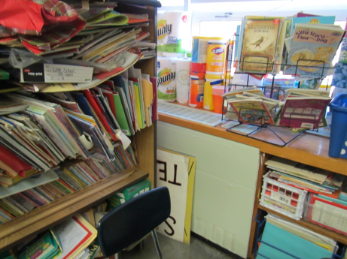
Classroom univent, note obstructions with furniture, placement of items
Picture 2
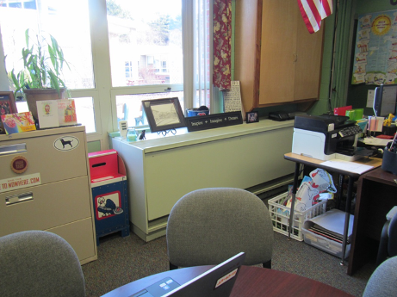
Univent in office
Picture 3
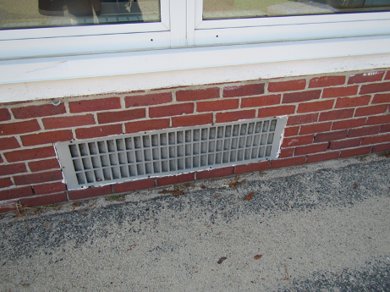
Air intake for univent
Picture 4
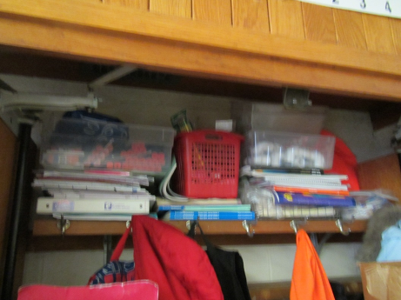
Coat closet containing classroom exhaust (arrow); note items partially obstructing vent
Picture 5
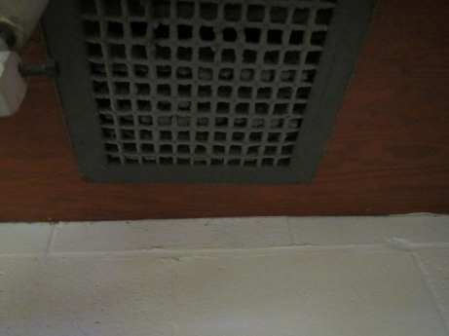
Close-up of coat closet exhaust, note dust
Picture 6
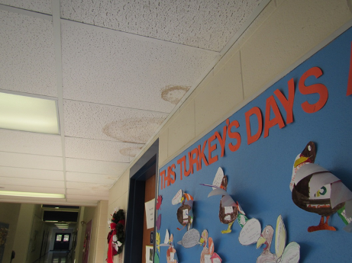
Water-damaged ceiling tiles
Picture 7
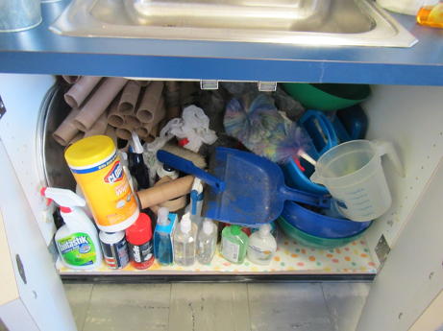
Large amounts of items, including porous items and cleaning products, under classroom sink
Picture 8
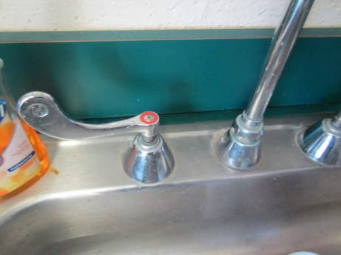
Open backsplash behind sink
Picture 9
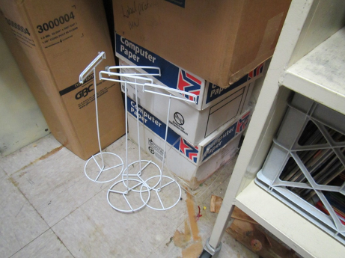
Evidence of water damage on floor and water-damaged boxes in storeroom
Picture 10
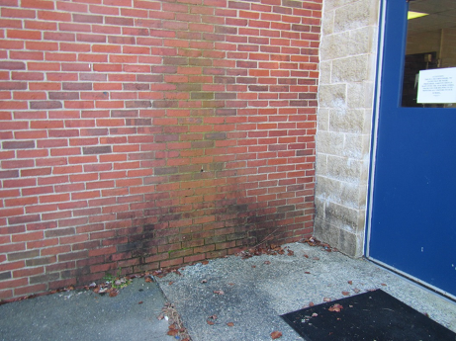
Water staining/moss growth on exterior wall
Picture 11
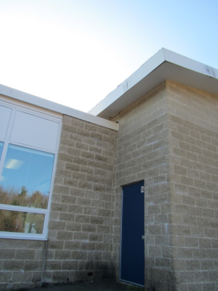
“Splash zone” at corner of building in the 1997 wing showing evidence of chronic dampness
Picture 12
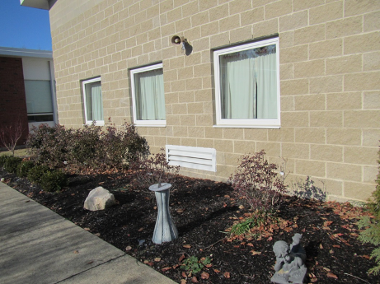
Plants next to building and air intake
Picture 13
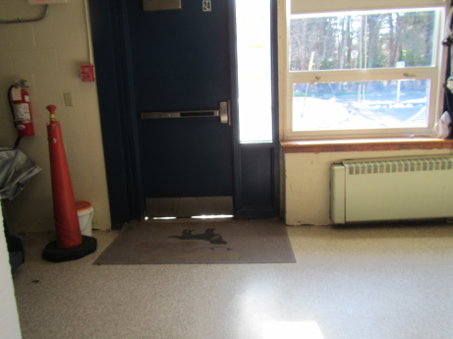
Light visible beneath door showing lack of weatherstripping
Picture 14
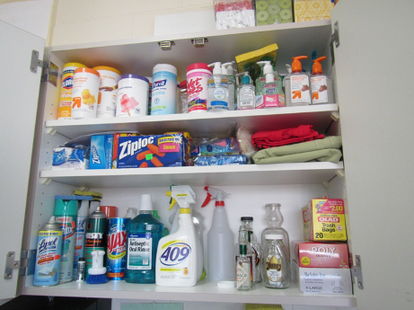
Cleaning products and hand sanitizers in a cabinet in a classroom
Picture 15
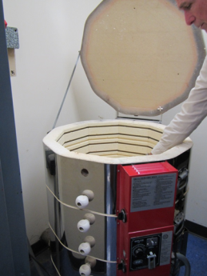
Kiln in closet off art room
Picture 16
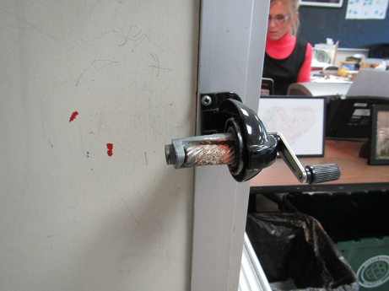
Pencil sharpener with no cover
Picture 17
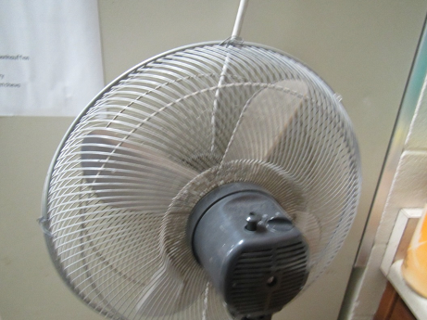
Dusty personal fan
Picture 18
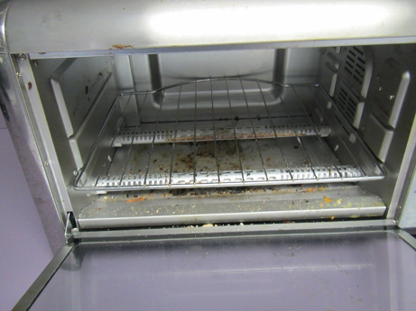
Toaster oven with crumbs
Picture 19
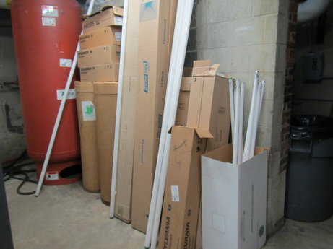
Improperly stored fluorescent bulbs

Location | Carbon  Dioxide  (ppm) | Carbon Monoxide  (ppm) | Temp  (°F) | Relative  Humidity  (%) | PM2.5  (µg/m³) | Occupants  in Room | Windows  Openable | Ventilation |  |  | Remarks
 |  |  |  |  |  |  |  | Supply | Exhaust
Background | 493 | 1.2 | 31 | 20 | 32 |  |  |  |  |  | Chilly, partly cloudy
1 | 679 | ND | 72 | 18 | 20 | 4 | Y and door | Y UV |  | Y closet on, dusty | NC, area rugs, items, PF, plants, CP and items under sink
2 | 900 | ND | 73 | 19 | 20 | 15 | Y | Y UV |  | Y closet on | NC, area rugs, items under sink, PF, plants
3 | 1134 | ND | 74 | 22 | 35 | 16 | Y | Y UV |  | Y closet | NC,. Area rug, sink, items under sink, plants, DEM, items on UV, weatherstripping missing from door
4 | 848 | ND | 74 | 15 | 26 | 1 | Y | Y UV |  | Y closet | Items under sink, fridge, microwave, backsplash open
5 | 941 | ND | 72 | 18 | 26 | 20 | Y | Y UV |  | Y closet | UV obst., items, HS
6 | 1136 | ND | 73 | 21 | 26 | 21 | Y | Y UV |  | Y off | Carpet, HS, items under sink, backsplash open, CP,
7 | 1578 | ND | 73 | 25 | 32 | 20 | Y | Y UV |  | Y off, obst. | Items from ceiling, area rug
8 | 1238 | ND | 73 | 21 | 32 | 21 | Y and door | Y UV |  | Y off, obst. | Backsplash open, area rug, items under sink, plush items
9 | 1939 | ND | 71 | 26 | 34 | 22 | Y | Y UV |  | Y wall | DEM, food, HS, CP, plant, PF dusty sink
10 Art | 756 | ND | 69 | 21 | 11 | 0 | N | Y UV |  | Y wall | Area rug, art supplies. Kiln in storeroom next door.(electric with exhaust from below, and room exhaust) lead-free glazes
11 music | 1119 | ND | 70 | 23 | 24 | 40 | Y | Y |  | Y | Carpet – wrinkled, DEM, HS, sink backsplash open
12 | 906 | ND | 69 | 21 | 16 | 0 | Y | Y UV on |  | Y | DEM
13 | 1042 | ND | 70 | 21 | 24 | 16 | Y open | Y UV debris/items |  | Y UE | Area rug, PF, HS, CP, sink – one piece, WD CT
14 | 1010 | ND | 71 | 20 | 15 | 18 | Y | Y UV |  | Y US, obst. | Debris in UV, plants, DEM, rubber floor mats, odors near or in/under sink
15 | 765 | ND | 72 | 16 | 17 | 0 | Y | Y UV |  | Y UE off
16 | 1197 | ND | 72 | 21 | 19 | 0 | Y | Y UV on |  | Y UE off | NC, items under sink, chalk, DEM
17 | 1079 | ND | 72 | 22 | 21 | 17 | Y | Y UV obst. |  | Y UE | Cleaning odor/room just cleaned, PS, UV loud
18 | 1241 | ND | 73 | 21 | 26 | 2 | Y | Y UV |  | Y UE off
19 | 748 | ND | 72 | 18 | 12 | 1 | Y | Y UV |  | Y UE off | Area rug, bathroom with exhaust
20 | 715 | ND | 72 | 18 | 14 | 1 | Y | Y UV |  | Y UE off | Area rugs, bathroom with exhaust. Strong odor near/in or under sink.
21 | 594 | ND | 71 | 12 | 16 | 0 | Y | Y UV |  | Y celling
22 |  | ND | 70 | 25 | 21 | 24 | Y | Y UV |  | Y
23 | 616 | ND | 72 | 10 | 24 | 3 | Y | Y |  | Y | Carpet
Admin Conference | 616 | ND | 70 | 18 | 14 | 0
Administrative area | 795 | ND | 73 | 18 | 20 | 2 | N | Y |  | Y
Conference A | 628 | ND | 72 | 15 | 26 | 3 | Y | N |  | N | NC
Copy area |  |  |  |  |  |  |  |  |  |  | PCs, paper storage
Girls restroom |  |  |  |  |  |  |  |  |  | Y on, dusty
Gym | 706 | ND | 69 | 13 | 22 | 19 | Y | Y |  | Y | Rubber floor, climbing wall
Library | 686 | ND | 69 | 20 | 12 | 0 | N | Y |  | Y | Shades, carpeted
Library copy room |  |  |  |  |  |  | N | N |  |  | Laminator, copiers, sink blocked off
Library storage/AV |  |  |  |  |  |  | N | N |  |  | Items on floor, wax and paper, water-damaged boxes and residue on floor
Mrs. Greenwald | 610 | ND | 71 | 15 | 28 | 1 | Y | N |  | N | NC, DEM, HS
Mrs. Kasle | 890 | ND | 69 | 20 | 15 | 0 | N | Y |  | Y | Area rug
Mrs. Pepper | 896 | ND | 69 | 28 | 16 | 1 | Y | Y |  | Y | NC, DEM
Nurse | 689 | ND | 71 | 21 | 22 | 1 | Y |  |  | Y in bathroom | NC
Principal’s Office | 718 | ND | 68 | 25 | 27 | 3 | Y | Y UV on |  | Y weak | Candle, DEM, carpet, plants
Restroom in modular |  |  |  |  |  |  |  | Y |  | Y on
Staff lunchroom | 585 | ND | 71 | 15 | 27 | 2 | Y | Y UV off |  | N | Microwave, fridge, toaster, vending. Toaster oven has crumbs, NC
Tech Center | 1045 | ND | 72 | 13 | 21 | 18 | Y | Y |  | Y | AC, 30 computers, NC
Therapy room next to 23 | 601 | ND | 71 | 10 | 23 | 1 | Y | Y |  | Y | Carpet
Title 1 math room | 890 | ND | 69 | 21 | 18 | 2 | Y | Y |  | Y | Area rug, solar gain
Women’s restroom |  |  |  |  |  |  |  |  |  | Y | Exhaust off

The service life is the median time during which a particular system or component of …[an HVAC]… system remains in its original service application and then is replaced. Replacement may occur for any reason, including, but not limited to, failure, general obsolescence, reduced reliability, excessive maintenance cost, and changed system requirements due to such influences as building characteristics or energy prices (ASHRAE, 1991).

