INDOOR AIR QUALITY ASSESSMENT
ODOR INVESTIGATION

E. Ethel Little School
7 Barberry Rd
North Reading, MA 01864

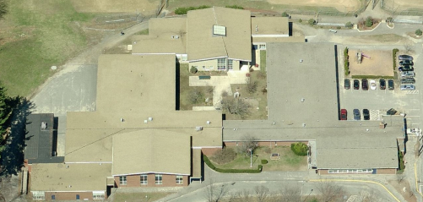

Prepared by:
Massachusetts Department of Public Health
Bureau for Environmental Health
Indoor Air Quality Program
December 2014

Background/Introduction
At the request of Mr. Wayne Hardacker, Supervisor of Buildings & Grounds, North Reading Public Schools, the Massachusetts Department of Public Health (MDPH), Bureau of Environmental Health (BEH) provided assistance and consultation regarding an odor concern in a newer addition of the E. Ethel Little School (LS), 7 Barberry Road, North Reading, Massachusetts. On November 13, 2014, a visit to the LS was made by Ruth Alfasso, Environmental Engineer, and Sharon Lee, Environmental Analyst within BEH’s Indoor Air Quality (IAQ) Program. The request was prompted by concerns of odors in a newer addition at the LS.

Methods
MDPH staff performed visual inspection of building materials for water damage, microbial growth, and other conditions that can contribute to odors in a building.

Results
The LS was observed under normal operating conditions.

Discussion
As previously mentioned, odors reported by LS and North Reading Public Schools (NRPS) staff in a newer addition prompted this assessment. While odors were reportedly sporadic, and the location of the odor varied every few days, they seemed isolated to the newer addition at the LS. NRPS staff reported that odors appeared stronger when a ceiling-mounted heating unit serving the hallway of the addition was operating. In response to odor complaints, this heating unit was turned off by school officials.
At the time of the assessment, BEH/IAQ staff noted an odor in the hallway leading to the LS addition. Staff examined conditions in each of the rooms reportedly impacted by these odors. One feature common to these rooms was exhaust vents mounted to the hallway wall. Since the height of the exhaust vent in the classroom corresponded to the space above the ceiling tile system in the hallway, BEH/IAQ staff observed the space above the hallway ceiling tiles and noted that ductwork for these exhaust vents terminated in this space (Picture 1). The current configuration (e.g. ducts for classroom exhausts opening into the hallway ceiling space) suggests that the ceiling space in the hallway is designed to be a plenum.
With the assistance of NRPS staff, BEH/IAQ staff examined the ceiling plenum for exhaust equipment and noted a louver for air exhaust; light from the outdoors could be seen penetrating around the louver (Picture 2). BEH/IAQ staff examined the louver from the roof and noted that there was no fan motor on the roof to draw air out from the ceiling plenum (Pictures 3 and 4). Without an exhaust fan to actively remove air, outdoor air can penetrate around the louvers, causing dust and odors in the hallway ceiling plenum to backdraft into the classrooms via the classroom exhaust vents.
At the time of the assessment, BEH/IAQ staff did not observe any moisture sources that would contribute to water damage and associated odors. However, rodent droppings were noted on ceiling tiles in the hallway plenum (Picture 5). The presence of droppings suggests that rodents are likely nesting in the plenum. The ceiling-mounted heating unit likely serves as a heat source for the pests. Since pests congregate near heat sources for warmth, it is possible that animal waste (e.g. urine) may be collected on the ceiling-mounted heating unit. When the unit is turned on, heat likely enhances the odor of the waste. Animal waste odors would then be distributed into classrooms serviced by the plenum system when outdoor air penetrates through openings around the ceiling plenum exhaust louver.

Conclusions/Recommendations
At the time of the assessment, BEH/IAQ staff recommended interim methods to exhaust air from the hallway ceiling plenum. At the time, the NRPS devised a plan to install a fan to draw air out of the plenum to reduce odors in the building. The NRPS provided confirmation and pictures to show that a temporary exhaust system had been installed (Picture 6). Based on findings at the time of the assessment, the following is recommended:
- Continue with plans to install a permanent exhaust fan to the rooftop opening.
- Vacuum visible wastes in the ceiling plenum using a HEPA-filtered vacuum.
- Clean/disinfect the hallway ceiling-mounted heating unit, as well as flat surfaces nearby.
- Locate/remove pests that may be in the nesting in the ceiling system. Seal breaches in the wall to prevent future entry.
- Replace ceiling tiles in the hallway.

Picture 1
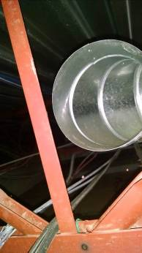
Open exhaust ductwork in hallway ceiling plenum
Picture 2
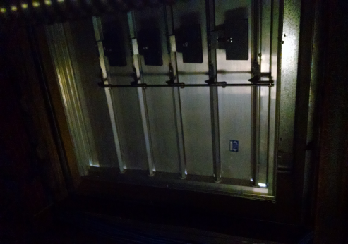
Exhaust louver (view from ceiling plenum), note light penetrating at the botom corners
Picture 3
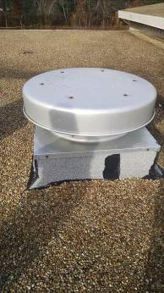
Rooftop return vent ductwork, notice lack of fan motor
Picture 4
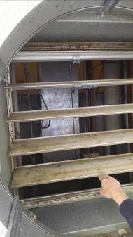
Exhaust louver open, looking out from hallway ceiling plenum, note no fan motor
Picture 5
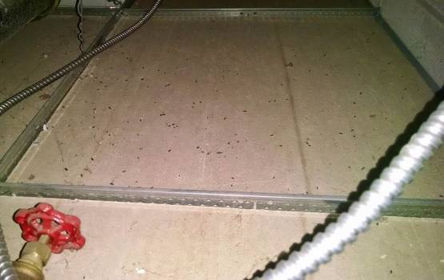
Rodent droppings on ceiling tiles
Picture 6
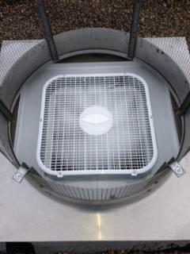
Box fan installed to remove odors (image courtesy of Mike Parow, NRPS)

Plenum refers to a space used to circulate or move air

