INDOOR AIR QUALITY/WATER DAMAGE INVESTIGATION

Eames Way Elementary School
165 Eames Way
Marshfield, Massachusetts

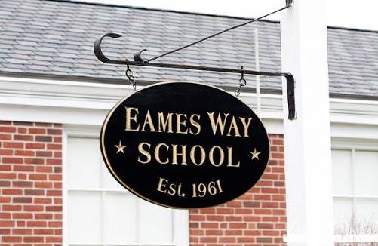

Prepared by:
Massachusetts Department of Public Health
Bureau of Environmental Health
Indoor Air Quality Program
December 2021

BACKGROUND
Building: | Eames Way Elementary School (EWES)
Address: | 165 Eames Way, Marshfield, MA
Assessment Requested by: | Fred Russell, Facilities Director, Town  of Marshfield
Reason for Request: | Musty odors/mold concerns in several classrooms
Date of Assessment: | December 1, 2021
Massachusetts Department of Public Health/Bureau of Environmental Health (MDPH/BEH) Staff Conducting Assessment: | Cory Holmes, Assistant Director,  Indoor Air Quality (IAQ) Program
Date of Building Construction: | The EWES is a one-story red brick building that was constructed in the early 1960s. The building was unused from 1990 until 1995 when it was reopened. Building improvements have been conducted over the years including new floor tiles (2004), carpeting (2006), and a new roof (2007).
Building/Site Description: | Building components in the areas assessed consist of concrete block walls, floor tiles, wooden beams/fixtures and ceiling tiles that are adhered directly to the ceiling substrate.
Windows: | Openable

METHODS
DPH staff conducted a series of visual assessments, temperature and relative humidity measurements to identify likely areas that could be prone to condensation in hot, humid weather. Please refer to the IAQ Manual for methods, sampling procedures, and interpretation of results (MDPH, 2015).

RESULTS AND DISCUSSION
The following is a summary of indoor air testing results (Tables 1 & 2):
- Temperature was within or close to the lower end of the MDPH recommended range of 70°F to 78°F in areas tested.
- Relative Humidity was below the MDPH recommended range of 40 to 60% in areas tested, which were reflective of outside conditions.
- Moisture Measurement of porous materials (i.e., wood and carpeting) prone to moisture/mold growth due to elevated relative humidity conditions were normal (i.e., dry) at the time of the assessment.
- Carbon Monoxide was not detected (ND) in the areas tested.
- Total Volatile Organic Compounds (TVOCs) were ND in the areas tested.
- Particulate Matter (PM2.5) concentrations measured were below the National Ambient Air Quality (NAAQS) level of 35 μg/m³ in all areas tested.

Ventilation
A heating, ventilating and air conditioning (HVAC) system has several functions. First it provides heating and, if equipped, cooling. Second, it is a source of fresh air. Finally, an HVAC system will dilute and remove normally occurring indoor environmental pollutants by not only introducing fresh air, but by filtering the airstream and ejecting stale air to the outdoors via exhaust ventilation. Even if an HVAC system is operating as designed, point sources of respiratory irritation may exist and cause symptoms in sensitive individuals.
Fresh air in classrooms is supplied by unit ventilator (univent) systems. Univents are designed to draw air from outdoors through a fresh air intake located on the exterior wall of the building and return air through an air intake located at the base of each unit (Figure 1). Fresh and return air are mixed, filtered, heated and provided to classrooms through a fresh air diffuser located on the top of the unit. Obstructions to airflow, such as furniture and other items in front of univent return vents, were noted in classrooms (Picture 1). In order for univents to provide fresh air as designed, univent air diffusers and return vents must remain free of obstructions. Exhaust ventilation in these areas is provided by vents mounted on wooden cabinets (Picture 2) in coat closets or ceilings (Picture 3).
To maximize air exchange, the IAQ program recommends that both supply and exhaust ventilation operate continuously during periods of occupancy. In order to have proper ventilation with a mechanical ventilation system, the systems must be balanced after installation to provide an adequate amount of fresh air to the interior of a room while removing stale air from the room. It is recommended that HVAC systems be re-balanced every five years to ensure adequate air systems function (SMACNA, 1994).

Microbial/Moisture Concerns
The assessment was prompted by reports of musty odors in classrooms, particularly rooms 4 and 6. Occupants reported the odors are most prominent from wooden cabinets and the corner storage closets (containing wooden shelving), which are fixtures in most classrooms (Pictures 4 and 5). Although, no evidence of current water damage, visible mold growth or elevated moisture measurements were recorded at the time of assessment, musty odors were detected within both closets and wooden shelving units. It is most likely that the wooden fixtures themselves are the main source of odors:
- Wood is a semi-porous material that can absorb moisture/odors from the environment;
- The school was designed as a non-air-conditioned space and consists of solid/cool surfaces that are prone to condensation (e.g., concrete block and tile);
- These wooden fixtures are original to construction of the building (approximately 60 years old) and have been subjected to moist New England summers since 1961;
- Closets and storage cabinet enclosures are not ventilated either mechanically or a passively (e.g., door vent/grill);
- Closets and cabinets are used to store classroom items such as books, paper, cardboard and fabric items (Pictures 6 through 9) that are porous and also absorb moisture/odors;
- Rooms also contain corkboards (Picture 9) that appear to be original to the building and are a porous material that can absorb moisture/emit odors.

It is also important to note that Massachusetts has experienced extended periods of relative humidity during the summer of 2021. This July was the wettest ever recorded in Massachusetts, and the three-month period from June through August, known as the meteorological summer, was the fourth wettest on record, according to the National Oceanic and Atmospheric Administration’s Centers for Environmental Information. The three-month period also was the third warmest ever in the state and was tied for the warmest on record across the United States (HG, 2021, NOAA, 2021).
According to American Society of Heating, Refrigerating and Air-Conditioning Engineers (ASHRAE), if relative humidity exceeds 70%, mold growth may occur due to wetting of building materials (ASHRAE, 1989). It is recommended that porous material be dried with fans and heating within 24 to 48 hours of becoming wet (US EPA, 2008, ACGIH, 1989). If porous materials are not dried within this time frame, mold growth may occur. Water-damaged porous materials cannot be adequately cleaned to remove mold growth.

Building Materials Prone to Condensation
The key to managing condensation in hot, humid weather indoors is understanding dew point. When warm, moist air passes over a cooler surface, condensation can form. Condensation is the collection of moisture on a surface at or below the dew point. The dew point is the temperature that air must reach for saturation to occur. If a building material/component has a temperature below the dew point, condensation will accumulate on that material. Over time, condensation can collect and form water droplets.
A method to locate areas in a building prone to condensation is to measure air and building material temperatures using a laser thermometer (Table 1). If a wide temperature range exists between measurements, the building materials at the colder end of the range may be prone to becoming moistened with condensation if exposed to hot, humid weather (outdoor relative humidity >70%) for extended periods of time (at least 48 hours). According to the test results in Table 1, a number of areas may be prone to condensation if exposed to hot, humid weather for extended periods of time.

Other Sources of Water Damage/Moisture
As previously mentioned, this visit included a visual inspection for signs of water damage and microbial growth. Water-damaged ceilings/tiles were observed in a number of classrooms, hallways and common areas (Table 2, Pictures 3 and 10). No current/active leaks were reported, which indicates damaged tiles are from historic roof/plumbing leaks or other water infiltration. Water-damaged ceiling tiles can provide a source of mold and should be replaced after a water leak is discovered and repaired. However, it is important to note that ceiling at the EWES are a type that are directly adhered to the ceiling substrate, therefore would necessitate the destruction of the ceiling tile to remove. In addition, replacement tiles may not be available.
Other potential sources and/or pathways for moisture and odors existed in the form of open utility holes or breaches in floors/wall cavities. Classroom walls had holes around electrical conduits that cool drafts could be detected from (Picture 11). Univent cabinets had spaces around hot water pipes that come up from the crawlspace (Picture 12). Holes/breaches in wall and floors can provide pathways for moisture, odors, dust and drafts from unconditioned spaces into occupied areas and should be sealed.

Other Issues
The main office areas contained wall to wall carpeting, which appeared old/worn (Picture 13). Carpets should be cleaned annually (or semi-annually in soiled/high traffic areas) in accordance with Institute of Inspection, Cleaning and Restoration Certification (IICRC) recommendations, (IICRC, 2012). The service life of carpeting is approximately 10-11 years (IICRC, 2002). Regular cleaning with a high efficiency particulate air (HEPA) filtered vacuum in combination with an annual cleaning will help to reduce accumulation and potential aerosolization of materials from carpeting. Several rooms had area rugs, which should also be vacuumed/cleaned on a regular basis. Area rugs should be rolled up and stored in a clean, dry place when rooms are not occupied during the summer months to prevent moistening due to condensation.
Exposure to low levels of total VOCs (TVOCs) may produce eye, nose, throat, and/or respiratory irritation in some sensitive individuals. To determine if VOCs were present, BEH/IAQ staff examined rooms for products containing VOCs. BEH/IAQ staff dry erase materials, hand sanitizers, spray cleaners and air fresheners in use within the building. These products have the potential to be irritants to the eyes, nose, throat, and respiratory system of sensitive individuals.
It was reported that to supplement mechanical ventilation and filtration, classrooms are provided with a HEPA-filtered air purifiers. In several rooms the filters were found to be covered with accumulated dust/debris (Picture 14). Filters should be changed and these units be maintained in accordance with the manufacturers’ recommendations. In addition, many classrooms contained portable air conditioning units that have filters that need to be cleaned regularly.
The MDPH recommends that HVAC equipment be outfitted with filters of a Minimum Efficiency Reporting Value (MERV) of 8 or higher, which are adequate in filtering out pollen and mold spores (ASHRAE, 2012). In addition, filters should be changed 2-4 times a year or in accordance with the manufacturers’ recommendations. Univents at the EWES utilize MERV 13 filters.

CONCLUSIONS AND RECOMMENDATIONS

Odor Recommendations
Due to years of chronic moisture exposure, it appears that wooden fixtures, mainly closet shelving and cabinets, are the likely source of old/musty odors. Therefore, any porous materials (e.g., cardboard, paper, clothing) stored within will also absorb and become a source of odors. In view of the findings at the time of the visit, the following recommendations are made. Please note some of these recommendations may take time, planning and additional resources to complete:
- Remove all items from classroom closets, thoroughly clean and/or replace all existing wooden/porous shelving and ceiling materials.
- Remove doors from closets or install passive door vents to provide airflow.
- Remove wooden shelving units (Picture 4).
- For built-in wooden shelving/storage units that cannot be removed easily, consider sealing with a fungicidal, mold-resistant coating and refinishing.
- Remove and discard corkboards.
- Discard/replace any other porous items (e.g., books, paper, cardboard, fabric) that have been exposed to chronic moisture or that have an odor.
- Reduce the amount of books, paper, cardboard and fabric materials stored in classrooms.
- If porous items are to be stored in closets and shelving units, consider storing them in airtight plastic totes/containers.
- Consider creating a central, conditioned space to store books, paper, and other porous stock items.
- Seal holes/breaches in walls, floors, ceilings and univent cabinets (e.g., around pipes from the crawlspace) to reduce/eliminate pathways for odors and moisture into occupied spaces.

Water Damage Recommendations
- Continue to monitor for any roof and plumbing leaks and report to the Facilities Department for prompt remediation.
- Consider a long-term plan to replace water-damaged/failing ceiling tiles with a suspended ceiling tile system or alternate material.
- Consider utilizing dehumidifiers in classrooms to supplement moisture control in combination with portable air conditioning units as needed.
- Ensure windows are shut during periods of elevated relative humidity (e.g., over 70%).
- Closely monitor parameters such as temperature, relative humidity, and dew point over summer months to prevent condensation on floors/surfaces. Refrain from storing porous items, such as cardboard and paper on floors in these areas. Consider removing any carpeting from areas that are prone to condensation.
- Area rugs should be rolled up and stored in a clean, dry place when rooms are not occupied during the summer months to prevent moistening due to condensation.
- Move furniture away from walls several inches to allow airflow and prevent “moisture trapping”, which can lead to mold growth on walls.
- Consider using the methods described in the document “Preventing Mold Growth in Massachusetts Schools During Hot, Humid Weather” to help reduce impact of conditions during hot, humid weather. This guideline can be found online at: https://www.mass.gov/service-details/preventing-mold-growth-in-massachusetts-schools-during-hot-humid-weather

Ventilation Recommendations
- Remove all items from top/front of classroom univents, supply and exhaust vents.
- Operate all supply and exhaust ventilation systems throughout the building continuously during periods of occupancy to maximize air exchange and filtration.
- Consider adopting a balancing schedule of every 5 years for all mechanical ventilation systems, as recommended by ventilation industrial standards (SMACNA, 1994).
- Change filters for HVAC equipment 2-4 times a year using the best quality/highest Minimum Efficiency Reporting Value (MERV) rated filters that can be used with current equipment.
- Use openable windows to supplement fresh air during temperate weather. Ensure all windows are tightly closed at the end of the day and during periods of elevated relative humidity to avoid condensation/mold growth conditions.
- The U.S. Department of Education has released new guidance encouraging the use of American Rescue Plan (ARP) funds to improve ventilation systems and make other indoor air quality improvements in schools. More information can be found at this link https://www.ed.gov/coronavirus/improving-ventilation.

Other Recommendations
- Change filters and maintain portable air purifying units as per manufacturers’ recommendations.
- Regularly clean/vacuum supply/exhaust/return vents and personal fans to avoid aerosolizing accumulated particulate matter.
- Reduce use of products and equipment that create irritating volatile organic compounds (VOCs) and only use in well-ventilated areas. Minimize the use of air fresheners (e.g., plug-ins), deodorizers and scented products.
- Keep spray bottles/cleaning products out of the reach of children. Ensure that products are compatible with one another. It is suggested that only school-supplied products be used to avoid product interactions.
- Clean carpeting annually (or semi-annually in soiled high traffic areas) as per the recommendations of the Institute of Inspection, Cleaning and Restoration Certification (IICRC, 2012).
- Consider replacing any carpeting that is beyond its service life (i.e., > 11 yrs.).
- For buildings in New England, periods of low relative humidity during the winter are often unavoidable. Therefore, scrupulous cleaning practices should be adopted to minimize common indoor air contaminants whose irritant effects can be enhanced when the relative humidity is low. To control dusts, a high efficiency particulate arrestance (HEPA) filter equipped vacuum cleaner in conjunction with wet wiping of all surfaces is recommended. Avoid the use of feather dusters. Drinking water during the day can help ease some symptoms associated with a dry environment (throat and sinus irritations).
- Consider forming an IAQ committee in each school building district wide. Committees should have an IAQ liaison/teacher representative, a member of maintenance/facilities and administration that conduct regular walk-throughs to identify on-going and/or potential environmental issues.
- Consider adopting the US EPA (2000) document, “Tools for Schools”, as an instrument for maintaining a good IAQ environment in the building available at: https://www.epa.gov/iaq-schools/indoor-air-quality-tools-schools-action-kit
- Refer to resource manual and other related IAQ documents located on the MDPH’s website for further building-wide evaluations and advice on maintaining public buildings. These documents are available at: http://mass.gov/dph/iaq.

REFERENCES
ACGIH. 1989. Guidelines for the Assessment of Bioaerosols in the Indoor Environment. American Conference of Governmental Industrial Hygienists, Cincinnati, OH.
ASHRAE. 1989. Ventilation for Acceptable Indoor Air Quality. American Society of Heating, Refrigeration and Air Conditioning Engineers. ANSI/ASHRAE 62-1989.
ASHRAE. 2012. American Society of Heating, Refrigeration and Air Conditioning Engineers (ASHRAE) Standard 52.2-2012 -- Method of Testing General Ventilation Air-Cleaning Devices for Removal Efficiency by Particle Size (ANSI Approved). 2012.
HG. 2021. Mold keeps South Hadley High School shuttered. Hampshire Gazette. https://www.gazettenet.com/South-Hadley-High-School-still-closed-amid-mold-remediation-42413519.
IICRC. 2002. Institute of Inspection, Cleaning and Restoration Certification. A Life-Cycle Cost Analysis for Floor Coverings in School Facilities.
IICRC. 2012. Institute of Inspection, Cleaning and Restoration Certification. Carpet Cleaning: FAQ.
MDPH. 2015. Massachusetts Department of Public Health. “Indoor Air Quality Manual: Chapters I-III”. Available at: https://www.mass.gov/lists/indoor-air-quality-manual-and-appendices
NOAA. 2021. Summer 2021 neck and neck with Dust Bowl summer for hottest on record. National Oceanic and Atmospheric Administration, 1401 Constitution Avenue NW, Room 5128, Washington, DC 20230 https://www.noaa.gov/news/summer-2021-neck-and-neck-with-dust-bowl-summer-for-hottest-on-record
SMACNA. 1994. HVAC Systems Commissioning Manual. 1st ed. Sheet Metal and Air Conditioning Contractors’ National Association, Inc., Chantilly, VA.
US EPA. 2000. Tools for Schools. Office of Air and Radiation, Office of Radiation and Indoor Air, Indoor Environments Division (6609J). EPA 402-K-95-001, Second Edition. https://www.epa.gov/iaq-schools/indoor-air-quality-tools-schools-action-kit
US EPA. 2008. “Mold Remediation in Schools and Commercial Buildings”. Office of Air and Radiation, Indoor Environments Division, Washington, DC. EPA 402-K-01-001. September 2008. Available at: http://www.epa.gov/mold/mold-remediation-schools-and-commercial-buildings-guide.
Figure 1

Unit Ventilator (Univent)

Mixed Air

Air Diffuser

Outdoors Indoors

Fan

Heating/Cooling Coil

Air Mixing Plenum

Filter

Outdoor Return
Air Air

Air
Flow
Control
Louvers

Air Flow

= Fresh Air/Return Air

= Mixed Air

Picture 1
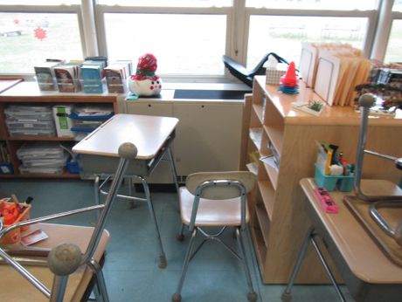
Classroom furniture partially obstructing univent return vent (bottom front)
Picture 2
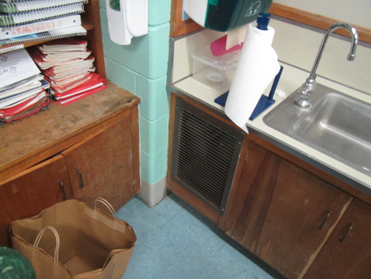
Exhaust vents on wooden cabinets
Picture 3
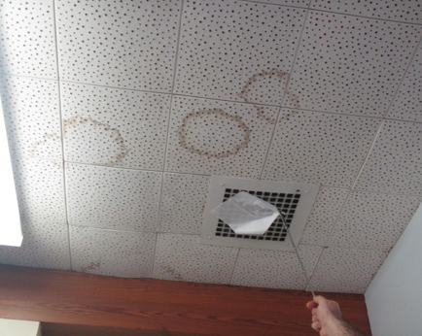
Ceiling-mounted exhaust vent, also note water-damaged ceiling tiles
Picture 4
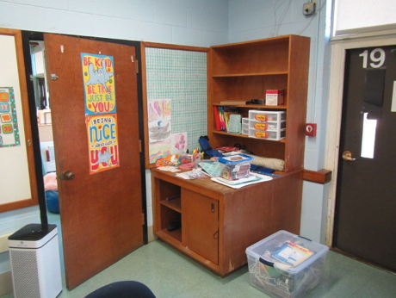
Typical wooden storage cabinet in classroom
Picture 5
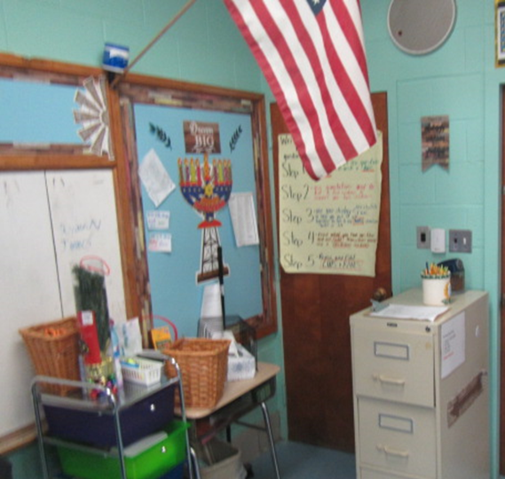
Typical classroom storage closet (behind wooden door)
Picture 6
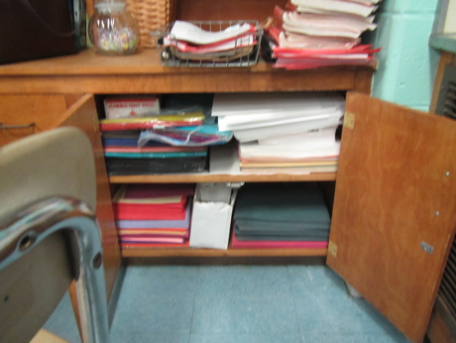
Wooden storage cabinet filled with paper items
Picture 7
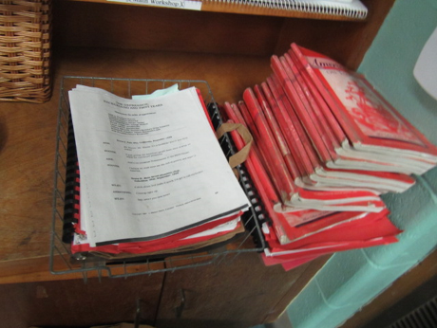
Books/paper items in classroom
Picture 8
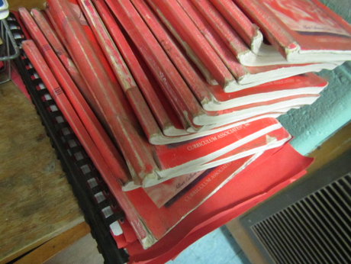
Close-up of books/paper items in classroom
Picture 9
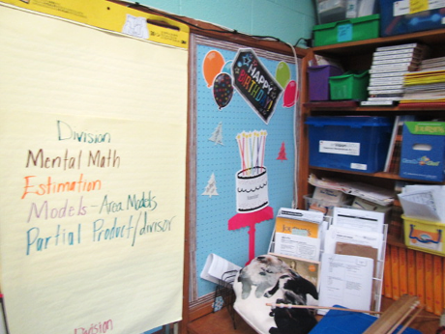
Cork boards and paper/porous items in classrooms
Picture 10
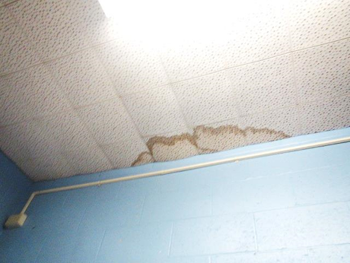
Water-damaged ceiling tiles
Picture 11
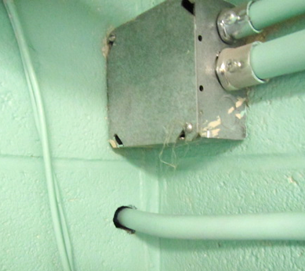
Space around electrical conduits in classroom
Picture 12
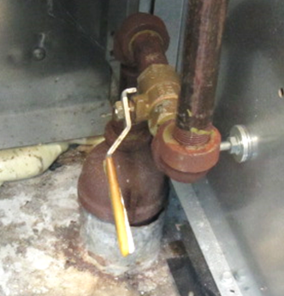
Space around pipe within univent cabinet, pathway to crawlspace (arrow)
Picture 13
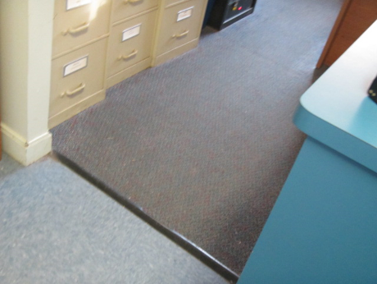
Wall to wall carpeting in main office
Picture 14
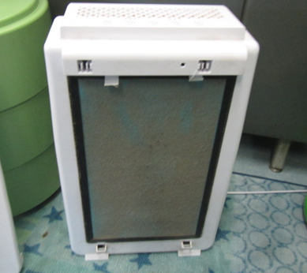
Dusty filter on air purifier in classroom (cover removed)
Location | Air Temp  (ºF) | Relative Humidity  (%) | Dew Point  (%) | Floor Temp  (ºF) | Temp at Floor/ Exterior Wall Junction  (ºF) | Water-Damaged Ceiling Tiles-stained | Water-Damaged  Bowed Ceiling Tile | Ventilation |  |  | Floor to Air Temp  Difference  (ºF) | Comments
 |  |  |  |  |  |  |  | Windows openable | Supply | Exhaust
Background (outdoors) | 49 | 33 | 23 |  |  |  |  |  |  |  |  | Cold & overcast
4 | 68 | 29 | 33 | 63 | 62 | Y | N | Y | Y | Y | 5 | Musty odors detected around storage closet/wooden cabinets and paper products, no visible growth, moisture measurements of wood in closets and cabinets - normal (i.e., dry)
6 | 68 | 35 | 39 | 58 | 59 | Y | N | Y | Y | Y | 10 | Musty odors detected around storage closet/wooden cabinets and paper products, no visible growth, moisture measurements of wood in closets and cabinets - normal (i.e., dry)
2 | 71 | 20 | 28 | 66 | 65 | Y |  | Y  Open | Y | Y | 5 | Portable air conditioner
20 | 69 | 23 | 29 | 59 | 59 | Y | Y | Y  Open | N | N | 10 | Portable air conditioner
Main Office | 75 | 23 | 23 | 70 | 68 | Y | N | Y | N | Y |  | Air purifier, portable air conditioner, old carpeting, moisture measurements of carpet - normal (i.e., dry)

Location | Carbon Monoxide  (ppm) | Temp  (°F) | Relative  Humidity  (%) | PM2.5  (µg/m³) | TVOCs  (ppm) | Windows  Openable | Ventilation |  | Remarks
 |  |  |  |  |  |  | Supply | Exhaust
Background  (outside) | ND | 49 | 33 | 6 | ND |  |  |  | Cold & overcast
4 | ND | 68 | 29 | 4 | ND | Y | Y | Y | AP-filter dusty, AC, DEM
6 | ND | 68 | 35 | 3 | ND | Y | Y | Y | AP, DEM, AC
2 | ND | 71 | 20 | 4 | ND | Y  Open | Y | Y | AP, DEM, AC
Office | ND | 75 | 23 | 5 | ND | Y | N | Y | AP, carpet, AC
20 | ND | 69 | 23 | 4 | ND | Y  Open | Y | Y | AP, DEM, AC

