INDOOR AIR QUALITY ASSESSMENT

Eames Way Elementary School
164 Eames Way
Marshfield, Massachusetts 02050



Prepared by:
Massachusetts Department of Public Health
Bureau of Environmental Health
Indoor Air Quality Program
March 2009

Background/Introduction
At the request of the Marshfield Public School Department (MPSD), the Massachusetts Department of Public Health (MDPH), Bureau of Environmental Health (BEH) provided assistance and consultation regarding indoor air quality concerns at Eames Way Elementary School (EWES), 164 Eames Way, Marshfield, Massachusetts. The request was prompted by reports of respiratory irritation and reoccurring sinus infections among employees in the main office, as well as mold concerns due to previous roof leaks throughout the building. On January 23, 2009, Cory Holmes, Environmental Analyst/Inspector in BEH’s Indoor Air Quality (IAQ) Program, visited to the EWES to conduct an IAQ assessment.
The EWES is a one-story red brick building that was constructed in the early 1960s. The building was dormant from 1990-1995. It reopened in 1995. Building improvements have been conducted over the years including new floor tiles (2004), carpeting (2006), and new roof (2007). The building has two classroom wings that branch off the main portion of the building, which occupants refer to as the primary and upper wings.
The primary wing contains general classrooms for kindergarten through 2nd grade. The upper wing contains general classrooms for 3rd trough 5th grade. The main portion of the building contains general classrooms, art room, teacher’s work room, nurse’s clinic, cafeteria, gymnasium, several small resource rooms and office space.
Methods
Air tests for carbon monoxide, carbon dioxide, temperature and relative humidity were conducted with the TSI, Q-Trak, IAQ Monitor, Model 8554. Air tests for airborne particle matter with a diameter less than 2.5 micrometers were taken with the TSI, DUSTTRAK™ Aerosol Monitor Model 8520. BEH staff also performed visual inspection of building materials for water damage and/or microbial growth. Water content of porous building materials was measured with a Delmhorst, BD-2000 Model, Moisture Detector with a Delmhorst Standard Probe.
Results
The school houses a student population of approximately 385 and a staff of approximately 50. The tests were taken during normal operations and results appear in Table 1. Since the main office was the primary area of concern, this area was visited several times during the course of the assessment.
Discussion
Ventilation
It can be seen from Table 1 that carbon dioxide levels were above 800 parts per million (ppm) in of 10 of 29 areas, indicating poor air exchange in approximately one-third of the areas surveyed during the assessment. The majority of areas with elevated carbon dioxide levels were located in the upper classroom wing, where exhaust vents were not operating.
Fresh air in classrooms is supplied by unit ventilator (univent) systems (Picture 1). A univent draws air from outdoors through a fresh air intake located on the exterior wall of the building (Picture 2) and returns air through an air intake located at the base of the unit (Figure 1). Fresh and return air are mixed, filtered (Picture 3), heated and provided to classrooms through an air diffuser located in the top of the unit. Univents are reportedly original equipment from the 1960’s. Univents of this age can be difficult to maintain because replacement parts are often unavailable. In several classrooms, items were seen on and/or in front of univents obstructing airflow (Picture 4). Univents in classrooms 3 and 15 were reportedly deactivated by occupants, due to excessive heat. In order for univents to provide fresh air as designed, air diffusers, intakes and return vents must remain free of obstructions. Importantly, these units must remain “on” and be allowed to operate while rooms are occupied.
The main exhaust vent in classrooms is located on the front face of sink cabinets (Picture 5). Supplementary exhaust vents are located in coat closets (Picture 6). As previously mentioned, exhaust vents were not drawing air in the upper wing classrooms during the assessment, which can indicate that motors were deactivated or inoperable. Similarly exhaust vents in the gym were not drawing air. Exhaust vents in the main office and several other areas are located in the ceiling (Picture 7). The exhaust vent in the main office is activated by a wall switch (Picture 8) and was also found deactivated at the time of the assessment. Without adequate supply and exhaust ventilation, excess heat and environmental pollutants can build up and lead to indoor air/comfort complaints.
To maximize air exchange, the MDPH recommends that both supply and exhaust ventilation operate continuously during periods of school occupancy. In order to have proper ventilation with a mechanical supply and exhaust system, the systems must be balanced to provide an adequate amount of fresh air to the interior of a room while removing stale air from the room. It is recommended that HVAC systems be re-balanced every five years to ensure adequate air systems function (SMACNA, 1994). The date of the last balancing of these systems was not available at the time of the assessment.
The Massachusetts Building Code requires a minimum ventilation rate of 15 cubic feet per minute (cfm) per occupant of fresh outside air or have openable windows in each room (SBBRS, 1997; BOCA, 1993). The ventilation must be on at all times that the room is occupied. Providing adequate fresh air ventilation with open windows and maintaining the temperature in the comfort range during the cold weather season is impractical. Mechanical ventilation is usually required to provide adequate fresh air ventilation.
Carbon dioxide is not a problem in and of itself. It is used as an indicator of the adequacy of the fresh air ventilation. As carbon dioxide levels rise, it indicates that the ventilating system is malfunctioning or the design occupancy of the room is being exceeded. When this happens, a buildup of common indoor air pollutants can occur, leading to discomfort or health complaints. The Occupational Safety and Health Administration (OSHA) standard for carbon dioxide is 5,000 parts per million parts of air (ppm). Workers may be exposed to this level for 40 hours/week, based on a time-weighted average (OSHA, 1997).
The MDPH uses a guideline of 800 ppm for publicly occupied buildings. A guideline of 600 ppm or less is preferred in schools due to the fact that the majority of occupants are young and considered to be a more sensitive population in the evaluation of environmental health status. Inadequate ventilation and/or elevated temperatures are major causes of complaints such as respiratory, eye, nose and throat irritation, lethargy and headaches. For more information concerning carbon dioxide, consult Appendix A.
Temperature measurements in occupied areas on the day of the assessment ranged from 68º F to 74º F, which were within or close to the lower end of the MDPH recommended comfort range. The MDPH recommends that indoor air temperatures be maintained in a range of 70º F to 78º F in order to provide for the comfort of building occupants. In many cases concerning indoor air quality, fluctuations of temperature in occupied spaces are typically experienced, even in a building with an adequate fresh air supply. In addition, it is often difficult to control temperature and maintain comfort with equipment of this vintage (> 40 years old). BEH staff observed conditions above ceiling tiles in the main hallway (near the front entrance) and noted bats of insulation that were dislodged, damaged or hanging (Picture 9). This area is near a centrally located cupola (Picture 10). Cold drafts were detected upon removal of ceiling tiles, which indicates a source of unimpeded airflow from the cupola into the building. The building also has original single-paned windows, which are loose and drafty in many areas. These breaches can lead to heat/energy loss and make temperature control difficult.
Indoor relative humidity ranged from 20 to 33 percent, which was below the MDPH recommended comfort range in all areas surveyed during the assessment. The MDPH recommends a comfort range of 40 to 60 percent for indoor air relative humidity. Relative humidity would be expected to drop below comfort levels during the heating season. The sensation of dryness and irritation is common in a low relative humidity environment. Low relative humidity is a very common problem during the heating season in the northeast part of the United States.

Microbial/Moisture Concerns
In order for building materials to support mold growth, a source of water exposure is necessary. Identification and elimination of the source of water moistening building materials is necessary to control mold growth. In this case, the main source of water penetration over the years has been the roof, which, as stated previously, was replaced in 2007. Although the roof has been replaced, residual water damage in the form of damaged ceiling tiles and staining on wooden beams/ceilings was seen throughout the building.
In most areas ceiling tiles are of an inter-locking type (as opposed to drop ceiling tiles), which makes removal/replacement difficult (Pictures 11 and 12). Water-damaged ceiling tiles can provide a source of mold growth and should be replaced after a water leak is discovered and repaired. Active leaks were reported in the main hallway. Occupants believed the leaks were most likely the result of water penetration though the cupola (Picture 10). BEH staff removed drop ceiling tiles in this area and observed dark staining on the surface of paper backed insulation, which may indicate mold growth (Pictures 13 and 14). White staining on the wooden ceilings of coat closets was also observed, which may indicate either mold growth or efflorescence (Picture 15). Efflorescence is a characteristic sign of water damage but it is not mold growth. As moisture penetrates and works its way through building materials, water-soluble compounds dissolve, creating a solution. As the solution moves to the surface the water evaporates, leaving behind white, powdery mineral deposits.
Several other areas of the building showed evidence of historical water damage and or had potential sources of moisture, which could lead to mold growth. Throughout the school, caulking around interior and exterior windowpanes was crumbling, missing or damaged (Pictures 16 and 17). Water penetration through window frames can lead to mold growth under certain conditions. Repairs of window leaks are necessary to prevent further water penetration. A broken window in the music office has resulted in chronic water penetration illustrated by severe water damage and mold growth to the wooden windowsill (Picture 18). Water staining and peeling paint was observed beneath a skylight in the main hallway (Picture 19), which appears to be historic damage.
BEH staff conducted moisture testing of building materials (i.e., insulation, ceiling tiles, wood) to determine if the materials were wet. Materials with increased moisture content over normal concentrations may indicate the possible presence of mold growth. All materials tested during the assessment were found to have low (i.e., normal) moisture content (Table 1). Moisture content of materials measured is a real-time measurement of the conditions present at the time of the assessment.
The US Environmental Protection Agency (US EPA) and the American Conference of Governmental Industrial Hygienists (ACGIH) recommends that porous materials be dried with fans and heating within 24 to 48 hours of becoming wet (US EPA, 2001; ACGIH, 1989). If porous materials are not dried within this time frame, mold growth may occur. Water-damaged porous materials cannot be adequately cleaned to remove mold growth. The application of a mildewcide to moldy porous materials is not recommended.
Several classrooms had a number of plants. Moistened plant soil and drip pans can be a source of mold growth. Plants should be equipped with drip pans; the lack of drip pans can lead to water pooling and mold growth on windowsills. Plants are also a source of pollen. Plants should be located away from the air stream of ventilation sources to prevent the aerosolization of mold, pollen or particulate matter throughout the classroom.
The assessment occurred shortly after a heavy snowstorm. As a result, several fresh air intakes near the gym were blocked by snowdrifts (Picture 20), which both limits the draw of fresh air into the room and likely results in increased moisture inside each univent

Other Concerns
Indoor air quality can be negatively influenced by the presence of respiratory irritants, such as products of combustion. The process of combustion produces a number of pollutants. Common combustion emissions include carbon monoxide, carbon dioxide, water vapor and smoke (fine airborne particle material). Of these materials, exposure to carbon monoxide and particulate matter with a diameter of 2.5 micrometers (μm) or less (PM2.5) can produce immediate, acute health effects upon exposure. To determine whether combustion products were present in the building, BEH staff obtained measurements for carbon monoxide and PM2.5.
Carbon Monoxide
Carbon monoxide is a by-product of incomplete combustion of organic matter (e.g., gasoline, wood and tobacco). Exposure to carbon monoxide can produce immediate and acute health affects. Several air quality standards have been established to address carbon monoxide and prevent symptoms from exposure to these substances. The MDPH established a corrective action level concerning carbon monoxide in ice skating rinks that use fossil-fueled ice resurfacing equipment. If an operator of an indoor ice rink measures a carbon monoxide level over 30 ppm, taken 20 minutes after resurfacing within a rink, that operator must take actions to reduce carbon monoxide levels (MDPH, 1997).
The American Society of Heating Refrigeration and Air-Conditioning Engineers (ASHRAE) has adopted the National Ambient Air Quality Standards (NAAQS) as one set of criteria for assessing indoor air quality and monitoring of fresh air introduced by HVAC systems (ASHRAE, 1989). The NAAQS are standards established by the US EPA to protect the public health from six criteria pollutants, including carbon monoxide and particulate matter (US EPA, 2006). As recommended by ASHRAE, pollutant levels of fresh air introduced to a building should not exceed the NAAQS levels (ASHRAE, 1989). The NAAQS were adopted by reference in the Building Officials & Code Administrators (BOCA) National Mechanical Code of 1993 (BOCA, 1993), which is now an HVAC standard included in the Massachusetts State Building Code (SBBRS, 1997). According to the NAAQS, carbon monoxide levels in outdoor air should not exceed 9 ppm in an eight-hour average (US EPA, 2006).
Carbon monoxide should not be present in a typical, indoor environment. If it is present, indoor carbon monoxide levels should be less than or equal to outdoor levels. On the day of assessment, outdoor carbon monoxide concentrations were non-detect (ND) (Table 1). No detectable levels of carbon monoxide were measured inside the building at the time of the assessment (Table 1).
Particulate Matter (PM2.5)
The US EPA has established NAAQS limits for exposure to particulate matter. Particulate matter is airborne solids that can be irritating to the eyes, nose and throat. The NAAQS originally established exposure limits to particulate matter with a diameter of 10 μm or less (PM10). According to the NAAQS, PM10 levels should not exceed 150 microgram per cubic meter (μg/m³) in a 24-hour average (US EPA, 2006). These standards were adopted by both ASHRAE and BOCA. Since the issuance of the ASHRAE standard and BOCA Code, US EPA established a more protective standard for fine airborne particles. This more stringent PM2.5 standard requires outdoor air particle levels be maintained below 35 μg/m³ over a 24-hour average (US EPA, 2006). Although both the ASHRAE standard and BOCA Code adopted the PM10 standard for evaluating air quality, MDPH uses the more protective PM2.5 standard for evaluating airborne particulate matter concentrations in the indoor environment.
Outdoor PM2.5 concentrations were measured at 41 μg/m³ (Table 1), which were above the NAAQS PM2.5 level of 35 μg/m³ the day of the assessment. PM2.5 levels measured indoors ranged from 24 to 32 μg/m³ (Table 1), which were below the NAAQS PM2.5 level of 35 μg/m³. Frequently, indoor air levels of particulates (including PM2.5) can be at higher levels than those measured outdoors. A number of mechanical devices and/or activities that occur in buildings can generate particulate during normal operations. Sources of indoor airborne particulates may include but are not limited to particles generated during the operation of fan belts in the HVAC system, cooking in stoves and microwave ovens; use of photocopiers, fax machines and computer printing devices; operation of an ordinary vacuum cleaner and heavy foot traffic indoors.
Volatile Organic Compounds
Indoor air quality can also be impacted by the presence of materials containing volatile organic compounds (VOCs). VOCs are substances that have the ability to evaporate at room temperature. Frequently, exposure to low levels of total VOCs (TVOCs) may produce eye, nose, throat and/or respiratory irritation in some sensitive individuals. For example, chemicals evaporating from a paint can stored at room temperature would most likely contain VOCs. In an effort to identify materials that can potentially increase indoor VOC concentrations, BEH staff examined classrooms for products containing these respiratory irritants.
The majority of classrooms contained dry erase boards and related materials. Materials such as dry erase markers and dry erase board cleaners may contain VOCs, such as methyl isobutyl ketone, n-butyl acetate and butyl-cellusolve (Sanford, 1999), which can be irritating to the eyes, nose and throat. Cleaning products were also observed on countertops or below sinks in a number of classrooms (Picture 21). Like dry erase materials, cleaning products contain VOCs and other chemicals. These chemicals can be irritating to the eyes, nose and throat and should be kept out of reach of students.
In the teacher’s workroom, photocopiers and a laminator were noted (Picture 22). VOCs and ozone can be produced by photocopiers, particularly if the equipment is older and in frequent use. Ozone is a respiratory irritant (Schmidt Etkin, 1992). Excess heat, VOCs and odors can be produced by lamination machines. This area is not equipped with windows to introduce fresh/outside air or local exhaust ventilation to help remove/reduce excess heat and odors.
Other Conditions
Other conditions that can affect indoor air quality were observed during the assessment. In several classrooms, items were observed on windowsills, tabletops, counters, bookcases and desks. The large number of items stored in classrooms provides a source for dusts to accumulate. These items (e.g., papers, folders, boxes) make it difficult for custodial staff to clean. Items should be relocated and/or be cleaned periodically to avoid excessive dust build up. In addition, these materials can accumulate on flat surfaces (e.g., desktops, shelving and carpets) in occupied areas and subsequently be re-aerosolized causing further irritation.
A number of personal fans, exhaust/return vent and air conditioners/filters were observed to have accumulated dust, particularly the vents in coat closets (Pictures 23 through 24). If exhaust vents are not functioning, backdrafting can occur, which can re-aerosolize accumulated dust particles. Re-activated fans can also aerosolize dust accumulated on vents/fan blades. Accumulated dust and debris was also observed in and around the wall-mounted radiator in the music office (Picture 25).
It was also reported that univent filters are changed once per year. In most cases filters are typically changed two to four times a year. Univents were equipped with fibrous mesh filters that provide minimal filtration of respirable particulates (Picture 3). Univents should be equipped with filters that strain particulates from airflow. In order to decrease aerosolized particulates, disposable filters with an increased dust spot efficiency can be installed in univents. The dust spot efficiency is the ability of a filter to remove particulates of a certain diameter from air passing through the filter. Filters that have been determined by ASHRAE to meet its standard for dust spot efficiency of a minimum of 40 percent would be sufficient to reduce airborne particulates (MEHRC, 1997; ASHRAE, 1992). Note that increased filtration can reduce univent airflow through increased resistance. Prior to any increase of filtration, a ventilation engineer should be consulted as to whether univents can maintain function with more efficient filters.
Finally, in an effort to reduce noise from sliding chairs, tennis balls had been sliced open and placed on chair legs (Picture 26). Tennis balls are made of a number of materials that are a source of respiratory irritants. Constant wearing of tennis balls can produce fibers and off-gas VOCs. Tennis balls are made with a natural rubber latex bladder, which becomes abraded when used as a chair leg pad. Use of tennis balls in this manner may introduce latex dust into the school environment. Some individuals are highly allergic to latex (e.g., spina bifida patients) (SBAA, 2001). It is recommended that the use of materials containing latex be limited in buildings to reduce the likelihood of symptoms in sensitive individuals (NIOSH, 1997). A question and answer sheet concerning latex allergy is attached as Appendix B (NIOSH, 1998).
Conclusions/Recommendations
To improve indoor environmental conditions in the building, a two-phase approach is recommended. This approach consists of short-term measures to improve air quality and long-term recommendations that will require planning and resources to adequately address the overall indoor air quality concerns.
The following short-term measures should be considered for implementation:
- Operate both supply and exhaust ventilation continuously during periods of school occupancy. Consider contacting an electrician to install automatic timer for exhaust ventilation in main office to operate during work hours.
- Restore exhaust ventilation in upper wing, make repairs as necessary.
- Remove all blockages from univents and exhaust vents to ensure adequate airflow.
- Use openable windows in conjunction with classroom univents and exhaust vents to increase air exchange. Care should be taken to ensure windows are properly closed at night and weekends to avoid the freezing of pipes and potential flooding.
- Close classroom doors to maximize air exchange.
- Investigate excessive heat complaints in classrooms 3 and 15. Make adjustments to thermostats, repair/replace as necessary.
- Consider adopting a balancing schedule of every 5 years for all mechanical ventilation systems, as recommended by ventilation industrial standards (SMACNA, 1994).
- Fix leaks in cupola. Remove/replace water damaged drop ceiling tiles and insulation in main hallway.
- Clean white material in ceilings of coat closets using a HEPA filtered equipped vacuum cleaner in conjunction with light sanding (if needed).
- For removal/replacement of interlocking ceiling tiles, such removal would be considered a renovation activity that can release debris/particulates. In order to minimize occupant exposure, repairs should be done while the area is unoccupied.
- Contact a masonry firm or general contractor to repair holes/breaches in exterior walls to prevent water penetration, drafts and pest entry.
- Seal around windows/frames to prevent drafts and water penetration.
- Repair broken window in music office and remove/replace water damaged/mold colonized wooden windowsill.
- Scrape loose paint from skylight, seal and repaint.
- Avoid over-watering plants and examine drip pans periodically for mold growth. Disinfect with an appropriate antimicrobial where necessary.
- Ensure univent air intakes along exterior of the building are cleared of snow drifts.
- For buildings in New England, periods of low relative humidity during the winter are often unavoidable. Therefore, scrupulous cleaning practices should be adopted to minimize common indoor air contaminants whose irritant effects can be enhanced when the relative humidity is low. To control for dusts, a high efficiency particulate arrestance (HEPA) filter equipped vacuum cleaner in conjunction with wet wiping of all surfaces is recommended. Avoid the use of feather dusters. Drinking water during the day can help ease some symptoms associated with a dry environment (throat and sinus irritations).
- Relocate or consider reducing the amount of materials stored in classrooms to allow for more thorough cleaning of classrooms. Clean items regularly with a wet cloth or sponge to prevent excessive dust build-up.
- Clean personal fans, univent air diffusers and exhaust vents periodically of accumulated dust. Particular attention should be paid to closet exhaust vents and exterior wall (near AC/radiator) in main office.
- Increase univent/HVAC filter changes from two to four times a year.
- Consider increasing the dust-spot efficiency of HVAC filters. Prior to any increase of filtration, each piece of air handling equipment should be evaluated by a ventilation engineer as to whether it can maintain function with more efficient filters.
- Clean AC filters as per the manufacture’s instructions or more frequently if needed.
- Inspect wall-mounted radiator/housing in music offices periodically, clean as needed. Consider “blowing out” unit with pressurized air for thorough cleaning/removal of accumulated dust/debris.
- Store cleaning products properly and out of reach of students.
- Replace latex-based tennis balls with latex-free tennis balls or glides.
- For more advice on mold please consult the document “Mold Remediation in Schools and Commercial Buildings” published by the US Environmental Protection Agency (US EPA, 2001). Copies of this document can be downloaded from the US EPA website at: http://www.epa.gov/iaq/molds/mold_remediation.html.
- Consider adopting the US EPA (2000) document, “Tools for Schools”, as an instrument for maintaining a good indoor air quality environment in the building. This document is available at: http://www.epa.gov/iaq/schools/index.html.
- Refer to resource manual and other related indoor air quality documents located on the MDPH’s website for further building-wide evaluations and advice on maintaining public buildings. These documents are available at: http://www.state.ma.us/dph/MDPH/iaq/iaqhome.htm.

The following long-term measures should be considered:
  - Contact an HVAC engineering firm for an assessment of the ventilation system’s control system (e.g., controls, air intake louvers, thermostats). Based on the age and availability of parts for ventilation components, such an evaluation is necessary to determine the operability and feasibility of repairing/replacing the equipment.
  - Consider replacing interlocking ceiling tiles with drop ceiling tile system.
  - Consider replacing window systems to prevent air infiltration and water penetration.
  - Install local exhaust ventilation in teacher’s workroom.
References
ACGIH. 1989. Guidelines for the Assessment of Bioaerosols in the Indoor Environment. American Conference of Governmental Industrial Hygienists, Cincinnati, OH.
ASHRAE. 1989. Ventilation for Acceptable Indoor Air Quality. American Society of Heating, Refrigeration and Air Conditioning Engineers. ANSI/ASHRAE 62-1989
BOCA. 1993. The BOCA National Mechanical Code/1993. 8th ed. Building Officials & Code Administrators International, Inc., Country Club Hills, IL.
MDPH. 1997. Requirements to Maintain Air Quality in Indoor Skating Rinks (State Sanitary Code, Chapter XI). 105 CMR 675.000. Massachusetts Department of Public Health, Boston, MA.
NIOSH. 1997. NIOSH Alert Preventing Allergic Reactions to Natural Rubber latex in the Workplace. National Institute for Occupational Safety and Health, Atlanta, GA.
NIOSH. 1998. Latex Allergy A Prevention. National Institute for Occupational Safety and Health, Atlanta, GA.
OSHA. 1997. Limits for Air Contaminants. Occupational Safety and Health Administration. Code of Federal Regulations. 29 C.F.R 1910.1000 Table Z-1-A.
Sanford. 1999. Material Safety Data Sheet (MSDS No: 198-17). Expo® Dry Erase Markers Bullet, Chisel, and Ultra Fine Tip. Sanford Corporation, Bellwood, IL.
SBAA. 2001. Latex In the Home And Community Updated Spring 2001. Spina Bifida Association of America, Washington, DC.
SBBRS. 1997. Mechanical Ventilation. State Board of Building Regulations and Standards. Code of Massachusetts Regulations. 780 CMR 1209.0
Schmidt Etkin, D. 1992. Office Furnishings/Equipment & IAQ Health Impacts, Prevention & Mitigation. Cutter Information Corporation, Indoor Air Quality Update, Arlington, MA.
SMACNA. 1994. HVAC Systems Commissioning Manual. 1st ed. Sheet Metal and Air Conditioning Contractors’ National Association, Inc., Chantilly, VA.
US EPA. 2000. Tools for Schools. Office of Air and Radiation, Office of Radiation and Indoor Air, Indoor Environments Division (6609J). EPA 402-K-95-001, Second Edition. http://www.epa.gov/iaq/schools/tools4s2.html
US EPA. 2001. “Mold Remediation in Schools and Commercial Buildings”. Office of Air and Radiation, Indoor Environments Division, Washington, DC. EPA 402-K-01-001. March 2001. Available at: http://www.epa.gov/iaq/molds/mold_remediation.html
US EPA. 2006. National Ambient Air Quality Standards (NAAQS). US Environmental Protection Agency, Office of Air Quality Planning and Standards, Washington, DC. http://www.epa.gov/air/criteria.html.
Picture 1

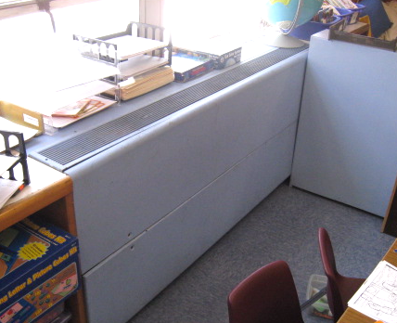

Vintage Univent Circa 1960’s

Picture 2

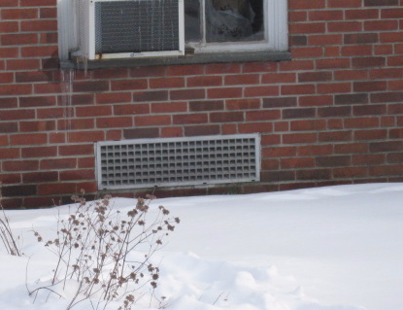

Univent Fresh Air Intake

Picture 3

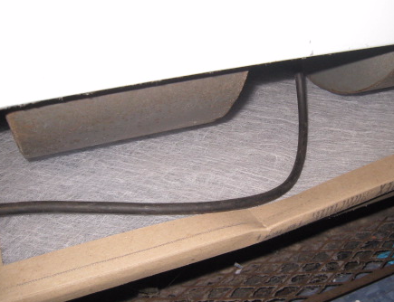

Fibrous Mesh Filter in Classroom Univent

Picture 4

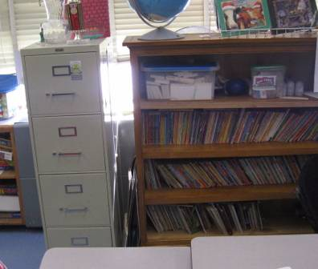

Classroom Univent, Note Return Vent (Front Bottom) Obstructed by Furniture/Items

Picture 5

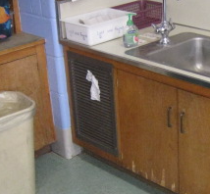

Classroom Exhaust Vent in Sink Cabinet, Note Tissue Indicating Draw of Air

Picture 6

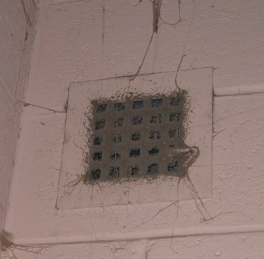

Classroom Closet Exhaust Vent, Note Accumulated Dust/Debris

Picture 7

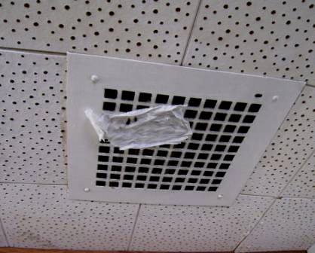

Ceiling Exhaust Vent in Main Office, Note Tissue Indicating Draw of Air

Picture 8

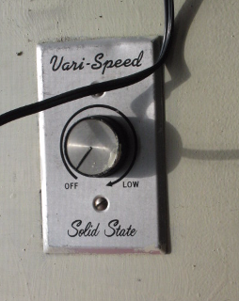

Wall Switch Used to Activate Exhaust Vent in Main Office

Picture 9

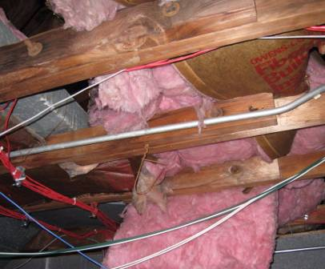

Dislodged/Damaged/Hanging Fiberglass Insulation above Ceiling in Main Hallway

Picture 10

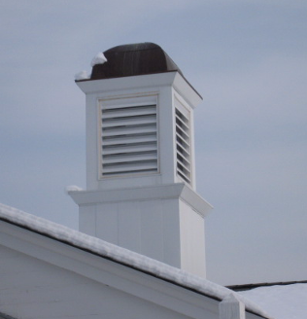

Centrally Located Cupola

Picture 11

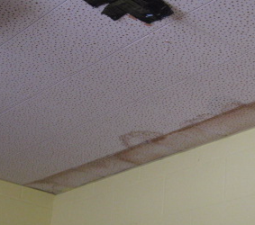

Water Damaged “Interlocking” Ceiling Tiles in PT/OT Room

Picture 12

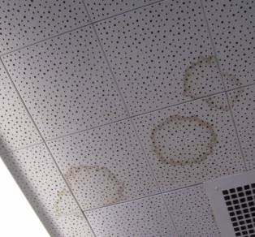

Water Damaged “Interlocking” Ceiling Tiles in Main Office

Picture 13

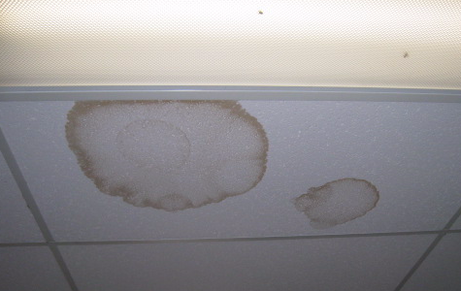

Water Damaged “Drop” Ceiling Tiles in Main Hallway

Picture 14

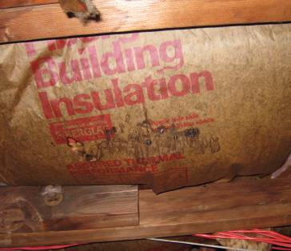

Dark Staining Indicating Possible Mold Growth on Insulation Paper Backing in Main Hallway near Entrance

Picture 15

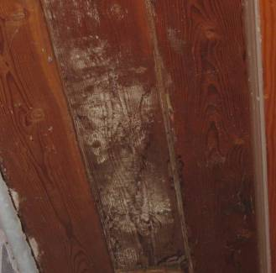

White Material (Possible Mold Growth) on Ceiling of Coat Closet

Picture 16

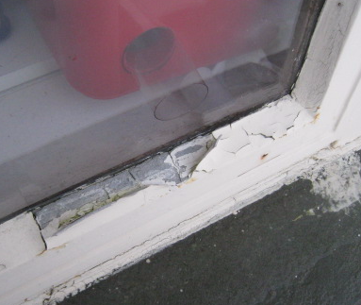

Missing/Damaged Exterior Window Caulking around Original Single-Paned Windows

Picture 17

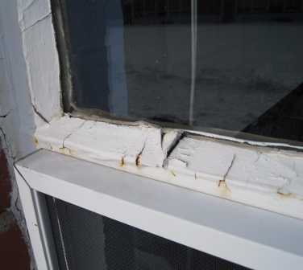

Missing/Damaged Exterior Window Caulking around Original Single-Paned Windows

Picture 18



Severely Water Damaged/Mold Colonized Wooden Windowsill
and Broken Window in Music Office

Picture 19

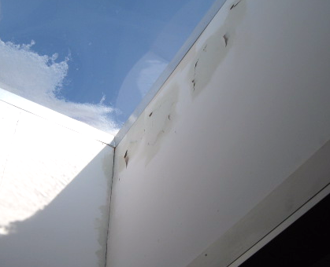

Peeling Paint Staining below Skylight in Main Hallway

Picture 20

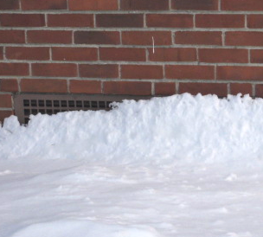

Snow Drifts Partially Covering Fresh Air Intake

Picture 21

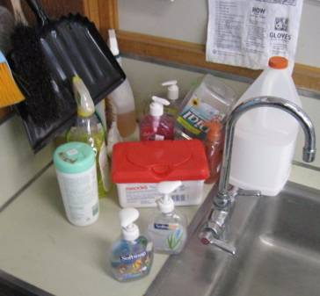

Spray Cleaning Products on Sink Countertop in Classroom

Picture 22

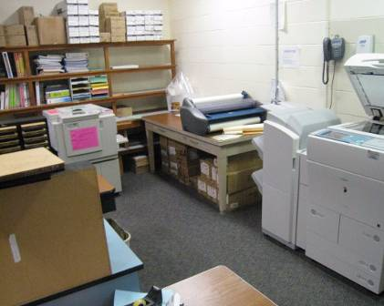

Photo Copiers and Lamination Machine in Unvented Teacher’s Workroom

Picture 23

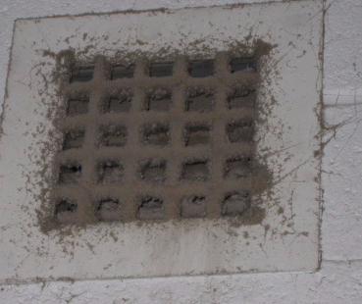

Classroom Closet Exhaust Vent, Note Accumulated Dust/Debris

Picture 24

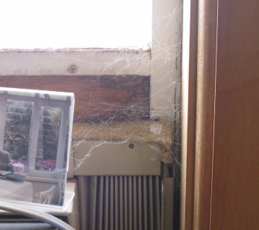

Cobwebs near AC in Main Office

Picture 25

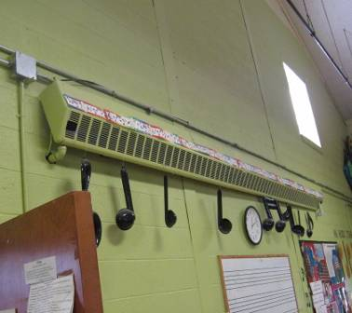

Accumulated Dirt, Dust/Debris in/around Wall-Mounted Radiator in Music Office

Picture 26

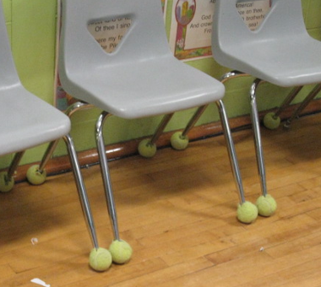

Tennis Balls on Chair Legs
Location/ Room | Occupants  in Room | Temp  (°F) | Relative  Humidity  (%) | Carbon  Dioxide  (ppm) | Carbon Monoxide  (ppm) | PM2.5  (µg/m3) | Windows  Openable | Ventilation |  | Remarks
 |  |  |  |  |  |  |  | Supply | Exhaust
background | N/A | <32 |  |  | ND
Main Office 10:40 am | 3 | 71 | 21 | 663 | ND | 25 | Y | N | Y | Plants, 6 WD CT, AP, CF, PC, DO, exhaust off-deactivated by wall switch, low (normal) moisture measurements: CT
Main Hallway |  |  |  |  |  |  |  |  |  | WD CT-dark staining-possible mold growth on insulation paper above CT, WD/peeling paint around skylight, low (normal) moisture measurements: CT, insulation, skylight
20 | 22 | 70 | 23 | 746 | ND | 26 | Y | Y | Y | DO, 3 CT
21 | 23 | 70 | 24 | 793 | ND | 28 | Y | Y | Y
18 | 20 | 71 | 23 | 808 | ND | 27 | Y | Y | Y | TB, PF, plants
19 | 21 | 72 | 22 | 837 | ND | 26 | Y | Y | Y | 6 CT, AC-dusty filter, items blocking UV return vent
16 | 20 | 71 | 23 | 777 | ND | 25 | Y | Y | Y | TB, items blocking UV return vent
17 | 3 | 73 | 26 | 659 | ND | 30 | Y | Y | Y | 15 occupants gone 35 mins, DO 14 WD CT
14 | 19 | 74 | 20 | 636 | ND | 28 | Y | Y | Y | TB, 13 WD CT
15 | 1 | 73 | 21 | 590 | ND | 27 | Y | Y | Y | 12 occupants gone 50 mins, 10 WD CT, UV-off due to excessive heat
PT/OT | 0 | 68 | 22 | 672 | ND | 24 | Y | N | N | 15 WD CT
Cafeteria | 125 | 70 | 23 | 669 | ND | 25 | Y | Y | Y | AHU-wall
Music Office | 1 | 72 | 22 | 601 | ND | 25 | Y | N | N | WD wooden windowsill, elevated moisture measurements: wood, recommend removal, broken window, dust accumulation-radiator
Library | 20 | 70 | 21 | 580 | ND | 24 | Y | Y | Y | Plants, 8 WD CT, AC
29 Resource Room | 2 | 71 | 21 | 588 | ND | 24 | Y | N | Y | AC, PF
Main Office 12:15 pm | 1 | 70 | 21 | 629 | ND | 24 | Y | N | Y | Dust/cobwebs-exterior wall around AC-filter, AP
10 Teacher Work Room | 0 | 71 | 24 | 762 | ND | 29 | N | N | N | Laminator, PCs, DO
Nurse | 5 | 69 | 20 | 618 | ND | 28 | Y | Y | N | DO, AC
Gym | 20 | 69 | 21 | 533 | ND | 32 | Y | Y | Y | Gym activity-obstacle course, exhaust off
9 | 20 | 69 | 33 | 1076 | ND | 24 | Y | Y | Y | TB, exhaust off
7 | 20 | 70 | 31 | 1406 | ND | 29 | Y | Y | Y | UV and exhaust-deactivated, TB
5 | 18 | 70 | 27 | 1005 | ND | 31 | Y | Y | Y | UV and exhaust-deactivated, TB, DO, UV return vent obstructed by furniture, plants
3 | 22 | 74 | 20 | 1075 | ND | 26 | Y | Y | Y | UV and exhaust-deactivated (UV-reactivated by occupant with pen), TB, AC
1 | 24 | 73 | 23 | 820 | ND | 25 | Y | Y | Y | Exhaust off, TB, WD CT
2 | 19 | 74 | 24 | 888 | ND | 26 | Y | Y | Y | Exhaust off, TB, AC, PF
4 | 22 | 71 | 25 | 851 | ND | 27 | Y | Y | Y | Exhaust off, TB, DO
6 | 19 | 69 | 25 | 803 | ND | 27 | Y | Y | Y | Exhaust off, TB, DO
8 | 15 | 69 | 27 | 744 | ND | 27 | Y | Y | Y | Exhaust off, TB, DO, 10 + WD CT
11 LC/PT/OT Office | 1 | 69 | 26 | 755 | ND | 28 | Y | N | N
22 | 2 | 69 | 27 | 714 | ND | 23 | Y | N | Y

