INDOOR AIR QUALITY ASSESSMENT

Early Childhood Center
100 Walnut Street
Newtonville, Massachusetts

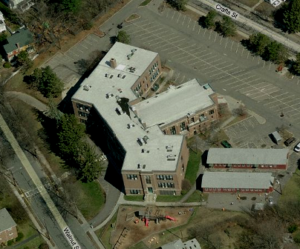

Prepared by:
Massachusetts Department of Public Health
Bureau of Environmental Health
Indoor Air Quality Program
July 2012

Background/Introduction
At the request of the Newton Parent Teacher’s Organization and the Newton Teacher’s Association, the Massachusetts Department of Public Health (MDPH), Bureau of Environmental Health (BEH) provided assistance and consultation regarding indoor air quality (IAQ) issues at the Newton Early Childhood Center (ECC) located at 100 Walnut Street, Newtonville, Massachusetts. On May 30, 2012, a visit was made to this building by Cory Holmes, Environmental Analyst/Inspector for BEH’s IAQ Program to conduct an IAQ assessment. The request was prompted by concerns of water damage, mold and moisture issues.
The building was originally constructed as a three-story red brick middle school in the early 1930s. The ECC has reportedly been in the building for 25 to 30 years, and occupies the lower level, which is below grade in some areas. Newton Public School Central Administration occupies the upper floors. Windows are openable throughout the building.

Methods
Air tests for carbon monoxide, carbon dioxide, temperature and relative humidity were conducted with the TSI, Q-Trak, IAQ Monitor, Model 7525. Air tests for airborne particle matter with a diameter less than 2.5 micrometers were taken with the TSI, DUSTTRAK™ Aerosol Monitor Model 8520. BEH staff also performed visual inspection of building materials for water damage and/or microbial growth.

Results
The tests were taken during normal operations. Test results appear in Table 1.

Discussion

Ventilation
It can be seen from Table 1 that carbon dioxide levels were above 800 parts per million (ppm) in 9 of 13 areas, indicating poor air exchange in the majority of areas surveyed at the time of assessment. It is important to note that windows were shut and mechanical ventilation components were deactivated in a number of areas during the assessment. Without sufficient mechanical supply and exhaust ventilation, environmental pollutants can build up, which can lead to indoor air quality/comfort complaints.
Fresh air is supplied to ECC areas by unit ventilator (univent) systems and/or air handling units (AHUs) (Pictures 1 though 6). A univent is designed to draw air from outdoors through a fresh air intake located on the exterior wall of the building (Picture 4) and return air through an air intake located at the base of each unit (Figure 1). Fresh and return air are mixed, filtered, heated and provided to classrooms through a fresh air diffuser located in the top of the unit. As previously mentioned, univents and AHUs were found deactivated in a number of areas; therefore mechanical means of air exchange was limited at the time of assessment. The back office near the kitchen was reported to have up to 6 occupants at times, and has no means of mechanical ventilation.
The Massachusetts Building Code requires a minimum ventilation rate of 20 cubic feet per minute (cfm) per occupant of fresh outside air or must have openable windows in each room (SBBRS, 1997). The ventilation must be on at all times that the rooms are occupied. Providing adequate fresh air ventilation with open windows and maintaining the temperature in the comfort range during the cold weather season is impractical. Mechanical ventilation is usually required to provide adequate fresh air ventilation.
Carbon dioxide is not a problem in and of itself. It is used as an indicator of the adequacy of the fresh air ventilation. As carbon dioxide levels rise, it indicates that the ventilating system is malfunctioning or the design occupancy of the room is being exceeded. When this happens, a buildup of common indoor air pollutants can occur, leading to discomfort or health complaints. The Occupational Safety and Health Administration (OSHA) standard for carbon dioxide is 5,000 parts per million parts of air (ppm). Workers may be exposed to this level for 40 hours/week, based on a time-weighted average (OSHA, 1997).
The MDPH uses a guideline of 800 ppm for publicly occupied buildings. A guideline of 600 ppm or less is preferred in schools due to the fact that the majority of occupants are young and considered to be a more sensitive population in the evaluation of environmental health status. Inadequate ventilation and/or elevated temperatures are major causes of complaints such as respiratory, eye, nose and throat irritation, lethargy and headaches. For more information concerning carbon dioxide, consult Appendix A.
Temperature readings in the ECC ranged from 71°F to 76°F, which were within the MDPH recommended range at the time of assessment (Table 1). The MDPH recommends that indoor air temperatures be maintained in a range of 70°F to 78°F in order to provide for the comfort of building occupants. In many cases concerning indoor air quality, fluctuations of temperature in occupied spaces are typically experienced, even in a building with an adequate fresh air supply. In addition, it is difficult to control temperature and maintain comfort without operating the ventilation equipment as designed (e.g., univents/AHUs and exhaust vents deactivated).
The relative humidity measured in the ECC ranged from 64 to 77 percent at the time of assessment (Table 1), which was above the MDPH recommended comfort range and reflective of outside conditions (85 percent humidity). The MDPH recommends a comfort range of 40 to 60 percent for indoor air relative humidity. While temperature is mainly a comfort issue, relative humidity in excess of 70 percent for extended periods of time can provide an environment for mold and fungal growth (ASHRAE, 1989). It is difficult to obtain optimal relative humidity levels without a mechanical means to remove moisture from the air (e.g., dehumidifiers or air conditioning). In addition, without operating the mechanical ventilation and air-conditioning (AC) systems as designed (i.e., during occupied periods), air becomes stagnant leading to increased relative humidity and condensation issues, which is explained in further detail in the Microbial/Moisture Concerns section of this report.
Relative humidity levels in the building would be expected to drop during the winter months due to heating. The sensation of dryness and irritation is common in a low relative humidity environment. Low relative humidity is a very common problem during the heating season in the northeast part of the United States.

Microbial/Moisture Concerns
Building occupants reported chronic moisture issues in below-grade areas and specifically reported mold growth on classroom items. Below-grade areas are often subjected to chronic dampness, therefore it is important to take measures to reduce relative humidity (e.g., dehumidification or AC) to prevent condensation. It is also important to limit the presence of materials that can grow mold (e.g., porous building materials and/or stored materials). At the time of assessment, no mold growth was observed on classroom items. However, old worn carpeting was observed in the Occupational Therapy (OT) clinic. Carpeting is generally not recommended in below-grade areas. Also noted in the OT clinic was rust and water damage around the window (Picture 7), which appears to be the result of chronic water penetration.
Other potential sources of mold growth were identified including an area where a number of porous items were stored in an unconditioned space at the bottom of an exterior stairwell (Picture 8), and exercise mats and large cushions/pillows on the basement floor (Picture 9). Pillows/cushions are covered with fabric that comes in contact with human skin. This type of contact can leave oils, perspiration, hair and skin cells. Dust mites feed upon human skin cells and excrete waste products that contain allergens. In addition, if relative humidity levels increase above 60 percent, dust mites tend to proliferate (US EPA, 1992). In order to remove dust mites and other pollutants, frequent vacuuming/cleaning is recommended (Berry, M.A., 1994). It is also recommended these items (if present in schools), be professionally cleaned on an annual basis. If an excessive dusty environment exists due outdoor conditions or indoor activities (e.g., renovations), cleaning frequency should be increased (every six months) (IICRC, 2000). These large surface items, if located on the floor, can also trap moisture and lead to condensation and mold growth.
The US EPA and the American Conference of Governmental Industrial Hygienists (ACGIH) recommend that porous materials be dried with fans and heating within 24 to 48 hours of becoming wet (US EPA, 2001; ACGIH, 1989). If not dried within this time frame, mold growth may occur. Once mold has colonized porous materials, they are difficult to clean and should be removed/discarded. Visible mold growth was observed in portable refrigerators. Upon opening refrigerators, BEH staff found refrigerator door gaskets to be colonized with mold (Pictures 10 through 12). The refrigerators appeared not to have been cleaned for some time.
BEH staff examined the building to identify breaches in the building envelope that could provide a source of water penetration. Several potential sources were identified:
- Damaged/flaking masonry (Picture 13);
- Open utility holes (Picture 14);
- Moss growth was noted in several areas along exterior brickwork (Picture 15). A substantial source of water is needed for moss to grow. Moss growth is a sign of heavy/continuous water exposure which can threaten the structural integrity of the building;
- Missing/damaged mortar around brickwork (Pictures 15 and 16); and
- Drains at the bottom of exterior stairwells (Picture 17). Although the drains were not clogged at the time of assessment, this design provides limited drainage and makes them tend towards blockage.
The aforementioned conditions represent potential water penetration sources. Over time, these conditions can undermine the integrity of the building envelope and provide a means of water entry into the building via capillary action through exterior walls, foundation concrete and masonry (Lstiburek & Brennan, 2001). The freezing and thawing action of water during the winter months can create cracks and fissures in the foundation. In addition, they can serve as pathways for insects, rodents and other pests into the building.

Other IAQ Evaluations
Indoor air quality can be negatively influenced by the presence of respiratory irritants, such as products of combustion. The process of combustion produces a number of pollutants. Common combustion emissions include carbon monoxide, carbon dioxide, water vapor, and smoke (fine airborne particle material). Of these materials, exposure to carbon monoxide and particulate matter with a diameter of 2.5 micrometers (μm) or less (PM2.5) can produce immediate, acute health effects upon exposure. To determine whether combustion products were present in the indoor environment, BEH staff obtained measurements for carbon monoxide and PM2.5.

Carbon Monoxide
Carbon monoxide is a by-product of incomplete combustion of organic matter (e.g., gasoline, wood and tobacco). Exposure to carbon monoxide can produce immediate and acute health affects. Several air quality standards have been established to address carbon monoxide and prevent symptoms from exposure to these substances. The MDPH established a corrective action level concerning carbon monoxide in ice skating rinks that use fossil-fueled ice resurfacing equipment. If an operator of an indoor ice rink measures a carbon monoxide level over 30 ppm, taken 20 minutes after resurfacing within a rink, that operator must take actions to reduce carbon monoxide levels (MDPH, 1997).
The American Society of Heating Refrigeration and Air-Conditioning Engineers (ASHRAE) has adopted the National Ambient Air Quality Standards (NAAQS) as one set of criteria for assessing indoor air quality and monitoring of fresh air introduced by HVAC systems (ASHRAE, 1989). The NAAQS are standards established by the US EPA to protect the public health from six criteria pollutants, including carbon monoxide and particulate matter (US EPA, 2006). As recommended by ASHRAE, pollutant levels of fresh air introduced to a building should not exceed the NAAQS levels (ASHRAE, 1989). The NAAQS were adopted by reference in the Building Officials & Code Administrators (BOCA) National Mechanical Code of 1993 (BOCA, 1993), which is now an HVAC standard included in the Massachusetts State Building Code (SBBRS, 1997). According to the NAAQS, carbon monoxide levels in outdoor air should not exceed 9 ppm in an eight-hour average (US EPA, 2006).
Carbon monoxide should not be present in a typical, indoor environment. If it is present, indoor carbon monoxide levels should be less than or equal to outdoor levels. On the day of assessment, outdoor carbon monoxide concentrations were non-detect (ND) (Table 1). No measurable levels of carbon monoxide were detected in the building during the assessment (Table 1).

Particulate Matter
The US EPA has established NAAQS limits for exposure to particulate matter. Particulate matter is airborne solids that can be irritating to the eyes, nose and throat. The NAAQS originally established exposure limits to particulate matter with a diameter of 10 μm or less (PM10). According to the NAAQS, PM10 levels should not exceed 150 micrograms per cubic meter (μg/m³) in a 24-hour average (US EPA, 2006). These standards were adopted by both ASHRAE and BOCA. Since the issuance of the ASHRAE standard and BOCA Code, US EPA established a more protective standard for fine airborne particles. This more stringent PM2.5 standard requires outdoor air particle levels be maintained below 35 μg/m³ over a 24-hour average (US EPA, 2006). Although both the ASHRAE standard and BOCA Code adopted the PM10 standard for evaluating air quality, MDPH uses the more protective PM2.5 standard for evaluating airborne particulate matter concentrations in the indoor environment.
Outdoor PM2.5 was measured at 31 μg/m³ (Table 1), which was below but close to the NAAQS PM2.5 level of 35 μg/m³ possibly due to elevated pollen counts. PM2.5 levels measured indoors ranged from 21 to 30 μg/m³ (Table 1), which were below the NAAQS PM2.5 level of 35 μg/m³. Frequently, indoor air levels of particulates (including PM2.5) can be at higher levels than those measured outdoors. A number of mechanical devices and/or activities that occur in buildings can generate particulate during normal operations. Sources of indoor airborne particulates may include but are not limited to particles generated during the operation of fan belts in the HVAC system, use of stoves and/or microwave ovens in kitchen areas; use of photocopiers, fax machines and computer printing devices; operation of an ordinary vacuum cleaner and heavy foot traffic indoors.

Other Conditions
Other conditions that can affect indoor air quality were observed during the assessment. In several classrooms, items were observed on windowsills, tabletops, counters, bookcases and desks. The large number of items stored in classrooms provides a source for dusts to accumulate. These items (e.g., papers, folders, boxes) make it difficult for custodial staff to clean. Items should be relocated and/or be cleaned periodically to avoid excessive dust build up. In addition, these materials can accumulate on flat surfaces (e.g., desktops, shelving and carpets) in occupied areas and subsequently be re-aerosolized causing further irritation.
Personal fans, supply diffusers and exhaust vents were observed to have accumulated dust/debris (Pictures 2 and 18). Re-activated diffusers, vents or fans can aerosolize accumulated dust. If exhaust vents are not functioning, backdrafting can occur, which can re-aerosolize dust particles. Accumulated dust and debris was also noted on metal ductwork in the gym (Room 112). This should be cleaned to avoid the debris serving as a source of mold growth should condensation form on the cool metal ductwork.
Finally, a hole was observed in the wall of the gym and open utility holes in walls were seen in a number of areas (Pictures 19 and 20). Breaches in walls and open spaces around pipes/utilities can serve as pathways for dust, dirt, odors and other pollutants to move from the floor/wall cavities into occupied areas.

Conclusions/Recommendations
In view of the findings at the time of the visit, the following recommendations are made to improve general indoor air quality and to reduce the likelihood of future condensation and issues related to excess humidity and mold growth. Also included as Appendix B is MDPH guidance “Preventing Mold Growth in Massachusetts Schools During Hot, Humid Weather” and Appendix C “Guidance Concerning Remediation and Prevention of Mold Growth and Water Damage in Public Schools/Buildings to Maintain Air Quality”. The MDPH has prepared these guidance documents in order to prevent/reduce the occurrence of water damage/mold growth in occupied buildings.
- Operate all ventilation systems (e.g., AHUs, univents and exhaust vents) throughout the building continuously during periods of occupancy. To increase airflow in classrooms, set univent controls to “high”. School staff should be encouraged to not deactivate classroom univents but to report any complaints regarding univent function to the facilities department.
- Ensure classroom exhaust vents are operating at the start of each school day and are allowed to operate during occupancy. Make repairs as needed.
- Install a means to mechanically ventilate the back office near kitchen.
- Consider contacting a ventilation engineer to inspect HVAC equipment and control systems for proper function. Repair or replace components as necessary to ensure adequate air supply and exhaust capability throughout classrooms, offices and common areas.
- Monitor conditions in classrooms as needed to adjust the HVAC system (including portable ACs where used) to avoid elevated relative humidity (>70%) conditions for extended periods of time to prevent condensation and/or mold growth.
- Ensure all portable ACs are equipped with filters. Clean/change filters for ACs per the manufacturer’s instructions or more frequently if needed.
- Supplement the HVAC system in below-grade areas with portable dehumidifiers as needed during humid, spring/summer months. Ensure dehumidifiers are cleaned and maintained as per the manufacturer’s instructions to prevent standing water and mold growth. If a drain/sink is available (e.g., OT clinic), consider installing dehumidifier in a manner to provide continuous drainage, thus avoiding standing water within the units.
- Examine areas prone to condensation/mold growth periodically during spring/summer months and address as needed.
- Reduce the amount of porous materials in below-grade areas (e.g., paper, cardboard, fabric) to reduce the potential for these items to become moistened and grow mold. Consider storing items in plastic totes.
- Porous items should not be stored directly on the floor. All portable classroom furniture (e.g., book cases, file cabinets, shelving) should be moved out from walls approximately 1 to 2 inches to allow airflow to prevent “moisture trapping”.
- Refrain from using the unconditioned space in the stairwell outside of room 114 for storage, particularly of porous items (Picture 8).
- Ensure classroom doors are closed for proper operation of HVAC system/dehumidification equipment and to maintain comfort.
- Ensure window leaks are repaired and reseal as needed. Scrape and clean loose paint/rust/debris from around OT clinic window. Monitor for further leakage and repair as needed.
- Contact a masonry firm or general contractor to repair holes/breaches in exterior walls/joints to prevent water penetration, drafts and pest entry. Remove moss accumulation on masonry and mortar.
- Remove carpeting in OT clinic and replace with non-porous flooring material (e.g., rubber, tile). Carpeting is generally not recommended in below-grade areas.
- For buildings in New England, periods of low relative humidity during the winter are often unavoidable. Therefore, scrupulous cleaning practices should be adopted to minimize common indoor air contaminants whose irritant effects can be enhanced when the relative humidity is low. To control for dusts, a high efficiency particulate arrestance (HEPA) filter equipped vacuum cleaner in conjunction with wet wiping of all surfaces is recommended. Avoid the use of feather dusters. If used store them away from occupied areas. Drinking water during the day can help ease some symptoms associated with a dry environment (throat and sinus irritations).
- Clean and disinfect interior of refrigerators and freezers with mild detergent or antimicrobial agent. Consider replacing mold-contaminated gaskets. Clean spilled food promptly, and clean out the refrigerator of expired items on a regular schedule.
- Take measures to tighten exterior doors (e.g., weather-stripping) to prevent drafts, moisture infiltration and pest/rodent entry. Ensure tightness of doors by monitoring for light penetration and drafts around doorframes.
- Clean dust/debris from ductwork in gym (room 112).
- Clean personal fans, supply air diffusers and exhaust/return vents periodically of accumulated dust.
- Professionally clean large pillows/cushions annually or more frequently as needed.
- Inspect exterior stairwell drains on a regular basis; consider replacing drain caps to provide better drainage.
- Clean air diffusers, exhaust vents and personal fans periodically of accumulated dust. If stained ceiling tiles cannot be cleaned, replace.
- Relocate or consider reducing the amount of materials stored in classrooms to allow for more thorough cleaning of classrooms. Clean items regularly with a wet cloth or sponge to prevent excessive dust build-up.
- Patch hole in gym wall and seal open utility holes in walls with a fire-rated sealant.
- Refer to resource manuals and other related indoor air quality documents for further building-wide evaluations and advice on maintaining public buildings. These materials are located on the MDPH’s website: http://mass.gov/dph/iaq.

References
ACGIH. 1989. Guidelines for the Assessment of Bioaerosols in the Indoor Environment. American Conference of Governmental Industrial Hygienists, Cincinnati, OH.
ASHRAE. 1989. Ventilation for Acceptable Indoor Air Quality. American Society of Heating, Refrigeration and Air Conditioning Engineers. ANSI/ASHRAE 62-1989.
Berry, M.A. 1994. Protecting the Built Environment: Cleaning for Health. Michael A. Berry, Chapel Hill, NC.
BOCA. 1993. The BOCA National Mechanical Code/1993. 8th ed. Building Officials and Code Administrators International, Inc., Country Club Hill, IL.
IICRC. 2000. IICRC S001 Reference Guideline for Professional On-Location Cleaning of Textile Floor Covering Materials Institute of Inspection, Cleaning and Restoration Certification. Institute of Inspection Cleaning and Restoration, Vancouver, WA.
Lstiburek, J. & Brennan, T. 2001. Read This Before You Design, Build or Renovate. Building Science Corporation, Westford, MA. U.S. Department of Housing and Urban Development, Region I, Boston, MA.
MDPH. 1997. Requirements to Maintain Air Quality in Indoor Skating Rinks (State Sanitary Code, Chapter XI). 105 CMR 675.000. Massachusetts Department of Public Health, Boston, MA.
OSHA. 1997. Limits for Air Contaminants. Occupational Safety and Health Administration. Code of Federal Regulations. 29 C.F.R 1910.1000 Table Z-1-A.
SBBRS. 1997. Mechanical Ventilation. State Board of Building Regulations and Standards. Code of Massachusetts Regulations. 780 CMR 1209.0
US EPA. 1992. Indoor Biological Pollutants. US Environmental Protection Agency, Environmental Criteria and Assessment Office, Office of Health and Environmental Assessment, research Triangle Park, NC. EPA 600/8-91/202. January 1992.
US EPA. 2001. Mold Remediation in Schools and Commercial Buildings. US Environmental Protection Agency, Office of Air and Radiation, Indoor Environments Division, Washington, D.C. EPA 402-K-01-001. March 2001.
US EPA. 2006. National Ambient Air Quality Standards (NAAQS). US Environmental Protection Agency, Office of Air Quality Planning and Standards, Washington, DC. http://www.epa.gov/air/criteria.html
Picture 1

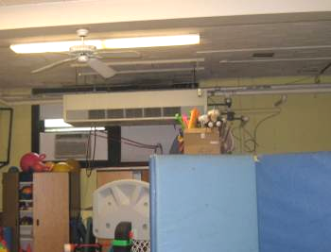

Ceiling-Mounted Univent (arrow)

Picture 2

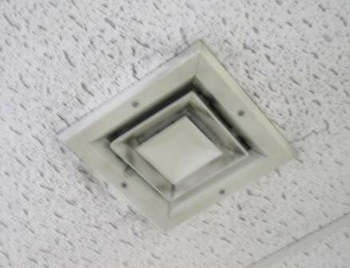

Ceiling-Mounted Supply Diffuser, Note Dust/Debris Accumulation

Picture 3

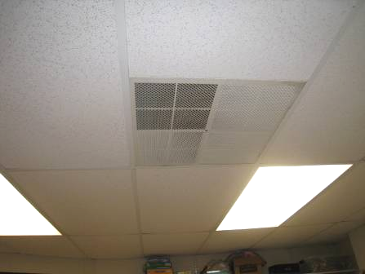

Ceiling-Mounted Vent

Picture 4

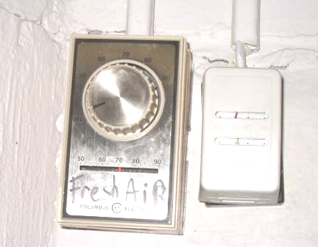

Control for HVAC System in Room 107, Note System in “Off” Position

Picture 5

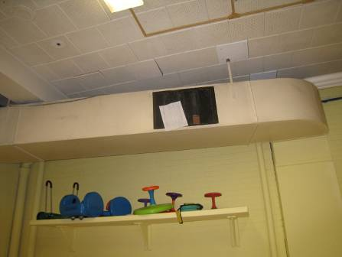

Exhaust Vent/Duct in Gym

Picture 6

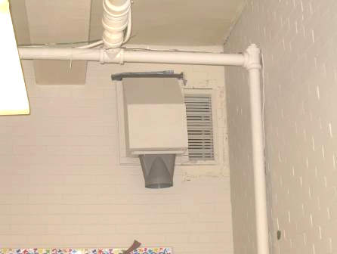

Wall-Mounted Exhaust Vent

Picture 7

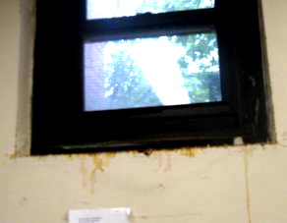

Rust and Water Damage around Window in OT Clinic, Note Dripping/Staining on Wall

Picture 8

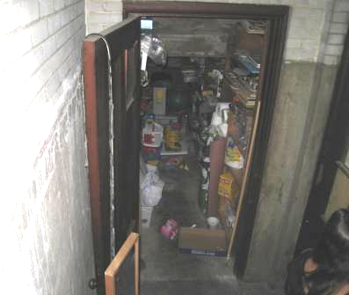

Porous Materials Stored in an Unconditioned Space/Exterior Stairwell

Picture 9

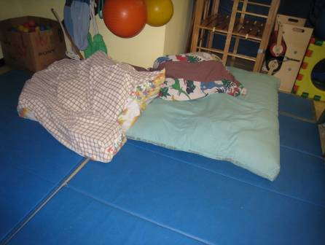

Exercise Mats and Large Cushions/Pillows on Floor

Picture 10

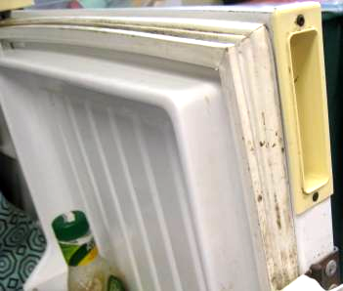

Refrigerator Gasket Colonized with Mold (Dark Staining)

Picture 11

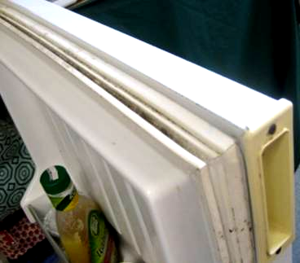

Refrigerator Gasket Colonized with Mold (Dark Staining)

Picture 12

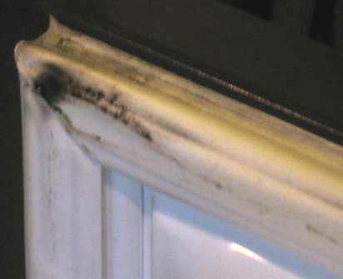

Refrigerator Gasket Colonized with Mold (Dark Staining)

Picture 13

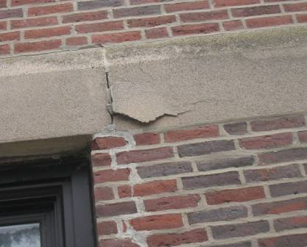

Damaged/Flaking Masonry

Picture 14

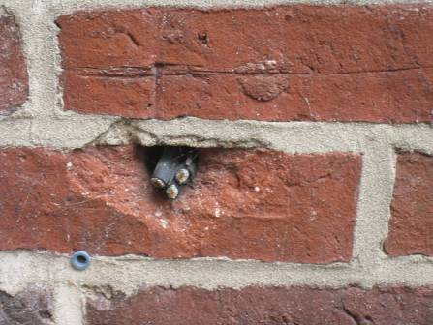

Open Utility Hole

Picture 15

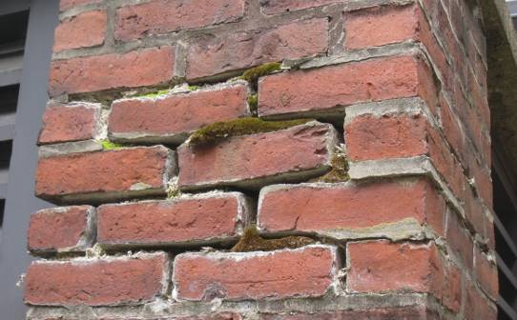

Moss Growth, Missing/Damaged Mortar around Brickwork

Picture 16

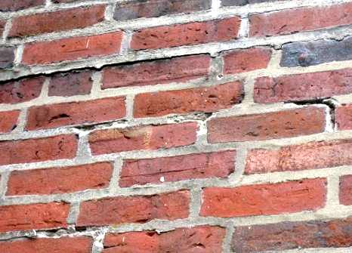

Missing/Damaged Mortar around Brickwork

Picture 17

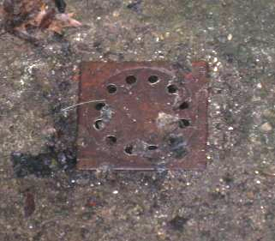

Drain at bottom of Exterior Stairwell

Picture 18

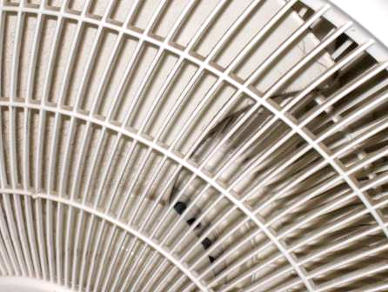

Dust/Debris Accumulation on Personal Fan

Picture 19

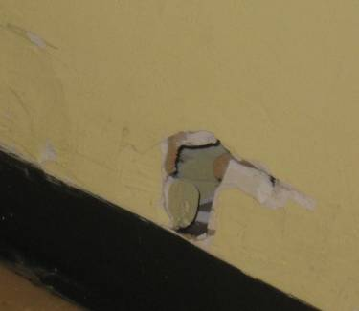

Hole in Gym Wall

Picture 20

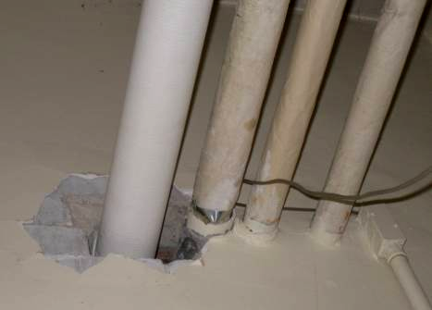

Open Hole in Wall around Utility Pipes
Location | Carbon  Dioxide  (ppm) | Carbon Monoxide  (ppm) | Temp  (°F) | Relative  Humidity  (%) | PM2.5  (µg/m³) | Occupants  in Room | Windows  Openable | Ventilation |  | Remarks
 |  |  |  |  |  |  |  | Supply | Exhaust | Remarks
Background | 348 | ND | 70 | 85 | 31 |  |  |  |  | Warm, humid, overcast, elevated pollen count
107 | 945 | ND | 74 | 77 | 30 | 10 | Y | Y | Y | Mechanical ventilation-off, AC-off, mold on refrigerator gasket, dust/debris on vents, accumulated items
112 Gym | 752 | ND | 72 | 77 | 28 | 0 | Y | Y | Y | Dust/debris on ductwork, UV-off, CF, hole in wall near floor
113 A | 1178 | ND | 71 | 70 | 21 | 2 | N | Y | Y
113 B | 1140 | ND | 71 | 67 | 23 | 0 | N | Y  Passive door vent | Y | PF-dusty, passive door vent partially obstructed
114 | 1101 | ND | 71 | 67 | 23 | 17 | Y | Y | Y | AC-no filter, area carpet
115 | 832 | ND | 73 | 71 | 25 | 1 | N | Y | N | Shares UV with rm 116
116 | 1009 | ND | 73 | 68 | 22 | 0 | Y | Y | Y | AC
117 Nurse | 803 | ND | 71 | 64 | 23 | 1 | Y | N | N | Peeling paint
125 Office | 656 | ND | 72 | 71 | 26 | 0 | N | N | N | Window to hallway, wall holes, fiberglass insulation
Psychologist Office | 875 | ND | 71 | 64 | 24 | 1 | N | Y | N | Occasional odors from sink/pump-not properly vented (on work order)
Storage Room |  |  |  |  |  |  |  |  |  | In unconditioned hallway/stairwell, storage of porous items-musty odors
Occupational Therapy Clinic | 758 | ND | 72 | 76 | 26 | 1 | Y | N | N | Wall-to-wall carpeting, rust/WD around window frame, dehumidifier, large cushion/pillows, WD CT (near outside vent)
Kitchen | 799 | ND | 75 | 68 | 28 | 0 | Y | N | N
Back Office | 817 | ND | 76 | 67 | 24 | 1 | N | N | N | 1 WD CT (up to 6 people occupy), recommend mech ventilation

