Background

INDOOR AIR QUALITY
PRE-OCCUPANCY ASSESSMENT

Department of Early Education and Care
Southeast and Cape Regional Office
100 Myles Standish Boulevard
Taunton, Massachusetts

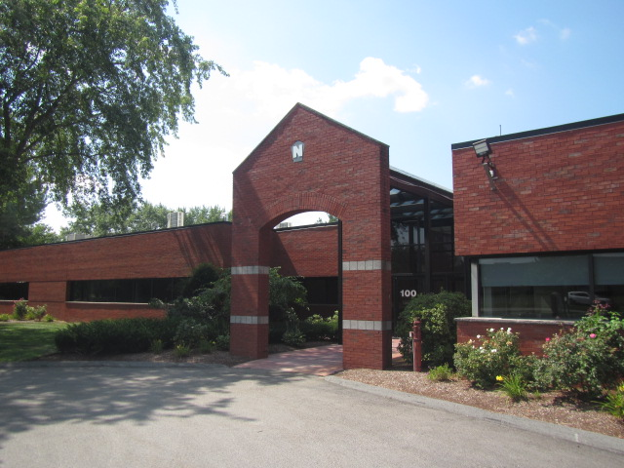

Prepared by:
Massachusetts Department of Public Health
Bureau of Environmental Health
Indoor Air Quality Program
October 2021
Building: | Department of Early Education and Care (EEC)  Southeast and Cape Regional Office
Address: | 100 Myles Standish Boulevard  Taunton, Massachusetts
DCAMM Project Manager: | Paul J. Burke
Date of Pre-Occupancy Assessment: | August 26, 2021
BEH/IAQ Staff Conducting Assessment: | Cory Holmes, Assistant Director, Indoor Air Quality (IAQ) Program
Date of Building Construction: | 1987
Proposed Use of Building:
The space assessed is to be used as the EEC southeast and cape regional office. At the time of the assessment, it had undergone complete renovations, including interior walls/paint, dropped ceiling tile systems, floors (carpet squares and vinyl tile), appliances and heating, ventilating and air conditioning (HVAC) system. The new HVAC system consists of rooftop air handling units (AHUs), which draw air from intakes on the roof into a direct-ducted supply system. Windows are not openable within the space.
Prior Use of Building:
The building was originally constructed as commercial office space.
Surrounding Businesses/Activities:
Industrial Park Setting (e.g., office buildings, manufacturing).
Previous Relevant Environmental History:
No current/active or historic Massachusetts Contingency Plan (MCP) projects for this building were found in the Massachusetts Department of Environmental Protection (MDEP) database.

Methods
Air tests for carbon monoxide, temperature and relative humidity were taken with the TSI, Q-Trak, IAQ Monitor 7565. Air tests for airborne particle matter with a diameter less than 2.5 micrometers were taken with the TSI, DUSTTRAK™ Aerosol Monitor Model 8520. Screening for volatile organic compounds (VOCs) was conducted using a MiniRAE Lite Photo Ionization Detector (PID). BEH/IAQ staff also performed visual inspection of building materials for water damage and/or microbial growth and examined the space for the presence of odors or other environmental concerns.
Note that at the time of the assessment, some limited activities such as painting, finish work, clean-up and other tasks were in their final stages. The HVAC system was operational and activated in areas assessed. The building was unoccupied on the day of the assessment.
Air Testing Results
Media sampled |  | MDPH Guideline/  Comparison Value |  | Measured Range |  |  | Comments
 |  |  |  | Outdoors/  Background |  | Indoors
Total Volatile Organic Compounds (TVOCs) |  | Equal to or below background level measured on the day of the assessment |  | ND |  | ND
Carbon Monoxide (CO) |  | Non-detectable (ND) or equal to or below background level measured on the day of the  assessment |  | ND |  | ND | HVAC system activated at time of the assessment
Particulate Matter 2.5 (PM2.5) |  | US EPA National Ambient Air Quality Standards (NAAQS) 35 μg/m³ or less |  | 55 μg/m³ |  | 15 to 22 μg/m³ | Indoor PM2.5 levels were below the NAAQS of 35 μg/m³, vehicle traffic/idling outdoors
Temperature |  | 70 to 78ºF |  | 96 ºF |  | 74 to 75 ºF | Temps within MDPH guidelines
Relative Humidity (RH) |  | 40% to 60% |  | 65 |  | 43 to 61 | RH within or very close to MDPH guidelines
ppm = parts per million | µg/m³ = microgram per cubic meter |  | ND = non-detectable |  | HVAC = heating, ventilation and air-conditioning

Discussion/Visual Observations
As mentioned, build-out was mostly complete with minor punch-list items (outlets/some wiring/ceiling tile installation, etc.) remaining. No evidence of water leaks or moisture to building materials was noted during the assessment. However, several minor issues were observed and are listed below:
- Spaces were noted between sink countertop and backsplash in room 117
- Spaces were noted between sink countertop and backsplash in room 115

Recommendations
In view of the findings at the time of the visit, the following recommendations are made:
- Seal spaces between backsplash and sink countertops in rooms 115 and 117.
- Perform a final, thorough cleaning of the space using wet wiping of all surfaces and high efficiency particulate arrestance (HEPA) vacuuming of all carpeting prior to agency staff moving into the space.
- During occupied hours the MDPH recommends that thermostats be set to the fan “On” setting, not “Auto”, throughout the space to provide for continuous filtration and ventilation.
- Consistent with previously established protocol, once the space has been occupied for a minimum of three weeks, contact the BEH/IAQ Program to conduct a follow-up assessment of the space.

