INDOOR AIR QUALITY ASSESSMENT

Early Learning Center
25 School Street
North Attleborough, Massachusetts

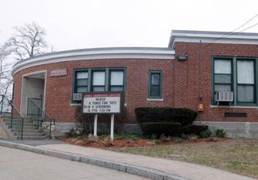

Prepared by:
Massachusetts Department of Public Health
Bureau of Environmental Health
Indoor Air Quality Program
September 2021

BACKGROUND
Building: | Early Learning Center (ELC)
Address: | 25 School Street, North Attleborough, MA
Assessment Requested by: | North Attleborough Public Schools (NAPS)
Reason for Request: | Collaborative effort to perform general indoor air quality (IAQ) assessments throughout the NAPS
Date of Assessment: | August 20, 2021
Massachusetts Department of Public Health/Bureau of Environmental Health (MDPH/BEH) Staff Conducting Assessment: | Cory Holmes, Assistant Director, IAQ Program
Building Description: | The ELC is a one-story red brick building constructed in 1955. A modular wing was added in 2019. It appears that the majority of building materials (e.g., floor tiles, heating and ventilation components, ceiling tiles) are original.
Windows: | Openable

Although the majority of building components are original to the building, some building improvements have been made including: replacement of windows; the installation of several heating, ventilation and air conditioning (HVAC) units; and addition of the modular wing. At the time of assessment the building was undergoing a thorough summer break cleaning.

METHODS
MDPH IAQ staff conducted a series of visual assessments, and temperature and relative humidity measurements to identify likely areas that could be prone to condensation in hot, humid weather. Please refer to the IAQ Manual for methods, sampling procedures, and interpretation of results (MDPH, 2015).

RESULTS and DISCUSSION
The following is a summary of testing results (Table 1):
- Temperature was within or very close to the MDPH recommended range of 70°F to 78°F in areas tested. It is important to note that although the ELC is not an air-conditioned building, most areas are equipped with window-mounted units for comfort control.
- Relative Humidity was above the MDPH recommended range of 40 to 60% in some areas on the day of assessment due to outside conditions.

Ventilation
A heating, ventilating, and air conditioning (HVAC) system has several functions. First it provides heating and, if equipped, cooling. Second, it is a source of fresh air. Finally, an HVAC system will dilute and remove normally-occurring indoor environmental pollutants by not only introducing fresh air, but by filtering the airstream and ejecting stale air to the outdoors via exhaust ventilation. Even if an HVAC system is operating as designed, point sources of respiratory irritation may exist and cause symptoms in sensitive individuals.
Fresh air in the majority of classrooms is supplied by 1950’s era unit ventilators (univents, Picture 1). Univents draw air from the outdoors through a fresh air intake located on the exterior wall of the building (Picture 2) and for units at the ELC, return air is drawn through air intakes located on the sides of the unit (Picture 3). Fresh and return air are mixed, filtered, heated or cooled and provided to rooms through an air diffuser located in the top of the unit (Figure 1). Obstructions to airflow, such as bookcases, carts, and desks in front of univent return vents, were seen in a few classrooms (Pictures 4 and 5). In order for univents to provide fresh air as designed, units must remain free of obstructions.
Mechanical exhaust ventilation in classrooms is provided by wall-mounted exhaust vents (Picture 6) and ceiling-mounted closet vents (Picture 7) connected to rooftop motors. The MDPH IAQ Program recommends that supply and exhaust ventilation operate continuously during occupied periods to provide air exchange and filtration. Without sufficient supply and exhaust ventilation, normally occurring environmental pollutants can build-up and lead to indoor air quality/comfort complaints.
It is also important to note that despite ongoing maintenance and replacement of parts/components by NAPS facilities staff, many of the HVAC units are at the end of their life cycle. Efficient function of equipment of this age (> 65 years old) is difficult to maintain, since compatible replacement parts are often unavailable. According to the American Society of Heating, Refrigeration, and Air-Conditioning Engineering (ASHRAE), the service life of this type of unit is 15-20 years, assuming routine maintenance of the equipment (ASHRAE, 1991).
Mechanical ventilation for modular classrooms is provided by air handling units (AHUs) mounted on the rear exterior wall of the building (Picture 8). Fresh air is distributed via ductwork connected to ceiling-mounted air diffusers. Return vents draw air back to the AHUs through wall or ceiling-mounted grilles. Thermostats control each HVAC system and have fan settings of “on” and “automatic”. The automatic setting on the thermostat activates the HVAC system at a preset temperature (Picture 9). Once the preset temperature is reached, the HVAC system is deactivated. Therefore, no mechanical ventilation is provided until the thermostat re-activates the system.
To maximize air exchange, the IAQ program recommends that both supply and exhaust ventilation operate continuously during periods of occupancy. To have proper ventilation with a mechanical ventilation system, the systems must be balanced after installation to provide an adequate amount of fresh air to the interior of a room while removing stale air from the room. It is recommended that HVAC systems be re-balanced every five years to ensure adequate air systems function (SMACNA, 1994).
Mechanical ventilation in classrooms 3, 5 and the OT/PT areas is provided by ceiling-mounted or rooftop AHUs (Pictures 10 and 11). These units were retrofitted over the last several years.

Microbial/Moisture Concerns
As previously mentioned, this visit included a visual inspection for signs of water damage and microbial growth. Water-damaged ceilings/tiles were observed in a number of classrooms, hallways and common areas (Table 1, Picture 12), which can indicate current/historic roof/plumbing leaks or other water infiltration. Water-damaged ceiling tiles can provide a source of mold and should be replaced after a water leak is discovered and repaired. It is important to note that ceiling tiles in the ELC are of a type that are directly adhered to the ceiling substrate, therefore would necessitate the destruction of the ceiling tile to remove. In addition, replacement tiles are not likely to be available. Ceiling tiles in the modular classrooms and a few other areas are of the suspended type (Picture 13), which can be more easily changed.
A perimeter inspection of the building was conducted to identify any breaches/potential pathways for water intrusion. Overhanging branches (Picture 14) and plant growth against the building were observed (Pictures 2, 14 and 15). Over time, these conditions can undermine the integrity of the building envelope and provide a means of water entry into the building via capillary action through foundation concrete and masonry (Lstiburek & Brennan, 2001). The freezing and thawing action of water during the winter months can create cracks and fissures in the foundation. These breaches may provide a means for moisture and pests to enter the building. In addition, plants growth near fresh air intakes (Picture 2) can draw in pollen, pests and moisture.

Building Materials Prone to Condensation
The key to managing condensation in hot, humid weather indoors is understanding dew point. When warm, moist air passes over a cooler surface, condensation can form. Condensation is the collection of moisture on a surface at or below the dew point. The dew point is the temperature that air must reach for saturation to occur. If a building material/component has a temperature below the dew point, condensation will accumulate on that material. Over time, condensation can collect and form water droplets.
A method to locate areas in a building prone to condensation is to measure air and building material temperatures using a laser thermometer (Table 1). If a wide temperature range exists between measurements (>5°F), the building materials at the colder end of the range may be prone to becoming moistened with condensation if exposed to hot, humid weather (70% relative humidity) for extended periods of time. According to the test results in Table 1, a number of areas of the building would appear to be prone to condensation if exposed to hot, humid weather for extended periods of time.
According to American Society of Heating, Refrigerating and Air-Conditioning Engineers (ASHRAE), if relative humidity exceeds 70% for extended periods of time, mold growth may occur due to wetting of building materials (ASHRAE, 1989). It is recommended that porous material be dried with fans and heating within 24 to 48 hours of becoming wet (US EPA, 2008, ACGIH, 1989). If porous materials are not dried within this time frame, mold growth may occur. Water-damaged porous materials cannot be adequately cleaned to remove mold growth.

Other Issues
Some areas were carpeted. Carpets should be cleaned annually (or semi-annually in soiled/high traffic areas) in accordance with Institute of Inspection, Cleaning and Restoration Certification (IICRC) recommendations, (IICRC, 2012). The service life of carpeting is approximately 10-11 years (IICRC, 2002). Regular cleaning with a high efficiency particulate air (HEPA) filtered vacuum in combination with an annual cleaning will help to reduce accumulation and potential aerosolization of materials from carpeting. Several rooms had area rugs, which should also be vacuumed/cleaned on a regular basis. In addition, area rugs should not be placed on top of other carpeting because it can trap moisture beneath and create conditions where mold could grow.
The MDPH recommends that HVAC equipment be outfitted with filters of a Minimum Efficiency Reporting Value (MERV) of 8 or higher, which are adequate in filtering out pollen and mold spores (ASHRAE, 2012). In addition, filters should be changed 2-4 times a year or in accordance with the manufacturers’ recommendations.
It was reported that to supplement mechanical ventilation and filtration, every classroom is provided with a HEPA-filtered air purifier. It is important to note that filters should be changed and these units be maintained in accordance with the manufacturers’ recommendations. As mentioned previously, many areas had window-mounted air conditioners (Table 1), which also have filters that need to be cleaned regularly.
In an effort to reduce noise from sliding chairs, tennis balls had been sliced open and placed on chair legs (Picture 16). Tennis balls are made of a number of materials that are a source of respiratory irritants. Constant wearing of tennis balls can produce fibers and off-gas TVOCs. Tennis balls are made with a natural rubber latex bladder, which becomes abraded when used as a chair leg pad. Use of tennis balls in this manner may introduce latex dust into the school environment. Some individuals are highly allergic to latex (e.g., spina bifida patients) (SBAA, 2001). It is recommended that the use of materials containing latex be limited in buildings to reduce the likelihood of symptoms in sensitive individuals (NIOSH, 1997).
The Environmental Protection Agency (EPA) conducted a National School Radon Survey in which it discovered nearly one in five schools had “…at least one frequently occupied ground contact room with short-term radon levels above 4 [picocuries per liter] pCi/L” (US EPA, 1993). The BEH/IAQ Program therefore recommends that every school be tested for radon, and that this testing be conducted during the heating season while school is in session in a manner consistent with USEPA radon testing guidelines. Radon measurement specialists and other information can be found at www.nrsb.org and http://aarst-nrpp.com/wp, with additional information at: http://www.mass.gov/eohhs/gov/departments/dph/programs/environmental-health/exposure-topics/iaq/radon.

CONCLUSIONS AND RECOMMENDATIONS
In view of the findings at the time of the visit, the following recommendations are made:

Ventilation Recommendations
- As previously discussed, due to the age (> 65 years old), physical deterioration and availability of parts, the mechanical ventilation system components and controls should be fully evaluated by an HVAC engineering firm to determine the operational lifespan of existing equipment and/or examining the feasibility of repair vs. replacement.
- The U.S. Department of Education has released new guidance encouraging the use of American Rescue Plan (ARP) funds to improve ventilation systems and make other indoor air quality improvements in schools. More information can be found at this link https://www.ed.gov/coronavirus/improving-ventilation.
- Operate all supply and exhaust ventilation equipment continuously during occupied periods. Make repairs as needed.
- Ensure all obstructions are removed from exhaust vents and the top and sides of univents.
- Check exhaust vents for draw periodically and repair any non-operating vents.
- Consider adopting a balancing schedule of every 5 years for all mechanical ventilation systems, as recommended by ventilation industrial standards (SMACNA, 1994).
- Continue to change filters for HVAC equipment 2-4 times a year using the highest MERV rating a building’s ventilation system can accommodate to improve air filtration as much as possible without significantly reducing airflow.
- Use openable windows to supplement fresh air during temperate weather. Ensure all windows are tightly closed at the end of the day.

Water Damage Recommendations
- Ensure roof and plumbing leaks are repaired and replace water-damaged ceiling tiles.
- Remove plants and trees/branches a minimum of 5 feet away from the building.
- Closely monitor parameters such as temperature, relative humidity and dew point over summer months to prevent condensation on floors/surfaces. Refrain from storing porous items, such as cardboard and paper on floor in these areas. If carpeting is present, consider removing from areas that are prone to condensation.
- Do not place area rugs on carpeting.
- Consider using the methods described in the document “Preventing Mold Growth in Massachusetts Schools During Hot, Humid Weather” to help reduce impact of conditions during hot, humid weather. This guideline can be found online at: https://www.mass.gov/service-details/preventing-mold-growth-in-massachusetts-schools-during-hot-humid-weather

Other Recommendations
- Change filters and maintain HEPA units per manufacturers’ recommendations.
- Regularly clean/vacuum supply/exhaust/return vents and personal fans to avoid aerosolizing accumulated particulate matter.
- Clean air conditioner filters prior to the start of the cooling season and on a regular basis while in use.
- Reduce use of products and equipment that create irritating volatile organic compounds (VOCs) and only use in well-ventilated areas. Minimize the use of air fresheners, deodorizers and scented products.
- Keep spray bottles/cleaning products out of the reach of children. Ensure that products are compatible with one another. It is suggested that only school-supplied products be used to avoid product interactions.
- Clean carpeting annually (or semi-annually in soiled high traffic areas) as per the recommendations of the Institute of Inspection, Cleaning and Restoration Certification (IICRC, 2012).
- Consider replacing any carpeting that is beyond its service life (i.e., > 11yrs.).
- Consider discontinuing the use of tennis balls on chair/desk legs to prevent latex dust generation. Alternative “glides” or latex free tennis balls can be purchased.
- For buildings in New England, periods of low relative humidity during the winter are often unavoidable. Therefore, scrupulous cleaning practices should be adopted to minimize common indoor air contaminants whose irritant effects can be enhanced when the relative humidity is low. To control dusts, a high efficiency particulate arrestance (HEPA) filter equipped vacuum cleaner in conjunction with wet wiping of all surfaces is recommended. Avoid the use of feather dusters. Drinking water during the day can help ease some symptoms associated with a dry environment (throat and sinus irritations).
- The school should be tested for radon by a certified radon measurement specialist during the heating season when school is in session. Radon measurement specialists and other information can be found at: www.nrsb.org, and http://aarst-nrpp.com/wp.
- To learn more about radon, review the MDPH’s Radon in Schools and Child Care Programs factsheet, with additional information at: http://www.mass.gov/eohhs/gov/departments/dph/programs/environmental-health/exposure-topics/iaq/radon.
- Consider forming an IAQ committee in each school building district-wide. Committees should have an IAQ liaison/teacher representative, a member of maintenance/facilities and administration that conduct regular walk-throughs to identify on-going and/or potential environmental issues.
- Consider adopting the US EPA (2000) document, “Tools for Schools”, as an instrument for maintaining a good IAQ environment in the building available at: https://www.epa.gov/iaq-schools/indoor-air-quality-tools-schools-action-kit
- Refer to resource manual and other related IAQ documents located on the MDPH’s website for further building-wide evaluations and advice on maintaining public buildings. These documents are available at: http://mass.gov/dph/iaq.

REFERENCES
ACGIH. 1989. Guidelines for the Assessment of Bioaerosols in the Indoor Environment. American Conference of Governmental Industrial Hygienists, Cincinnati, OH.
ASHRAE. 1989. Ventilation for Acceptable Indoor Air Quality. American Society of Heating, Refrigeration and Air Conditioning Engineers. ANSI/ASHRAE 62-1989
ASHRAE. 1991. ASHRAE Applications Handbook, Chapter 33 “Owning and Operating Costs”. American Society of Heating, Refrigeration and Air Conditioning Engineers, Atlanta, GA.
ASHRAE. 2012. American Society of Heating, Refrigeration and Air Conditioning Engineers (ASHRAE) Standard 52.2-2012 – Method of Testing General Ventilation Air-Cleaning Devices for Removal Efficiency by Particle Size (ANSI Approved).
IICRC. 2002. Institute of Inspection, Cleaning and Restoration Certification. A Life-Cycle Cost Analysis for Floor Coverings in School Facilities.
IICRC. 2012. Institute of Inspection, Cleaning and Restoration Certification. Carpet Cleaning: FAQ.
Lstiburek, J. & Brennan, T. 2001. Read This Before You Design, Build or Renovate. Building Science Corporation, Westford, MA. U.S. Department of Housing and Urban Development, Region I, Boston, MA
MDPH. 2015. Massachusetts Department of Public Health. “Indoor Air Quality Manual: Chapters I-III”. Available at: https://www.mass.gov/lists/indoor-air-quality-manual-and-appendices#indoor-air-quality-manual-
NIOSH. 1997. NIOSH Alert Preventing Allergic Reactions to Natural Rubber latex in the Workplace. National Institute for Occupational Safety and Health, Atlanta, GA.
NIOSH. 1998. Latex Allergy A Prevention. National Institute for Occupational Safety and Health, Atlanta, GA.
SMACNA. 1994. HVAC Systems Commissioning Manual. 1st ed. Sheet Metal and Air Conditioning Contractors’ National Association, Inc., Chantilly, VA.
US EPA. 1993. Radon Measurement in Schools, Revised Edition. Office of Air and Radiation, Office of Radiation and Indoor Air, Indoor Environments Division (6609J). EPA 402-R-92-014.
US EPA. 2000. Tools for Schools. Office of Air and Radiation, Office of Radiation and Indoor Air, Indoor Environments Division (6609J). EPA 402-K-95-001, Second Edition. http://www.epa.gov/iaq/schools/index.html.
US EPA. 2008. “Mold Remediation in Schools and Commercial Buildings”. Office of Air and Radiation, Indoor Environments Division, Washington, DC. EPA 402-K-01-001. September 2008. Available at: http://www.epa.gov/mold/mold-remediation-schools-and-commercial-buildings-guide.

Figure 1

Unit Ventilator (Univent)

Mixed Air

Air Diffuser

Outdoors Indoors

Fan

Heating/Cooling Coil

Air Mixing Plenum

Filter

Outdoor Return
Air Air (drawn in through side of unit)

Air
Flow
Control
Louvers

Air Flow

= Fresh Air/Return Air

= Mixed Air

Picture 1

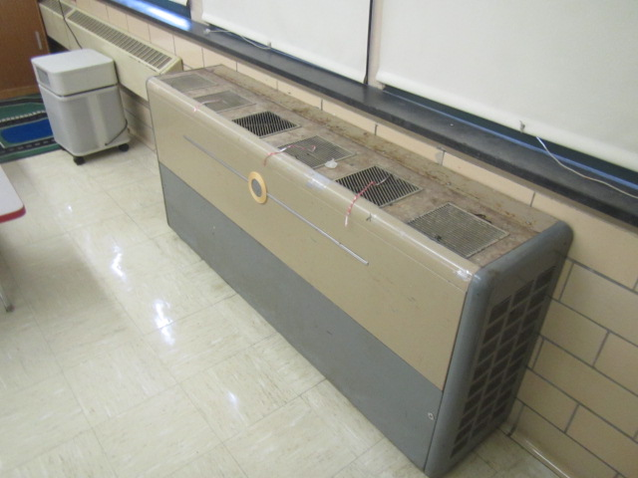
1950’s vintage univent
Picture 2
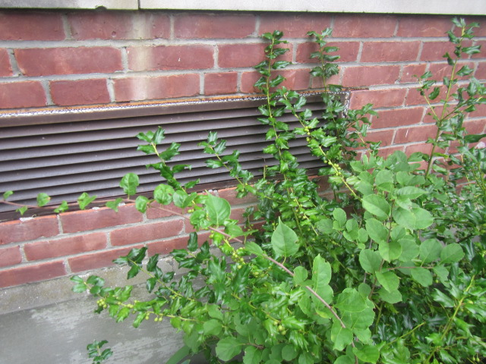
Univent air intake, note plant growth in close proximity
Picture 3
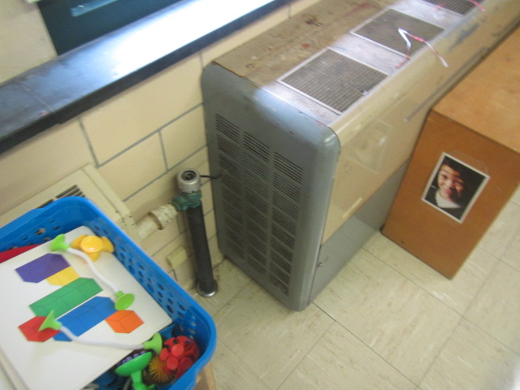
Return vents on sides of univent (arrow indicates airflow)
Picture 4
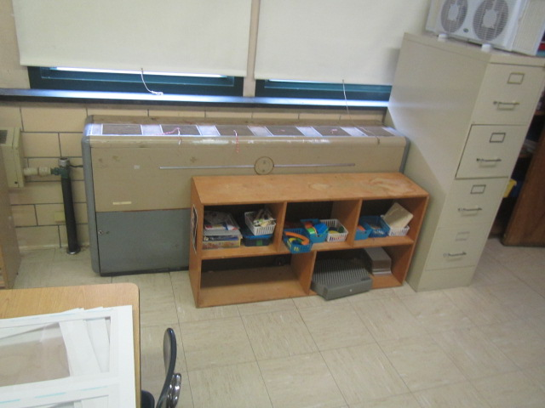
Univent return vent (on sides of unit) obstructed by file cabinet
Picture 5
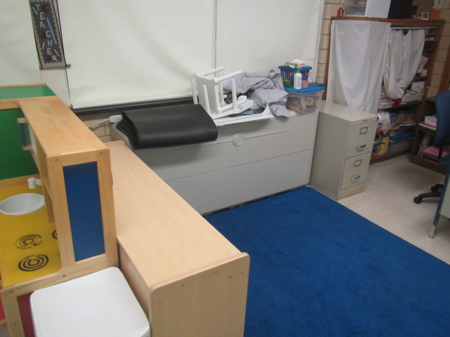
Univent return vent (on sides of unit) obstructed by file cabinet/bookshelf
Picture 6
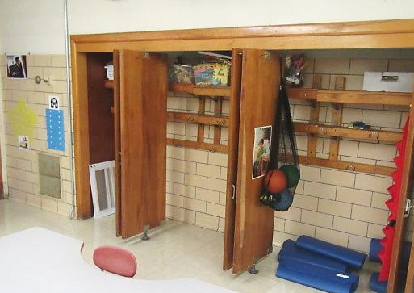
Wall and coat closet exhaust (arrows), note undercut doors to allow airflow when doors are shut
Picture 7
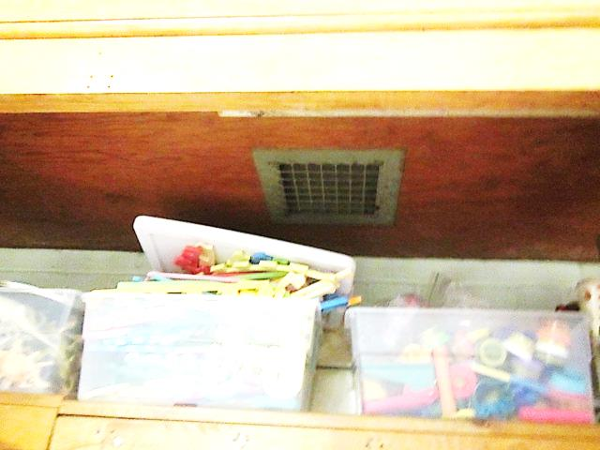
Coat closet exhaust vent
Picture 8
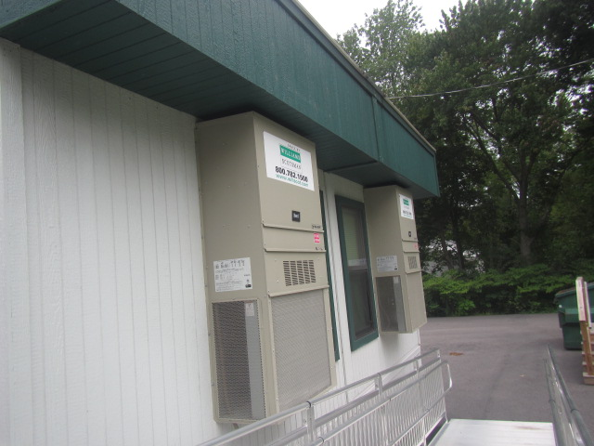
AHUs mounted on rear of modular wing
Picture 9
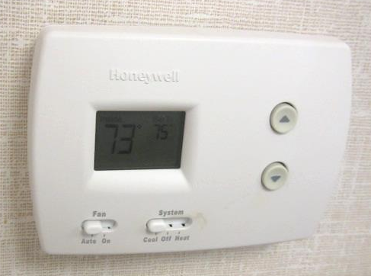
Digital thermostat for modular unit HVAC system
Picture 10
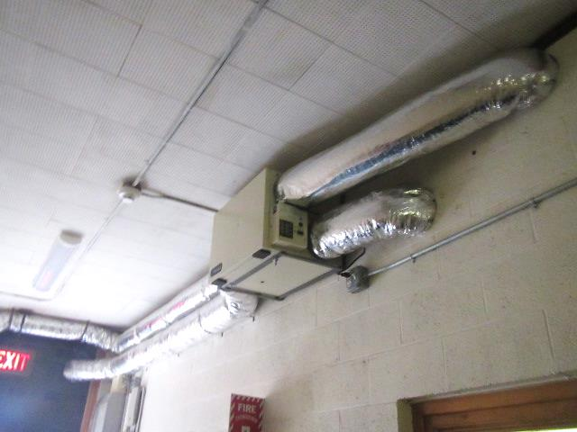
Retrofitted AHU for OT/PT areas
Picture 11
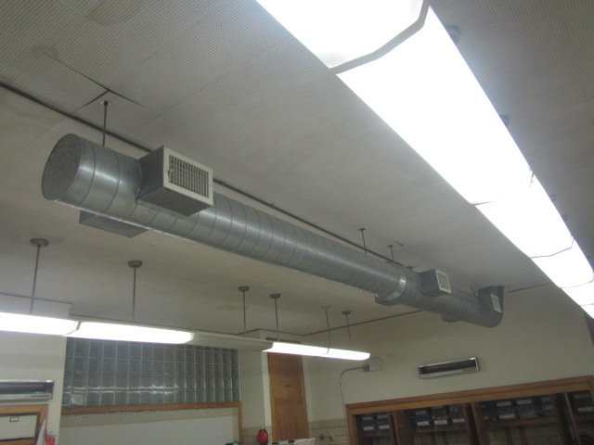
Retrofitted ductwork for AHU classrooms 3 and 5
Picture 12
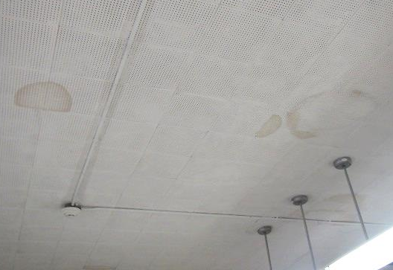
Water-damaged interlocking ceiling tiles
Picture 13
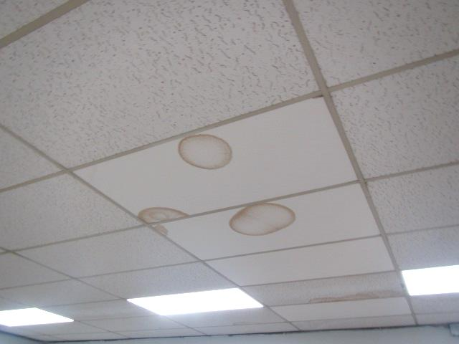
Water-damaged suspended ceiling tiles
Picture 14
Overhanging branches and plant growth against exterior walls
Picture 15
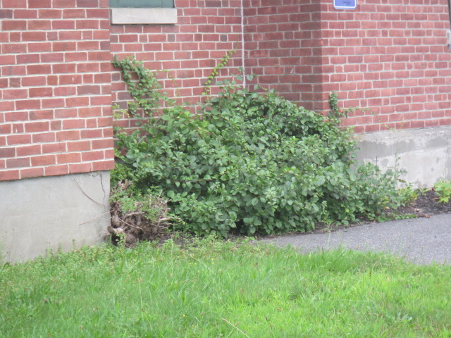
Plant growth against exterior walls
Picture 16
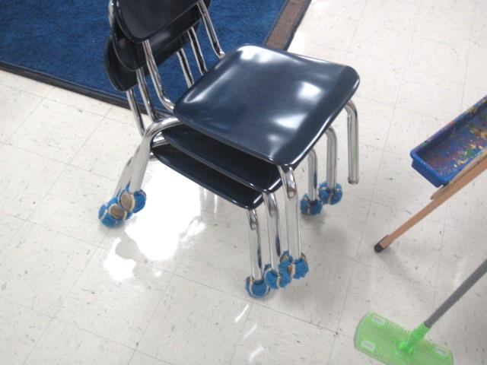
Tennis balls on chair legs

Location | Air Temp  (ºF) | Relative Humidity  (%) | Dew Point  (ºF) | Floor Temp  (ºF) | Temp at Floor/ Exterior Wall Junction  (ºF) | Water-Damaged Ceiling Tiles-stained  (#) | Water-Damaged  Bowed Ceiling Tile  (#) | Ventilation |  |  | Floor to Air Temp  Difference  (ºF) | Comments
 |  |  |  |  |  |  |  | Windows openable | Supply | Exhaust
Background (outside) | 76 | 81 | 69 |  |  |  |  |  |  |  |  | Humid, heavy clouds, tropical weather system
OT/PT | 73 | 55 | 56 | 70 | 70 |  |  | N | Y | Y | -3 | PF
OT/PT2 | 73 | 57 | 57 | 70 | 69 |  |  |  |  |  | -3
1 | 74 | 56 | 58 | 68 | 69 | Y |  | Y | Y | Y | -6 | UV obstructed-sides, area rugs, AC
2 | 69 | 64 | 57 | 67 | 67 | Y |  | Y | Y | Y | -2
3 | 69 | 63 | 56 | 66 | 68 | Y |  | Y | Y | Y | -3 | Area rugs, AHU, AP, PF
5 | 70 | 64 | 57 | 66 | 66 | Y |  | Y | Y | Y | -4 | Area rugs, AHU, AP, PF, items next to UV
6 | 72 | 68 | 61 | 66 | 66 | Y |  | Y | Y | Y | -6 | Area rugs, items on/next to UV, AC
7 | 74 | 61 | 59 | 69 | 69 | Y |  | Y | Y | Y | -5 | Area rugs, TB, 2 AC
8 Modular | 73 | 48 | 52 | 68 | 67 |  | 1 | Y | Y | Y | -5 | Area rugs, TB
9 Modular | 73 | 50 | 53 | 68 | 68 |  |  | Y | Y | Y | -5 | Area rugs
Cafetorium | 75 | 55 | 57 | 70 | 70 |  |  | Y | Y | Y | -5

The service life is the median time during which a particular system or component of …[an HVAC]… system remains in its original service application and then is replaced. Replacement may occur for any reason, including, but not limited to, failure, general obsolescence, reduced reliability, excessive maintenance cost, and changed system requirements due to such influences as building characteristics or energy prices (ASHRAE, 1991).

