**INDOOR AIR QUALITY ASSESSMENT**

**East Brookfield Town Hall/Library**

**122 Connie Mack Drive**

**East Brookfield, Massachusetts**

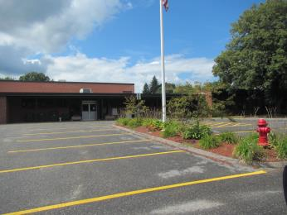

Prepared by:

Massachusetts Department of Public Health

Bureau of Environmental Health

Indoor Air Quality Program

November 2016

# Background

|  |  |
| --- | --- |
| Building: | East Brookfield Town Hall/Library (EBTHL) |
| Address: | 122 Connie Mack Drive  East Brookfield, MA |
| Assessment Requested by: | East Brookfield Board of Health |
| Reason for Request: | General indoor air quality (IAQ) |
| Date of Assessment: | August 26, 2016 |
| Massachusetts Department of Public Health/Bureau of Environmental Health (MDPH/BEH) Staff Conducting Assessment: | Michael Feeney, Director, IAQ Program |
| Building Description: | Originally constructed as a one-story school. The building currently serves as the police department, town hall and public library. |
| Building Population: | Approximately 5 employees |
| Year of Construction: | 1956, complete renovation of space in 2007 |
| Windows: | Openable |

# Methods

Please refer to the IAQ Manual for methods, sampling procedures, and interpretation of results (MDPH, 2015).

This report details conditions found in the EBTHL section of the building. IAQ assessment results and recommendation regarding the East Brookfield Police Department are detailed in a separate report.

# IAQ Testing Results

The following is a summary of indoor air testing results (Table 1).

* ***Carbon dioxide levels*** were below 800 parts per million (ppm) in all but one area assessed, indicating adequate fresh air in the space at the time of this assessment.
* ***Temperature*** was within the recommended range of 70°F to 78°F in all areas assessed.
* ***Relative humidity*** was above the recommended range of 40% to 60% in most areas assessed.
* ***Carbon monoxide*** levels were non-detectable in all areas assessed.
* ***Fine particulate matter (PM2.5)*** concentrations measured were below the National Ambient Air Quality Standard (NAAQS) level of 35 μg/m3 in all areas assessed.

The assessment results indicate that the ventilation system is providing adequate fresh air for the occupancy in the building. Note that many areas had low occupancy, which can reduce the creation of carbon dioxide. To maximize air exchange, the BEH recommends that mechanical ventilation systems operate continuously during periods of occupancy. Without the system operating as designed, normally occurring pollutants cannot be diluted or removed, allowing them to build up and lead to IAQ/comfort complaints.

## Ventilation

A heating, ventilating, and air conditioning (HVAC) system has several functions. First it provides heating and, if equipped, cooling. Second, it is a source of fresh air. Finally, an HVAC system will dilute and remove normally occurring indoor environmental pollutants by not only introducing fresh air, but by filtering the airstream and ejecting stale air to the outdoors via exhaust ventilation. Even if an HVAC system is operating as designed, point sources of respiratory irritation may exist and cause symptoms in sensitive individuals. The following analysis examines and identifies components of the HVAC system and likely sources of respiratory irritant/allergen exposure due to water damage, aerosolized dust, and/or chemicals found in the indoor environment.

Fresh air is provided by an air handling unit (AHU) located on the roof (Picture 1). Air from the AHUs is filtered, heated/cooled, and delivered to rooms via ducted supply vents. Air is returned/exhausted through vents in the ceiling.

On the roof, fresh air is drawn into the AHU through an air intake. Air is exhausted from the AHU through a vent with moveable louvers. The AHU is designed to have air bleed from the AHU through these moveable louvers. The orientation (facing west) of the AHU with respect to the prevailing wind can allow uncontrolled entrainment of cold air during winter through the passive louvered exhaust vent. Prevailing winter winds are generally northwestern (Picture 3). This airflow can lift the edge of the passive vents and force outdoor air into the return air chamber. The condition is enhanced by lifting of the exhaust vent louvers when return vent louvers restrict airflow. In the winter this condition can introduce cold air that may result in the AHU coils freezing. During warm, humid weather, uncontrolled air introduction can result in increased condensation inside the AHU cabinet.

Restrooms have exhaust ventilation which were not operating during this visit. Without functioning exhaust ventilation, water vapor and other pollutants generated inside the building would be redistributed inside the space.

It is recommended that HVAC systems be re-balanced every five years to ensure adequate air systems function (SMACNA, 1994). The HVAC system has reportedly just undergone balancing as part of a recent renovation.

## Microbial/Moisture Concerns

Water-damaged ceiling tiles were observed in a number of areas. Some of the observed stained tiles were from roof leaks that have reportedly been repaired. The roof of the building was also examined. The roof membrane had become loose resulting in pooling water (Picture 2). Debris is also present from tree branches that overhang the roof (Picture 3). Debris holds moisture on the roof, which can damage the membrane and can be attractive to pests.

## Other IAQ Evaluations

## All of the AHUs on the building contain a natural gas combustion system that is used to provide heat to the coils. The products of combustion from the natural gas are vented from the side of each AHU (Picture 4). It is possible that products of combustion from the AHU exhaust vent may be directed toward the fresh air intake hood under certain wind conditions. With sufficient air velocity drawing air into the AHU, these products of combustion may be entrained by each AHU and distributed to occupied spaces.

# Conclusions/Recommendations

Based on observations at the time of assessment, the following is recommended:

1. Repair all frozen AHU exhaust vent louvers.
2. Consider installing a chimney on each AHU over the heating exhaust vent at a height two feet minimum above the top of the AHU cabinet.
3. Install a hood over the AHU louvered exhaust vent to limit possible wind impingent.
4. Operate supply and exhaust ventilation in all areas during occupied periods.
5. Have the HVAC system balanced every 5 years in accordance with SMACNA recommendations (SMACNA, 1994).
6. Repair damage to the roof on an as-needed basis.
7. Replace water-damaged ceiling tiles once any contributing leaks are repaired.
8. Clear debris from the roof. Consider removing tree branches overhanging the roof.
9. Refer to resource manual and other related IAQ documents located on the MDPH’s website for further building-wide evaluations and advice on maintaining public buildings. These documents are available at: <http://mass.gov/dph/iaq>.

# References

MDPH. 2015. Massachusetts Department of Public Health. Indoor Air Quality Manual: Chapters I-III. Available at: <http://www.mass.gov/eohhs/gov/departments/dph/programs/environmental-health/exposure-topics/iaq/iaq-manual/>.

SMACNA. 1994. HVAC Systems Commissioning Manual. 1st ed. Sheet Metal and Air Conditioning Contractors’ National Association, Inc., Chantilly, VA.

**Picture 1**

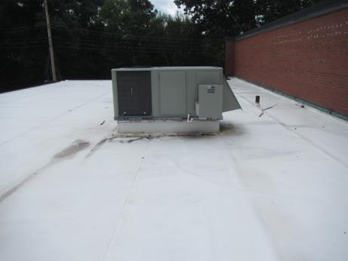

**Rooftop air handling unit (AHU)**

**Picture 2**

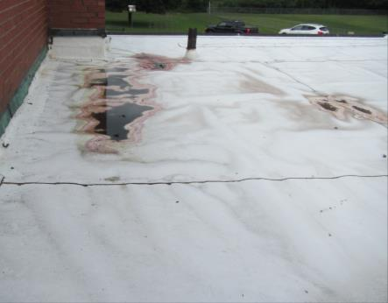

**Loosened roof membrane**

**Picture 3**

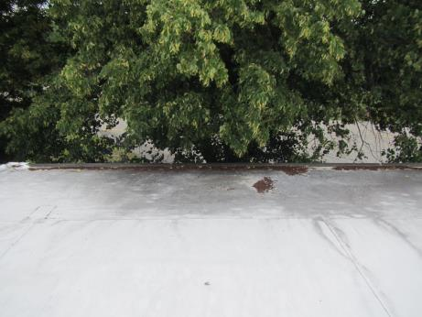

**Debris on the roof from overhanging tree branches**

**Picture 4**

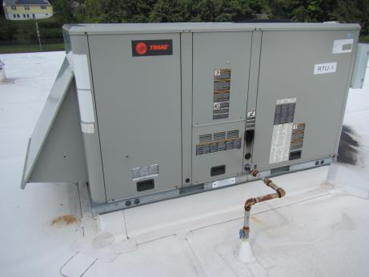

**Gas exhaust vent on AHU, note it is blackened by soot (circle)**

| Location | **Carbon**  **Dioxide**  **(ppm)** | **Carbon Monoxide**  **(ppm)** | **Temp**  **(°F)** | **Relative**  **Humidity**  **(%)** | **PM2.5**  **(µg/m3)** | **Occupants**  **in Room** | **Windows**  **Openable** | **Ventilation** | | **Remarks** |
| --- | --- | --- | --- | --- | --- | --- | --- | --- | --- | --- |
| **Supply** | **Exhaust** |
| Background (outdoors) | 421 | ND | 79 | 69 | 19 |  |  |  |  |  |
| Board of Selectmen | 829 | ND | 77 | 54 | 16 | 3 | Y | Y | Y |  |
| Selectman reception | 694 | ND | 75 | 56 | 17 | 1 | Y | Y | Y |  |
| Meeting room A | 681 | ND | 74 | 59 | 13 | 0 | Y | Y | Y |  |
| Town Clerk | 572 | ND | 74 | 65 | 11 | 0 | Y | Y | Y |  |
| Assessors | 577 | ND | 73 | 64 | 11 | 0 | Y | Y | Y |  |
| Tax collector | 571 | ND | 73 | 64 | 10 | 0 | Y | Y | Y |  |
| Treasurer | 586 | ND | 74 | 64 | 9 | 0 | Y | Y | Y |  |
| Accounting | 544 | ND | 73 | 63 | 7 | 0 | Y | Y | Y |  |
| Meeting room B | 616 | ND | 74 | 65 | 11 | 0 | Y | Y | Y |  |
| Library | 510 | ND | 74 | 63 | 8 | 0 | Y | Y | Y |  |
| Library director | 509 | ND | 74 | 62 | 8 | 0 | Y | Y | N | 3 water-damaged ceiling tiles |
| Break room | 571 | ND | 74 | 63 | 11 | 0 | N | Y | Y | Refrigerator |