INDOOR AIR QUALITY ASSESSMENT

East Gloucester Elementary School
8 Davis Street Extension
Gloucester, Massachusetts

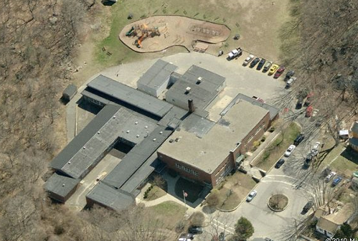

Prepared by:
Massachusetts Department of Public Health
Bureau of Environmental Health
Indoor Air Quality Program
February 2011

Background/Introduction
At the request of the Gloucester Public Schools (GPS), the Massachusetts Department of Public Health’s (MDPH) Bureau of Environmental Health (BEH) conducted an indoor air quality assessment at the East Gloucester Elementary School (EGES), 8 Davis Street Extension, Gloucester, Massachusetts. On September 14, 2010, a visit to conduct an indoor air quality assessment (IAQ) was made to the EGES by Sharon Lee, an Environmental Analyst/Inspector in BEH’s IAQ Program. The request was prompted by mold growth and general indoor air quality concerns.
The EGES is a single-story building constructed in 1948. A number of additions were made to the building including a wing in 1974 and modular buildings in 2001 and 2007. Renovations to the building also added four additional classrooms in 2008. Most areas are constructed on slab; however, a crawlspace runs below a portion of it. The school consists of classrooms, a gymnasium, auditorium, library and offices. Windows throughout the school are openable.

Methods
Air tests for carbon dioxide, carbon monoxide, temperature and relative humidity were conducted with the TSI, Q-Trak, IAQ Monitor, Model 7565. Air tests for airborne particle matter with a diameter less than 2.5 micrometers were taken with the TSI, DUSTTRAK™ Aerosol Monitor Model 8520. BEH staff also performed a visual inspection of building materials for water damage and/or microbial growth.

Results
The school houses approximately 260 students in kindergarten through grade 5 and approximately 45 staff members. Tests were taken during normal operations, and results appear in Table 1.

Discussion

Ventilation
It can be seen from Table 1 that carbon dioxide levels were above 800 parts per million (ppm) in 13 of 22 areas, indicating less than optimal air exchange in roughly half the building at the time of the assessment. In many areas, ventilation equipment was found deactivated, therefore no means of mechanical ventilation was being provided to these areas at the time of testing. It is also important to note that several areas had open windows or were empty/sparsely populated, which can greatly reduce carbon dioxide levels. Carbon dioxide levels would be expected to increase with higher occupancy, windows closed and ventilation equipment deactivated.
Fresh air to classrooms in the original building as well as the 1974 and 2008 additions is supplied by unit ventilator (univent) systems (Picture 1). A univent draws air from the outdoors through a fresh air intake located on the exterior wall of the building (Picture 2). Return air from the classroom is drawn through an air intake located at the base of the unit (Figure 1). Fresh and return air are mixed, filtered, heated and provided to classrooms through an air diffuser located in the top of the unit. As mentioned, univents were found deactivated in the majority of rooms/areas in the school at the time of assessment (Table 1). In addition, several univents were found obstructed by furniture and other items on top of air diffusers and/or in front of return vents along the bottom of the units (Pictures 1 and 3). In order for univents to provide fresh air as designed, they must remain “on” and operating while rooms are occupied. Furthermore, units must remain free of obstructions.
Exhaust ventilation for classrooms in the original building as well as the 1974 and 2008 additions is provided by switch activated cubby exhausts ducted to rooftop motors (Picture 4). At time of the MDPH assessment, exhaust ventilation was not operating. At the conclusion of the assessment, BEH staff notified Principal Gregory Bach that exhaust ventilation in these areas was not operating. Principal Bach manually reactivated all exhausts in these areas. In several classrooms, exhaust vents are located near hallway doors. When these classroom doors are open, exhaust vents will tend to draw air from both the hallway and the classroom, reducing the effectiveness of the exhaust vents to remove common environmental pollutants. Furthermore, many exhaust vents were obstructed by furniture (Picture 5). As with univents, in order to function properly, exhaust vents must be activated and allowed to operate while rooms are occupied. Without adequate supply and exhaust ventilation, excess heat and environmental pollutants can accumulate, leading to indoor air/comfort complaints.
Mechanical ventilation for modular classrooms and common areas (e.g., gymnasium, auditorium) is provided by rooftop, ceiling or side-mounted air-handling units (AHUs) (Pictures 6 and 7). Fresh air is distributed via ceiling-mounted air diffusers (Picture 8) and ducted back to AHUs via ceiling or wall-mounted return vents (Picture 9). AHUs for modular classrooms are controlled by thermostats, which have fan settings of “on” and “auto” (Pictures 10 and 11). The automatic setting on the thermostat activates the HVAC system at a preset temperature. Once a preset temperature is measured by the thermostat, the HVAC system is deactivated. Therefore, no mechanical ventilation is provided until the thermostat re-activates the system. Thermostats were set to the “auto” setting in all modular rooms surveyed during the assessment. The AHUs for the gymnasium and auditorium were also found deactivated at the time of the assessment; therefore, there was no means of mechanical air exchange. As with univents, AHUs should be activated and allowed to operate continuously during occupied periods. Consideration should be given to setting thermostat controls for modular classrooms to the fan “on” setting.
To maximize air exchange, the MDPH recommends that both supply and exhaust ventilation operate continuously during periods of occupancy. In order to have proper ventilation with a mechanical supply and exhaust system, the systems must be balanced to provide an adequate amount of fresh air to the interior of a room while removing stale air from the room. It is recommended that heating, ventilation and air conditioning (HVAC) systems be re-balanced every five years to ensure adequate air systems function (SMACNA, 1994). The date of the last balancing of these systems was not available at the time of the assessment.
The Massachusetts Building Code requires a minimum ventilation rate of 15 cubic feet per minute (cfm) per occupant of fresh outside air or have openable windows in each room (SBBRS, 1997; BOCA, 1993). The ventilation must be on at all times that the room is occupied. Providing adequate fresh air ventilation with open windows and maintaining the temperature in the comfort range during the cold weather season is impractical. Mechanical ventilation is usually required to provide adequate fresh air ventilation.
Carbon dioxide is not a problem in and of itself. It is used as an indicator of the adequacy of the fresh air ventilation. As carbon dioxide levels rise, it indicates that the ventilating system is malfunctioning or the design occupancy of the room is being exceeded. When this happens, a buildup of common indoor air pollutants can occur, leading to discomfort or health complaints. The Occupational Safety and Health Administration (OSHA) standard for carbon dioxide is 5,000 parts per million parts of air (ppm). Workers may be exposed to this level for 40 hours/week, based on a time-weighted average (OSHA, 1997).
The MDPH uses a guideline of 800 ppm for publicly occupied buildings. A guideline of 600 ppm or less is preferred in schools due to the fact that the majority of occupants are young and considered to be a more sensitive population in the evaluation of environmental health status. Inadequate ventilation and/or elevated temperatures are major causes of complaints such as respiratory, eye, nose and throat irritation, lethargy and headaches. For more information concerning carbon dioxide, consult Appendix A.
Temperatures ranged from 71° F to 77° F, which were within the MDPH recommended range in all areas surveyed (Table 1). The MDPH recommends that indoor air temperatures be maintained in a range of 70° F to 78° F in order to provide for the comfort of building occupants. In many cases concerning indoor air quality, fluctuations of temperature in occupied spaces are typically experienced, even in a building with an adequate fresh air supply. A number of occupants that had temperature complaints reported that they often turn off their univents in an attempt to reduce heat. Occupants experiencing temperature issues should work with school administration, custodial staff and the Gloucester Department of Public Works to resolve such issues.
Relative humidity measurements in the building ranged from 48 to 64 percent at the time of the assessment, which were within or close to the upper end of the MDPH recommended comfort range (Table 1). The MDPH recommends a comfort range of 40 to 60 percent for indoor air relative humidity. Relative humidity levels in the building would be expected to drop during the winter months due to heating. The sensation of dryness and irritation is common in a low relative humidity environment. Low relative humidity is a very common problem during the heating season in the northeast part of the United States.

Microbial/Moisture Concerns
As mentioned, mold growth concerns, specifically in classrooms 10, 11 and 12 prompted the assessment. In order for building materials to support mold growth, a source of water exposure is necessary. Identification and elimination of the source of water moistening building materials is necessary to control mold growth. Occupants reportedly expressed concerns of suspected mold growth that was observed on floor tiles in these areas in late winter/early spring 2010. These floors were reportedly cleaned and disinfected at the time concerns were reported. During the summer of 2010, floor tiles for classrooms 10 and 12 were replaced. Floor tiles in classroom 11 were not replaced, and some evidence of the black material can still be observed.
The black material examined on tiles in classroom 11 as well as in the hallway of this area, appeared sticky (Picture 12). This material is not mold, but mastic that adheres tiles to the floor. Since this portion of the building is constructed on cement slab, it is likely that temperature differences between the slab and classroom floor are resulting in condensation generation on the slab. Evidence of slight staining along floor tile seams and cracks in the floor, confirm that moisture/condensation is occurring in this area. As moisture penetrates through the cement slab towards the classroom floor, mastic under floor tiles becomes more fluid and expands between floor tiles.
Evidence of active water leaks was observed in the auditorium and gymnasium in the form of water-stained wood beams (Picture 13). At the time of assessment, ceiling tiles in the auditorium had been removed to allow buckets to catch water (Picture 14). Removal of the tiles will also facilitate drying of the wood beams.
Water-damaged ceiling tiles were also observed in a number of other areas, including modulars (Table 1). These leaks are likely related to the roofs, which has not been replaced in some time. Given that roofs in the 1948/1974/2007 areas consists of a ballast system covered in stone, determining the origin of the leak may be difficult.
Water-damaged ceiling tiles in the modular ramp hallway (Picture 15) are likely the result of damaged flashing where the modular wing is adjoined to the original building (Picture 16). Damaged flashing was also observed around the exterior of modular buildings.
Water damage was seen around sinks where open seams were observed between backsplashes and countertops (Picture 17). If not watertight, water can penetrate through the seam, causing water damage. Improper drainage or sink overflow can lead to water penetration into the countertop, cabinet interior and areas behind cabinets. Water penetration and chronic exposure of porous and wood-based materials can cause these materials to swell and show signs of water damage. Many classrooms were also found to have porous materials (e.g., cardboard, paper, cloth) stored beneath sinks, which is a humid environment. Repeated moistening of porous materials can result in mold growth. Water damage/mold growth was observed in some sink cabinets (Picture 18).
The US Environmental Protection Agency (US EPA) and the American Conference of Governmental Industrial Hygienists (ACGIH) recommend that porous materials be dried with fans and heating within 24 to 48 hours of becoming wet (US EPA, 2001; ACGIH, 1989). If not dried within this time frame, mold growth may occur. Once mold has colonized porous materials, they are difficult to clean and should be removed/discarded.
Plants were observed in several areas (Table 1). Plants should be properly maintained and equipped with drip pans. Plants should also be located away from ventilation sources to prevent aerosolization of dirt, pollen or mold (Picture 3). Finally, they should not be placed on porous materials, since water damage to porous materials may lead to microbial growth.
Plants were also observed growing in close proximity to the building’s exterior, in some instances near univent fresh air intakes. Univents can draw in pollen and mold from these plants and distribute them throughout the classroom. Furthermore, the growth of roots against exterior walls can bring moisture in contact with the foundation. Plant roots can eventually penetrate the wall, leading to cracks and/or fissures in the sublevel foundation. Over time, these conditions can undermine the integrity of the building envelope and provide a means of water entry into the building via capillary action through exterior walls, foundation concrete and masonry (Lstiburek & Brennan, 2001). The freezing and thawing action of water during the winter months can also create cracks and fissures in the foundation resulting in additional penetration points for both water and pests.
Lastly, fiberglass insulation was observed in the louvered vent that provides ventilation for the crawlspace (Picture 19). Fiberglass exposed to chronic moisture can result in odors and mold growth over time. Considering the proximity of a univent fresh air intake to this vent (Picture 20), the potential exists for odors to become entrained by the univent and distributed to the classroom.

Other IAQ Evaluations
Indoor air quality can be negatively influenced by the presence of respiratory irritants, such as products of combustion. The process of combustion produces a number of pollutants. Common combustion emissions include carbon monoxide, carbon dioxide, water vapor and smoke (fine airborne particle material). Of these materials, exposure to carbon monoxide and particulate matter with a diameter of 2.5 micrometers (μm) or less (PM2.5) can produce immediate, acute health effects upon exposure. To determine whether combustion products were present in the indoor environment, BEH staff obtained measurements for carbon monoxide and PM2.5.

Carbon Monoxide
Carbon monoxide is a by-product of incomplete combustion of organic matter (e.g., gasoline, wood and tobacco). Exposure to carbon monoxide can produce immediate and acute health affects. Several air quality standards have been established to address carbon monoxide and prevent symptoms from exposure to these substances. The MDPH established a corrective action level concerning carbon monoxide in ice skating rinks that use fossil-fueled ice resurfacing equipment. If an operator of an indoor ice rink measures a carbon monoxide level over 30 ppm, taken 20 minutes after resurfacing within a rink, that operator must take actions to reduce carbon monoxide levels (MDPH, 1997).
The American Society of Heating Refrigeration and Air-Conditioning Engineers (ASHRAE) has adopted the National Ambient Air Quality Standards (NAAQS) as one set of criteria for assessing indoor air quality and monitoring of fresh air introduced by HVAC systems (ASHRAE, 1989). The NAAQS are standards established by the US EPA to protect the public health from six criteria pollutants, including carbon monoxide and particulate matter (US EPA, 2006). As recommended by ASHRAE, pollutant levels of fresh air introduced to a building should not exceed the NAAQS levels (ASHRAE, 1989). The NAAQS were adopted by reference in the Building Officials & Code Administrators (BOCA) National Mechanical Code of 1993 (BOCA, 1993), which is now an HVAC standard included in the Massachusetts State Building Code (SBBRS, 1997). According to the NAAQS, carbon monoxide levels in outdoor air should not exceed 9 ppm in an eight-hour average (US EPA, 2006).
Carbon monoxide should not be present in a typical, indoor environment. If it is present, indoor carbon monoxide levels should be less than or equal to outdoor levels. Outdoor carbon monoxide concentrations were non-detect (ND) at the time of the assessment (Table 1). No measureable levels of carbon monoxide were detected inside the building during the assessment (Table 1).

Particulate Matter
The US EPA has established NAAQS limits for exposure to particulate matter. Particulate matter is airborne solids that can be irritating to the eyes, nose and throat. The NAAQS originally established exposure limits to particulate matter with a diameter of 10 μm or less (PM10). According to the NAAQS, PM10 levels should not exceed 150 micrograms per cubic meter (μg/m³) in a 24-hour average (US EPA, 2006). These standards were adopted by both ASHRAE and BOCA. Since the issuance of the ASHRAE standard and BOCA Code, US EPA established a more protective standard for fine airborne particles. This more stringent PM2.5 standard requires outdoor air particle levels be maintained below 35 μg/m³ over a 24-hour average (US EPA, 2006). Although both the ASHRAE standard and BOCA Code adopted the PM10 standard for evaluating air quality, MDPH uses the more protective PM2.5 standard for evaluating airborne particulate matter concentrations in the indoor environment.
Outdoor PM2.5 concentrations the day of the assessment were measured at 15 μg/m³. PM2.5 levels measured inside the building ranged from 13 to 23 μg/m³ (Table 1). Both indoor and outdoor PM 2.5 levels were below the NAAQS PM2.5 level of 35 μg/m³. Frequently, indoor air levels of particulates (including PM2.5) can be at higher levels than those measured outdoors. A number of activities that occur indoors and/or mechanical devices can generate particulate during normal operations. Sources of indoor airborne particulates may include but are not limited to particles generated during the operation of fan belts in the HVAC system, use of stoves and/or microwave ovens in kitchen areas; use of photocopiers, fax machines and computer printing devices; operation of an ordinary vacuum cleaner and heavy foot traffic indoors.
In a few instances, BEH staff observed pencil sharpeners placed on top/near univent air diffusers. Pencil shavings that collect on the diffuser or fall into the univent can be distributed throughout the classroom, which can result in irritation to the eyes and respiratory system (Picture 1).
While examining some univents at the school, BEH staff observed accumulated dust and debris within the cabinets of the units (Picture 21). Spaces were also observed around pipes (Picture 22). These spaces can allow materials and odors to be drawn from the pipe chaseways and/or crawlspace below. Spaces between the cabinets and main compartment can allow dust, debris and odors to be drawn from the cabinet into the main compartment where these materials can bypass filtration. Measures should be taken to seal breaches and prevent aerosolization of dust/debris.
Staff members had concerns regarding univent filtration. When examining univent filters, BEH staff observed that some filters had heavy deposits of dust/debris and appeared to have not been changed for some time. In one instance, a filter was missing from the univent (Table 1). The purpose of a filter is to provide filtration of respirable dusts. A filter with a dust spot efficiency of a minimum of 40 percent (Minimum Efficiency Reporting Value equal to 9) would be sufficient to reduce many airborne particulates (Thornburg, 2000; MEHRC, 1997; ASHRAE, 1992).

Volatile Organic Compounds
Indoor air concentrations can be greatly impacted by the use of products containing volatile organic compounds (VOCs). VOCs are carbon-containing substances that have the ability to evaporate at room temperature. Frequently, exposure to low levels of total VOCs (TVOCs) may produce eye, nose, throat and/or respiratory irritation in some sensitive individuals. For example, chemicals evaporating from a paint can stored at room temperature would most likely contain VOCs. In an effort to identify materials that can potentially increase indoor VOC concentrations, BEH staff examined rooms for products containing these respiratory irritants.
Cleaning products were found in several rooms throughout the building (Picture 23/Table 1). Cleaning products contain chemicals that can be irritating to the eyes, nose and throat of sensitive individuals. These products should be properly labeled and stored in an area inaccessible to children. In addition, a Material Safety Data Sheets (MSDS) should be available at a central location for each product in the event of an emergency. Consideration should be given to providing teaching staff with school issued cleaning products and supplies to prevent any potential for adverse chemical interactions between residues left from cleaners used by the facilities staff and those left by cleaners brought in by others.
The majority of classrooms contained dry erase boards and related materials. Materials such as dry erase markers and dry erase board cleaners may contain VOCs, such as methyl isobutyl ketone, n-butyl acetate and butyl-cellusolve (Sanford, 1999), which can be irritating to the eyes, nose and throat.
Air fresheners/scented oils were found to be in use in some areas (Table 1). Air fresheners contain chemicals that can be irritating to the eyes, nose and throat of sensitive individuals. Further, air fresheners do not remove materials causing odors, but rather, mask odors which may be present in the area.
In an effort to reduce noise from sliding desks/chairs, tennis balls had been sliced open and placed on the base of the legs. The covering for some tennis balls had been removed, exposing the rubber (Picture 24). Tennis balls are made of a number of materials that are a source of respiratory irritants. Constant wearing of tennis balls can produce fibers and cause VOCs to off-gas. Tennis balls are made with a natural rubber latex bladder, which becomes abraded when used as a chair leg pad. Use of tennis balls in this manner may introduce latex dust into the school environment. Some individuals are highly allergic to latex (e.g., spina bifida patients) (SBAA, 2001). It is recommended that the use of materials containing latex be limited in buildings to reduce the likelihood of symptoms in sensitive individuals (NIOSH, 1997). At the time of assessment, Principal Bach indicated that plans to replace tennis balls with alternative floor protectors were in process.

Other Conditions
Other conditions that can affect indoor air quality were observed during the assessment. In several classrooms, items were observed on windowsills, tabletops, counters, bookcases and desks. The large number of items stored in classrooms provides a source for dusts to accumulate. These items (e.g., papers, folders, boxes) make it difficult for custodial staff to clean. Items should be relocated and/or be cleaned periodically to avoid excessive dust build up. In addition, these materials can accumulate on flat surfaces (e.g., desktops, shelving and carpets) in occupied areas and subsequently be re-aerosolized causing further irritation.
Finally, a number of air diffusers, exhaust vents and personal fans in classrooms were observed to have accumulated dust/debris. Re-activated supply vents/fans can aerosolize dust accumulated on fan blades/housing. If exhaust vents are not functioning, backdrafting can occur, which can re-aerosolize dust particles.

Conclusions/Recommendations
The conditions observed at the EGES suggest that the roofs at the school may be nearing the end of their useful life. A number of active leaks were identified throughout the building, in areas of varying age. Long-term measures should be taken to replace the roofs to prevent future leaks. In view of the findings at the time of the visit, the following recommendations are made:
- Examine roofs and establish a timeline for replacement. In the interim, repair/patch portions of the roofs to prevent/reduce leaks. Continue to monitor the auditorium, gymnasium and other areas of the building for roof leaks; change ceiling tiles as necessary.
- Examine flashing around the buildings exterior and repair to prevent further water penetration.
- Consider operating dehumidifiers in classrooms on slab during periods of elevated relative humidity (> 70%) to reduce indoor humidity and prevent the breakdown of tile mastic. If problems persist, consider contacting a flooring and/or building envelope specialists with expertise in water penetration issues for further investigation/mitigation.
- Operate all ventilation systems (e.g., AHUs, exhaust vents and univents) throughout the building continuously during occupied periods. To increase airflow in classrooms, set univent controls to “high”.
- Particular attention should be made to ensure classroom exhaust vents are turned on at the start of school and are allowed to operate during occupancy. Consider contacting an electrician or HVAC firm to install timer for exhaust vents.
- Remove all blockages from univents and exhaust vents to ensure adequate airflow.
- Operate thermostats for AHUs in the fan “on” position to increase fresh air supplied to these areas.
- Use openable windows in conjunction with mechanical ventilation to facilitate air exchange. Care should be taken to ensure windows are properly closed at night and weekends to avoid the freezing of pipes and potential flooding.
- Consider adopting a balancing schedule of every 5 years for all mechanical ventilation systems, as recommended by ventilation industrial standards (SMACNA, 1994).
- Work with city officials to develop a preventative maintenance program for all mechanical ventilation equipment. Change filters for air-handling equipment (e.g., univents, AHUs and ACs) as per the manufacturer’s instructions or more frequently if needed. Write date of filter change directly on filter housing. Ensure filters fit flush in racks with no spaces between to allow bypass of unfiltered air into the unit. Vacuum interior of units prior to activation to prevent the aerosolization of dirt, dust and particulates.
- Seal spaces around pipes in univent cabinets with a fire-rated sealant.
- For buildings in New England, periods of low relative humidity during the winter are often unavoidable. Therefore, scrupulous cleaning practices should be adopted to minimize common indoor air contaminants whose irritant effects can be enhanced when the relative humidity is low. To control for dusts, a high efficiency particulate arrestance (HEPA) filter equipped vacuum cleaner in conjunction with wet wiping of all surfaces is recommended. Avoid the use of feather dusters. Drinking water during the day can help ease some symptoms associated with a dry environment (throat and sinus irritations).
- Ensure plants have drip pans and avoid over-watering. Examine drip pans periodically for mold growth. Disinfect with an appropriate antimicrobial where necessary. Remove plants from univent air diffusers.
- Remove plants growing in close proximity of the building. Repair damage to the building’s foundation to prevent water/pest intrusion.
- Seal areas around sink in kitchen to prevent water damage to the interior of cabinets and adjacent wallboard. Repair/replace countertop as necessary. Consider replacing with a one piece/seamless molded countertop.
- Clean mold growth from sink cabinets with a mild detergent or anti-microbial agent. Replace damaged building components as necessary. Refrain from storing porous items (e.g., cardboard, paper) beneath sinks.
- Remove fiberglass insulation in the crawlspace vents to prevent mold growth/odors. Consider alternate means for insulating.
- Remove pencil sharpeners from the vicinity of air supply sources to prevent aerosolization debris.
- Store cleaning products properly and out of reach of students. Ensure spray bottles are properly labeled. Consider providing school issued cleaning products to staff.
- Relocate or consider reducing the amount of materials stored in classrooms to allow for more thorough cleaning of classrooms. Clean items regularly with a wet cloth or sponge to prevent excessive dust build-up.
- Clean personal fans, univent air diffusers, return vents and exhaust vents periodically of accumulated dust.
- Refrain from using air fresheners and deodorizers to prevent exposure to VOCs.
- Continue with plans to replace latex-based tennis balls with latex-free tennis balls or glides.
- Consider adopting the US EPA (2000) document, “Tools for Schools”, as an instrument for maintaining a good indoor air quality environment in the building. This document is available at: http://www.epa.gov/iaq/schools/index.html.
- Refer to resource manual and other related indoor air quality documents located on the MDPH’s website for further building-wide evaluations and advice on maintaining public buildings. These documents are available at: http://mass.gov/dph/iaq.

References
ACGIH. 1989. Guidelines for the Assessment of Bioaerosols in the Indoor Environment. American Conference of Governmental Industrial Hygienists, Cincinnati, OH.
ASHRAE. 1989. Ventilation for Acceptable Indoor Air Quality. American Society of Heating, Refrigeration and Air Conditioning Engineers. ANSI/ASHRAE 62-1989
ASHRAE. 1992. Gravimetric and Dust-Spot Procedures for Testing Air-Cleaning Devices Used in General Ventilation for Removing Particulate Matter. American Society of Heating, Refrigeration and Air Conditioning Engineers. ANSI/ASHRAE 52.1-1992.
BOCA. 1993. The BOCA National Mechanical Code/1993. 8th ed. Building Officials and Code Administrators International, Inc., Country Club Hill, IL.
Lstiburek, J. & Brennan, T. 2001. Read This Before You Design, Build or Renovate. Building Science Corporation, Westford, MA. U.S. Department of Housing and Urban Development, Region I, Boston, MA
MDPH. 1997. Requirements to Maintain Air Quality in Indoor Skating Rinks (State Sanitary Code, Chapter XI). 105 CMR 675.000. Massachusetts Department of Public Health, Boston, MA.
MEHRC. 1997. Indoor Air Quality for HVAC Operators & Contractors Workbook. MidAtlantic Environmental Hygiene Resource Center, Philadelphia, PA.
NIOSH. 1997. NIOSH Alert Preventing Allergic Reactions to Natural Rubber latex in the Workplace. National Institute for Occupational Safety and Health, Atlanta, GA.
OSHA. 1997. Limits for Air Contaminants. Occupational Safety and Health Administration. Code of Federal Regulations. 29 C.F.R 1910.1000 Table Z-1-A.
Sanford. 1999. Material Safety Data Sheet (MSDS No: 198-17). Expo® Dry Erase Markers Bullet, Chisel, and Ultra Fine Tip. Sanford Corporation. Bellwood, IL.
SBAA. 2001. Latex In the Home And Community Updated Spring 2001. Spina Bifida Association of America, Washington, DC.
SBBRS. 1997. Mechanical Ventilation. State Board of Building Regulations and Standards. Code of Massachusetts Regulations. 780 CMR 1209.0
SMACNA. 1994. HVAC Systems Commissioning Manual. 1st ed. Sheet Metal and Air Conditioning Contractors’ National Association, Inc., Chantilly, VA.
Thornburg, D. 2000. Filter Selection: a Standard Solution. Engineering Systems 17:6 pp. 74-80.
US EPA. 2000. Tools for Schools. Office of Air and Radiation, Office of Radiation and Indoor Air, Indoor Environments Division (6609J). EPA 402-K-95-001, Second Edition. http://www.epa.gov/iaq/schools/tools4s2.html
US EPA. 2001. “Mold Remediation in Schools and Commercial Buildings”. Office of Air and Radiation, Indoor Environments Division, Washington, DC. EPA 402-K-01-001. March 2001. Available at: http://www.epa.gov/iaq/molds/mold_remediation.html
US EPA. 2006. National Ambient Air Quality Standards (NAAQS). US Environmental Protection Agency, Office of Air Quality Planning and Standards, Washington, DC. http://www.epa.gov/air/criteria.html.
Picture 1

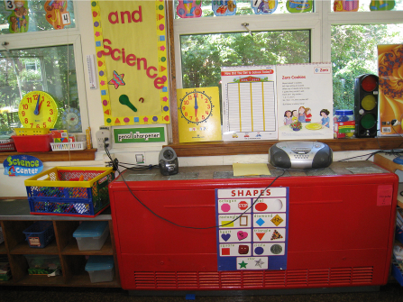

Classroom univent

Picture 2

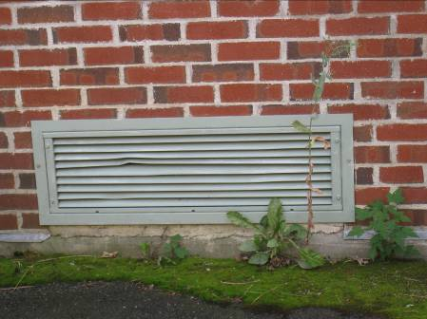

Univent fresh air intake

Picture 3

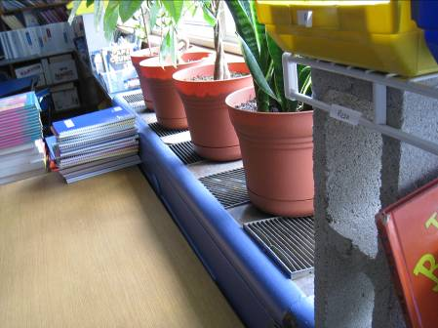

Items on top and in front of univent

Picture 4

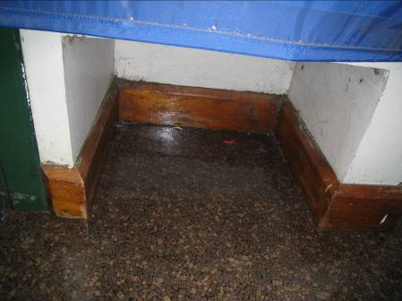

Switch activated classroom exhaust

Picture 5

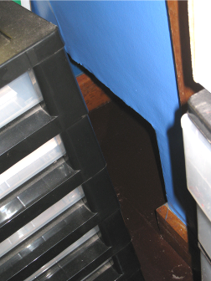

Obstructed exhaust

Picture 6

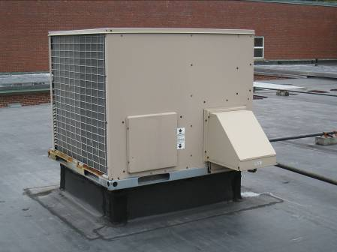

Rooftop AHU

Picture 7

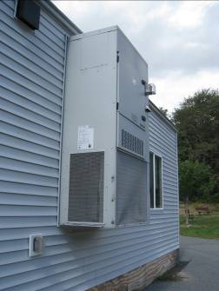

Side-mounted AHU

Picture 8

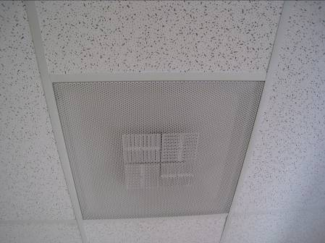

Ceiling-mounted diffuser

Picture 9

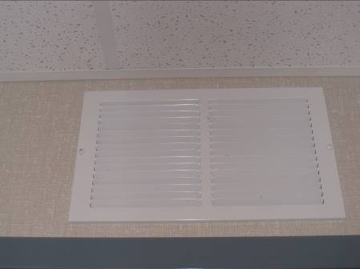

Wall-mounted exhaust vent

Picture 10

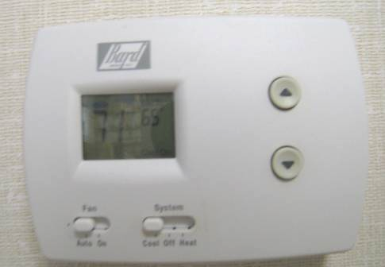

Thermostat set to auto

Picture 11

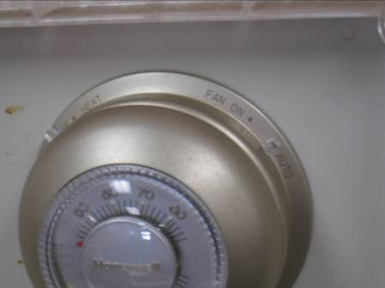

Thermostat set to auto

Picture 12

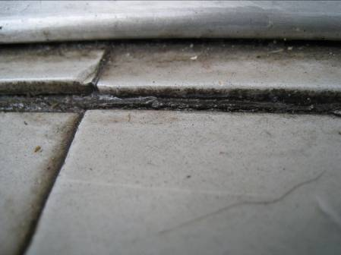

Mastic between floor tiles in hallway

Picture 13

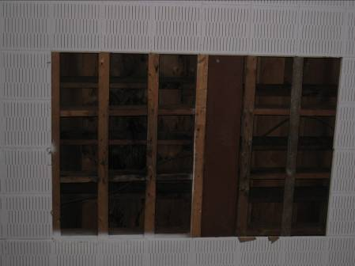

Missing ceiling tiles revealing water-damaged wood beams in auditorium

Picture 14

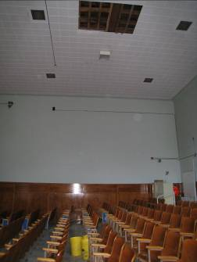

Buckets to catch water in auditorium

Picture 15

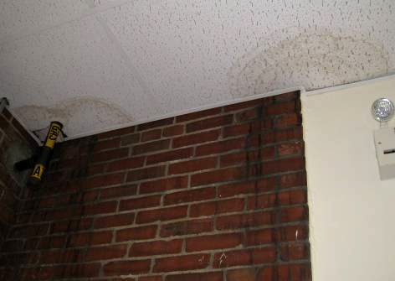

Water-damaged ceiling tiles in ramp to modulars

Picture 16

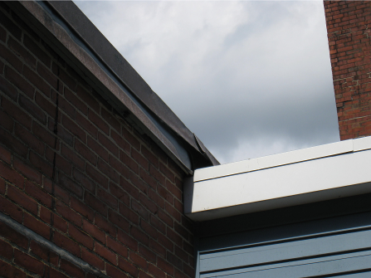

Damaged flashing outside ramp to modulars

Picture 17

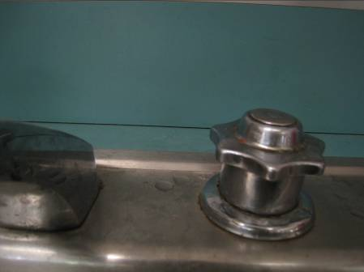

Breach between sink countertop and backsplash

Picture 18

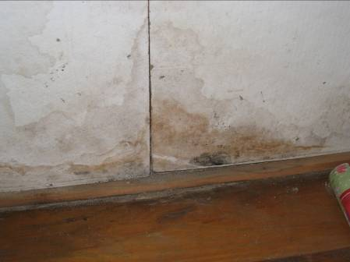

Water damage/mold growth under sink

Picture 19

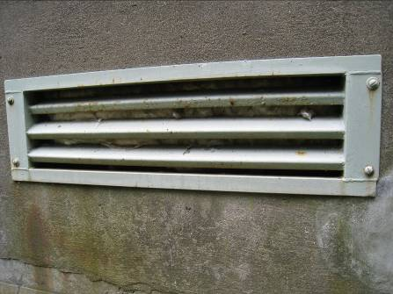

Crawlspace vent

Picture 20

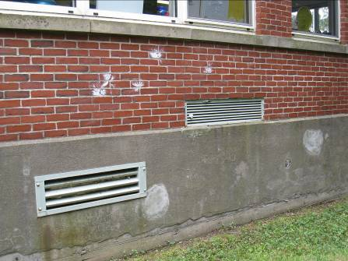

Univent fresh air intake in close proximity to crawlspace vent

Picture 21

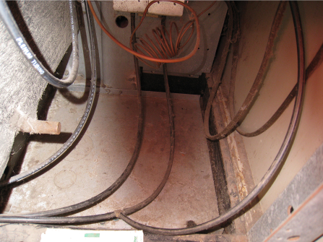

Dusty univent cabinet

Picture 22

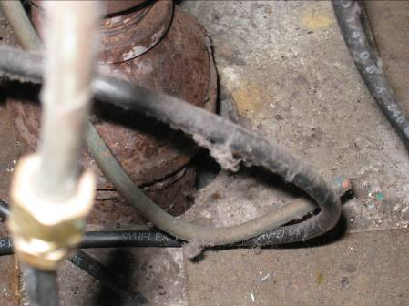

Spaces around univent pipes

Picture 23

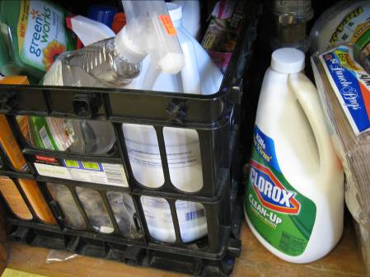

Assortment of cleaning products

Picture 24

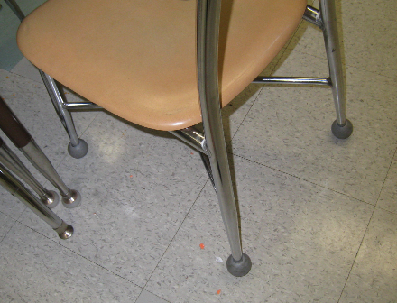

Tennis balls with covering removed
Location | Carbon  Dioxide  (ppm) |  | Temp  (°F) |  |  | Relative  Humidity  (%) |  | Carbon Monoxide  (ppm) |  | PM2.5  (µg/m³) |  | Occupants  in Room |  | Windows Openable | Ventilation |  |  |  | Remarks
 |  |  |  |  |  |  |  |  |  |  |  |  |  |  | Supply |  | Exhaust
background |  | 437 |  | 71 | 58 |  | ND |  | 15 |  |  |  |  |  |  |  |  |  |  | overcast
Auditorium |  | 1286 |  | 71 | 62 |  | ND |  | 16 |  | 3 |  |  |  |  | Y  Off |  | Y  Off |  | DO
Girls room |  |  |  | 75 | 57 |  |  |  | 21 |  |  |  |  |  |  | N |  | Y  Off |  | DO
Gym |  | 567 |  | 71 | 62 |  | ND |  | 17 |  | 50 |  |  |  |  | Y  Off |  | Y  Off |  | Exterior DO, roof leaks/WD
Library |  | 445 |  | 74 | 56 |  | ND |  | 13 |  | 0 |  | N |  |  | Y  PS |  | DNL |  | Plants
Nurse |  | 857 |  | 73 | 61 |  | ND |  | 20 |  | 1 |  | Y |  |  | N |  | N |  | DO, PF
Office |  | 719 |  | 77 | 53 |  | ND |  | 16 |  | 1 |  | Y  ½ open |  |  | N |  | N |  | DO, PF
Principal |  | 403 |  | 77 | 48 |  | ND |  | 15 |  | 0 |  | Y |  |  | N |  | N |  | Exterior DO, DO
Ramp |  |  |  |  |  |  |  |  |  |  |  |  |  |  |  |  |  |  |  | WD-CTs; leak at building seams
Special Education office |  | 1019 |  | 75 | 57 |  | ND |  | 19 |  | 0 |  | N |  |  | N |  | Y |  | DO, subdivided
SPED/PSYCH |  | 1241 |  | 77 | 51 |  | ND |  | 22 |  | 1 |  | Y |  |  | Y |  | Y
1 |  | 1212 |  | 74 | 61 |  | ND |  | 23 |  | 20 |  | Y |  |  | Y  Off, items |  | Y  Weak, blocked |  | DO, TB, CPs
2 |  | 941 |  | 74 | 64 |  | ND |  | 23 |  | 20 |  | Y |  |  | Y  Off, items |  | Y |  | DO, DEM, TB
3 |  | 650 |  | 74 | 64 |  | ND |  | 17 |  | 20 |  | Y  1/7 open |  |  | Y  Off |  | Y |  | DO, TB, plants, UF
5 |  | 637 |  | 76 | 54 |  | ND |  | 16 |  | 18 |  | Y  2/4 open |  |  | Y  Off |  | Y |  | DO
6 |  | 817 |  | 76 | 55 |  | ND |  | 18 |  | 3 |  | Y  3/5 open |  |  | Y  Off |  | Y  blocked |  | TB, 6 WD-CT, PF, DO, DEM, CPs
7 |  | 758 |  | 76 | 52 |  | ND |  | 17 |  | 2 |  | Y  ¾ |  |  | Y  Off |  | Y  Blocked |  | DO, DEM, TB
9 |  | 543 |  | 76 | 51 |  | ND |  | 17 |  | 24 |  | Y  3/3 open |  |  | Y  Off |  | Y |  | Exterior DO, DO, TB, PF, CPs
10 |  | 908 |  | 77 | 54 |  | ND |  | 18 |  | 24 |  | Y |  |  | Y  Off |  | Y |  | DO, DEM, PF
11 |  | 1774 |  | 77 | 60 |  | ND |  | 19 |  | 23 |  | Y |  |  | Y  Off |  | Y |  | DO, DEM, items
12 |  | 1280 |  | 76 | 55 |  | ND |  | 17 |  | 3 |  | Y |  |  | Y  Off |  | Y |  | Items, breach in sink, DO, 4 WD-CTs, PF, DEM
18 |  | 870 |  | 75 | 57 |  | ND |  | 18 |  | 22 |  | 2 |  |  | Y |  | Y |  | Exterior DO, DEM, WD-CTs
22 |  | 1087 |  | 71 | 48 |  | ND |  | 17 |  | 0 |  | Y |  |  | Y |  | Y  In bathrm |  | DO, DEM, plants
22 office |  | 907 |  | 71 | 48 |  | ND |  | 17 |  | 0 |  | N |  |  | Y |  | N |  | AT, DEM
2008 room addition |  | 635 |  | 75 | 51 |  | ND |  | 16 |  | 2 |  | Y  1/3 open |  |  | Y  Off |  | DNL |  | UV missing filter

