INDOOR AIR QUALITY REASSESSMENT

East Gloucester Elementary School
8 Davis Street Extension
Gloucester, Massachusetts

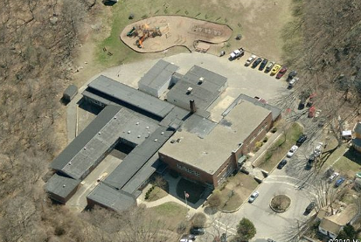

Prepared by:
Massachusetts Department of Public Health
Bureau of Environmental Health
Indoor Air Quality Program
May 2012

Background/Introduction
At the request of the Gloucester Public Schools (GPS), the Massachusetts Department of Public Health’s (MDPH) Bureau of Environmental Health (BEH) conducted an indoor air quality (IAQ) assessment at the East Gloucester Elementary School (EGES), 8 Davis Street Extension, Gloucester, Massachusetts. On March 9, 2012, a visit was made to the EGES by Michael Feeney, Director, of BEH’s IAQ Program. The IAQ air sampling was conducted to evaluate the EGES with the heating, ventilating and air conditioning (HVAC) systems operating during the heating season.
The BEH/IAQ Program has previously assessed the building and issued reports detailing conditions observed at that time, as well as recommendations to improve IAQ (MDPH, 2011; MDPH 2012). Please refer to the MDPH, 2011 report for general recommendations regarding IAQ.
The EGES is a single-story building constructed in 1948. A number of additions were made to the building including a wing in 1974 and modular buildings in 2001 and 2007. Renovations to the building also added four additional classrooms in 2008. Most areas are constructed on slab; however, a crawlspace runs below a portion of the building. The school consists of classrooms, a gymnasium, auditorium, library and offices. Windows throughout the school are openable.

Methods
Air tests for carbon dioxide, carbon monoxide, temperature and relative humidity were conducted with the TSI, Q-Trak, IAQ Monitor, Model 7565. Air tests for airborne particle matter with a diameter less than 2.5 micrometers were taken with the TSI, DUSTTRAK™ Aerosol Monitor Model 8520.

Results
The school houses approximately 260 students in kindergarten through 5th grade with approximately 45 staff members. Tests were taken during normal operations, and results appear in Table 1.

Discussion

Ventilation
It can be seen from Table 1 that carbon dioxide levels were above 800 parts per million (ppm) in 20 of 23 areas, indicating less than optimal air exchange in most of the building at the time of assessment. In some areas, ventilation equipment was found deactivated, therefore no means of mechanical ventilation was being provided to these areas at the time of testing. It is also important to note that several areas had open windows or were empty/sparsely populated, which can greatly reduce carbon dioxide levels. Carbon dioxide levels would be expected to increase with higher occupancy and windows closed.
Fresh air to classrooms in the original building as well as the 1974 and 2008 additions is supplied by unit ventilator (univent) systems (Picture 1). A univent draws air from the outdoors through a fresh air intake located on the exterior wall of the building (Picture 2). Return air from the classroom is drawn through an air intake located at the base of the unit (Figure 1). Fresh and return air are mixed, filtered, heated and provided to classrooms through an air diffuser located in the top of the unit. As mentioned, univents were found deactivated in the majority of rooms/areas in the school at the time of assessment (Table 1). In addition, several univents were found obstructed by furniture and other items on top of air diffusers and/or in front of return vents along the bottom of the units (Pictures 1 and 3). In order for univents to provide fresh air as designed, they must remain “on” and operating while rooms are occupied. Furthermore, units must remain free of obstructions.
Exhaust ventilation for classrooms in the original building as well as the 1974 and 2008 additions is provided by switch activated cubby exhausts ducted to rooftop motors (Picture 4). During the assessment, exhaust ventilation was not operating. At the conclusion of the assessment, BEH staff notified Principal Gregory Bach that exhaust ventilation in these areas was not operating. Principal Bach manually reactivated all exhausts in these areas.
In several classrooms, exhaust vents are located near hallway doors. When these classroom doors are open, exhaust vents will tend to draw air from both the hallway and the classroom, reducing the effectiveness of the exhaust vents to remove common environmental pollutants from classrooms. Furthermore, many exhaust vents were obstructed by furniture (Picture 5). As with univents, in order to function properly, exhaust vents must be activated and allowed to operate while rooms are occupied. Without adequate supply and exhaust ventilation, excess heat and environmental pollutants can accumulate, leading to indoor air/comfort complaints.
Mechanical ventilation for modular classrooms and common areas (e.g., gymnasium, auditorium) is provided by rooftop, ceiling or side-mounted air-handling units (AHUs) (Pictures 6 and 7). Fresh air is distributed via ceiling-mounted air diffusers (Picture 8) and ducted back to AHUs via ceiling or wall-mounted return vents (Picture 9). AHUs for modular classrooms are controlled by thermostats, which have fan settings of “on” and “auto” (Pictures 10 and 11). The automatic setting on the thermostat activates the heating, ventilation and air-conditioning (HVAC) system at a preset temperature. Once a preset temperature is measured by the thermostat, the HVAC system is deactivated. Therefore, no mechanical ventilation is provided until the thermostat re-activates the system. Thermostats were set to the “auto” setting in all modular rooms surveyed during the assessment. The AHUs for the gymnasium and auditorium were also found deactivated at the time of the assessment; therefore there was no means of mechanical air exchange. As with univents, AHUs should be activated and allowed to operate continuously during occupied periods. Consideration should be given to setting thermostat controls for modular classrooms to the fan “on” setting.
To maximize air exchange, the MDPH recommends that both supply and exhaust ventilation operate continuously during periods of occupancy. In order to have proper ventilation with a mechanical supply and exhaust system, the systems must be balanced to provide an adequate amount of fresh air to the interior of a room while removing stale air from the room. It is recommended HVAC systems be re-balanced every five years to ensure adequate air systems function (SMACNA, 1994). The date of the last balancing of these systems was not available at the time of the assessment.
The Massachusetts Building Code requires a minimum ventilation rate of 15 cubic feet per minute (cfm) per occupant of fresh outside air or have openable windows in each room (SBBRS, 1997; BOCA, 1993). The ventilation must be on at all times that the room is occupied. Providing adequate fresh air ventilation with open windows and maintaining the temperature in the comfort range during the cold weather season is impractical. Mechanical ventilation is usually required to provide adequate fresh air ventilation.
Carbon dioxide is not a problem in and of itself. It is used as an indicator of the adequacy of the fresh air ventilation. As carbon dioxide levels rise, it indicates that the ventilating system is malfunctioning or the design occupancy of the room is being exceeded. When this happens, a buildup of common indoor air pollutants can occur, leading to discomfort or health complaints. The Occupational Safety and Health Administration (OSHA) standard for carbon dioxide is 5,000 parts per million parts of air (ppm). Workers may be exposed to this level for 40 hours/week, based on a time-weighted average (OSHA, 1997).
The MDPH uses a guideline of 800 ppm for publicly occupied buildings. A guideline of 600 ppm or less is preferred in schools due to the fact that the majority of occupants are young and considered to be a more sensitive population in the evaluation of environmental health status. Inadequate ventilation and/or elevated temperatures are major causes of complaints such as respiratory, eye, nose and throat irritation, lethargy and headaches. For more information concerning carbon dioxide, consult Appendix A.
Temperatures ranged from 69 °F to 76 °F, which were within or very close to the MDPH recommended range in all areas surveyed (Table 1). The MDPH recommends that indoor air temperatures be maintained in a range of 70 °F to 78 °F in order to provide for the comfort of building occupants. In many cases concerning indoor air quality, fluctuations of temperature in occupied spaces are typically experienced, even in a building with an adequate fresh air supply. In addition, it is difficult to control temperature and maintain comfort without operating the ventilation equipment as designed (e.g., univents/exhaust vents deactivated/obstructed).
Relative humidity measurements in the building ranged from 23 to 42 percent at the time of the assessment, which were below the MDPH recommended comfort range in the majority of areas surveyed (Table 1). The MDPH recommends a comfort range of 40 to 60 percent for indoor air relative humidity. Relative humidity levels in the building would be expected to drop during the winter months due to heating. The sensation of dryness and irritation is common in a low relative humidity environment. Low relative humidity is a very common problem during the heating season in the northeast part of the United States.

Microbial/Moisture Concerns
Concerns about mold growth on floor tile prompted a previous MDPH assessment of the EGES (MDPH, 2012). No evidence of the black material previously observed on floor tile was noted in any classrooms during this visit. The US Environmental Protection Agency (US EPA) and the American Conference of Governmental Industrial Hygienists (ACGIH) recommend that porous materials (e.g., carpeting, gypsum wallboard) be dried with fans and heating within 24 to 48 hours of becoming wet (US EPA, 2001; ACGIH, 1989). If not dried within this time frame, mold growth may occur. Once mold has colonized porous materials, they are difficult to clean and should be removed/discarded.
Plants were observed in several areas (Table 1). Plants should be properly maintained and equipped with drip pans. Plants should also be located away from ventilation sources to prevent aerosolization of dirt, pollen or mold (Picture 3). Finally, they should not be placed on porous materials, since water damage to porous materials may lead to microbial growth.

Other IAQ Evaluations
Indoor air quality can be negatively influenced by the presence of respiratory irritants, such as products of combustion. The process of combustion produces a number of pollutants. Common combustion emissions include carbon monoxide, carbon dioxide, water vapor and smoke (fine airborne particle material). Of these materials, exposure to carbon monoxide and particulate matter with a diameter of 2.5 micrometers (μm) or less (PM2.5) can produce immediate, acute health effects upon exposure. To determine whether combustion products were present in the indoor environment, BEH staff obtained measurements for carbon monoxide and PM2.5.

Carbon Monoxide
Carbon monoxide is a by-product of incomplete combustion of organic matter (e.g., gasoline, wood and tobacco). Exposure to carbon monoxide can produce immediate and acute health affects. Several air quality standards have been established to address carbon monoxide and prevent symptoms from exposure to these substances. The MDPH established a corrective action level concerning carbon monoxide in ice skating rinks that use fossil-fueled ice resurfacing equipment. If an operator of an indoor ice rink measures a carbon monoxide level over 30 ppm, taken 20 minutes after resurfacing within a rink, that operator must take actions to reduce carbon monoxide levels (MDPH, 1997).
The American Society of Heating Refrigeration and Air-Conditioning Engineers (ASHRAE) has adopted the National Ambient Air Quality Standards (NAAQS) as one set of criteria for assessing indoor air quality and monitoring of fresh air introduced by HVAC systems (ASHRAE, 1989). The NAAQS are standards established by the US EPA to protect the public health from six criteria pollutants, including carbon monoxide and particulate matter (US EPA, 2006). As recommended by ASHRAE, pollutant levels of fresh air introduced to a building should not exceed the NAAQS levels (ASHRAE, 1989). The NAAQS were adopted by reference in the Building Officials & Code Administrators (BOCA) National Mechanical Code of 1993 (BOCA, 1993), which is now an HVAC standard included in the Massachusetts State Building Code (SBBRS, 1997). According to the NAAQS, carbon monoxide levels in outdoor air should not exceed 9 ppm in an eight-hour average (US EPA, 2006).
Carbon monoxide should not be present in a typical, indoor environment. If it is present, indoor carbon monoxide levels should be less than or equal to outdoor levels. Outdoor carbon monoxide concentrations were non-detect (ND) at the time of the assessment (Table 1). No measureable levels of carbon monoxide were detected in classrooms. However, slight amounts of carbon monoxide were measured in the cafeteria (1 ppm). The source of the carbon monoxide was traced to the gas-fired stove in the kitchen (Picture 12), near which a carbon monoxide level of 15 ppm was measured. BEH staff determined that the kitchen hood over the stove was not drawing air, despite the presence of an operating motor in the hood. BEH staff attempted to examine the exterior vent for the kitchen hood (Picture 13), which may have its shutter vent frozen in the closed position, preventing exhaust from exiting the kitchen. Kitchen hood shutter vents should be functional and freely open when the fan is activated. In addition, if any seams exist in the kitchen hood ducts, exhaust air and cooking pollutants may be directed into adjacent wall cavities.

Particulate Matter
The US EPA has established NAAQS limits for exposure to particulate matter. Particulate matter is airborne solids that can be irritating to the eyes, nose and throat. The NAAQS originally established exposure limits to particulate matter with a diameter of 10 μm or less (PM10). According to the NAAQS, PM10 levels should not exceed 150 micrograms per cubic meter (μg/m³) in a 24-hour average (US EPA, 2006). These standards were adopted by both ASHRAE and BOCA. Since the issuance of the ASHRAE standard and BOCA Code, US EPA established a more protective standard for fine airborne particles. This more stringent PM2.5 standard requires outdoor air particle levels be maintained below 35 μg/m³ over a 24-hour average (US EPA, 2006). Although both the ASHRAE standard and BOCA Code adopted the PM10 standard for evaluating air quality, MDPH uses the more protective PM2.5 standard for evaluating airborne particulate matter concentrations in the indoor environment.
Outdoor PM2.5 concentrations the day of the assessment were measured at 4 μg/m³. PM2.5 levels measured inside the building ranged from 3 to 16 μg/m³ (Table 1). Both indoor and outdoor PM 2.5 levels were below the NAAQS PM2.5 level of 35 μg/m³. Frequently, indoor air levels of particulates (including PM2.5) can be at higher levels than those measured outdoors. A number of activities that occur indoors and/or mechanical devices can generate particulate during normal operations. Sources of indoor airborne particulates may include but are not limited to particles generated during the operation of fan belts in the HVAC system, use of stoves and/or microwave ovens in kitchen areas; use of photocopiers, fax machines and computer printing devices; operation of an ordinary vacuum cleaner and heavy foot traffic indoors.

Other Conditions
Other conditions that can affect indoor air quality were observed during the assessment. Of note was the use of food for student art projects (Picture 14). Exposed food products and reused food containers can attract a variety of pests. The presence of pests inside a building can produce conditions that can degrade indoor air quality. For example, rodent infestation can result in indoor air quality related symptoms due to materials in their wastes. Mouse urine is known to contain a protein that is a known sensitizer (US EPA, 1992). A sensitizer is a material that can produce symptoms in exposed individuals on repeated exposure, including nose irritations and skin rashes. Pest attractants should be reduced/eliminated. Proper food storage is an integral component in maintaining indoor air quality. Food should be properly stored and clearly labeled. Reuse of food containers (e.g., for art projects) is not recommended since food residue adhering to the container surface may serve to attract pests.

Conclusions/Recommendations
As mentioned earlier in this report, the carbon dioxide measurements indicate that the HVAC system is89 the building in not functioning to provide for the comfort of the building occupants. Long-term measures should be considered regarding the rehabilitation or replacement of the existing HVAC system. In view of the findings at the time of the visit, the following additional recommendations are made:
- Repair the kitchen hood exhaust vent to allow for ejection of cooking pollutants from the building. Inspect exhaust ductwork for integrity and seal any breaches/seams as necessary.
- Consideration should be given to replacing the gas stove with pilot lights with one using automatic ignition.
- Use alternative materials to food for student art projects.
- Implement the recommendations made in previous BEH IAQ assessments of the EGES. These can be found at http://www.mass.gov/eohhs/consumer/community-health/environmental-health/exposure-topics/iaq/iaq-rpts/towns-e-h.html#gloucester.

References
ACGIH. 1989. Guidelines for the Assessment of Bioaerosols in the Indoor Environment. American Conference of Governmental Industrial Hygienists, Cincinnati, OH.
ASHRAE. 1989. Ventilation for Acceptable Indoor Air Quality. American Society of Heating, Refrigeration and Air Conditioning Engineers. ANSI/ASHRAE 62-1989.
BOCA. 1993. The BOCA National Mechanical Code/1993. 8th ed. Building Officials and Code Administrators International, Inc., Country Club Hill, IL.
MDPH. 1997. Requirements to Maintain Air Quality in Indoor Skating Rinks (State Sanitary Code, Chapter XI). 105 CMR 675.000. Massachusetts Department of Public Health, Boston, MA.
MDPH. 2011. Indoor Air Quality Assessment, East Gloucester Elementary School, Gloucester, MA. Massachusetts Department of Public Health, Bureau of Environmental Health, Boston, MA. February 2011.
MDPH. 2012. Indoor Air Quality Assessment, East Gloucester Elementary School, Gloucester, MA. Massachusetts Department of Public Health, Bureau of Environmental Health, Boston, MA. January 2012.
OSHA. 1997. Limits for Air Contaminants. Occupational Safety and Health Administration. Code of Federal Regulations. 29 C.F.R 1910.1000 Table Z-1-A.
SBBRS. 1997. Mechanical Ventilation. State Board of Building Regulations and Standards. Code of Massachusetts Regulations. 780 CMR 1209.0
SMACNA. 1994. HVAC Systems Commissioning Manual. 1st ed. Sheet Metal and Air Conditioning Contractors’ National Association, Inc., Chantilly, VA.
US EPA. 1992. Indoor Biological Pollutants. US Environmental Protection Agency, Environmental Criteria and Assessment Office, Office of Health and Environmental Assessment, research Triangle Park, NC. EPA 600/8-91/202 January 1992.
US EPA. 2001. “Mold Remediation in Schools and Commercial Buildings”. Office of Air and Radiation, Indoor Environments Division, Washington, DC. EPA 402-K-01-001. March 2001. Available at: http://www.epa.gov/iaq/molds/mold_remediation.html.
US EPA. 2006. National Ambient Air Quality Standards (NAAQS). US Environmental Protection Agency, Office of Air Quality Planning and Standards, Washington, DC. http://www.epa.gov/air/criteria.html.
Picture 1

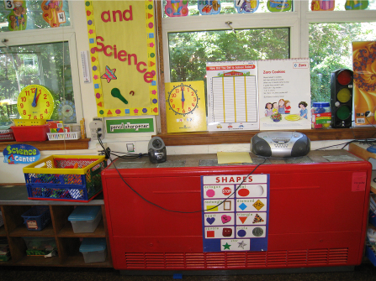

Classroom univent

Picture 2

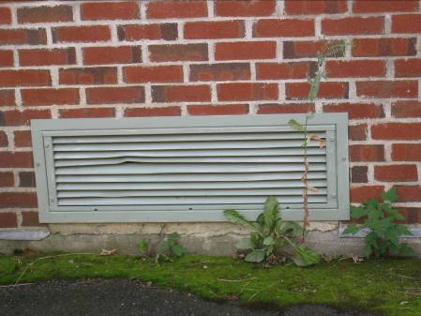

Univent fresh air intake

Picture 3

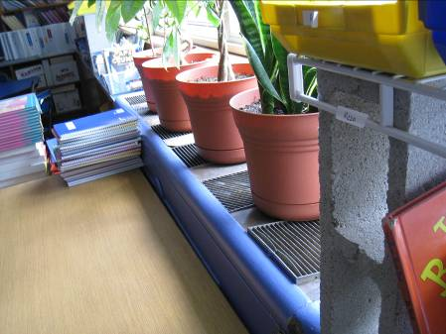

Items on top and in front of univent

Picture 4

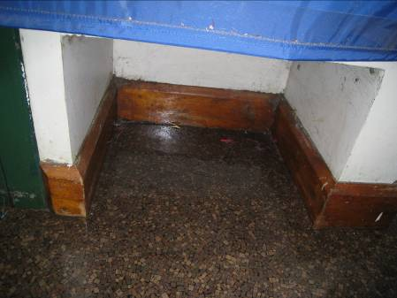

Switch-activated classroom exhaust cubby

Picture 5

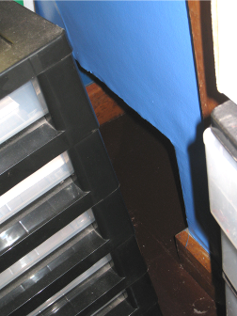

Obstructed exhaust cubby (arrow)

Picture 6

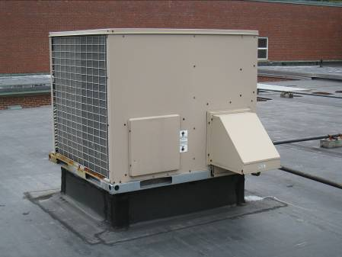

Rooftop AHU

Picture 7

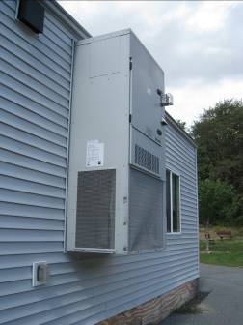

Side-mounted AHU

Picture 8

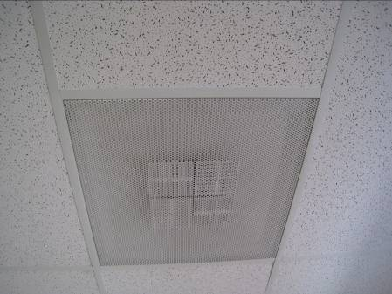

Ceiling-mounted diffuser

Picture 9

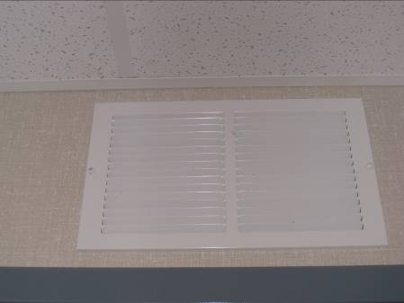

Wall-mounted exhaust vent

Picture 10

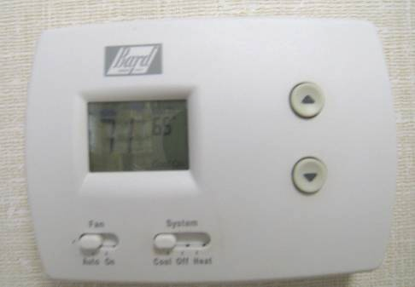

Thermostat set to auto

Picture 11

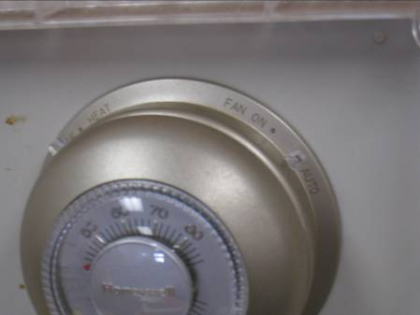

Thermostat set to auto

Picture 12

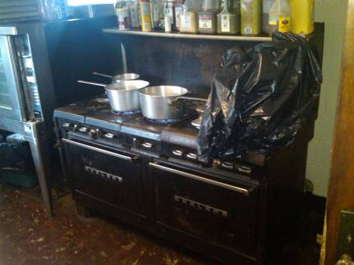

Gas stove in kitchen

Picture 13

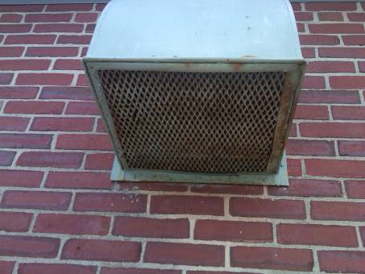

Exterior vent for kitchen hood

Picture 14

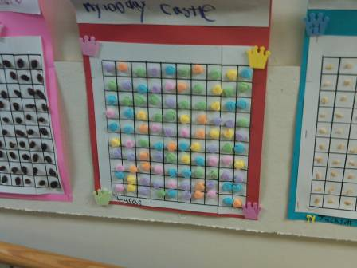

Food being used for art projects
Location | Carbon  Dioxide  (ppm) | Carbon Monoxide  (ppm) | Temp  (°F) | Relative  Humidity  (%) | PM2.5  (µg/m³) | Occupants  in Room | Windows  Openable | Ventilation |  | Remarks
 |  |  |  |  |  |  |  | Supply | Exhaust | Remarks
Background (Outdoor) | 340 | ND | 49 | 18 | 4
1 | 914 | ND | 70 | 27 | 9 | 24 | Y | Y | Y | Door open
2 | 1113 | ND | 70 | 33 | 10 | 0 | Y | Y | Y | Door open
3 | 734 | ND | 69 | 28 | 6 | 2 | Y | Y | Y | Door open
4 | 610 | ND | 69 | 28 | 3 | 4 | Y | Y | Y | Supply off
5 | 1103 | ND | 71 | 32 | 10 | 23 | Y | Y | Y
6 | 1117 | ND | 70 | 37 | 7 | 21 | Y | Y | Y
7 | 979 | ND | 73 | 37 | 13 | 22 | Y | Y | Y | Supply off, exhaust off, door open
8 | 1570 | ND | 72 | 37 | 7 | 17 | Y | Y | Y
9 | 1201 | ND | 72 | 28 | 5 | 22 | Y | Y | Y | Supply blocked by rolling shelf, door open
10 | 1072 | ND | 73 | 28 | 4 | 21 | Y | Y | Y | Door open
11 | 703 | ND | 72 | 24 | 3 | 2 | Y | Y | Y | Door open
12 | 902 | ND | 73 | 29 | 4 | 1 | Y | Y | Y
18 | 979 | ND | 74 | 36 | 6 | 20 | Y | Y | Y | Window open
22 | 2348 | ND | 71 | 41 | 14 | 19 | Y | Y | Y | Supply off, exhaust off
Cafeteria | 952 | 1 | 76 | 23 | 13 | 2 | Y | Y | N | Supply off
Kitchen | 1441 | 15 | 76 | 38 | 16 | 3 | Y | N | Y | Gas-fired stove, kitchen hood not drawing
Learning Center | 1387 | ND | 73 | 37 | 6 | 1 | Y | Y | Y | Supply off, exhaust off
Multipurpose room | 869 | ND | 71 | 27 | 6 | 3 | Y | Y | Y
Nurses office | 990 | ND | 71 | 29 | 11 | 1 | Y | Y | Y
OT | 2229 | ND | 71 | 42 | 11 | 1 | Y | Y | Y | Supply off, exhaust off, door open
School psychologist | 1199 | ND | 74 | 32 | 9 | 0 | Y | Y | Y | Supply off, exhaust off, door open
Staff room | 1823 | ND | 70 | 33 | 10 | 5 | Y | N | N | Door open
Time out | 1191 | ND | 73 | 33 | 7 | 1 | Y | Y | Y | Supply off, exhaust off, door open

