Background

INDOOR AIR QUALITY ASSESSMENT

East Middle School
305 River Street
Braintree, Massachusetts

Prepared by:
Massachusetts Department of Public Health
Bureau of Environmental Health
Indoor Air Quality Program
May 2019
Building: | East Middle School
Address: | 305 River Street, Braintree, MA
Assessment Requested by: | Dr. Frank Hackett, Superintendent, Braintree Public Schools
Reason for Request: | Follow up; building is currently involved in a construction/renovation project.
Date of Assessment: | May 13, 2019
Massachusetts Department of Public Health/Bureau of Environmental Health (MDPH/BEH) Staff Conducting Assessment: | Cory Holmes, Environmental Analyst, Indoor Air Quality (IAQ) Program
Date of Building Construction: | Late 1950s/early 1960s

Methods
Please refer to the IAQ Manual for methods, sampling procedures, and interpretation of results (MDPH, 2015).

RESULTS
The following is a summary of indoor air testing results (Table 1).
- Carbon dioxide levels were below the MDPH guideline of 800 parts per million (ppm) in all areas surveyed, with the exception of the Media Commons (which is unoccupied by students/staff) inside the construction zone.
- Temperature in occupied areas was slightly below the MDPH recommended range of 70°F to 78°F.
- Relative humidity was within the MDPH recommended range of 40 to 60% in all areas.
- Carbon monoxide (CO) levels were non-detect (ND) in all areas.
- Particulate matter (PM2.5) concentrations measured were below the National Ambient Air Quality (NAAQS) level of 35 μg/m³ in all occupied areas. Note readings in the construction zone were in excess of the NAAQS levels (125 μg/m³), which illustrates that construction barriers along with depressurization techniques are working to prevent migration of construction dusts.
- Total Volatile Organic Compounds (TVOCs) levels were ND in areas tested.

Frequently, indoor air levels of particulates (including PM2.5) can be at higher levels than those measured outdoors. A number of mechanical devices and/or activities that occur in schools can generate particulate during normal operations. Sources of indoor airborne particulates may include but are not limited to particles generated during the operation of fan belts in the HVAC system, cooking in cafeteria stoves and microwave ovens; use of photocopiers, fax machines and computer printing devices; operation of an ordinary vacuum cleaner and heavy foot traffic indoors.

Discussion/ Observations
At the time of the assessment, on-going construction activities were being conducted outside and inside the building. It is important to note that school officials and teacher representatives reported that a number of steps have been taken, including implementation of previous MDPH/IAQ Program recommendations, to vastly improve conditions within the building. These include:
- Weekly walkthroughs conducted by School Principal, John Sheehan and Board of Health Director, Marybeth McGrath, with any issues immediately reported to construction liaisons for prompt remediation;
- Construction of solid gypsum wallboard (GW) and/or wooden barriers (Pictures 1 through 4);
- The addition of walk-off mats to trap dirt/dust/debris at entrances/exits;
- The creation of airlocks (Pictures 5 and 6), where construction areas connect to occupied areas to provide additional protection against the migration of airborne pollutants into occupied areas;
- Implementation of high efficiency particulate arrestance (HEPA)-filtered air scrubber/depressurization units (Pictures 5 through 7) to collect airborne pollutants and depressurize construction areas relative to occupied areas;
- The creation of a shared “electronic folder” for staff to voice any concerns and share follow-up regarding actions taken/resolutions to issues identified;
- Monthly air testing by a 3rd party environmental consultant; and
- Additional cleaning/staff from 2:00-5:00 PM daily, mainly focused in hallways where dust and foot traffic is a concern. Further cleaning activities are also planned for weekends this spring (once windows are typically opened).

Overall, the steps taken have greatly improved conditions as observed by MDPH/IAQ staff, verified by air testing, and confirmed by both school administration and teacher representatives.
Although no elevated levels of construction-related pollutants were measured in the 3rd floor elevator shaft/construction area (no work was being done); BEH/IAQ staff noted that the area was pressurized at the time of the visit. A HEPA-filtered air scrubber was located in this area, which should be ducted to the exterior (Picture 7). Construction representatives communicated that it typically is, as indicated by a hole in the plastic containment (Picture 8). In addition, the plastic barrier covering the former window bank should be resealed/tightened up to prevent/reduce pressurization by outside drafts/wind conditions (Pictures 7 and 8).
Finally, an abandoned vent was noted in the main lobby/construction area (Picture 9). It was not clear where the terminus of this vent was located. It was recommended that the vent be sealed on both open ends as needed.

Recommendations
Based on observations and measurements at the time of the visit, the following recommendations should be implemented in order to further reduce the migration of construction/renovation generated pollutants into occupied areas:
- Continue with current policies and procedures as well as previous MDPH/IAQ Program recommendations. Previous reports can be accessed at: https://www.mass.gov/report/indoor-air-quality-reports or by request.
- Consult the MDPH guidance on construction and renovation generated pollutants in occupied buildings, which can be found at: https://www.mass.gov/service-details/construction-and-renovation-generated-pollutants-in-occupied-buildings.
- Reseal/tighten up barrier around former window bank in 3rd floor elevator shaft/construction area. Ensure HEPA-filtered air scrubber is directed away from occupied areas and outside (if possible) to prevent pressurization.
- Investigate abandoned vent in main lobby/construction area and seal/remove as necessary.
- As the weather warms towards the end of the school year, building occupants will likely use openable windows to increase air exchange. Ensure faculty members are aware of construction activities that may be conducted in close proximity to their classrooms. In certain cases, HVAC equipment and windows to classrooms adjacent to construction activities may need to be deactivated/closed periodically to prevent unfiltered air and vehicle exhaust from entering the building. In addition, please note that springtime in New England also brings pollen/allergy season, which can create an additional source of eye and respiratory irritation.
- Refer to resource manuals and other related indoor air quality documents for further building-wide evaluations and advice on maintaining public buildings. These materials are located on the MDPH’s website at http://www.state.ma.us/dph/beha/iaq/iaqhome.htm.

References
MDPH. 2015. Massachusetts Department of Public Health. Indoor Air Quality Manual: Chapters I-III. Available at: http://www.mass.gov/eohhs/gov/departments/dph/programs/environmental-health/exposure-topics/iaq/iaq-manual/.
Picture 1
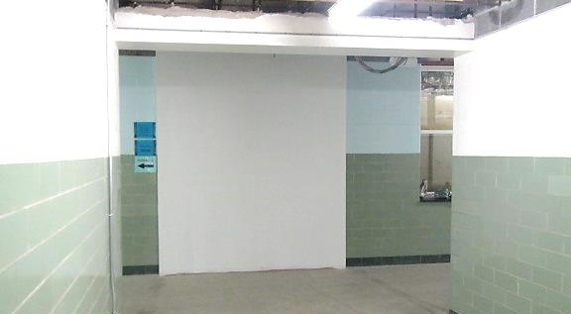
Solid/gypsum wallboard containment/construction barrier
Picture 2
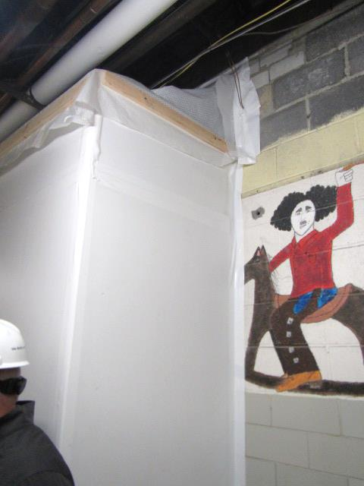
Solid/gypsum wallboard containment/construction barrier, note tape used to seal edges
Picture 3
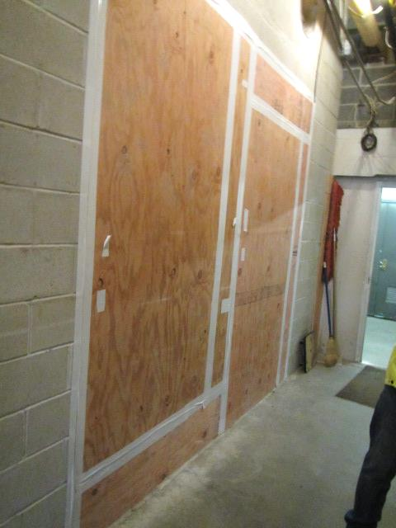
Solid/wooden containment/construction barrier, note tape used to seal edges
Picture 4
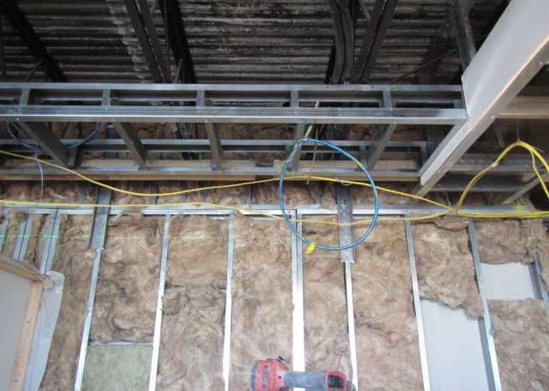
Solid/gypsum wallboard containment barrier (construction side), note insulation material to prevent drafts
Picture 5
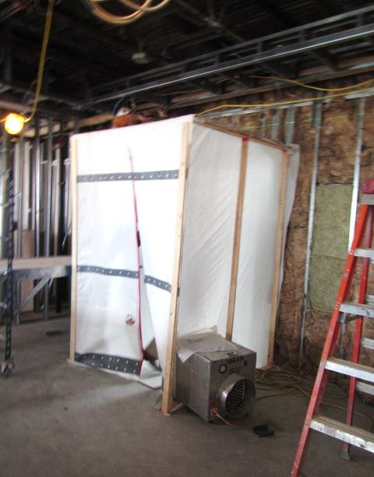
Example of airlock (construction side) sealing off entrances/exits between occupied and construction areas, also note depressurization unit (arrow)
Picture 6
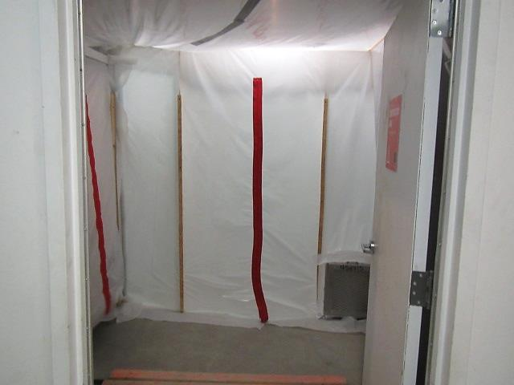
Example of airlock (occupied side) sealing off entrances/exits between occupied and construction areas, also note depressurization unit (arrow)
Picture 7
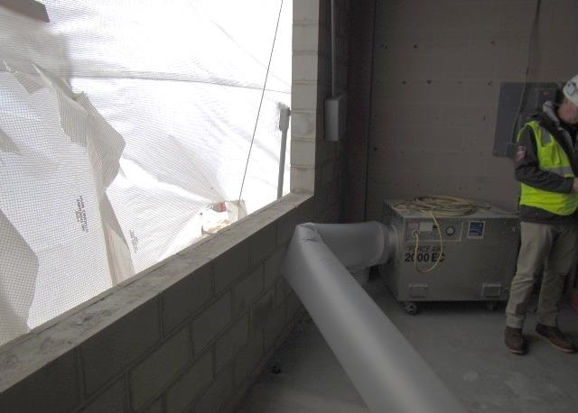
HEPA-filtered air scrubber in 3rd floor elevator shaft/construction area, note plastic covering former window bank, arrow indicates hole to exhaust unit
Picture 8
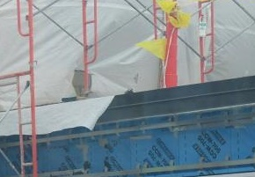
Exterior shot of plastic covering former window bank in 3rd floor elevator shaft/construction area, arrow indicates hole to exhaust unit
Picture 9
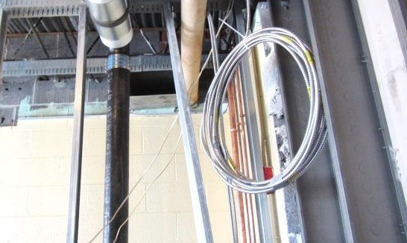
Abandoned/open vent (arrow) in main lobby/construction area

Location | Carbon  Dioxide  (ppm) | Carbon Monoxide  (ppm) | Temp  (°F) | Relative  Humidity  (%) | PM2.5  (µg/m³) | TVOC  (ppm) | Remarks
Background | 380 | ND | 56 | 51 | 15 | ND | Cool, windy, cloudy, Nor’easter expected later in day
3rd Floor Elevator Shaft/Construction Area | 496 | ND | 57 | 50 | 6 | ND | Pressurized, HEPA unit not exhausted, window barrier/plastic loose/hole
3rd Floor Hallway outside construction area | 677 | ND | 65 | 52 | 11 | ND
2nd Floor Hallway outside construction area | 601 | ND | 65 | 51 | 28 | ND | Recent foot traffic between classes
Main Lobby/Construction Area | 503 | ND | 56 | 51 | 6 | ND | Open to outdoors, air lock, abandoned vent
Media Commons/Construction Area | 970 | ND | 55 | 42 | 125 | ND | Active construction activities
Gym/Locker Room Hallway outside construction area | 601 | ND | 65 | 46 | 29 | ND | Recent foot traffic between classes
Cafeteria/Auditorium Hallway outside construction area | 596 | ND | 68 | 49 | 28 | ND | Recent foot traffic between classes/lunch activities/food prep

