Background

INDOOR AIR QUALITY ASSESSMENT

East Middle School
305 River Street
Braintree, Massachusetts

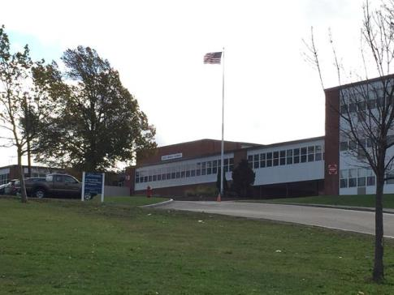

Prepared by:
Massachusetts Department of Public Health
Bureau of Environmental Health
Indoor Air Quality Program
October 2018
Building: | East Middle School
Address: | 305 River Street, Braintree, MA
Assessment Requested by: | Referral by Massachusetts Department of Labor Standards, Workplace Safety and Health Program
Reason for Request: | Reports of excessive dust conditions and respiratory irritation/symptoms by occupants. Building is currently involved in a construction/renovation project.
Date of Assessment: | September 21, 2018
BEH/IAQ Staff Conducting Assessment: | Cory Holmes, Environmental Analyst, Indoor Air Quality (IAQ) Program
Date of Building Construction: | Late 1950s/early 1960s

Methods
Please refer to the IAQ Manual for methods, sampling procedures, and interpretation of results (MDPH, 2015).

Results
The primary purpose of air testing at the school was to identify and reduce/prevent pollutant pathways. Outdoor PM2.5 concentrations ranged from 11-216 μg/m³ (Table 1). PM2.5 levels measured indoors ranged from 15 to 150 μg/m³, which were above the National Ambient Air Quality Standard (NAAQS) level of 35 μg/m³ in several areas assessed. Most likely due to several conditions:
- Infiltration of outdoor pollutants generated by construction activities via open windows/doors, as well as natural infiltration around old-single-paned window frames and spaces under/around exterior doors;
- Infiltration of indoor pollutants generated by construction activities into occupied areas from breaches in/around construction barriers;
- Typical dust/debris from school occupants/usage, note the building has over 900 occupants daily with typical high school activities.
Frequently, indoor air levels of particulates (including PM2.5) can be at higher levels than those measured outdoors. A number of mechanical devices and/or activities that occur in schools can generate particulate during normal operations. Sources of indoor airborne particulates may include but are not limited to particles generated during the operation of fan belts in the HVAC system, cooking in the cafeteria stoves and microwave ovens; use of photocopiers, fax machines and computer printing devices; operation of an ordinary vacuum cleaner and heavy foot traffic indoors.

Discussion/Visual Observations
It is important to note that in 2010, the Massachusetts School Building Authority (MSBA) amended their regulations 963 CMR 2.04 to address concerns associated with school renovation projects in Massachusetts. The regulations specifically state that “[e]ligible Applicants shall implement containment procedures for dusts, gases, fumes, and other pollutants created during construction of an Approved Project if the building is occupied by students, teachers or school department staff while such renovation and construction is occurring. Such containment procedures shall be consistent with the “IAQ Guidelines for Occupied Buildings Under Construction” published by the Sheet Metal and Air Conditioning Contractors National Association, Inc. (SMACNA, 1995), in effect at time of project approval. All bids and proposals received for an Approved Project shall include the cost of planning and execution of containment of construction/renovation pollutants consistent with such SMACNA guidelines” (MSBA, 2010).
Given the construction/renovation activities conducted, the MDPH assessment focused on the presence of airborne (respirable) particulates, settled dust and general cleanliness (Picture 1). At the time of the assessment, active construction activities were being conducted outside and inside the building. A number of construction vehicles and large piles of dirt/construction debris were noted around the building (Pictures 2 and 3). This activity should be closely monitored to avoid the entrainment of vehicle exhaust and other construction generated pollutants inside the building via open doors, windows or univent fresh air intakes. The opening of windows allows for unfiltered air to enter the classroom environment carrying with it airborne dirt, dust and particulates. Also noted in these areas were items seen piled on flat surfaces such as windowsills, countertops, cabinets and desks, which make it difficult for custodial staff to clean. Dusts can be irritating to the eyes, nose and respiratory tract.
In several areas construction zones were separated from occupied areas with solid barriers. In some cases the barriers were sealed along the edges with caulking (Pictures 4 and 5). In some cases, as with the largest barrier in the first floor main hallway, they were not sealed (Pictures 6 and 7) and slight drafts could be detected around the barriers. The outside of this area is sealed with a vapor wall barrier (Picture 8), however, if not perfectly sealed, outdoor pollutants can enter under certain wind and weather conditions.
In contrast, elevated levels of PM2.5 were detected in the arts hallway that were most likely related to indoor construction activities, such as drywall installation/sanding. At the time of assessment, the exterior door was open, which pressurized the room where dust was present/being generated (Picture 9), which then was forced into the hallway under the door (Picture 10). It is important to note that once airborne dust/debris from any source is in the hallway, it will have uncontrolled movement throughout the building (through hallways, up stairwells, into classrooms, into elevator shafts to different floors, etc.) by air currents generated by the large population moving through the building. Doors were pegged open throughout the building (cafeteria, classrooms, hallways, stairwells, etc.; Pictures 11 through 13) which allows the free movement of dust/debris. In many cases, classroom exhaust vents, which are designed to remove airborne pollutants from classrooms, will actually draw air from the hallway into classrooms if the doors are left open (Picture 13). School maintenance staff reported, however, that one rooftop exhaust motor was not operable at the time of assessment, therefore no exhaust ventilation was being provided to areas serviced by this motor.
In addition to interior construction barriers previously mentioned, the school and their construction/environmental managers were reportedly employing a number of methods to reduce dust generation including; sealing of concrete floors (prior to school opening), wetting down dirt by spraying around the exterior, installing a filter medium on the outside of fresh air intakes (Picture 14), exterior construction barriers (Picture 15) and hiring additional outside cleaning crews. In addition, portable carbon monoxide detectors were in use in classrooms adjacent to construction activities, although in one room the unit was unplugged (Picture 16).

Recommendations
Based on observations and measurements at the time of the visit, a number of potential pathways exist for pollutants to move from areas under construction/renovation into occupied spaces. The following recommendations should be implemented in order to reduce the migration of construction/renovation generated pollutants into occupied areas. We suggest that the majority of these steps be taken on any renovation project within a public building.
- Seal construction barriers on all sides with polyethylene plastic and/or duct tape/caulking. Seal these barriers on the construction as well as the occupied side (if possible) to provide a dual barrier. Ensure integrity of barriers by monitoring for light penetration and drafts around seams. In the case of the large barrier in the main hallway (Picture 7), seal around edges.
- Inspect classrooms for cleanliness and construction barriers for integrity daily prior to the opening of school. Consideration should also be given to inspect construction barriers at the end of the school day prior to construction work. In addition, encourage school staff to report any breaches in construction barriers immediately to the main office during the school day.
- Keep interior doors shut (e.g., classrooms, hallways, stairwells, common areas) to prevent the free migration of pollutants.
- Seal around exterior doors in construction areas with weather-stripping and door sweeps. Ensure they are closed as much as possible to avoid pressurizing in relation to occupied areas.
- Develop a notification system to provide building occupants immediately adjacent to construction activities a means to report construction/renovation related odors and/or dusts problems to the building administrator. Have these concerns relayed to the contractor in a manner to allow for a timely remediation of the problem.
- If possible, schedule projects that produce large amounts of dusts, odors and emissions during unoccupied periods or periods of low occupancy.
- Cover dirt/debris piles with tarps or wet down to decrease aerosolization of particulates, when possible.
- Ensure faculty members are aware of construction activities that may be conducted in close proximity to their classrooms. In certain cases, HVAC equipment and windows to classrooms adjacent to construction activities may need to be deactivated/closed periodically to prevent unfiltered air and vehicle exhaust from entering the building. For this reason, prior notification(s) should be made.
- Disseminate scheduling itinerary to all affected parties through meetings, newsletters and/or weekly bulletins.
- Ensure Material Safety Data Sheets (MSDS) are available upon request for all construction materials used during renovations and keep them in an area that is accessible to all individuals during periods of building operations as required by the Massachusetts Right-To-Know Act (MGL, 1983). Provide proper ventilation and allow sufficient curing time as per the manufacturer’s instructions concerning these materials.
- Relocate susceptible persons and those with pre-existing medical conditions (e.g., hypersensitivity, asthma) away from areas of renovations, if possible.
- Implement prudent housekeeping and work site practices to minimize exposure to renovation pollutants. Consider increasing the number of full-time equivalents or work hours for existing staff (e.g., before school) to accommodate increase in dirt, dust accumulation due to construction/renovation activities. To control for dusts, a high efficiency particulate air filter (HEPA) equipped vacuum cleaner in conjunction with wet wiping/mopping of all surfaces is recommended.
- Consider changing HVAC filters more regularly in areas impacted by renovation activities.
- Continue to use carbon monoxide detectors in classrooms near the construction zone in order to rapidly detect any infiltration of carbon monoxide into occupied areas.
- Because construction will continue in the building while portions of the building are occupied, follow the MDPH guidelines on “Methods Used to Reduce/Prevent Exposure to Construction/Renovation Generated Pollutants in Occupied Buildings”, attached as Appendix A and also available at: http://www.mass.gov/eohhs/gov/departments/dph/programs/environmental-health/exposure-topics/iaq/pollution/renovate/constructionrenovation-pollutants-prevention.html.

General Indoor Air Quality Recommendations
- Operate both supply (univents/Figure 1) and exhaust ventilation continuously during periods of school occupancy independent of classroom thermostat control to maximize air exchange.
- Inspect univent/exhaust motors and belts for proper function, repair and replace as necessary.
- Remove all blockages from univents and exhaust vents.
- Adopt scrupulous cleaning practices. For buildings in New England, periods of low relative humidity during the winter are often unavoidable. Therefore, scrupulous cleaning practices should be adopted to minimize common indoor air contaminants whose irritant effects can be enhanced when the relative humidity is low. To control for dusts, a high efficiency particulate arrestance (HEPA) filter equipped vacuum cleaner in conjunction with wet wiping of all surfaces is recommended. Drinking water during the day can help ease some symptoms associated with a dry environment (throat and sinus irritations).
- Clean personal fans, supply and exhaust vents periodically to prevent excessive dust build-up.
- Relocate or consider reducing the amount of materials stored in classrooms to allow for more thorough cleaning. Clean items regularly with a wet cloth or sponge to prevent excessive dust build-up.
- Consider adopting the US EPA document, “Tools for Schools” in order to maintain a good indoor air quality environment on the building. This document can be downloaded from the Internet at http://www.epa.gov/iaq/schools/index.html.
- Refer to resource manuals and other related indoor air quality documents for further building-wide evaluations and advice on maintaining public buildings. These materials are located on the MDPH’s website at http://www.state.ma.us/dph/beha/iaq/iaqhome.htm.

References
MDPH. 2015. Massachusetts Department of Public Health. Indoor Air Quality Manual: Chapters I-III. Available at: http://www.mass.gov/eohhs/gov/departments/dph/programs/environmental-health/exposure-topics/iaq/iaq-manual/.
MGL. 1983. Hazardous Substances Disclosure by Employers. Massachusetts General Laws. M.G.L. c. 111F.
MSBA. 2010. Massachusetts School Building Authority’s Regulations, 963 CMR 2.04(2) (2) Design and Construction Standards: Indoor Air Quality. Page 11. Promulgated 4/16/10.
SMACNA. 1995. IAQ Guidelines for Occupied Buildings Under Construction. 1st ed. Sheet Metal and Air Conditioning Contractors’ National Association, Inc., Chantilly, VA.
Picture 1
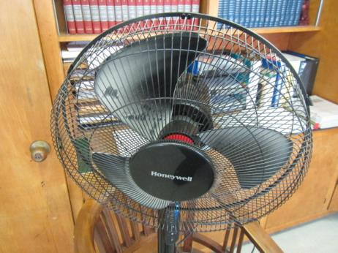
Dust/debris accumulation on portable fan
Picture 2
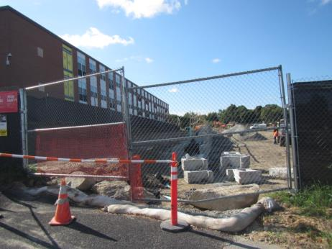
Outdoor construction activities adjacent to the occupied building
Picture 3
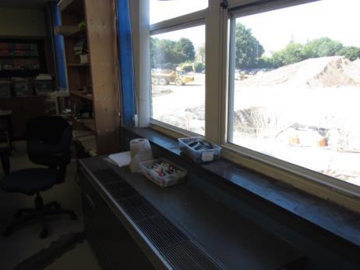
Outdoor construction activities adjacent to the occupied building
Picture 4
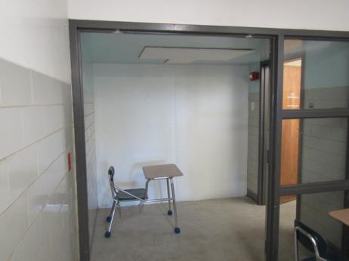
Construction barrier outside room 213, edges sealed with caulking
Picture 5
Close-up of construction barrier outside room 213, edges sealed with caulking
Picture 6
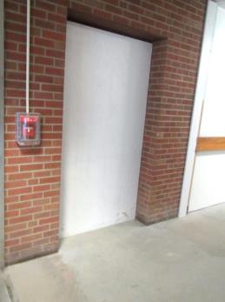
Solid construction barrier in first floor hallway
Picture 7
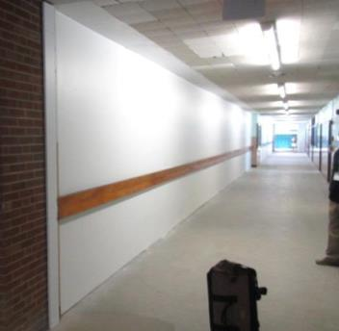
Large solid construction barrier in first floor hallway
Picture 8
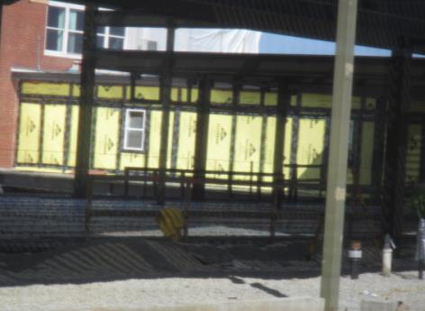
Vapor barrier on exterior outside large construction barrier in Pictures 6 and 7
Picture 9
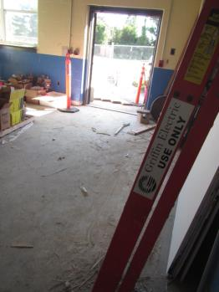
Room off Arts hallway, note exterior door open and accumulated dust/debris on floor
Picture 10
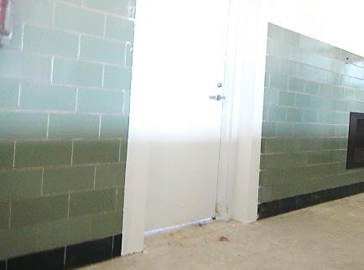
Note space under door where drywall work in Picture 9 was being done
Picture 11
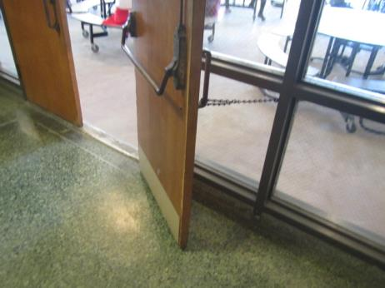
Cafeteria door chained open
Picture 12
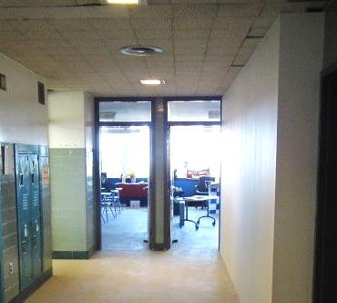
Classroom doors pegged open
Picture 13
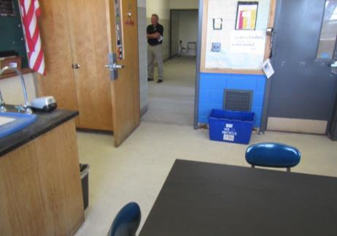
Classroom doors open during class, note location of exhaust vent; arrow indicates the draw of air from the hallway
Picture 14
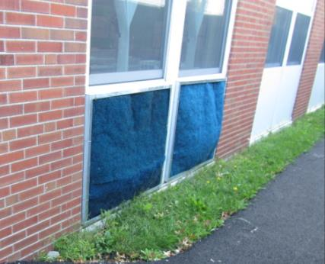
Filter media over fresh air intakes
Picture 15
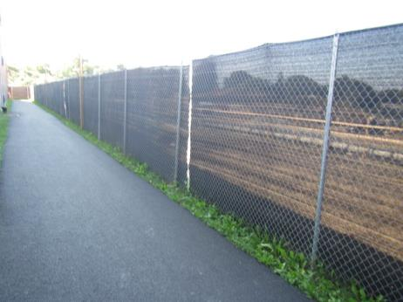
Exterior construction barriers
Picture 16
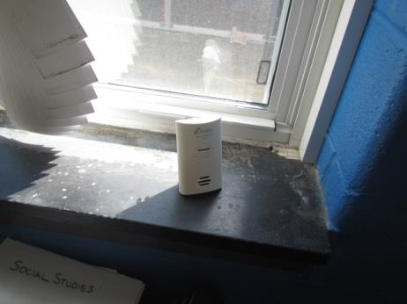
Portable carbon monoxide detector in classroom
Location | PM2.5  (µg/m³) | Windows  Openable | Ventilation |  | Remarks
 |  |  | Supply | Exhaust
Background (outdoors) | 11-216* |  |  |  | Partly sunny, winds SSE 6-12 MPH  *near construction activities
1st Floor Hallway near Main Office | 46-58 | N | N | N | Large/solid construction barrier, slight drafts underneath, heavy foot traffic
205 | 39 | Y | Y | Y | Exhaust vent blocked by desk/off, door open, portable fan-dusty, carbon monoxide monitor
213 | 24 | N | Y | Y | Portable AC unit, portable fans (2), DO
Barrier outside Room 213 | 32 |  |  |  | Solid, caulked around barrier
216 | 34-43 | Y | Y | Y | Exhaust off/backdrafting
Hallway 216 | 69-88 |  |  |  | Measurement taken between classes, heavy foot traffic
Arts Hallway | 150 |  |  |  | Drywall work/accumulated dust in room off hallway with exterior door open-pressurizing the room
Art 222 | 97 | Y | Y | Y | Personal fan, exhaust off/backdrafting
Gym Hallway | 15-21
Gym | 15 | N | Y | Y | ~ 50 occupants having class
Girls Locker Room | 17 | N | Y | Y
Boys Locker Room | 40 | Y | Y | Y | Single-paned windows-drafty
307 | 35-42 | Y | Y | Y | Exhaust behind door, DO
311 | 23 | Y open | Y | Y
3rd Floor Elevator Shaft Area | 75 | Y | N | N | Windows can be used for negative ventilation
3rd Floor Hallway 301-303 | 128 |  |  |  | Heavy foot traffic

