INDOOR AIR QUALITY ASSESSMENT

Easthampton City Hall
50 Payson Avenue
Easthampton, MA

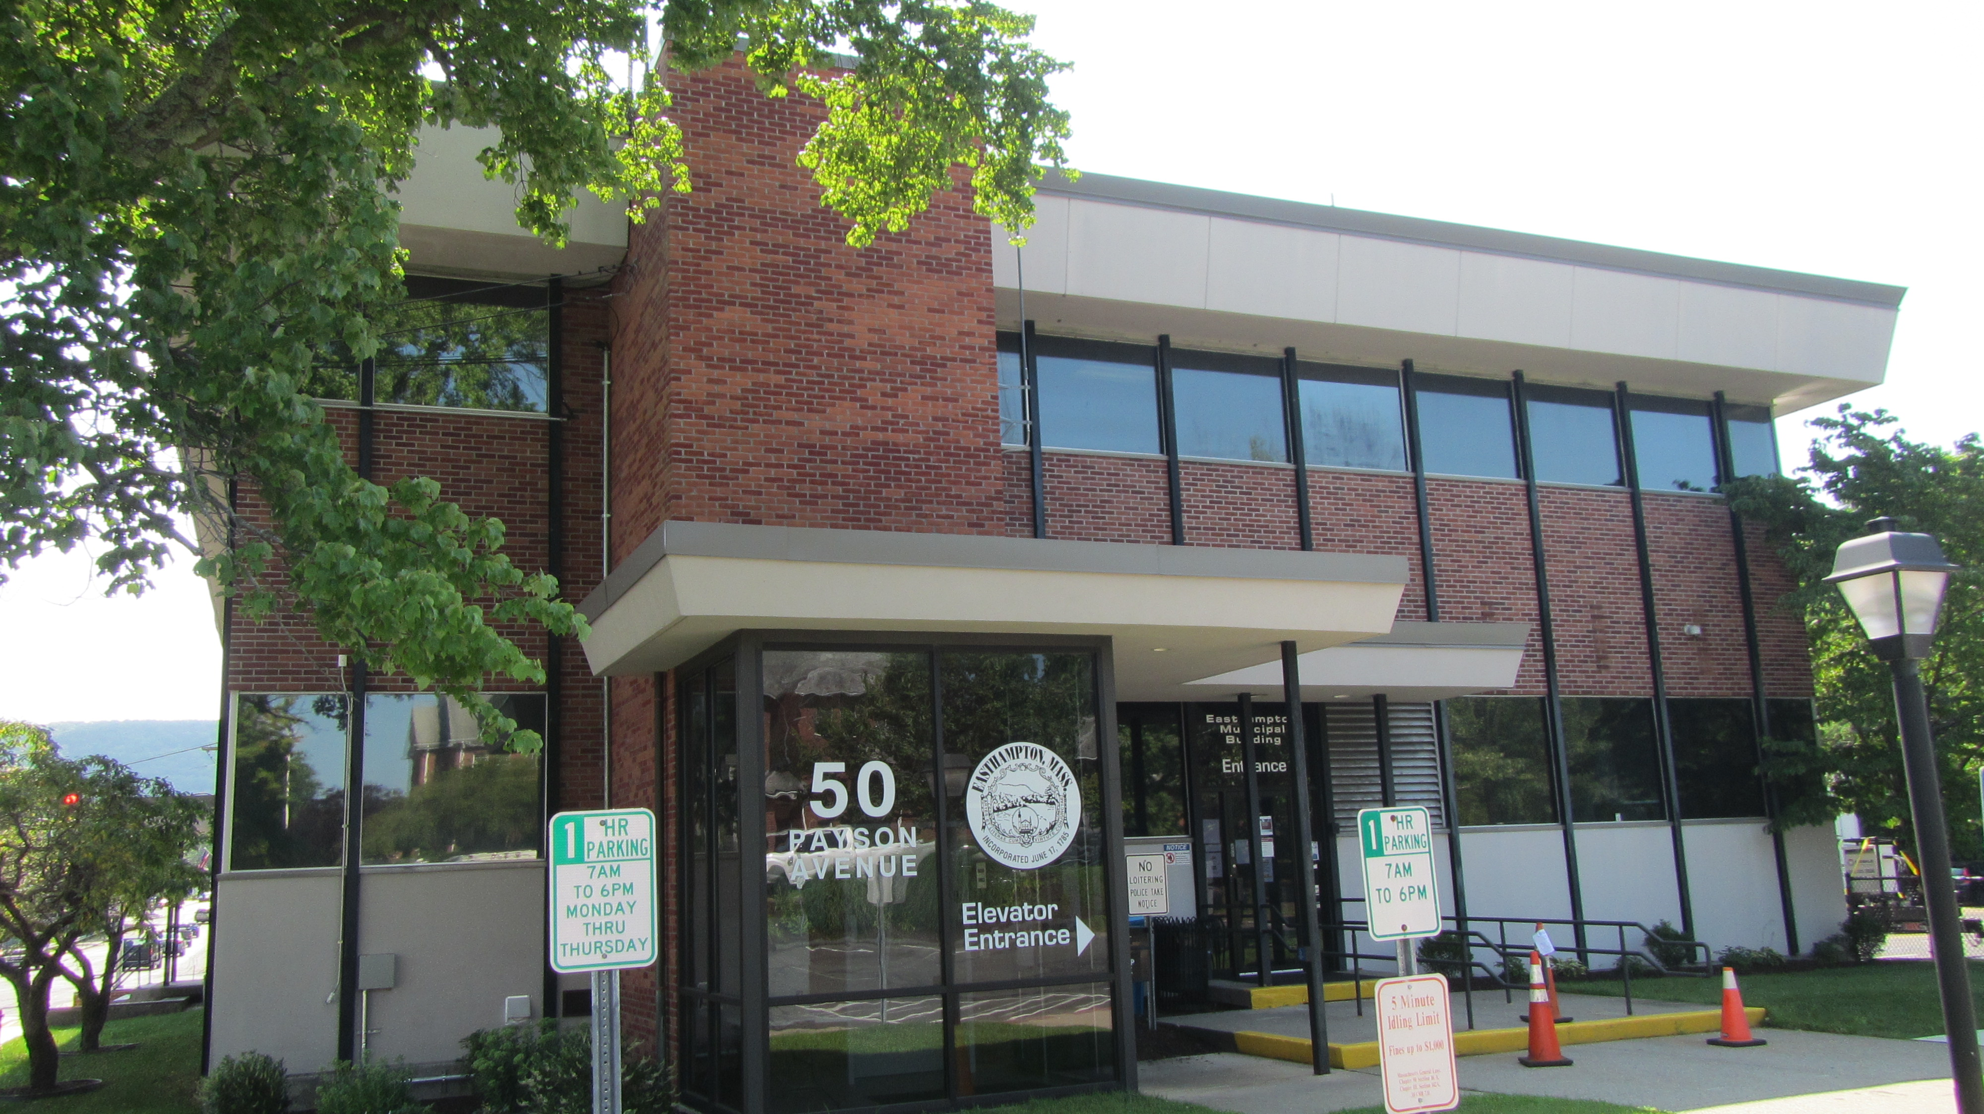

Prepared by:
Massachusetts Department of Public Health
Bureau of Climate and Environmental Health
Indoor Air Quality Program
August 2023

BACKGROUND
Building: | Easthampton City Hall (ECH)
Address: | 50 Payson Avenue, Easthampton, MA
Assessment Requested by: | Allison Egan, Director of Public Health, City of Easthampton
Reason for Request: | Renovation of the building while occupied
Date of Assessment: | July 28, 2023
Massachusetts Department of Public Health/Bureau of Climate and Environmental Health (MDPH/BCEH) Staff Conducting Assessment: | Mike Feeney, Director, Indoor Air Quality  (IAQ) Program
Building Description: | The ECH is a two-story brick building built in the 1970s
Building Population: | ~20
Windows: | Windows are not openable.

IAQ TESTING RESULTS
Please refer to the IAQ Manual for methods, sampling procedures, and interpretation of results (MDPH, 2015). The following is a summary of indoor air testing results:
- Carbon dioxide levels were below the MDPH guideline of 800 parts per million (ppm) in all areas tested. However, most areas were empty, which can reduce carbon dioxide levels.
- Temperature was within or close to the recommended range of 70°F to 78°F the day of the assessment.
- Relative humidity was below the recommended range of 40 to 60% in all areas tested on the day of assessment.
- Carbon monoxide levels were non-detectable (ND) in all areas tested.
- Fine particulate matter (PM2.5) concentrations measured were below the National Ambient Air Quality (NAAQS) limit of 35 μg/m³ in all areas tested.
- Volatile Organic Compounds were ND throughout all areas tested.

RENOVATION ISSUES
This request was prompted by concerns about indoor air quality related to construction/renovation activities. As reported by city officials, the ECH heating, ventilating, and air-conditioning (HVAC) system was undergoing replacement. To install new HVAC equipment, a basement wall of the mechanical room was jackhammered open, which generated cement dust that migrated to occupied areas of the building. At the time of this assessment, the new HVAC equipment had been moved into the basement mechanical room and the wall was repaired (Picture 1). No direct renovation activities were being conducted at the time of the visit.
To assess whether pollutants related to construction remained in occupied areas of the ECH, air monitoring for total volatile organic compounds (TVOCs), airborne particulates, and carbon monoxide were conducted. Air tests for carbon monoxide and particulate matter of a diameter of 2.5 microns or less (PM2.5) were taken with the TSI, Q-Trak XP, IAQ Monitor. Screening for TVOCs was conducted using a RAE Systems MiniRAE Lite Photo Ionization Detector (PID) equipped with a 10.6 (eV) electronic volt lamp. Outdoor measurements for all parameters were taken as comparison values to indoor levels measured (e.g., background).
Construction/demolition activities can produce several pollutants, including dirt, dust, and other particulates. Construction vehicles also produce combustion products, such as carbon monoxide and particulate matter. Particles generated from construction activities can settle on surfaces. Dust can be irritating to the eyes, nose, and respiratory tract.
Using an instant read meter for particulates can allow sources of particles to be identified by moving the measuring device through a building towards the highest measured concentration of airborne particles. Measured levels of particles in the air would increase as the device moves closer to the source of particle production. The primary purpose of the tests conducted was to identify and reduce/prevent pollutant pathways.
Air monitoring was conducted in offices, hallways, and other areas, which may be directly impacted due to close proximity to the areas under renovation. For comparison, measurements were also taken in areas away from renovation sites indoors as well as outdoors. Levels of particulates and other constituents were not noted above background; however, no renovation activities were occurring during this assessment. If renovations were to restart, all construction/renovation-related activity should be closely monitored to prevent migration of airborne pollutants inside the building.
The MDPH IAQ Program recommends that any public building undergoing renovations while occupied utilize containment procedures be consistent with the “IAQ Guidelines for Occupied Buildings Under Construction” published by the Sheet Metal and Air Conditioning Contractors National Association, Inc. (SMACNA, 2007). Additional information can be found in the MDPH Guideline “Construction and Renovation Generated Pollutants in Occupied Buildings” (https://www.mass.gov/service-details/construction-and-renovation-generated-pollutants-in-occupied-buildings).

Carbon monoxide
If renovation equipment uses fossil fuel or combustible gas (e.g., gas-fired cutters, electrical generators, vehicles), the process of combustion also produces carbon monoxide. Carbon monoxide is a by-product of incomplete combustion of organic matter (e.g., gasoline, wood and tobacco). Exposure to carbon monoxide can produce immediate and acute health effects. Several air quality standards have been established to address carbon monoxide pollution and prevent symptoms from exposure to these substances.
The MDPH established a corrective action level concerning carbon monoxide in ice skating rinks that use fossil-fueled ice resurfacing equipment. If an operator of an indoor ice rink measures a carbon monoxide level over 30 ppm, taken 20 minutes after resurfacing within a rink, that operator must take actions of reduce carbon monoxide levels (MDPH, 1997). If this measurement is exceeded, ventilation of non-renovation sections of the building in recommended to reduce carbon monoxide levels. The American Society of Heating, Refrigeration and Air Conditioning Engineers (ASHRAE) has adopted the National Ambient Air Quality Standards (NAAQS) as one set of criteria for assessing indoor air quality and monitoring of fresh air introduced by HVAC systems (ASHRAE, 2022). The NAAQS are standards established by the US EPA to protect the public health from 6 criteria pollutants, including carbon monoxide and particulate matter (US EPA, 2023). As recommended by ASHRAE, pollutant levels of fresh air introduced to a building should not exceed the NAAQS (ASHRAE, 2022). According to the NAAQS established by the US EPA, carbon monoxide levels in outdoor air should not exceed 9 ppm in an eight-hour average (US EPA, 2023). Carbon monoxide should not be present in a typical, indoor environment. If it is present, indoor carbon monoxide levels should be less than or equal to outdoor levels. Outdoor carbon monoxide concentrations were non-detect (ND). Carbon monoxide levels measured in the building were also ND.

Volatile organic compounds
Indoor air quality can also be impacted by the presence of materials containing volatile organic compounds (VOCs). VOCs are substances that have the ability to evaporate at room temperature. Frequently, exposure to low levels of total VOCs (TVOCs) may produce eye, nose, throat and/or respiratory irritation in some sensitive individuals. For example, chemicals evaporating from a paint can stored at room temperature would most likely contain VOCs. In an effort to determine whether VOCs were present in the building, air monitoring for TVOCs was conducted. Outdoor air samples were taken for comparison. Outdoor TVOC concentrations were ND. No TVOC levels related to construction activities were measured indoors.

Particulate matter (PM 2.5)
The US EPA has established NAAQS limits for exposure to particulate matter. Particulate matter includes airborne solids that can be irritating to the eyes, nose and throat. The NAAQS originally established exposure limits to PM with a diameter of 10 μm or less (PM10). In 1997, US EPA established a more protective standard for fine airborne particulate matter with a diameter of 2.5 μm or less (PM2.5). This more stringent PM2.5 standard requires outdoor air particle levels be maintained below 35 μg/m³ over a 24-hour average (US EPA, 2023). MDPH uses the more protective PM2.5 standard for evaluating airborne PM concentrations in the indoor environment.
Frequently, indoor air levels of particulates (including PM2.5) can be at higher levels than those measured outdoors. A number of activities that occur indoors and/or mechanical devices can generate particulate matter during normal operations. Sources of indoor airborne particulates may include but are not limited to particles generated during the operation of fan belts in the HVAC system; use of stoves and/or microwave ovens in kitchen areas; use of photocopiers, fax machines and computer printing devices; operation of an ordinary vacuum cleaner; and heavy foot traffic indoors. Renovations such as jackhammering cement walls, would produce significant airborne particulate. At the time of this assessment PM2.5 concentrations measured were below the NAAQS limit of 35 μg/m³ in all areas tested.

Carbon dioxide, Temperature and Relative Humidity
General air quality testing for comfort parameters (carbon dioxide, temperature, and relative humidity) was also conducted. Carbon dioxide levels were below 800 parts per million (ppm) parts in all areas surveyed, however with very low occupancy this may or may not indicate adequate air exchange. It is important to note that windows do not open in the ECH, therefore the sole source of outside air is the HVAC system. At the time of this assessment, a temporary portable mechanical ventilation unit was connected to the existing ventilation system in the ECH (Picture 2).
Carbon dioxide is not a problem in and of itself. It is used as an indicator of the adequacy of fresh air ventilation. As carbon dioxide levels rise, it indicates that the ventilating system is malfunctioning, or the design occupancy of the room is being exceeded. When this happens, a buildup of common indoor air pollutants can occur, leading to discomfort or health complaints. The Occupational Safety and Health Administration (OSHA) standard for carbon dioxide is 5,000 parts per million parts of air (ppm). Workers may be exposed to this level for 40 hours/week, based on a time-weighted average (OSHA, 1997).
The MDPH uses a guideline of 800 ppm for publicly occupied buildings. Inadequate ventilation and/or elevated temperatures are major causes of complaints such as respiratory, eye, nose and throat irritation, lethargy, and headaches.
Temperature measurements ranged from 69°F to 71°F, ranging from slightly below to the lower end of the MDPH comfort guidelines. The MDPH recommends that indoor air temperatures be maintained in a range of 70°F to 78°F to provide for the comfort of building occupants. In many cases concerning indoor air quality, fluctuations of temperature in occupied spaces are typically experienced, even in a building with an adequate fresh air supply.
The relative humidity measured in the building ranged from 30 to 34 percent, which was below the MDPH recommended comfort range. The MDPH recommends a comfort range of 40 to 60 percent for indoor air relative humidity. Relative humidity levels in the building would be expected to drop during the winter months due to heating. The sensation of dryness and irritation is common in a low relative humidity environment. Low relative humidity is a very common problem during the heating season in the northeast part of the United States.

CONCLUSIONS/RECOMMENDATIONS
Based on observations made during this visit, the following recommendations are made.

General Indoor Air Quality Recommendations
- Continue to operate both supply and exhaust ventilation continuously during periods of occupancy to maximize air exchange.
- Continue working with HVAC engineering company for options to increase the introduction of outside air to occupied areas.

Construction/Renovations Recommendations
A number of pathways exist for pollutants to move from areas under renovation to occupied spaces. These pathways indicate that containment measures implemented at the time of the assessment were not sufficient to contain pollutants related to renovation work. The following recommendations should be implemented to reduce the migration of renovation-generated pollutants into occupied areas and the potential impact on indoor air quality:

- Use containment procedures that are consistent with the most current edition of the IAQ Guidelines for Occupied Buildings Under Construction published by the Sheet Metal and Air Conditioning Contractors National Association, Inc. (SMACNA, 2007).
- Also use guidance in “Construction and Renovation Generated Pollutants in Occupied Buildings” (https://www.mass.gov/service-details/construction-and-renovation-generated-pollutants-in-occupied-buildings).
- Seal construction barriers with polyethylene plastic sheeting and duct tape in a proper manner. Consider creating dual barriers by installing polyethylene on both sides of the barrier (construction and occupied sides). Seal any utility holes in barriers separating occupied areas from the construction zone. Inspect these areas regularly (e.g., daily) to ensure integrity is maintained.
- Establish communications among all parties involved with building renovations to prevent potential IAQ problems. Develop a forum for occupants to express concerns about renovations as well as a program to resolve IAQ issues.
- Develop a notification system for building occupants, especially those immediately adjacent to construction activities, to report construction/renovation related odors and/or dusts problems to the building administrator. Have these concerns relayed to the contractor in a manner to allow for timely remediation of the problem.
- Disseminate scheduling itinerary to all affected parties via meetings or weekly bulletins.
- Schedule projects that produce large amounts of dusts, odors, and emissions during unoccupied or low occupancy periods, when possible.
- Obtain Safety Data Sheets (SDS) for all construction materials used during renovations and keep them in an area that is accessible to all individuals during periods of building operations as required by the Massachusetts Right-To-Know Act (MGL, 1983).
- Consult SDSs for any material applied to the affected area during construction including any sealant, adhesives, tile mastic, flooring and/or roofing materials. Provide proper ventilation and allow sufficient curing time as per the manufacturer’s instructions concerning these materials.
- Relocate susceptible persons and those with pre-existing medical conditions (e.g., hypersensitivity, asthma) away from areas of construction/renovations, if possible.
- Implement thorough housekeeping and work site practices to minimize exposure to renovation pollutants. Consider increasing manpower or work hours for cleaning staff (e.g., before daily activities begin) to accommodate increased need for cleaning of dirt and dust due to construction activities. To control dust, a high efficiency particulate air filter (HEPA) equipped vacuum cleaner in conjunction with wet wiping/mopping of all surfaces is recommended. These methods minimize aerosolization of dust.

REFERENCES
ASHRAE, 2022. American Society of Heating, Refrigeration and Air Conditioning Engineers (ASHRAE) Ventilation for Acceptable Indoor Air Quality. ANSI/ASHRAE Standard 62.1-2022. Atlanta, GA.
MDPH. 1997. Requirements to Maintain Air Quality in Indoor Skating Rinks (State Sanitary Code, Chapter XI). 105 CMR 675.000. Massachusetts Department of Public Health, Boston, MA.

MDPH. 2015. Massachusetts Department of Public Health. “Indoor Air Quality Manual: Chapters I-III”. Available at: Indoor air quality - manual and appendices | Mass.gov

MGL. 1983. Hazardous Substances Disclosure by Employers. Massachusetts General Laws. M.G.L. c. 111F.

OSHA. 1997. Limits for Air Contaminants. Occupational Safety and Health Administration. Code of Federal Regulations. 29 C.F.R 1910.1000 Table Z-1-A.

SMACNA. 2007. IAQ Guidelines for Occupied Buildings Under Construction. 2nd ed. Sheet Metal and Air Conditioning Contractors’ National Association, Inc., Chantilly, VA.

US EPA. 2023. National Ambient Air Quality Standards (NAAQS). US Environmental Protection Agency, Office of Air Quality Planning and Standards, Washington, DC. Last updated on March 15, 2023, NAAQS Table | US EPA
Picture 1

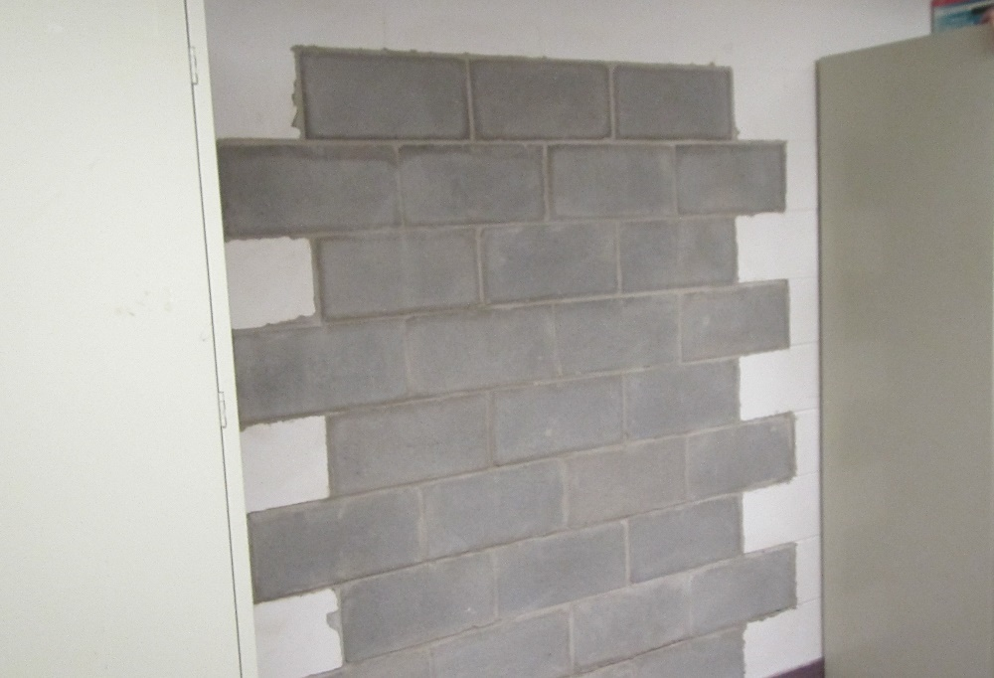

Repaired wall in basement that had been jackhammered

Picture 2

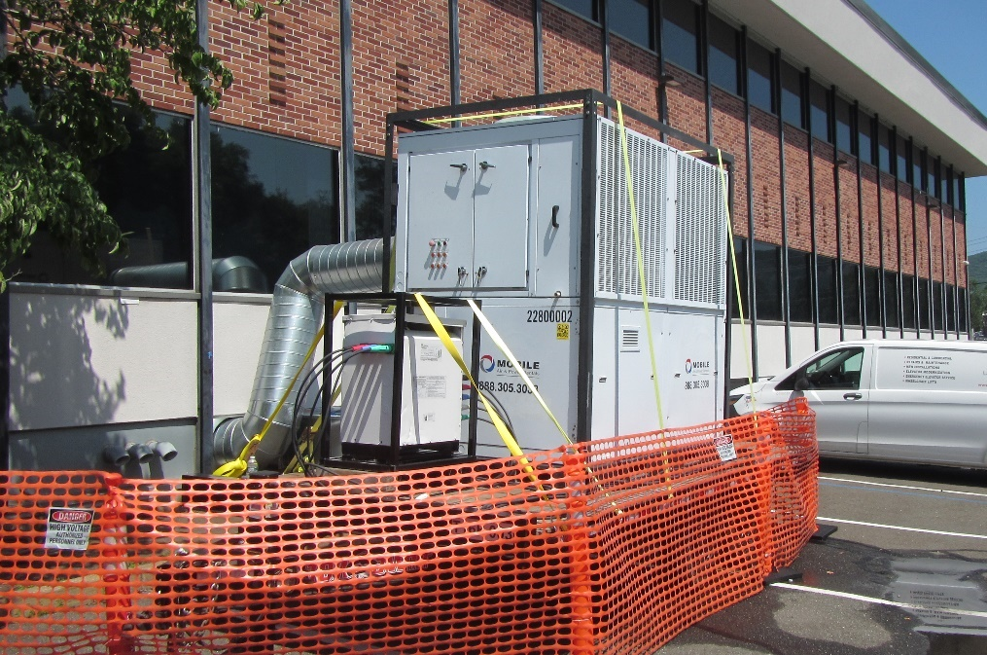

Temporary HVAC AHU connected to ECH existing ventilation ductwork

