INDOOR AIR QUALITY ASSESSMENT

Easthampton RMV Branch
Eastworks Building
116 Pleasant Street
Easthampton, MA

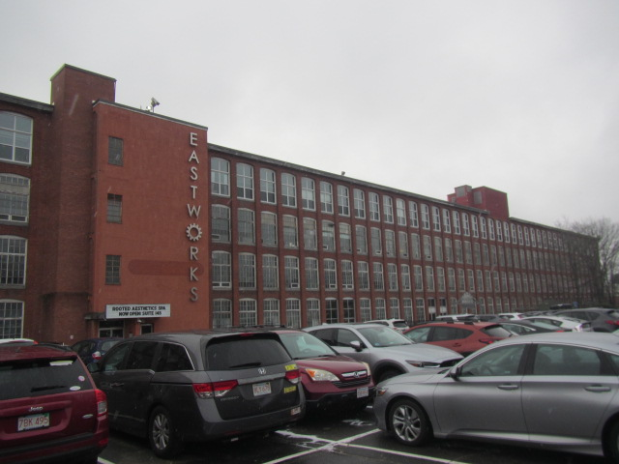

Prepared by:
Massachusetts Department of Public Health
Bureau of Climate and Environmental Health
Division of Environmental Health Regulations and Standards
December 2025

BACKGROUND
Building: | Easthampton Registry of Motor Vehicles (RMV)
Address: | Eastworks Building, 116 Pleasant Street, Easthampton, MA
Assessment Requested by: | RMV Union Employees
Reason for Request: | General indoor air quality (IAQ) and airborne dust concerns
Date of Assessment: | December 23, 2025
Massachusetts Department of Public Health/Bureau of Climate and Environmental Health (MDPH/BCEH) Staff Conducting Assessment: | Cory Holmes, Senior Advisor for IAQ Inspections, Audits, Outreach and Education, Division of Environmental Health Regulations and Standards
Building Description: | The Easthampton RMV has occupied space on the first floor of the renovated Eastworks mill building for approximately 17 years. The space contains wooden plank floors, brick and gypsum wallboard walls, and an open ceiling configuration.
Windows: | Not openable, sealed with plastic to prevent drafts.

METHODS
Please refer to the IAQ Manual for methods, sampling procedures, and interpretation of results (MDPH, 2015).

RESULTS AND DISCUSSION
Measurements for IAQ parameters are shown in Table 1 and summarized below:
- Carbon dioxide (CO₂) | a measure of the adequacy of ventilation | Levels were above the MDPH guideline of 800 parts per million (ppm) in all RMV areas, indicating a lack of air exchange at the time of assessment.
- Temperature | a measure of comfort | Was within the MDPH recommended range of 70°F to 78°F in areas tested.
- Relative humidity | a measure of comfort and, when in excess for an extended period, a way to reflect the potential for mold and fungal growth | Was below the MDPH recommended range of 40 to 60% in all areas tested. This is reflective of outdoor conditions. Low relative humidity is common indoors during the heating season. Relative humidity would be expected to be higher during hot, humid weather.  Note, low relative humidity can lead to common symptoms such as: dry skin, lips, and scalp; dry/scratchy throats and noses (nose bleeds); exacerbation of asthma, eczema, or allergies; dry/irritated eyes; and irritation of respiratory tract.
- Carbon monoxide  (CO) | a product of combustion that can result in acute and long term cardiovascular, respiratory, and neurological symptoms | Carbon monoxide should not be present in a typical, indoor environment. If it is present, indoor carbon monoxide levels should be less than or equal to outdoor levels. On the day of assessment, outdoor carbon monoxide concentrations were 5.3 ppm (Table 1). Slight levels (3.0 to 3.7 ppm) were detected in indoor areas assessed, which were below and reflective of outdoor conditions (Table 1).  The National Ambient Air Quality Standard (NAAQS) states that carbon monoxide levels in outdoor air should not exceed 9 ppm in an eight-hour average (US EPA, 2025).  The MDPH established a corrective action level of 30 ppm concerning carbon monoxide in ice skating rinks that use fossil-fueled ice resurfacing equipment.
- Particulate matter (PM2.5) | a way to measure inhalable particle distribution in the air | Concentrations were well below the National Ambient Air Quality Standard (NAAQS) of 35 micrograms per cubic meter (μg/m³), as well as background/outside levels (13 μg/m³) in all areas tested, with most ND.
- Total Volatile Organic Compounds (TVOCs) | VOCs are carbon-containing substances that can evaporate at room temperature. Frequently, exposure to low levels of total VOCs (TVOCs) may produce eye, nose, throat and/or respiratory irritation in some sensitive individuals. | Slight levels (<1.0 ppm) were detected in all areas assessed, most likely due to VOC-containing products (hand sanitizers and alcohol wipes) in use within the RMV.

Ventilation
A heating, ventilating, and air conditioning (HVAC) system has several functions. First, it provides heating and, if equipped, cooling. Second, it is a source of fresh air. Finally, an HVAC system will dilute and remove normally occurring indoor environmental pollutants by not only introducing fresh air but also filtering the airstream and ejecting stale air to the outdoors via exhaust ventilation. Even if an HVAC system is operating as designed, point sources of respiratory irritation may exist and lead to symptoms in sensitive individuals.
Fresh air is provided by a ceiling-mounted air handling unit (AHU, Picture 1) that appeared to be connected to an air exchanger that both draws in outside air and exhausts to the exterior (Pictures 2 and 3). Supply air drawn in by the air exchanger is filtered, heated/cooled by the AHU, and delivered throughout the space via ducted supply vents (Picture 4). Exhaust air appears to be drawn through an open duct on the air exchanger (Picture 2) to be removed from the building. However, the exhaust vent is angled down towards the supply vent (Picture 3), which could lead to pollutants being drawn back into the system, called “short-circuiting”. This vent should be extended or angled away from the supply vent.
The ventilation system should be on and operational to supply fresh air continuously during occupied periods. Without adequate fresh air supply and removal of stale air, common indoor air pollutants can build up and cause irritation. The system was on and appeared to be operating normally at the time of assessment. However, as the elevated carbon dioxide levels indicate, more fresh air (or more exhaust) should be provided to increase air exchange.
Please note, carbon dioxide is not a problem in and of itself. It is used as an indicator of the adequacy of the fresh air ventilation. As carbon dioxide levels rise, it indicates that the ventilating system is malfunctioning or the design occupancy of the room is being exceeded. When this happens, a buildup of common indoor air pollutants can occur, leading to discomfort or health complaints. The Occupational Safety and Health Administration (OSHA) standard for carbon dioxide is 5,000 parts per million parts of air (ppm). Workers may be exposed to this level for 40 hours/week, based on a time-weighted average (OSHA, 1997).

Airborne Dust/Debris and Particulate Matter
The IAQ Unit recommends that HVAC filters be changed 2-4 times a year (or per the manufacturer’s recommendations) and be at least a minimum efficiency reporting value (MERV) 8, or higher if the equipment can handle them without a degradation in airflow, as these are adequate to filter out pollen, mold, and similar particulates (ASHRAE, 2012). Filters in use at the RMV are pleated MERV 8 (Picture 5) and are reportedly changed four times a year as part of a preventative maintenance contract. In addition, DOT facilities staff reported that their HVAC vendor plans to upgrade to MERV 13 filters.
Particulate matter is airborne solids that can be irritating to the eyes, nose and throat. The US EPA has established national ambient air quality standard (NAAQS) limits for exposure to particulate matter. The NAAQS originally established exposure limits to particulate matter with a diameter of 10 μm or less (PM10). According to the NAAQS, PM10 levels should not exceed 150 micrograms per cubic meter (μg/m³) in a 24-hour average (US EPA, 2025). These standards were adopted by both the American Society of Heating, Refrigeration and Air Conditioning Engineers (ASHRAE) and Building Officials and Code Administrators International (BOCA).
Since the issuance of the ASHRAE standard and BOCA Code, US EPA established a more protective standard for fine airborne particles. This more stringent PM2.5 standard requires outdoor air particle levels be maintained below 35 μg/m³ over a 24-hour average (US EPA, 2025). Although both the ASHRAE standard and BOCA Code adopted the PM10 standard for evaluating air quality, MDPH uses the more protective PM2.5 standard for evaluating airborne particulate matter concentrations in the indoor environment.
While some dust was observed on surfaces, levels of particulate matter in the 2.5 µm size range, which is the range most associated with health impacts, were very low or non-detectable (ND, Table 1). All measurements were lower than the EPA NAAQS level of 35 μg/m³, which is used to determine if outdoor air is in a healthy range. Outdoor levels were measured at 13 μg/m³. These measurements indicate that while dust/debris can be unsightly, it is not remaining suspended in the air where it can be inhaled.
Frequent cleaning of dusty areas should be conducted using methods that will not aerosolize the dust, including wet wiping or use of a high-efficiency particulate arrestance (HEPA) filter-equipped vacuum cleaner. Dry sweeping or similar cleaning methods should not be used. It was reported by DOT Facilities staff that the RMV is cleaned nightly, with a deep-cleaning scheduled every quarter.
Also found in this RMV office were a number of large, ceiling-mounted, air purifiers (Pictures 4 and 6), which are equipped with IAQ sensors that feed information to an app (Picture 7). Stand-alone air purifiers were also present (Picture 8). These all appear to use high efficiency particulate arrestance (HEPA) filters which are good choices for use in occupied areas. Air purifiers that may produce ozone should not be used (US EPA, 2025). All air purifiers should be cleaned and maintained in accordance with manufacturers’ instructions.
As mentioned, the recently-installed ceiling-mounted air purifiers contain IAQ sensors that can feed real-time information to a phone application. However, at the time of assessment the app was not set up to receive information yet. It is also important that any IAQ sensors be replaced or calibrated as in accordance with the manufacturer’s recommendations.

Other IAQ Evaluations
VOCs are carbon-containing substances that can evaporate at room temperature. Frequently, exposure to low levels of total VOCs (TVOCs) may produce eye, nose, throat and/or respiratory irritation in some sensitive individuals. As noted, slight levels of TVOCs were detected within the RMV, most likely due to VOC-containing cleaning and sanitizing materials in use including hand sanitizer and alcohol wipes (Pictures 9 and 10).
The break area contained a refrigerator and a microwave. While this refrigerator is not covered by the food code, it is good practice to have a thermometer in each refrigerator that is visible to ensure refrigerated food temperatures are kept at 5ºC (41ºF) or less (US FDA, 2022).The refrigerator was at a proper temperature (37°F) and was clean, however the interior of the microwave was dirty (Picture 11). Food preparation equipment should be kept clean and free from spills to prevent mold growth, pests, and odors. Food should also be stored in pest-proof containers that are closed every night.
Peeling paint and efflorescence was observed on the interior brickwork in the Manager’s Office/Cash Room (Picture 12). Efflorescence results when rainwater penetrates into brick and mortar. A suspension of water and salts forms in the brick and mortar, which then travels to the wall surface. As the water evaporates, a white, powdery material is formed (efflorescence). While efflorescence is a sign of water exposure to brick, it is not mold growth.

CONCLUSIONS/RECOMMENDATIONS
At the time of assessment, no elevated levels of respirable particulates (PM2.5) were measured, illustrating that current filtration/air cleaning methods (HVAC filters and air purifiers) are successful in filtering out airborne debris. In addition, ductwork cleaning was reported to be scheduled for the next several weeks following the MDPH IAQ assessment as well as upgrading filters from MERV 8 to MERV 13, which should further improve IAQ.
In view of the findings at the time of the visit, the following recommendations are made:
- If RMV employees have continued concerns about airborne levels of respirable dust, they should work with the RMV facilities staff to monitor real-time measurements for PM2.5 via the app associated with the ceiling-mounted air purifiers, once software is installed.
- Concurrent to this time period Union leadership should have RMV staff maintain a detailed log, recording:
      - time of day,
      - inside and outside building conditions and activities,
      - number of occupants in the room,
      - any other related information (comfort issues, odors, perceived lack of airflow, etc.)
- Once this time period is complete the data/information should be shared between RMV staff, DOT leadership, and DPH IAQ to identify any trends or issues and evaluated for corrections/adjustments to the HVAC system or building related activities.
- Continue to operate supply and exhaust ventilation in all areas continuously during occupied periods. Work with an HVAC contractor to increase air exchange and lower carbon dioxide levels through increasing fresh air introduction or improving exhaust.
- Extend the exhaust vent or redirect airflow away from the supply vent to prevent short-circuiting/entrainment of airborne pollutants.
- Have the HVAC system balanced every 5 years in accordance with SMACNA recommendations (SMACNA, 1994).
- Continue to change filters for HVAC units at least two to four times a year or as per the manufacturers’ recommendations using filters with a Minimum Efficiency Rating Value (MERV) of 8 or better. Prior to upgrading filters from MERV 8 to 13, the RMV’s HVAC Vendor should ensure that existing equipment can handle them without a degradation in airflow.
- Continue with nightly and quarterly cleaning schedules.
- Periodically clean dust from supply and return vents and fans.
- For buildings in New England, periods of low relative humidity during the winter are often unavoidable. Therefore, scrupulous cleaning practices should be adopted to minimize common indoor air contaminants whose irritant effects can be enhanced when the relative humidity is low. To control dust, a high efficiency particulate arrestance (HEPA) filter equipped vacuum cleaner in conjunction with wet wiping of all surfaces is recommended. Avoid the use of feather dusters. Drinking water during the day can help ease some symptoms associated with a dry environment (throat and sinus irritations).
- Air purifiers that use HEPA filters are good choices for occupied areas. Units that may produce ozone should not be used. Maintain all in accordance with manufacturers’ instructions including cleaning and filter changes.
- Ensure IAQ sensors are replaced or calibrated as per manufacturer’s recommendations.
- Routinely clean food/liquid stains from the refrigerator and food residues from microwaves, toasters, coffee makers, or any other appliances used to prepare or heat food.
- Clean/scrape peeling paint and efflorescence off the interior brickwork and flat surfaces using a HEPA-filtered vacuum cleaner and wet wiping methods.
- Refer to resource manual and other related IAQ documents located on the MDPH’s website for further building-wide evaluations and advice on maintaining public buildings. These documents are available at: http://mass.gov/dph/iaq.

REFERENCES
ASHRAE. 2012. American Society of Heating, Refrigeration and Air Conditioning Engineers (ASHRAE) Standard 52.2-2012 -- Method of Testing General Ventilation Air-Cleaning Devices for Removal Efficiency by Particle Size (ANSI Approved).
MDPH. 2015. Massachusetts Department of Public Health. Indoor Air Quality Manual: Chapters I-III. Available at: https://www.mass.gov/lists/indoor-air-quality-manual-and-appendices.
OSHA. 1997. Limits for Air Contaminants. Occupational Safety and Health Administration. Code of Federal Regulations. 29 C.F.R 1910.1000 Table Z-1-A.
SMACNA. 1994. HVAC Systems Commissioning Manual. 1st ed. Sheet Metal and Air Conditioning Contractors’ National Association, Inc., Chantilly, VA.
US EPA. 2025. National Ambient Air Quality Standards (NAAQS). US Environmental Protection Agency, Office of Air Quality Planning and Standards, Washington, DC. Last updated on November 4, 2025
US EPA. 2025. “Ozone Generators that are Sold as Air Cleaners: An Assessment of Effectiveness and Health Consequences”. United States Environmental Protection Agency, Office of Air and Radiation, Indoor Environments Division, Washington, DC. Last updated September 8, 2025. https://www.epa.gov/indoor-air-quality-iaq/ozone-generators-are-sold-air-cleaners.
US FDA. 2022. 2022 Food Code. U.S. Department of Health and Human Services. U.S. Food and Drug Administration. College Park, MD January 18, 2023 Version. https://www.fda.gov/media/164194/download

Picture 1
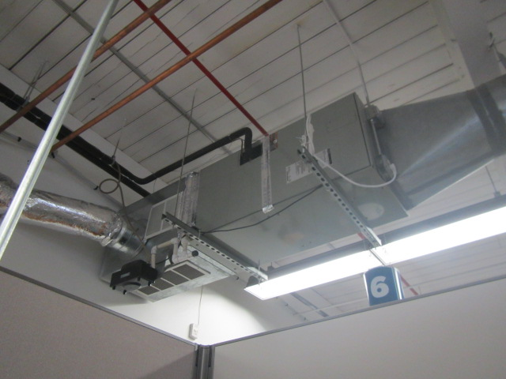
Ceiling-mounted air handling unit
Picture 2
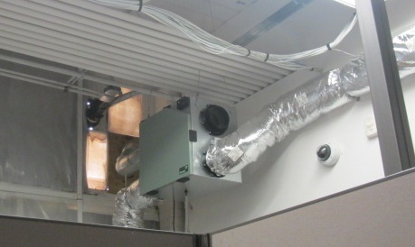
Air exchanger or energy recovery ventilator (ERV), note the top (black/open) duct appears to serve as an exhaust and the insulated/foil duct serves as a fresh air supply (see Picture 3)
Picture 3
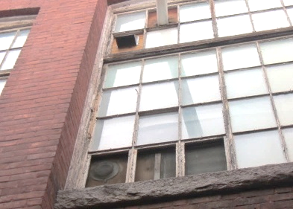
Top/angled vent is likely exhaust (arrow), and bottom vent is likely supply (arrow), note direction of exhaust (pushing down toward supply)
Picture 4
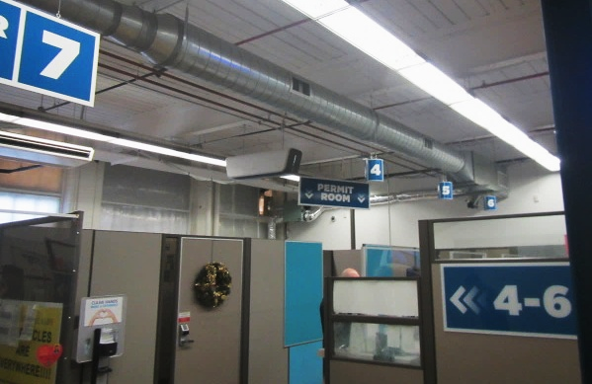
Ductwork suspended from ceiling, black arrows indicate supply vents, white arrow shows 1 of 4 recently installed ceiling-mounted air purifiers
Picture 5
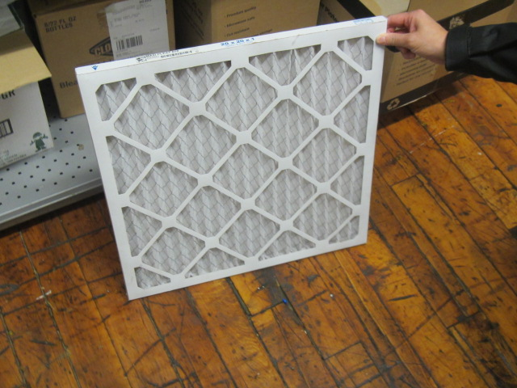
Pleated MERV 8 filter for HVAC system
Picture 6
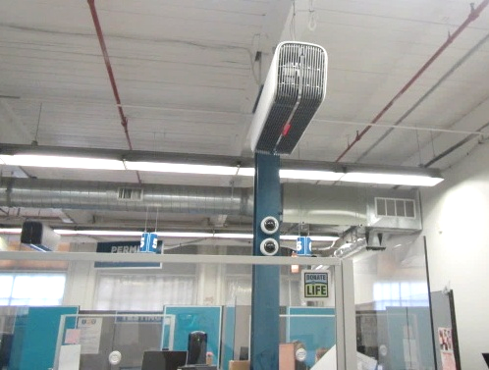
Two of four recently installed ceiling-mounted air purifiers (arrows) equipped with IAQ sensors
Picture 7
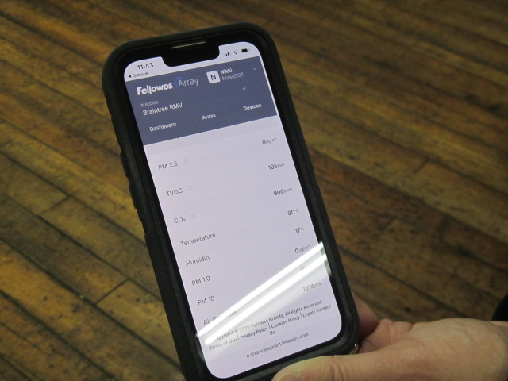
Phone App displaying an example of data generated by IAQ sensors, note these readings were from the Braintree RMV; Easthampton RMV had not been set up/connected at the time of assessment

Picture 8
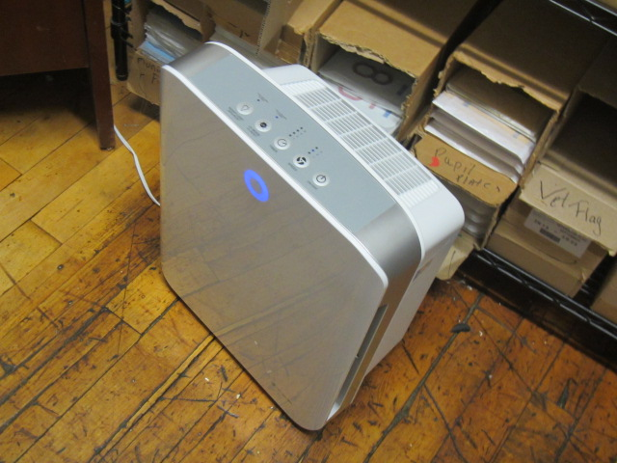
Floor model air cleaning unit in storeroom
Picture 9
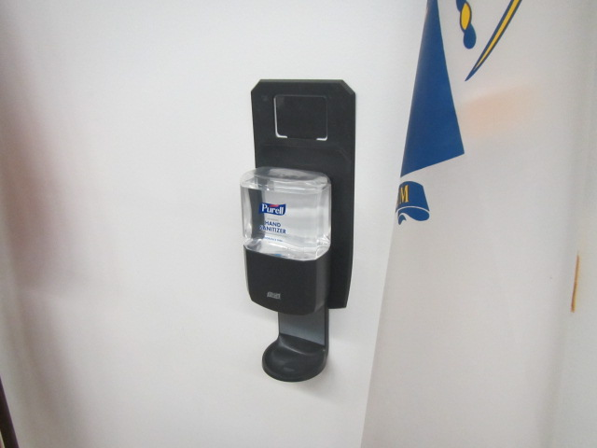
One of a number of hand sanitizer stations mounted throughout the RMV
Picture 10
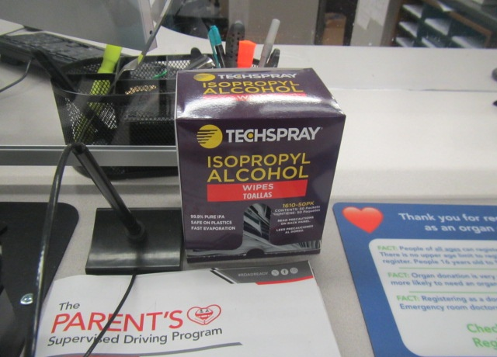
Alcohol wipes used at stations throughout the RMV
Picture 11
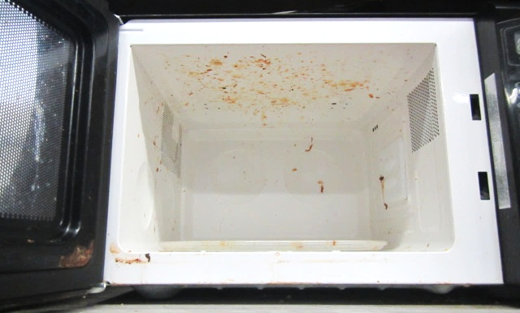
Dirty microwave oven in break area
Picture 12
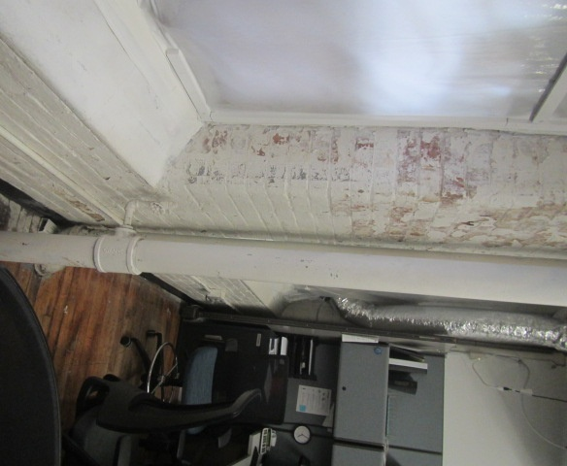
Peeling paint and efflorescence in Manager’s Office/Cash Room
Location | Carbon  Dioxide  (ppm) | Carbon Monoxide  (ppm) | Temp  (°F) | Relative  Humidity  (%) | PM2.5  (µg/m³) | TVOC  (ppm) | Occupants  in Room | Windows  Openable | Ventilation |  | Remarks
 |  |  |  |  |  |  |  |  | Supply | Exhaust | Remarks
Background | 438 | 5.3 | 45 | 55 | 13 | ND |  |  |  |  | Cold, snow flurries, moderate traffic/cars idling in parking lot
Waiting Area | 1164 | 3.4 | 71 | 28 | ND | 0.8 | 13 | N | Y | Y | Hand sanitizer, pedestal fan, ceiling-mounted air purifier
Stations 1-3 | 1157 | 3.0 | 72 | 28 | ND | 0.8 | 4 | N | Y | Y | Hand sanitizer
Stations 2-6 | 1186 | 3.0 | 73 | 27 | ND | 0.8 | 4 | N | Y | Y | Hand sanitizer
Permit Room | 1137 | 3.0 | 73 | 26 | ND | 0.8 | 0 | N | Y | Y | Hand sanitizer, ceiling-mounted air purifier
Advocate Station | 1151 | 3.7 | 73 | 26 | ND | 0.8 | 1 | N | Y | Y | Hand sanitizer, ceiling-mounted air purifier
Breakroom | 1128 | 3.7 | 73 | 26 | 1 | 0.8 | 0 | N | Y | Y | Microwave dirty, refrigerator 37°F
IT Equipment Area | 1102 | 3.6 | 73 | 26 | ND | 0.9 | 0 | N | Y | Y
Manager’s Office/Cash Rm | 1154 | 3.5 | 72 | 26 | 1 | 0.8 | 0 | N | Y | Y | Peeling paint on interior brick
Customer Service | 1155 | 3.6 | 72 | 28 | 1 | 0.9 | 5 | N | Y | Y | Ceiling-mounted air purifier
Storage Room | 1328 | 3.5 | 73 | 27 | ND | 0.7 | 0 | N | N | N | Floor Model Air Purifier
Lobby (outside RMV) | 654 | 3.1 | 72 | 22 | 6 | 0.9 | 2

