INDOOR AIR QUALITY ASSESSMENT

Easthampton Senior Center
19 Union Street
Easthampton

Prepared by:
Massachusetts Department of Public Health
Bureau of Environmental Health
Indoor Air Quality Program
September 2022

BACKGROUND
Building: | Easthampton Council on Aging (ECA)
Address: | 19 Union Street, Easthampton, MA
Assessment Requested By: | Cynthia Tarail, Director
Reason for Request: | Water intrusion and general indoor air quality (IAQ) concerns
Date of Assessment: | August 31, 2022
Massachusetts Department of Public Health/Bureau of Environmental Health (MDPH/BEH) Staff Conducting Assessment: | Ruth Alfasso and Stefanie Santora,  Environmental Inspectors, IAQ Program
Building Description: | The ECA occupies a building that was originally built as a post office in the 1930s and is now on the National Register of Historic Places. The building is red brick with a mostly flat roof. The first floor has high ceilings, and a basement level is also occupied.
Windows: | Openable on the first floor

METHODS
Please refer to the IAQ Manual for methods, sampling procedures, and interpretation of results (MDPH, 2015).

RESULTS AND DISCUSSION
The following is a summary of indoor air testing results (Table 1).
- Carbon dioxide levels were below or close to 800 parts per million (ppm) in all areas tested. Note that most areas were lightly occupied or unoccupied at the time of the assessment, carbon dioxide levels would be expected to increase with higher occupancy.
- Temperature was within or slightly above the recommended range of 70°F to 78°F in areas assessed.
- Relative humidity was within the recommended range of 40% to 60% in all areas assessed.
- Carbon monoxide levels were non-detectable (ND) in all areas assessed.
- Fine particulate matter (PM2.5) concentrations measured were below the National Ambient Air Quality Standard (NAAQS) level of 35 μg/m³ in all areas assessed

Ventilation
A heating, ventilating, and air conditioning (HVAC) system has several functions. First it provides heating and, if equipped, cooling. Second, it is a source of fresh air. Finally, an HVAC system will dilute and remove normally occurring indoor environmental pollutants by not only introducing fresh air, but by filtering the airstream, and ejecting stale air to the outdoors via exhaust ventilation. Even if an HVAC system is operating as designed, point sources of respiratory irritation may exist and cause symptoms in sensitive individuals. The following analysis examines and identifies components of the HVAC system and likely sources of respiratory irritant/allergen exposure due to water damage, aerosolized dust, and/or chemicals found in the indoor environment.
The ECA has two air handling units (AHU) located on the main floor in closets that serve as mixing rooms (Pictures 1-3). These AHUs have no source of fresh air, so the units recirculate, heat or cool, and filter the air in the building. The air from the AHU is delivered to spaces all over the first floor via supply vents (Picture 4). Air is drawn back into the mixing room via a grill in the wall of the closet (Picture 1). At the time of the visit, the AHUs units could not be opened for inspection. However, an AHU of this design should be equipped with filters. AHU filters should be changed two or more times a year. Filters used should be the best quality that can be used with the equipment. In addition, as the closets also serve as air mixing rooms, they should be kept clean and free from stored items and debris.
The restrooms in the basement have been retrofitted with exhaust vents that were operating at the time of the visit. Restrooms on the main level have no exhaust vent and only one has an openable window.
No fresh air supply is available for the basement, and due to water intrusion concerns, the windows to the basement have been sealed shut. This provides for very limited fresh air circulation for this floor. A large exhaust fan has been fitted into a window in the basement (Picture 5), which is used occasionally on a manual basis to remove odors, such as from cleaning products. However, in the current configuration, there is no source of fresh make-up air for this vent, or for the vents operating in the restrooms. Thus, during use of exhaust ventilation, air will be drawn from any accessible area, including from upstairs, through gaps in the building envelope, and from unconditioned, unfinished areas located on the basement level. This is discussed further under Microbial/Moisture Concerns below.
Additional heating is supplied by radiators. Window-mounted air conditioners (WAC) are also in use in a few areas which can supply a limited amount of fresh air during use. WAC have filters which need to be cleaned periodically. It is important to use water resistant sealing material when installing into window frames to prevent infiltration of moisture and pests, or the material could become mold colonized after long periods of time.
Note that the building is equipped with a commercial-style kitchen. This kitchen is currently non-operational, but occupants would like to restore it to use in the future. The kitchen has a stove equipped with an exhaust fan that is currently non-functional. If the kitchen is to be used, there needs to be sufficient exhaust capacity to remove odors, smoke, and products of combustion from cooking, and an appropriate amount of make-up air, such as through an automatic shutter vent.

Microbial/Moisture Concerns

Humidity and condensation issues in the basement
Basements tend to be a humid environment during summer months, particularly when no mechanical fresh air or air conditioning exists. Basements and other below-grade space are prone to accumulating condensation during hot, humid weather. When warm, moist air passes over a cooler surface, condensation can form. The key to managing condensation is understanding dew point. The dew point is the temperature that air must reach for saturation to occur. If a building material/component has a temperature below the dew point, condensation will accumulate on that material.
A method to locate areas in a building prone to condensation is to measure air and building material temperatures using a laser thermometer. If a wide temperature range exists between measurements (>5°F), the building materials at the colder end of the range may be prone to becoming moistened with condensation if exposed to hot, humid weather for extended periods of time. While floors in the basement were found to have similar temperatures as the air (Table 1), building staff report that in a few basement rooms, the floor becomes slick with condensation during wet weather. While the floor was dry at the time of the assessment, damage to floor tiles in the Welcome Room suggest they are chronically exposed to moisture (Picture 6).
Condensation can also occur on other surfaces, such as cold-water pipes (Picture 7). Insulation has a rating (R value) for how much it can resist heat flow. If the R value is insufficient, or the pipe wrap is incomplete, the exterior of the pipe and wrap can become chilled below the dew point, collect condensation droplets, and lead to water damage and mold growth. If pipe wrap gets wet, the R value typically decreases as well, making additional condensation more likely.
Water-damaged and mold-colonized pipe wrap should be removed, however before disturbing this material, it should be determined if it may contain asbestos, and handled in accordance with the relevant state and federal laws.
If the carpeted floors in the Tranquility Room have become chronically dampened, these flooring materials may be one source of musty odors reported to occur in the building.
In general, it is recommended that porous material be dried with fans and heating within 24 to 48 hours of becoming wet (US EPA, 2008, ACGIH, 1989). If porous materials are not dried within this time frame, mold growth may occur. Water-damaged porous materials cannot be adequately cleaned to remove mold growth.

Drainage issues
Building staff report water intrusion occurs in several areas of the basement during wet weather. Water intrusion may contribute to the dampness of flooring during wet weather. The wall in the stairwell to the basement is damaged/deteriorated, likely due to water intrusion (Picture 8).
While there are several sources of moisture in the basement, one significant source is related to the manner water drains from the roof. Two pipes exit the sides of the building (Pictures 9 and 10). These drain the roof either through internal roof drains or as a scupper along the roof parapet. According to building staff, when it rains, water drains at great speed from these pipes, impacting the ground near the building and entering the ramp to the basement on one side (Picture 8) and window wells on the other (Picture 9). Extending these drains to proper downspouts, or into storm drains with sufficient capacity would help direct water away from the building.
The window wells reportedly fill with water during wet weather. Draining the water from the roof away from the building will help reduce water in the wells. In addition, the well drains need to be kept clear of debris such as leaves and trash. Because water build up is reported even after the wells have been cleaned, the drains may have become clogged or damaged over time. Having the drains cleaned by a professional drain cleaning company may restore enough function to properly drain the window wells.

Unfinished areas
A portion of the basement is unfinished tunnel-like space with two doors and a hatchway from the finished part of the basement (Pictures 11 through 13). It is not known what the original intended use was for this space. In its current condition, this space should not be used for storage or other uses. Wherever possible, unfinished/unconditioned areas should be separated from conditioned areas to prevent the transfer of odors, dust, and pests. In this situation, the doors and hatchway should be sealed with either a gasket or weatherstripping. The vent in the door shown in Picture 12 should also be sealed with an appropriate waterproof and fire-resistant material. This will help reduce transfer of air between the unfinished space and the occupied space.

Building exterior
Many plants were located close to the exterior of the building (Pictures 14 and 15). Plants can hold moisture against the building, can be a source of pollen and odors through open windows, are a source of debris for window well drains, and can provide harborage for pests. Plants should be trimmed at least five feet away from the building particularly near window wells.
Badly peeling paint and stains were noted all along the underside of the loading dock overhang (Picture 16). While this area is not indoors, given the age of the building, this paint may contain lead that can be tracked into the building.

Other water damage issues
Water-damaged ceiling tiles were noted in several places in the basement (Picture 17). Based on the location of these tiles, water damage could be from plumbing on the first floor, or leaks through the building envelope. Water-damaged ceiling tiles should be replaced.
The fitness room had a strong musty or musky odor but no obvious source inside the room was found for this odor. It may originate outside, where building staff report that people sometimes use this area for shelter.

Other Concerns
Several kinds of portable air filters were present in the building. Some of the units were called “PlasmaWaves” (Picture 18). A review of the website for this brand of equipment indicates that these units use both filtration (high-efficiency particulate arrestance [HEPA] and carbon filters) along with an ionization technology. Ionic air purifiers produce ozone, which is a respiratory irritant. Air purifiers that produce ozone should not be used in occupied areas (USEPA, 2008).
Building staff reported that cleaning can only occur a few times a week in this building due to staffing issues, and that deep cleaning is infrequent. Thorough cleaning with methods that do not produce aerosolized dust, such as use of a vacuum cleaner with a HEPA filter, or wet wiping where appropriate, is recommended on a regular basis to remove dust, debris, pollen, and other potential irritants.
Storage of items in the building can also be a source of potential irritants and may transfer contaminants from one area to another. For example:
- Items stored on the floor can become moistened by condensation and make it harder to clean (Picture 19).
- Items stored in unconditioned areas can be subject to moisture, dust, and pests.
- Loose storage of fluorescent bulbs can break and release mercury along with broken glass fragments.

CONCLUSIONS AND RECOMMENDATIONS
Based on the observations made during this assessment, the IAQ program makes the following recommendations. These recommendations are separated into short-term and long-term recommendations. Note that several issues were discovered relating to potential regulated material (asbestos and lead). Ensure all applicable State and Federal asbestos regulations and guidance are followed with regarding to potential asbestos-containing materials:

Short-term recommendations

Ventilation Recommendations
- Operate the AHU during occupied periods to filter, circulate, and condition the air. Keep the AHU closets/mixing rooms clean and free of stored items.
- Change filters in AHU equipment regularly in accordance with manufacturer’s instructions. Use high-quality filters with a Minimum Efficiency Rating Value (MERV) of at least 8, or higher if the HVAC equipment can operate with more restrictive filters.
- Use openable windows on the first floor for fresh air during temperate weather. Keep windows closed during heavy rain and during hot, humid weather when the air conditioning is operating. Ensure windows have intact screens to exclude pests, and that windows are tightly closed at the end of the day.
- Consider unsealing one or more of the basement windows, choosing those that are in the best condition to be opened readily and closed tightly. Ensure windows are opened especially during use of the exhaust fan shown in Picture 5 to allow for make-up air.
- Continue to operate restroom exhaust fans in the basement restrooms.
- Maintain window air conditioners including periodic cleaning of filters. Ensure that gaps around them are sealed with water resistant material.

Water Damage Recommendations
- Ensure any potential asbestos-containing materials such as pipe wrap and floor tile are assessed for asbestos. If asbestos is present, remove the affected materials in a manner consistent with Massachusetts and Federal asbestos laws.
- Replace pipe wrap with a material with sufficient R rating to prevent future condensation, and ensure the wrap is complete.
- Examine materials stored in the basement for water damage, mold growth, and odors. If an item is water-damaged or colonized with visible mold, it should be discarded in a manner consistent with recommendations made in “Mold Remediation in Schools and Commercial Buildings”, which can be found at https://www.epa.gov/mold/mold-remediation-schools-and-commercial-buildings-guide.
- Consider using dehumidifiers in the basement during humid weather. Empty units of collected water and clean frequently to avoid odors. Discontinue use of dehumidifiers if humidity is low to prevent irritation associated with low humidity.
- Trim bushes and plants away from the exterior of the building a minimum of five feet.
- Have the scuppers/drains extended so the water is directed away from the building.
- Have the drains in window wells professionally cleaned to restore drainage capacity.
- Seal unconditioned areas away from occupied areas using weather stripping, gaskets, or an appropriate water and fire resistant material. This includes the door vent shown in Picture 12.
- Replace water-damaged ceiling tiles.
- Clean the loose cement from the stairwell wall and repaint.
- Have the paint on the underside of the loading dock overhang tested for lead and remove in accordance with State and Federal regulations.
- Have the concrete area outside the fitness room pressure-washed to see if that alleviates the odor in the gym. If not, examine all items in the gym including the window air conditioner, gym mats, and other items to see if they are the source of the odor.
- Consider removing carpeting from the Tranquility Room.

Other Recommendations
- In both the basement and other areas, keep stored materials organized and in closed containers, on shelves, or in cabinets to protect from moisture, dust, and pests. Sort through stored items and discard unneeded items regularly.
- Avoid use of air purifiers that may produce ozone. Maintain units in accordance with manufacturer’s instructions. When units are needed, place in a manner to intercept air between people.
- Keep food storage and preparation equipment clean. Only store food in sealed pest-proof containers.
- Clean all carpeting in accordance with IICRC recommendations (IICRC 2012). This includes daily vacuuming, or as frequently as possible, with a HEPA-equipped vacuum cleaner, and annual or semi-annual deep cleaning.
- Store new and spent fluorescent bulbs securely and remove spent bulbs on a regular basis to prevent breakage and release of mercury.
- Refer to resource manual and other related IAQ documents located on the MDPH’s website for further building-wide evaluations and advice on maintaining public buildings. These documents are available at: http://mass.gov/dph/iaq.

Long Term Recommendations

- If the kitchen is returned to service, ensure that sufficient exhaust ventilation and make-up air is available for the use of the stove.
- Consult with an HVAC engineering contractor to determine the feasibility of adding fresh air mechanical ventilation to the building, including to the basement area.
- Consult with a building envelope specialist regarding improving drainage around the building.
- Consider a plan to remodel the basement to allow for more conditioned storage areas and to eliminate or separate unconditioned areas from occupied areas.
- Consider if budgets can be modified to include daily cleaning and regular deep cleaning of this space for improved IAQ.

REFERENCES
ACGIH. 1989. Guidelines for the Assessment of Bioaerosols in the Indoor Environment. American Conference of Governmental Industrial Hygienists, Cincinnati, OH.
ASHRAE, 2019. American Society of Heating, Refrigeration and Air Conditioning Engineers (ASHRAE) Ventilation for Acceptable Indoor Air Quality. ANSI/ASHRAE Standard 62.1-2019. Atlanta, GA.
IICRC. 2012. Institute of Inspection, Cleaning and Restoration Certification. Carpet Cleaning: FAQ.
MDPH. 2015. Massachusetts Department of Public Health. Indoor Air Quality Manual: Chapters I-III. Available at: https://www.mass.gov/lists/indoor-air-quality-manual-and-appendices.
US EPA. 2008. “Mold Remediation in Schools and Commercial Buildings”. Office of Air and Radiation, Indoor Environments Division, Washington, DC. EPA 402-K-01-001. September 2008. Available at: http://www.epa.gov/mold/mold-remediation-schools-and-commercial-buildings-guide.
US EPA. 2003. “Ozone Generators that are Sold as Air Cleaners: An Assessment of Effectiveness and Health Consequences”. US Environmental Protection Agency, Office of Air and Radiation, Indoor Environments Division, Washington, D.C. https://www.epa.gov/indoor-air-quality-iaq/ozone-generators-are-sold-air-cleaners

Picture 1
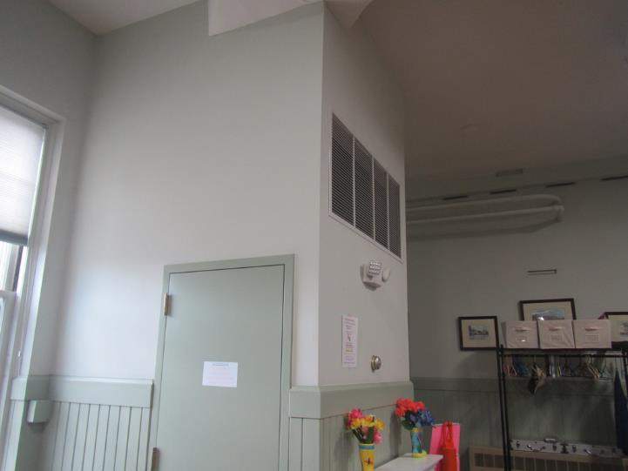
One of two mixing room closets for an AHU, note return grate at the top center
Picture 2
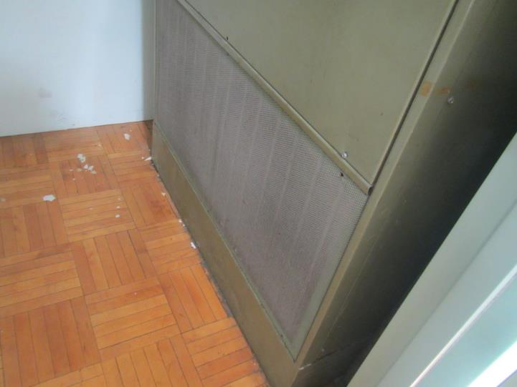
Air handling unit in mixing room closet; air return grill at the bottom is dusty
Picture 3
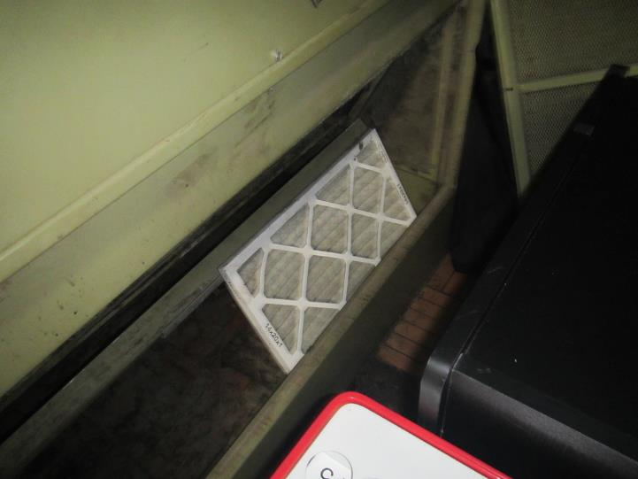
Air handling unit in mixing room closet; note filter outside of unit and return grill missing
Picture 4
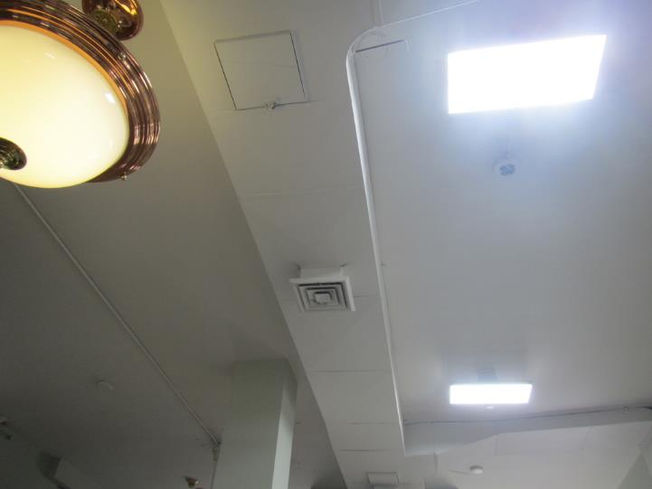
Air supply vent near the ceiling
Picture 5
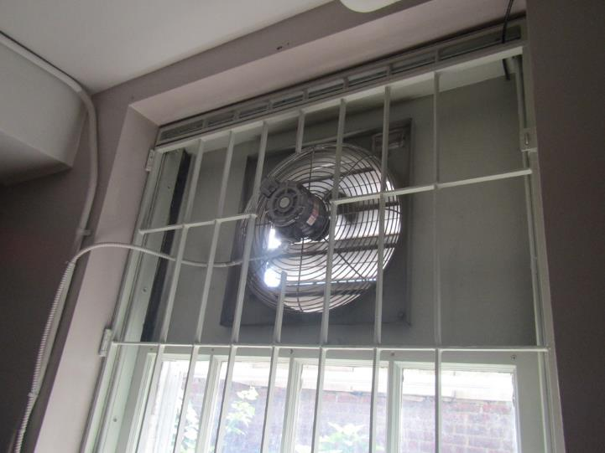
Large exhaust fan in the basement
Picture 6
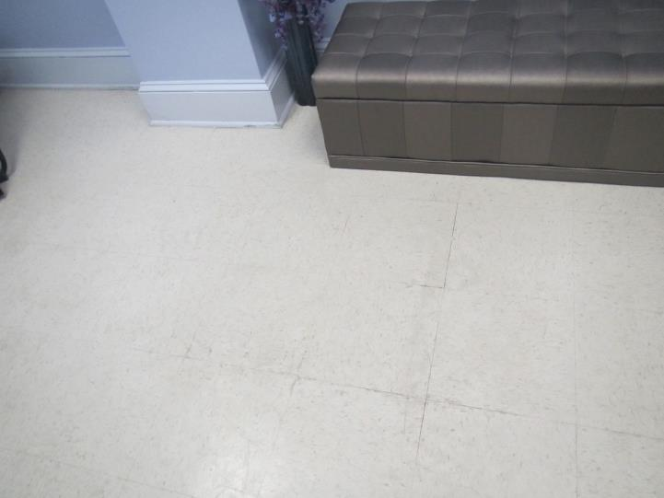
Floor tiles lifting slightly, indicating chronic moisture exposure
Picture 7
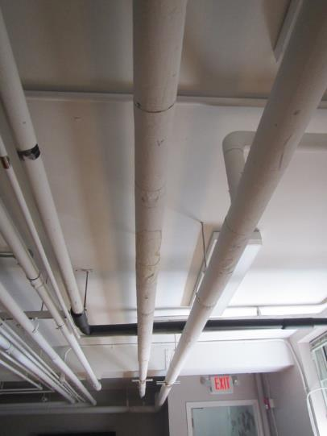
Water damage to basement pipe wrap
Picture 8
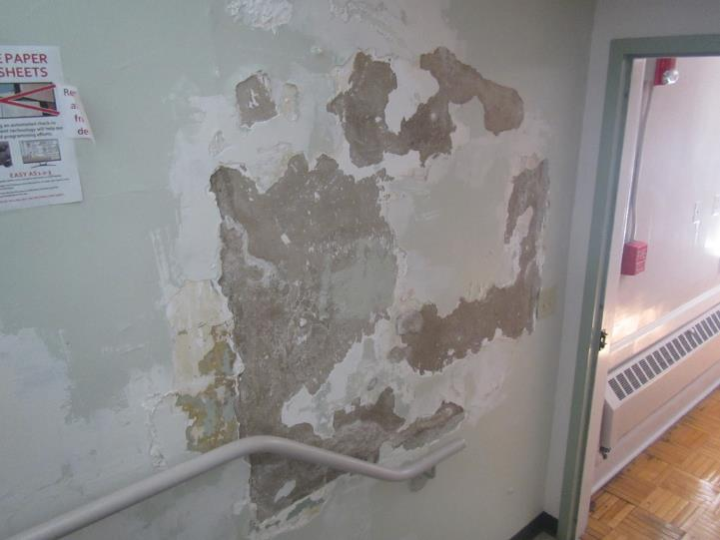
Damaged wall in the basement stairwell
Picture 9
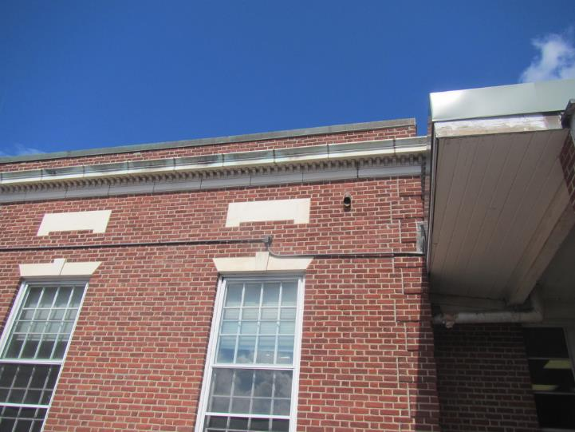
Drainpipe from roof drain along the side of the building
Picture 10
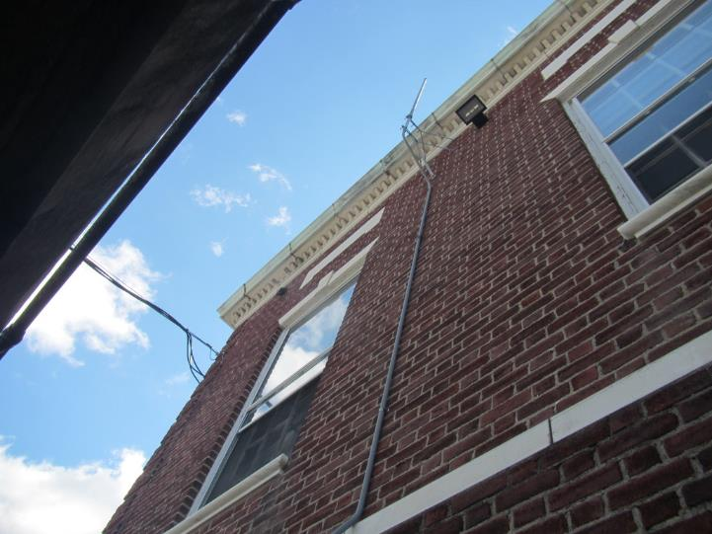
Drainpipe (arrow) high on the side of the building
Picture 11
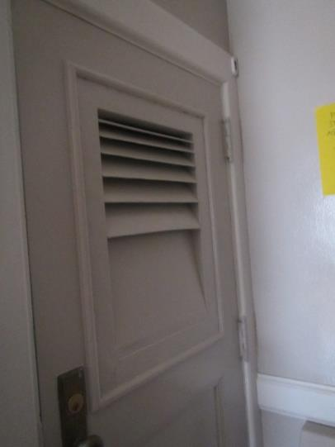
Door from basement room into unfinished area, note vent in door
Picture 12
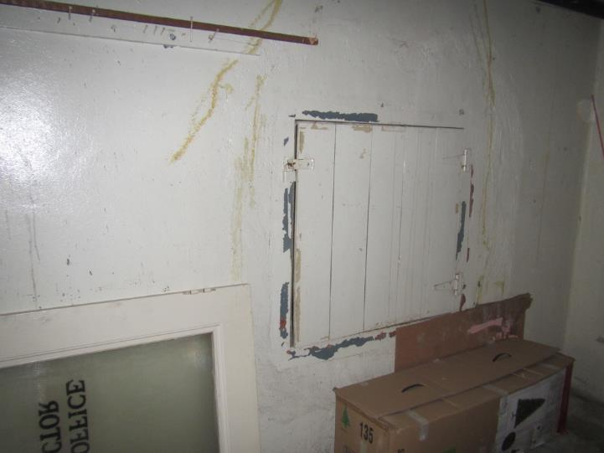
Hatch from basement room into unfinished space
Picture 13
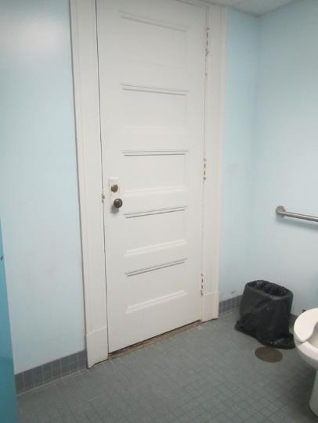
Door in basement men’s restroom into unfinished area
Picture 14
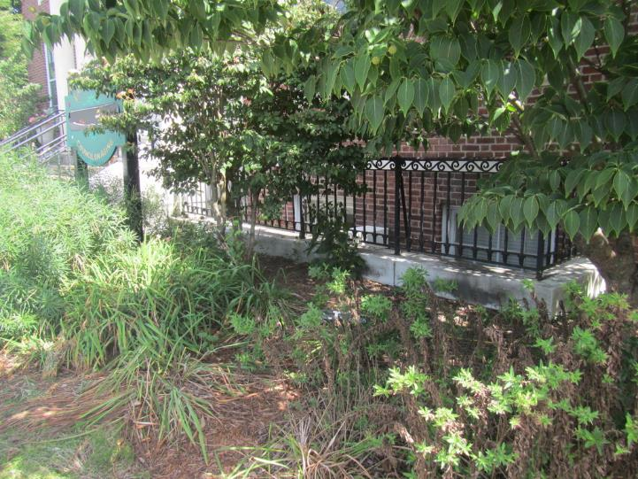
Plants growing near the exterior of the building and overhanging window wells
Picture 15
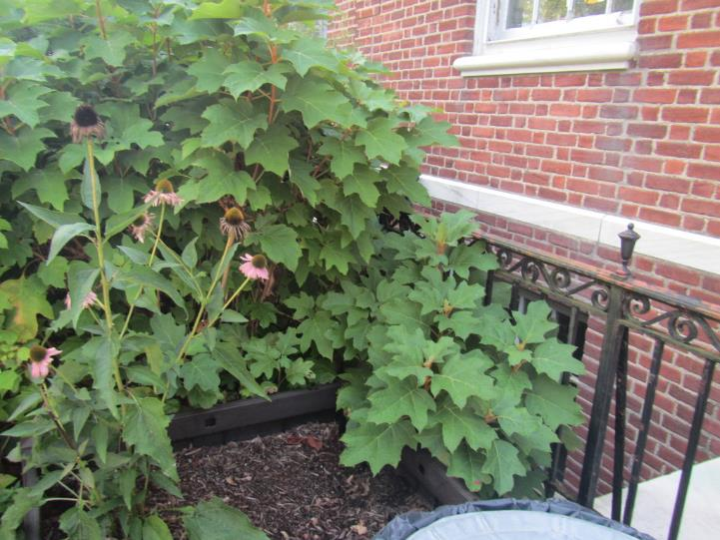
Plants near the exterior of the building
Picture 16
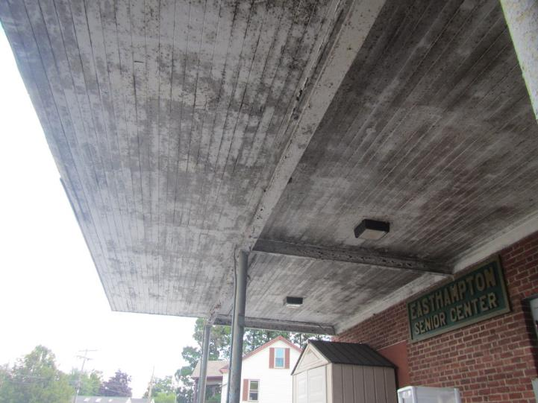
Peeling paint on loading dock overhang
Picture 17
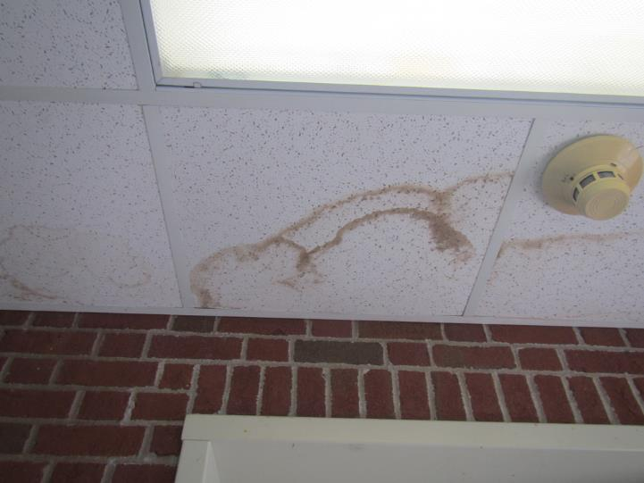
Water-damaged ceiling tiles
Picture 18
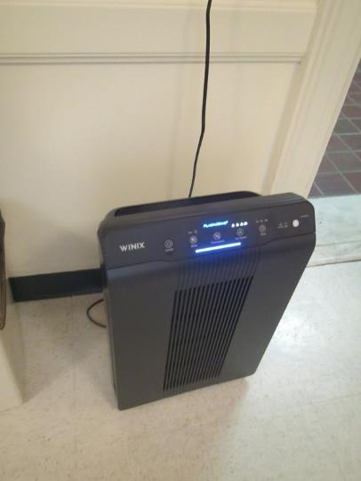
PlasmaWave unit air purifier
Picture 19
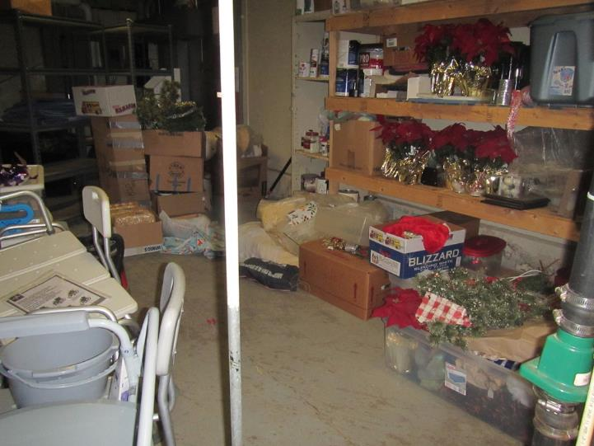
Items stored on the floor

Location | Carbon  Dioxide  (ppm) | Carbon Monoxide  (ppm) | Temp  (°F) | Relative  Humidity  (%) | PM2.5  (µg/m3) | Dew Point  (°F) | Occupants in Room | Floor Temp  (°F) | Floor/Wall Junction Temp (°F) | Windows  Openable | Ventilation |  | Remarks
 |  |  |  |  |  |  |  |  |  |  | Intake | Exhaust
Background (outdoors) | 383 | 1.2 | 85 | 50 | 14
Basement
Civil Service Room | 766 | ND | 76 | 44 | ND | 53 | 0 | 70 | 70 | N | N | N
Common Area | 771 | ND | 77 | 42 | 1 | 52 | 0 | 73 | 73 | N | N | N | Air purifier, dehumidifier, area rug, vent in door to “crawlspace,” hardwired window-mounted exhaust fan off
Men’s Restroom |  |  |  |  |  |  | 0 |  |  | N/A | N | Y | 1 water-damaged ceiling tile, crawlspace with fluorescent lightbulbs on floor
Tranquility Room | 757 | ND | 74 | 45 | ND | 52 | 0 | 72 | 71 | N | N | N | Air purifier, carpeting
Welcome Room | 765 | ND | 75 | 44 | ND | 52 | 0 | 70 | 70 | N/A | N | N | Air purifier
Women’s Restroom |  |  |  |  |  |  | 0 |  |  | N/A | N | Y | 4 water-damaged ceiling tiles
First Floor
Director’s Office | 790 | ND | 75 | 44 | ND | 52 | 0 | 73 | 74 | Y | N | N | Interior restroom has no intake/exhaust and window not openable
Fitness Room | 815 | ND | 76 | 45 | ND | 53 | 0 | 70 | 70 | N | N | N | Window air conditioner
Friends Office | 809 | ND | 75 | 44 | ND | 51 | 0 | 74 | 75 | Y | N | N
Front Outreach Office | 774 | ND | 79 | 39 | ND | 51 | 0 | 70 | 73 | Y | N | N
Kitchen | 504 | ND | 74 | 50 | ND | 54 | 0 | 69 | 69 | N | N | N | Kitchen non-operational, window air conditioner off and stove exhaust non-operational
Lobby | 739 | ND | 77 | 41 | ND | 52 | 3 | 72 | 73 | Y | N | N
Outreach Office | 799 | ND | 74 | 45 | ND | 51 | 0 | 70 | 71 | Y | N | N | Sink
Restroom |  |  |  |  |  |  | 0 |  |  | Y | N | N

