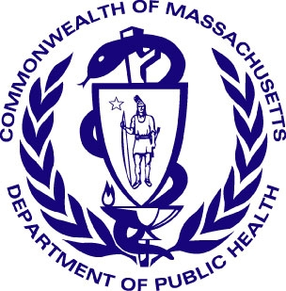
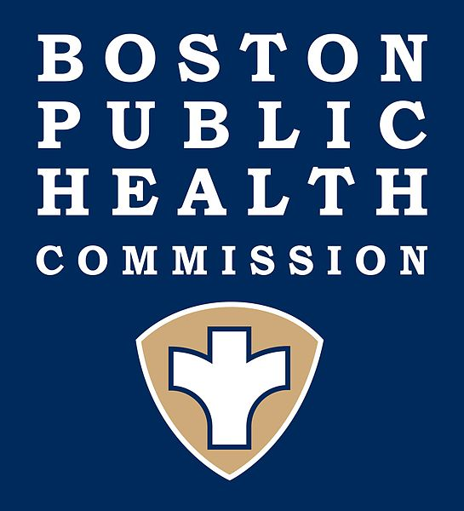

Boston Public Health Commission

Massachusetts Department of Public Health

Clinical Advisory

Management of Suspected Ebola Virus Cases or Contacts

Ebola virus disease (EVD) was first described in 1976, and until recently outbreaks have occurred mostly in rural areas of Central Africa. Since March 2014, there has been widespread transmission of Ebola in areas of West Africa; a situation now being brought under control. Liberia was declared Ebola-free by the World Health Organization (WHO) on May 9, 2015 and on November 7, 2015, WHO declared the end of Ebola transmission in Sierra Leone. While tremendous strides have been made in Guinea, it has not yet been declared Ebola-free, resulting in the continuation of heightened public vigilance in the US. The Ebola virus is transmitted through direct contact with blood and other body fluids from infected patients, including saliva, sweat, breast milk, urine and semen. There is no evidence that infection is transmitted prior to symptom onset. There have been importations into the United States and other countries with limited transmission. There have been no cases in Massachusetts. For up-to-date travel advisories go to the Center for Disease Control and Prevention (CDC) travel advisory website.

The incubation period for EVD can be from 2 to 21 days, but 8-10 days is typical. Sudden onset of fever and malaise is characteristic, with variable development of myalgia, headache, sore throat, cough, nausea, vomiting, and diarrhea. Severe disease is characterized by multiorgan failure and sometimes a bleeding diathesis related to reduced vascular integrity and disseminated intravascular coagulation. This may be associated with petechiae, purpura, or ecchymoses. Vomiting and diarrhea may be profound, disabling and dehydrating. Severe disease may also include confusion, seizures and coma. Laboratory abnormalities include leukopenia, thrombocytopenia and abnormal liver function tests. The differential diagnosis includes more common illnesses such as malaria, typhoid fever, dengue, meningitis, hepatitis or leptospirosis. Care is non-specific and supportive.

Any case of suspected EVD (suspect case) or individual identified as having potential exposure to a case of EVD (contact) in Guinea should be immediately reported to the local board of health or health department and DPH. Suspect cases in the City of Boston should be reported directly to the Boston Public Health Commission (BPHC).
- A suspect case is an individual visiting an area of a country with ongoing transmission of Ebola virus within the previous 21 days, who has had exposure to ill individuals or their body fluids through social or professional contact and has fever (temperature ≥100.4°F, 38°C) and additional symptoms such as severe headache, muscle pain, vomiting, diarrhea, abdominal pain, or unexplained hemorrhage.
- A potential contact is someone who, in the course of work as a health care provider in the U.S. or abroad, has had possible direct, unprotected contact with an EVD case or cases; or who, in the course of travel, has had close contact with a possible case of EVD.
Travel per se does not put an individual at risk for EVD, nor does casual contact; only unprotected exposure to blood or body fluids of someone with symptomatic EVD puts an individual at risk. Situations should be evaluated as to likelihood of Ebola virus infection as a cause of symptoms, as well as details about the exposure to a possible case. These evaluations should be done in consultation with public health officials.

Management of potential cases:
- Isolate the case and place on the currently recommended precautions. CDC recommends contact and droplet precautions with full body coverage. For details go to: Guidance on Personal Protective Equipment.
- Provide supportive care as required.
- Contact the local board of health or health department immediately (BPHC in Boston, see instructions at the end of this advisory).
- Maintain isolation until an alternative diagnosis is made or EVD is ruled out.
- Two plastic tubes of whole blood (>4mL) preserved with EDTA (purple top) specimens should be collected. When collecting patient specimens for laboratory testing, care should be taken to avoid contamination of the external surfaces of the container. Specimens should be hand delivered in a clearly labeled, durable, leak-proof container directly to the specimen handling area of the laboratory, avoiding the use of automated systems. The facility laboratory director and supervisor should be alerted immediately to the suspected diagnosis so that they can prepare for specimen receipt and processing using enhanced precautions. Specimens should be processed, including decanting, preparation of slides for microscopic examination and heat inactivation if used, in a class II biological safety cabinet following biosafety level 3 practices. Diagnostic testing for Ebola Zaire virus is available at the DPH Hinton State Laboratory Institute. Prior to sending a sample, the facility should consult the DPH Hinton State Laboratory Institute (HSLI) for specimen collection, handling, packaging and transport advice via the 24/7 lab number (617-590-6390). The DPH HSLI will perform the PCR test on one tube. A duplicate sample may be simultaneously shipped to the CDC for other comprehensive testing. The results will be reported to the healthcare provider and local health department in 4-6 hours from specimen receipt. Routine laboratory tests such as blood cultures, complete blood counts (CBCs) or metabolic panels are not provided at the DPH HSLI or at the CDC.

Care should be taken when collecting clinical specimens on suspect cases of EVD. In the circumstances of a high level of suspicion of a diagnosis of EVD, or a presumptive or confirmed diagnosis, guidelines for handling of specimens in the laboratory, including biosafety, decontamination of equipment, and packaging and shipping should be consulted and followed.

Further information:

DPH Website

CDC Website

Travel Advisories
Interim Guidance on EVD for Healthcare Workers

WHO Website
DPH Surveillance, Reporting and Control Manual
BPHC Reporting Form

Fact Sheet

To report a suspect case or contact, or if you have questions, call:

Boston Public Health Commission: 617-534-5611
Your local board of health/health department: number under government in the telephone book or online
Massachusetts Department of Public Health: 617-983-6800 or toll-free at
888-658-2850

