## ED202 Education Personnel by Age Group/Gender/Race-Ethnicity

Displays demographic FTE and percentage information for any or all EPIMS job classification according to either age group, gender, or race/ethnicity.

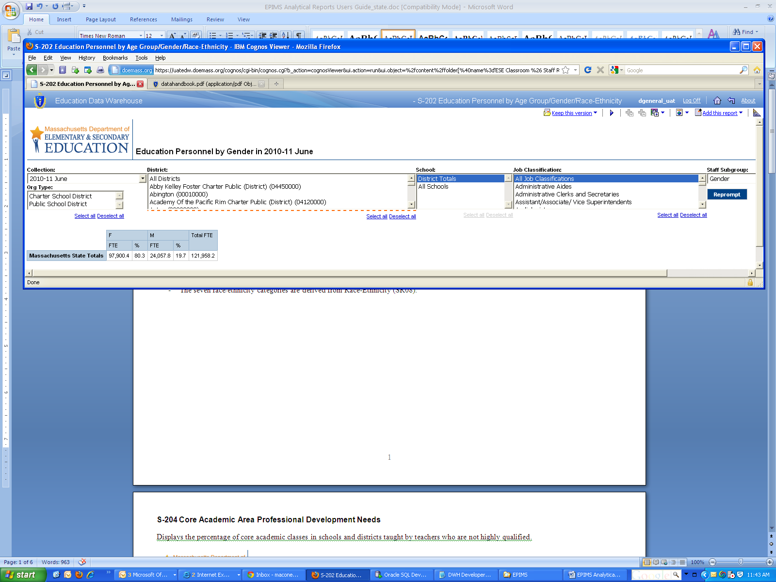

**Prompts:**

* Report Type- Selects which demographic report to display- age or gender or race/ethnicity. Mandatory single-select.
* Collection Period- Selects the EPIMS collection period. Available for October and June collections. Mandatory single-select.
* Job Classification- Selects job classifications (WA07). Optional single or multi-select. Selection will be reflected in state total at the top of the report.
* Org Type- Selects charter schools or non-charter schools. Optional single or multi-select. Selection will be reflected in report totals rather than state totals
* District- Optional single or multi-select of school district(s).
* School- Optional single or multi-select of schools

**Notes for users:**

* The EPIMS data handbook can be found at: <http://www.doe.mass.edu/infoservices/data/epims/datahandbook.pdf>.
* Age is derived from DOB (SR07) and date of collection, e.g., October 1, 20XX.
* The seven race/ethnicity categories are derived from Race-Ethnicity (SR08).

## ED204 Core Academic Area Professional Development Needs

Displays the percentage of core academic classes in schools and districts taught by teachers who are not highly qualified.

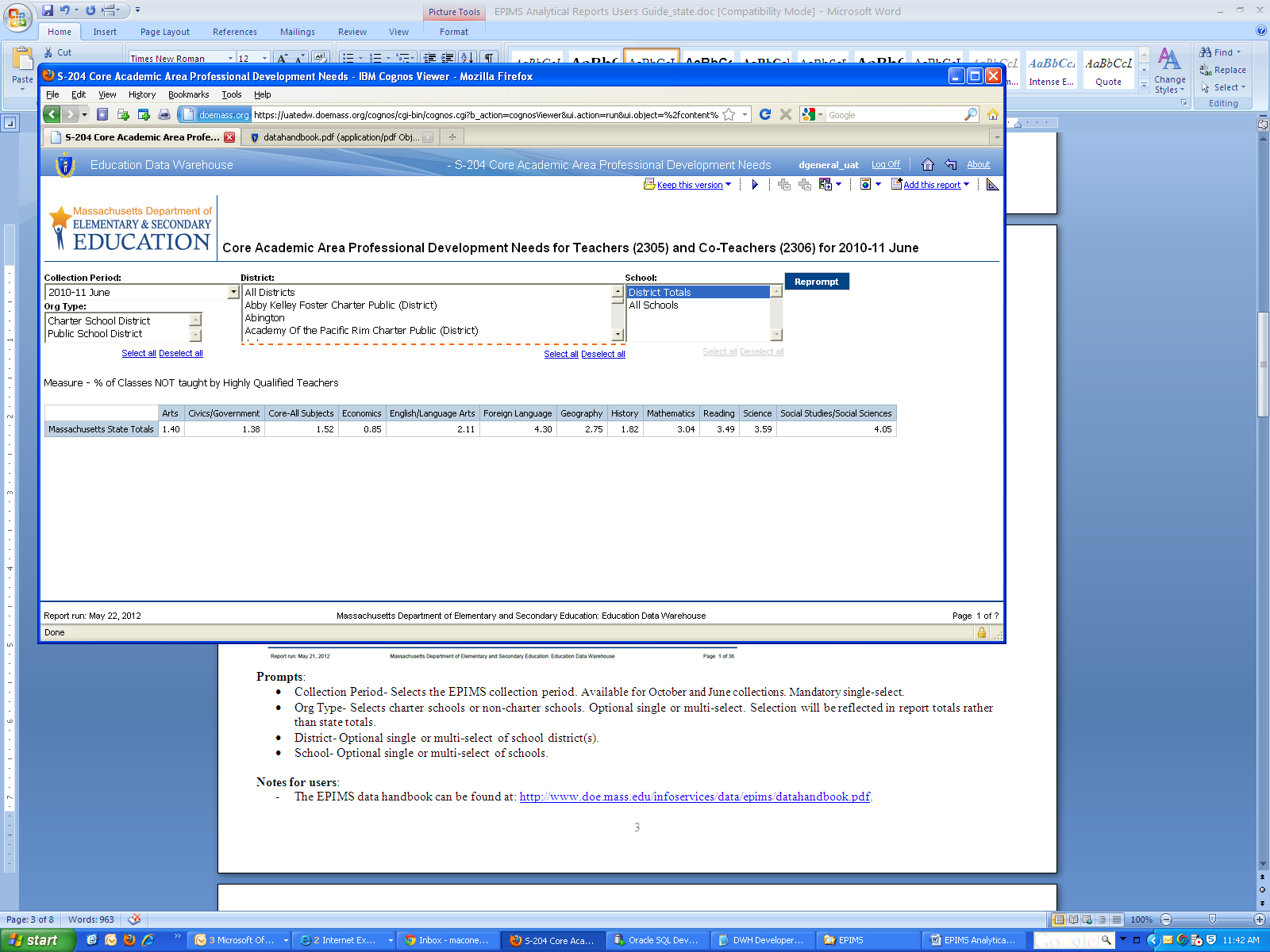

**Prompts**:

* Collection Period- Selects the EPIMS collection period. Available for October and June collections. Mandatory single-select.
* Org Type- Selects charter schools or non-charter schools. Optional single or multi-select. Selection will be reflected in report totals rather than state totals.
* District- Optional single or multi-select of school district(s).
* School- Optional single or multi-select of schools.

**Notes for users**:

* The EPIMS data handbook can be found at: <http://www.doe.mass.edu/infoservices/data/epims/datahandbook.pdf>.

## ED206 Staff by Federal Funding Source

Displays FTEs by federal funding source and 8 staffing categories.

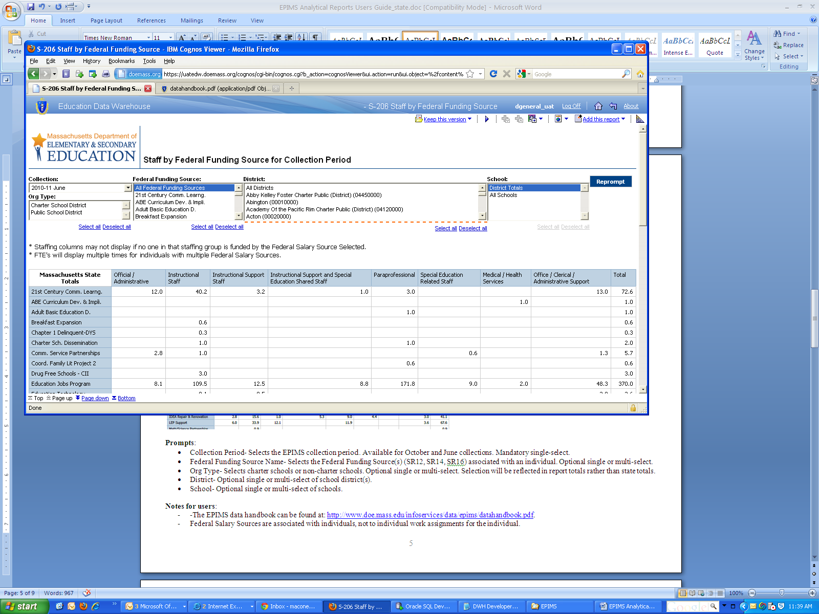

**Prompts**:

* Collection Period- Selects the EPIMS collection period. Available for October and June collections. Mandatory single-select.
* Federal Funding Source Name- Selects the Federal Funding Source(s) (SR12, SR14, SR16) associated with an individual. Optional single or multi-select.
* Org Type- Selects charter schools or non-charter schools. Optional single or multi-select. Selection will be reflected in report totals rather than state totals.
* District- Optional single or multi-select of school district(s).
* School- Optional single or multi-select of schools.

**Notes for users**:

* -The EPIMS data handbook can be found at: <http://www.doe.mass.edu/infoservices/data/epims/datahandbook.pdf>.
* Federal Salary Sources are associated with individuals, not to individual work assignments for the individual.
* Individuals may have up to three federal funding sources. Their full FTE will be associated with each source.
* Staffing categories are determined by EPIMS Job Classifications. Please see the “Appndx E WA07 Job Class” tab at <http://www.doe.mass.edu/infoservices/data/epims/DHAppendices.xls>.

## ED208 Class Count by District and Program

Displays class counts for instructional staff by core and non-core breakdowns as well as by program areas of CVTE, ELL, General Education and Special Education. A drill through feature allows the viewer to display the actual courses and class counts that make up the numerical count.

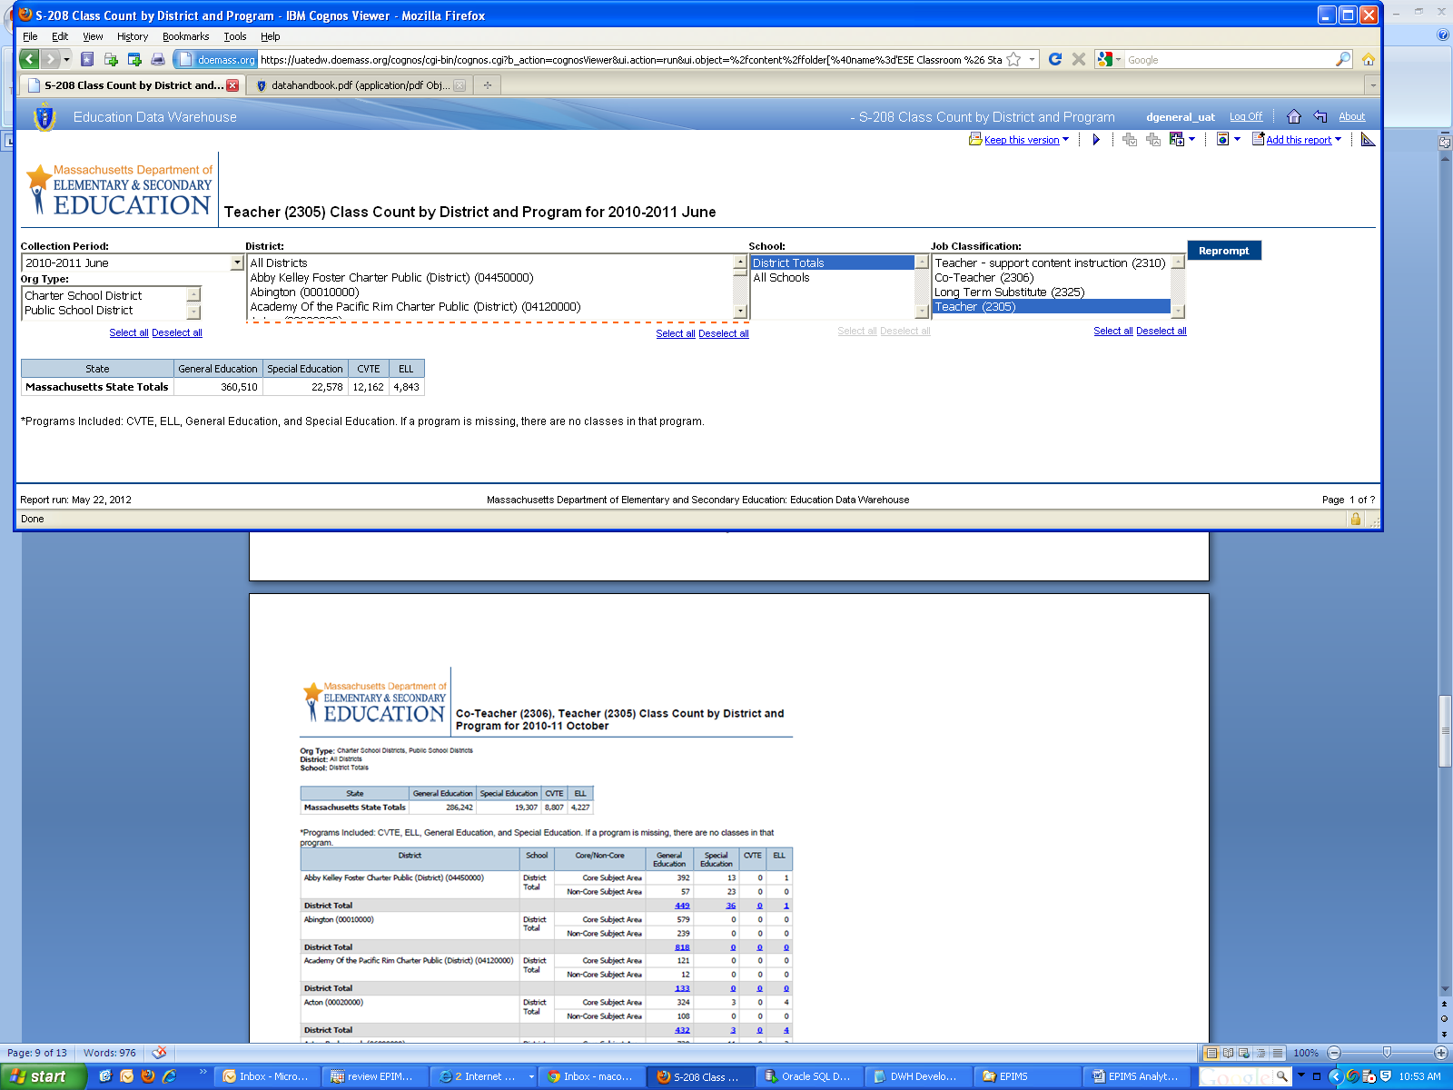

**Drill Through Report to Course Level Data**

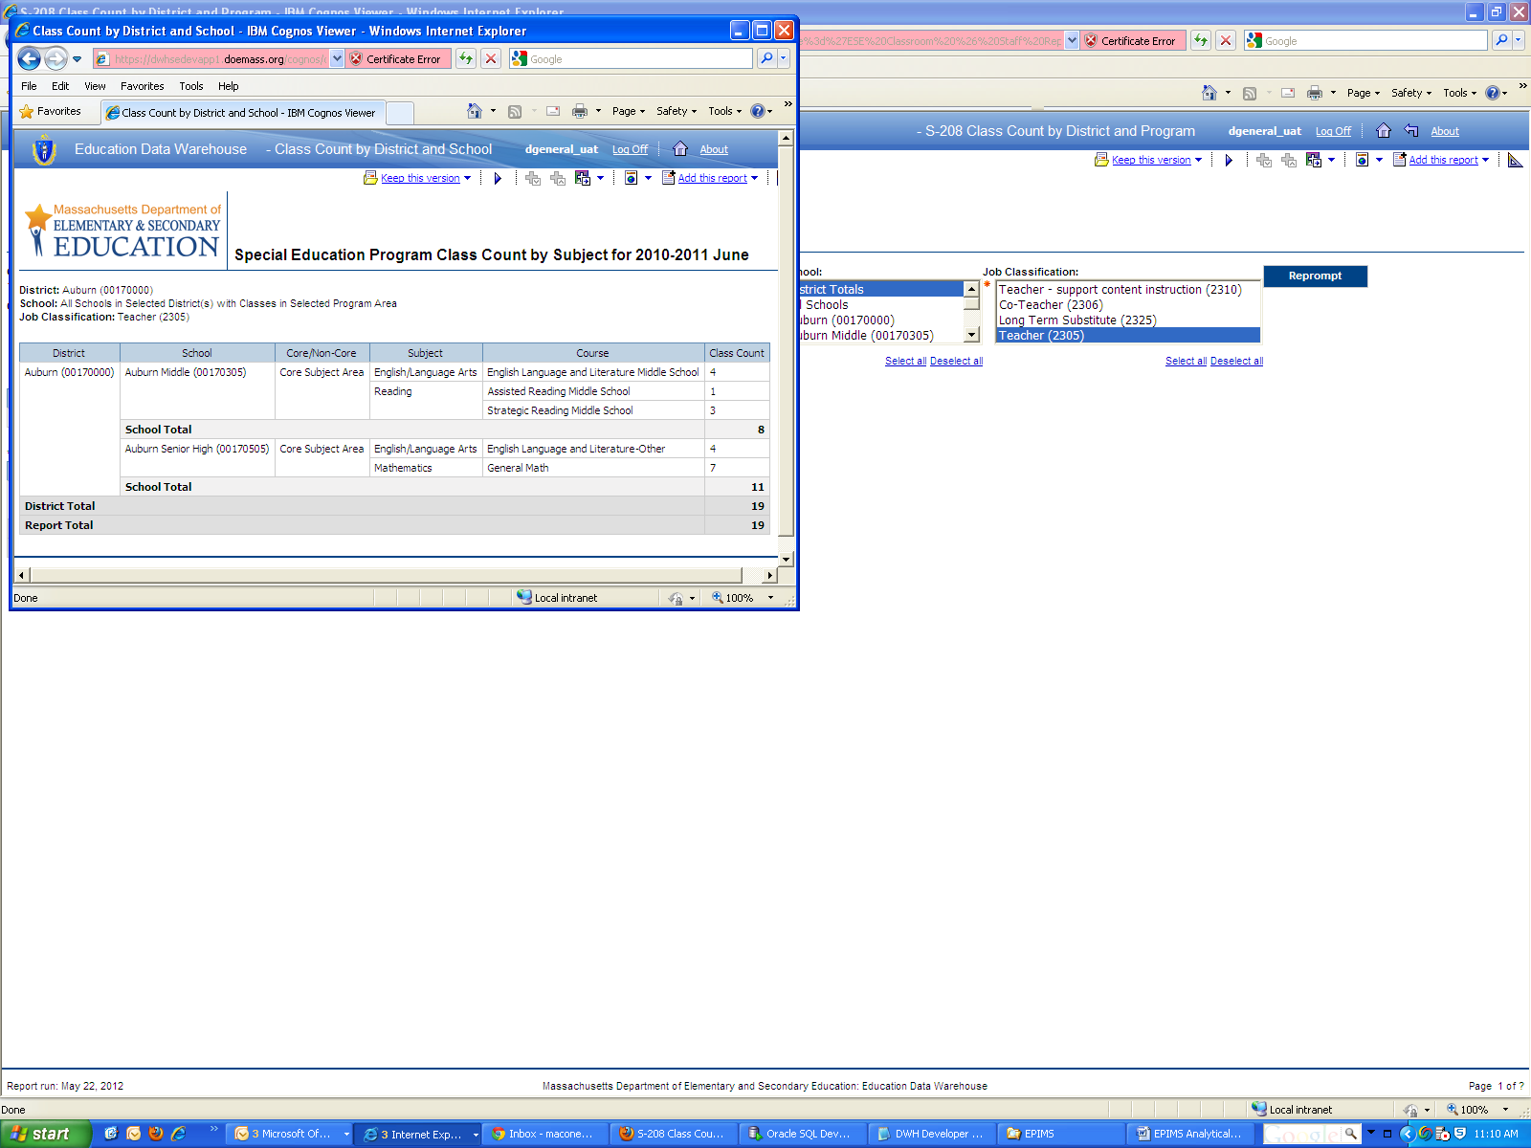**Prompts**:

* Collection Period- Selects the EPIMS collection period. Available for October and June collections. Mandatory single-select.
* Job Classification- Selects one of three job classifications (WA07) associated with instruction. Mandatory single-select. Selection will be reflected in state total at the top of the report.
* Org Type- Selects charter schools or non-charter schools. Optional single or multi-select. Selection will be reflected in report totals rather than state totals.
* District- Optional single or multi-select of school district(s).
* School- Optional single or multi-select of schools.

**Notes for users**:

* The EPIMS data handbook can be found at: <http://www.doe.mass.edu/infoservices/data/epims/datahandbook.pdf>.

Program Areas are determined by EPIMS Assignment Codes (WA08). Please see the EPIMS_EPIMS Report tab at <http://www.doe.mass.edu/infoservices/data/epims/sumreports.xls> for the program designation for EPIMS Assignments.

## ED209 Staff FTE by Length of Service

Displays staffing FTEs and percentages by length of service in the district. Additionally, subject areas are displayed for instructional and some paraprofessional staff.

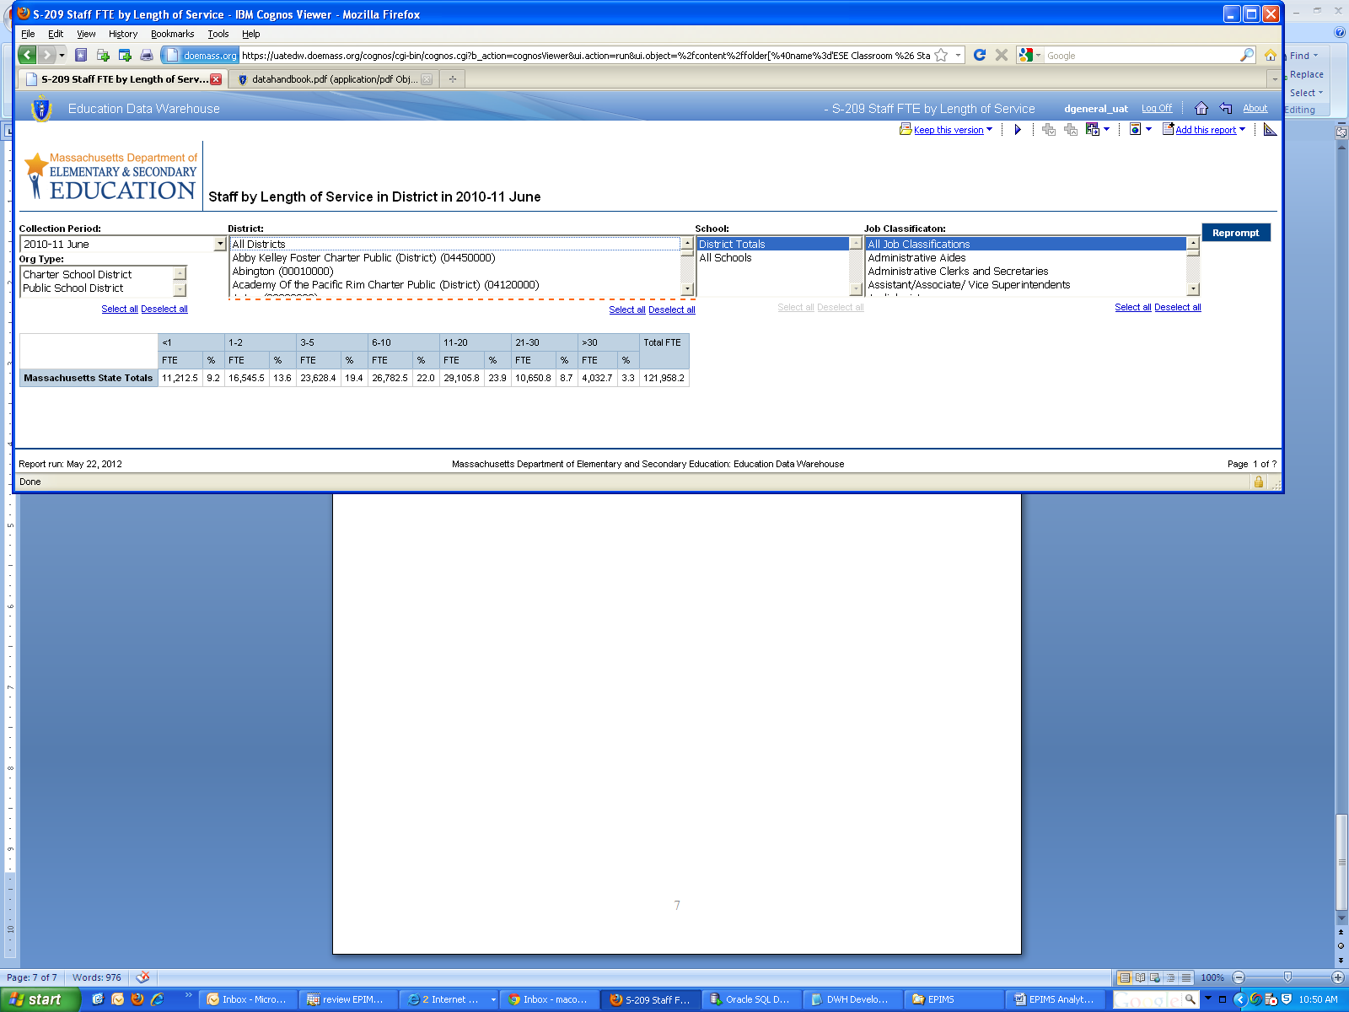

**Prompts**:

* Collection Period- Selects the EPIMS collection period. Available for October and June collections. Mandatory single-select.
* Job Classification- Selects job classifications (WA07). Optional single or multi-select. Selection will be reflected in state total at the top of the report.
* Org Type- Selects charter schools or non-charter schools. Optional single or multi-select. Selection will be reflected in report totals rather than state totals.
* District- Optional single or multi-select of school district(s).
* School- Optional single or multi-select of schools.

**Notes for users**:

* The EPIMS data handbook can be found at: <http://www.doe.mass.edu/infoservices/data/epims/datahandbook.pdf>.

Course and subject information is only required for teachers. Districts may submit course and subject for paraprofessionals if desired, but it is not required. “Not Applicable” will appear for all non-teaching and non-paraprofessional positions, may appear for paraprofessional positions, and in a very limited number of cases where there was a system error, may occasionally display for teaching positions.

## EV319 Educator Evaluation Rating District Summary

EV319 provides a summary view of a single district’s educator evaluation rating distribution across schools for a single school year. It includes educator evaluation ratings on the overall rating, standards 1-4, and the impact rating. Additionally, the report includes educator PTS and Waiver information, as well as student enrollment information for each school.

The educator population includes those who were required to be evaluated in the June EPIMS collection in the selected school year, and may be filtered by a set of educator employment characteristics. The report includes only evaluations submitted by the selected district during the selected year.

Educator evaluation rating and district employment information is reported by the district of employment.