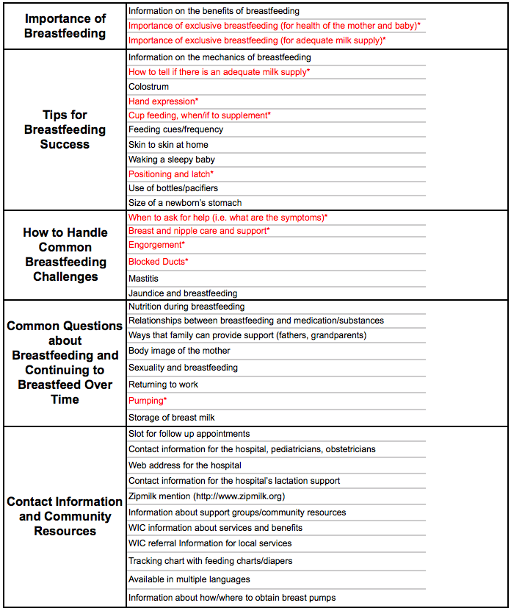
*Required For Discharge Packet According to Baby-Friendly Hospital Initiative Criteria
Educating Breastfeeding Families – Discharge Packet Content Planning Tool

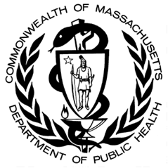

Developed by the Massachusetts Department of Public Health and Northeastern University

