INDOOR AIR QUALITY ASSESSMENT

Connolly Center
(Former Everett Armory)
90 Chelsea Street
Everett, Massachusetts

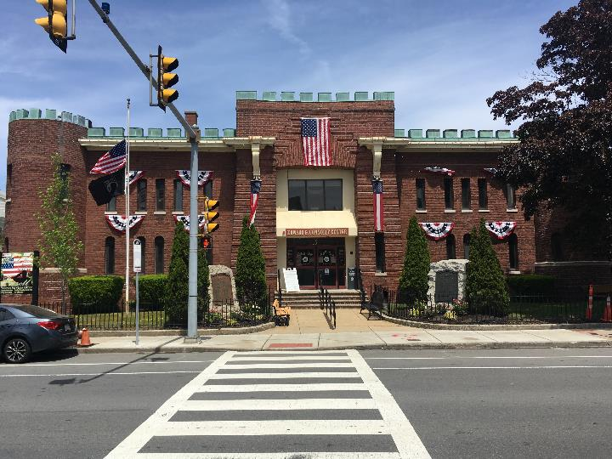

Prepared by:
Massachusetts Department of Public Health
Bureau of Environmental Health
Indoor Air Quality Program
August 2022

BACKGROUND
Building: | Edward G. Connolly Center (CC)
Address: | 90 Chelsea Street, MA
Assessment Requested by: | Erin C. Deveney, Chief of Staff, Office of the Mayor, City of Everett
Reason for Request: | General indoor air quality (IAQ)
Date of Assessment: | May 26, 2022
Massachusetts Department of Public Health/Bureau of Environmental Health (MDPH/BEH) Staff Conducting Assessment: | Mike Feeney, Director, IAQ Program
Building Description: | The CC was constructed in 1903 as a Massachusetts National Guard armory. It has a two-story front office space used for administrative offices (front offices), a large assembly room, and a kitchen and office in the back (rear offices). Currently, the front offices as well as the assembly room, kitchen, and rear offices are in use.  An extensive basement exists beneath the front offices and the assembly room. The basement contains unused finished space beneath the front of the building, including previously occupied offices, a furnace room, an abandoned shooting range, and areas formerly used for storage of weapons and ammunition. The basement primarily has a cement floor and walls.
Building Occupancy: | The CC is now used as a Senior Center and City of Everett municipal offices.
Windows: | Openable

METHODS
Please refer to the IAQ Manual for methods, sampling procedures, and interpretation of results (MDPH, 2015).

RESULTS AND DISCUSSION
The following is a summary of indoor air testing results.
- Carbon dioxide levels were below 800 parts per million (ppm) in all areas surveyed, indicating adequate air exchange for the population at the time of assessment.
- Temperature was within the MDPH recommended range of 70°F to 78°F in most areas.
- Relative humidity was within the MDPH recommended range of 40 to 60% in most areas tested.
- Carbon monoxide levels were below the National Ambient Air Quality Standards (NAAQS) guideline of 9 ppm.
- Particulate matter (PM2.5) concentrations were below the NAAQS guideline of 35 μg/m³ in all areas of the building during testing.

Ventilation
As shown by the results above, carbon dioxide levels were below 800 ppm in all areas surveyed. Note, however, that the building was lightly occupied on the day of the assessment. Carbon dioxide levels would be expected to be higher with higher occupancy. An air handling unit (AHU) equipped with a fresh air intake is located at the rear of the building (Picture 1). This AHU appears to provide mechanical ventilation, heating, and cooling for the assembly room, kitchen, and associated offices located at the rear of the building.
The front offices do not have mechanical ventilation to introduce fresh air into the space. Fresh air is supplied primarily by opening windows and by infiltration through gaps in the building envelope. The building is heated by radiators or ceiling-mounted fan coil units. An AHU without a fresh air intake exists in the second-floor hallway of the second floor (Picture 2) that likely provides air-conditioning during hot weather. This AHU is connected by ducts to ceiling-mounted air diffusers located in suspended ceiling of the first and second floor. An air intake in the front of this AHU draws air from the hallway. In this configuration, the hallways deliver return air back to the AHU.
The kitchen contains a stove hood and restrooms have mechanical exhaust ventilation. The basement does not appear to be connected to any existing, operating ventilation system.

Mold/Moisture Concerns
Of note were conditions in the formerly used office space in the basement. At some previous time, the areas beneath the front offices were finished with the installation of a suspended ceiling (Picture 3) and gypsum wallboard (GW) attached to foundation walls on wood strapping (Picture 4). The floor was covered with floor tile. Both ceiling tiles and GW appear to have been water-damaged repeatedly. Floor tile appears to have disintegrated in some locations which can be a sign of repeated water damage (Picture 5).
Several conditions of the exterior of the CC can contribute to water penetration in the basement:
- A large number of shrubs and other plants exist around the building, particularly around the front of the building (Picture 6). The roots of shrubs can draw and hold moisture against the foundation, which can then penetrate through the cement wall.
- The assembly room roof edge does not have a gutter/downspout system. It is recommended that roofs have a gutter/downspout system to drain rainwater away from foundation walls.
- The east and west walls of the building have a tarmac driveway that is installed directly against the exterior wall (Pictures 7). This configuration creates a seam between the brick and the tarmac in which rainwater can readily accumulate. No sealant or other material to seal this seam was observed.
- In general buildings of this age will have a cement foundation wall sill on which the exterior brick walls rest. The assembly room roof appears to be supported by brick columns (pilasters, Pictures 8 and 9). Since the interior of the foundation walls appear to be cement not brick, then the exterior wall/foundation sill could still be buried beneath soil and is likely below the driveway tarmac around the CC. If such a condition exists, water can penetrate through the buried foundation sill/wall junction to enter the basement.
Each of these conditions can increase water exposure to exterior brick and foundation cement, which can in turn result in degradation of brick and mortar as well as water penetration into the basement.
No water damage was apparent in the front offices. However, paper and cardboard were observed stored directly against exterior walls in some locations (Picture 10). Such material may become moistened due to water migration through exterior wall brick. Items should not be stored, or hung (e.g. posters), on or adjacent to exterior brick walls to prevent water damage.
Potential pathways for basement air to unintentionally migrate into first floor offices were noted. Radiators are heated by the furnace via pipes that pass through the floor (Picture 11). Significant spaces between the floor and radiator pipes can provide a path for basement air to migrate into occupied space.
The US Environmental Protection Agency and the American Conference of Governmental Industrial Hygienists (ACGIH) recommends that porous materials (carpeting, etc.) be dried with fans and heating within 24 to 48 hours of becoming wet (US EPA, 2008; ACGIH, 1989). If porous materials are not dried within this time frame, mold growth may occur. Water-damaged porous materials cannot be adequately cleaned to remove mold growth. The application of a mildewcide to moldy porous materials is not recommended.

Other Concerns

Former shooting range
As mentioned, the armory contains an abandoned shooting range that is currently used for storage. A bullet trap exists in the range (Picture 12). The use of firearms can produce lead contamination of surfaces in firing ranges. Lead is toxic to people by either inhalation or ingestion and is particularly harmful to pregnant people and to children (ATSDR, 2020). Information as to whether this space had undergone lead decontamination was not available. Since the basement is not in use and does not appear to be accessed by the general public, precautions should be taken to secure the basement from entry by unauthorized persons. It is also highly recommended that employees who are pregnant do not access the former pistol range. Any individual who accesses this area should increase hand and face washing afterwards to reduce exposure from residual lead that may contaminate flat surfaces in this area.

Kitchen appliances
The kitchen uses gas-fueled cooking appliances, including the stove which has continuously burning pilot lights. The kitchen is designed such that the products of combustion and cooking odors are to be drawn in and subsequently ejected from the building via a large exhaust hood that is connected to an exhaust fan on the side of the building. The process of combustion produces a number of pollutants, depending on the composition of the material. Common combustion emissions include carbon dioxide, carbon monoxide, water vapor and smoke. Of these constituents, carbon monoxide can produce immediate, acute health effects upon exposure. While no carbon monoxide was measured during the assessment, the use of this type of stove would require that the exhaust hood operate continuously to vent pilot light emissions from the building.

Other considerations
Some areas contain older carpeting. Carpeting should be vacuumed regularly with a high efficiency particulate arrestance (HEPA) filter equipped vacuum cleaner to avoid particulates from causing further irritation or serving as a reservoir for microbial colonization. Also, carpeting and rugs should be cleaned at least once per year according to IICRC recommendations (IICRC 2012). Aging carpet can produce fibers that can be irritating to the respiratory system and may be difficult to clean effectively. Non-porous flooring solutions should be considered instead of carpeting for areas subjected to condensation (e.g., on slab, below grade).

CONCLUSIONS AND RECOMMENDATIONS
The conditions observed at the CC are complicated. Water readily accumulates on and through the cement slab floor, resulting in chronic moistening of the basement, which is the likely source of any musty odor in the building. The possibility of lead in the abandoned shooting range may result in cross-contamination of materials in the basement. It is also likely that long-term issues involving the building exterior, floor, and exterior walls have resulted in cracks and other breaches that allow moisture to penetrate the building.
Based on observations made in the CC, short-term and long-term recommendations are provided to address the conditions described in this assessment and to improve IAQ. The short-term recommendations can be implemented as soon as practicable. Long-term measures are more complex and will require planning and resources to adequately address overall IAQ concerns within the building.

Short-term Recommendations

Shooting range
- It is not recommended to use the former pistol range for any purpose, unless it is deleaded or documentation is identified that deleading has previously occurred. For more information on deleading, visit https://www.mass.gov/deleading-and-lead-safety.
- Take measures to secure access to the former shooting range from unauthorized persons.
- If employees need to access the area, they should wash their hands and faces and follow other good hygiene practices to reduce exposure.

Ventilation recommendations
- Repair the kitchen exhaust fan and operate continuously. Install carbon monoxide detectors in the kitchen and dining hall.
- Consideration should be given to replacing the stove with one using an automatic ignition system rather than a pilot light.
- Maintain the AHUs in the building in accordance with manufacturer’s recommendations, including periodic filter changes. Use the best quality/highest MERV rated filters that can be used with current equipment. During filter changes, vacuum debris from AHU cabinets.
- For buildings in New England, periods of low relative humidity during the winter are often unavoidable. Therefore, scrupulous cleaning practices should be adopted to minimize common indoor air contaminants whose irritant effects can be enhanced when the relative humidity is low. To control for dusts, a high efficiency particulate arrestance (HEPA) filter equipped vacuum cleaner in conjunction with wet wiping of all surfaces is recommended. Drinking water during the day can help ease some symptoms associated with a dry environment (throat and sinus irritation).

Water damage recommendations
- Remove items stored near or hung on the exterior walls of the front office to reduce the potential for water damage.
- Seal all first-floor radiator pipe holes/spaces with an appropriate fire-rated expandable spray foam to eliminate possible basement airflow into offices.
- Examine all materials stored in the basement for water damage, mold growth, and odors. If an item is water-damaged or colonized with visible mold, it should be discarded in a manner consistent with recommendations made in “Mold Remediation in Schools and Commercial Buildings”, which can be found at https://www.epa.gov/mold/mold-remediation-schools-and-commercial-buildings-guide. Where materials may also be contaminated with lead, ensure all regulations and guidelines regarding the disposal of lead-contaminated waste are followed.
- Remove all water-damaged ceiling tiles, GW, and wood affixed to foundation walls in a manner consistent with “Mold Remediation in Schools and Commercial Buildings”.
- Remove plants from exterior walls to a distance at least 5 feet.
- Seal the wall/apron junction (e.g. Picture 7) with an appropriate material.
- Repoint exterior wall brick as needed.
- Refer to resource manual and other related indoor air quality documents located on the MDPH’s website for further building-wide evaluations and advice on maintaining public buildings. These documents are available at http://mass.gov/dph/iaq.

Long-term Recommendations
- Consider installing a gutter downspout system with sufficient capacity to drain rainwater from the roof to prevent direct impact on the exterior wall.
- Identify if floor tiles and/or mastic contains asbestos. If tile contains asbestos remove tile in a manner consistent with Massachusetts and Federal asbestos laws. Once removed, replace tiles.
- Consult a building engineer as to the best method for assessing the cause, as well as preventing/minimizing water penetration through the foundation walls and floors.
- Consult with a building engineer regarding the best manner to reduce/eliminate water accumulation in the cellar.

REFERENCES
ACGIH. 1989. Guidelines for the Assessment of Bioaerosols in the Indoor Environment. American Conference of Governmental Industrial Hygienists, Cincinnati, OH.
ATSDR. 2020. Toxicological Profile for Lead (Update). Agency for Toxic Substances and Disease Registry, Atlanta, GA. Last reviewed August 07, 2020
IICRC. 2012. Institute of Inspection Cleaning and Restoration Certification. Institute of Inspection, Cleaning and Restoration Certification. Carpet Cleaning: FAQ.
Massachusetts Department of Public Health (MDPH). 2015. Indoor Air Quality Manual: Chapters I-III. Available at: https://www.mass.gov/lists/indoor-air-quality-manual-and-appendices.
US EPA. 2008. Mold Remediation in Schools and Commercial Buildings. US Environmental Protection Agency, Office of Air and Radiation, Indoor Environments Division, Washington, D.C. EPA 402-K-01-001. http://www.epa.gov/mold/mold-remediation-schools-and-commercial-buildings-guide.

Picture 1
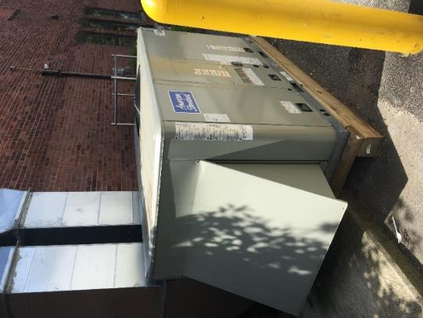
AHU at rear of building
Picture 2
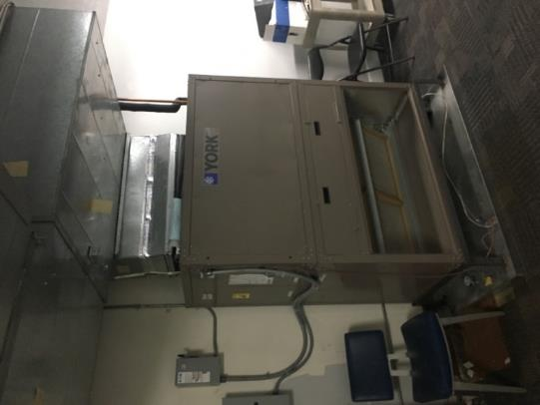
AHU in front offices hallway with missing grill front

Picture 3
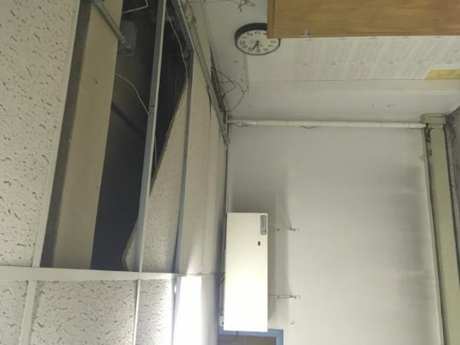
Basement suspended ceiling
Picture 4
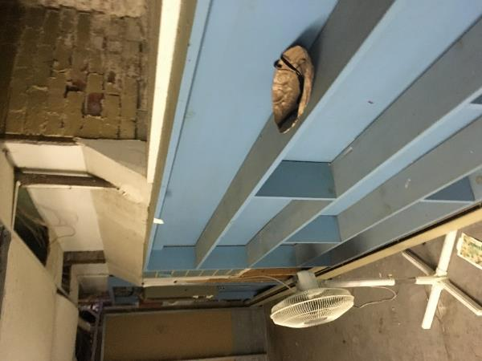
GW and shelves installed on foundation walls in basement
Picture 5
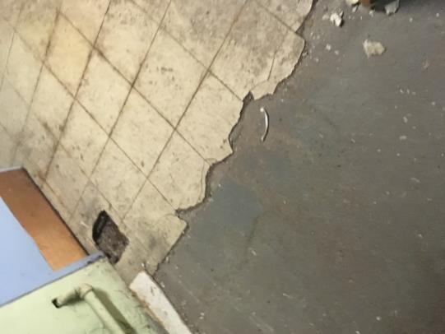
Disintegrating floor tiles in basement
Picture 6
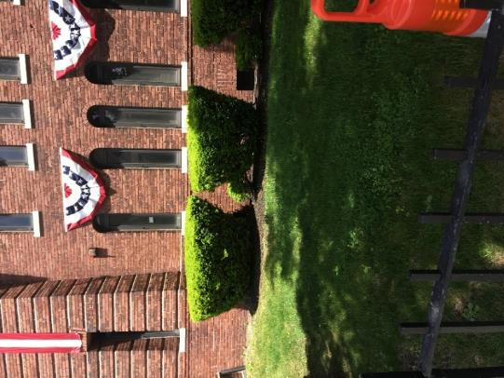
Shrubs at front of building

Picture 7
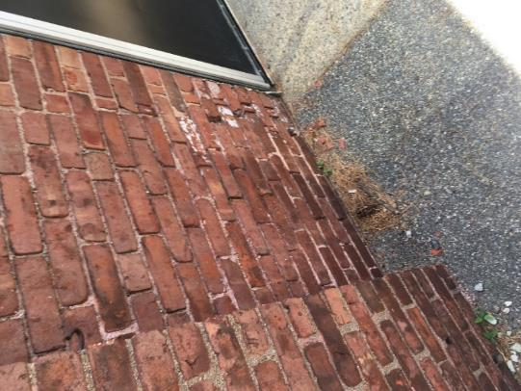
Tarmac driveway installed directly against the exterior wall
Picture 8
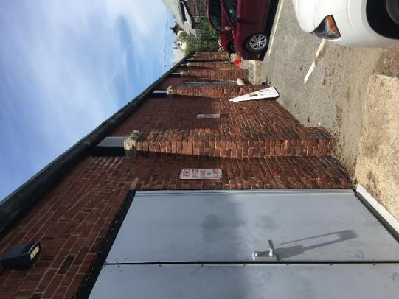
Exterior view of brick columns supporting assembly room roof (pilasters)

Picture 9
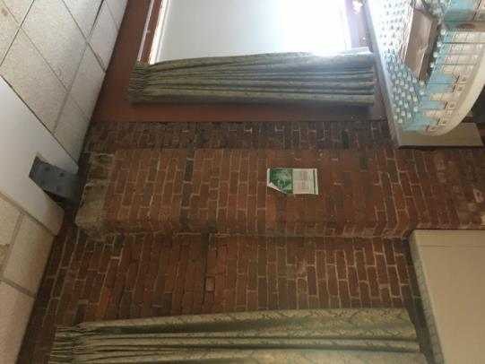
Interior view of brick columns supporting assembly room roof
Picture 10
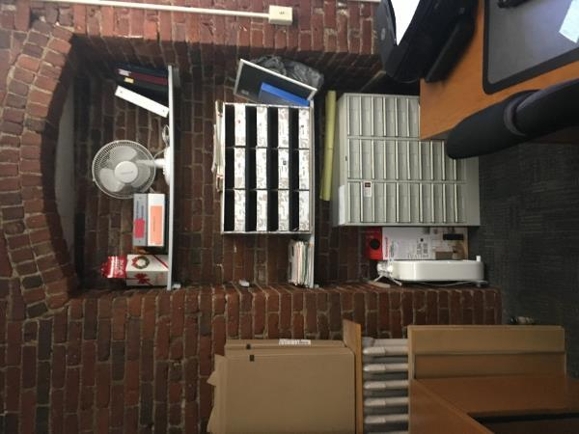
Paper and cardboard stored directly against exterior walls.
Picture 11
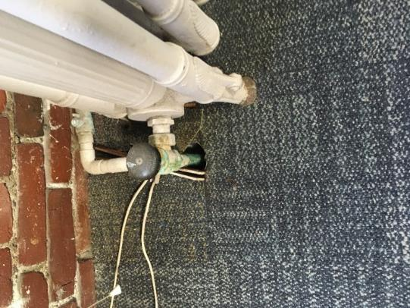
Space in floor around radiator pipes
Picture 12
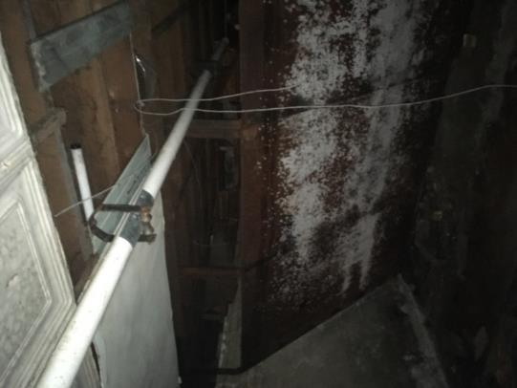
Bullet trap in basement

