INDOOR AIR QUALITY WALKTHROUGH

Edward Nelson White School
1 Jefferson Street
Holyoke, MA

May 2025



Prepared by:
Massachusetts Department of Public Health
Bureau of Climate and Environmental Health
Division of Environmental Health Regulations and Standards
Contents

EXECUTIVE SUMMARY 3
BACKGROUND 5
RESULTS AND DISCUSSION 5
Ventilation 5
Water Damage and Moisture Concerns 7
Sources of Respiratory Irritants/Possible Asthma Triggers 9
Other IAQ Issues 11
CONCLUSIONS AND RECOMMENDATIONS 12
REFERENCES 18
FIGURES 19
PICTURES 20
Ventilation Pictures 20
Water Damage Pictures 26
Respiratory Irritants Pictures 33
Table 1 41
Table 2A 45
Table 2B 46
Table 2C 47
Table 3 48
Table 4 50

EXECUTIVE SUMMARY
Massachusetts Department of Public Health’s (MDPH), Division of Environmental Health, Regulations and Standards (EHRS) conducted an Indoor Air Quality (IAQ) walkthrough of the Edward Nelson White School located at 1 Jefferson Street in Holyoke on March 27, 2025. This walkthrough was in conjunction with the “Asthma in Schools: Data to Action Project”- a collaboration between Massachusetts Department of Public Health (DPH) programs, local health departments, and local school health and administration officials to support asthma prevention and intervention efforts in school settings.
Any building can have IAQ issues. These issues can be made worse through conditions common to marginalized communities (Environmental Justice communities or EJ) such as inequitable exposure to outdoor air pollution and a greater likelihood of poor building conditions leading to deterioration of IAQ resulting in higher asthma rates. The Edward Nelson White School is within an EJ community. In addition, the pediatric asthma rate for this school as of 2023-2024 is 24.1%, which is a statistically significantly higher compared to the statewide pediatric prevalence rate of 9.6% (MAEPHT, 2025).
The assessment was conducted by evaluating several key elements within the school; a visual inspection of the heating, cooling, and ventilating (HVAC) systems, water/microbial damage, exterior building envelope evaluation, cleanliness, and point sources of respiratory irritants such as chemicals. Data is collected in this manner to identify potential asthma triggers, allergens, and other environmental factors that can cause indoor air quality symptoms. Please refer to the Indoor Air Quality Manual on the MDPH website for methods, sampling procedures, and interpretation of results.
As a result of this walkthrough, there are several findings: conditions in this school are typical of elementary schools of this age and type, univents and other HVAC components may be beyond their lifespan, some water-stained ceiling tiles were observed, and there are occupant induced issues such as clutter and blockage of HVAC units. (Results and Discussion)
During the assessment many supply and exhaust components of the mechanical ventilation system were not operating to full capacity. This limits its ability to dilute and remove typical indoor pollutants as well as outdoor pollutants, such as vehicle exhaust, pollen, mold spores, and wildfire smoke. In addition, excess water vapor during hot, humid weather may also build up in the building and lead to water damage/mold growth to building materials over summer months. Several areas with visible water damage were noted during the assessment.
Upon review of these findings, a number of recommendations are made to optimize existing HVAC systems and improve air exchange, however, the age of univents and other HVAC components make maintenance increasingly difficult. It is a testament to the facilities and maintenance staff that the current HVAC system in the building is still operating. Issues regarding the presence of point sources of irritation such as clutter can be addressed to reduce dust and odors. (Conclusions)
Based on the results of the assessment, the following primary recommendations are made:
- Operate supply and exhaust ventilation continuously when the building is occupied. Check univents and exhaust vents during occupied periods to ensure they are on and operating to their full capacity.
- Educate teachers and staff on the operation of univents and exhaust vents so they can avoid blocking units and can report off or inoperable units to facility staff. If not already in use, consider using a tracking program to collect and administer work orders for mechanical systems.
- Consider reducing the number of items stored in rooms to make cleaning easier. Meticulous cleaning practices should be adopted to minimize common indoor air contaminants whose irritant effects can be enhanced when the relative humidity is low. To control dust, a high efficiency particulate arrestance (HEPA) filter equipped vacuum cleaner in conjunction with wet wiping of all surfaces is recommended. Avoid the use of brooms and feather dusters (Conclusions and Recommendations).

Please note: this report contains a series of recommendations that should serve as Best Practices that apply to most public-school buildings across the Commonwealth and should be shared amongst other buildings in the school district.

R an BACKGROUND
Building: | Edward Nelson White School
Address: | 1 Jefferson Street  Holyoke, Massachusetts
Coordinated Via: | Holyoke School Administration, Board of Health, and District and School Nursing Leaders
Reason for Request: | Pediatric Asthma Project and General IAQ
Date of Assessment: | March 27, 2025
Massachusetts Department of Public Health/Bureau of Climate and Environmental Health/Division of Environmental Health Regulations and Standards (MDPH/BCEH/EHRS) Staff and Bureau of Community Health and Prevention (BCHAP) | Cory Holmes, Thomas Murphy, and Bharathi Patimalla-Dipali, IAQ Education and Outreach Unit, EHRS  Michelle Warner, and Victoria Hill, Asthma Prevention and Control Program, BCHAP
Building Description: | The Edward Nelson White School is a brick-faced two-story building, originally constructed in 1953. A wing was added and much of the original building was renovated in 1989-1991, however some equipment is original to the construction of the building. The school contains general classrooms, offices, and accessory rooms including a combination gym/cafeteria/auditorium.
Windows: | Most windows in the building are openable, but lack screens, and many are difficult to open due to them being past their lifecycle.

R an RESULTS AND DISCUSSION
A summary of conditions observed during the indoor air quality walkthrough can be found in (Table 1).

Ventilation
Ventilation refers to both the supply of fresh air and the removal of stale air from a room. The introduction of fresh air into an occupied space will dilute normally occurring pollutants that are generated by occupancy and other activities. In addition, an HVAC system will remove pollutants from a building if operating appropriately. All ventilation systems throughout the building should operate continuously during periods of occupancy.

The Edward Nelson White School has a combination of unit ventilators (univents, Picture 1) and rooftop air handing units (AHUs, Picture 2). Cooling is provided to many areas by window-mounted air conditioning units (Picture 3). Univents bring in fresh air from a vent on the outside of the building, filter it, heat it, and supply the air through a vent on the top. Some room air is recirculated along with the fresh air through a vent at the bottom (Figure 1). The air handling units bring in fresh air from the roof, filter it, heat it, and bring it into the occupied areas through ceiling-mounted supply vents. Classrooms are also equipped with exhaust vents that remove stale air within the rooms (Table 2B).

At the time of the assessment, exhaust ventilation in most of the classrooms and restrooms were functioning but some were off or weak (Table 1). Classroom exhaust vents were found in various areas including in coat closets (Picture 4) or on the wall close to the door (Picture 5). In numerous instances, wall-mounted exhaust vents were found obstructed by items (Pictures 6 through 8). Without proper supply and exhaust ventilation, normally occurring environmental pollutants can build up and lead to IAQ or comfort complaints. In addition, without proper exhaust ventilation, excess moisture cannot be removed from the building, which can lead to mold growth conditions over the summer.

The various types of ventilation components as well as devices that can move/redirect airflow are listed in Table 2A, Table 2B and Table 2C.

HVAC System Maintenance
- Univents, AHUs, window-mounted air conditioners, and other HVAC components may be beyond their service life According to the American Society of Heating, Refrigeration, and Air-Conditioning Engineering (ASHRAE), the service life of this type of unit is 15-20 years, assuming routine maintenance of the equipment (ASHRAE, 1991).

HVAC Types and Specific Conditions
Balancing
To have proper ventilation with a mechanical supply and exhaust system, a system must be balanced to provide an adequate amount of fresh air to the interior of a room while also removing stale air from the room.
It is recommended that HVAC systems be re-balanced every five years to ensure adequate air systems function (SMACNA, 1994).

(see HVAC pictures)

Classroom Unit ventilators:
- Some univents were blocked with items or furniture (Picture 9; Table 1).
- Some univents were set to fan “off” (Table 1), so although they were radiating heat, no fresh air was being provided during the walkthrough.

- The MDPH IAQ program recommends that filters of at least minimum efficiency reporting value (MERV) 8 or better be used, if an HVAC engineer confirms system can be so equipped without adversely affecting function, as these are adequate to filter out pollen, mold, and similar particulates (ASHRAE, 2012).
Classroom Exhaust vents:
- As noted above, many of the exhaust vents observed were blocked by items such as trash containers, furniture, or school supplies.
- Many of the exhaust vents were not operating to full capacity, as noted by a lack of or minimal air draw (Table 1). This could be due to them being past their service life, malfunctioning, or from dust collected on and/or clogged within the system (Picture 10).
Additional HVAC Conditions:
- Industrial-sized Portable Air Purifiers were found in most classrooms (Picture 11). In response to the COVID pandemic, each classroom was equipped with a portable air filter device equipped with a high efficiency particle arrestance (HEPA) filter. This type of device can filter airborne microscopic dust and other materials from the air while operating. It is important not to block the vent in front of the air purifier with classroom items, which prevents effective airflow from the unit (Picture 12).
- Most classrooms have openable windows, but without screens (Table 1). These can be used for additional fresh air during temperate weather. Windows should be kept closed during wet weather when air conditioning is operating in the room to prevent condensation and mold growth during elevated relative humidity, and at the end of the school day to prevent frozen pipes during the winter. The windows are also past their service life with many of them difficult to operate.
- A number of classrooms contain a window-mounted AC unit (Picture 2). It is important to ensure that the units are not obstructed by items that would prevent airflow. Many of the filters in these units need to be cleaned or changed (Picture 13; Table 1), as per the manufacturer’s recommendation or more frequently if needed, to ensure circulation of clean air in the classroom. Due to windows not being able to be opened, an alternative to bring fresh air into the classroom is by setting the WAC to “fan only” mode. This setting can provide fresh air into a classroom during temperate weather without opening a window.

Water Damage and Moisture Concerns
Please note that the IAQ Program does not recommend conducting mold testing in a typical water damage remediation. For details, please consult Guidance Regarding Testing for Mold in Water-Damaged Public Buildings | Mass.gov
The application of a mildewcide to moldy porous materials is not recommended.

Molds are found naturally in our environment both indoors and outdoors. Inside, mold growth may occur when items, particularly porous products such as paper or gypsum wallboard, are exposed to moisture. Typical water sources include leaks, floods, and condensation. To avoid mold growth, dry all water-damaged items and affected areas within 24-48 hours and reduce indoor humidity. Some people with chronic respiratory conditions, such as asthma, are more likely to experience health symptoms associated with molds, including allergic reactions and respiratory irritation. Controlling moisture is the key to preventing mold growth and potential health symptoms.

Hot humid summers are becoming more frequent due to climate change. Massachusetts has experienced hot, humid, and rainy summers in 2018, 2021, and 2023. July of 2021 was the wettest ever recorded in Massachusetts, and the three-month period from June through August, known as the meteorological summer, was the fourth wettest on record, according to the National Oceanic and Atmospheric Administration’s (NOAA) Centers for Environmental Information (NOAA, 2021). The summer of 2023 was measured as the second rainiest on record (WBUR, 2023). The summer of 2024 also had significant stretches of hot, humid weather. These conditions are challenging for buildings, particularly those without central air conditioning.

During these hot and wet summers, extended periods of outdoor relative humidity above 70% occurred. Public buildings experienced extended periods of water vapor exposure from high relative humidity. When exposed to these conditions, porous materials such as gypsum wallboard, cardboard, and other materials may become mold colonized, particularly if located in areas that are prone to developing condensation (e.g., floors and walls in below grade space).
- Water-damaged ceiling tiles were found in many locations (Pictures 14 and 15; Table 1), which can indicate current/historic roof/plumbing leaks or other water infiltration. Water-damaged ceiling tiles can provide a source of mold and should be replaced after a water leak is discovered and repaired. The roof has reportedly been replaced in the last 5 years. Therefore, the school should continue to patch and make repairs as needed. Staff are encouraged to report any active leaks to the Facilities Department for prompt remediation.
- Spaces were noted beneath/around exterior doors, which can allow drafts, moisture, and pests into the building (Picture 16; Table 1).
- Plants were noted in some classrooms and offices (Picture 17). Plants can be a source of pollen or mold especially if overwatered or not well maintained.
- Bowed or sagging ceiling tiles were noted in some areas (Table 1). This is an indication that these rooms have been subjected to an extended period of high humidity. While bowing tiles are not a direct IAQ issue, it is a reminder that long periods of high relative humidity may lead to water damage to other materials, particularly those stored in contact with cooler temperatures such as on uninsulated floors, and in the airstream of air conditioning.
- Many rooms on the ground floor had porous items directly on the floor (Pictures 18 and 19; Table 1). Porous items should be elevated on shelves or pallets to prevent getting wet from condensation on the cool surface of the floor.
- Water-damaged laminate countertops were noted in several areas (Picture 20; Table 1). If a sink backsplash is damaged, it becomes very difficult to keep clean and can lead to mold growth and additional damage to the material underneath.
- A leaking toilet was noted in the staff restroom near Room 106 (Table 1). Leaking plumbing can be a source of moisture to damage adjacent materials and will increase the humidity. Water sources can also be attractive to pests.
An exterior evaluation was also conducted to identify potential pathways for water penetration and pest entry. The following issues were noted.
- Exterior doors/frames were corroded and damaged creating gaps that allow for uncontrolled drafts, moisture and pest entry (Picture 21).
- Missing/damaged strip caulking was noted around windows (Picture 22).
- Shrubbery was noted near the building (Picture 23), which can prevent the exterior of the building from drying, and may damage walls and foundations. In addition, moisture, mold spores, and pollen may be drawn through air intakes on exterior walls.
- Plant/tree growth was noted along the seam between the concrete foundation and tarmac surrounding the building (Picture 24). Plants near the building can cause water damage to brickwork and mortar. In addition, plants shading exterior walls can slow drying. Water can eventually penetrate the brick, subsequently freezing and thawing during the winter. This freezing/thawing action can weaken and damage bricks and mortar.
- Efflorescence was noted on exterior brickwork in a number of areas (Pictures 25 and 26). Efflorescence results when rainwater penetrates into brick and mortar. A suspension of water and salts forms in the brick and mortar, which then travels to wall surface. As the water evaporates, a white, powdery material is formed (efflorescence). While efflorescence is a sign of water exposure to brick, and water intrusion, it is not mold growth. This is an indication that the exterior walls may need repointing.

These conditions represent potential water penetration sources. Over time, these conditions can undermine the integrity of the building envelope and provide a means of water entry into the building via capillary action through foundation concrete and masonry (Lstiburek & Brennan, 2005).

A list of water damage issues identified inside and outside the building were identified which can contribute to water issues, is included as Table 3.
(see Water Damage and Moisture Concern Pictures)

Mold Growth
Porous materials (e.g., gypsum wallboard, ceiling tiles and carpeting) can be dried with fans and heating within 24 to 48 hours of becoming wet (US EPA, 2008).
If porous materials are not dried within this time frame, mold growth may occur.

Sources of Respiratory Irritants/Possible Asthma Triggers

Asthma is a lung disease that can make breathing difficult. Without careful management of asthma, some people can have symptoms, like a tight feeling in the chest, shortness of breath, coughing, or wheezing. Although there is no cure for asthma, people with asthma can live healthy, active lives. A safe and healthy environment helps to reduce asthma symptoms.

Comparison of Local and State-wide Asthma Rates (2023-2024 school year/MAEPHT, 2025)
16.7% of children
have asthma
Holyoke
9.6% of children
have asthma
Massachusetts
24.1% of children
have asthma
Edward Nelson While School

- Sometimes, learning tools and personal items in a classroom can be a source of irritants. For example, a bird or insect nest is a great learning tool for students but may harbor microbes and allergens. Similarly, food-based projects can attract pests that carry disease or trigger allergies. Particularly, breakfast in the classroom would increase food sources in classrooms (Picture 27; Table 1). Food should be stored off the floor and in closed containers (Picture 28 Table 1).
- Personal products, particularly those with volatile organic compounds (VOCs) including scents, can also be a source of respiratory irritation. VOCs are carbon-containing substances that have the ability to evaporate at room temperature. Frequently, exposure to low levels of total VOCs (TVOCs) may produce eye, nose, throat and/or respiratory irritation in some sensitive individuals. Products noted were dry erase markers, label removal liquid, scented candles, and plug-in air fresheners (Pictures 29 through 31; Table 1). Consult “Clean Air Is Odor Free” for more information on fragrances in schools and other building.
- Dust, a common respiratory and eye irritant, can collect on surfaces and items. Although janitorial and maintenance staff perform routine cleaning in classrooms, they may not be able to clean as effectively if classroom items are not picked up or surfaces are cluttered. Many classrooms had dust, grime, and clutter along many surfaces, walls and floor (Picture 32). Many areas within the rooms are being used as additional storage which could make it difficult to clean. Additionally, ceiling décor was noted in many classrooms collecting dust (Picture 33; Table 1). It was noted that many of the classrooms use brooms for cleaning purposes, which aerosolize particulate matter (Picture 34; Table 1). To control for dusts, a high efficiency particulate arrestance (HEPA) filter equipped vacuum cleaner in conjunction with wet wiping of all surfaces is recommended. Avoid the use of feather dusters.
Even with a properly functioning ventilation system, it is necessary to either eliminate or reduce the use of materials that can be a source of respiratory irritants to prevent symptoms in individuals who have sensitivity to such pollutants.

For guidance on maintaining an asthma-friendly healthy school environment, please consult the MDPH Asthma Prevention and Control Program’s Clearing the Air: An Asthma Toolkit for Healthy Schools.
Possible asthma triggers and/or airborne pollutants exist in the building. These are listed below as well as in (Table 4).
(see Sources of Respiratory Irritant Pictures)

- Tennis balls had been sliced open and placed on table/chair footings to reduce noise in a few areas (Picture 35; Table 1). Tennis balls are made of a number of materials that are a source of respiratory irritants. Constant wearing of tennis balls can produce fibers and lead to off-gassing of VOCs. Tennis balls are made with a natural rubber latex bladder, which becomes abraded when used as a chair leg pad. Use of tennis balls in this manner may introduce latex dust into the school environment. Some individuals are highly allergic to latex (e.g., spina bifida patients) (SBAA, 2001). It is recommended that the use of materials containing latex be limited in buildings to reduce the likelihood of symptoms in sensitive individuals (NIOSH, 1997).
- Many classrooms had area rugs, pillow cushions, and upholstered chairs (Picture 36; Table 1). Area rugs need to be cleaned regularly to remove dust, debris, and odors. Area rugs should also be stored off the floor in a climate-controlled area during the summer to prevent moistening by condensation. Used area rugs should not be brought into the school as they may harbor allergens such as pet dander. It was stated that the facilities staff frequently vacuum these rugs.
- Most schools contain photocopiers and laminators. Photocopiers produce heat and ozone, and laminators melt plastic and produce odors when in use. Local exhaust should be provided for these areas.
- Some classrooms and storage rooms had an excess of items such as books, craft materials, papers, and other miscellaneous materials. Items need to be stored neatly so that effective cleaning can be performed. Most rooms had excess material stored above cabinets and on the floor collecting dust. Items such as backpacks, jackets, books and other porous items should not be stored on the floor to prevent mold growth due to condensation on cool surfaces. Elevate items off the floor with pallets or store on top of shelving and cabinets.
- In many areas supply vents and surrounding ceiling tiles, exhaust/return vents, AC’s, and personal fans had accumulated dust and debris (Pictures 10, 13, 37 through 39; Table 1). This dust can be aerosolized under certain conditions and can also be a medium for mold growth. Univent and AHU cabinets can also accumulate dust and debris and should be cleaned out during filter changes.
- Many areas were in need of cleaning (Pictures 40 and 41).

Other IAQ Issues

Radon

Radon is a naturally occurring radioactive gas that seeps into buildings from the surrounding soil and can increase the risk of lung cancer at elevated levels.

The Environmental Protection Agency (EPA) conducted a National School Radon Survey “in which it discovered nearly one in five schools has at least one schoolroom with a short-term radon level above the action level of 4pCi/L (picocuries per liter) – the level at which the EPA recommends that schools take action to reduce the level” (US EPA, 1993).

The MDPH therefore recommends that every school be tested for radon, and that this testing be conducted during the heating season while school is in session in a manner consistent with US EPA radon testing guidelines. Radon measurement specialists and other information can be found at www.nrsb.org and http://aarst-nrpp.com/wp, with additional information at: https://www.mass.gov/radon

R an CONCLUSIONS AND RECOMMENDATIONS

Please note: this report contains a series of recommendations that should serve as Best Practices that apply to most public-school buildings across the Commonwealth and should be shared amongst other buildings in the School District.

Issues typical to many schools were found in this building. The age of the HVAC equipment will make controlling temperature and airflow more difficult as time goes on. Other issues described can be mitigated with repairs to the building, and changes to occupant behaviors to reduce blockages of univents/exhaust vents and clutter.
Short-term recommendations can be implemented as soon as practicable, however long-term measures are more complex and will require planning and resources to adequately address overall indoor air quality issues within the building.

Short-term Recommendations
HVAC System |  | Helpful Links
1. | Ensure all AHUs and univents are on and operating continuously during occupied periods if operable. If univent fan operation is linked to thermostat, work with HVAC vendor to operate independently as to not “cycle” off/on during the school day.
2. | Remove blockages from exhaust vents, and the top/front of univents, ACs, and air purifiers including furniture and items.
3. | Periodically check the function of all classroom and restroom exhaust vents. Repair as needed.
4. | Close classroom doors for improved exhaust vent function and air exchange.
5. | Continue with regular filter changes for HVAC equipment using a minimum efficiency rating value (MERV) 8 or the best quality/highest MERV-rated filter that can be used without effecting airflow.  Ensure filters fit flush within their racks to prevent filter bypass. | ANSI/ASHRAE Standard 52.2-2017
6. | During filter changes, clean dust and debris from the inside of univent and AHU cabinets.
7. | Use openable windows for additional fresh air during temperate weather. Tightly close windows at the end of the day and avoid opening windows during extreme cold to prevent freezing of pipes. Keep windows closed when outdoor air quality is unhealthy.  Add screens to the windows if possible to encourage keeping them open when needed. | https://www.airnow.gov/
8. | Clean and maintain window-mounted air conditioners in accordance with manufacturer’s instructions.  Keep windows closed in rooms where air conditioners are operating to avoid condensation and clean the filters routinely.
Water Damage Sources
9. | Replace water-damaged ceiling tiles. Repeated water damage to ceiling tiles indicates leaks from the roof or plumbing/HVAC system which should be repaired. | http://www.epa.gov/mold/mold-remediation-schools-and-commercial-buildings-guide
10. | Do not store cardboard, backpacks, clothing items or other porous items directly on floors to prevent mold growth due to condensation on cool surfaces, Elevate items with pallets or store on shelving.
11. | Seal spaces around exterior doors with weatherstripping, to prevent drafts, moisture, and pest entry. Make repairs as needed.
12. | Make repairs to missing/damaged window caulking.
13. | Conduct a thorough building envelope evaluation to make repairs/repointing efforts to eliminate leaks.  Clean efflorescence from exterior brickwork.
14. | Trim trees, branches and shrubbery at least 5 feet away from the building.
15. | Properly maintain plants to avoid mold and odors. Keep plants away from airflow of HVAC equipment.
16. | Use these guidelines to control moisture and increase comfort in a non-air-conditioned school especially during heatwaves. | - Mold Growth Prevention During Hot, Humid Weather https://www.mass.gov/service-details/preventing-mold-growth-in-massachusetts-schools-during-hot-humid-weather  - Remediation and Prevention of Mold Growth and Water Damage in Public Schools https://www.mass.gov/service-details/remediation-and-prevention-of-mold-growth-and-water-damage-in-public-schools-and  - Methods for Increasing Comfort in Non-air-conditioned Schools https://www.mass.gov/doc/methods-for-increasing-comfort-in-non-air-conditioned-schools/download
17. | While bowed/sagging ceiling tiles are not a source of mold, this indicates extended exposure to high humidity. Therefore, care should be taken with storage of materials in these areas during hot, humid weather and over the summer.
18. | During summer months, pull furniture away (1 to 2 inches) from walls to prevent mold growth due to lack of airflow and remove impermeable wall coverings that can trap moisture such as laminated posters.
19. | Make repairs to water-damaged countertops and cabinets in classrooms.
20. | Make repairs to leaking toilet in staff restroom near Room 106.
Respiratory Irritants/Possible Asthma Triggers
21. | Avoid using latex-containing tennis balls as chair or table glides. Replace with latex-free glides or other materials. | https://www.cdc.gov/niosh/docs/97-135/default.html  https://www.spinabifidaassociation.org/wp-content/uploads/latex-in-the-home-and-community-eng.pdf
22. | Clean personal fans, ACs, supply, and exhaust/return vents periodically to remove dust and debris.  If soiled ceiling tiles around vents cannot be cleaned, replace.
23. | Reduce use of products and equipment that create irritating volatile organic compounds (VOCs) and only use in well-ventilated areas. Minimize the use of air fresheners (e.g., plug-ins), deodorizers and scented products. | https://www.mass.gov/cleaner-greener-healthier-schools
24. | Use only District-approved cleaning products. Keep spray bottles properly labeled and out of the reach of children.
25. | Provide exhaust ventilation or move copiers and laminators to a well-ventilated area with an exhaust vent.
26. | Periodically sort classroom and stored items to remove unwanted items. Store remaining items neatly and off the floor. Where rooms have a history of moisture issues, consider storing items in waterproof totes.
27. | Clean area rugs frequently using a HEPA-equipped vacuum cleaner. Avoid bringing used area rugs into the school. It is important not to block the vents on the front/back of the air purifier, which blocks the filtered air emitted back into the room.
28. | Supplement mechanical ventilation with portable air purifiers equipped with high efficiency particulate arrestance (HEPA) filters. While these do not supply fresh air, they can remove particles including mold spores and microbes.  Units that may produce ozone should not be used. Maintain all in accordance with the manufacturer’s instructions.  Place them so the filtered airstream is in the breathing zone of occupants and away from open doors and exhaust vents. | https://www.epa.gov/indoor-air-quality-iaq/ozone-generators-are-sold-air-cleaners
29. | Replace missing ceiling tiles and seal open utility holes/breaches in floors, walls, and ceilings.
30. | Ensure the principles of integrated pest management (IPM) are followed in accordance with state regulations. Continue with district-wide plans to work with a professional pest contractor to address rodent infestation issues, including:  - reducing harborages inside and outside the building,  - sealing breaches and pathways of entry,  - centralizing food prep appliances to central location,  - reducing/eliminating eating in classrooms, and  - improving cleaning protocols | https://massnrc.org/ipm/docs/ipmkitforbuildingmanagers.pdf
Other Recommendations to Improve Air Quality Conditions
31. | Test the school for radon by a certified radon measurement specialist during the heating season when school is in session. | Radon measurement specialists and other information can be found at: www.nrsb.org, and http://aarst-nrpp.com/wp
32. | To learn more about radon, review the MDPH’s Radon in Schools and Child Care Programs factsheet. | https://www.mass.gov/radon.
33. | Utilize the US EPA’s (2000), “Tools for Schools” as an instrument for maintaining a good IAQ environment in the building. | https://www.epa.gov/iaq-schools.
34. | For guidance on maintaining an asthma-friendly healthy school environment, please consult the MDPH Asthma Prevention and Control Program’s Clearing the Air: An Asthma Toolkit for Healthy Schools. | https://www.maasthma.org/schooltoolkit
35. | Include an IAQ component in the school’s Wellness Advisory Committee program. An IAQ plan should have an IAQ liaison/teacher representative, a member of maintenance/facilities and administration that conduct regular walk-throughs to identify on-going and/or potential environmental issues.
Long-term Recommendations
36. | Since the HVAC system is likely beyond its service life contact an HVAC engineering firm for advice regarding conditions noted, including a building-wide HVAC equipment assessment to determine:  - Whether the existing HVAC system can be balanced as recommended.  - The operability and feasibility repairing the existing equipment.  - If the equipment should be replaced due to age, physical deterioration, and availability of parts for ventilation components.
37. | Consider installing sensor technology in classrooms to provide continuous monitoring of the following indoor air parameters (particularly temperature and relative humidity). Sensors should be re-calibrated quarterly or according to manufacturer’s specifications and building management software updated as per manufacturers’ instructions, industrial standards, and/or change in operating systems. As an example, the link to the right illustrates how this technology is serving Boston Public Schools to improve air quality (i.e., carbon dioxide, temperature, relative humidity, carbon monoxide, and particulate matter). | COVID-19 Health & Safety Information / Indoor Air Quality Sensor Dashboard (bostonpublicschools.org)
38. | Replace windows with modern energy effect ones.
39. | Replace carpeting that is beyond its lifespan.
40. | Replace water-damaged countertops in classrooms.

REFERENCES
ASHRAE. 1991. ASHRAE Applications Handbook, Chapter 33 “Owning and Operating Costs”. American Society of Heating, Refrigeration and Air Conditioning Engineers, Atlanta, GA.
ASHRAE. 2012. American Society of Heating, Refrigeration and Air Conditioning Engineers (ASHRAE) Standard 52.2-2012 -- Method of Testing General Ventilation Air-Cleaning Devices for Removal Efficiency by Particle Size (ANSI Approved).
Lstiburek, J. & Brennan, T. 2005. Read This Before You Design, Build or Renovate. Building Science Corporation, Westford, MA. U.S. Department of Housing and Urban Development, Region I, Boston, MA. https://www.buildingscience.com/documents/guides-and-manuals/gm-read-this-before-you-design-build-renovate/view
MAEPHT. 2025. Massachusetts Environmental Public Health Tracking. Massachusetts Department of Public Health – Bureau of Climate and Environmental Health. https://matracking.ehs.state.ma.us/
NIOSH. 1997. NIOSH Alert Preventing Allergic Reactions to Natural Rubber latex in the Workplace. National Institute for Occupational Safety and Health, Atlanta, GA.
NOAA. 2021. Summer 2021 neck and neck with Dust Bowl summer for hottest on record. National Oceanic and Atmospheric Administration, 1401 Constitution Avenue NW, Room 5128, Washington, DC 20230 https://www.noaa.gov/news/summer-2021-neck-and-neck-with-dust-bowl-summer-for-hottest-on-record
SBAA. 2001. Latex In the Home And Community Updated Spring 2001. Spina Bifida Association of America, Washington, DC.
SMACNA. 1994. HVAC Systems Commissioning Manual. 1st ed. Sheet Metal and Air Conditioning Contractors’ National Association, Inc., Chantilly, VA.
US EPA. 1993. Radon Measurement in Schools, Revised Edition. Office of Air and Radiation, Office of Radiation and Indoor Air, Indoor Environments Division (6609J). EPA 402-R-92-014.
US EPA. 2000. Tools for Schools. Office of Air and Radiation, Office of Radiation and Indoor Air, Indoor Environments Division (6609J). EPA 402-K-95-001, Second Edition. https://www.epa.gov/iaq-schools.
US EPA. 2008. Mold Remediation in Schools and Commercial Buildings. US Environmental Protection Agency, Office of Air and Radiation, Indoor Environments Division, Washington, D.C. EPA 402-K-01-001. http://www.epa.gov/mold/mold-remediation-schools-and-commercial-buildings-guide.
WBUR. 2023. “It's been a summer of rain and flooding misery in Mass.” WBUR local news. September 12, 2023. https://www.wbur.org/news/2023/09/12/summer-flooding-rain-massachusetts.

R an FIGURES
Figure 1

Unit Ventilator (Univent)

Mixed Air

Air Diffuser

Outdoors Indoors

Fan

Heating/Cooling Coil

Air Mixing Plenum

Filter

Outdoor Return
Air Air

Air
Flow
Control
Louvers

Air Flow

= Fresh Air/Return Air

= Mixed Air

R an PICTURES
(Click to link back to report)

Ventilation Pictures
Picture 1

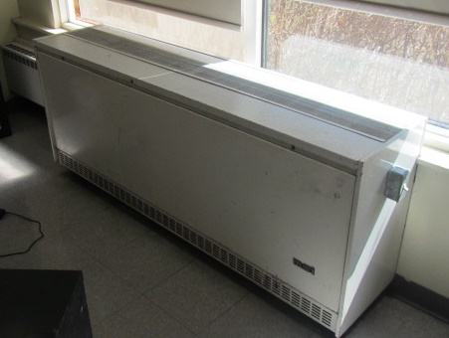

One style of classroom unit ventilator (univent)
Picture 2
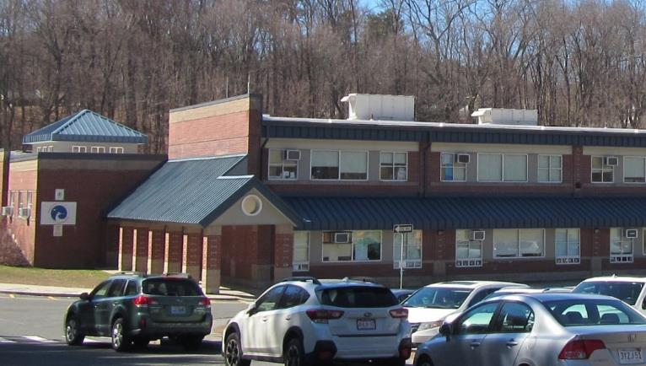
Rooftop air handling units (arrows)

Picture 3

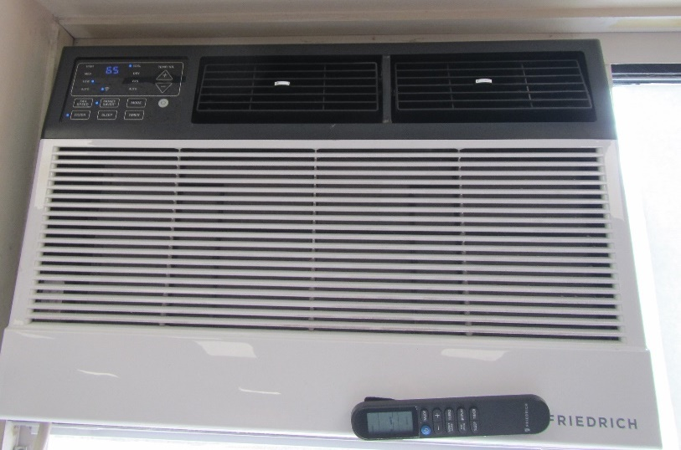

Window-mounted air conditioning unit
Picture 4

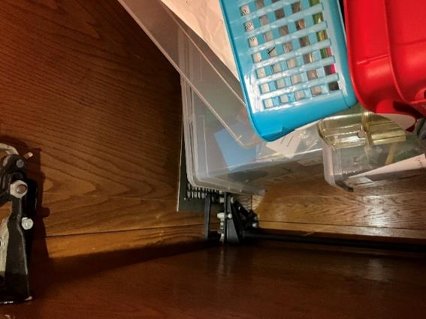

Exhaust vent (arrow) in the classroom coat closet obstructed by items

Picture 5

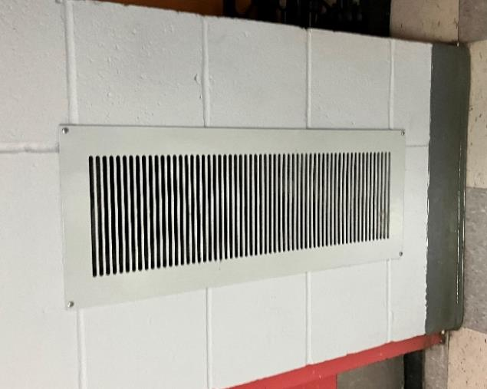

Wall-mounted exhaust vent
Picture 6

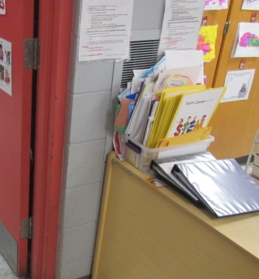
Blocked wall-mounted exhaust vent (arrow)

Picture 7
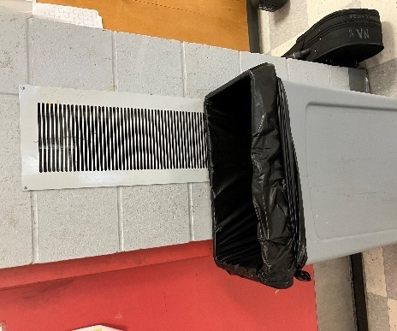

Blocked wall-mounted exhaust vent

Picture 8

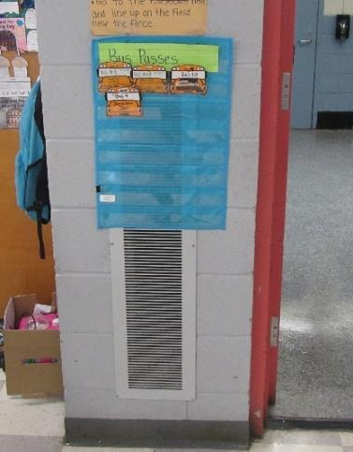

Blocked wall-mounted exhaust vent

Picture 9

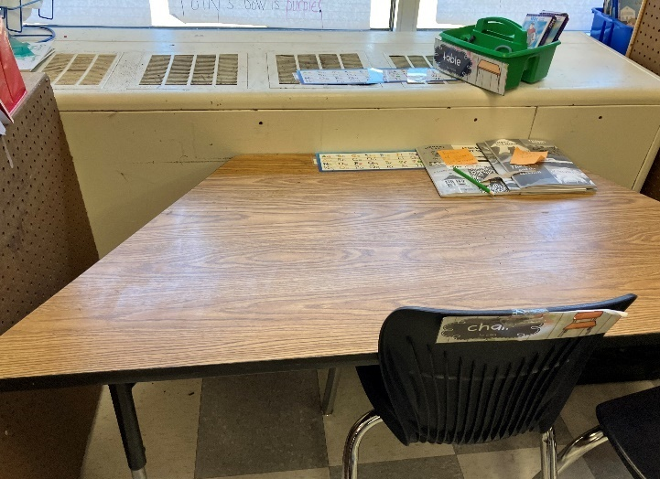

Blocked uninvent return (bottom front) with classroom furniture

Picture 10

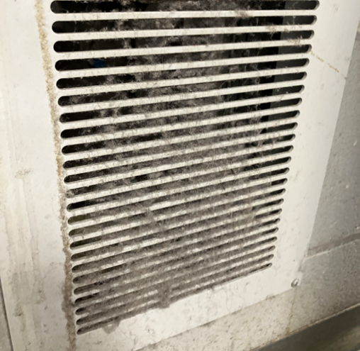

Exhaust vent clogged with dust

Picture 11

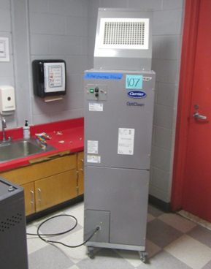

Industrial-sized portable air purifier

Picture 12
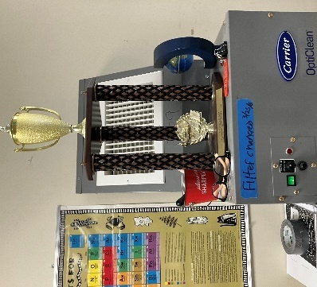

Blocked air purifier supply vent

Picture 13

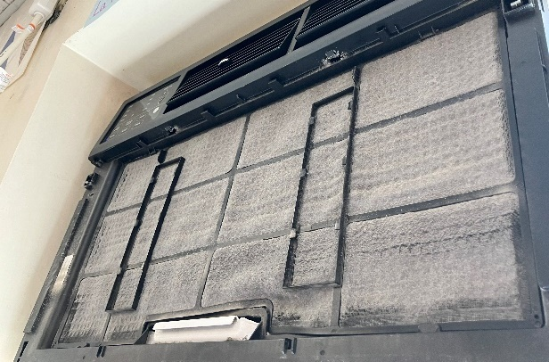

Dusty window-mounted air conditioning unit filter

Water Damage Pictures
Picture 14

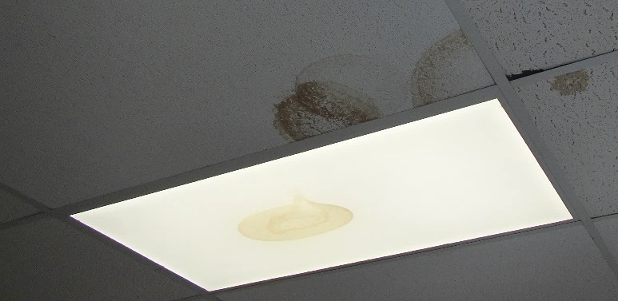

Water-damaged ceiling tiles and light cover

Picture 15

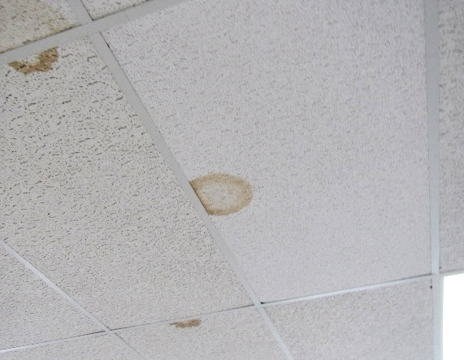

Water-damaged ceiling tiles

Picture 16

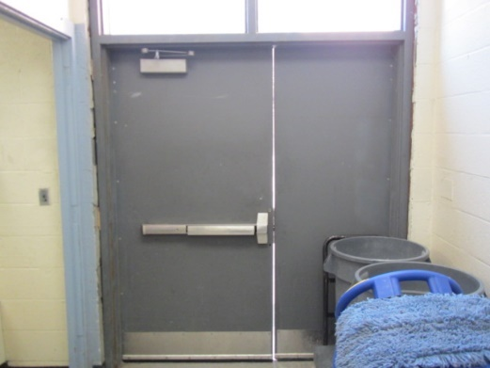

Space under and between exterior doors
Picture 17
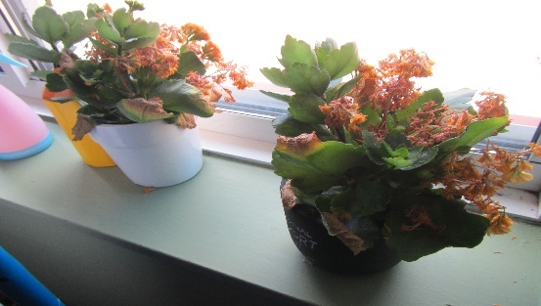
Plants in classroom

Picture 18

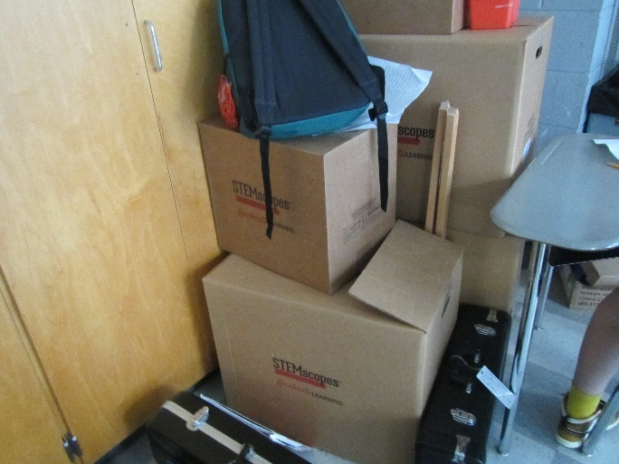

Cardboard boxes stored on the ground

Picture 19

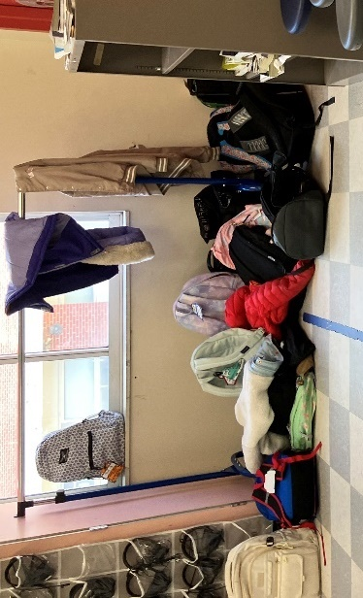

Clothing and backpacks stored on the floor

Picture 20
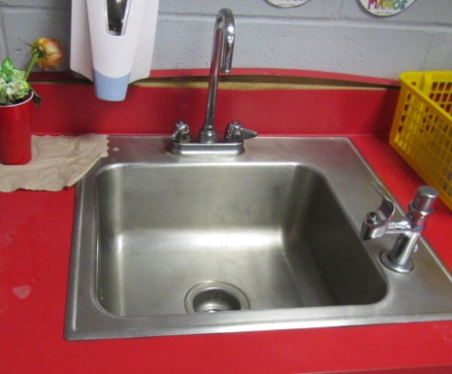
Water-damaged laminate countertop

Picture 21

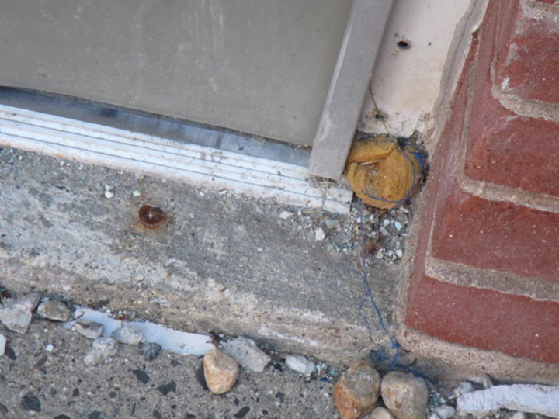

Hole in exterior door frame plugged with what appears to be steel wool to prevent rodent entry

Picture 22

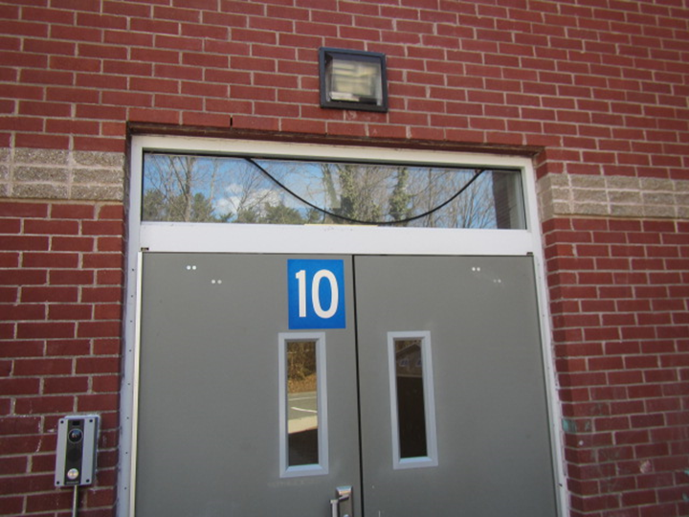

Failing strip of caulking around window above exterior door

Picture 23
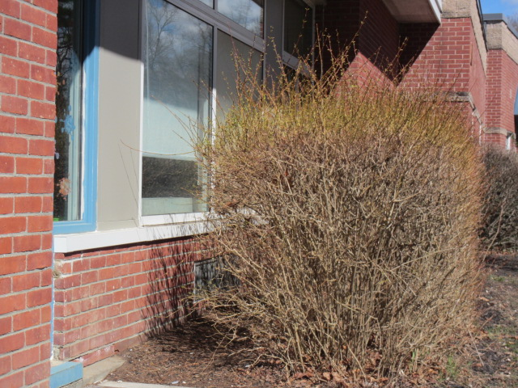
Shrubbery close to the building exterior, note proximity to fresh air intake for classroom (arrow)

Picture 24

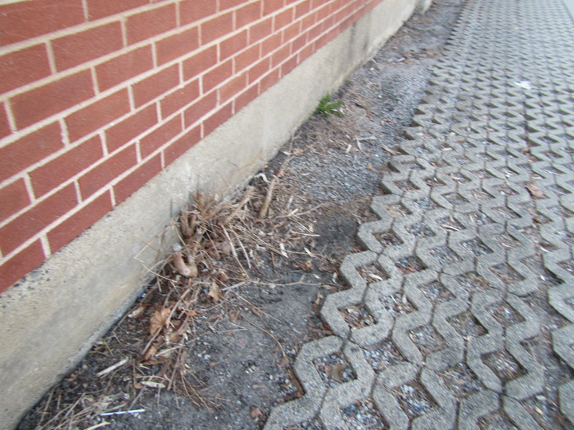

Plant/tree growth between tarmac and concrete foundation

Picture 25

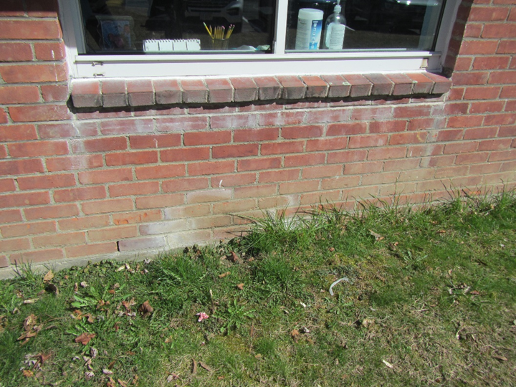

Efflorescence (white mineral deposits) on exterior brickwork

Picture 26

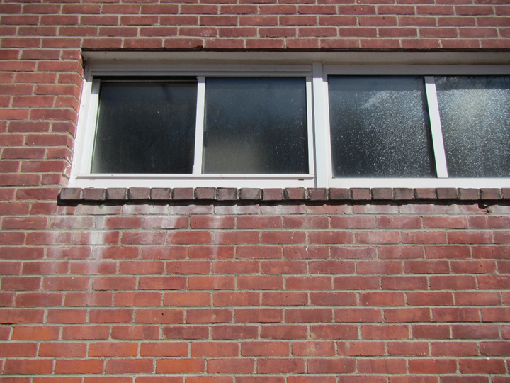

Efflorescence (white mineral deposits) on exterior brickwork

Respiratory Irritants Pictures
Picture 27

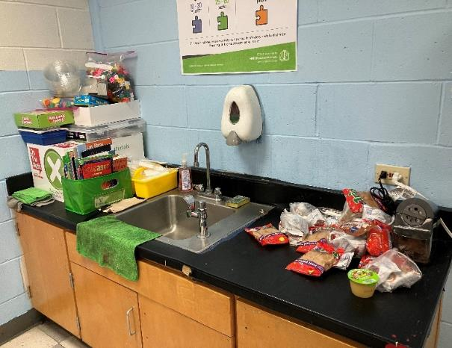

Food stacked next to the sink

Picture 28

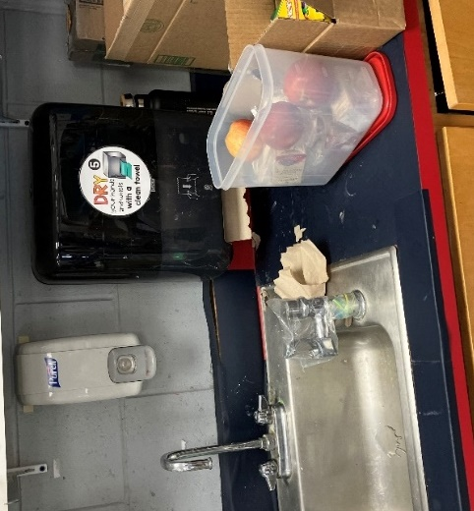

Food stored in an open container by the classroom sink

Picture 29

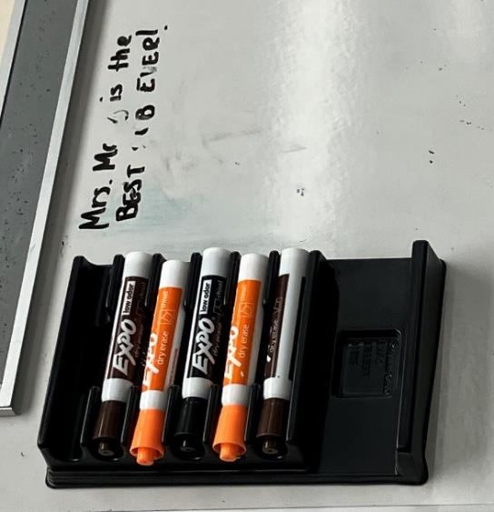

Dry erase markers in classroom

Picture 30

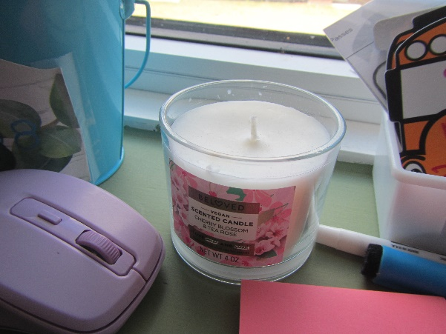

Scented candle in classroom

Picture 31

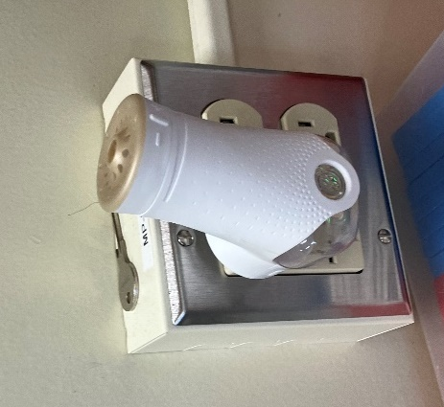

Plug-in air freshener

Picture 32

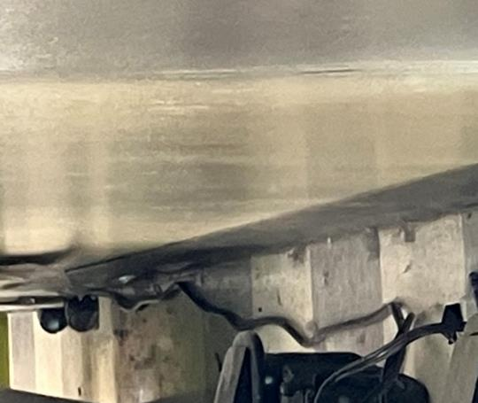

Dust settled in many areas of the classrooms

Picture 33

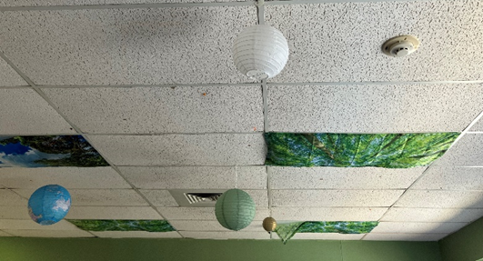

Ceiling décor collecting dust

Picture 34

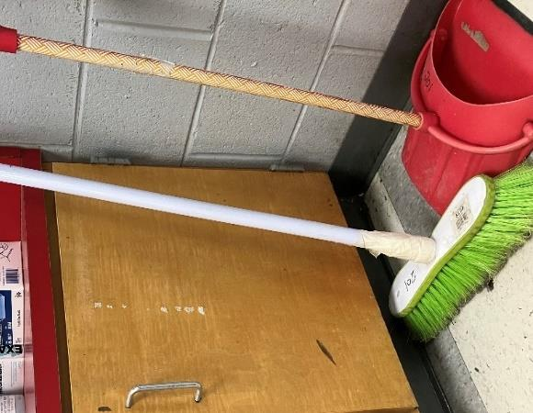

Brooms and dustpans found and being used in classrooms

Picture 35

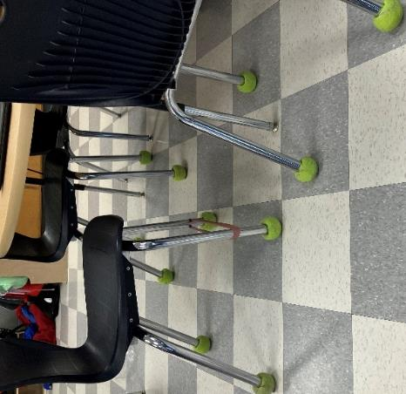

Tennis balls placed on chair footing to reduce noise in classrooms

Picture 36

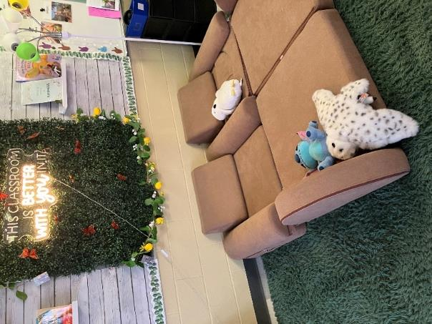

Area rugs, cushions, upholstered chairs and stuffed toys in classroom

Picture 37

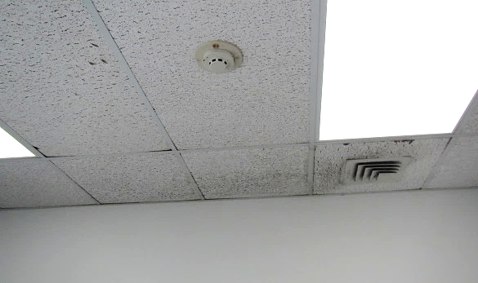
Dust/debris accumulation on vent and surrounding ceiling tiles
Picture 38

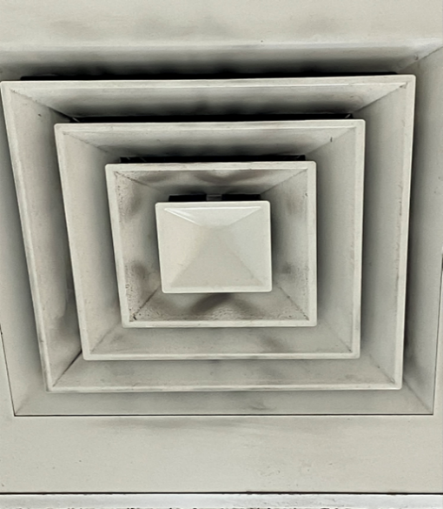

Dust/debris accumulation on vent

Picture 39
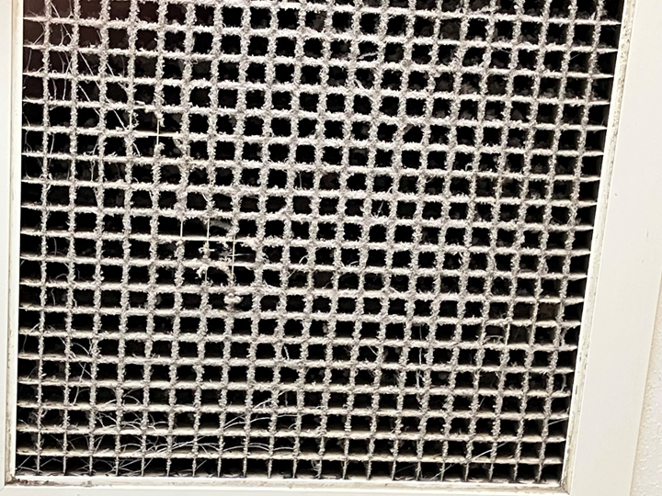
Dust/debris accumulation on exhaust vent
Picture 40

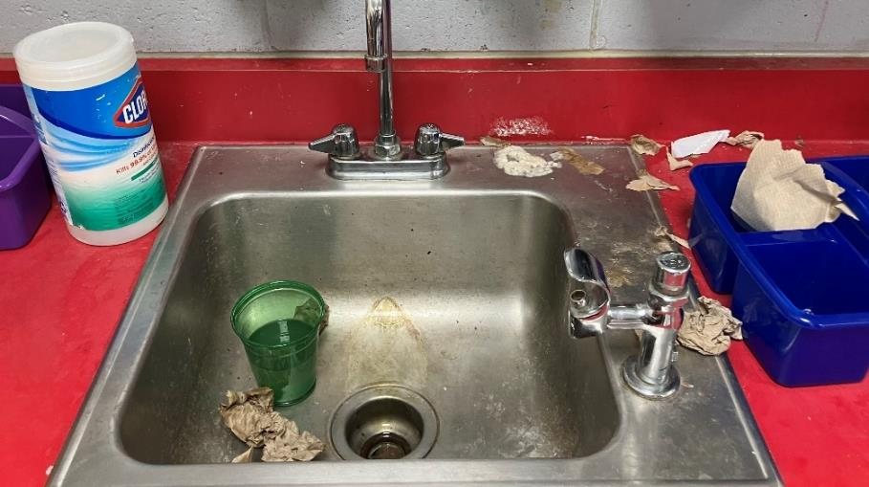

Many areas in classrooms were unkempt

Picture 41

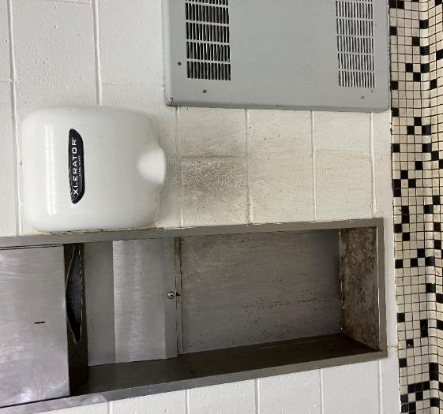
Wall in need of cleaning in restroom

Click to link back to report

Table 1
Room | Openable Windows | HVAC | Ventilation |  | Ceiling Tiles/Staining (Y or N)  Bowed = B | Comments
 |  |  | Intake | Exhaust
Gym | N | Y | Y | Y |  | Spaces under exterior door – needs weather-stripping
Library | N | Y | Y | Y | Y | 2 WD CTs, exhaust vent partially obstructed, window AC
101 | Y | Y | Y | Y | Y | 5 WD CTs, accumulated items, dust/debris accumulation on vents
102 | Y | Y | Y | Y |  | Bathroom exhaust vent dusty, classroom exhaust blocked, dust/debris accumulation on vents and surrounding CTs, CP on countertop, area rug
103 | Y | Y | Y | Y |  | Area rug, dust/debris accumulation on AC, vents and surrounding CTs
104 | Y | Y | Y | Y |  | Area rug, exhaust blocked, WD countertop, DO, dust/debris on vents, 3 WD CTs, AC-dusty
105 | Y | Y | Y | Y | Y | AP, exhaust blocked, dust/debris on vents, DO, area rugs, 1 WD CT, WD countertop
106 | Y | Y | Y | Y |  | Dust/debris accumulation, supply blocked, TB, area rug, PF, AP, AC
107 | Y | Y | Y | Y |  | Area rug, exhaust blocked in closet, AP, TB, WD gypsum wallboard/beam - historical, WD countertop
108 | Y | Y | Y | Y | Y | Area rug, 1 WD CT, upholstered furniture
109 | Y | Y | Y | Y |  | DO, dust/debris accumulation on vents and surrounding CTs
110 | Y | Y | Y | Y |  | Spray deodorizer on sink countertop, bathroom exhaust off
111 A & B | Y | Y | Y | Y |  | WD sink countertop, dust/debris accumulation on AC, vents and surrounding CTs, area rug, DO
Staff Restroom near Room 106 |  |  |  |  |  | Toilet leak
Staff Dining Room | Y | Y | Y | Y | Y | WD CT, AC, supply off, AP
207 | Y | Y | Y  dusty | Y  blocked | Y | Area rug, AP, DEB, 13 WD CTs, exhaust on the wall blocked, window AC on and filter dirty, sink was cluttered and cabinet under the sink was full, holes in CTs
206 | Y | Y | Y | Y | Y, B | Area rug, AP, DEB, 9 WD CTs, TB on chairs, room cluttered, dust and debris on the floor near carpet, grime along the walls, sink on cabinet door stuck.
2nd floor female bathroom | Y | Y | Y | Y |  | Exhaust off and toilet paper stuck on the ceiling wall.
2nd floor male bathroom | Y | Y | Y | Y |  | Exhaust weak, blocked and clogged with dust, ceiling plaster damaged, grime on walls.
204 | Y | Y | Y  dusty | Y  blocked | Y, B | Area rug, AP, DEB, 4 WD CTs, exhaust weak, blocked and clogged with dust, sink dirty and rusted, CP
205 | Y | Y | Y  dusty | Y | Y | Area rug, AP, DEB, TB, 6 WD CTs, sink dirty, holes in CT
208 | Y | Y | Y  dusty | Y | Y | Area rug, lounge chairs, faux wall plant installation, AP off, dry erase materials, 3 WD CTs, plants on windowsill without a drain dish, hanging ceiling décor, supply vent dusty, window AC on, scented candle, plants with no drip pan, furniture, candle, CP, hand sanitizer, dry erase materials
209 | Y | Y | Y  dusty | Y  Partially blocked | Y, B | AP on with items stored in front of the airflow, ceiling tiles off their channel setting, 14 WD-CTs, area carpet, coffee maker dirty, window AC on
203 | Y | Y | Y  dusty | Y  blocked/ weak | Y | Window-mounted air conditioner, plants in the room, open food container with apples next to the sink, TB, DEB, 9 WD CTs, dust and debris around the room, cardboard covering cracked window, dusty broom, area carpet, CP
202 | Y | Y | Y  dusty | Y  weak | Y | AP on with items stored in front of the airflow, 6 WD CTs, walls dirty, dust and debris around the room, food not stored in container, bleach in sink cabinet, CP
210 | Y | Y | Y  dusty | Y  dusty | Y | Exhaust partially blocked, AP on, TB, under the sink cabinet cluttered, used paint cans stored on top of cabinet., 22 WD CTs
211A | N | Y | Y  dusty | Y  dusty | Y | Exhaust on and weak, standing fan dirty, broom dirty, multi-purpose spray in front of AP airflow, 1 WD CT, window AC filter light on & dusty, window AC being used as “fan only mode”, furniture
201 | Y | Y | Y  dusty | Y | Y | Exhaust on and weak, hole in CT, CP, food not properly stored, dry erase materials, 7 WD CTs
M1 | Y | Y | Y | Y | N | Window AC filter dusty, AP close to exhaust vent & in corner surrounded by items, plants, area carpet, exterior door propped ajar
M2 | Y | Y | Y  off | Y | N | Exhaust in the closet on, sink area and under the sink cabinet cluttered, AP in corner close to exhaust vent, window AC filter dusty, area carpet, dust/debris around exterior door.
M3 | Y | Y | Y | Y | Y | Exhaust in the closet on, window AC filter light on, area carpet, furniture, 2 WD CTs
M4 | Y | Y | Y  off | Y | Y | Exhaust in the closet on and weak, window AC filter dusty, area carpet, furniture, 4 WD CTs
M5 Right |  |  | Y | Y | Y | Univent with minimal air flow, exhaust in the closet on and weak, window AC, plug-in air freshener, AP off, furniture, area carpet, 5 WD CTs
M5 Hallway | N | Y | Y | Y | Y | 3 WD CTs
M5 Left | Y | Y | Y | Y | Y | Window AC, air freshener in attached restroom
M6 | Y | Y | Y | ? | Y | WD CT-near back door, 2 plug in APs – strong chemical odors, supply off, very stuffy/uncomfortable, windows shut, exhaust could not be located
M7 Student Support | N | N | N | N |  | AC prevents opening of window, passive vent in door
M7 Art | Y | Y | N | Y
M7 Councilor’s Office | Y | Y | Y | Y |  | Supply off, area rug, shrubbery directly outside
Instrument Storage |  |  |  |  |  | Area rug, water-stained gypsum wallboard wall – dry, wall-to-wall carpeting, MT
Cafeteria Hallway |  |  |  |  |  | Space under exterior door
Vice Principal’s Office | N | N | N | N |  | AC prevents the opening of window
Nurse | N | Y | Y | Y |  | PF, area rug
Main Office | N | Y | Y | Y
Principal Office | Y | Y | Y | N
Mrs. Grasso | N | Y | Y | Y |  | Supply vent dusty, exhaust blocked

(Click to link back to report)

Table 2A
Equipment Present in Building  (X = Yes) | Type of Heating/Cooling Ventilation  Equipment | Fresh  Air  Supply  (X = Yes) | Type of Location(s) | Air Filters Installed  MERV Rating  (1-15, U*)  (X = Yes) | Comments
X | Univents | X | Classrooms | X
X | Rooftop Air Handling Units | X | Modular classrooms | X 13
 | Outdoor, Ground-Installed Air Handling Units
 | Attic/Crawlspace Air Handling Units
X | Ceiling-Mounted Air Handling Units (including inside plenum) | X | Cafetorium | X 13
 | Basement/Crawlspace-Installed Air Handling Units
 | Mechanical Room-installed Air Handling Units
 | Fan Coil Units
X | Window-Mounted Air Conditioners | X | Classrooms, offices
 | Wall Louver-Controlled Gravity Air Supply
X | Windows |  | Classrooms, offices |  | No screens
 | Fan in window (blowing in)
 | Built in wall fan (switched)
 | Heat recovery ventilator unit
 | Energy recovery ventilator unit
 | Chilled Beam
 | Passive combustion supply vent in basement/boiler room

*U = Filter Rating underdetermined due to inaccessibility during building visit

(Click to link back to report)

Table 2B
Equipment Present in Building  (X = Yes) | Type of Exhaust Ventilation  Equipment | Ducted  To Outdoors  (X = Yes) | Type of Location(s) | Comments
X | Rooftop Motors/Fans | X | Classroom coat closets
 | Unit Exhaust
 | Ceiling Return Vent
 | Ceiling Return Vent, Plenum
X | Wall Return Vent | X | Cafetorium
 | Kitchen Stove Hood
X | Restroom Exhaust Vent | X
 | Photocopier Exhaust Vent
 | Garage
 | Chemical Hood(s)
 | Locker Rooms
 | Showers
 | Clothes Dryers
 | Gas Water Heaters
 | Furnace-Flue to Chimney
 | Furnace/Boiler direct vent or power vent (no combustion air supply)
 | Kiln, Pottery
 | Dark Room
 | Generator Room
 | Wood Shop Dust Collector
 | Spray Paint Booths
 | Fan in window (blowing out)

Table 2C
Equipment Present in Building  (X = Yes) | Type of Equipment | Type of Location(s) | Comments
X | Floor Fans, pedestal | Classroom, offices
X | Floor Fans, portable
X | Air Purifier (HEPA, other) | Classrooms, offices
 | Floor heaters, portable
X | Refrigerators, Cold Beverage Vending Machines
X | Radiator, wall-mounted | All rooms with exterior walls
 | Radiator, floor-mounted
 | Passive Vents (Wall/Door)

(Click to link back to report)

Table 3
Found in Building  X = Yes | Water-Damaged Materials, Building Components or Stored Materials | Location | Visible Microbial Growth?  X = Yes | Musty odor detected?  X = Yes | Comments
 | Books-other bound materials
 | Brick walls – broken, missing mortar
 | Brick walls – blocked weep holes
 | Cardboard boxes
 | Carpet tiles
 | Carpet - Area rugs
 | Carpet wall-to-wall
 | Ceiling tiles - affixed directly to ceiling surface
X | Ceiling tiles - bowing-in suspended ceiling | Classrooms, offices
 | Ceiling tiles - water-stained in splined ceiling
X | Ceiling tiles - water-stained in suspended ceiling | Classrooms, offices
 | Chairs - laminated
 | Cloth
 | Countertops (around sinks)
 | Curtains
 | Dust/debris within AHU, uninvent, HVAC, chilled beam units, etc. (WD through condensation, humidity, or leaks)
X | Efflorescence (i.e., mineral deposits) | Exterior walls
 | Engineered woods - particleboard, plywood, Masonite
 | Flooring – loosened tiles
 | Flooring - wooden
 | Furniture - laminated
 | Furniture - upholstered
 | Gypsum wallboard - ceiling
 | Gypsum wallboard - restroom wall
 | Gypsum wallboard - interior wall
 | Gypsum wallboard – located on exterior wall
 | HVAC drain pan – lack of draining
 | HVAC filters
 | Insulation- attic (paper-backed)
 | Insulation - inside air handling unit
 | Insulation - on pipe(s) fiberglass
 | Insulation - on pipe(s) other/plaster-like material
 | Insulation - wall cavity
 | Insulation – ceiling plenum
 | Modular furniture – walls/cloth partitions
 | Musical instrument cases
 | Plaster ceilings
 | Records/files
 | Refrigerator - door gasket
 | Refrigerator - drip pan
 | Refrigerator - Interior surfaces
 | Room divider - ceiling-mounted, sliding
X | Sink backsplash | Classrooms
 | Tables – laminated
 | Wallpaper
 | Wood - attic/roof materials
 | Wood - floor joists in basement ceiling
 | Wood - wall framing
 | Wood - window sills
 | Wood - window-mounted air conditioner framing
 | OTHER

WHAT ARE ENVIRONMENTAL ASTHMA TRIGGERS?
Asthma triggers are any chemical, pollutant, or allergen that can make your asthma worse. Asthma triggers can also be strong chemical smells, dust, or pets. Your asthma triggers may be different from those of other people. Not all asthma triggers affect people the same way. Environmental asthma triggers are found both indoors and outdoors. DPH link: Asthma and Your Environment (mass.gov)

(click to link back to report)

Table 4
Condition Present  X = Yes | Possible asthma symptom-inducing environmental pollutant | Recommendation to reduce or eliminate the pollutant
X | Water Damage and/or Mold  (allergen) | Identify water source and repair to eliminate.  Clean non-porous materials.  Remove and replace porous materials susceptible to mold growth.  Perform regular water damage assessments as a tool to ensure timely mitigation as needed.  Use NIOSH water damage assessment protocol as a guide: NIOSH water damage assessment guideline.
X | Moistening of building components during hot, humid weather (>2 days in length) (mold, allergen) | Remove materials not dried in <2 days in a manner consistent with US EPA Mold Removal in Commercial Buildings guideline.  Use dehumidification in occupied basement areas and other areas with chronic dampness.
X | Vegetation against exterior of building (water damage-mold) | Remove all vegetation preventing building exterior drying.  Remove all vegetation capable of falling onto a building or depositing debris onto the roof.
 | Personal humidifiers (lack of proper maintenance)  (pollutant and allergen) | Clean and maintain properly.  Use distilled water to eliminate metal and water treatment odors.  Maintain hydration by increasing water consumption.
 | Drains: Floor drains, Sink drains (abandoned use)  Water bubblers (abandoned use) | If in use, pour water into drain at least twice a week.  If not in use, seal the drain with an appropriate material in accordance with Massachusetts Plumbing Code (248 CMR 10.00).
 | Live Animals (turtles, gerbils, birds, rabbits, etc.) | Ensure cleanliness or remove animals from the location.
 | Improperly maintained aquariums and terrariums (allergen) | Maintain such equipment properly to eliminate odor.  Discontinue use.
X | Plants and flowers  (allergen and mold) | Keep indoor plants well maintained and not overwatered. Monitor for signs of mold and pests.  Ensure water for cut flowers does not become stagnant.  Ensure dried plant material is free of odors, mold, and pests and handled carefully  If asthma risks are high, eliminate plants and flowers.
 | HVAC system moisture issues  (mold, allergen) | Consult ASHRAE’s minimum standards for HVAC maintenance and inspection of commercial HVAC systems (https://www.ashrae.org/technical-resources/bookstore/standards-180-and-211).
 | HVAC system contaminant issues (allergen) | Consult ASHRAE’s minimum standards for HVAC maintenance and inspection of commercial HVAC systems (https://www.ashrae.org/technical-resources/bookstore/standards-180-and-211).
 | Indoor swimming pool odors outside of swimming pool (mold, chemical) | Maintain and operate pool HVAC systems to vent odors from building.  Ensure locker room exhaust vents are operating during building hours.  All doors leading to pool should be rendered airtight and be closed.
X | Pollen (allergen) | Recommend installation of MERV 8 or better filters if HVAC engineer confirms HVAC system can be so equipped without adversely affecting function.  Cut grass after hours.  Cut grass in a pattern to direct clippings away from exterior wall.  Remove trees and shrubs from in front of windows and air intakes.
 | Dry air | Maintain hydration.  Avoid overheating of air.
X | Dust mites  (allergen) | Recommendation to remove non-official upholstered furniture, area rugs, pillows, cushions, etc.  Cleaning with use of HEPA-filtered vacuum cleaner.  Eliminating clutter, storing items in dust and moisture-proof containers, and regularly removing dust through wet wiping.
 | Pests, including rodents and cockroaches  (allergen) | Use of integrated pest management guidelines, including:  - Proper disposal of food containers  - Proper storage of food products in airtight containers  - Elimination of use of food as art projects  - Remove pest harborages/clutter  - Regular monitoring for pests  EPA IPM guideline link
X | Latex-containing materials | Remove tennis balls from furniture legs or replace with latex free ones.
X | Fragrances  (chemical) | Eliminate point sources, such as:  - Plug-in air fresheners  - Aroma/oil reed diffusers  - Scented sprays  - Discontinue use of other scented materials  - Consult DPH fragrance guideline: Clean air is odor-free
X | Strong smells from /use of Chemicals (such as cleaning products)  (chemical) | Use building-issued cleaning products.  Use products in accordance with manufacturer’s instructions including dilution, application, and ventilation.  Avoid using products that are stronger than needed for the situation.
 | Strong odors from new building materials (carpeting/furniture)  (chemical) | Use low VOC-emitting materials.  Air out materials (outside or in unoccupied area) prior to installation.
 | Tobacco smoke  Secondhand Smoke  (pollutant) | Eliminate tobacco smoking.  Seal all shared wall penetrations.
X | Products with strong odor such as paint, perfume, hairspray, air fresheners, bug-spray, laminators, candles, wax melters, dry erase markers and other VOC-containing products  (chemical) | If essential:  - Provide proper exhaust ventilation to eject aerosolized product directly outdoors.  - Avoid/reduce use during occupied hours.  If not necessary, remove and eliminate.
 | Vehicle exhaust  (pollutant) | Enforce anti-idling regulations and post signs to give notice.  Relocate vehicles away from fresh air intakes.  Require cars to park face-in at building walls.  MA anti-idling law FAQs
 | Vapors and or fumes from gas, oil, or kerosene stoves  (pollutant) | Operate stove hood when stove in use.  Install stove hood if not present.  Ensure equipment is in good working order.
 | Ozone (pollutant) | Eliminate use of ozone generating equipment.
X | Window Air Conditioners (if not properly maintained) (allergen) | Equip with proper filter and clean periodically.  Clean drip pans.  Install in window with weathertight, non-mold-growth sustaining material.
 | Pottery (pollutant) | Do not operate kiln during occupied hours.  Operate kiln with exhaust system activated.  Seal all seams and holes in kiln vent.  Ensure kiln exhaust discharge terminates outdoors.
X | Carpeting (allergen) | Clean carpeting in a manner consistent with IICRC standards, including regular vacuuming with a high efficiency particulate air (HEPA) filtered vacuum in combination with annual cleaning or semi-annual cleaning in soiled high traffic areas.
X | Sweeping/dusting vs HEPA vacuuming/wet wiping  (allergen or pollutant) | Refrain from using feather dusters or brooms.  Utilize HEPA vacuums and wet wiping to minimize aerosolizing particulate matter.
X | Lack of adequate air exchange/mechanical ventilation | Make repairs as necessary and ensure all HVAC system components are operating continuously when building is occupied.
 | Lack of local exhaust at source of pollution (vocational shop activities, kitchen exhaust hood) (all) | Recommend installation of exhaust ventilation to direct pollutants directly outdoors.
 | Renovating buildings while occupied  (chemical) | Use all SMACNA guidelines for Renovation While Buildings Are Occupied. For information, visit https://www.mass.gov/service-details/construction-and-renovation-generated-pollutants-in-occupied-buildings.
 | Chemistry program chemical storage  (chemical) | Repair (if needed) and operate chemical storeroom vents appropriately.  Reduce or eliminate unneeded or overstocked chemicals.  Store all chemicals in a manner to separate incompatible chemicals.  Keep chemical storerooms clean.
X | Photocopiers/duplicating machines | All machines should have dedicated exhaust vents.

