EFT/RA Operating Rule
Trace Reassociation Data will enable you to link your remittance advice to your EFT Payment

At a minimum, the TRN02 segment must be displayed on the bank statement (paper & online). Financial institutions may display additional Trace Reassociation Data on their statements. The generic example below illustrates what providers may receive from their financial institutions.

MassHealth Sample 835 – Trace Reassociation Data Sample Bank XX Statement
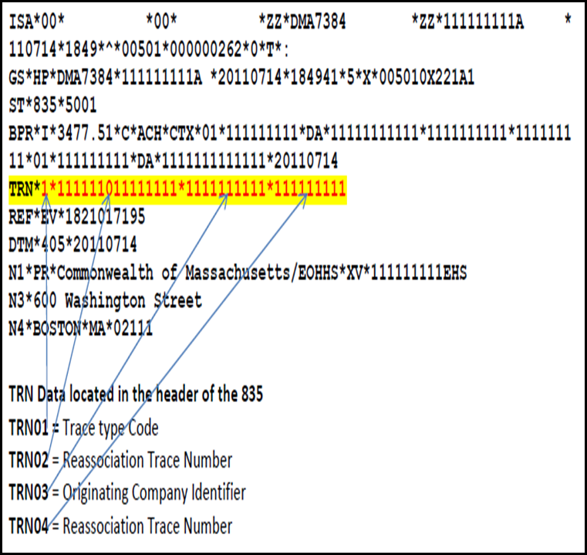
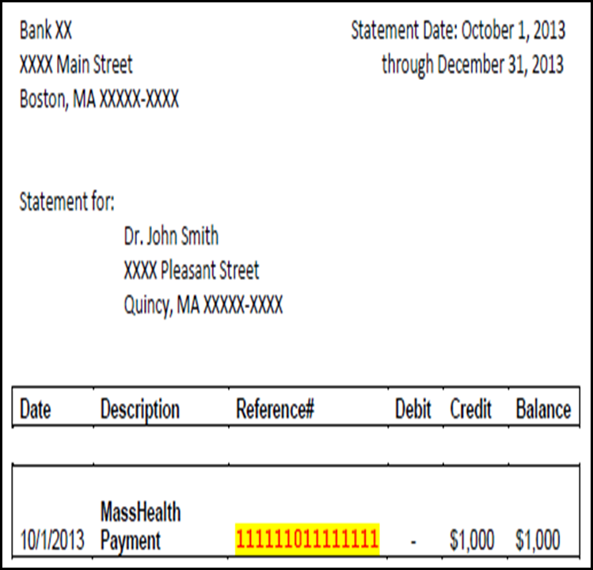
*Please note that your paper bank statement and online bank statement will look different.

