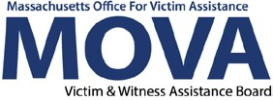
617-586-1340 | mass.gov/mova

eGrants Programmatic Change and Subcontract Request Step-by-Step Guide
All aspects of MOVA grants management will occur over the electronic grants management (eGrants) system beginning July 1, 2022 (FY23). This guide will walk through each step necessary to request a programmatic change or subcontractor via eGrants. Additional training, videos, and guides for eGrants can be found on MOVA’s eGrants webpage. This guide will apply to expenditure reporting for both SAFEPLAN and VSS with or without match.

Access to eGrants

The Website
Use this link to access the MOVA eGrants system. Additional technical information about logging onto the eGrants system can be found in the eGrants Subrecipient Manual on eGrants by clicking the book icon in the top right corner of your Dashboard or on MOVA’s eGrants webpage.
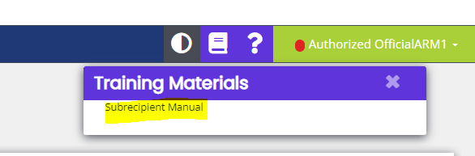

Registered Users
Current subrecipient users were required to register in the eGrants system by July 1, 2021. If a user has not yet been registered, visit the Registration Tutorial on MOVA’s eGrants webpage or the eGrants Subrecipient Manual for instructions on registration.

Different user roles have different permissions in the system. Only the following users have the permissions to initiate, fill out, and submit programmatic change and subcontract requests to MOVA:

- Agency Administrator
- Authorized Representative
- Programmatic Contact
- Alternative Programmatic Contact
- Fiscal Contact

Please ensure that the individual(s) working on the applicable process is assigned to one or more of these roles for the specific application before moving on.

Programmatic Change Forms (PCFs) in eGrants
Programmatic change forms (PCFs) are required to be submitted to MOVA when there are any changes (i.e. salary increases, extended leaves, change in hours, etc.) in MOVA-funded staff. Oftentimes, PCFs will beget a budget amendment in eGrants as well, which is a separate process. More information about budget amendments in eGrants can be found in the eGrants Budget Amendment Guide on MOVA’s website, and more information about programmatic changes can be found in MOVA’s Policies and Procedures.

Initiating a Programmatic Change Request
To initiate a programmatic change, start by logging into the application for which you will be completing the form for. From your Dashboard, select the Searches tab at the top and click Applications.

On the Applications Document Search page, search for your application using the filters. Once found, click on your application name to be taken to the Document Landing Page for the application.
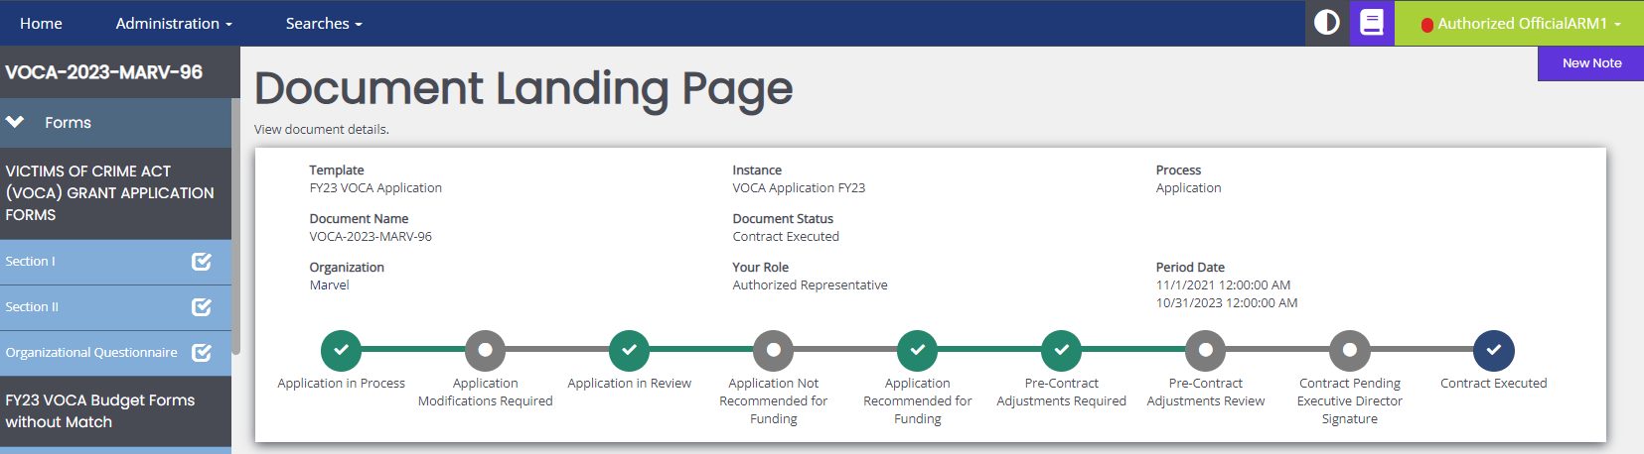

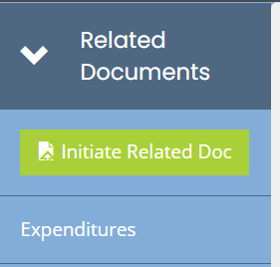
Here, you will find all your application information. To initiate a PCF, scroll to the bottom of the lefthand panel to the Related Documents section and select the green Initiate Related Doc button.

In the pop up, click the drop-down arrow for Available Documents and select “Programmatic Change Request FY24.” Click the green Create button.

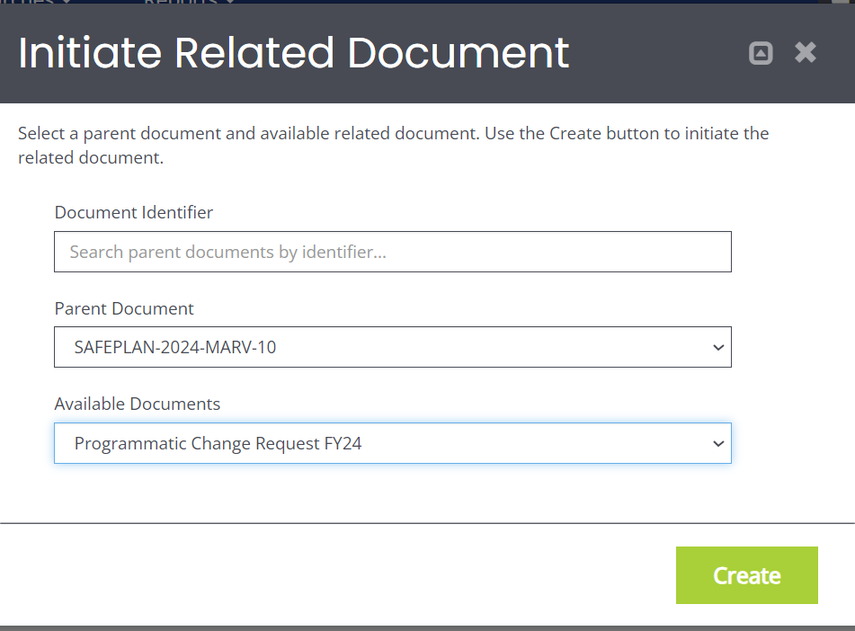

From the second pop up, click Proceed.
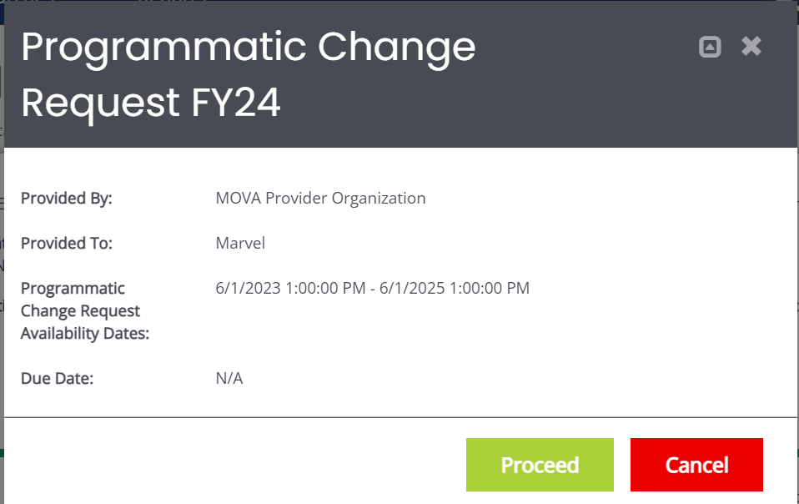

The page will refresh and take you to the Document Landing Page for the Programmatic Change Form. This form is attached to your application, but now exists separately so that it has its own process and statuses. On the Document Landing Page, you will be able to see that the status for the PCF is Programmatic Change in Process. The PCF has been successfully initiated.
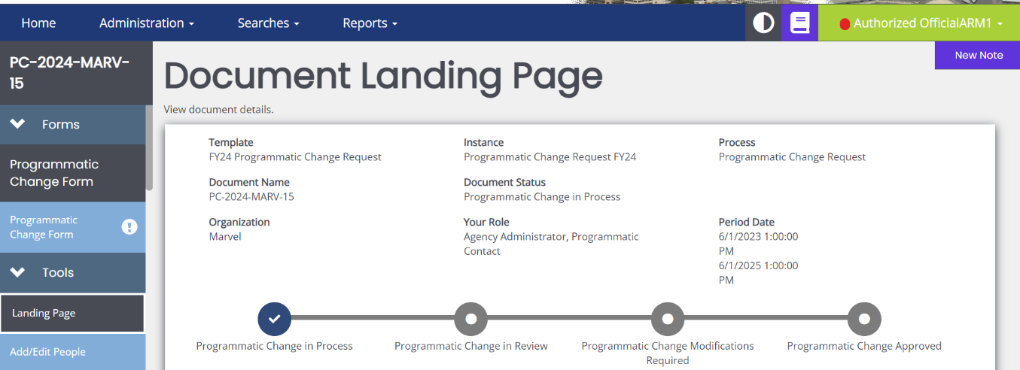

Completing a Programmatic Change Form

Once initiated, you will be able to click into the Programmatic Change Form from the lefthand panel and fill it out using the following instructions.

Much of the top portion of the form will be automatically filled out with the Grant Fund, Grant Fiscal Year, Agency Name, and Program Name.
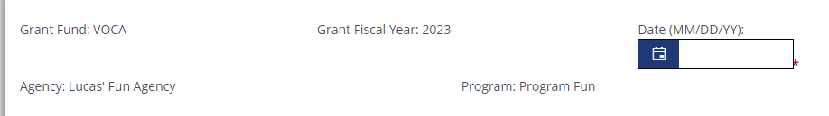

Fill out the rest of the form with the relevant information using the guidance below.

- Date—the date in which the form is being filled out
- Name of Employee—the first and last name of the employee being changed
- Position Title—the job title of the employee being changes
- Reason for Change—select from the following drop-down options: Resignation; New Hire; Change in Hours, Salary, Position; Extended Leave. Note that some of these options will their own additional fields to fill out once selected*
- Date Effective—the date the change will take place
- Affected Invoice—the first invoice that the change will occur on
- Memorandum—explanation for the proposed staffing change

Once the name of the employee and the date have been entered and saved, the PCF will update its name to reflect these two fields. For example, if Sam Smith is resigning on July 1, 2023, the name will be updated to the following. This is so that multiple PCFs are easier to refer back to through their titles.
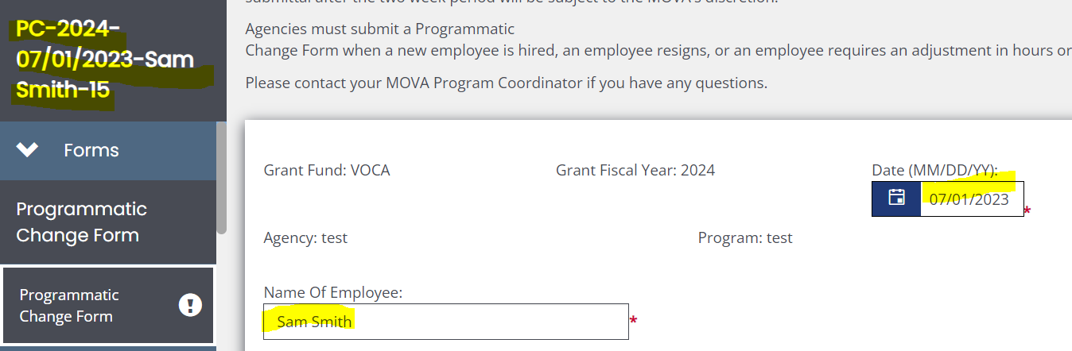

Within the form, if you select the following from the Reason for Change drop-down, you will also be required to fill out the following information.

New Hire
- Hours—estimated number of hours per week the employee will be billed to the grant
- Weeks—number of weeks (out of 52 for the fiscal year) that the employee will be billed to the grant
- Salary Budget Amt.—VSS/SAFEPLAN salary for the new employee
- Fringe Budget Amt.—VSS/SAFEPLAN fringe for the new employee
- Fringe Rate—the fringe percentage rate for the new employee
- Documentation Upload—optional space for the employee’s resume to be uploaded

Change in Hours, Salary, Position
- Change in Position—the former and new title of the employee
- Change in Hours—the former and new number of hours per week the employee will be billed to the grant
- Change in Weeks—the former and new number of weeks the employee will be billed to the grant
- Change in Budgeted Salary—the former and new salary amount
- Change in Fringe Rate—the former and new fringe rate; only numbers can be input

Extended Leave
- Leave From—the date the employee is leaving from
- Leave to—the date the employee will be back in the office

Make sure to save the page frequently, and once the information has been filled out and all the errors have been satisfied, you can submit the form using the steps below.

Submitting a Programmatic Change Request

When you have completed and saved the form, scroll down the lefthand panel and select Programmatic Change Submitted from the Status Options. If there are any errors, the system will tell you in the pop up below and prevent you from submitting:
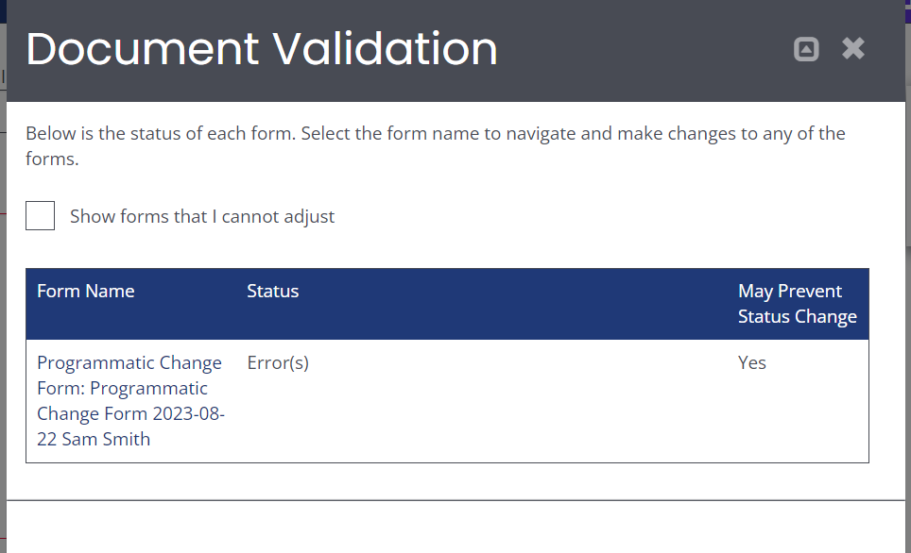

Otherwise, you will see the following pop up if your programmatic change request is ready for submission:

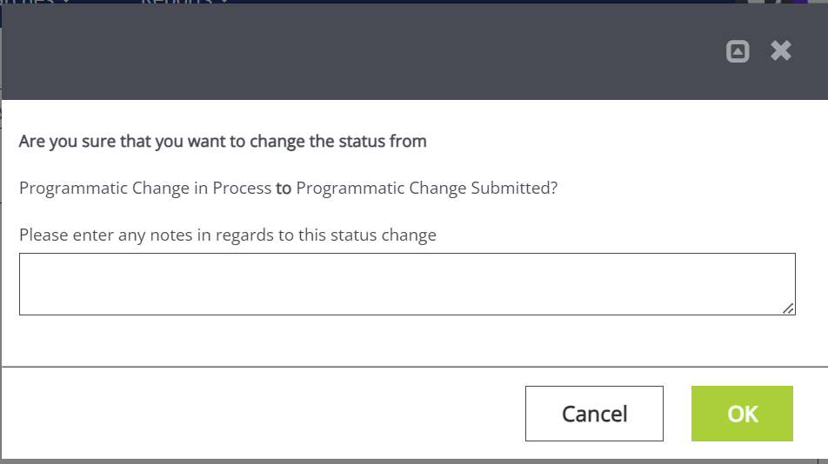

Click the green OK to submit. The system will take you back to the Document Landing Page. Here, you can find the status changed from Programmatic Change in Process to Programmatic Change in Review.
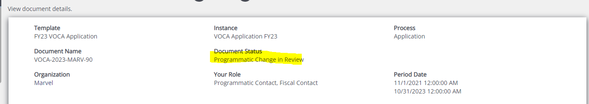

A few minutes after, you will also receive an email notification confirming that the programmatic change request has been submitted.
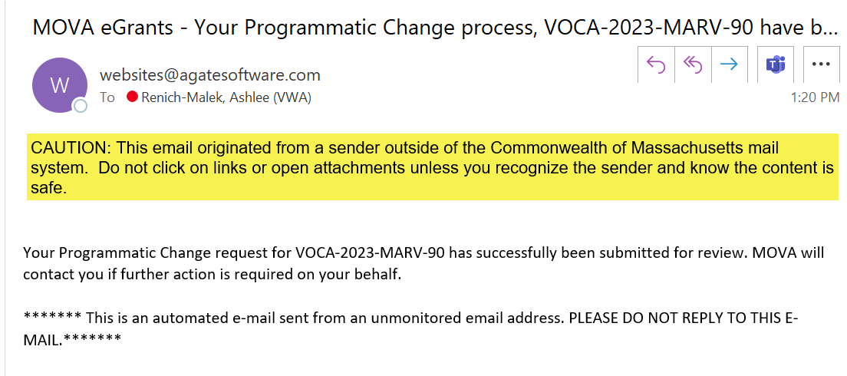

No further actions will be required of you at this time. Below, find the steps on how to find MOVA’s questions and feedback and how to submit additional information to support the programmatic change request.

Programmatic Change Canceled

If you or anyone else mistakenly initiates a programmatic change or otherwise no longer need to request a programmatic change, scroll down the lefthand panel to Status Options, select Programmatic Change Canceled, and click the green OK on the pop up. This will permanently change the PCF’s status to Programmatic Change Canceled and no additional changes can be made to the document.

Programmatic Change Denied

You will receive an email if MOVA denies your programmatic change request. MOVA will leave a comment in the Notes section to document the denial and then follow up over email if this occurs.
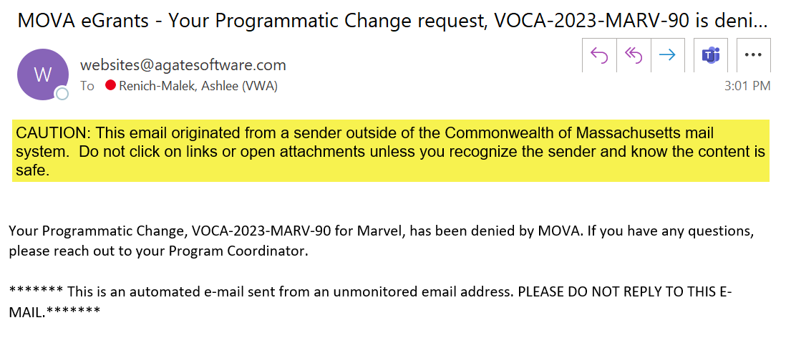

Programmatic Change Modifications Required

If MOVA requires more information from you, the request will be pushed back to the status of Programmatic Change Modifications Required. You will receive a My Task on your Dashboard on eGrants, and you will receive an email notification.
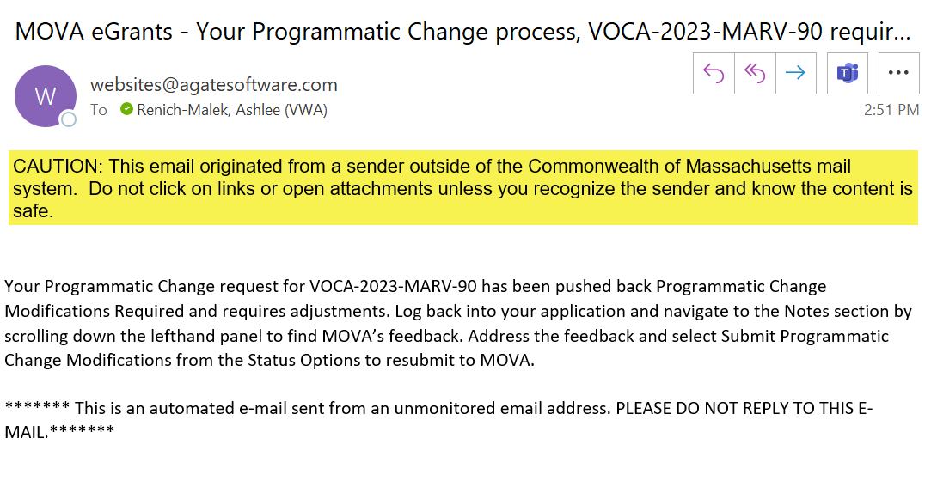

Similar to other eGrants processes, you will be responsible for logging into eGrants, navigating to the document, scrolling down the lefthand panel, and clicking into the Notes section to see MOVA’s follow up and questions. Address MOVA’s follow up and resubmit the PCF by scrolling down the lefthand panel to Status Options, clicking Programmatic Change Submitted, and confirming OK in the pop again. Once again, the page will be refreshed to the Document Landing Page, and your application will be in the status of Programmatic Change in Review.

For more information about how to work the Notes section, refer to previous step-by-step eGrants guides for contracting and expenditure reporting.

Programmatic Change Approved

Once your programmatic change request has been approved, you will receive an email notification from the system.

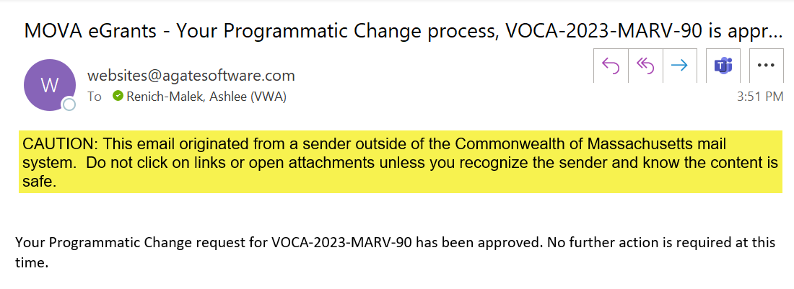

You will be able to click into the form(s) that you submitted for future reference, but you will not be able to change them.

Multiple Programmatic Change Forms

At any time, you can initiate and have multiple PCFs in various statuses. To initiate another PCF, simply follow the same steps: click Initiated Related Doc and select & confirm “Programmatic Change Request FY24.”

To navigate between multiple PCFs, scroll all the way to the bottom of the lefthand panel and click on Programmatic Change Request under Related Documents.

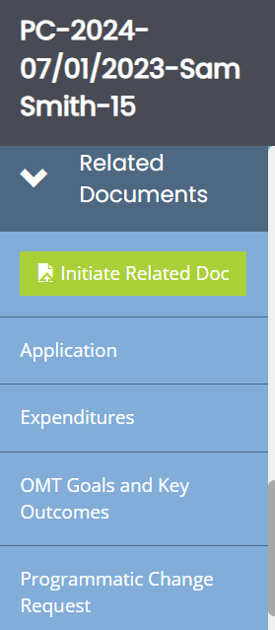

Doing so will pop out another panel with all the PCFs for the fiscal year connected to that contract. Clicking on any of the documents will take you to their Document Landing Pages and subsequent PCF information.
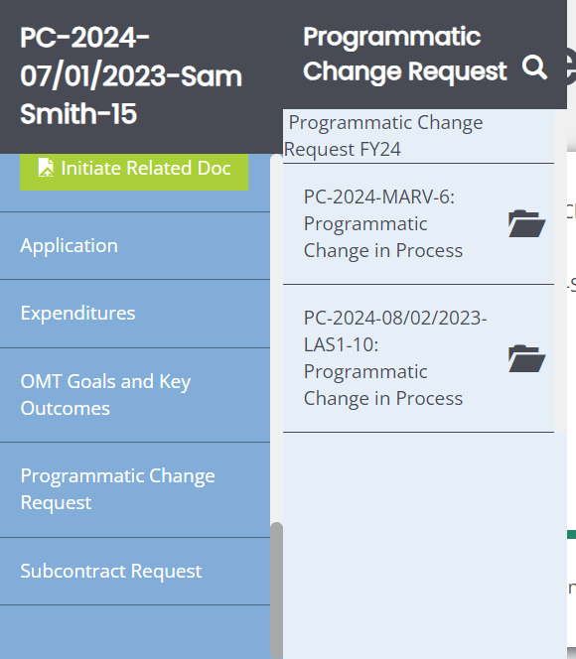

Subcontract Requests in eGrants

The subcontract request process allows subrecipients to initiate, fill out, and submit the Sub Contract Approval Request and Certification form (SCR), which is one of the required forms to contract with a consultant or contractor to provide services to your program that costs $10,000 or more. If this form has not yet been provided for a consultant or contractor on the Approved Budget that costs $10,000 or more or you would like to add a new consultant or contractor to your Approved Budget that costs $10,000 or more, you must submit this form along with a conflict of interest letter and the signed contract between your organization and the consultant or contractor. More information about subcontract requests can be found in MOVA’s Policies and Procedures.

This process will function exactly like the programmatic change process detailed above, but steps and screenshots specific to the subcontract request process have also been included below.

Initiating a Subcontract Request
To initiate a subcontract request, start by logging into the application for which you will be completing the form for. From your Dashboard, select the Searches tab at the top and click Applications.

On the Applications Document Search page, search for your application using the filters. Once found, click on your application name to be taken to the Document Landing Page for the application.

Here, you will find all your application information. To initiate the process and open a SCR, scroll to the bottom of the lefthand panel to the Related Documents section and select the green Initiate Related Doc button.

In the pop up, click the drop-down arrow for Available Documents and select “Subcontract Request FY24.” Click the green Create button.
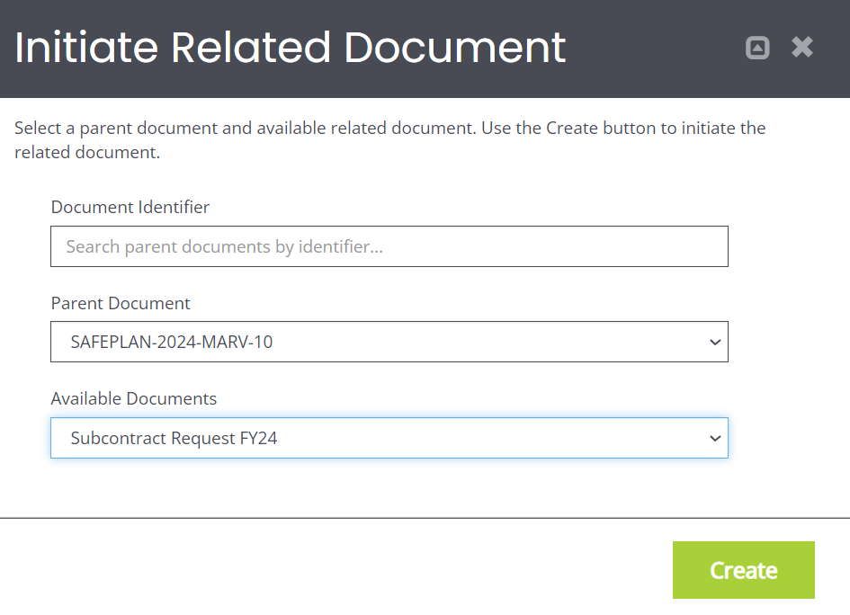

From the second pop up, click Proceed.
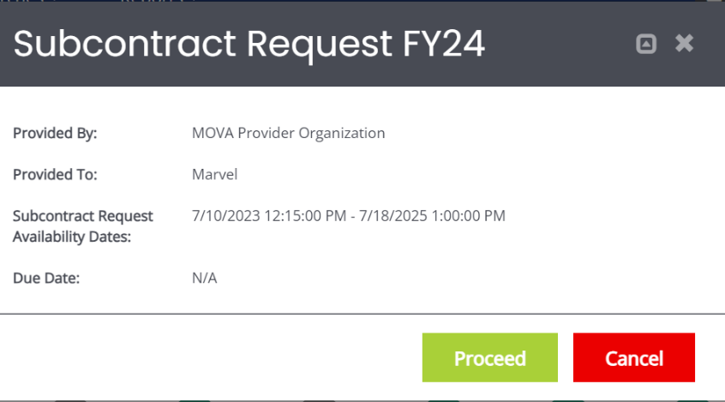

The page will refresh and take you to the Document Landing Page for the subcontract request process. This form is attached to your application, but now exists separately so that it has its own process and statuses. On the Document Landing Page, you will be able to see that the status for the SCR is Subcontract Request in Process. The SCR has been successfully initiated.
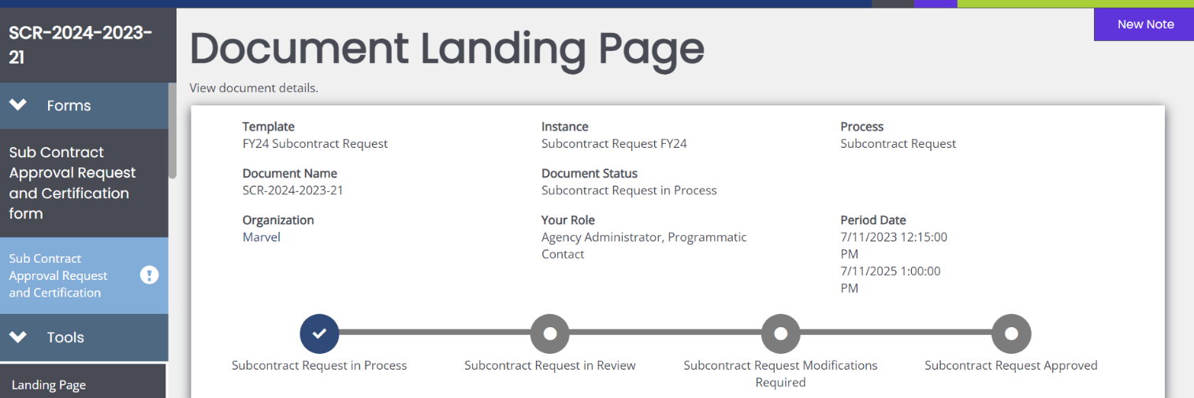

Completing a Sub Contract Approval Request and Certification Form

Once initiated, you will be able to click into the Sub Contract Approval Request and Certification form from the lefthand panel and fill it out using the following instructions.

Much of the top portion of the form will be automatically filled out with the Grant Fund, Grant Fiscal Year, Agency Name, and Program Name.
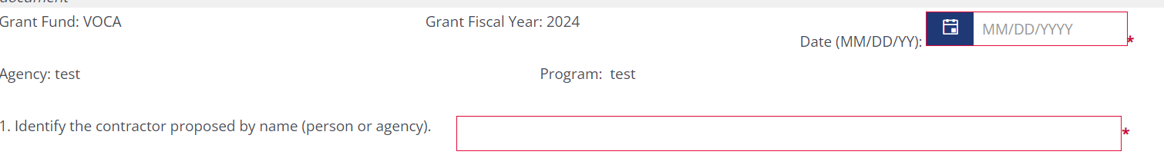

Fill out the rest of the form by answering the questions and attaching the required conflict of interest and signed contract between your organization and the consultant/contractor.

Just like the PCF, when the date and name of the contractor/consultant are entered and saved, the document name will be updated to reflect this information. Using Sam Smith as an example:
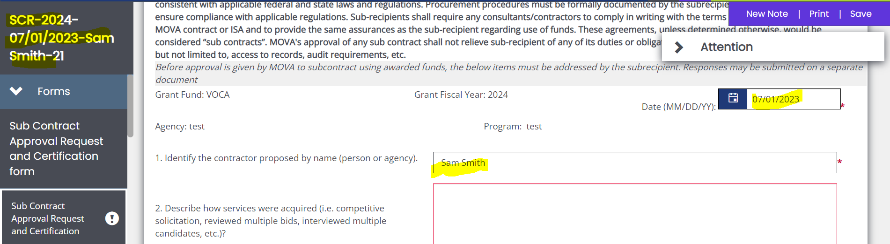

Request to Exceed Standard Consultant Rate

Beginning in FY24, subrecipients will have the option to request a consultant rate that exceeds the standard following the procedure outlined in MOVA’s Policies and Procedures.

In eGrants, the Request to Exceed Standard Consultant Rate section exists at the end of the Sub Contract Approval Request and Certification form, where the form can be downloaded, filled out, and uploaded for MOVA’s review.

Make sure to save the page frequently, and once the information has been filled out and all the errors have been satisfied, you can submit the form using the steps below.

Submitting a Sub Contract Approval Request and Certification Form

When you have completed and saved the form, scroll down the lefthand panel and select Subcontract Request Submitted from the Status Options.
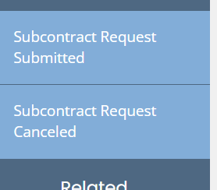

If there are any errors, the system will tell you in the pop up below and prevent you from submitting:
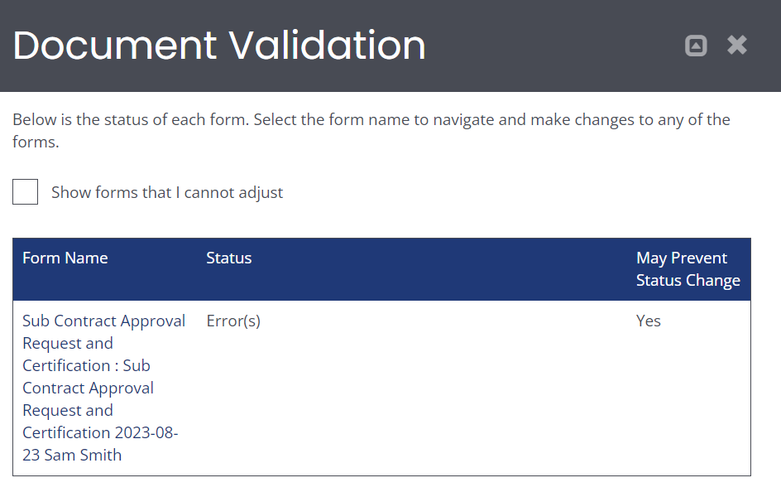

Otherwise, you will see the following pop up if your subcontract request is ready for submission:

Click the green OK to submit. The system will take you back to the Document Landing Page. Here, you can find the status changed from Subcontract Request in Process to Subcontract Request in Review.
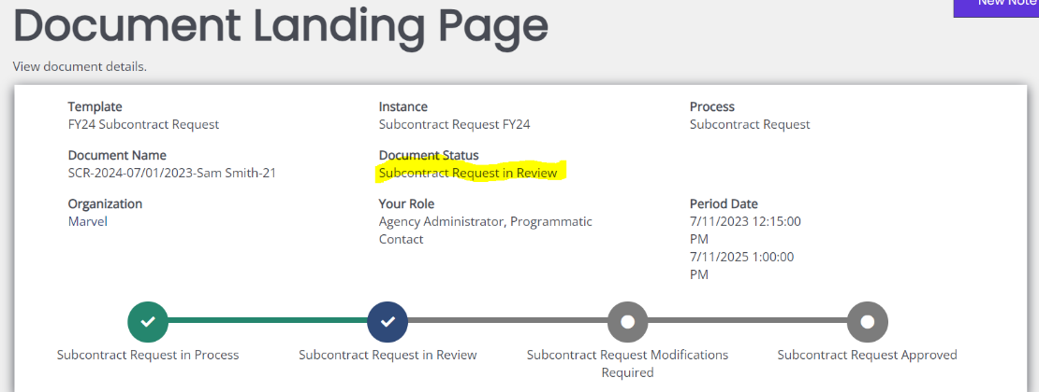

A few minutes after, you will also receive an email notification confirming that the subcontract request has been submitted.
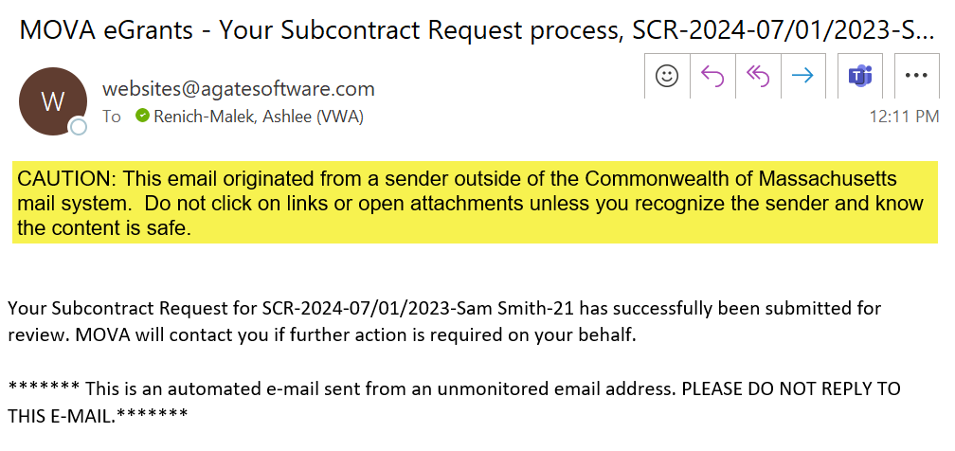

No further actions will be required of you at this time. Below, find the steps on how to find MOVA’s questions and feedback and how to submit additional information to support the subcontract request.

Subcontract Request Canceled

If you or anyone else mistakenly initiates a subcontract request or otherwise no longer need to request a subcontract request, scroll down the lefthand panel to Status Options, select Subcontract Request Canceled, and click the green OK on the pop up. This will permanently change the SCR’s status to Subcontract Request Canceled and no additional changes can be made to the document.

Subcontract Request Denied

You will receive an email if MOVA denies your subcontract request. MOVA will leave a comment in the Notes section to document the denial and then follow up over email if this occurs.
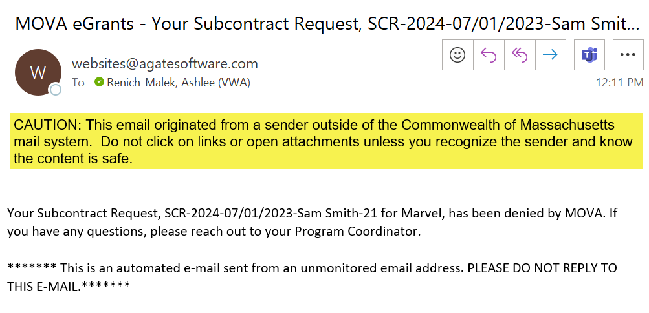

Subcontract Request Modifications Required

If MOVA requires more information from you, the request will be pushed back to the status of Subcontract Request Modifications Required. You will receive a My Task on your Dashboard on eGrants, and you will receive an email notification.
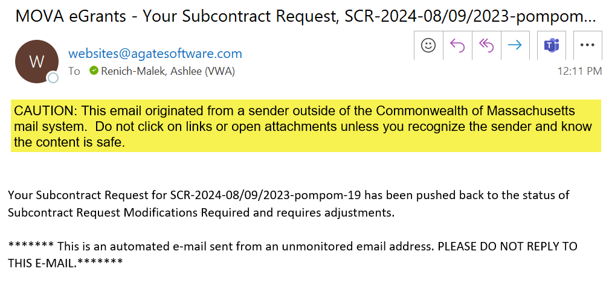

Similar to other eGrants processes, you will be responsible for logging into eGrants, navigating to the document, scrolling down the lefthand panel, and clicking into the Notes section to see MOVA’s follow up and questions. Address MOVA’s follow up and resubmit the SCR by scrolling down the lefthand panel to Status Options, clicking Subcontract Request Submitted, and confirming OK in the pop again. Once again, the page will be refreshed to the Document Landing Page, and your application will be in the status of Subcontract Request in Review.

For more information about how to work the Notes section, refer to previous step-by-step eGrants guides for contracting and expenditure reporting.

Subcontract Request Approved

Once your subcontract request has been approved, you will receive an email notification from the system.
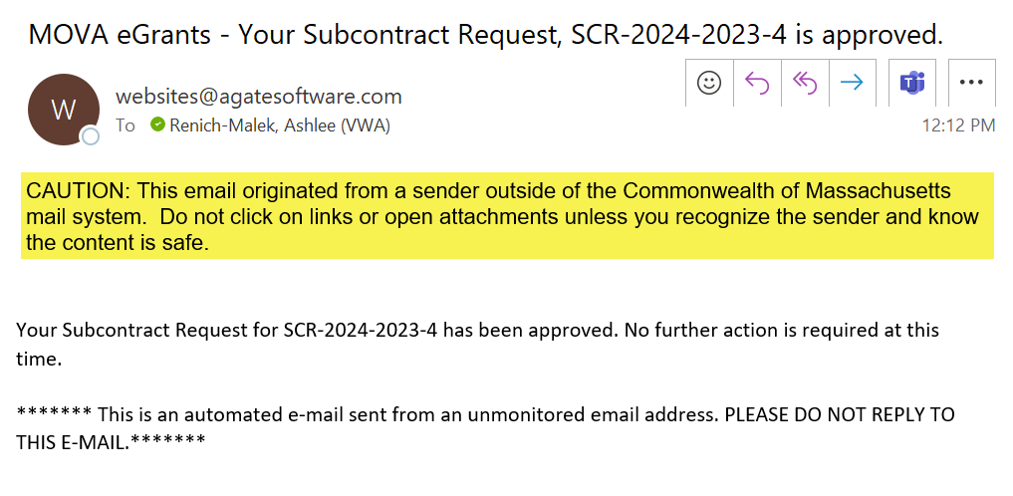

You will be able to click into the form(s) that you submitted for future reference, but you will not be able to change them.

Multiple Subcontract Requests

At any time, you can initiate and have multiple SCRs in various statuses. To initiate another SCR, simply follow the same steps: click Initiated Related Doc and select & confirm “Subcontract Request FY24.”

To navigate between multiple SCRs, scroll all the way to the bottom of the lefthand panel and click on Subcontract Request under Related Documents.

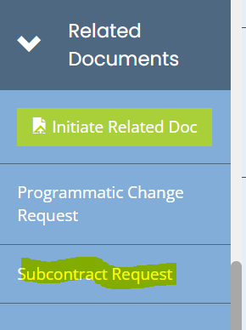

Doing so will pop out another panel with all the SCRs for the fiscal year connected to that contract. Clicking on any of the documents will take you to their Document Landing Pages and subsequent SCR information.

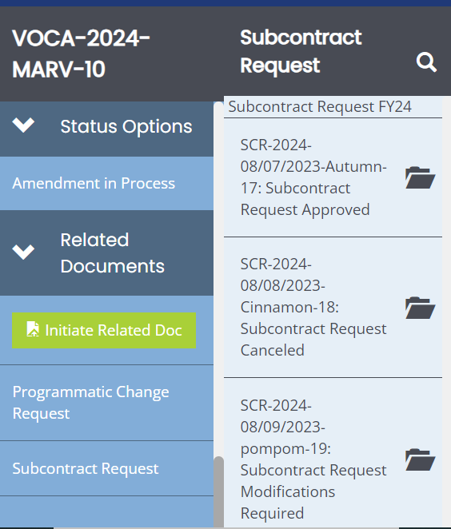

Conclusion
By following all of the above steps, subrecipients can successfully use the MOVA eGrants system to complete programmatic change and subcontract requests.

Resources
This document serves as a step-by-step guide and provides best practices for successfully proposing programmatic changes and subcontract requests for VSS and SAFEPLAN contracts. More information about this process can be found on MOVA’s eGrants webpage.

Please direct your questions to your assigned MOVA Program Coordinator or the Grants Administration Specialist, Ashlee Renich-Malek.

