INDOOR AIR QUALITY ASSESSMENT

Egremont Elementary School
84 Egremont Avenue
Pittsfield, MA

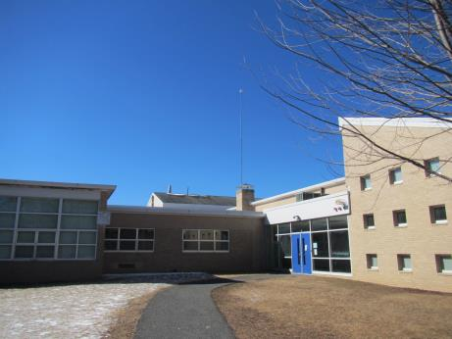

Prepared by:
Massachusetts Department of Public Health
Bureau of Environmental Health
Indoor Air Quality Program
March 2016

Background

Building: | Egremont Elementary School (EES)
Address: | 84 Egremont Avenue, Pittsfield, MA
Assessment Requested by: | Denis Guyer, Director of Maintenance, City of Pittsfield
Reason for Request: | Odors and health concerns
Date of Assessment: | Site visit on January 15, 2016, and full assessment on February 26, 2016
Massachusetts Department of Public Health/Bureau of Environmental Health (MDPH/BEH) Staff Conducting Assessment: | Mike Feeney, Director, and Ruth Alfasso,  Environmental Engineer, Indoor Air Quality (IAQ) Program
Date of Building Construction: | Early 1950s with a mid-1950s addition and significant addition/renovation in the late 1990s
Building Description: | Elementary School, brick construction, slanted shingled roof
Building Population: | 480 students in grades K through 5 with a staff of approximately 130
Windows: | Mostly openable

IAQ Testing Results
Please refer to the IAQ Manual for methods, sampling procedures, and interpretation of results (MDPH, 2015). The following is a summary of indoor air testing results (Table 1).
- Carbon dioxide levels were above 800 parts per million (ppm) in a little less than half of the areas surveyed, indicating adequate air exchange in more than half of areas.
- Temperature was within the recommended range of 70°F to 78°F in most areas tested with a few below.
- Relative humidity was below the recommended range of 40 to 60% in all areas tested. This was reflective of outdoor conditions.
- Carbon monoxide levels were non-detectable in all indoor areas tested. Background (outside) levels were 2.5 ppm, likely due to vehicle traffic, since the measurement was taken shortly after the afternoon buses departed.
- Fine particulate matter (PM2.5) concentrations measured were below the National Ambient Air Quality Standard (NAAQS) level of 35 μg/m³ in all areas tested.

This sampling indicates that the ventilation system in the building could provide more fresh air in some areas. Temperature control may need to be improved if occupants are reporting they are cold.

Ventilation
A heating, ventilating and air conditioning (HVAC) system has several functions. First it provides heating and, if equipped, cooling. Second, it is a source of fresh air. Finally, an HVAC system will dilute and remove normally occurring indoor environmental pollutants by not only introducing fresh air, but by filtering the airstream and ejecting stale air to the outdoors via exhaust ventilation. Even if an HVAC system is operating as designed, point sources of respiratory irritation may exist and cause symptoms in sensitive individuals. The following analysis examines and identifies components of the HVAC system and likely sources of respiratory irritant/allergen exposure due to water damage, aerosolized dust and/or chemicals found in the indoor environment.
Fresh air is provided by a combination of unit ventilators (univents) located in individual classrooms along the outside wall (Picture 1) and air handling units (AHUs) above the ceiling which serve central areas such as the gym and cafeteria. The unit ventilators draw fresh air through a vent on the outside wall (Picture 2) or the roof. Air is mixed with return air from the room, filtered, heated (if needed) and delivered back to the room (Figure 1). In some locations, univents were found partly obstructed by items on top or in front, which can impair proper operation. Air from the AHUs is filtered, heated and delivered to rooms via ducted supply vents. At least one of these vents was deliberately blocked with a ceiling tile due drafts/noise (Table 1). Exhaust vents are located on the walls of classrooms (Picture 3) and are ducted to fans on the roof. Additional exhaust vents are located in toilet rooms and other areas.
It is important to note that the 1950s addition containing rooms 25-29 (the addition) is connected to the other part of the school via a short breezeway and therefore functions like a separate building regarding its ventilation system. As noted in both visits, BEH/IAQ staff noted that the general exhaust system in the addition is strongly drawing air from the breezeway, creating significant depressurized in relation to the rest of the building. A strong draft was detected through seams between the double-doors that separate the breezeway and addition. A significant draw of air from the hallway into rooms beneath hallway doors was also detected. This depressurization (negative air pressure) was confirmed during the February 26, 2016 visit through use of a micro-manometer which measured a large pressure difference between the breezeway and addition hallway as well as between the addition hallway and classrooms, in particular room 25. This condition relates to the odor concerns reported in this part of the building, and specifically room 25, as discussed in the section below under “Odor and Microbial/Moisture Concerns.”

Odor and Microbial/Moisture Concerns
During the January 15, 2016 visit, a strong “musty” odor was detected in the addition hallway and room 25. Since univents were reported by facilities staff to have fixed louvers, it appears that the addition rooms, (specifically room 25) do not have means to provide sufficient make-up air to help balance the depressurization created by the general exhaust ventilation system. In this condition, the exhaust system likely draws air from unconditioned areas such as the crawlspace below the building, gaps in walls, broken toilet rings and/or plumbing vents. Several potential sources/pathways for the odor were identified during the January visit, including the crawlspace/basement area that underlies the wing.
Several modifications were made in the crawlspace to help vent it to the outside and reduce pathways to occupied areas. These included the installation of an active vent system that uses fans to vent crawlspace air to the outside (Pictures 4 and 5), sealing of many holes/breaches between the crawlspace and occupied areas, as well as replacing wax rings beneath toilets in room 25. Facilities staff reported a reduction, but not elimination of the musty odor. Upon further examination, BEH/IAQ staff noted gaps around pipes for the girls restroom inside room 25 (Picture 6).
Upon returning to the building in February 2016, BEH/IAQ staff noted that the musty odor seemed to be centralized near the addition’s breezeway doors. The odor was traced to gaps in the ceiling of the custodial closet next to room 25 (Picture 7), some of which appear to be connected to interior wall space that may connect to the basement. Gaps were also identified in the exterior building envelope along the edges of the roof of the addition above the breezeway (Picture 8) which may lead to wetting of wood materials inside the wall cavity likely contributing to reported odors.
Additional moisture/microbial issues were identified in the building as well. A few stained ceiling tiles were observed in the building (Picture 9) which appear to be due to historic roof or plumbing leaks. Water-damaged ceiling tiles can be a source of mold, and should be replaced once the leaks have been repaired.
Many of the sinks in classrooms had backsplashes with a gap (Picture 10; Table 1) which can allow for moistening of the wood material and potential microbial growth. A few sinks also had porous items stored beneath them, where they could become damaged due to condensation or leaks. Porous items and large amounts of items should not be stored under sinks.
The refrigerator in the teacher’s workroom had a slight odor of spoiled food and some mold-related staining on the gaskets. Refrigerators should be cleaned regularly, including cleaning the gaskets with an anti-microbial solution.
Plants were observed in a few areas, including on top of univents (Picture 11). Plants can be a source of pollen and mold, which can be respiratory irritants to some individuals. Plants should be properly maintained and equipped with drip pans and located away from air diffusers to prevent the aerosolization of dirt, pollen and mold.
Gutters along the outside of the building had accumulations of ice and were found to be dripping/pouring onto the ground in several locations (Pictures 12 and 13). These conditions can lead to water infiltration along seams at the roofline due to ice dams/broken gutters, and through the foundation due to accumulation of water at the base. The gutter system should be inspected for breaches and repaired once weather permits. The insulation/venting of the roof along the edge may need to be improved to prevent ice damming. And the ground near the foundation may need to be regraded to reduce ponding in areas such as those in Picture 13.
Some of the exterior doors from classrooms and hallways lacked sufficient weather-stripping, as light could be observed beneath them (Picture 14). Weather-stripping should be repaired/replaced to prevent moisture, unconditioned air and pests from entering the building.

Other IAQ Evaluations
Exposure to low levels of total volatile organic compounds (TVOCs) may produce eye, nose, throat, and/or respiratory irritation in some sensitive individuals. To determine if VOCs were present, BEH/IAQ staff examined rooms for products containing VOCs. BEH/IAQ staff noted air fresheners, hand sanitizers, cleaners, and dry erase materials in use within the building (Table 1). All of these products have the potential to be irritants to the eyes, nose, throat, and respiratory system of sensitive individuals.
In a few classrooms, tennis balls were found sliced open and placed around chair legs to reduce noise (Picture 15). Tennis balls are made of a number of materials that are a source of respiratory irritants. Constant wearing of tennis balls can produce fibers and off-gas VOCs. Tennis balls are made with a natural rubber latex bladder, which becomes abraded when used as a chair leg pad. Use of tennis balls in this manner may introduce latex dust into the school environment. Some individuals are highly allergic to latex (e.g. spina bifida patients) (SBAA, 2001). It is recommended that the use of materials containing latex be limited to reduce the potential for symptoms in sensitive individuals (NIOSH, 1997). Latex-free glides should be used for this purpose. Some areas of the school already had glides. Tennis and other balls were also found wedged in the vent for the gymnasium, where they may contribute to particulate matter in the interior and obstruct airflow (Picture 16); they should be removed.
Some personal fans, supply and exhaust vents were observed to be dusty (Picture 17; Table 1). In some areas, items were observed on the floor, windowsills, tabletops, counters, bookcases, and desks (Table 1). Many univent cabinets had dust and debris in them as well.
Most classrooms had built-in area rugs, and some other areas were carpeted. Carpeting should be cleaned annually or semi-annually in soiled high traffic areas as per the recommendations of the Institute of Inspection, Cleaning and Restoration Certification (IICRC, 2012). Carpeting in the library was significantly worn and wrinkled (Picture 18) and may be beyond its service life, consideration should be made to replacing.

Conclusions/Recommendations
The following recommendations are made to assist in improving IAQ:

- Examine the wood shown in Picture 8 and replace all rotten wood as needed.
- Seal the space in the ceiling of the custodial closet shown in Picture 7.
- Consider turning off the exhaust system for the addition (rooms 25-29) to prevent the creation of negative pressure that draw unconditioned air and odors into occupied areas.
- Activate/ repair restroom exhaust vents and use during occupied periods to remove stale room air.
- Operate supply ventilation in all areas during occupied periods. Consider adjusting temperature settings for locations that are below the recommended temperatures. During temperate weather, use windows to supplement fresh air.
- Continue sealing breaches in the interior walls in the addition restroom to contain crawlspace odors, including those areas identified in Picture 6.
- Repair roof/plumbing leaks and replace stained ceiling tiles.
- Repair sink backsplashes to render them watertight. Refrain from storing porous or significant amounts of materials under sinks.
- Clean refrigerators regularly, including cleaning the gaskets with an antimicrobial solution.
- Keep plants in good condition, avoid overwatering, and remove from the airstream of univents and other air sources.
- Inspect and repair the gutter system once outdoor conditions allow. Inspect insulation and vents along the edge of the roof to minimize the creation of ice dams and allow the gutters to flow freely.
- Regrade the ground where ponding occurs to direct water away from the building.
- Repair/replace weather-stripping on doors so that no light or drafts are present.
- Replace tennis balls in classrooms with latex-free glides.
- Remove tennis balls from the gymnasium vent.
- Change filters regularly in univents (2 to 4 times a year), and vacuum the cabinets of debris each time the filters are changed.
- Clean other supply and exhaust vents regularly to prevent aerosolization of debris.
- Clean carpeting and area rugs regularly and discard those that are worn out or too soiled to be cleaned.
- Consider adopting the US EPA (2000) document, “Tools for Schools”, as an instrument for maintaining a good IAQ environment in the building. This document is available at: http://www.epa.gov/iaq/schools/index.html.
- Refer to resource manual and other related IAQ documents located on the MDPH’s website for further building-wide evaluations and advice on maintaining public buildings. These documents are available at: http://mass.gov/dph/iaq.

References
IICRC. 2012. Institute of Inspection, Cleaning and Restoration Certification. Carpet Cleaning: FAQ. Retrieved from http://www.iicrc.org/consumers/care/carpet-cleaning/#faq.
NIOSH. 1997. NIOSH Alert Preventing Allergic Reactions to Natural Rubber latex in the Workplace. National Institute for Occupational Safety and Health, Atlanta, GA.
SBAA. 2001. Latex In the Home And Community Updated Spring 2001. Spina Bifida Association of America, Washington, DC.
MDPH. 2015. Massachusetts Department of Public Health. Indoor Air Quality Manual: Chapters I-III. Available at: http://www.mass.gov/eohhs/gov/departments/dph/programs/environmental-health/exposure-topics/iaq/iaq-manual/.
US EPA. 2000. Tools for Schools. Office of Air and Radiation, Office of Radiation and Indoor Air, Indoor Environments Division (6609J). EPA 402-K-95-001, Second Edition. http://www.epa.gov/iaq/schools/tools4s2.html.
Picture 1
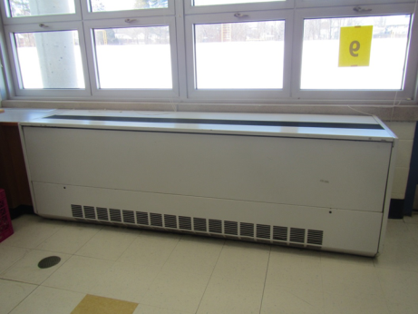
Unit ventilator (univent)
Picture 2
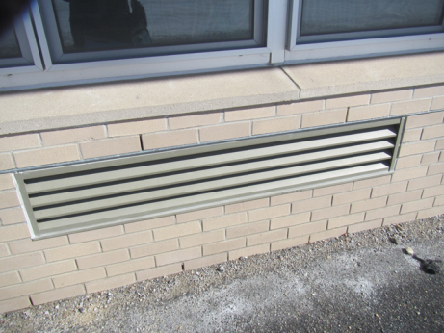
Fresh air intake for univent
Picture 3
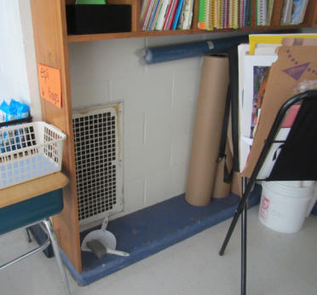
Exhaust vent in classroom
Picture 4
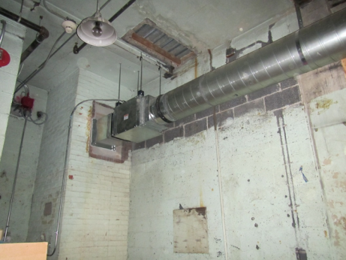
Active vent system as viewed from the lower basement
Picture 5
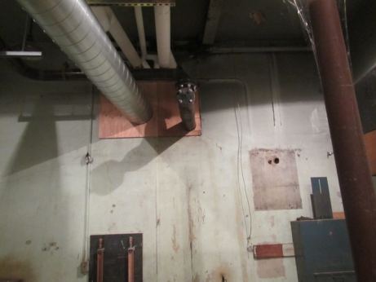
Active vent system as viewed from the lower basement
Picture 6
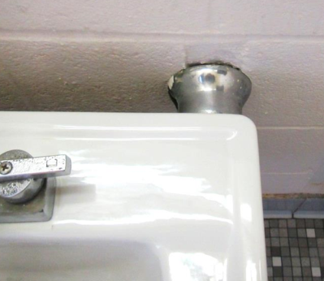
Gap around pipe in restroom inside room 25
Picture 7
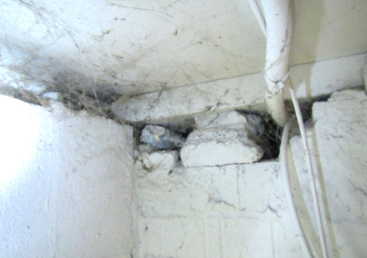
Breaches inside janitors closet
Picture 8
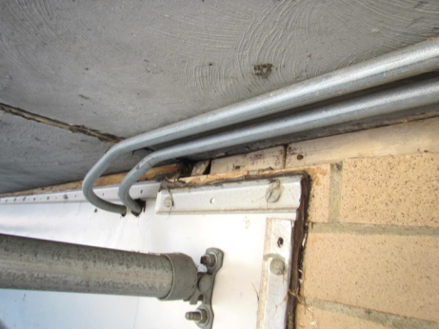
Openings in exterior wall above breezeway roof allowing for air and moisture to cause wood rot (arrows)
Picture 9
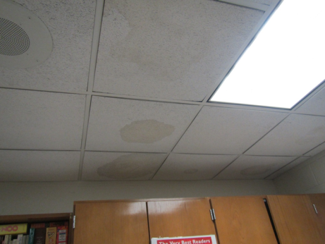
Water-damaged ceiling tiles
Picture 10
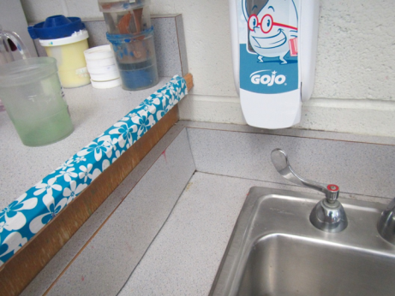
Unsealed sink backsplash
Picture 11
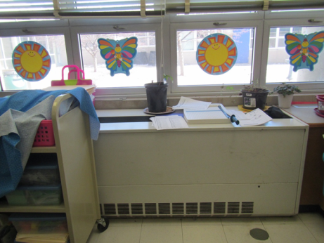
Plants on univent
Picture 12
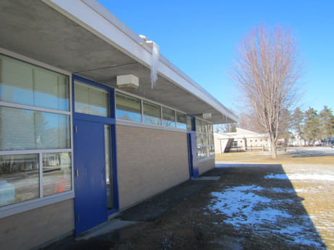
Ice accumulations from gutter
Picture 13
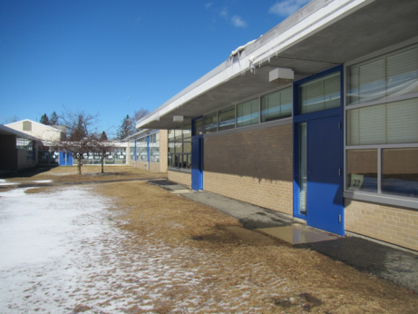
Puddles from dripping gutter
Picture 14
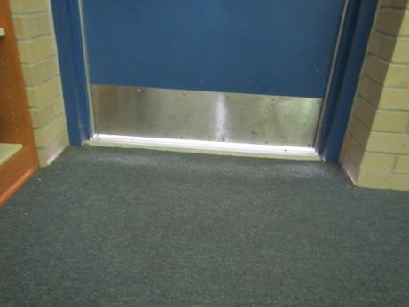
Light visible underneath door showing lack of weather-stripping
Picture 15
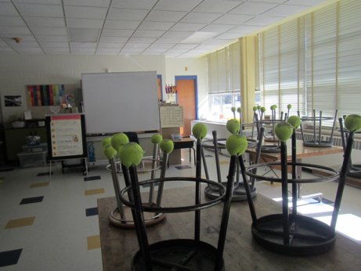
Tennis balls on chair legs
Picture 16
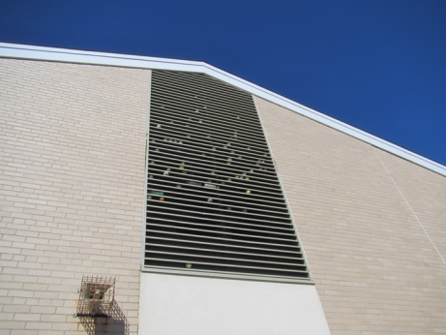
Tennis balls and other items in gymnasium vent
Picture 17
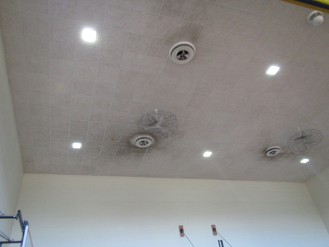
Dusty supply vents
Picture 18
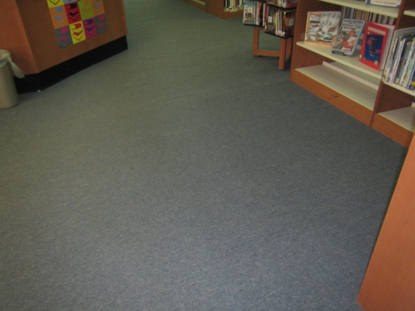
Wrinkled, worn library carpet
Location | Carbon  Dioxide  (ppm) | Carbon Monoxide  (ppm) | Temp  (°F) | Relative  Humidity  (%) | PM2.5  (µg/m³) | Occupants  in Room | Windows  Openable | Ventilation |  | Remarks
 |  |  |  |  |  |  |  | Supply | Exhaust
Background | 305 | 2.5 | 32 | 15 |  |  |  |  |  | Cold and very windy
Auditorium stage area | 551 | ND | 73 | 15 | 1 | 0 | N | Y | Y
Cafeteria | 771 | ND | 70 | 26 | 4 | 30+ | N | Y | Y
Custodian office | 603 | ND | 73 | 16 | 4 | 0 | N | Y | Y
Equipment | 689 | ND | 72 | - | -
Gym | 440 | ND | 73 | 10 | 2 | 4 | N, door | Y | Y
Library | 662 | ND | 74 | 15 | 16 | ~6 | Y | Y | Y | Worn carpet, DEM, door needs weather stripping
Main office | 782 | ND | 71 | 19 | 3 | 1 | N | Y | Y | PC
Ms. Nichols’ and Ms. Whelihan’s office | 718 | ND | 75 | 16 | 2 | 1 | N | Y | Y | Vent covered with tile
Music | 562 | ND | 70 | 18 | ND | 0 | N | Y | Y
Nurse’s office | 981 | ND | 72 | 21 | ND | 3 | Y | Y | Y
Office conference room | 932 | ND | 70 | 25 | 2 | 2 | N | Y | Y
Principal’s office | 748 | ND | 71 | 18 | 2 | 0 | Y | Y | Y | Plants
Speech | 781 | ND | 74 | 17 | 2 | 1 | N | Y | Y | NC, slight odor, WD-CT, dusty vent
Teacher’s workroom | 645 | ND | 68 | 23 | 1 | 2 | Y | Y | Y | PC, NC, laminator, refrigerator has slight odor and staining, other food prep equipment
1 | 715 | ND | 72 | 16 | 18-22 | 18 | Y and door | Y UV | Y | Debris in UV, 2 sinks, sink backsplash open, built-in area rug
2 | 772 | ND | 71 | 19 | 2 | 18 | Y and door | Y UV | Y | Building-in area rug, toilet room, dusty exhaust
3 | 614 | ND | 72 | 14 | 9-17 | 15 | Y and door | Y UV | Y | Toilet room, built-in area rug, sink – open backsplash, art supplies, DO
4 | 760 | ND | 71 | 21 | 12-23 | 20 | Y and door | Y UV | Y | Built-in area rug, PF, toilet room, sink- items under sink
5 SPED | 606 | ND | 71 | 15 | 3 | 11 | Y | Y UV | Y | Skylight, NC, backsplash open on sink, internal room with AT
6 | 580 | ND | 73 | 18 | ND | 2 | Y and door | Y UV | Y | NC
7 | 579 | ND | 70 | 14 | ND | 0 | Y and door | Y UV, debris | Y | AI, built-in area rug, sink – backsplash open
8 | 588 | ND | 70 | 15 | 1 | 1 | Y and door | Y UV | Y | Building-in area rug, sink
9 | 531 | ND | 70 | 13 | 1 | 1 | Y and door | Y UV noisy | Y | Built-in area rug, sink
10 | 641 | ND | 69 | 18 | 2 | 3 | Y and door | Y UV part obst. | Y | Sink, built-in area rug, PF
11 | 828 | ND | 71 | 23 | 8 | 15 | Y and door | Y UV debis | Y | Door needs weather-stripping, built-in area rug
12 | 1112 | ND | 71 | 25 | 27-33 | 16 | Y and door | Y UV off | Y | Built-in area rug
13 | 1250 | ND | 73 | 20 | 8 | 20 | Y and door | Y UV | Y | UV off and has debris, built-in area rug, sink backplash open
14 | 1077 | ND | 71 | 24 | 27 | 15 | Y and door | Y UV | Y | UV has plants and part obstructed, sink backsplash open, built-in area rug
15 | 1350 | ND | 69 | 24 | 22-32 | 0 | Y | Y UV | Y | Items on univent, potatoes used for project, built-in area rug
15 | 1681 | ND | 71 | 26 | 4 | 0 | Y | Y | Y
16 | 1073 | ND | 72 | 21 | 3 | - | Y | Y | Y
17 | 1535 | ND | 72 | 25 | 5 | 0 | Y | Y | Y
18 | 1476 | ND | 73 | 20 | 3 | 16 | Y | Y | Y box
19 | 1143 | ND | 70 | 19 | 3 | 15 | Y | Y | Y
20 | 833 | ND | 72 | 16 | 2 | 19 | Y open | Y | Y box
21 | 1069 | ND | 72 | 21 | 3 | 26 | Y | Y | Y
22 | -- | ND | 73 | - | 1 | 22 | Y | Y | Y
23 | 1269 | ND | 73 | - | 10 | 24 | Y | Y | Y box
24 | 1025 | ND | 76 | 21 | 1 | 19 | Y | Y | N
25 | 562 | ND | 70 | 23 | 1 | 0 | Y | Y | Y | Mold odor, DEM, DO
26 | 849 | ND | 73 | 18 | 1 | 21 | Y | Y | Y | Books
27 | 906 | ND | 72 | 28 | 2 | 25 | Y | Y | Y | DEM, DO
28 | 641 | ND | 74 | 14 | 2 | 21 | Y open | Y | Y
29 | 810 | ND | 75 | 20 | 2 | 16 | Y | Y | Y | TBs, DEM, DO

