Coding Insurance Information in EIM-ESM
Introduction
In EIM-ESM, insurance information is required before a client can be enrolled in most Activities. This information is vital to understanding the client population served by DPH and documenting the impact of insurance accessibility on their health care. Insurance information is also necessary for the adjudication of claims. The two required fields in EIM-ESM that are key to meeting these goals are Insurance Type and Insurance Name.
This job aid provides the information necessary to correctly enter these fields in EIM-ESM. In addition, users should review the Insurance Job Aid on the EIM-ESM website for more detail on when to enter and/or close a client’s insurance record. Incorrectly managing a client’s active insurance information can also affect claim adjudication. https://www.mass.gov/files/documents/2016/07/td/training-insurance-job-aid.doc.

Insurance Type.
- The data entered in this field will determine whether your claims will be rejected or accepted for payment by the Department of Public Health.

- There are many HIPAA compliant Insurance Types listed in EIM-ESM. Only a select few are to be used when entering data in EIM-ESM for DPH/BSAS clients. The appropriate choices are listed in Table 1.

Table 1: Insurance Types
Insurance Type
Uninsured | Client has neither public or private insurance
MC | MassHealth / MCO/ACO/ PCC/MBHP
MP | Medicare –Over 65-some disabled Part A
MB | Medicare Part B
VA | Veterans Administration
HM* | Private HMO – through employment or client pay
CI | Private Insurance – through employment or client pay with no subsidy
OT | Other - Includes State subsidy – ConnectCare / Health Safety Net

*HM or CI can be used to code commercial HMO plans
Insurance Name.
- This field can also impact the adjudication of claims, and is critical in the management of the MassHealth Waiver for residential services.

See Table 2-4 for the correct coding of MassHealth plans and Table 5 for coding commercial insurance in EIM-ESM.

MassHealth Insurance
MassHealth has several plans for Massachusetts residents that have varying eligibility requirements. For all of the MassHealth plans, the Insurance Type is MC.
Table 2: MassHealth Plans
Insurance Type | Insurance Name
MC | MassHealth Standard
MC | MassHealth CommonHealth
MC | MassHealth CarePlus
MC | MassHealth Family Assistance
MC | MassHealth Limited
MC | MassHealth Senior Buy-in
MC | MassHealth Children's Medical Security Plan
MC | MassHealth Healthy Start
MC | MassHealth - Buy-in

MassHealth Managed Care Plans
In addition, MassHealth enrolls eligible members in managed care plans. There are three managed care options offered by MassHealth.
- MCO: Managed Care Organization. Insurance providers who offer managed care plans for MassHealth members.
- ACO: Accountable Care Organization. The ACO health plans are groups of doctors, hospitals and other health care providers who come together to give coordinated, high-quality care to MassHealth members. This way, MassHealth members get the right care at the right time. MassHealth has worked with the ACOs to make sure they provide high-quality care.
- PCC: Primary Care Clinician plan. Primary care physician coordinates care within MassHealth network of health care providers.
If a client is enrolled in an ACO, PCC or MCO plan, that plan must be entered in the Insurance Name field and the Insurance Type must be entered as MC.
Table 3: MassHealth Managed Care Plans
Insurance Type | Insurance Name | Managed Care Type | Behavioral Health  Management Vendor
MC | Health New England Be Healthy Partnership | ACO | Massachusetts Behavioral Health Partnership
MC | Berkshire Fallon Health Collaborative | ACO | Beacon Health Options
MC | BMC HealthNet Plan Community Alliance | ACO | Beacon Health Strategies
MC | BMC HealthNet Plan Mercy Alliance | ACO | Beacon Health Strategies
MC | BMC HealthNet Plan Signature Alliance | ACO | Beacon Health Strategies
MC | BMC HealthNet Plan Southcoast Alliance | ACO | Beacon Health Strategies
MC | Fallon 365 Care | ACO | Beacon Health Options
MC | NHP Merrimack Valley ACO My Care Family | ACO | Beacon Health Options
MC | Tufts Health Together with Atrius Health | ACO | N/A
MC | Tufts Health Together with BIDCO | ACO | N/A
MC | Tufts Health Together with Boston Children’s ACO | ACO | N/A
MC | Tufts Health Together with CHA | ACO | N/A
MC | Fallon Wellforce Care Plan | ACO | Beacon Health Options
MC | Steward Health Choice | Primary Care ACO | Massachusetts Behavioral Health Partnership
MC | Partners Healthcare Choice | Primary Care ACO | Massachusetts Behavioral Health Partnership
MC | Community Care Cooperative (C3) | Primary Care ACO | Massachusetts Behavioral Health Partnership
MC | BMC Healthnet Plan | MCO | Beacon Health Options
MC | Tufts Health Together | MCO | N/A
MC | Primary Care Clinician Plan | PCC | Massachusetts Behavioral Health Partnership
MC | CCA One Care  Commonwealth Care Alliance | One Care – combined Medicare/Medicaid managed care plan | N/A
MC | Tufts Unify | One Care –combined Medicare/Medicaid managed care plan | N/A

MassHealth Behavioral Managed Care Vendors
Mental health and substance use disorders are managed by behavioral health vendors for all the MassHealth members enrolled in the Primary Care Clinician (PCC) and are associated with certain Accountable Care Partnership Plans, as listed above. If the client’s behavioral health care is being managed through a Behavioral Health Managed Care Vendor, the behavioral health vendor will be listed under Insurance Name and the Insurance Type with be MC.

Table 4: Behavioral Health Plans
Insurance Type | Insurance Name
MC | Massachusetts Behavioral Health Partnership
MC | Beacon Health Options
MC | Beacon Health Strategies

MassHealth EVS
The MassHealth member’s eligibility and enrollment information is available in the EVS application. In the sample EVS screen below, the client is enrolled in MassHealth Standard and in the ACO, Berkshire Fallon Health Collaborative. The EIM-ESM Insurance record for this client should be:
Insurance Type: | MC | Insurance Name: | Berkshire Fallon Health Collaborative

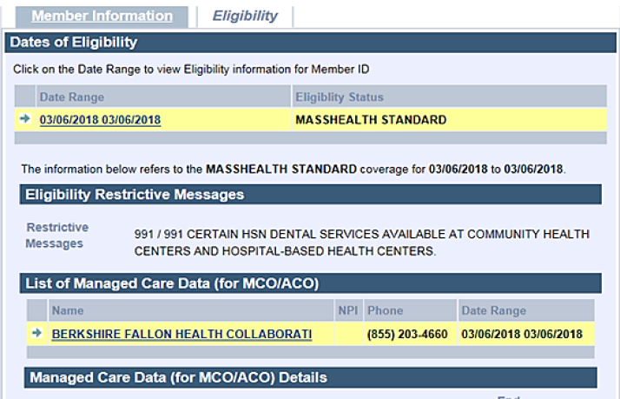

The following table lists the non-MassHealth insurance plans available in EIM-ESM.

Table 5: Commercial Insurance
Insurance Type | Code Value | Comments
CI | AARP | Medicare Supp
CI | Aetna_US_Healthcare
CI | Amalgamated
CI | American_Medical_Security
CI | American_National
CI | Anthem
CI | APWU
CI | Bankers_Life
CI | Blue_Care_65 | Medicare Sup
CI | Blue_Cross_Blue_Shield_Dental
CI- | Blue_Cross_Blue_Shield_Medex | Medicare Sup
CI | Blue_Cross_Blue_Shield_of_MA
CI | Blue_Cross_Blue_Shield_Other
CI | Boston Medical Center HealthNet Plan
VA | Champus_Tricare | Veterans
CI | Chesterfield_Resource | Salvation Army
CI | Cigna_Health
CI | Cigna_Health
OT | ConnectCare-Boston Medical Center HealthNet Plan
OT | ConnectCare-CeltiCare
OT | ConnectCare-Fallon Community Health Plan
OT | ConnectCare-Health New England
OT | ConnectCare-Minuteman Health
OT | ConnectCare-Neighborhood Health Plan
OT | ConnectCare-Network Health
CI | Connecticut_General
CI | Conseco
CI | Consolidate_Health
CI | Coresource
CI | Delta_Dental
CI | DUA_Medical_Security_Program
CI | Fallon_Community_Health_Plan
CI | Fallon_Senior_Plan | Medicare Sup
CI | Fed_Mutual
Ci | First_Health
CI | Fortis
CI | General_American
CI | Guardian
CI | Hartford
CI | Harvard_Pilgrim
CI | Harvard Vanguard
CI | Harvard_Pilgrim_First_Senority | CMedicare Sup
CI | Health_NE
CI | Health_Plans_Inc
CI | Health_Source
CI | Humana
CI | John_Alden
CI | John_Hancock
CI | Kaiser
CI | London_Health
CI | Mass_Fisherman_Partnership_ins
CI | Mass_Laborers_Health_and_Welfare
CI | Mass_Mutual
MP | Medicare
MB | Medicare
CI | Mega_Life_and_Health
CI | Mutual_of_Omaha
CI | MVP_Select
CI | National_Assoc_of_Letters_Carriers
CI | Neighborhood_Health_Plan
CI | Network Health
CI | New_England
CI | North_American_Preferred
OT | Not Collected
CI | One_Health_Plan
OT | Other
CI | Pioneer_Life
CI | Principal
CI | Provident
CI | Prudential
CI | Star_Admin
CI | Starbridge
CI | State_Mutual
CI | Student_Health_Insurance
CI | Teamsters
VA | Tricare | Veterans
CI | Trustmark
CI | Tufts_Aff_Health_Plan
CI | Tufts_Secure_Horizons | CI-Medicare Sup
CI | UFCW
CI | Unicare
CI | United_Health_NE
CI | University_Health_Plan
CI | Wausau
CI | Harvard Vanguard

