EIM/ESM HIPAA File Transfer Service Reference Guide
All health care providers, clearinghouses, or billing services wishing to send or receive electronic transmissions directly to Virtual Gateway EIM/ESM application may use the File transfer Service (FTS) functionality from the Virtual Gateway landing page.

Click on File Transfer Service
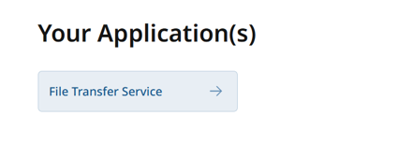
Screenshot 1- file transfer service URL

Users will be presented with the FTS landing screen.
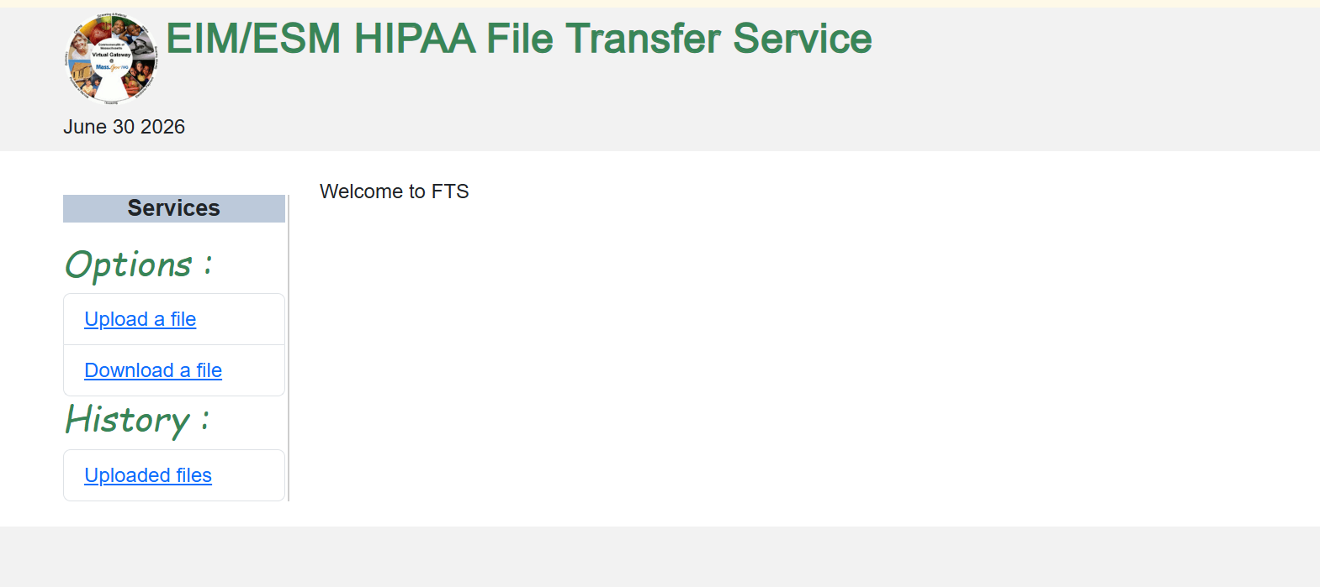
Screenshot 2- FTS landing page

Functions a user can do
- Upload a file
- Download a file to your computer.
- Look up an Uploaded files
- Delete files

Upload a File
Click on Upload a File menu option from services panel
Select radio button option HIPAA837I or HIPAA837P
Click on Choose file button to browse files from your computer
Click on “Upload File” button to upload the file.

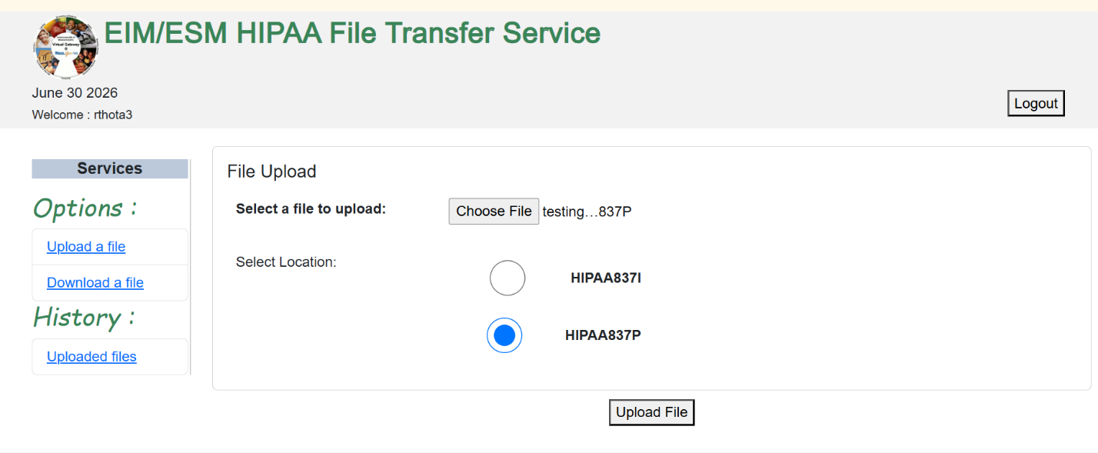
Screenshot 3- Upload a file screen

File uploaded with a confirmation message and file ID at the bottom of the screen.
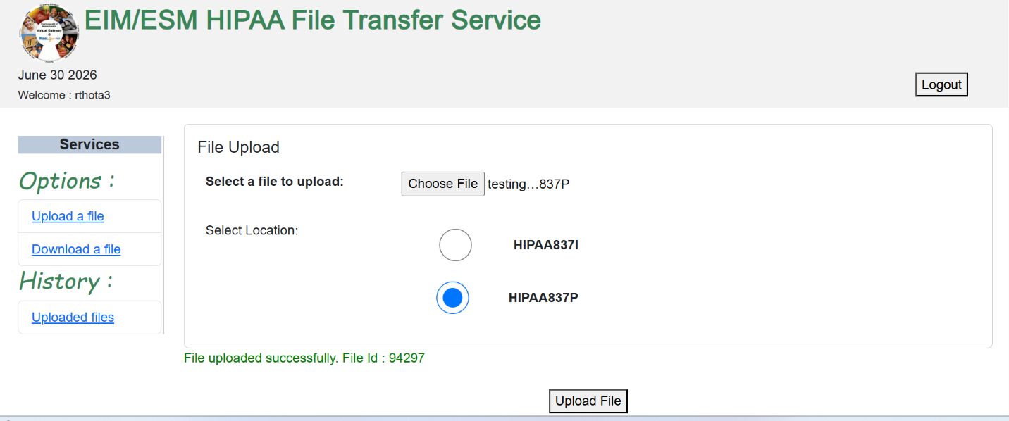
Screenshot 4- File upload confirmation

Download a file – Results will show your organization’s TA1, 999, 277 and 835 response files.

Click on Download a File menu option from services panel
- Users can search for a file
- Users can do a date search for a particular file
- Users can sort the fields (Name, File Size, Upload Id, upload timestamp)
- Users can clear the search field to do a new search
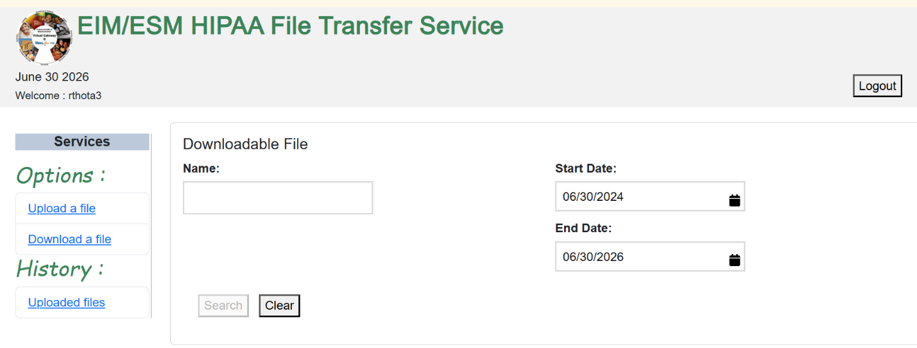
Screenshot 5- Download a file screen

View Uploaded files

Click on “Uploaded files” menu option from services panel

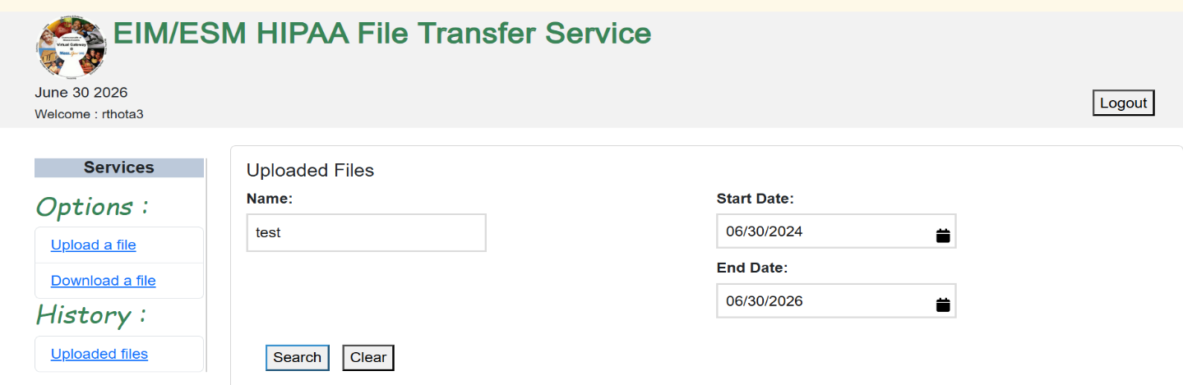
Screenshot 6- History, uploaded files search screen

Users can look for history files which were uploaded (837I/P)
- Users can search for a file
- Users can do a date search for a particular file
- Users can sort the fields (Name, File Size, Upload Id, upload timestamp)
- Users can clear the search field to do a new search
- User can Delete the file

Search results:
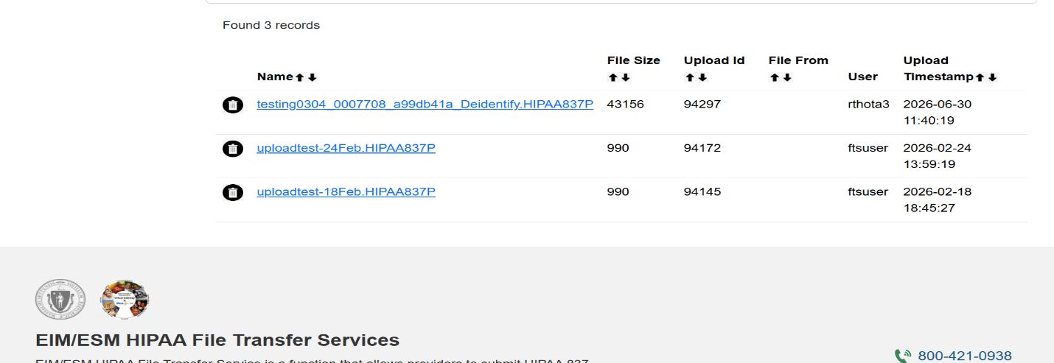
Screenshot 7- Uploaded files results screen

Delete a previously uploaded file

In the search results screen click on the “delete” button beside the file name to delete the file.
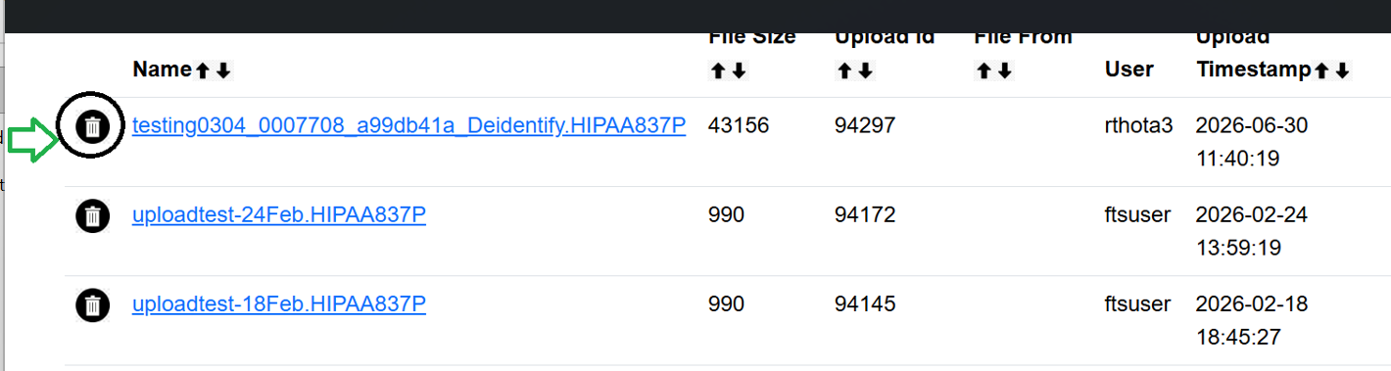
Screenshot 8- delete uploaded files

Download file to your computer

In the search results screen click on the file name Hyperlink to download the file.

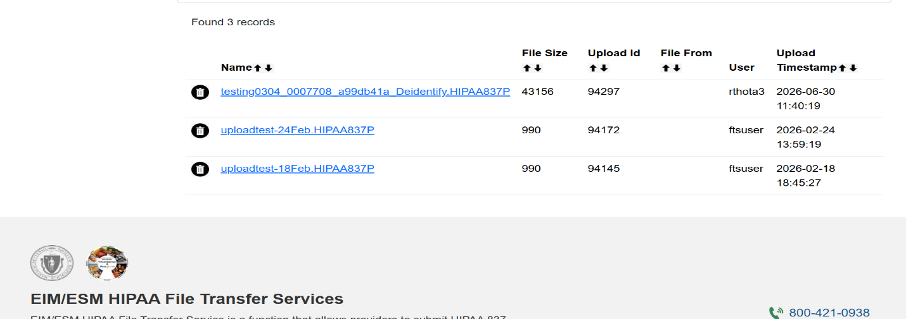
Screenshot 9- download a file

EIM/ESM Assistance
- Email the Virtual Gateway Business Operations Unit for assistance:
  - EHS-DL-EIM-ESMBusinessOperations@massmail.state.ma.us
- Call Virtual Gateway Customer Service for assistance:
  - (800) 421-0938
  - 617-847-6578 (TTY people who are deaf, hard of hearing, or speech disabled)
  - Monday – Friday: 8:30am - 5:00pm

