EIM/ESM Application Browser Restrictions
The EIM/ESM application will be imposing certain browser restrictions within the application to improve security, transaction processing and help prevent billing and data entry errors.
Use of the back and forward buttons have been disabled. We encourage the use of the breadcrumbs and application menus for navigation.

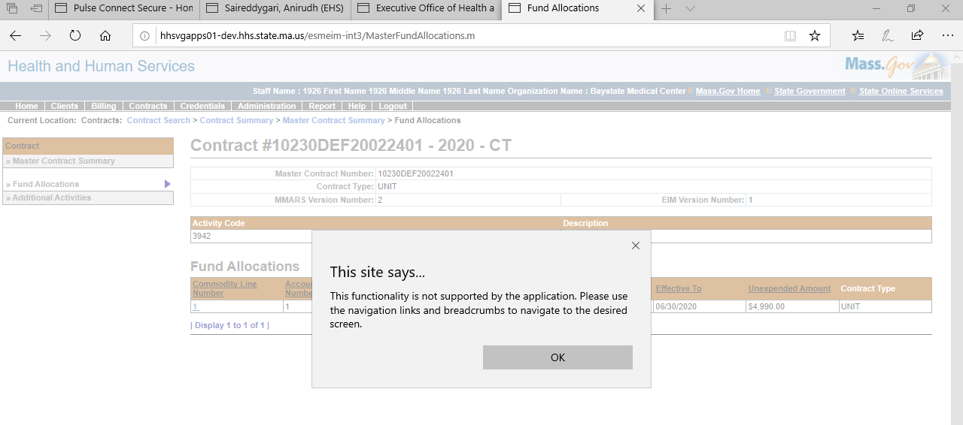
Use of Back and Forward buttons disabled

To comply with EIM/ESM best practices and help prevent billing and data entry errors, opening new tabs or windows within the same session have been disabled. This will allow for a more efficient billing and client data entry experience and reduce delays.

Right-click to open in New window disabled

