EIP Monthly CST One Care Activity Report — through March 21, 2014
The MassHealth Customer Service Team (CST) receives calls requesting information about and enrollment in One Care. Data about call volume from English and Spanish speakers are shown below.
English
CST experienced a tremendous increase in call volume related to communications emergencies in other MassHealth programs in late December 2013 and early January 2014. Around the same time, CST was affected by weather-related and holiday closures.
Week Ending: | English Calls Recv’d. | % of Calls Answered | Avg.Speed to Answer | Avg.Call Length
Mar. 2014
03/21/2014 | 1,600 | 79% | 4:04 | 6:59
03/14/2014 | 1,737 | 75% | 4:54 | 7:38
03/07/2014 | 1,674 | 78% | 4:36 | 7:34
Feb. 2014
02/28/2014 | 1,643 | 83% | 4:13 | 7:05
02/21/2014 | 1,314 | 79% | 4:03 | 6:51
02/14/2014 | 1,527 | 87% | 2:53 | 7:09
02/07/2014 | 1,515 | 81% | 3:48 | 7:34
Jan. 2014
01/31/2014 | 2,601 | 78% | 4:40 | 6:50
01/24/2014 | 1,700 | 72% | 5:26 | 7:33
01/17/2014 | 2,305 | 77% | 4:36 | 7:02
01/10/2014 | 3,147 | 42% | 8:44 | 7:17
01/02/2014 | 1,475 | 60% | 6:57 | 7:28
Dec. 2013
12/27/2013 | 1,694 | 74% | 3:10 | 6:31
12/20/2013 | 2,696 | 70% | 5:02 | 6:45
12/13/2013 | 2,196 | 97% | 0:53 | 6:04
12/06/2013 | 2,455 | 98% | 0:39 | 6:02
Nov. 2013
11/29/2013 | 1,366 | 99% | 0:18 | 6:02
11/22/2013 | 2,257 | 98% | 0:26 | 6:15
11/15/2013 | 2,071 | 98% | 0:44 | 6:10
11/08/2013 | 2,474 | 97% | 0:58 | 6:02
11/01/2013 | 2,097 | 98% | 0:20 | 5:53
Oct. 2013
10/25/2013 | 2,233 | 99% | 0:30 | 5:45
10/18/2013 | 2,119 | 98% | 1:03 | 6:20
10/11/2013 | 2,463 | 98% | 0:36 | 6:08
10/04/2013 | 2,452 | 94% | 0:39 | 6:31
CST has also experienced unusually high call volumes related to other MassHealth programs that were implemented as of January 1, 2014. This activity has affected overall customer service resources, including around One Care support.
MassHealth continues to monitor the percentage of calls answered, wait times, and as other data from CST, and expects these metrics continue to improve as call volume to CST around other programs related to federal health reform implementation gradually stabilizes.

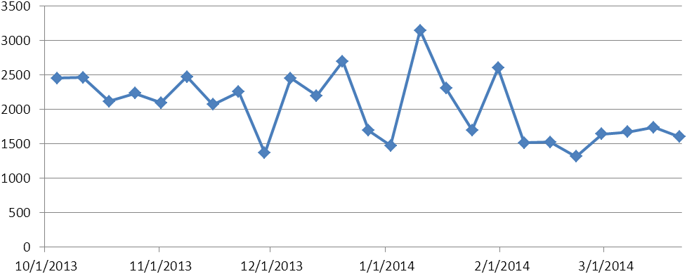
Figure 1. Weekly call volume - English

Spanish

Week Ending: | Spanish  Calls Received | % of Calls Answered | Average  Speed to Answer | Average  Call Length
March
03/21/2014 | 15 | 100% | 1:49 | 8:36
03/14/2014 | 18 | 94% | 1:16 | 7:52
03/07/2014 | 34 | 94% | 2:38 | 7:42
February
02/28/2014 | 34 | 97% | 1:58 | 9:04
02/21/2014 | 22 | 91% | 1:33 | 8:34
02/14/2014 | 21 | 95% | 1:24 | 8:53
02/07/2014 | 37 | 100% | 1:45 | 7:22
January
01/31/2014 | 54 | 98% | 1:50 | 5:45
01/24/2014 | 24 | 96% | 2:22 | 6:10
01/17/2014 | 22 | 100% | 1:57 | 7:43
01/10/2014 | 19 | 95% | 2:07 | 9:12
01/02/2014 | 11 | 100% | 2:15 | 6:44
December
12/27/2013 | 16 | 88% | 1:45 | 6:43
12/20/2013 | 13 | 100% | 2:23 | 6:40
12/13/2013 | 38 | 89% | 2:07 | 5:58
12/06/2013 | 45 | 100% | 0:50 | 7:37
November
11/29/2013 | 18 | 100% | 1:28 | 4:29
11/22/2013 | 22 | 95% | 1:00 | 7:49
11/15/2013 | 31 | 100% | 1:14 | 6:23
11/08/2013 | 38 | 87% | 2:23 | 6:06
11/01/2013 | 21 | 100% | 0:44 | 7:46
October
10/25/2013 | 33 | 97% | 0:46 | 7:11
10/18/2013 | 29 | 100% | 1:02 | 7:36
10/11/2013 | 41 | 95% | 1:27 | 7:18
10/04/2013 | 42 | 98% | 0:58 | 8:48

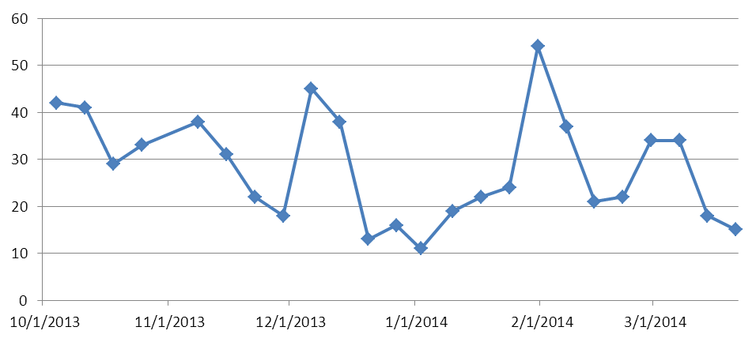
Figure 2. Weekly Call Volume - Spanish

