EIP Monthly CST One Care Activity Report — through April 25, 2014
The MassHealth Customer Service Team (CST) receives calls requesting information about and enrollment in One Care. Data about calls from English and Spanish speakers are shown below.
CST experienced a tremendous increase in call volume related to communications emergencies in other MassHealth programs in late December 2013 and early January 2014. Around the same time, CST was affected by weather-related and holiday closures.
CST has also experienced unusually high call volumes related to other MassHealth programs that were implemented as of January 1, 2014. This activity has affected overall customer service resources, including for callers seeking One Care support.
MassHealth continues to monitor the percentage of calls answered, wait times, and other data from CST, and expects these metrics will continue to improve as call volume to CST associated with other programs related to federal health reform implementation gradually stabilizes.

Figure 1. Call data (English)
Figure 2. Monthly call volume (English)
Month | Calls  Recv’d. | % of Calls Answered | Avg.Speed to Answer | Avg.Call Length
2013 |  |  | (min:sec) | (min:sec)
October | 9,267 | 98% | 0:42 | 6:11
November | 10,265 | 98% | 0:33 | 6:04
December | 9,041 | 85% | 2:26 | 6:21
2014
January | 11,228 | 64% | 6:05 | 7:14
February | 5,999 | 83% | 3:44 | 7:10
March | 6,788 | 78% | 4:23 | 7:19
April | 6,079 | 81% | 4:24 | 7:07

Figure 3. Call data (Spanish)
Figure 4. Monthly call volume (Spanish)

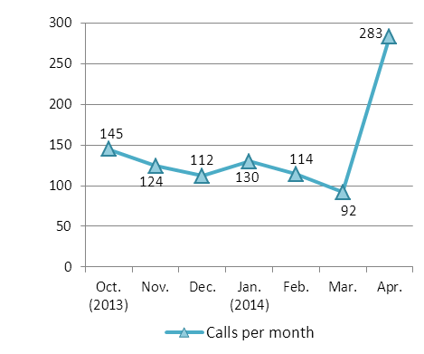
Month | Calls Recv’d. | % of Calls Answered | Avg.Speed to Answer | Avg. Call Length
2013 |  |  | (min:sec) | (min:sec)
October | 145 | 97% | 1:03 | 7:43
November | 124 | 95% | 1:42 | 6:31
December | 112 | 95% | 1:46 | 6:45
2014
January | 130 | 98% | 2:07 | 7:07
February | 114 | 96% | 1:40 | 8:28
March | 92 | 96% | 2:07 | 8:10
April | 283 | 96% | 3:01 | 7:21

