EIP Monthly CST One Care Activity Report — through September 26, 2014
The MassHealth Customer Service Team (CST) receives calls requesting information about and enrollment in One Care. Data about calls from English and Spanish speakers are shown below.
CST experienced a tremendous increase in call volume related to communications emergencies in other MassHealth programs in December 2013 and January 2014. Around the same time, CST was affected by weather-related and holiday closures. CST also experienced unusually high call volumes related to other MassHealth programs that implemented on January 1, 2014. This activity affected overall customer service resources, including for callers seeking One Care support.
The data below show significant improvement since March for percentage of calls answered and wait times for calls in English to CST. MassHealth continues to monitor these metrics.

Figure 1. Monthly call data (English) Figure 2. Monthly call volume (English)
Month | Calls  Recv’d. | % of Calls Answered | Avg.Speed to Answer | Avg.Call Length
2013 |  |  | (min:sec) | (min:sec)
October | 9,267 | 98% | 0:42 | 6:11
November | 10,265 | 98% | 0:33 | 6:04
December | 9,041 | 85% | 2:26 | 6:21
2014
January | 11,228 | 64% | 6:05 | 7:14
February | 5,999 | 83% | 3:44 | 7:10
March | 6,788 | 78% | 4:23 | 7:19
April | 6,079 | 81% | 4:24 | 7:07
May | 6,126 | 93% | 1:45 | 5:49
June | 4,394 | 97% | 0:47 | 6:11
July | 3,993 | 95% | 0:55 | 5:37
August | 4,746 | 95% | 1:00 | 5:40
September | 3,894 | 93% | 1:19 | 5:59

Figure 3. Monthly call data (Spanish) Figure 4. Monthly call volume (Spanish)
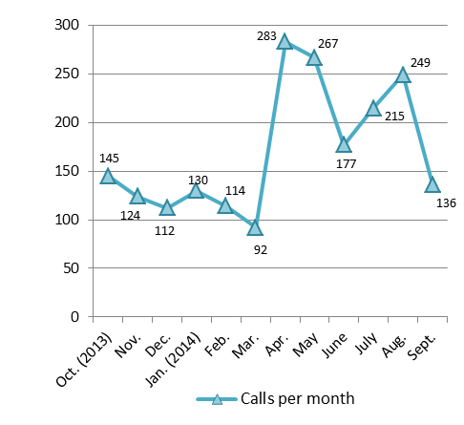
Month | Calls Recv’d. | % of Calls Answered | Avg.Speed to Answer | Avg. Call Length
2013 |  |  | (min:sec) | (min:sec)
October | 145 | 97% | 1:03 | 7:43
November | 124 | 95% | 1:42 | 6:31
December | 112 | 95% | 1:46 | 6:45
2014
January | 130 | 98% | 2:07 | 7:07
February | 114 | 96% | 1:40 | 8:28
March | 92 | 96% | 2:07 | 8:10
April | 283 | 96% | 3:01 | 7:21
May | 267 | 96% | 2:11 | 8:15
June | 177 | 95% | 2:13 | 7:54
July | 215 | 93% | 2:03 | 7:12
August | 249 | 92% | 2:04 | 7:51
September | 136 | 94% | 1:57 | 7:07

