EIP Monthly One Care Enrollment Data Report—February 2014

Introduction
The data in this report reflects One Care activity as of February 1, 2014. MassHealth takes a snapshot of enrollments and opt-outs shortly after the beginning of the month to allow time for resolution of a small number of delayed successful enrollments at the beginning of each month.
1. February Enrollment Summary
Since January 1, there have been 542 new enrollments in One Care with an effective coverage date of February 1, 2014. All of the new enrollments for February were self-selected enrollments. As of February 1, 2014, total enrollment in One Care across all three plans was 9,541. Enrollment in One Care is distributed across three plans as follows:
Plan | New enrollments for February 2014 | Total enrollment
Commonwealth Care Alliance (CCA) | 362 (67%) | 6,238 (65%)
Fallon Total Care (FTC) | 146 (27%) | 2,503 (26%)
Network Health (NH) | 34 (6%) | 800 (8%)
All Plans | 542 (100%) | 9,541 (100%)
N = approx. 82,000 (number of individuals who received a One Care introduction and enrollment packet from MassHealth in October 2013)

Why was One Care enrollment in January so much higher than other months? Enrollment in One Care began in October 2013. The spike in enrollments for January 2014 reflects the first group of passive enrollments, on top of a regular monthly volume of self-enrollments. Passive enrollment is MassHealth’s process of assigning, notifying, and automatically enrolling someone in a One Care plan (also referred to as “auto-assignment”). Passive enrollment happens in large groups, rather than on a rolling basis.
Figure 1. Trends in monthly One Care enrollment volume
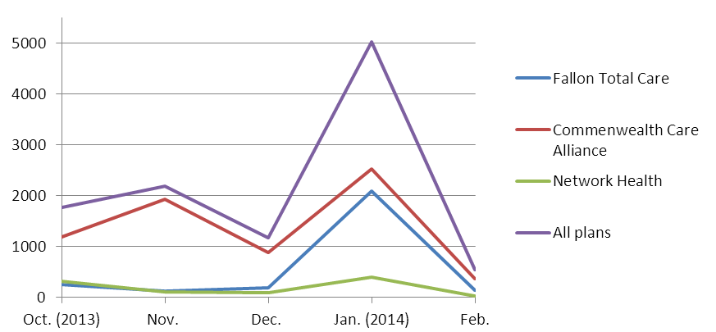
2. Rating Category Data. One Care enrollees are categorized based on anticipated or actual service needs as follows:
- F1: Residing in an institutional setting
- C3B: Very high community long term services and supports needs
- C3A: High community long term services and supports needs
- C2B: Very high community behavioral health services needs
- C2A: High community behavioral health services needs
- C1: Other individuals living in the community
Why is One Care enrollment mostly in the C1 rating category? The first wave of passive enrollment, which included 4,187 members, took effect on January 1, 2014. That group included only individuals in the C1 rating category. The large influx of C1s in January affected the overall percentage of enrollment across rating categories.
Since then, new self-selection enrollments for February caused the proportion of C1 enrollments to decrease for One Care overall (from 79% to 76%), as well as within each plan: Commonwealth Care Alliance from 74% to 71%; Fallon Total Care from 92% to 86%; and Network Health 78% to 72%. (See Figure 3, below.)
Note: The F1 rating category represents <1% of enrollments, and therefore does not appear in this chart.

What accounts for Fallon Total Care’s higher proportion of C1 enrollments? FTC has a higher proportion of C1 enrollments because passively-enrolled members, all of whom were in the C1 category at the time of their enrollment, represent over two-thirds of its total membership.
Figure 2. Total One Care enrollment by rating category
[N = 9,541]

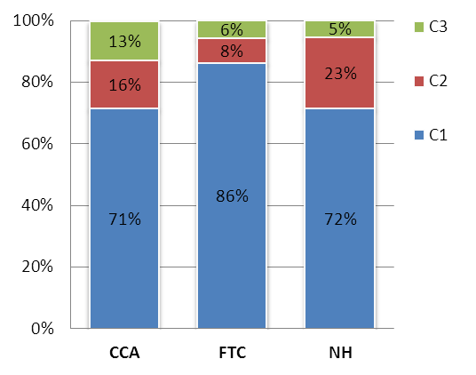
What is the enrollment penetration rate among One Care-eligible individuals in the different rating categories?
Figure 3. One Care plans' rating category enrollment (Feb. 1)
The rate of enrollment is highest among eligible individuals in the C3B rating category (11.9%), followed by C1 (11.1%), C2A (8.5%), C3A (8.3%), and C2B (7.7%). The lowest penetration rate is among individuals in the F1 rating category (1.4%).

As enrollees’ assessments are completed, more specific information about their needs may indicate some should be in a different rating category, and it is anticipated that there will continue to be adjustments across rating categories for all plans.
Note: The F1 rating category represents <1% of enrollments in each plan, and therefore does not appear in this chart.

3. County-Specific Data
One Care is available in nine Massachusetts counties. The three One Care plans each serve a different number of counties. One Care enrollments by county are geographically distributed as follows:
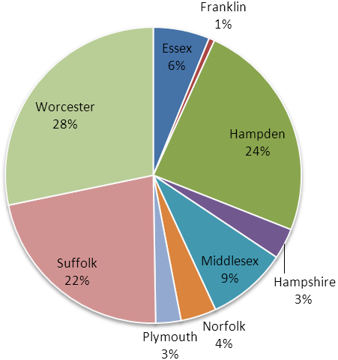
* Data point includes a small number (≤2) of potentially invalid enrollments
that were unresolved at the time of reporting.
Figure 4. Total One Care enrollment
One Care County | New enrollments for February 1, 2014 | Total enrollment [N = approx. 82,000]
Essex (CCA only) | 48 | 589
Franklin (CCA only) | 2* | 56
Hampden | 143 | 2,307
CCA | 711 (46%) | 1,351 (59%)
FTC | 850 (54%) | 956 (41%)
Hampshire | 8 | 321
CCA | 6 (75%) | 137 (43%)
FTC | 2 (25%) | 184 (57%)
Middlesex (CCA only) | 63 | 835*
Norfolk (CCA only) | 24 | 373
Plymouth (CCA only) | 23 | 263
Suffolk | 1,264 | 2,101
CCA | 73 (91%) | 1,757 (84%)
NH | 7 (9%) | 344 (16%)
Worcester | 1,673 | 2,694
CCA | 38 (25%) | 880 (33%)
FTC | 85 (57%) | 1,360 (50%)
NH | 27 (18%) | 454 (17%)
All Counties | 542 | 9,541*

In the counties where One Care is available, between 2.7% and 18.5% of eligible MassHealth members were enrolled in One Care as of February 1. The greatest enrollment penetration rate is in Worcester County, where all three One Care plans are available.
Figure 3. County-level One Care enrollment penetration among eligible MassHealth members
N = 93,759 (total number of One Care-eligible MassHealth members)

4. Opt-outs
The table below shows the number of individuals who indicated to MassHealth in January 2014 that they do not want to participate in One Care (referred to as “opting out”), as well as each county’s total number of active opt-outs (individuals who opted out, remain eligible, and have not subsequently enrolled). All counties have a small number of member-initiated enrollments (“self-selections”) by individuals who had previously opted out. Note that MassHealth does not remove from the data individuals who have opted out, but who are not eligible for One Care. As a result, the number of opt-outs reported is higher than it would be if the data reflected only opt-outs by eligible members.
County | January  Opt-outs | Total Active  Opt-outs | Total number of current enrollees who self-selected after previously opting out
Essex | 64 | 2,010 | 18
Franklin | 8 | 324 | 1
Hampden | 305 | 2,770 | 63
Hampshire | 77 | 672 | 6
Middlesex | 100 | 2,949 | 34
Norfolk | 31 | 1,232 | 11
Plymouth | 15 | 912 | 12
Suffolk | 171 | 2,209 | 57
Worcester | 391 | 3,490 | 135
Other* | 4 | 74 | 1
Total  *Individuals in counties that do not have a N = approx. 82,000  One Care plan are ineligible for One Care. | 1,166 | 16,642 | 338

5. Monthly One Care Plan Transitions and Disenrollments
The following chart shows the percentage of One Care members who left plans either to enroll in a different plan or disenroll from One Care altogether from October 2013 through January 2014. Notably, the rate of disenrollment has dropped by about half since the program began: In October, approximately ten percent of enrolled One Care members disenrolled; while only about five percent of enrolled members disenrolled during the months of December and January.

Figure 4. Disenrollments from and plan transfers within One Care, over time

