EIP Monthly One Care Enrollment Data Report—January 2014

Introduction
The data in this report reflects One Care activity as of January 1, 2014. MassHealth takes a snapshot of enrollments and opt-outs shortly after the beginning of the month to allow time for resolution of a small number of delayed successful enrollments at the beginning of each month.
1. January Enrollment Summary
Since December 1, there have been 5,026 new enrollments in One Care with an effective coverage date of January 1, 2014. Of the new enrollments for January, 839 members self-selected, and 4,187 were passively enrolled. As of January 1, 2014, total enrollment in One Care across all three plans was 9,506.
Enrollment in One Care is distributed across three plans as follows:
Plan | New enrollments for January 2014 | Total enrollment
Commonwealth Care Alliance (CCA) | 2,525 (50%) | 6,120 (64%)
Fallon Total Care (FTC) | 2,099 (42%) | 2,570 (27%)
Network Health (NH) | 402 (8%) | 816 (9%)
All Plans | 5,026 (100%) | 9,506 (100%)

Why did One Care enrollment increase so dramatically in January 2014? Enrollment in One Care began in October 2013 (see Figure 1). The spike in enrollments for January 2014 reflects the first group of passive enrollments, on top of a regular volume of self-enrollments for the month. Passive enrollment is MassHealth’s process of assigning, notifying, and automatically enrolling someone in a One Care plan (also referred to as “auto-assignment”).
Figure 1. Trends in monthly One Care enrollment volume
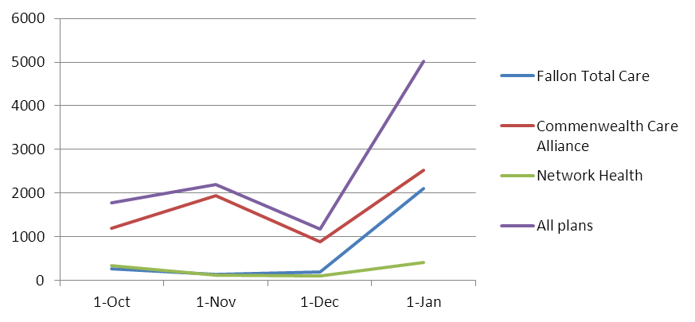
2. Enrollment Distribution: Rating Categories
One Care enrollees are categorized based on anticipated or actual service needs as follows:
- F1 – Residing in an institutional setting
- C3B – Very high community long term services and supports needs
- C3A – High community long term services and supports needs
- C2B – Very high community behavioral health services needs
- C2A – High community behavioral health services needs
- C1 – Other individuals living in the community
Figure 2. Total One Care enrollment across rating categories

Why is One Care enrollment mostly in the C1 rating category? The first wave of passive enrollment, which included 4,187 members, took effect on January 1, 2014. Only individuals in the C1 rating category were included in this wave of passive enrollment. The large influx of C1s affected the overall percentage of enrollment in the different rating categories.

Note: The F1 rating category represents <1% of enrollments, and therefore does not appear in this chart.

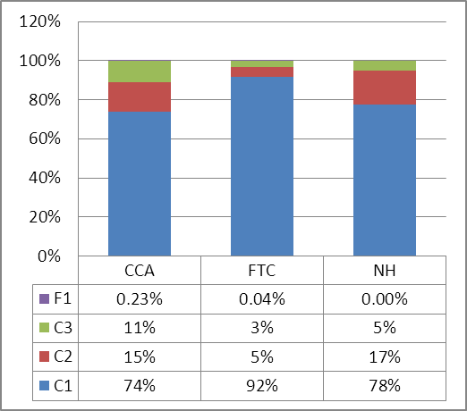
As of January 1, 2014, the percentage of the One Care plans’ enrollment across rating categories (Figure 3) generally reflects the overall distribution of enrollment in One Care (Figure 2). Fallon Total Care has a higher proportion of enrollment by individuals in the C1 rating category because passively-enrolled members, all of whom are in the C1 category, represent over three-quarters of its total enrollment; Network Health has a slightly higher proportion of enrollment from the C2 category.
Figure 3. One Care plans' rating category enrollment

As enrollees’ assessments are completed, more specific information about their needs may indicate some should be in a different rating category, and it is anticipated that there will be adjustments across rating categories for all plans.
3. Enrollment Distribution: Geographic
One Care is available in nine Massachusetts counties. The three One Care plans each serve a different number of counties. One Care enrollments by county are geographically distributed as follows:
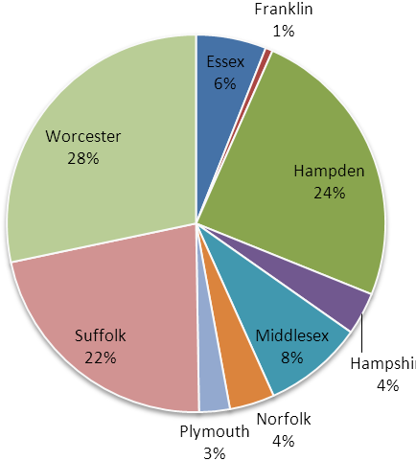
N = approx. 82,000
*January 1, 2014 enrollment data reflects 1 Essex County enrollment in Network Health, indicating a member who moved to Essex county from a county where Network Health is available after enrolling; Network Health is not available in Essex County.
Figure 4. Total One Care enrollment
One Care County | New enrollments for January 1, 2014 | Total enrollment
Essex (CCA only) | 57* | 571
Franklin (CCA only) | 7 | 59
Hampden | 1,561 | 2,326
CCA | 711 (46%) | 1,319 (57%)
FTC | 850 (54%) | 1,007 (43%)
Hampshire | 249 | 347
CCA | 73 (29%) | 138 (40%)
FTC | 176 (71%) | 209 (60%)
Middlesex (CCA only) | 120 | 810
Norfolk (CCA only) | 60 | 366
Plymouth (CCA only) | 34 | 250
Suffolk | 1,264 | 2,087
CCA | 1,070 (85%) | 1,734 (83%)
NH | 194 (15%) | 353 (17%)
Worcester | 1,673 | 2,689
CCA | 393 (23%) | 874 (33%)
FTC | 1,073 (64%) | 1,354 (50%)
NH | 207 (12%) | 461 (17%)
All Counties | 5,026 | 9,506

3. Opt-outs
The table below shows the number of individuals who indicated to MassHealth in December 2013 that they do not want to participate in One Care (referred to as “opting out”), as well as each county’s total number of active opt-outs (individuals who opted out, remain eligible, and have not subsequently enrolled). All counties have a small number of member-initiated enrollments by individuals who had previously opted out. Note that MassHealth does not remove from the data individuals who have opted out, but who are not eligible for One Care. As a result, the number of opt-outs reported is higher than it would be if the data reflected only opt-outs by eligible members.
County | December  Opt-outs | Total Active  Opt-outs | Total active enrollments by members  who self-enrolled after previously opting out
Essex | 162 | 1,950 | 16
Franklin | 28 | 316 | 1
Hampden | 311 | 2,484 | 48
Hampshire | 89 | 597 | 5
Middlesex | 279 | 2,856 | 26
Norfolk | 134 | 1,205 | 8
Plymouth | 88 | 903 | 9
Suffolk | 273 | 2,057 | 40
Worcester | 297 | 3,127 | 104
Other* | 38 | 72 | N/A
Total  *Individuals in counties that do not have a N = approx. 82,000  One Care plan are ineligible for One Care. | 1,699 | 15,567 | 257

4. Monthly One Care Plan Transitions and Disenrollments
One Care offers members the option to change plans or disenroll from the program at any time. Overall, 66 members (1.4%) have transferred from one plan to another, and 653 (6.4%) have disenrolled from One Care.
The following chart shows the percentage of One Care members who left plans either to enroll in a different plan or disenroll from One Care altogether from October to December, 2013. Notably, the rate of disenrollment has dropped by about half since the program began: In October, approximately ten percent of enrolled One Care members disenrolled; while only about five percent of enrolled members disenrolled during the month of December.

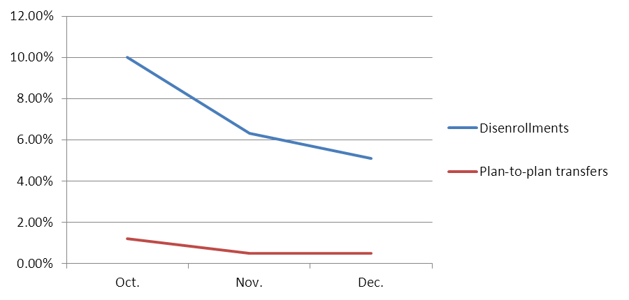
Figure 3. Disenrollments from and plan transfers within One Care, over time

