EIP Monthly One Care Enrollment Data Report—July 2014

Introduction
The data in this report reflects One Care activity as of July 1, 2014. MassHealth takes a snapshot of enrollments and opt-outs shortly after the beginning of the month to allow time for resolution of a small number of delayed successful enrollments at the beginning of each month.
1. Enrollment Summary
Since June 1st, there have been 5,870 new enrollments in One Care with an effective coverage date of July 1, 2014. As of July 1, 2014, total enrollment in One Care across all three plans was 18,836.
Plan | New enrollments for July 2014 | Total enrollment
Commonwealth Care Alliance (CCA) | 1,997 (34%) | 9,714 (52%)
Fallon Total Care (FTC) | 3,173 (54%) | 7,551 (40%)
Network Health (NH) | 700 (12%) | 1,571 (8%)
All Plans | 5,870 (100%) | 18,836 (100%)
N = approx. 94,589 (number of eligible MassHealth members as of 7/1/14)

Why was One Care enrollment in January, April, and July so much higher than other months? The spikes in enrollment for January, April, and July 2014 reflect the first three groups of passive enrollments, on top of a regular volume of self-enrollments in those months. Passive enrollment is MassHealth’s process of assigning, notifying, and automatically enrolling someone in a One Care plan (also referred to as “auto-assignment”). Passive enrollment currently happens at specific points in time for large groups, rather than on a rolling basis.
Figure 1. Monthly One Care enrollments, October 2013 – July 2014
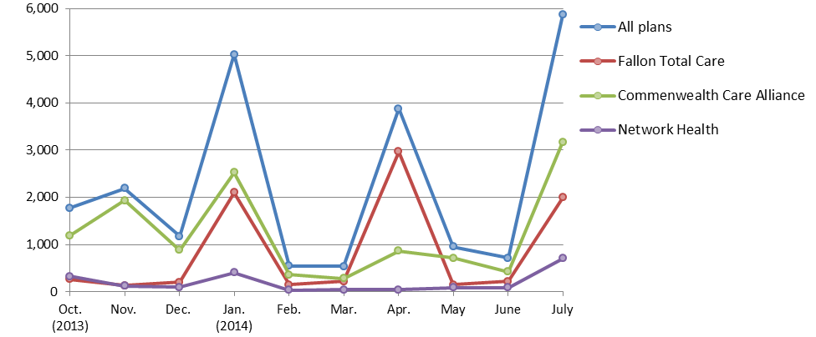

2. Rating Category Data. One Care enrollees are categorized based on anticipated or actual service needs as follows:
- F1: Residing in an institutional setting
- C3B: Very high community long term services and supports needs
- C3A: High community long term services and supports needs
- C2B: Very high community behavioral health services needs
- C2A: High community behavioral health services needs
- C1: Other individuals living in the community

Why is One Care enrollment mostly in the C1 rating category? Individuals in the C1 rating category represent a majority of MassHealth members who are eligible for One Care. Currently, MassHealth estimates that 64% of eligible members, and 62% of enrolled members are in the C1 rating category.
Figure 2. Total One Care enrollment by rating category
(N = 18,836)
As members enroll in One Care and their assessments are completed, more specific information about their needs may indicate some should be in a different rating category.

Enrollment penetration refers to the percent of individuals who are enrolled out of the total number eligible in a given group. In the different rating categories, enrollment penetration is currently highest in C2A (23%) and lowest in F1 (2%). Overall, 20% of eligible individuals are enrolled in One Care. (Figure 3)
Note: The F1 rating category represents <1% of all enrollments, and therefore does not appear in this chart.
Figure 3. Rating category enrollment penetration

Figure 4. One Care plans' rating category enrollment
Within each plan, what is the distribution of enrollees in each rating category? The three One Care plans’ rating category enrollment distribution fluctuates month-to-month. New enrollments drive most of these changes. In addition, as plans complete the assessment process for new enrollees, some individuals move to a different rating category. Figure 4 shows the relative distribution of rating category enrollments by plan compared to the overall distribution in One Care.

Note: The F1 rating category represents <1% of enrollments in each plan, and therefore does not appear in this chart.

3. County-Specific Data
One Care is available in nine Massachusetts counties. The three One Care plans each serve a different number of counties. One Care enrollments by county are geographically distributed as follows:
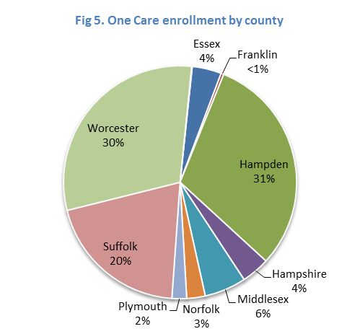
One Care County | New One Care enrollments  for July 1, 2014 | Total enrollment  [N = 94,589]
Essex (CCA only) | 39 | 767*
Franklin (CCA only) | 4 | 71*
Hampden | 2,326 | 5,782
CCA | 671 (29%) | 2,414 (42%)
FTC | 1,655 (71%) | 3,368 (58%)
Hampshire | 315 | 740
CCA | 34 (11%) | 182 (25%)
FTC | 281 (89%) | 558 (75%)
Middlesex (CCA only) | 61 | 1,090
Norfolk (CCA only) | 31 | 483
Plymouth (CCA only) | 22 | 384
Suffolk | 1,341 | 3,764
CCA | 812 (61%) | 2,885 (77%)
NH | 529 (39%) | 878 (23%)
Worcester | 1,731 | 5,743*
CCA | 327 (19%) | 1,442 (25%)
FTC | 1,234 (71%) | 3,612 (63%)
NH | 170 (10%) | 689 (12%)
All Counties | 5,870 | 18,836*

Enrollment penetration refers to the percent of enrolled individuals out of the total number eligible in a given group. In the counties where One Care is available, between 3.5% and 39.7% of eligible MassHealth members were enrolled as of July 1. Hampden and Worcester Counties currently have the greatest enrollment penetration rates.
Figure 6. County-level One Care enrollment penetration (N = 94,589)

There is no auto-assignment in counties with 1 One Care plan

Counties with ≥2 One Care plans; enrollment includes auto-assigned members

4. Opt-outs
The table below shows the number of individuals who indicated to MassHealth in June 2014 that they do not want to participate in One Care (referred to as “opting out”), as well as total active opt-outs (individuals who opted out, remain eligible, and have not subsequently enrolled). A MassHealth member need not be enrolled in One Care (voluntarily or though the auto-assignment process) to opt out. The numbers reported below include opt-outs by members who were not enrolled at the time they opted out and by members who were enrolled at the time they opted out.
MassHealth does not remove from the data individuals who have opted out, but who are not eligible for One Care. As a result, the number of opt-outs reported is higher than it would be if the data reflected only opt-outs by eligible members.
All counties show member-initiated enrollments (“self-selections”) by individuals who had previously opted out.
County | June  Opt-outs | Total Active  Opt-outs | Total number of current enrollees who  self-selected after previously opting out
Essex | 29 | 2,316 | 40
Franklin | 3 | 376 | 1
Hampden | 471 | 5,152 | 172
Hampshire | 106 | 1,242 | 21
Middlesex | 24 | 3,361 | 68
Norfolk | 11 | 1,423 | 23
Plymouth | 8 | 1,050 | 22
Suffolk | 143 | 2,962 | 109
Worcester | 458 | 5,899 | 266
Other* | 5 | 99 | 3
Total  *Individuals in counties that do not have a N = 94,589  One Care plan are ineligible for One Care. | 1,258 | 23,880 | 725

5. Monthly One Care Plan Transitions and Disenrollments
Figure 7 shows the percentage of One Care members who leave their One Care plan either to enroll in a different One Care plan or who disenroll from One Care altogether. In October, approximately ten percent of enrolled One Care members disenrolled; in March 2014, the rate had dropped to about four percent, and by June was approximately three percent. The spike in the disenrollment rate in April 2014 reflects that an additional 13,000 newly-eligible MassHealth members received One Care materials in the mail at the end of March. (Approximately 85,000 individuals received One Care materials from MassHealth in the first bulk mailing in September-October 2013.) Since November, the rate of enrollees switching to a different One Care plan has been less than one percent.
Figure 7. Rate of disenrollments from and plan transfers within One Care
