EIP Monthly One Care Enrollment Data Report—June 2014

Introduction
The data in this report reflects One Care activity as of June 1, 2014. MassHealth takes a snapshot of enrollments and opt-outs shortly after the beginning of the month to allow time for resolution of a small number of delayed successful enrollments at the beginning of each month.
1. Enrollment Summary
Since May 1st, there have been 712 new enrollments in One Care with an effective coverage date of June 1, 2014. As of June 1, 2014, total enrollment in One Care across all three plans was 13,409.
Plan | New enrollments for June 2014 | Total enrollment
Commonwealth Care Alliance (CCA) | 417 (59%) | 7,846 (59%)
Fallon Total Care (FTC) | 214 (30%) | 4,661 (35%)
Network Health (NH) | 81 (11%) | 902 (7%)
All Plans | 712 (100%) | 13,409 (100%)
N = approx. 94,358 (number of eligible MassHealth members as of 6/1/14)

Why was One Care enrollment in January and April so much higher than other months? The spikes in enrollment for January and April 2014 reflect the first two groups of passive enrollments, on top of a regular volume of self-enrollments in those months. Passive enrollment is MassHealth’s process of assigning, notifying, and automatically enrolling someone in a One Care plan (also referred to as “auto-assignment”). Passive enrollment currently happens at specific points in time for large groups, rather than on a rolling basis.
Figure 1. Monthly One Care enrollments, October 2013 – June 2014
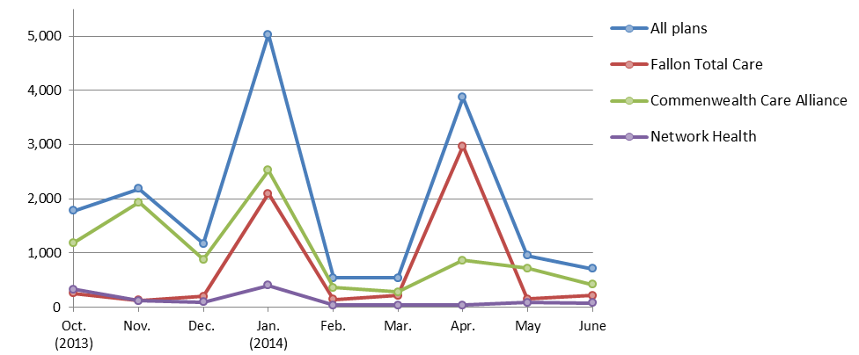

2. Rating Category Data. One Care enrollees are categorized based on anticipated or actual service needs as follows:
- F1: Residing in an institutional setting
- C3B: Very high community long term services and supports needs
- C3A: High community long term services and supports needs
- C2B: Very high community behavioral health services needs
- C2A: High community behavioral health services needs
- C1: Other individuals living in the community

Why is One Care enrollment mostly in the C1 rating category? Individuals in the C1 rating category represent a majority of MassHealth members who are eligible for One Care. Currently, MassHealth estimates that 64% of eligible members, and 56% of enrolled members are in the C1 rating category.
Figure 2. Total One Care enrollment by rating category
(N = 13,409)
As members enroll in One Care and their assessments are completed, more specific information about their needs may indicate some should be in a different rating category.
Note: The F1 rating category represents <1% of all enrollments, and therefore does not appear in this chart.

Enrollment penetration refers to the percent of individuals who are enrolled out of the total number eligible in a given group. In the different rating categories, enrollment penetration is currently highest in C2A (19%) and lowest in F1 (1.5%). (Figure 3)
Figure 3. Rating category enrollment penetration

Figure 4. One Care plans' rating category enrollment
Within each plan, what is the distribution of enrollees in each rating category? The three One Care plans’ rating category enrollment distribution fluctuates month-to-month. New enrollments drive most of these changes. In addition, as plans complete the assessment process for new enrollees, some individuals move to a different rating category.

MassHealth anticipates that the next round of passive enrollment, in July, will result in additional shifts in the percentage of enrollees in the various rating categories.
Note: The F1 rating category represents <1% of enrollments in each plan, and therefore does not appear in this chart.

3. County-Specific Data
One Care is available in nine Massachusetts counties. The three One Care plans each serve a different number of counties. One Care enrollments by county are geographically distributed as follows:
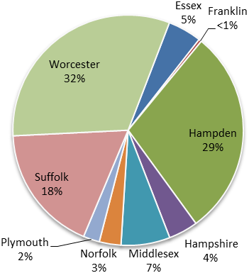
* Data point includes ≤7 potentially invalid enrollments
that were unresolved at the time of reporting.
Figure 5. Total One Care enrollment (N=13,409)
One Care County | New One Care enrollments  for June 1, 2014 | Total enrollment  [N = 94,358]
Essex (CCA only) | 51 | 751*
Franklin (CCA only) | 3 | 68*
Hampden | 229 | 3,620
CCA | 127 (55%) | 1,761 (49%)
FTC | 102 (45%) | 1,859 (51%)
Hampshire | 23 | 468
CCA | 7 (30%) | 155 (33%)
FTC | 16 (70%) | 313 (67%)
Middlesex (CCA only) | 51 | 1,049
Norfolk (CCA only) | 15 | 461
Plymouth (CCA only) | 24 | 369
Suffolk | 122 | 2,462
CCA | 90 (74%) | 2,101 (85%)
NH | 32 (26%) | 361 (15%)
Worcester | 194 | 4,161*
CCA | 49 (25%) | 1,138 (27%)
FTC | 96 (50%) | 2,479 (60%)
NH | 49 (25%) | 537 (13%)
All Counties | 712 | 13,409*

Enrollment penetration refers to the percent of enrolled individuals out of the total number eligible in a given group. In the counties where One Care is available, between 3.4% and 28.3% of eligible MassHealth members were enrolled as of June 1. The greatest enrollment penetration rate is in Worcester County, where all three One Care plans are available.
Figure 5. County-level One Care enrollment penetration (N = 94,358)

There is no auto-assignment in counties with 1 One Care plan

Counties with ≥2 One Care plans; enrollment includes auto-assigned members

4. Opt-outs
The table below shows the number of individuals who indicated to MassHealth in May 2014 that they do not want to participate in One Care (referred to as “opting out”), as well as total active opt-outs (individuals who opted out, remain eligible, and have not subsequently enrolled). A MassHealth member need not be enrolled in One Care (voluntarily or though the auto-assignment process) to opt out. The numbers reported below include opt-outs by members who were not enrolled at the time they opted out and by members who were enrolled at the time they opted out.
MassHealth does not remove from the data individuals who have opted out, but who are not eligible for One Care. As a result, the number of opt-outs reported is higher than it would be if the data reflected only opt-outs by eligible members.
All counties show member-initiated enrollments (“self-selections”) by individuals who had previously opted out.
County | May  Opt-outs | Total Active  Opt-outs | Total number of current enrollees who  self-selected after previously opting out
Essex | 38 | 2,288 | 38
Franklin | 5 | 373 | 1
Hampden | 538 | 4,700 | 145
Hampshire | 137 | 1,136 | 20
Middlesex | 54 | 3,343 | 62
Norfolk | 31 | 1,414 | 20
Plymouth | 20 | 1,041 | 22
Suffolk | 191 | 2,837 | 94
Worcester | 658 | 5,462 | 242
Other* | 3 | 92 | 3
Total  *Individuals in counties that do not have a N = 94,358  One Care plan are ineligible for One Care. | 1,675 | 22,686 | 647

5. Monthly One Care Plan Transitions and Disenrollments
Figure 7 shows the percentage of One Care members who leave their One Care plan either to enroll in a different One Care plan or who disenroll from One Care altogether. In October, approximately ten percent of enrolled One Care members disenrolled; in March 2014, the rate had dropped to about four percent. An increase in the rate of disenrollments in April 2014 correlates to MassHealth’s second bulk mailing of One Care materials to approximately 13,000 newly eligible individuals at the end of March. (Approximately 85,000 individuals received One Care materials from MassHealth in the first bulk mailing in September-October 2013.) Since November, the rate of enrollees switching to a different One Care plan has been less than one percent.
Figure 6. Disenrollments from and plan transfers within One Care
