EIP Monthly One Care Enrollment Data Report—March 2014

Introduction
The data in this report reflects One Care activity as of March 1, 2014. MassHealth takes a snapshot of enrollments and opt-outs shortly after the beginning of the month to allow time for resolution of a small number of delayed successful enrollments at the beginning of each month.
1. February Enrollment Summary
Since February 1, there have been 540 new enrollments in One Care with an effective coverage date of March 1, 2014. All of the new enrollments for March were self-selected enrollments. As of March 1, 2014, total enrollment in One Care across all three plans was 9,722, distributed as follows:
Plan | New enrollments for March 2014 | Total enrollment
Commonwealth Care Alliance (CCA) | 284 (53%) | 6,371 (66%)
Fallon Total Care (FTC) | 216 (40%) | 2,549 (26%)
Network Health (NH) | 40 (7%) | 802 (8%)
All Plans | 540 (100%) | 9,722 (100%)
N = approx. 94,705
(One Care-eligible MassHealth members who live in a county where One Care is available, as of 3/1/14)

Why was One Care enrollment in January so much higher than other months? Enrollment in One Care began in October 2013. The spike in enrollments for January 2014 reflects the first group of passive enrollments, on top of a regular monthly volume of self-enrollments. Passive enrollment is MassHealth’s process of assigning, notifying, and automatically enrolling someone in a One Care plan (also referred to as “auto-assignment”). Passive enrollment currently happens in large groups, rather than on a rolling basis.

Figure 1. Trends in monthly One Care enrollment volume
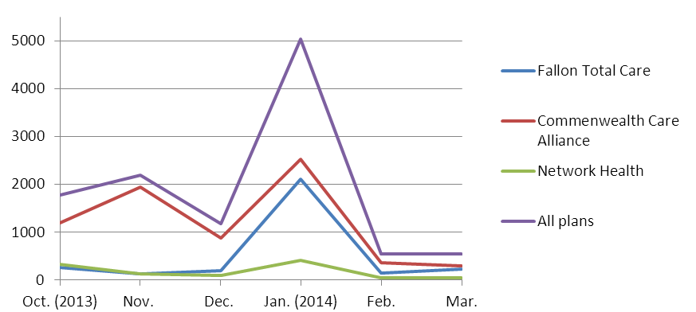
2. Rating Category Data. One Care enrollees are categorized based on anticipated or actual service needs as follows:
- F1: Residing in an institutional setting
- C3B: Very high community long term services and supports needs
- C3A: High community long term services and supports needs
- C2B: Very high community behavioral health services needs
- C2A: High community behavioral health services needs
- C1: Other individuals living in the community

Why is One Care enrollment mostly in the C1 rating category? The first wave of passive enrollment, which included 4,187 members, took effect on January 1, 2014. That group included only individuals in the C1 rating category. The large influx of C1s in January affected the overall percentage of enrollment across rating categories.
Since then, new self-selection enrollments for February and March have caused the proportion of C1 enrollments to decrease for One Care overall (from 79% to 71%), as well as within each plan: Commonwealth Care Alliance from 74% to 70%; Fallon Total Care from 92% to 79%; and Network Health 78% to 58%. (See Figure 3, below.)
Note: The F1 rating category represents <1% of enrollments, and therefore does not appear in this chart.

Figure 2. Total One Care enrollment by rating category
[N = 9,722]

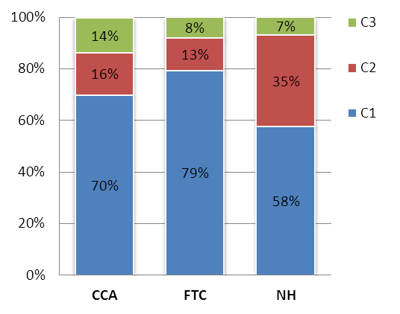
Figure 3. One Care plans' rating category enrollment (Mar. 1)

What is the enrollment penetration rate among One Care-eligible individuals in the different rating categories? The rate of enrollment is currently highest among eligible individuals in the C1 rating category (11.4%), followed by C3B (11.3%), C2A (8.9%), C3A (8.5%), and C2B (6.4%). The lowest penetration rate is among individuals in the F1 rating category (1.4%).

As enrollees’ assessments are completed, more specific information about their needs may indicate some should be in a different rating category, and it is anticipated that there will continue to be adjustments across rating categories for all plans.
Note: The F1 rating category represents <1% of enrollments in each plan, and therefore does not appear in this chart.

3. County-Specific Data
One Care is available in nine Massachusetts counties. The three One Care plans each serve a different number of counties. One Care enrollments by county are geographically distributed as follows:
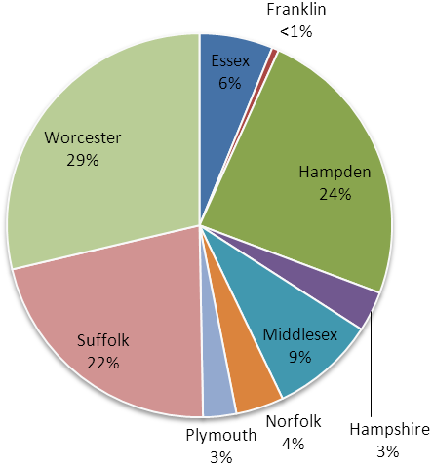
* Data point includes a small number (≤3) of potentially invalid enrollments
that were unresolved at the time of reporting.
Figure 4. Total One Care enrollment
One Care County | New enrollments for March 1, 2014 | Total enrollment [N = approx. 94,705]
Essex (CCA only) | 29 | 601
Franklin (CCA only) | 0 | 56
Hampden | 134 | 2,328
CCA | 56 (42%) | 1,384 (59%)
FTC | 78 (58%) | 943 (41%)
Hampshire | 31 | 329
CCA | 6 (19%) | 141 (43%)
FTC | 25 (81%) | 188 (57%)
Middlesex (CCA only) | 53 | 854*
Norfolk (CCA only) | 25* | 392*
Plymouth (CCA only) | 16 | 272
Suffolk | 65 | 2,100
CCA | 58 (89%) | 1,768 (84%)
NH | 7 (11%) | 332 (16%)
Worcester | 187 | 2,787
CCA | 41 (22%) | 908 (33%)
FTC | 113 (60%) | 1,412 (51%)
NH | 33 (18%) | 467 (17%)
All Counties | 540* | 9,722*

In the counties where One Care is available, between 2.7% and 18.9% of eligible MassHealth members were enrolled in One Care as of March 1. The greatest enrollment penetration rate is in Worcester County, where all three One Care plans are available. The overall enrollment penetration rate for One Care is 10.3%.
Figure 3. County-level One Care enrollment penetration among eligible MassHealth members
N = 94,705 (One Care-eligible MassHealth members living in One Care service area as of 3/1/14)

4. Opt-outs
The table below shows the number of individuals who indicated to MassHealth in February 2014 that they do not want to participate in One Care (referred to as “opting out”), as well total active opt-outs (individuals who opted out, remain eligible, and have not subsequently enrolled). A MassHealth member need not be enrolled in One Care (voluntarily or through the auto-assignment process) to opt out. The numbers reported below include opt-outs by members who were not enrolled at the time they opted out and by members who were enrolled at the time they opted out.
Note that MassHealth does not remove from the data individuals who have opted out, but who are not eligible for One Care. As a result, the number of opt-outs reported is higher than it would be if the data reflected only opt-outs by eligible members.
All counties have a small number of member-initiated enrollments (“self-selections”) by individuals who had previously opted out.
County | February  Opt-outs | Total Active  Opt-outs | Total number of current enrollees who self-selected after previously opting out
Essex | 28 | 2,036 | 21
Franklin | 5 | 329 | 1
Hampden | 407 | 3,149 | 75
Hampshire | 96 | 756 | 10
Middlesex | 41 | 2,982 | 42
Norfolk | 16 | 1,246 | 12
Plymouth | 11 | 922 | 14
Suffolk | 118 | 2,309 | 64
Worcester | 443 | 3,890 | 154
Other* | 8 | 82 | 1
Total  *Individuals in counties that do not have a N = approx. 94,705  One Care plan are ineligible for One Care. | 1,173 | 17,701 | 394

5. Monthly One Care Plan Transitions and Disenrollments
The following chart shows the percentage of One Care members who leave plans either to enroll in a different plan or disenroll from One Care altogether. Notably, the rate of disenrollment has dropped by well over half since the program began: In October, approximately ten percent of enrolled One Care members disenrolled; by February 2014, the rate was close to three percent. Since November, the rate of enrollees switching to a different One Care plan has been less than one percent.
Figure 4. Disenrollments from and plan transfers within One Care, over time

